The Importance and History of Concept Art.
The creation of any media begins somewhere; movies, video games, animation, characters, books, simple illustrations, posters and more. They all begin with an idea, a thought that needs to be visualized and that is where art comes through. Each idea - theory, character, and environment needs a canvas to tell its story and the role of the concept artist is to put it down on paper, to be an anchor for each process to follow. In this essay my intention is to highlight the importance of this role by giving a brief history through the years including how the career has changed since its beginning. I aim to answer the question: “How important is Concept Art?”

Concept Art is the visual representation of an idea and/or concept, to develop said idea into the industry development process and to further the idea into a product ready for the public. This creates a unified visual conceptualization and notion for other departments in the design process in the production of products such as: movies, animation, video games, the motor industry, book covers, characters, costumes, posters, and household items, as well as many others. The concept artists job is to visualize the product for the streamlining and ability of a team, which provides direction and unification for the proposed product's direction and design. (DeGuzman, 2024)
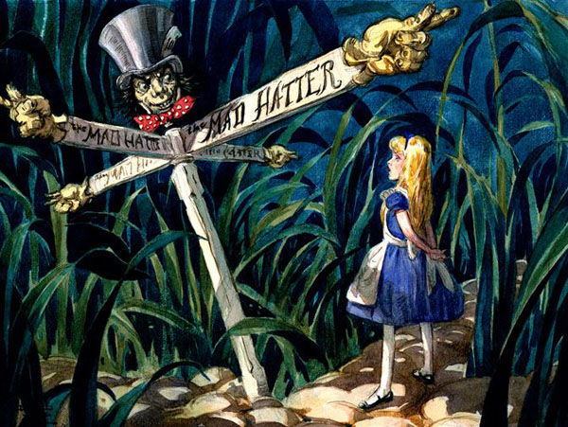
(Korkis, 2020)
(Hall. D (1939) Alice in Wonderland [graphite, watercolor and gouache on paper])

Concept art as a term dates from the early 1930’s coined and used by Walt Disney Animation Studios. During the early conceptualization of their earliest movies through drawings made by Mary Blair for projects such as Alice in Wonderland and Peter Pan. (NFI, 2021) Through time, concept art has shifted through processes, from traditional to digital, but has still been in the creative industry as a process through the ages.

There is a unified process in many of the creative industries that relate to briefs. In film making, these stages are development, pre-production, production, post-production and Distribution (Negishi, 2022) .These stages can be translated to other media, with either additional or fewer steps; for example, the video game industry, which has the process: pre-production, game design documentation, Prototyping, production, testing, pre-launch, launch and post launch (Admin/Walla Walla Studios, 2022). The two are different, but with many similarities. The method I personally respond to involves briefs and client feedback of researching the topic, creating thumbnails and ideas, developing the product, and finally presenting the product to the client. The general process calls for pre-production, production, and post-production for almost all creative industries. These three are pillars for the process of creation. Concept Art falls into the Pre-Production stage.

Using the same film example, the usage of concept art is said to create a visual tone for the movie being able to explore visual aspects using the direction and script of the director. These representations of the director's vision could be anything from character designs, scenes, props, costumes – all fundamental to a movie. Along with a script, concept artists can be given research or are left to do their own. (Mages, 2019) This often leaves the artist able to make symbolic references in their work, which can make the media more personal therefore resonating more with the audience. An example of this would be ‘Spiderman Across the Spider verse’ specifically the art choices for the different universes portrayed. The best example of this is Earth-65, the home world of Spider-Gwen. A quote from the Art Director of the film Dean Gordon stated that “A big part of our Earth-65 is based on some of the early Spider-Gwen comic-book covers, which feature a lot of bold, graphic treatments and colors...Gwen has her own color palette, which is very expressive and based off her mood...whatever she’s experiencing is expressed in the color of the scene.” (Zahed, 2023, p.132-135) The colour schemes are left to the imagination of the viewer. Which with several shots has left fans believing Gwen-Stacy to be unofficially transgender as the colours gradient the transgender flag. This theory is unconfirmed (Abad-Santos, 2023) but is still a good example of excellent concept art direction.
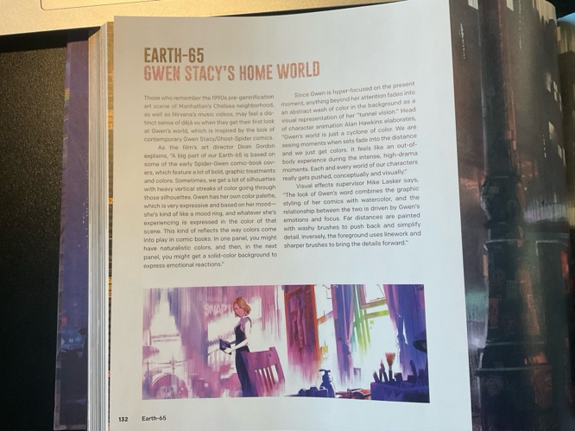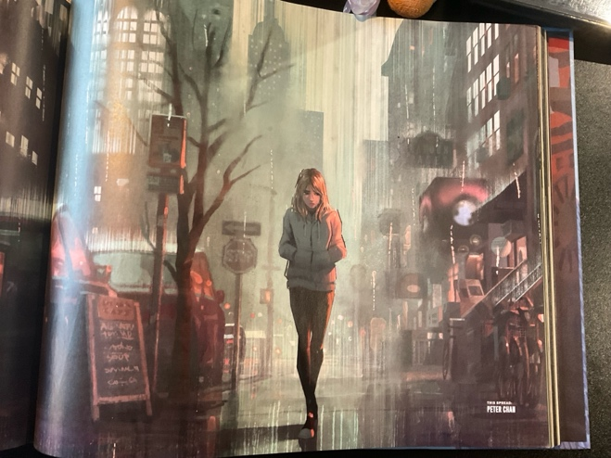
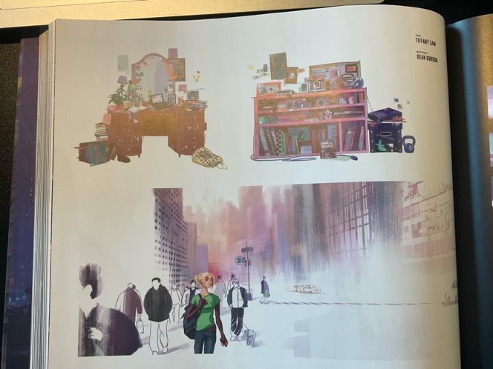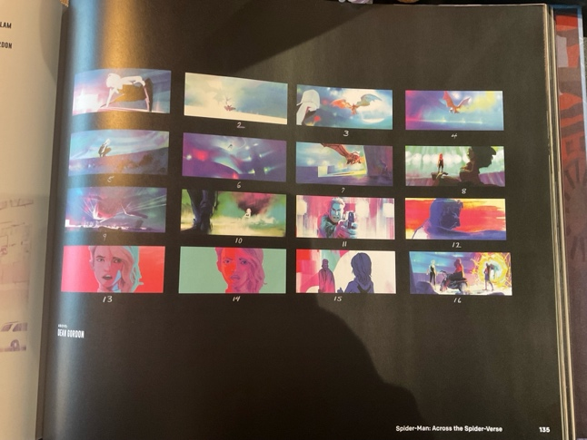
(Zahed, 2023, p.132 [top left] p.133 [top right] p.134 [bottom left] p.135 [bottom right])

In an interview with veteran concept artist Karl Simon on ArtStation, he stated that “In the very beginning of a project I might do sketches with nothing but the script as a basis. Quite soon though, I will get some imagery to work with as a starting point. It can be a napkin scribble from the director, plan and elevation sketches from the production designer or 3d model/renders from another artist. If the film is based more on location shoots than sets, I might do paint-overs on photos of these locations.” (Mon, 2017) This quote suggests the flexibility required to be a concept artist through different medium, additionally the creativity and conviction needed to work off only descriptive writing and text. Furthermore, “If the film is based more on location shoots than sets, I might do paint-overs on photos of these locations” suggests that the artists need to have excellent initiative and quick thinking to compete with others in the industry. ‘Animation – From Concept to Production’ by Hannes Rall also proves the importance of the above, stating that “The need for a consistent design world becomes apparent quickly when the characters and surroundings of the most widely differing concepts are exchanged” (Hannes Rall, 2018, p.115) This point also exemplifies the need for good initiative, but also the need to be consistent and clear, similar to the words of Karl Simon above.

Alternative sources suggest that concept art isn’t only an anchor for the other departments of creating media but also important for the development of the company. A quote from Ernest Adams and Andrew Rollings in Game Design and Development – Fundamentals of Game Design shows that “the vast majority of computer games rely heavily on visual content, and drawings are essential when pitching a product to a third party.” (Adams, Rollings, 2007, p.69) Adams and Rollings book entertains the idea that not only is concept art important and relied on heavily, but also that drawings done by concept artists can be especially important on the business and economical side of a company. To further add detail to this claim, concept art could be the making or breaking of a development company; if a pitch were to go well due to visual representation, the concept art would have directly increased the profits of the company.

In ‘LEVEL UP – The Guide to Great Video Game Design’ by Scott Rogers, concept artists are described as using multiple mediums such as traditional and digital to visualise what parts of the game would look like – for example characters and environments. What I found more important in this text was the section on what storyboard artists are, they “illustrate the games cinematics and sometimes elements of gameplay design to be passed on to other artists.” Reinforcing this statement is the following sentence, “Concept art is never used in the final game, only as reference to other artists.” (Rogers, 2014, p.19) This magnifies how important the role of concept art is, showing that the whole development rides on the shoulders of the initial processes of the concept artists, in collaboration with the storyboard artists. An interview on YouTube channel ‘stillalive labs’ with an indie game developer brings my favourite quote on this topic. “creating a 3D model of an object in a game world is a very time-consuming task. It's like building a house without a plan, you can't rearrange the rooms easily once they're built, you have to plan it out first or you'll end up with a living room with a toilet, and who wants that? That's why we and other game companies do sketches and concept their art first”. (stillalive labs, 2023, 0:15 – 0:34)
This quote is a direct answer to my question about the importance of the role, showing that not only is the concept artist creating a blueprint and foundation for the whole design of a project, but is a reference in every production stage. Moreover, since so much digital media uses 3D models, the usage of concept art streamlines and simplifies the process to being a less “time-consuming task”.

The question remains on the importance of concept art. It has through evidence proven itself to be a more than essential attribute to the development of all media. It is an important aspect in the video game, movie, and animation industry. With the necessary evidence gathered I can say with confidence that concept art is a valuable and overall significant role, especially significant in media production, and a pillar of information for the other stages and departments in making media. On a personal level, the research and development of this essay resonated with me, as this is a career I am extremely interested in, now more than ever. Ultimately, concept art is essential and will continue to be essential for many years to come. To conclude, I confirm that not only has concept art shown an importance in idea development in the past, but also an exciting role for projects in the future.

Word Count: 1,471

Bibliography

Abad-Santos, A. (2023). Why Spider-Verse fans see Gwen Stacy as a transgender allegory. [online] Vox. Available at: https://www.vox.com/culture/2023/6/7/23752735/across-the-spider-verse-gwen-stacy-transgender.

Adams, E. and Rollings, A. (2007). Fundamentals of Game Design. Prentice Hall.

admin (2022). Game Development Stages: How are video games created? [online] Walla Walla Studio. Available at: https://wallawallastudio.com/article/game-development-stages/.

DeGuzman, K. (2024). Concept Art in Film — Definition, Types & Iconic Examples. [online] StudioBinder. Available at: https://www.studiobinder.com/blog/what-is-concept-art-definition/.

Genesis Inspiration Foundation. (2021). The Importance of Concept Art. [online] Available at: https://genesisinspirationfoundation.org/the-importance-of-concept-art/.

Hall. D (1939) Alice in Wonderland [graphite, watercolor and gouache on paper]

Hannes Rall (2018). Animation : from concept to production. Boca Raton, Fl: Crc Press.

Korkis, J. (2020). The Disney ‘Alice in Wonderland’ Never Made |. [online] cartoonresearch.com. Available at: https://cartoonresearch.com/index.php/the-disney-alice-in-wonderland-never-made/.

Mages. (2019). What is the purpose of concept art in films? [online] Available at: https://mages.edu.sg/blog/what-is-the-purpose-of-concept-art-in-films/.

Mon, S. (2017). Becoming a Concept Artist for a Hollywood Film. [online] ArtStation Magazine. Available at: https://magazine.artstation.com/2017/07/concept-artist-hollywood-film/.

Nashville Film Institute (2021). Concept Art – Everything You Need to Know. [online] NFI. Available at: https://www.nfi.edu/concept-art/.

Negishi, A. (2022). The 5 Stages of Production. [online] Cinemagic. Available at: https://www.cinemagics.com/post/5-stages-of-production.

Ramin Zahed (2023). Spider-Man: Across the Spider-Verse: The Art of the Movie. Abrams.

Rogers, S. (2014). Level up : the guide to great video game design. 2nd ed. Chichester: Wiley.

stillalive Labs (2023). Indie Game Dev shows IMPORTANCE of Concept Art. [online] YouTube. Available at: https://www.youtube.com/watch?v=e8i3KXwJZZA [Accessed 1 Dec. 2024].

