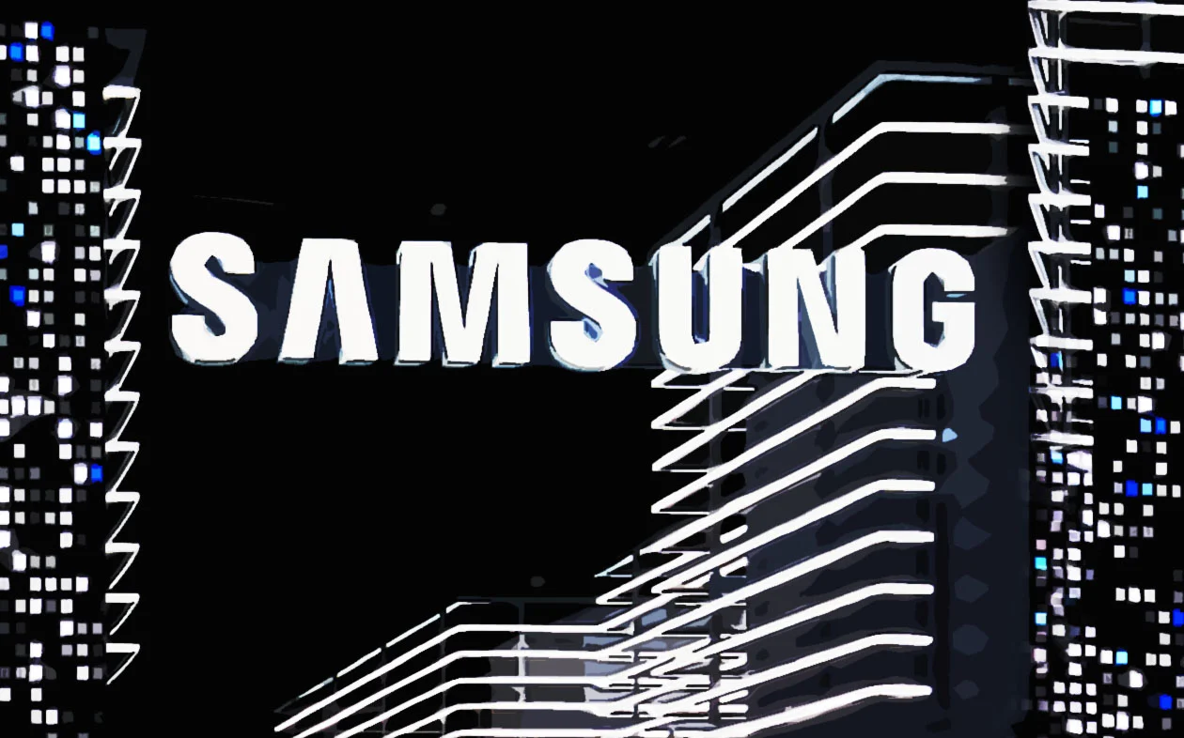
MBA Master of Business Administration MARKETING MANAGEMENT
Assestment 1 75% Report SAMSUNG

Moodle code: Marketing management (LCBB7001)
Moodle Lecture: Tushara Balendran
Prepared by: Dobrinka Kiryakova 1818047

Table of Contents

Introduction 4
Company Background 5
Mission Statement 5
Definition of Key Terms 6
Keller’s Brand Equity Model 7
Brand Identity 8
Brand Meaning 8
Brand Response 9
Brand Resonance 9
Keller’s Brand Equity Model in Context of Samsung Company 9
Brand Identity 9
Brand Meaning 9
Brand Response 10
Brand Resonance 10
Advantages and Disadvantages 10
Customer Journey Map 11
Step: 1-Awareness 13
Step: 2-Research 13
Step: 3-Engage 13
Step: 4-Convert 14
Step: 5-Deliver 14
Step: 6-Advocacy 14
Strengths & Weaknesses 15
Shannon And Weaver Model of Communication 16
Integrated Marketing Communications 17
Stage-1 17
Stage-2 17
Stage-3 17
Stage-4 18
Stage-5 18
Total Engagement Model 18
Push and Pull Strategy 20
Push strategy 20
Pull strategy 21
Internal stakeholders 21
External stakeholders 21
Conclusion and Recommendations 21
Recommendations 22
REFERENCES 23

Marketing Management-Assessment: 1

Introduction
In the fast-paced world of business, customer satisfaction has become a crucial metric for companies to measure their success. To achieve this, businesses have long emphasized individual touchpoints, such as customer service, advertising, and sales, to enhance their customer experience (Hao, et al., 2021). However, a recent shift in customer behavior and expectations has brought to light the limitations of a touchpoint-focused approach. Researchers and business experts now argue that to create an exceptional customer experience, companies must shift their focus to the customer's end-to-end journey, encompassing every interaction a customer has with the brand (Garanti and Kissi, 2019).
This shift in focus from touchpoints to the customer journey is crucial for businesses to remain competitive in today's market. As companies like Samsung, a global leader in consumer electronics, compete for customers' attention and loyalty, understanding their customers' needs and expectations has become essential (Fill and Turnbull, 2019). By examining the customer journey, businesses can gain a holistic view of how customers interact with their brand, including pre-purchase, purchase, and post-purchase experiences. This can help businesses identify pain points in the customer journey and develop strategies to improve the overall customer experience (Llopis-Amorós, et al., 2019).
In this marketing management assignment, we will explore the concept of the customer journey in the context of Samsung. We will discuss key marketing terms and models, promotional strategies, and customer journey mapping to analyse how Samsung can better align its marketing efforts with customer expectations and enhance its overall brand experience (Llopis-Amorós, et al., 2019). Additionally, we will consider how the rise of digital technologies has impacted the customer journey and what this means for Samsung's marketing strategies. Ultimately, our analysis will provide insights into how Samsung can improve its customer experience and build long-lasting relationships with its customers.

Company Background
Samsung is a South Korean multinational conglomerate that has become a household name in the consumer electronics industry. The company was founded in 1938 by Lee Byung-chul as a small trading company that focused on exporting and importing goods. Over time, Samsung diversified its operations and expanded into various industries, including electronics, construction, shipbuilding, and financial services. Samsung has grown to become one of the largest electronics manufacturers in the world, producing a wide range of products, including smartphones, TVs, appliances, and semiconductor chips (Rodríguez-Molina, et al., 2019). The company has a significant global presence, with operations in more than 80 countries and a workforce of over 300,000 employees worldwide.
Samsung has gained a reputation for being an innovative and forward-thinking company, consistently developing cutting-edge technology and staying ahead of industry trends (Cheung, et al., 2019). In recent years, Samsung has focused on developing new technologies such as 5G, AI, and IoT, positioning itself as a leader in the future of technology. Despite its success, Samsung has faced some challenges over the years. In 2016, the company faced a major setback with the recall of its Galaxy Note 7 smartphone due to battery issues that caused the devices to catch fire (Kim, et al., 2020). However, Samsung was able to rebound from this incident, and today it continues to thrive and innovate in the highly competitive consumer electronics industry.

Mission Statement
Samsung's mission statement is "Inspire the World, Create the Future." This statement reflects the company's commitment to leveraging its technological innovation to create a better future for people across the globe. Samsung aims to do this by delivering innovative products and services that inspire and enhance the lives of its customers, while also creating sustainable growth for its stakeholders. The company's mission statement underscores its dedication to driving innovation and making a positive impact on the world.

Definition of Key Terms
Communication: Communication can be defined as the exchange of information, ideas, or thoughts between two or more individuals, groups, or organisations. It involves transmitting a message from a sender to a receiver through various channels, such as verbal, written, or nonverbal means, with the intent of conveying a specific meaning or information (Kushwaha, et al., 2020). Effective communication requires not only transmitting information but also ensuring that the receiver has understood the message as intended. Effective communication is a vital component of any successful business, as it promotes understanding, builds trust, and fosters positive relationships between individuals and organisations (Porcu, et al., 2019).

Integrated Marketing Communication: The goal of the "integrated marketing communication" (IMC) strategic method is to harmonise and streamline a company's various forms of advertising and promotion (Kushwaha, et al., 2020). IMC works to ensure that all messages and communications are consistent, coherent, and complementary, regardless of medium or channel. IMC is a marketing and advertising strategy that combines traditionally separate tactics such as advertising, public relations, personal selling, sales promotion, and direct marketing into a unified whole to provide consumers with a consistent and satisfying brand experience. By unifying messaging across all customer touchpoints and channels, “integrated marketing communications (IMC)” helps businesses improve “brand recognition, customer loyalty, and sales” (Anabila, 2020).

Branding: Branding refers to the process of creating a unique name, design, symbol, or image that represents a company, product, or service (Šerić, et al., 2020). The goal of branding is to differentiate a company or product from its competitors and create a lasting impression on customers, which can lead to increased recognition, customer loyalty, and ultimately, sales. Effective branding involves a combination of visual elements, such as logos and color schemes, as well as intangible elements, such as brand values and messaging (Porcu, et al., 2019). A strong brand can help companies build trust and establish a positive reputation in the market, which can lead to long-term success.

Brand Equity: The "brand equity," or value and strength, of a brand is what makes it successful and valuable in the eyes of consumers. The monetary worth of a product or service that is based on how consumers feel about the brand itself, rather than the product or service itself, is referred to as brand value. Brand equity includes awareness, customer loyalty, perceived quality, brand associations, and other intangible brand assets. Solid brand equity can lead to brand loyalty, market dominance, and increased profits (Percy, 2023).

Keller’s Brand Equity Model
The Keller Brand Equity Model is a marketing framework that explains how a company can construct and maintain the value of its brand. Kevin Lane Keller, who teaches marketing at “Dartmouth College's Tuck School of Business”, is the one responsible for developing the model (Rodríguez-Molina, et al., 2019).
Keller's Brand Equity Model is based on the premise that brand equity is the result of a series of customer experiences and interactions with a brand. These experiences are influenced by various factors, such as “brand awareness, brand associations, perceived quality, and brand loyalty”. The model proposes that a strong brand should strive to build positive associations and perceptions in each of these areas, resulting in strong brand equity (Porcu, et al., 2019). The Keller's Brand Equity Model consists of four main steps, which are:
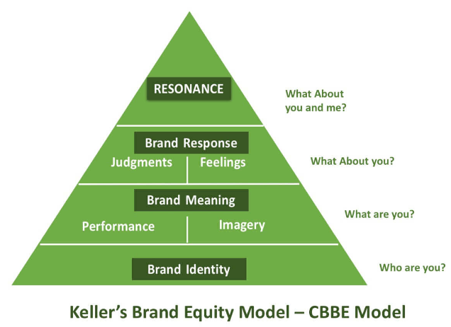

Brand Identity
This is the foundation of the brand and includes the core elements that define the brand, such as the brand name, logo, tagline, and other visual and sensory elements (Rodríguez-Molina, et al., 2019).

Brand Meaning
At this stage, the goal is to ensure that consumers are aware of the significance of the brand. This can be accomplished through the use of brand associations and the image of the brand (Rodríguez-Molina, et al., 2019). The mental connections that consumers make in their minds between a particular brand and attributes such as quality, dependability, or innovative ideas are known as brand associations. The way that clients feel about the business as a whole as a result of their interactions with various aspects of it is referred to as the brand image.

Brand Response
This step involves shaping customer attitudes and behavior towards the brand, which can be achieved through brand performance and brand imagery. Brand performance refers to the actual experience that customers have with the brand, such as the product quality or customer service (Fill and Turnbull, 2019). Brand imagery refers to the emotional and symbolic associations that customers make with the brand, such as the lifestyle or personality traits associated with the brand.

Brand Resonance
This step involves creating a deep, enduring relationship with customers, which can be achieved through brand loyalty and brand attachment. Brand loyalty refers to the degree of customer attachment to the brand, which can result in repeat purchases and advocacy (Garanti and Kissi, 2019). Brand attachment refers to the emotional connection that customers have with the brand, which can result in a sense of identity and community.

Keller’s Brand Equity Model in Context of Samsung Company
Samsung is a brand that has successfully leveraged the Keller's Brand Equity Model to build and maintain its strong brand equity (Hao, et al., 2021). Let's examine each of the four steps of the model in relation to Samsung:

Brand Identity
Samsung has established a strong brand identity through its recognisable logo, tagline, and consistent use of visual and sensory elements across its product lines. The brand identity is based on the values of “innovation, quality, and reliability” (Febriyantoro, 2020).

Brand Meaning
Samsung has created a positive brand meaning by associating itself with high-quality and innovative products. The brand has also built strong brand associations with certain product categories, such as smartphones and TVs, which are known for their advanced technology and superior performance (Cheung, et al., 2019). Additionally, Samsung has built a strong brand image by promoting itself as a lifestyle brand, appealing to customers who seek premium, cutting-edge products.

Brand Response
Samsung has ensured that its brand response is positive by delivering high-quality products and providing excellent customer service (Garanti and Kissi, 2019). The brand has also built strong brand imagery by promoting its products through aspirational marketing campaigns that emphasize its innovative technology and sleek design.

Brand Resonance
Samsung has established a deep, enduring relationship with its customers through its brand resonance. The company has achieved high levels of brand loyalty through its reputation for quality and innovation, as well as through its customer rewards program and other incentives (Fill and Turnbull, 2019). Samsung has also fostered brand attachment by positioning itself as a brand that is constantly pushing the boundaries of what is a possible, creative product that inspire and enable customers to achieve their goals and dreams.
Samsung has leveraged the “Keller's Brand Equity Model” to create a strong brand that is associated with quality, innovation, and reliability. The company has established a positive brand meaning, built strong brand associations, provided excellent customer service, and fostered strong brand loyalty and attachment (Febriyantoro, 2020). By doing so, Samsung has been able to maintain a competitive advantage in the highly competitive consumer electronics industry, and has become one of the most recognisable and valuable brands in the world.

Advantages and Disadvantages
Advantages | Disadvantages
The model offers a comprehensive approach to building and managing brand equity, which takes into account multiple factors that influence customer perceptions and behaviours (Hao, et al., 2021). This makes it easier for companies to develop a holistic brand strategy that aligns with their overall business objectives. | The model is complex and can be difficult to implement for companies with limited resources or marketing expertise. The multiple factors that influence brand equity require a deep understanding of customer behaviour and market trends, which may be challenging for some organisations to achieve (Rodríguez-Molina, et al., 2019).
The model places a strong emphasis on customer perceptions and experiences, which are critical to building a strong brand. By focusing on the customer, companies can create a brand that resonates with their target audience and fosters strong loyalty (Febriyantoro, 2020). | Implementing the model can be time-consuming, as it requires extensive research and analysis to identify the key drivers of brand equity and develop a comprehensive brand strategy. This may not be feasible for companies with limited resources or those operating in fast-moving industries.
The model provides a framework for measuring brand equity, which allows companies to track the effectiveness of their brand-building efforts over time. This enables them to make data-driven decisions about their brand strategy and investments. | The model may not be applicable to all types of brands or industries. For example, brands that operate in highly regulated industries may face restrictions on how they can build and promote their brand, which may limit the effectiveness of the model (Kim, et al., 2020). Additionally, brands that rely heavily on word-of-mouth or other non-traditional marketing channels may not be able to leverage the model effectively.

Customer Journey Map
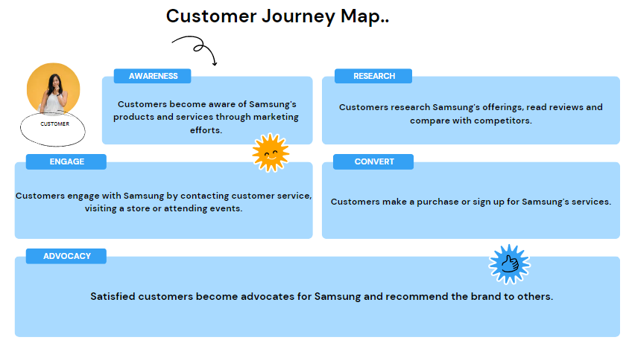
A customer journey map illustrates the various touchpoints and points of contact that a customer has with a particular business or brand over the course of their relationship with that business or brand (Rodríguez-Molina, et al., 2019). It illustrates the various stages of the customer journey, beginning with the customer's initial awareness and consideration and progressing through the customer's purchase, onboarding, use, and loyalty. In addition to this, it highlights significant moments during the customer's interaction with the brand, such as when the customer requests assistance, when the product is updated, or when the customer provides feedback (Kushwaha, et al., 2020). A customer journey map helps businesses see things from the perspective of the customer, discover ways to improve the customer experience, and concentrate marketing and sales efforts on the customer. In addition to this, it can assist businesses in ensuring that the internal processes and resources they utilize are in line with the requirements and desires of their customer base (Anabila, 2020).

Step: 1-Awareness
This stage represents the first point of contact between the customer and Samsung. The customer may become aware of Samsung through various channels such as TV advertisements, social media, or online search. Samsung can leverage its marketing campaigns to generate brand awareness and attract potential customers (Percy, 2023). Touchpoints in this stage include:
- TV ads
- Social media posts
- Online ads
- In-store displays

Step: 2-Research
Once the customer becomes aware of Samsung, they will likely start researching the brand and its products. They may visit the Samsung website, read reviews, or compare Samsung products to those of other brands (Llopis-Amorós, et al., 2019). At this stage, Samsung needs to provide clear and accurate information about its products and services to help the customer make an informed decision. Touchpoints in this stage include:
- Samsung website
- Online reviews and forums
- Customer service chatbots
- In-store product demonstrations

Step: 3-Engage
After conducting research, the customer may engage with Samsung through various channels such as social media, online chat, or phone support (Ebrahim, 2020). This interaction provides an opportunity for Samsung to build a relationship with the customer, answer questions, and address any concerns they may have. Touchpoints in this stage include:
- Samsung social media channels
- Customer service hotline
- Samsung Experience Stores
- Live chat support

Step: 4-Convert
If the customer decides to purchase a Samsung product, they will move to the conversion stage. This may involve visiting a Samsung store, purchasing online, or buying from a retail partner (Cheung, et al., 2019). Samsung needs to ensure that the purchase process is seamless, efficient, and easy to navigate. Touchpoints in this stage include:
- Samsung online store
- Samsung Experience Stores
- Samsung retail partners
- Online marketplaces

Step: 5-Deliver
Once the customer has made a purchase, Samsung needs to ensure that the product is delivered promptly and in good condition. This may involve working with delivery partners, providing tracking information, and sending follow-up emails or SMS messages (Hao, et al., 2021). Touchpoints in this stage include:
- Delivery and shipping notifications
- Unboxing and setup instructions
- Welcome emails or messages
- User manuals and guides

Step: 6-Advocacy
If the customer is satisfied with their purchase, they may become an advocate for Samsung, recommending the brand to friends and family or leaving positive reviews online (Rodríguez-Molina, et al., 2019). Samsung can encourage advocacy by providing excellent customer service, offering loyalty programs, and rewarding customers for their feedback. Touchpoints in this stage include:
- Social media mentions and shares
- Positive online reviews and ratings
- Referral programs and incentives
- Samsung customer loyalty programs
By mapping out the customer journey, Samsung can identify areas where it can improve the customer experience, streamline its processes, and strengthen its relationship with customers (Šerić, et al., 2020). By providing a seamless and satisfying customer journey, Samsung can enhance brand loyalty and drive sales.

Strengths & Weaknesses
Strengths | Weaknesses
The customer journey map provides a holistic view of the customer's experience with Samsung, from initial awareness to advocacy, helping the company to understand the customer's perspective and identify areas for improvement (Šerić, et al., 2020). | The customer journey map may be limited in scope, as it only considers the customer's experience with Samsung and may not take into account external factors such as competition or industry trends (Rodríguez-Molina, et al., 2019).
By focusing on the customer journey, Samsung can develop a customer-centric approach to marketing and sales, aligning its internal processes and resources to meet customer needs and expectations (Febriyantoro, 2020). | The customer journey map may be based on incomplete or inaccurate data, which can lead to incorrect assumptions about the customer's behavior or preferences.
The customer journey map highlights opportunities for Samsung to engage with customers at various touchpoints, such as online research or post-purchase support, which can help build stronger relationships and enhance brand loyalty. | The customer journey map may be too rigid or inflexible, failing to account for changes in customer behavior or market conditions that can impact the customer journey (Hanna, et al., 2021).

Shannon And Weaver Model of Communication

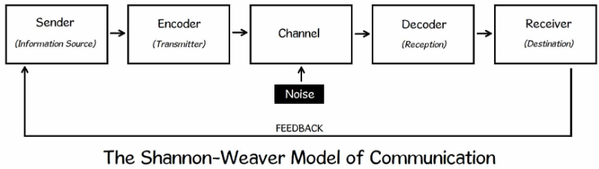

The marketing strategy that Samsung uses for its goods and services can be informed by the Shannon-Weaver model of communication, which the company can use to develop the plan. Let's say a potential buyer is interested in purchasing a smartphone made by Samsung. The communication process between Samsung and the customer would begin with the sending of a message to the customer through a variety of channels, such as advertising, social media, or email marketing. It's possible that the message is hidden in an email, a social media post, or an advertisement (Llopis-Amorós, et al., 2019). The message is able to be distributed via a variety of channels, including but not limited to social media platforms, email, and Samsung's website.
We know that Samsung would convey a message to the consumer in the form of an advertisement or a letter sent in the mail. The customer would then evaluate the communication and provide feedback to Samsung by either purchasing the advertised product or opting out of receiving any further communications altogether. The feedback would be received by Samsung, and the company would use it to adjust their marketing strategy in order to more effectively communicate with their target audience. If Samsung employs the Shannon-Weaver communication model, the company will be able to convey their message to prospective buyers and modify their marketing strategy so that it caters to the requirements and inclinations of their target audience (Cheung, et al., 2019).

Integrated Marketing Communications
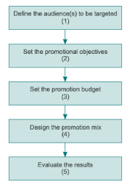

Stage-1
Defining the audience to be targeted
Samsung looks at things like demographics, psychographics, and behaviour to figure out who their target audience is. They focus on people between the ages of 18 and 34 who live in cities and are interested in technology.

Stage-2
Set the promotional objective
Samsung has set clear and specific goals for its marketing. For example, their goal for the next quarter is to boost sales of their newest smartphone model by 10%. Also, they want their target audience to know more about their brand by 20% in the next year.

Stage-3
Set the promotional budget
Samsung's marketing budget is based on their marketing goals, the people they want to reach, and the different platforms they want to use. If the company finds that advertising on social media or working with influencers is a better way to reach their target audience, they may put more money into these channels.

Stage-4
Design the promotion mix
Samsung makes a mix of advertising, sales promotion, personal selling, direct marketing, and public relations to get the word out about its products. A student could reach the people they want to reach by buying ads on social media and working with influential people. They could also offer discounts and special deals to get people to buy.

Stage-5
Evaluate the results
Samsung regularly looks at how their marketing campaigns are doing and makes changes to their strategy based on what they find. They use different metrics, like sales revenue, website traffic, and social media engagement, to figure out how well their marketing is working and where to focus their efforts in the future.

Total Engagement Model
The Total Engagement Model is a marketing framework that emphasizes the importance of engaging customers across all touchpoints and channels to create a comprehensive and integrated customer experience (Cheung, et al., 2019). The model focuses on developing a deep understanding of customer needs, preferences, and behaviour to create personalized and relevant interactions with the brand. It involves a multi-dimensional approach that encompasses various marketing channels, such as social media, email, mobile, and offline marketing, to reach customers at different stages of the customer journey (Llopis-Amorós, et al., 2019). By implementing the Total Engagement Model, companies can develop a consistent brand message, enhance customer loyalty, and drive sales. The model emphasizes the importance of measuring and analysing customer data to continually improve the customer experience and increase engagement (Percy, 2023).
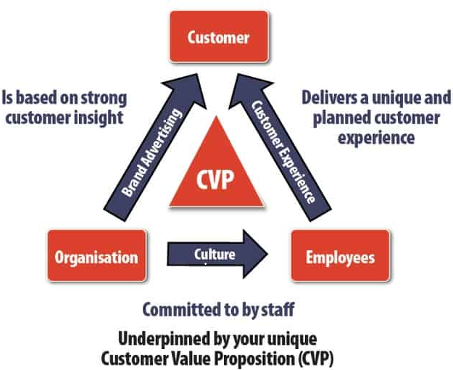
The Total Engagement Model has been implemented by Samsung in order to provide a unified and consistent experience for customers across all of the company's touchpoints and channels (Porcu, et al., 2019). Through the collection and examination of customer information, the business has achieved a profound comprehension of the requirements, preferences, and actions of its clientele.
The marketing strategy that Samsung employs includes significant contributions from a variety of social media platforms. Some of these include Facebook, Twitter, and Instagram. These platforms provide the company with the capability of connecting with customers and promoting its products in a manner that is both direct and interesting for the user to experience (Ebrahim, 2020). Email marketing is yet another method that the company utilizes in order to advertise price reductions and sales and to maintain communication with customers.
Customers can receive a more individualized experience with the help of a mobile app that Samsung has developed. This app provides customers with product recommendations, personalized discounts, and simple access to customer support. In addition, the company engages in offline marketing activities like events and sponsorships in order to raise the profile of the brand and encourage interaction with customers (Fill and Turnbull, 2019).
The implementation of the Total Engagement Model at Samsung has assisted the company in developing a unified brand message, boosting customer loyalty, and increasing sales (Cheung, et al., 2019). Through ongoing monitoring and analysis of customer data, Samsung is able to locate areas in which it can make enhancements and refine its marketing strategies in order to provide an exceptional experience for its clientele.

Push and Pull Strategy
Samsung uses push and pull marketing strategies to communicate with their internal and external stakeholders, such as wholesalers, retailers, consumers, and manufacturers.
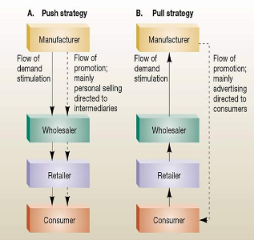

Push strategy
Samsung's push strategy is centred on promoting their products to wholesalers and retailers to convince them to purchase and stock their products. Samsung employs different strategies to market their products (Cheung, et al., 2019). These include giving incentives to wholesalers and retailers like discounts or longer payment periods, providing them with training and support to improve their sales skills, and collaborating with them in marketing campaigns to promote their products to final customers.

Pull strategy
Samsung's pull strategy is designed to lure in consumers and generate demand for their products, which in turn drives them through the supply chain. Samsung uses different methods to execute their plan, such as ads, social media ads, collaborating with influencers, and offering promotions to customers. Samsung wants to make people want their stuff by making their brand and marketing really good. Then, stores will want to sell their stuff because people want it (Fill and Turnbull, 2019).

Internal stakeholders
Samsung uses push and pull communication and engagement strategies with internal stakeholders like employees and manufacturers. Samsung gives its employees training and support so that they can sell products and promote the Samsung brand effectively. They work together with their manufacturers to do marketing activities together and make sure their products are always good and available (Ebrahim, 2020).

External stakeholders
Samsung uses both push and pull strategies to communicate and engage with their wholesalers, retailers, and consumers. Companies use push strategies to motivate wholesalers and retailers to purchase and store their products. Additionally, they use pull strategies to entice consumers and create a need, which then pulls the products through the supply chain (Porcu, et al., 2019).
Samsung can engage and communicate with stakeholders, promote products, and achieve marketing goals by using push and pull strategies in their marketing efforts.

Conclusion and Recommendations
Samsung has firmly established itself as a global brand by placing a significant emphasis on innovation as well as the overall satisfaction of its customers. We can see how effectively Samsung has built brand equity and cultivated a positive customer experience across a variety of touchpoints by using the Keller Brand Equity model and mapping the customer journey. Nevertheless, there is always room for improvement, and Samsung can continue to improve the customer journey by addressing pain points and leveraging emerging technologies in order to deliver even more value to its customers.

Recommendations
- Customers can receive support that is more convenient and tailored to their needs from Samsung if the company makes available additional customer service channels such as live chat and video chat.
- Customers will be better able to make educated purchasing decisions with the assistance of additional detailed product information, user reviews, and product comparisons if Samsung were to improve its online store.
- It is possible for Samsung to make investments in developing technologies such as virtual reality and artificial intelligence in order to provide its customers with even more engaging and personalized experiences.
- It is possible for Samsung to develop a comprehensive customer loyalty program that acknowledges and appreciates customers for their ongoing support, promotes repeat purchases, and offers referral bonuses.

REFERENCES

Anabila, P., 2020. Integrated marketing communications, brand equity, and business performance in micro-finance institutions: An emerging market perspective. Journal of Marketing Communications, 26(3), pp.229-242.
Cheung, M.L., Pires, G.D. and Rosenberger III, P.J., 2019. Developing a conceptual model for examining social media marketing effects on brand awareness and brand image. International Journal of Economics and Business Research, 17(3), pp.243-261.
Ebrahim, R.S., 2020. The role of trust in understanding the impact of social media marketing on brand equity and brand loyalty. Journal of Relationship Marketing, 19(4), pp.287-308.
Febriyantoro, M.T., 2020. Exploring YouTube Marketing Communication: Brand awareness, brand image and purchase intention in the millennial generation. Cogent Business & Management, 7(1), p.1787733.
Fill, C. and Turnbull, S., 2019. Marketing Communications. Pearson UK.
Garanti, Z. and Kissi, P.S., 2019. The effects of social media brand personality on brand loyalty in the Latvian banking industry: The mediating role of brand equity. International Journal of Bank Marketing.
Hanna, S., Rowley, J. and Keegan, B., 2021. Place and destination branding: A review and conceptual mapping of the domain. European Management Review, 18(2), pp.105-117.
Hao, A.W., Paul, J., Trott, S., Guo, C. and Wu, H.H., 2021. Two decades of research on nation branding: A review and future research agenda. International Marketing Review, 38(1), pp.46-69.
Kim, S.H. and Lee, S.A., 2020. The role of marketing communication mix on Korean customers' coffee shop brand evaluations. Journal of Hospitality and Tourism Insights.
Kushwaha, B.P., Singh, R.K., Varghese, N. and Singh, V.N., 2020. Integrating social media and digital media as new elements of integrated marketing communication for creating brand equity. Journal of Content, Community & Communication, 11(6), pp.52-64.
Llopis-Amorós, M.P., Gil-Saura, I., Ruiz-Molina, M.E. and Fuentes-Blasco, M., 2019. Social media communications and festival brand equity: Millennials vs Centennials. Journal of Hospitality and Tourism Management, 40, pp.134-144.
Percy, L., 2023. Strategic integrated marketing communications. Taylor & Francis.
Porcu, L., del Barrio-García, S., Alcántara-Pilar, J.M. and Crespo-Almendros, E., 2019. Analysing the influence of firm-wide integrated marketing communication on market performance in the hospitality industry. International Journal of Hospitality Management, 80, pp.13-24.
Rodríguez-Molina, M.A., Frías-Jamilena, D.M., Del Barrio-García, S. and Castañeda-García, J.A., 2019. Destination brand equity-formation: Positioning by tourism type and message consistency. Journal of Destination Marketing & Management, 12, pp.114-124.
Šerić, M., Ozretić-Došen, Đ. and Škare, V., 2020. How can perceived consistency in marketing communications influence customer–brand relationship outcomes?. European Management Journal, 38(2), pp.335-343.

