Vigil
The dictionary defines Vigil as “a period of keeping awake during the time usually spent asleep, especially to keep watch or pray” (Oxford English Dictionary, 2025). This exhibition focuses on the concept of vigil as a shifting perception and consideration of femininity through the ideas of ritual and shared experience.
Gold has historically been associated with divinity, ritual, and power, often used to elevate objects and figures beyond the ordinary. As an imagined exhibition, Vigil is situated within the Pantheon in Rome and will explore how femininity has been ritualised, idealised and sanctified across history. I will be conveying this through sacred objects, religious imagery, and contemporary feminist artworks, specifically the Mould Gold Cape, Duccio’s Maestà, Olga de Amaral’s Estela, Ana Mendieta’s Silueta Series, and Kiki Smith’s Lilith.
The exhibition's intention is to investigate the tension between reverence and restriction within representations of women. Through candlelit viewings as engagement events, visitors will be invited to participate in a ritual, encouraging them to reconnect to femininity not as a fixed image, but as something personal, formed by memory, mythology, devotion and bodily presence.
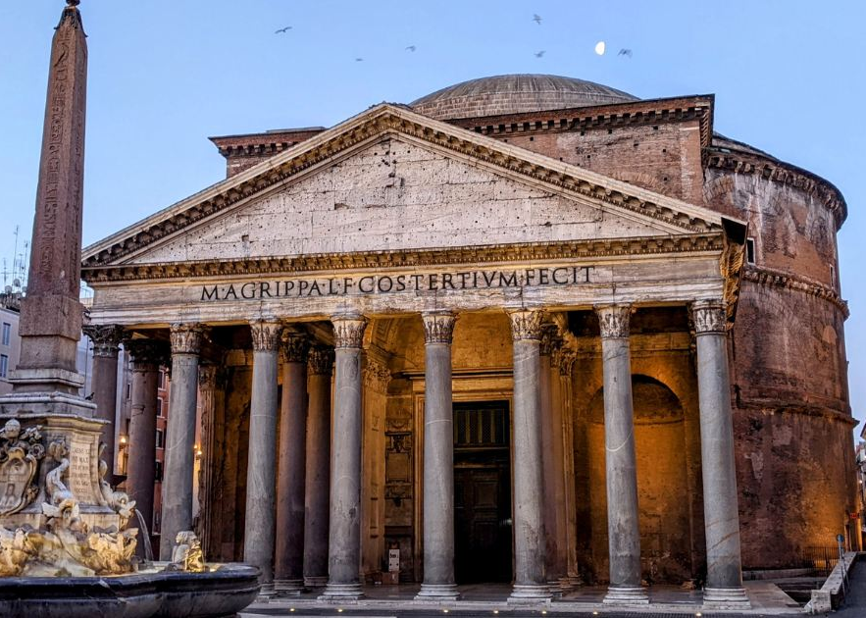
The ritual will invite visitors to write the names of women they admire, love or appreciate onto gold ribbons provided within the space. These ribbons will then be tied to a large, braided structure made from hair-like fibres or rope, symbolising interconnected female histories suspended above the entrance/exit. Care and collective memory gradually transform the entrance and exit through audience participation into a living artwork and contemporary artefact. As the exhibition progresses, the accumulation of names and ribbons will physically embody acts of remembrance, gratitude and female solidarity, allowing the audience to contribute to the work’s evolving meaning. The final piece could later be preserved and exhibited as documentation of shared devotion and collective recognition of women’s presence, labour and influence throughout history.
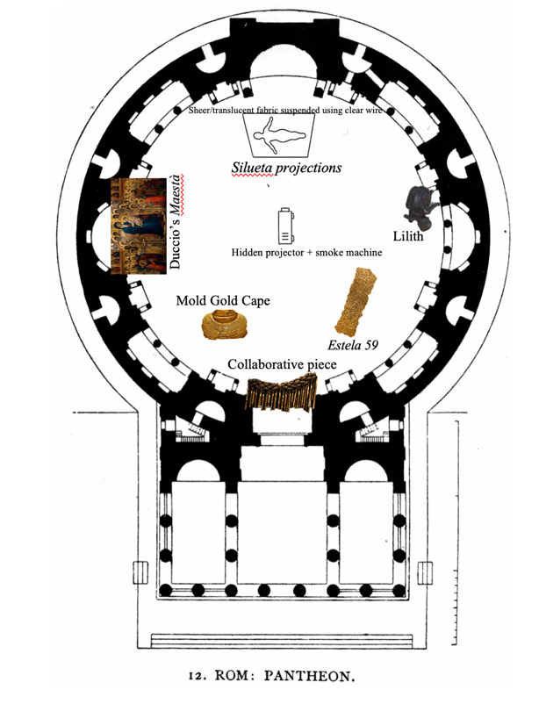
I chose the Pantheon as the setting for my exhibition because of its historical association with the inclusion and visibility of women within Roman ritual culture. Unlike most sacred spaces in Ancient Greek society, where women’s participation was often restricted, Roman women held a more significant public role within religious life. As Sarah Pomeroy states, “Roman women enjoyed considerably greater freedom and public visibility than their Greek counterparts” (Pomeroy, 1975).
I believe the Pantheon is an ideal architectural and symbolic space for exploring female presence, ritual, and collective memory. The circular space of the Pantheon reinforces notions of femininity, evoking the cyclical nature of the menstrual cycle and the associated rounder shape of the woman. The Pantheon will be transformed into a contemporary ceremonial space where connections to femininity are expressed through its spherical form and where ancient and current understandings of femininity coexist. The entire exhibition space will remain dark and atmospheric, enhancing the environment's immersive, contemplative quality. Each artwork will be individually illuminated and suspended using clear wire, creating the impression that the works are floating within the space. The only exceptions are the Mold Gold Cape, which will be displayed on a dark plinth, and Maestà, which will be mounted on a wall fixture.
The exhibition begins with the Mold Gold Cape, a Bronze Age ceremonial object discovered in Wales, believed to have been worn by a high-status female figure, possibly a priestess. The cape challenges widespread assumptions about prehistoric societies through its extraordinary craftsmanship and complex construction. It is “one of the most spectacular examples of prehistoric sheet-gold working from Europe” (Needham, 1996), positioning Bronze Age Wales within a wider narrative of ritual power and artistic production.
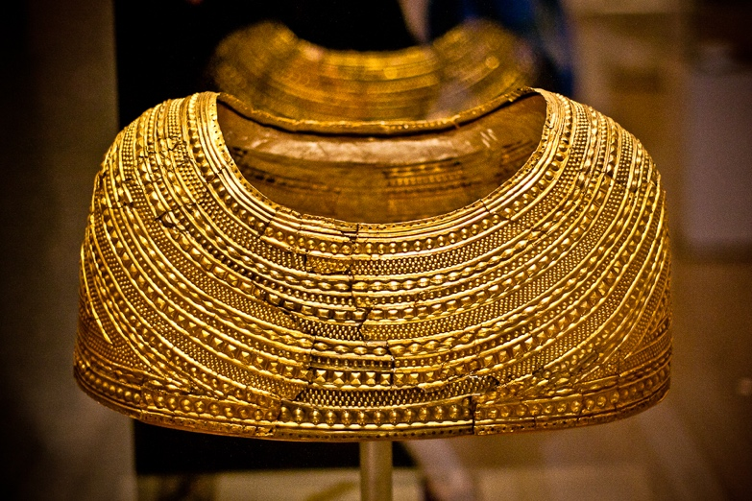
Being a Welsh woman and artist, I feel connected to this object in a way that is hard to describe. It feels spiritual, like a part of my history. Its restrictive form also transforms the body into a ceremonial object, suggesting that adornment can function simultaneously as protection, reverence and limitation. Gold itself becomes symbolic of permanence, divinity and status.
Positioned centrally along the circular route that circles the Pantheon’s open central dome, the works will all be within an intentionally darkened space that heightens the atmosphere and sense of reverence throughout the exhibition. Illuminated by warm, glowing spotlights, the cape serves as a ceremonial relic, connecting ancient ritual practices to contemporary discussions of the visibility, position, and power of women throughout history and in modern society.
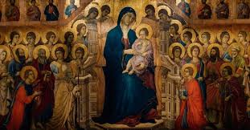
This relationship between femininity and worship continues in Duccio’s Maestà (1311), a medieval altarpiece depicting the Madonna enthroned in gold. The work reflects how women have historically been represented through religious symbolism and ideals of purity, motherhood and devotion.
The use of the Madonna is irreplaceable in this exhibition, due to the immense significance of the motif and its continuous presence across centuries of religious and cultural production; “The Virgin Mary became the most represented woman in Western Art” (Gold, 1985). Beyond functioning as a religious symbol, the Madonna became a wider representation of purity, motherhood, femininity, suffering, and divine compassion. The repetition of the Madonna motif across different historical periods reflects how deeply religious narratives have shaped the development of Western visual culture itself.
Religious art has historically served as a dominant force in art history, particularly before the modern period, when the Church was one of the primary patrons of artistic production. Religious imagery was not only decorative, but educational and symbolic, used to communicate narratives, morality, power and devotion to both literate and illiterate audiences. The Madonna, therefore, exists not simply as a recurring image but as part of a much larger tradition in which art operated as a spiritual and social language embedded within everyday life.
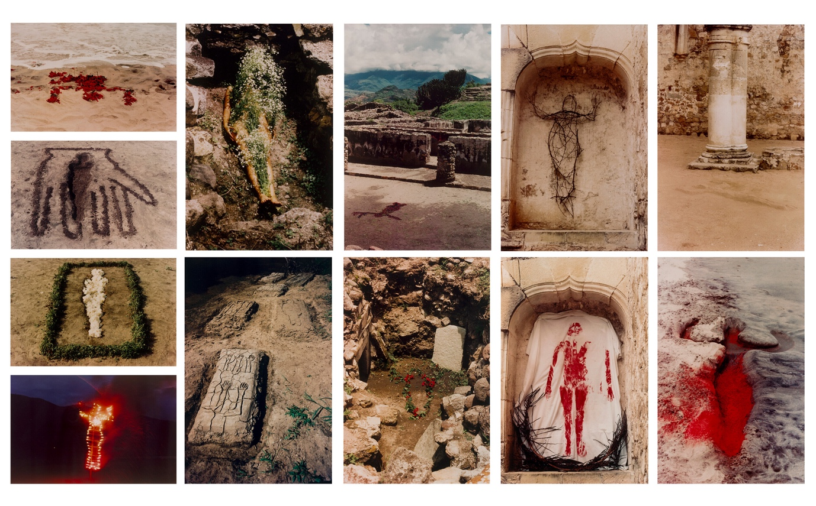
The Madonna is not simply a religious figure but a symbol of idealised femininity. The extensive use of gold in Byzantine and medieval iconography further removes the figure from ordinary reality, transforming her into an object of reverence rather than an individual. John Berger argues in Ways of Seeing that representations of women throughout art history are often shaped by viewers' expectations and desires rather than by lived female experience. “Men act, and women appear. Men look at women. Women watch themselves being looked at” (Berger, 1972, p. 47). The Madonna motif becomes a visual system through which ideas surrounding femininity, motherhood, virtue, and obedience have been repeatedly reinforced across generations. The monumental four-metre-long altarpiece will be positioned against the wall to the left of the exhibition's chronological route. The darkened space will draw attention to the reverie associated with the Virgin Mary, creating an atmospheric presence and highlighting the works’ visual impact. Warm spotlights will illuminate the piece, drawing attention to its magnificent use of gold and enhancing its sense of ritual.

The exhibition contrasts these historical ideals with contemporary feminist works, which challenge fixed representations of femininity. Ana Mendieta is one of my favourite artists; her Silueta Series introduces the female body through absence rather than visibility. Created through temporary interventions using earth, fire, flowers and bodily traces, the works explore ritual, displacement and spiritual connection to nature. Unlike the permanence of gold or stone architecture, Mendieta’s silhouettes are ephemeral and vulnerable, existing only briefly before disappearing. Her work shifts attention away from perfection and towards bodily presence, memory and transformation. The use of projection within the exhibition reinforces this instability, allowing the works to appear almost ghost-like within the darkened Pantheon space.
As Mendieta explained, “My art is the way I re-establish the bonds that unite me to the universe. It is a return to the maternal source” (Mendieta quoted in Jacob, 1991, p.17). This idea of returning to ‘Mother Earth’ reflects a spiritual understanding of femininity rooted not in idealised beauty, but in connection, ritual and the cycles of life and death. Through her earth-body sculptures, Mendieta presents the female body as inseparable from nature, transforming the landscape into a site of memory and feminine power. Her work, therefore, aligns closely with ecofeminist ideas, in which women and the natural world are understood as deeply interconnected through creation, nurture, and transformation.
This relationship between femininity, ritual and the land can also be linked to the cultural landscape surrounding the Mold Gold Cape. Much like Mendieta’s work, it reflects how women were historically associated with sacred power, the natural world and cycles of fertility and renewal. In Welsh prehistoric culture, the landscape itself often carried spiritual meaning, with mountains, water, and earth serving as spaces for ritual connection. By placing Mendieta’s temporary earth works alongside the permanence of the gold cape, the exhibition creates a dialogue between ancient and contemporary understandings of feminine power. One preserved in precious material and status, the other dissolved back into the earth itself.
Rather than presenting a single work from the Silueta Series, a projection of multiple silhouettes will move throughout the darkened space, appearing almost ghost-like within the Pantheon interior. This fragmented presentation reinforces the themes of absence, memory and spiritual presence embedded within Mendieta’s practice, while also subtly reflecting the tragic loss of the artist herself. Mendieta’s death in 1985, officially ruled a suicide but widely disputed within feminist discourse, became a significant point of controversy in the art world due to allegations surrounding her husband, the artist Carl Andre. The continued celebration of Andre through major exhibitions has since been viewed by many feminist critics as emblematic of the historical silencing and erasure of women within art history, adding a further layer of poignancy to Mendieta’s hauntingly ephemeral works.
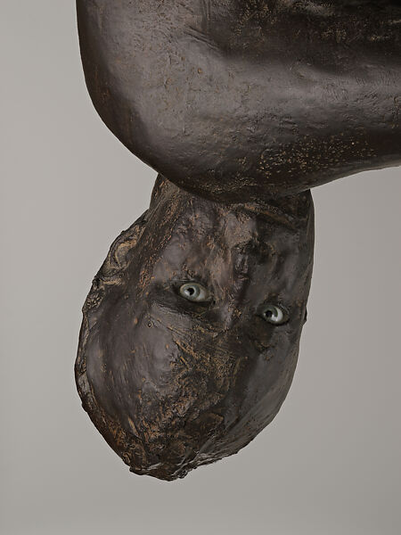
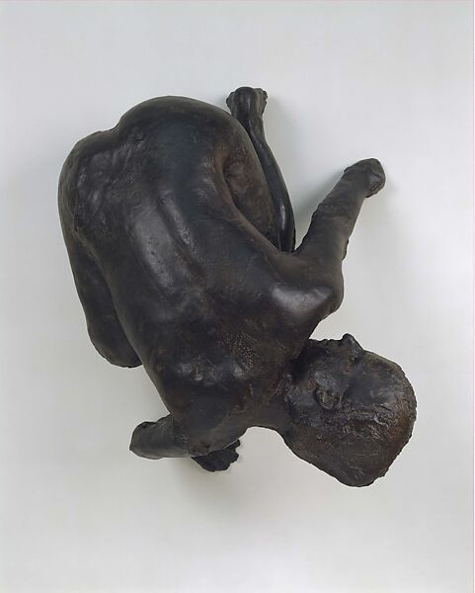
Similarly, Kiki Smith’s Lilith destabilises traditional ideas surrounding female purity and passivity. Based on the mythological figure Lilith, often described as Adam’s first wife who rejected submission, the sculpture introduces themes of fear, autonomy and female resistance. Positioned in direct contrast to the Madonna imagery within the exhibition, Lilith represents a form of femininity that exists outside patriarchal expectations and idealised representations of womanhood. As Simone de Beauvoir argued, women have historically been constructed as “the Other” within culture and representation (de Beauvoir, 2011), and Smith’s work actively confronts this tradition by presenting the female body as unsettling, confrontational and intensely self-aware.
The work visually contrasts with every other piece within the exhibition. Unlike the glowing gold surfaces, warm projections and illuminated imagery surrounding it, Lilith appears dark, flat and almost shadow-like, further intensifying its deliberately unsettling presence. Suspended high above the viewer’s head, the sculpture creates an atmosphere of discomfort and psychological tension, forcing the audience into an uneasy physical relationship with the work. Rather than using harsh direct spotlights, softer moving lights positioned below and level with the sculpture would cast subtle shifting shadows across its surface. This gentler lighting preserves the haunting and confrontational nature of the piece without overwhelming the viewer or reducing the work to spectacle, allowing its themes of female autonomy, fear and resistance to remain central to the experience.
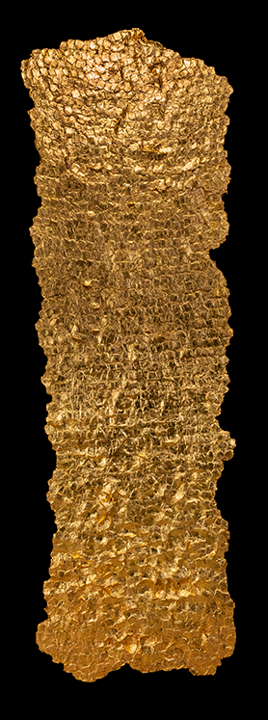
The exhibition concludes with Olga de Amaral’s Estela 59, a work which acts as a bridge between historical and contemporary representations of femininity through its monumental use of woven gold textiles. Resembling both devotional objects and fragments of sacred architecture, the work merges traditional weaving practices with spiritual iconography, transforming textile into something atmospheric, immersive and powerful. The labour embedded within the woven surface becomes particularly significant within the context of women’s histories, as textile and craft practices have long been associated with feminine labour while simultaneously excluded from dominant narratives of fine art and cultural importance. As Rozsika Parker argues, “the history of embroidery is the history of women” (Parker, 2010, p.6), highlighting the way craft practices became deeply tied to ideas surrounding femininity, domesticity and the visibility of women’s creative labour throughout history.
Within the exhibition, Estela 59 reclaims these traditionally feminised practices by presenting weaving on a monumental and almost sacred scale. Suspended towards the inner circumference of the Pantheon, the work interacts both with the natural light entering through the oculus and the intentional darkness of the surrounding space. As light shifts throughout the day, the woven gold surface appears to glow and dissolve, reinforcing the exhibition’s recurring themes of spirituality, ritual and transformation. The changing illumination allows the work to exist between object and atmosphere, connecting ancient sacred materials such as gold with the overlooked histories of women’s labour and craft traditions.

Bibliography
Berger, J. (1972). Ways of Seeing. London: Penguin Books.
de Beauvoir, S. (2011) The Second Sex. Translated by C. Borde and S. Malovany-Chevallier. London: Vintage Books. (Original work published 1949).
Gold, P.S. (1985). The Lady and the Virgin: Image, Attitude, and Experience in Twelfth-Century France. Chicago: University of Chicago Press.
Jacob, M.J. (1991) Ana Mendieta: The “Silueta” Series 1973–1980. New York: Galerie Lelong.
Needham, S. (1996) ‘Chronology and periodisation in the British Bronze Age’, Acta Archaeologica, 67, pp. 121–140.
Oxford English Dictionary (2025) Vigil. Available at: Oxford English Dictionary (Accessed: 19 May 2026).
Parker, R. (2010). The Subversive Stitch: Embroidery and the Making of the Feminine. London: I.B. Tauris.
Pomeroy, S.B. (1975) Goddesses, Whores, Wives, and Slaves: Women in Classical Antiquity. New York: Schocken Books.
List of Figures
Fig. 1 Exterior view of the Pantheon, Rome, Italy. Photograph showing the neoclassical portico, Corinthian columns and dome structure. Photograph by unknown photographer.
Fig 2 Interior view of the Pantheon, Rome, Italy. Photograph showing the central oculus and circular interior space. ( EDITED BY ME) to include my artworks and illustrate the layout.
Fig 3 Mold Gold Cape, c. 1900–1600 BCE. Gold repoussé ceremonial cape discovered in Mold, Flintshire, Wales. Collection of the British Museum.
Fig. 4 Duccio di Buoninsegna, Maestà, 1308–1311. Tempera and gold leaf on panel. Museo dell’Opera Metropolitana del Duomo, Siena, Italy.
Fig. 5 Ana Mendieta, Silueta Series, 1973–1980. Earth-body interventions using natural materials, various locations.
Fig. 6 Kiki Smith, Lilith, 1994. Bronze and glass sculpture. Collection of the Metropolitan Museum of Art.
Fig. 7 Kiki Smith, Lilith, 1994. Bronze and glass sculpture. Collection of the Metropolitan Museum of Art.
Fig. 8 Olga de Amaral, Estela 59, 2013. Linen, gesso, acrylic and gold leaf textile installation.

