Student Name: Cristina Tudureanu
Student number: 1917153
Programme: BA Business Management
Module: Leadership and management, theory and practice.
Module code: LCBB6003
Lecturer’s name: Dr. Mushfiqur Rahman

Leadership and Management, Theory and Practice

Table of contents

- Introduction……………………………………………………………………………….4
- Company Overview…………………………………………………………….………..4
- Leadership and management theories…………………………………………….….7
- The impact of leadership on Mc Donald’s…………………………………………….7
  - Management in Mc Donald’s……………………………………………….….7
  - Leadership in Mc Donald’s……………………………………………….…….8
- Leadership examples……………………………………………………………………9
- Conclusion………………………………………………………………………………..10
- Appendix 1: Leadership theories……………………………………………………….12
- Appendix 2: Leadership style quiz …………………………………………………….19
- Appendix 3: Leadership Development Plan…………………………………………..22
- References………………………………………………………………………………..24

- INTRODUCTION
Leadership theories and insights that are put into practise in the actual world are helpful and may help define good leadership from bad. Theories on leadership abound with helpful suggestions for effective leadership, as well as insights that might be hugely inspiring for aspiring leaders. Because the quality of the leaders in an organisation has such a profound impact on its performance, these thoughts can also benefit people already in positions of authority. Their achievement is proportional to the quality of their administration (Ike.L, 2017). Thus, leaders need to make sure they appropriately use leadership theories and concepts in order to have a positive effect on the organisations they represent. The purpose of this research is to inquire into leadership theories and their possible relevance within Mc Donald’s company, continuing with research analysing leadership examples from personal life for a deeper understanding.
- COMPANY OVERVIEW
McDonald's is a major fast-food chain. In 1940, Dick and Mac Donald launched McDonald's in California. Before founding the San Bernardino company, they operated a hot dog stand.
The 1948-closed eatery returned providing hamburgers, fries, and milkshakes. 1954: The brothers franchise their renowned restaurant. Fresno, California, was the second franchisee. Roy Kroc opened his first McDonald's restaurant in Des Plaines, Illinois, in 1955. This started McDonald's. 1 billion hamburgers were sold in 1958.
Roy Kroc got the McDonald's brothers to sell him their company for $2.7 million in 1961. In the same year, Hamburger University was founded to promote consistency, service, quality, and cleanliness. Ronald McDonald debuted as McDonald's mascot in 1963 as part of the company's U.S. marketing effort (Linch, 2017).
First McDonald's outside US established in 1967 in Richmond, BC. The 3000th McDonald's opened in Woolwich, UK, in 1974. 1984, the year Roy Kroc died, McDonald's became a prominent Olympic sponsor. In 2003, McDonald's launched the 'I'm Lovin' It' campaign.
McDonald's introduced 'McDelivery' in Singapore in 2005, and a year later, it revealed nutritional information on all its packaging to aid consumers and be environmentally responsible. Due to its fantastic reputation and success, McDonald's is currently one of the most popular fast food chains in practically all major cities worldwide.
Since its founding, McDonald's has focused on innovation and customer relationships. McDonald's has evolved from a modest network to include franchisees and drive-throughs. McDonald's values "experience" (Long, 2006). QSC & V developed their firm. QSC and V abbreviate Quality, Service, Cleanliness, and Values. McDonald's success depends on four management duties that prioritise and implement these areas.
- LEADERSHIP AND MANAGEMENT THEORIES

Management is "the activity of planning, organising, directing, coordinating, and managing human activities" (Dale & Stacey, 2007), and leadership develops from within this framework. To gather people together behind the banner of an organisation or union, you need to be a leader who is both charismatic and a capable manager. Instead of leaders being appointed, leaders should look to their followers for inspiration and direction.
The earliest attempts to theorise leadership focused on leaders' individual characteristics and behaviours. Over time, though, ideas about what makes a good leader, and the significance of context became more widely held. Great man theory and characteristic theory, two early perspectives, argued that leaders are born with certain innate skills (Ike.L, 2017).
The focus shifted from a leader's character traits to their actions in the third phase, which is represented by the behaviourist theory, situational leadership theory, and contingency theory. According to Infed.org, the third level includes transactional theory and transformational theory, both of which examine the relationship between a leader and his followers (Chron, 2021)(See Appendix 1 for all theories explained).
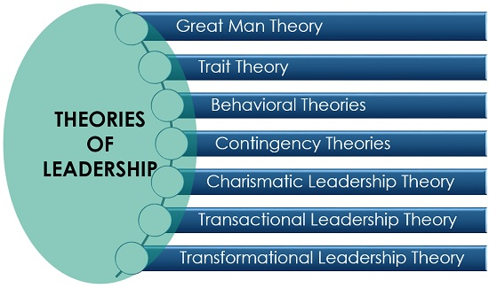
Fig.1.: Leadership theories
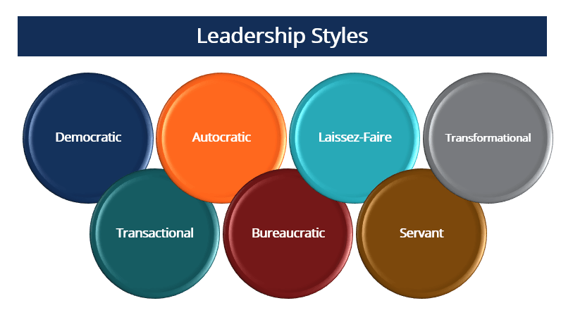
Fig.2: Leadership styles

- THE IMPACT OF LEADERSHIP ON MC DONALDS
  - Management in Mc Donald’s
Management involves finding creative solutions to issues to maximise the organization's resources in attaining its goals. McDonald's exemplifies the four managerial tasks that allow these results.
Planning involves expressing a company's goal and outlining actions to realise it. McDonald's has a well-defined mission. This vision statement brings the worldwide workforce together. Each is dedicated to servicing its clients by offering high-quality, easy-to-get items. Vision statement outlines the company's future. McDonald's employees know the company's direction and their position. McDonald’s planning process outlines the company's goals and how to achieve them. McDonald's strategy is versatile, since it adjusts to changing target markets and rival food offerings. McDonald's utilised this tactic to compete with 24-hour restaurants. This adjustment was designed to accommodate more consumers and take advantage of increased weekly hours to improve revenues.
"Organising" means creating an organization's internal structure. Information is openly communicated, and tasks are assigned, organised, and managed. This is how superiors assign work. Today's corporate climate values workers and consumers most.
Overly tight management stifles employees' creativity, therefore today's competitive economy favours empowerment and delegating. McDonald's cooperative management consolidates franchisees under one brand (Long, 2006). Franchisees are urged to collaborate to tackle external concerns and promote a responsible, collaborative culture to their consumers. All franchises must fulfil the same quality requirements. Training, supplies, and operations are centralised. McDonald's has a structured structure that separates the company into sections, and each employee understands his division's duties. There is no bureaucratic rigidity in the organisation since everyone is focused on achieving their best. The restaurant's organisational structure is productive and connected with its purpose to provide consistently high-quality service to every client.

  - Leadership in Mc Donald’s
CEO leads McDonald's. Jim Skinner, McDonald's CEO, has enjoyed this nickname for 35 years (Linch, 2017). Skinner is a respected, inventive leader. He wants to launch a new fast food franchise with his fresh approach.
His imaginative management turned around McDonald's. He led "plan to win," which emphasised the retail sector. His expertise and understanding helped him keep his team's interest and devotion. He prioritises delighted consumers over his staff and food service operations. He encourages innovative thinking but distracts workers from the company's objective. He promotes from inside and prioritises talent identification; top workers have more authority. Skinner values morality and ethics (Linch, 2017)
When McDonald's was criticised for obesity, its CEO took action. He's a moral leader who improves McDonald's for its staff and consumers.
McDonald's combines enthusiastic personnel with clear rules to keep them on target. Managers are responsible for enforcing rules. Every franchise has quality and supplier rules (Long, 2006). This ensures that franchisees don't damage the company's reputation. McDonald's trains all staff at Hamburger University. This ensures that all employees understand the standard and how to accomplish it.
Work-life balance, training opportunities, a nice work environment, and scheduling flexibility motivate workers. McDonald's bureaucratic management style doesn't seem to affect staff production or loyalty.
Skinner's inspired leadership and McDonald's clear practises have garnered customer trust. By responding to client requirements, the firm generated earnings without losing its beliefs. McDonald's success is due to well-rounded planning, organising, leading, and controlling (Rodrigues, J., Nikhil, S.,& Jacob, S. , 2016).

- LEADERSHIP IMPACT EXAMPLES
A leader's instincts may kick in, but leadership isn't always easy. Leadership may be learned through formal training and education courses that focus on building and honing in-demand skillsets. These skills can be used to make a convincing case for the value of leadership. All this can be proven in the next two past experiences that pushed me to reflect over my leadership strength and weaknesses.
My first experience starts from the moment when in the second year in University I was delegated as a group leader for a presentation. I remember, I was very enthusiastic about the fact that all my group colleagues where thinking about me. The topic of our presentation was to reflect upon the HR importance and theories and to analyse these from a chosen company spectrum. I loved the topic as I always was fascinated about Human resources and the importance of it within business. Since I learned that I am a participative leader, I kicked off the first meeting by having everyone pitch in on who would write about what and how many slides would need to be for each of us. At the presentation, I encouraged my employees to share their thoughts and provide solutions to any issues that arose. We did well despite having a lengthy first session meeting when much time was spent discussing the company we would be writing about.
For participative leadership to work, the person in charge needs to be authoritative enough to make the final call. After taking a step back to evaluate the presentation's execution, I can now say that the team did a fantastic job of communicating the presentation's overarching concept and supporting materials. My success as a leader in this fashion stems from the fact that I was able to exercise discretion over the ultimate decision, even after hearing numerous perspectives on how to best solve a problem.
On the other hand, leadership is not always about the best things that are happening or about the conclusion I think is more about the process. How I as a leader need to be aware of my strengths and weaknesses, how to improve every day and how to approach people I work with.
Here comes my second experience. Before university, I was working in a restaurant. I was shift manager there. Everyday came with its little problems to be solved, regarding the missing staff, or missing products that needed to be ordered in time and in the end unsatisfied customers. I enjoyed every shift as a manager even every day was a challenge. One evening, a client came and filled up a complaint that one of my team members, that served at its table didn’t gave him the meat as he asked and when he tried to talk with my colleague, she answered rude. The client felt offended and asked for a manager to come and solve the unpleasant situation. After discussing with the client and listen his opinion I offered to make the order again and in the meantime I came in the kitchen and started to criticise about this unpleasant situation. The problem was solved by losing our products and time for making again the client’s plate.
Assessing now over this pushed me to complete a quick quiz and see more about my leadership style (see Appendix 2) where the answer was that I am practicing a democratic and participative leadership style.
Members of the organisation play a larger involvement in making decisions under democratic leadership, also called participation leadership. Workers get together to hash out issues and find solutions, with everyone getting a voice in the process. This kind of leadership may be used in any organisation, from businesses to universities to governments. It has been found via study to be one of the most effective leadership styles, leading to more group output, greater member contributions, and higher morale. The advantages that this style has is: cooperation among workers, it fosters creative thinking, when morale among workers is high, productivity rises. Since they are now more invested in their work, productivity has increased. Lessen conflicts in the workplace. On the other hand, there are weaknesses too, weaknesses that I felt during my conflictual situation with staff in different situations as: leaders may feel fatigued by the challenges posed by coordinating the efforts of specialists on collaborative teams. Some team members may feel dissatisfied if they believe the optimal decision is not being taken despite the consensus of the group. Furthermore, the result might be a breakdown in communication and unfinished business when times are uncertain. It's possible that some of the group members won't have the expertise to help make decisions.
Assessing and analysing these two situations and researching about my leadership style there needs to be conducted a leadership development plan. A well-thought-out plan for developing leaders is an invaluable resource for propelling an organisation forward and realising individual ambitions (see APPENDIX 2)
In order to conclude this personal analysis, I think that everyone in an organisation has to be equipped with skills and willing to contribute for democratic leadership to thrive. It's also important to give people plenty of time to talk things over, form a plan, and then vote on the best way to move forward. With so many people having input, setting deadlines can help guarantee that you receive it in a timely manner. It might be helpful to set expectations beforehand. This outlines the circumstances under which group input will be sought and those under which management will make decisions without consulting the group.
- CONCLUSION
The changing nature of work requires better leadership and management from employees. This has been helped by a shift from top-down, performance-based leadership to collaborative, democratic leadership. Increasing workplace competitiveness and turmoil necessitate mental agility, skills, self-awareness, and capacities. Businesses and people have invested in professional development to gain a competitive edge. The characteristic hypothesis posits that certain features make some persons more likely to pursue leadership roles. The transformational leadership concept suggests that an individual may choose to become a leader and gain the abilities. The great event hypothesis argues that an ordinary person can develop leadership traits after a special event or experience.

- APPENDIX 1: LEADERSHIP THEORIES
  - The great men theory

Great leaders are born, not made, says the great man theory. According to this belief, leaders are born with success-oriented traits. These include charm, boldness, intellect, and self-confidence.
Supporters of the concept mention Mahatma Gandhi as an example. His nonviolent political activity inspired millions despite his lack of leadership experience. This idea gained hold in the 19th century but has since been criticised for stating that leadership needs no work and cannot be learnt. Some believe leadership styles lack variety since most traits are stereotypically male.
  - The trait theory
The core tenet of trait theory is that certain characteristics of a leader's character predict whether they will be successful or not. The level of your leadership ability may be judged in part by comparing your skills with those of great and bad leaders.
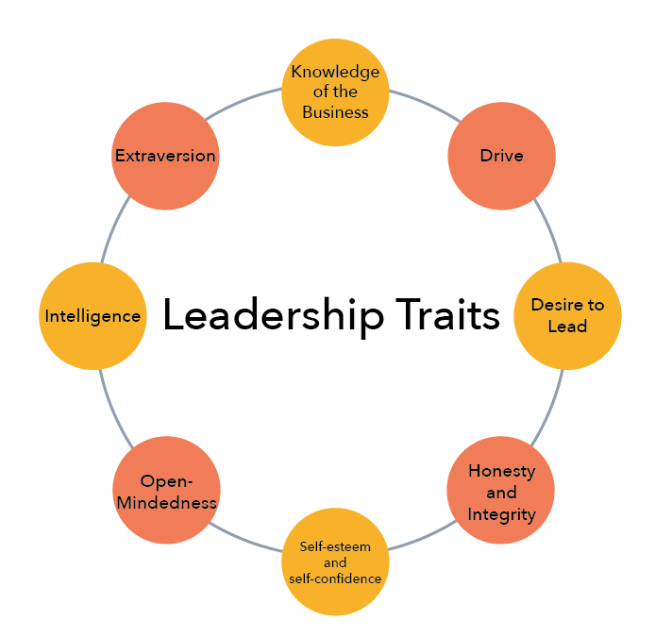
Fig.2: Leadership traits

  - Behavioural Theory
The great man and his defining views described above stand in stark contrast to the behavioural leadership theory that underpins modern management practises. It posits the idea that leaders may be developed, rather than born into their positions. The focus of this method is on a leader's behaviours and demeanour, rather than their appearance or innate abilities.
As an example could be a manager who is focused on results rather than employees. This manager will examine existing practises to see if there are any room for improvement in the event of a team problem. A leader with empathy would instead go to the group and inquire what's going on and how they can fix it.
According to the behavioural leadership theory, anyone can become a leader so long as they put in the time and effort to develop the skills essential for doing so. It's an admission that different circumstances call for different responses. These are things that can be picked up from observing others.
  - Transformational Theory
Transformational (or relational) leadership theory posits that leaders who put their followers' needs above their own may accomplish great things. These leaders put an emphasis on creating a positive work environment, leading by example, and coaching their subordinates. They take action to inspire and push their team members to excel in their work. Leaders who can inspire their people to achieve their full potential are called transformational leaders. However, this method of leadership is not appropriate in all situations. Employees who are less skilled or experienced may need more handholding and guidance than is provided by this type of leadership.
  - Transactional Theory
Contrasting with transformational leadership is transactional, or management, leadership. It's a "reward and punishment" system common in many fields. An employee may receive a bonus for outstanding performance, whereas poor performers may be subject to disciplinary action. While it's true that praise may be a very effective motivator, heavy punishment for bad performance can have the opposite effect, dampening morale and decreasing employee engagement. Employees, according to transactional leadership theory, are mostly motivated by the possibility of gain or the fear of loss. To the contrary, transformational leadership recognises the potential for individuals to self-motivate and inspire one another to achieve a common goal.
  - Contingency Theory
Fred Fiedler developed the concept of the contingency theory of leadership in 1958. According to Fiedler, there were essentially two types of leaders: those who prioritised getting things done, and those who prioritised building strong relationships with their subordinates. Fiedler used a controversially termed method called "least preferred co-worker" to identify leadership styles (LPC). Relationship-oriented leaders were far more reticent than task-oriented leaders to open up about their sentiments about their Lichfield’s methodology looked at which of these leadership approaches would work best in certain situations. He used ratings of three factors to determine the overall "favourability" of the situation.
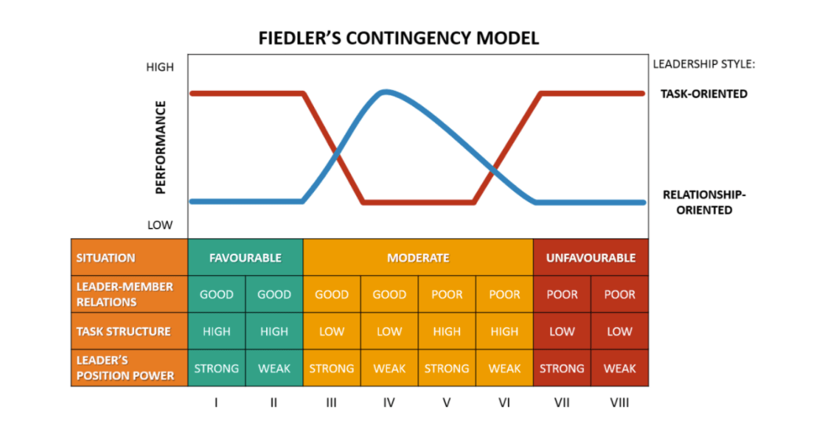
Fig.4: Contingency Model

  - Situational Leadership Theory
According to situational leadership theory, the most effective leaders must adjust their leadership style to the scenario they find themselves in. Unlike contingency theory, it believes leaders may adapt their leadership style. Leaders who recognise the need to adjust their approach have a far better chance of influencing people than those who do not.
Academic theorists Hersey and Blanchard used this concept to identify followers based on two variables. There were two of them: task readiness and psychological preparedness. Task readiness was an indicator of competence — the individual's capacity to do the task at hand. Their level of motivation to accomplish the work was reflected by their psychological preparedness.

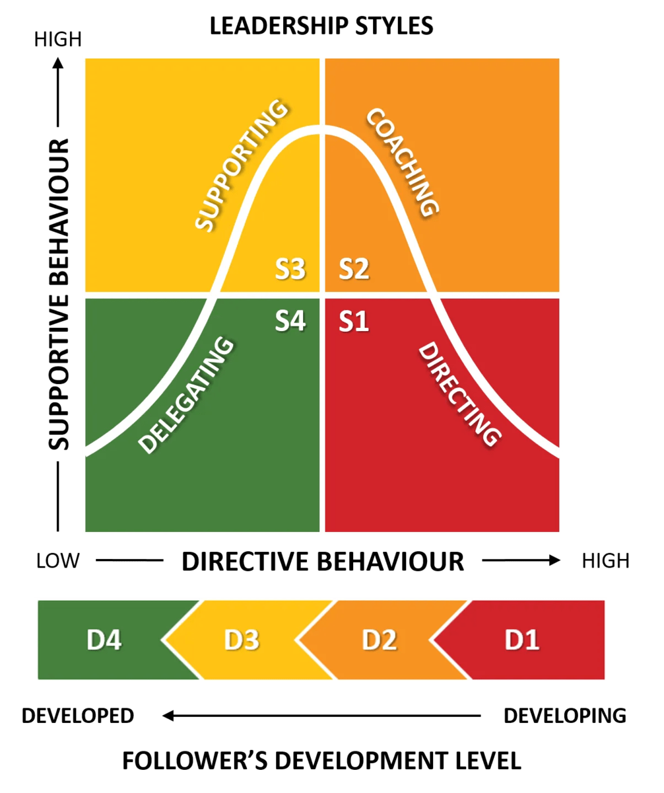
Fig.5: Situational leadership model

  - Participatory Theory
A leadership style based on employee participation is unusual in large organisations. This theory holds that a leader's primary role is that of a facilitator. Democratic leadership refers to a management style in which employees have a voice at every level of decision making. The role of the leader is to take into account the opinions of the group and come to a conclusion based on that consensus. While the leader ultimately has the say, group input is heavily considered.
Companies that are highly focused on innovation or newly formed businesses with a flat organisational structure may be more likely to use participative leadership.

- APPENDIX 2: LEADERSHIP STYLE QUIZ
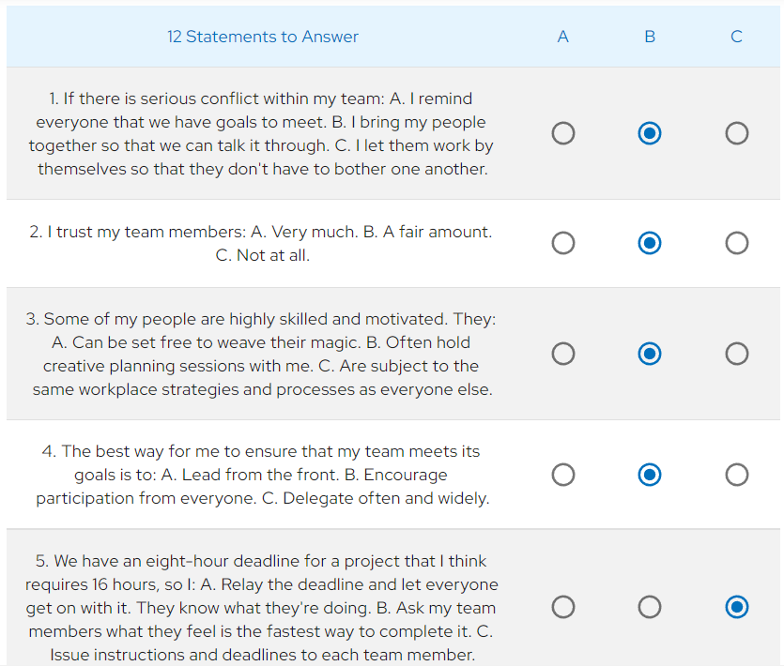
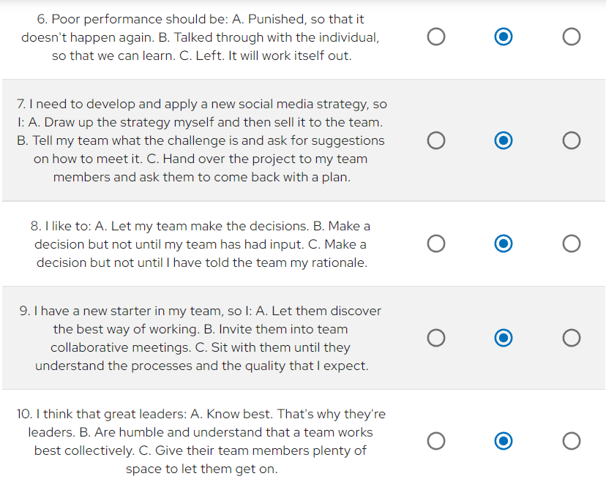
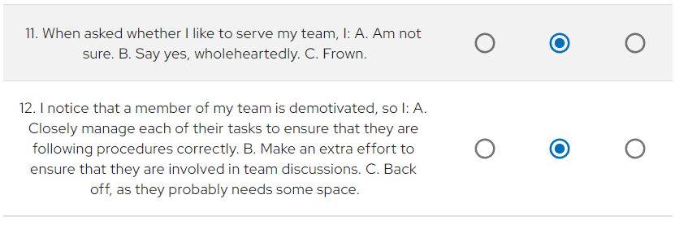
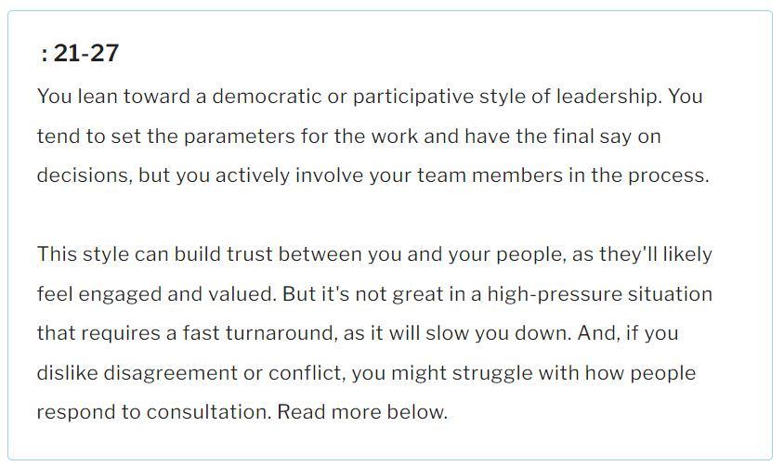

- APPENDIX 3: LEADERSHIP DEVELOPMENT PLAN

Leadership Development Objective | How? | Timescale | Where?
Improve communication skills | Participating more in school activities and work activities.  Spend more time listening to my colleagues and push my self in expressing my opinions and discuss it with my colleagues. | 01/01.2023 to 06/06/2023 | University and job
Embrace adaptability to change | Keep a fallback plan handy, establish a company-wide infrastructure, and avoid becoming too entrenched in my methods. Maintain my composure via the use of meditation, optimism, and innovation. | 03.02.2023 to 12.12.2023 | Job, University, Personal life
Improve my listening skills | Make time to meet with one of my subordinates once a week to work on my listening skills. | 01.01.2023 to 04..05.2023 | Job
Introduce positive feedback more frequent | Set up a what’s app group where I can share the weeks successes and areas of improvement. | 01.01.2023 to 03.03.2023. | Job and personal life (family)
Start being more openminded | Ask for my colleagues to complete a anonymous survey to see if they feel valued | 02.02.2023 and  12.12.2023 | Job

- REFERENCES
Ceil, C. (2017) Service quality and branding strategies at McDonalds, SSRN. Available at: https://papers.ssrn.com/sol3/papers.cfm?abstract_id=2984100 (Accessed: December 11, 2022).
Ike, L. (2017) International Management: Principles & Practices by Luke Ike - books on Google Play, Google. Google. Available at: https://play.google.com/store/books/details/International_Management_Principles_Practices?id=zkUiDgAAQBAJ&gl=US (Accessed: December 11, 2022).
Linch, C. (2017). Love, leadership and McDonald’s, Journal of the European Pentecostal Theological Association, 38(2), pp.113-125.
Ali, A. (2012). The Crucial Role of Leadership in Organizations: A Review of Literature. International Journal of Independent Research and Studies.
Rodrigues, J., Nikhil, S.,& Jacob, S. (2016). Promotional strategies of McDonalds and market effects, Journal of Management Research and Analysis, 3(1), pp. 53-55.
Smith, P., Yellowley, W., & McLachlan, C. (2020). Organizational behaviour: Managing people in dynamic organizations, Routledge.
Leadership style (2023) MindTools. Available at: https://www.mindtools.com/azr30oh/whats-your-leadership-style (Accessed: January 1, 2023).
Ge, L. (2020). Report on critical analysis on operation management for McDonalds, International Core Journal of Engineering, 6(11), pp.384.
Ike, L. (2017). International management: Principles & Practices, Xlibris UK.
Rodrigues, J., Nikhil, S.,& Jacob, S. (2016). Promotional strategies of McDonalds and market effects, Journal of Management Research and Analysis, 3(1), pp. 53-55.
Lynch, C. (2017). Love, leadership and McDonald’s, Journal of the European Pentecostal Theological Association, 38(2), pp.113-125.
Smith, P., Yellowley, W., & McLachlan, C. (2020). Organizational behaviour: Managing people in dinamic organizations, Routledge.
CFI, (2022), Leadership Styles, Available at: https://corporatefinanceinstitute.com/resources/management/leadership-styles/ , Accessed:02.01.2023.

