
MODULE NAME:
STRATEGIC MANAGEMENT FOR SMEs
MODULE CODE: BMSK6004
STUDENT NAME: SAIFUR RAHMAN
STUDENT NUMBER: 1605226
LECTURER NAME: DR. REXON NTING

Table of Contents
1.0 Introduction 3
2.0 Analysing the internal environment of CafePod Coffee Co. 4
2.1 SWOT analysis of CafePod Coffee Co. 4
2.2 McKinsey’s 7S model analysis of CafePod Coffee Co. 6
3.0 Analysing the External Environment of CafePod Coffee Co. 10
3.1 PESTEL analysis of CafePod Coffee Co. 10
3.2 Porter’s Five forces analysis of CafePod Coffee Co. 13
4.0 Stakeholder’s Expectations of CafePod Coffee Co. 17
5.0 Recommended growth strategies to achieve sustainable growth in the market for CafePod Coffee Co. 20
5.1 Ansoff’s Growth Matrix 20
6.0 Conclusion 24
References 25

List of Tables
Table 1. SWOT analysis of CafePod Coffee Co. 5
Table 2: Equation for calculating market penetration 20

List of Figures
Figure 1: McKinsey’s 7S model 7
Figure 2: Organisational structure of CafePod Coffee Co. 7
Figure 3: PESTEL analysis model. 10
Figure 4: The growth of coffee shop in the UK. 11
Figure 5: Porter’s Five Forces Analysis Model. 13
Figure 6: Competition in the Coffee shop in the UK. 14
Figure 7: Stakeholders of CafePod Coffee Co. 16
Figure 8: Ansoff’s Growth Matrix 20

1.0 Introduction
In today’s business world, the business environment inside and outside the organisation has become more dynamic and keeps changing frequently. With such changes, the performance and operation of the organisation get influenced. Those influences can be either positive or negative for the organisation depending on the size, nature, strengths, weaknesses, opportunities, threats, capabilities and other factors of the organisation. in such situations, the management of the organisation has to make strategic decisions or make changes in its strategies regarding its operations and functions (Stead and Stead, 2013). Adapting and managing those changes and undertaking strategic decision requires high managerial capability or skill in strategic management. Strategic management is the branch of management which identifies and analyse the changes within the business environment and its impact over the organisation and provides appropriate strategies for the organisation to adapt and manage the change in the organisation effectively so that the organisation can use the changes positively for the organisation (Thompson, Scott and Martin, 2017). in this particular paper, the internal and external environmental factors of CafePod Coffee Co. will be analysed along with the stakeholder’s expectations and an appropriate strategic option will be recommended in terms of having a competitive advantage and sustainable growth in the market. CafePod Coffee Co. is a UK based small Coffee retailing company which was established in the year of 2011 and the company earns annual revenue of £6 million.

2.0 Analysing the internal environment of CafePod Coffee Co.
With continuous changes in the business environment, business organisations all over the world are facing challenges to compete and achieve sustainable growth by having a competitive advantage in the marketplace (Aaker and Moorman, 2018). Such situations have made the management of an organisation to make decisions regarding whether they should change their strategies or not if the company is capable of doing so and which strategy should the company follow in order to overcome the existing and potential market challenges (Thompson, Scott and Martin, 2017). This is where the significance of strategic management can be understood. Strategic management suggests to analyse the internal and external business environment of the organisation to understand whether the company is able to face the challenge with its current strengths and opportunities or the weaknesses and market threats will create impediments before the company to do so. In order to understand this, CafePod Coffee Co. will have to conduct SWOT analysis which will determine the internal strengths and weaknesses and also the external opportunities and threats influencing the company. Another strategic model which CafePod Coffee Co. can use to analyse its internal business environment is McKinsey’s 7S model.

2.1 SWOT analysis of CafePod Coffee Co.
An organisation consists of several components and factors among which some are the strengths of the companies and some are weaknesses (Thompson, Scott and Martin, 2017). In order to operate the business having competitive advantages, an organisation is required to develop its strengths and lessen its weaknesses. For that, the organisation is required to identify its strengths and weaknesses first and to do so SWOT analysis is one of the most appropriate analytical tools. By producing a SWOT analysis of CafePod Coffee Co., the management of the company will be able to identify its current strengths and weaknesses along with the existing and potential market opportunities and threats which may influence overcoming the weaknesses and different other factors of the company. The SWOT analysis of CafePod Coffee Co. is given underneath:
Strengths | Weaknesses
- The company has a high rate of profitability compared to other competitors.  - The company provides fresh and quality coffee to its customers.  - The company has a strong business model and skilled management.  - All the outlets of the company are located in suitable geographical locations.  - The company has an effective pricing strategy which attracts the customers.  - The company has a skilled and innovative employee panel.  - The company has an enhanced brand value compared to other competitors in this market segment.  - The compared is growing rapidly and has reached in 7th position in the industry in just 8 years. | - The company is dependent on the supplier in order to get raw materials.  - There is a lack of decentralisation in terms of outlets and investment of the company.  - There is a lack of adaptability in case of changes in the environment of the industry.
Opportunities | Threats
- The company can develop a diversified product line as the market is growing rapidly.  - The increasing number of customers in the market is creating an opportunity for the company to have potential market growth.  - The demands of the coffee are increasing and the number of retailers is not so high to meet the increasing number of the customers.  - There is a high opportunity to internationalisation in the near future for the company. | - The number of competitors is high.  - There are many large companies in the industry which may impede in the growth of the company.  - High bargaining power of customer and supplier  - Several economic issues such as Brexit and changes in currency rate affects the performance of the company a lot.
Table 1. SWOT analysis of CafePod Coffee Co.
Source: (Own)
Strengths: The above SWOT analysis provides that the high profitability rate, fresh quality product line, appropriate business structure and systems are some of the strengths of the company which enables the company to compete successfully in the market. Moreover, the company has an effective pricing strategy which attracts customers and also the outlets of the company are located in suitable locations. Apart from this, the skilled and innovative employee panel and the increasing growth rate of the company is also enabling the company to have more grip over the market.
Weaknesses: The company has some weaknesses as well which are impeding the growth of the company such as high dependency on the supplier in order to get supply of raw materials for production. Also, the company follows a centralised policy of investment which can be a drawback for the company in attaining growth. Moreover, the adaptability of change within the organisation is low which may create challenges in changing the business situation.
Opportunities: The company has a lot of opportunities as the market and number of customers are increasing day by day and there is a lot of product line within the industry that the company can come up with. The demand for the product is increasing in an international context which is a huge opportunity for the company is expanding its business overseas.
Threats: There are some factors which may pose threats to the performance and operation of the company such as there are a high number of competitors in the market among which some companies are large in size and they have huge control over the market and the industry. Also, the bargaining power of both the suppliers and customers is high which can be a threat to the company for which the company may lose its customers and suppliers for any small disorder in the business. Moreover the current economic condition of UK is not so good for different reasons such as Brexit and changes in currency which may have an adverse impact on the company.

2.2 McKinsey’s 7S model analysis of CafePod Coffee Co.
In order to analyse the internal business environment of CafePod Coffee Co., the company can also use the 7S analytical model provided by McKinsey. McKinsey’s 7S model has been designed for the business organisations to identify the 7 key elements inside the company and they are strategy, structure, systems, shared values, style, staff and skills (Aaker and Moorman, 2018). The 7S model of McKinsey can help CafePod Coffee Co. in implementing new strategies in the organisation, facilitating changes in the organisation, facilitating the merger of the company and to determine future changes in the specific business area. The analysis of the internal environment of CafePod Coffee Co. using McKinsey’s 7S model is as follows:

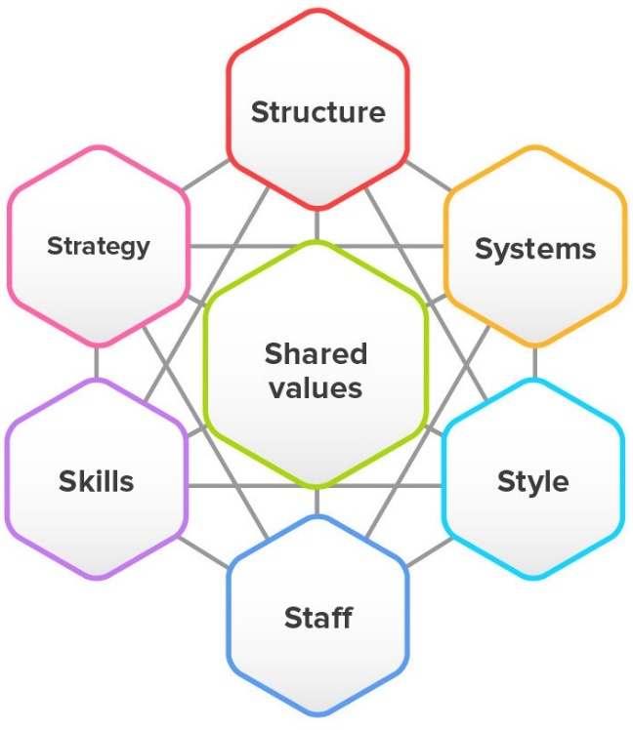
Figure 1: McKinsey’s 7S model
Source: (Thompson, Scott and Martin, 2017)
1. Strategy: The first element of this model refers to the long term plan that CafePod Coffee Co. has to accomplish. A strong strategy indicates the mission and vision of the organisation that the organisation wants to achieve throughout operating the company (Aaker and Moorman, 2018). The mission and vision of CafePod Coffee Co. are to achieve sustainable business growth in the marketplace through constant quality and innovation.
2. Structure: The second element of the model ‘structure’ refers to the organisational chart of the company which means the division of units and employees in order to perform different tasks or operation of the business and who will be accountable to whom etc. (Thompson, Scott and Martin, 2017). CafePod Coffee Co. follows a hierarchical organisational structure in operating its business functions. The structure of CafePod Coffee Co. is as follows:

Figure 2: Organisational structure of CafePod Coffee Co.
Source: (Own)
3. Systems: The third element of the model refers to the methods and procedures of accomplishing the organisation's daily activity which is how CafePod Coffee Co. operates its business every day. CafePod Coffee Co. follows a range of systems in its daily operation including customer relationship management system, employee recruitment and selection system, transaction processing system, team development and orientation system and so on.
4. Shared values: This element of the model includes the core value that an organisation holds in doing its business and reveals in its every functions, mission and vision (Ajmal and Lodhi, 2015). The core value of CafePod Coffee Co. is ‘Constant Quality through Innovation’. In every function of the company, the management of CafePod Coffee Co. tries to ensure constant quality through innovative measures.
5. Style: It indicates the leadership style within the organisation whether the management is autocratic or democratic in making their decisions regarding the operation of the company (Thompson, Scott and Martin, 2017). The management of CafePod Coffee Co. follows a democratic leadership style with an organisational hierarchy structure.
6. Staff: CafePod Coffee Co. is more likely to select and recruit employees with high communication and other interpersonal skills and innovation skill.
7. Skills: The employees working within CafePod Coffee Co. are well trained and innovative as well. The company provide training and development facilities in terms of improving their appearance before the customer, manner of serving their customers, improving customer relationship and quality of the product.
These are the 7 internal components of CafePod Coffee Co., which influences the decision making of the company and also be influenced by the change of any other internal and external factors.

3.0 Analysing the External Environment of CafePod Coffee Co.
While the internal environmental analysis, which constitutes the business organisation and lies within the organisation, enables CafePod Coffee Co. to understand the internal components of the business, the external environmental analysis assists the company to understand different external components which have influences on the performance and operation of the business. The external business environment consists of different components which lie outside the organisation and have a direct and indirect impact over the organisation (Sugahara, Daidj and Ushio, 2014). Unlike internal environments, the external environment cannot be controlled by the company and the organisation has to adapt their strategies and decisions as per the changes occurred in the external environments (Ajmal and Lodhi, 2015). Though it is said that the external environment cannot be controlled by the organisations, the larger organisations have control over the components of the external environment and their decisions may have such impacts which may affect the external environment of other small and medium-sized organisation (Sugahara, Daidj and Ushio, 2014). For example, if major competitors fall behind in the industry, it creates a huge market opportunity for CafePod Coffee Co. CafePod Coffee Co. can analyse its external business environment can be analysed using the following analytical tools.

3.1 PESTEL analysis of CafePod Coffee Co.
Among many analytical tools available, PESTEL analysis model is one of the most popular tools to analyse the components of the external environment of an organisation. This particular analytical model identifies a range of environmental aspects in the industry which are the political, economic, social, technological, environmental or ecological and legal (Stead and Stead, 2013).
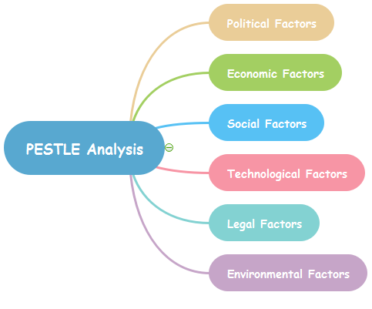
Figure 3: PESTEL analysis model.
Source: (Ajmal and Lodhi, 2015)
This model determines several aspects of different environmental factors which enables CafePod Coffee Co. to identifies the current and potential impacts of those factors over the organisations and make effective decisions in operating the business. The analysis of the external environment using the PESTEL model is as follows:
1. Political factors: This environmental factor includes the impact of government and its business policy on the organisation and its business relationship with other countries. It influences the availability and price of the raw materials which comes from different countries and the potentiality of the company to grow on the international market (Balogun, Hope Hailey and Gustafsson, 2016). The probable political factors which may influence the business operation of CafePod Coffee Co. are the integration of market policy of the government, the extent of government support in the particular industry and other industry complementary to it, bureaucratic relation with other governments.
2. Economic Factors: The economy of the country plays a significant role in determining the position and performance of an organisation as the organisations are part of the economy (Harris and Ogbonna, 2011). The growth of the industry highly depends on the economic factors of the country which includes Condition of the particular industry, the contribution of the industry to the economy, rate of interest, availability of finances and so on.
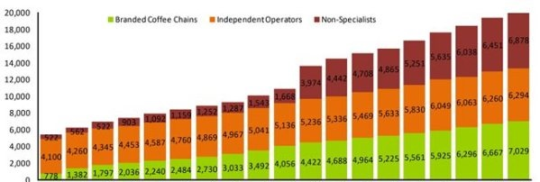
Figure 4: The growth of coffee shop in the UK.
Source: (Harris and Ogbonna, 2011)
The above statistics show the higher demand for the coffee in different sectors which indicates that CafePod Coffee Co., as a coffee retailer has a high potential in the marketplace. Several economic factors will have a potential impact on CafePod Coffee Co. such as a decline in the labour rates, high growth of developing countries and rising labour cost in the supplier countries and so on.
3. Social factors: These factors are more related to the culture, behaviour, perception and attitude of the customers or the society. These factors also have a huge impact on the performance and operation of CafePod Coffee Co. It is positive for CafePod Coffee Co. that the culture of consuming coffee is spreading and people are having a positive perception about having coffee. Apart from this, most of the customers prefer to have a cup of coffee from a popular coffee brand which has its own signature.
4. Technological factors: Due to globalisation and introduction of several innovative technologies, the business world has now completely changed than before (Stead and Stead, 2013). Technological factors have both positive and negative impact on CafePod Coffee Co. as it has enabled the company to increase its productivity effectively with efficiency. On the other hand, it has also led the competitors to have advantages which created more competition for the company.
5. Environmental factors: Though the coffee retailing industry does not affect the environment as compared to other industries, still CafePod Coffee Co. will have to be considerate about abiding the environmental policies to cause less affect to the ecological system. Otherwise, it may have an adverse impact on the performance of the company.
6. Legal factors: This particular factor includes the laws, regulations and policies made by the legislative body of the country or any other authoritative body in relation to opening, operating or doing anything regarding the business. There are certain laws and regulations that CafePod Coffee Co. must abide by in operating the business such as Employment law (Health and Safety at Work Act 1974, Equal Pay Act 1970, Employment Protection Act 1978, Sex Discrimination Act 1975, Race Relations Act 1976 etc.), competition law, consumer protection law (Sale and Supply of Goods Act, Trade Description Act, Consumer Credit Act etc.) and so on (Harris and Ogbonna, 2011).

3.2 Porter’s Five forces analysis of CafePod Coffee Co.
Every business industry consists of some core elements which is regarded as the business environment of that industry. Michael E. Porter has identified five such components which constitute the external business environment of an industry or organisation (Herrmann and Nadkarni, 2013). In this regards, Porter has provided five forces analysis model which identifies and analyse these five core factors of a business to understand the company’s external business. This model depends on the idea that there are five powers that decide the competitive force and engaging quality of a market (Herrmann and Nadkarni, 2013). Porter’s five forces analysis helps CafePod Coffee Co. to recognise where power lies in a business circumstance. This is helpful both in understanding the quality of focused position of CafePod Coffee Co. at the present time and the strengths that the company has against reaching its targeted market position. The analysis of the external business environment of CafePod Coffee Co. using Porter’s Five Forces Model is given below:
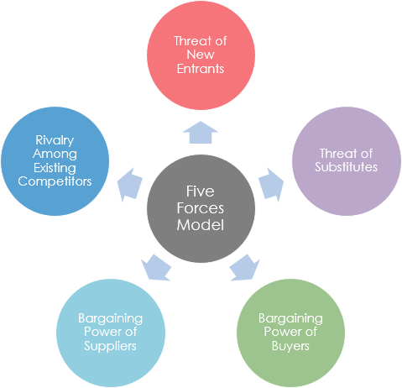
Figure 5: Porter’s Five Forces Analysis Model.
Source: (Herrmann and Nadkarni, 2013)
1. Rivalry among existing competitors (High): Being a small-sized coffee shop in the marketplace of UK, CafePod Coffee Co. has to compete with both the small, medium and large size organisations. The competition for CafePod Coffee Co., in the same segment as it is, are Café Direct, Bright, Dear Green and so on. Though CafePod Coffee Co. is now in number 7 position in terms of retailing coffee in the UK still the number of the competition is rising day by day which is posing threats to the company in the market. The company is aiming to become the number one coffee retailer in the UK and for that, the company needs to identify new effective strategies to beat the competitors in the market and have the most market shares compared to the competitors and for that, the company needs appropriate strategic management.

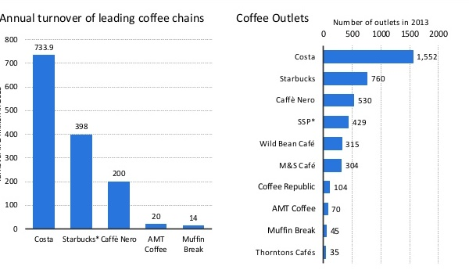
Figure 6: Competition in the Coffee shop in the UK.
Source: (Herrmann and Nadkarni, 2013)
From the above graph, it is evident that the competition for CafePod Coffee Co. in the market is very high and it will be quite difficult for the company to overlap those competitors existing in the marketplace.
2. The threat of new entrants (Moderate to High): It indicates whether the industry has the potential for new companies to enter into the market (Herrmann and Nadkarni, 2013). In this regard, as the coffee retailing industry has a huge revenue annually many entrepreneurs are highly interested to enter into this new marketplace. But there are some certain constraints as well for the newcomers as there is already an increasing number of competition existing in the market, the growth potential for the newcomers as a brand is highly challenging unless it is a non-branded individual coffee shop.
3. The threat of substitution (Low to Moderate): It indicates whether the product provided by CafePod Coffee Co. can be substituted with any other existing or potential products that may come in the market. In this regard, the possibility is very low because the people of the UK are quite used to having coffee. But some people are substituting coffee with tea or other drinks.
4. Bargaining power of the supplier (Low to Moderate): The suppliers of CafePod Coffee Co. can put low to moderate pressure in terms of bargaining with the company as a supplier. This is because there are lots of suppliers available in the market and CafePod Coffee Co. follows their own policy regarding selecting their suppliers for raw materials. Also due to increasing coffee farmers around the world, the bargaining power of the supplier has fallen more.
5. Bargaining power of the Buyers (Moderate to High): It indicates whether the customers of CafePod Coffee Co. are able to switch to another brand or another product without any cost of such switching (Herrmann and Nadkarni, 2013). Here, the threats of customers switching to other brands are very high as there are many alternative options available to the customers for getting the same product. Here, a positive aspect of CafePod Coffee Co. is that the company provides quality coffee with a reasonable price range compared to the competitors but still it is up to the customers.
The above analysis of Porter’s Fiver Forces of CafePod Coffee Co. indicates different market factors which the company must consider while making any decisions or undertaking any strategies for the company.

4.0 Stakeholder’s Expectations of CafePod Coffee Co.
Before making any strategic decisions, along with analysing the internal and external business environment of CafePod Coffee Co., the company should also analyse the expectations of the stakeholders (Stead and Stead, 2013). This will enable the company to understand how the new strategy or decision will affect the expectations of the stakeholders and undertake appropriate measures to manage the expectations of the stakeholders effectively (Balogun, Hope Hailey and Gustafsson, 2016). The term ‘stakeholder’ refers to any interested body either people or organisation such as employees, customers, investors and so on (Lasserre, 2016). following the stakeholders of CafePod Coffee Co. and their expectations from the company.

Figure 7: Stakeholders of CafePod Coffee Co.
Source: (Own)
Employees: The employees are the heart of the organisations as they run all the operation of the organisation (Lasserre, 2016). With regard to this major fact, CafePod Coffee Co. should always be considerate regarding the expectations of the employees. The major expectations of the employees are monetary increment and incentives, safety at the workplace, job security, high-performance workplace and so on. Unless the employee’s expectations are not fulfilled, the performance level of the company may fall (Ajmal and Lodhi, 2015).
Customers: Customers are everything to a business organisation, they are the reason the company has been established and operating (Lasserre, 2016). The expectations of the customer of CafePod Coffee Co. is simple, they always want quality products and services with a reasonable time. Apart from this, the customer is a part of the community also expect CafePod Coffee Co. to be more responsible towards the society, environment etc.
Suppliers: Suppliers are those who supply all the necessary goods and equipment required for producing and serving the products to the consumers (Lynch, 2015). Considering the expectation of the supplier is also significant along with other stakeholders (Ajmal and Lodhi, 2015). The suppliers mainly expect to have a prompt payment for their goods supplied and avoid delays in making payment (Balogun, Hope Hailey and Gustafsson, 2016).
Investors/owners: The investors of the organisation provide finances for the operation of the company and the owners or directors operate the company along with providing finances (Balogun, Hope Hailey and Gustafsson, 2016). The expectation of this group is to have a high profit against their investment and sustainable growth of the organisation with improved performance (Lynch, 2015). If their expectations are not fulfilled, they will not invest in the company anymore and such a situation will make other investors avoiding investing in CafePod Coffee Co.
Government: The government is the body governing every aspect of the country or state including all the business activity (Balogun, Hope Hailey and Gustafsson, 2016). The government’s expectation is that CafePod Coffee Co. pays the tax regularly and abide by all the rules and regulations imposed on business organisations in terms of operating business. If CafePod Coffee Co. does not comply with all the laws and policies imposed by the government, the company will have to face punishment or even shut down. Also, it will create a negative image of the company among the customers.
Community: Though this segment is not directly associated or interested in the company and its activity, still there is some expectation of this group regarding the operation of the company. The community or society expects that CafePod Coffee Co. will fulfil corporate social responsibilities and cause no harm to the society and environment. CafePod Coffee Co. may lose its brand value and acceptance among the customers if these expectations are not fulfilled.
The stakeholders constitute the company and each stakeholder is significant to the organisation. if any of CafePod Coffee Co.’s stakeholder’s expectations are not fulfilled, the company may face challenges and which can be a drawback for the company to operate in the market successfully. So, before making any strategic decisions CafePod Coffee Co. must consider whether the changed strategy will fulfil the stakeholder’s expectations or not. If any of the stakeholder’s interest or expectations are not fulfilled by any of the company’s activity, it may create complications for the company in operating the business.

5.0 Recommended growth strategies to achieve sustainable growth in the market for CafePod Coffee Co.
Once the management of CafePod Coffee Co. has analysed the internal, external environment and stakeholder’s expectations of the company, then the company can consider deciding strategies to implement in the operation of the company to have a competitive advantage and sustainable growth in the marketplace. While selecting the growth strategy for the company, the management should examine all the analysis they have done earlier and chosen the most appropriate growth strategy in accordance with the internal and external environmental influences and stakeholder’s expectations (Balogun, Hope Hailey and Gustafsson, 2016). With regard to selecting the growth strategy, the management of CafePod Coffee Co. may consider one of the most popular growth strategic model provided by Igor Ansoff which is known as Ansoff’s Growth Matrix.

5.1 Ansoff’s Growth Matrix
The Ansoff’s Growth Matrix is a highly useful growth strategy tools which provide several options for and organisations to choose from in terms of the appropriateness of its business environment and challenges (Schermerhorn, 2013). The Ansoff’s Growth Matrix is designed considering two main components namely the product and the marketplace. According to Igor Ansoff, in order to grow, an organisation should develop either the product or the market (Schermerhorn, 2013). With regard to this theory, this growth matrix was developed. CafePod Coffee Co. can use this growth matrix to select its growth strategies in order to have a competitive advantage and sustainable growth in the marketplace. The Ansoff's Growth Opportunity Matrix is discussed below in relation to selecting the appropriate strategic growth option for CafePod Coffee Co.
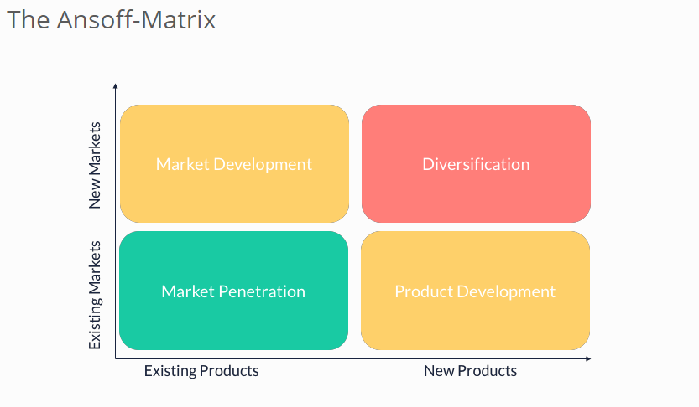
Figure 8: Ansoff’s Growth Matrix
Source: (Balogun, Hope Hailey and Gustafsson, 2016)
Market Penetration (existing market and existing product): In the first strategy, Ansoff has suggested ensuring more sell of the existing products in the existing market (Balogun, Hope Hailey and Gustafsson, 2016). This is the first and widely used growth strategy and it is about gaining more share in the market with the existing product line of the company. This strategy should be followed when CafePod Coffee Co. has an aim to increase market share. The market penetration strategy has a low market risk but also a low growth opportunity in the market. CafePod Coffee Co. can calculate the potentiality of its growth with this strategy with the following equation.
Market penetration = (Number of own customer / Number of potential customers) * 100
Table 2: Equation for calculating market penetration
Source: (Schermerhorn, 2013)
The lower the degree of the penetration of the market indicates the greater growth potential for CafePod Coffee Co. in the market using this strategy.
Market Development (new market and existing product): The next strategy suggests the organisation to develop new markets which are to launch the existing products in a new marketplace (Aaker and Moorman, 2018). The new market where CafePod Coffee Co. will launch its existing products can be a new area or country or just a new targeted people or group. In this strategy, the company is not required to do any change to its products but sometimes it is required to do so in order to adapt to the new customer base. If CafePod Coffee Co. follows this strategy, it will need to conduct research regarding the potentiality of the company to successfully survive in the new market. This strategy contains more risk than the previous one.
Product Development (existing market and new product): The third strategy provided by Ansoff suggests to develop the products in order to have growth in the market. This strategy is appropriate when the product of the company is nor providing satisfactory value to the customers and the customers want something new (Schermerhorn, 2013). Here CafePod Coffee Co. is required to develop its products and services in accordance with the taste, choice and demand of the customers. As CafePod Coffee Co. will be launching new products to the existing market, it will be of less risk for the company as the company is already known to the market. And as CafePod Coffee Co. is one of the large coffee retailers in the UK, this strategy can be quite good for the company as it has a high brand value among the customer. The product development strategy contains low risk and high opportunity for growth of the company.
Diversification (new market and new product): The last strategy provided by Ansoff is diversification which suggests introducing a completely new product in a new market (Stead and Stead, 2013). This strategy contains the highest risk and lowest growth opportunities for a company. This strategy is mostly adopted by the start-up company. Exceptionally, this strategy has been proved quite fruitful to many organisations which have recognition worldwide and highly famous for its products and services all over the world. But as CafePod Coffee Co. is a domestic retailing company, the company should not take such risk to launch a new product into a new market as because the company may not survive against the competitors as it is a new company in that market with a new product. Moreover, if an organisation chose to undertake this strategy as a growth strategy, the company must conduct a lot of survey and research regarding the growth opportunity in the market for the company (Ajmal and Lodhi, 2015).
By the above-mentioned discussion on the Ansoff’s Growth Matrix, it is evident that the market penetration strategy contains lower risk and lower growth opportunity. On the other hand, market development contains little higher risk than the previous one and higher growth opportunity but for companies like CafePod Coffee Co., this strategy should be followed only in the domestic market as the company is well known in the domestic market. Product development strategy contains lower risk and high growth potential for the company as the company has a brand value and brand loyalty among the customers in the existing market. Lastly, the diversification strategy contains higher risk and lower growth opportunity and the company is not capable of taking such risk right now. With regard to the discussion above, it can be suggested that CafePod Coffee Co. should go for the product development strategy as its strategic option in order to have a competitive advantage against the competitors and have sustainable growth in the marketplace.

6.0 Conclusion
Strategic management is highly significant to organisations as they have to face frequent changes in the business and its environment due to several reasons. These changes in the environment create challenges for the company and unless those changes are adapted and managed effectively, it may have an adverse impact over the performance and operation of the company (Stead and Stead, 2013). So, in order to manage such changes, new strategies should be developed by organisations. And before developing such strategies, the organisation must analyse the internal environment, external environment and stakeholder’s expectations to determine the appropriate strategy for the organisation. with the selection of an appropriate strategic growth option, the organisation will be able to have competitive advantages and sustainable growth in the marketplace.

References
Aaker, D. and Moorman, C. (2018). Strategic market management. Hoboken, NJ: John Wiley & Sons, Inc.
Ajmal, M. and Lodhi, S. (2015). Organisational consciousness: a new paradigm for sustainable change management. International Journal of Strategic Change Management, 6(3/4), p.254.
Balogun, J., Hope Hailey, V. and Gustafsson, S. (2016). Exploring strategic change. Harlow, United Kingdom: Pearson Education.
Berry, D. and Green, S. (2016). Cultural, Structural and Strategic Change in Management Buyouts. London: Palgrave Macmillan Limited.
Harris, L. and Ogbonna, E. (2011). Competitive advantage in the UK food retailing sector: past, present and future. Journal of Retailing and Consumer Services, 8(3), pp.157-173.
Herrmann, P. and Nadkarni, S. (2013). Managing strategic change: The duality of CEO personality. Strategic Management Journal, 35(9), pp.1318-1342.
Lasserre, P. (2016). Global strategic management.
Lynch, R. (2015). Strategic management. 4th ed.
Schermerhorn, J. (2013). Management. Hoboken: Wiley.
Stead, J. and Stead, W. (2013). Sustainable strategic management: an evolutionary perspective. International Journal of Sustainable Strategic Management, 1(1), p.62.
Sugahara, S., Daidj, N. and Ushio, S. (2014). Value creation in management accounting and strategic management.
Thompson, J., Scott, J. and Martin, F. (2017). Strategic management. Andover: Cengage Learning EMEA.

