
STUDENT’S NAME : HARSHINI A/P JANASINGGAM

STUDENT’S ID : 2321929

INTAKE : JUNE 2026

LEADING AND DEVELOPING PEOPLE - IUBA6005

LECTURER’S NAME : DR.EMMA ROBERTS

ASSIGNMENT TITLE : A COMPARATIVE CASE STUDY OF THE LEADERSHIP OF PEOPLE WITHIN TWO ORGANISATIONS

CHOOSEN COMPANIES : ZUS COFFEE AND LUCKIN COFFEE

Table of Contents
PART B: INDIVIDUAL SUPPLEMENTARY NOTES 3
1. Introduction 3
2. Key Concepts of the Study 3
2.1 Organisational Leadership 3
2.2 Organisational Culture 3
2.3 Strategic Human Resource Management (HRM) 3
2.4 Talent Management Initiatives 4
2.5 AMO Framework 4
3. Competitive Environment in the Coffee Industry 4
4. An overview of Zus Coffee 4
4.1 Overview 4
4.2 Justification for selection 5
4.3 People Strategy 5
4.4 Implementation Effectiveness 6
5. An Overview of Luckin Coffee 6
5.1 Overview 6
5.2 Justification for Selection 7
5.3 People Strategy 7
5.4 Implementation Effectiveness 7
6. Comparative Analysis from the Perspective of Meeting Future Organisational Needs 7
7. Recommendations 9
7.1 Recommendations for ZUS Coffee 9
7.2 Recommendations for Luckin Coffee 9
8. Conclusion 9
References 10

PART B: INDIVIDUAL SUPPLEMENTARY NOTES

1. Introduction
The ability to manage human resources and align them with the organisational goals is key to competitive success. In the “grab and go” coffee sector, customer service and recurring revenue, alongside product quality, are also dependent on the skills of the employees. Thus, the present study has selected Luckin Coffee and Zus Coffee for a comparative analysis of the strategic management of human resources, employee engagement and training, along with a plan of implementation. The report aims to compare the two coffee retail chains and provide recommendations to meet future goals. The analysis is largely in accordance with meeting long-term organisational goals.

2. Key Concepts of the Study
The concepts related to assessing the implementation effectiveness of people management strategies need certain anchors. The key concepts mentioned below thus serve this purpose.

2.1 Organisational Leadership
Organisational leadership is responsible for providing a vision and mission to the employees. This is thus one of the key concepts in people management at fast coffee retail. Organisational leadership is reflected in manpower management policies, and thus either enhances or downgrades existing employee engagement. Thus, assessing the same for the two selected brands is important.

2.2 Organisational Culture
A conducive organisational culture is a morale booster for the employees. It has been found that leadership have a transformative impact on the organisational culture (Nguyen et al. 2023). Thus, the organisational culture and leadership are interconnected. In fast coffee joints like Zus Coffee and Luckin Coffee, the backgrounds of employees can vary, making cross-cultural factors prominent; thus, they need evaluation.

2.3 Strategic Human Resource Management (HRM)
Strategic HRM is effective in aligning individual employee perceptions with long-term organisational goals based on strategic management of employee needs. Strategic HRM at present is directed towards managing a diverse workforce with new technologies for enhanced organisational outcomes (Nastase et al. 2025). The coffee retail chain is largely dependent on a digitally integrated platform, and implementation of HRM strategies also follows the same pathway. Thus, HRM is a key concept in the present analytical report.

2.4 Talent Management Initiatives
Talent management is a complex process that starts with attracting the right kind of prospective employee and undertaking continuous skill development. The fast coffee retails are dependent on both technological competence and soft skills of the frontline employees. Additionally, changing digital technologies and new AI models are revolutionising the coffee industry’s supply chain. Thus, initiatives for attracting and retaining the right talent add up to long-term competitive success.

2.5 AMO Framework
The Ability-Motivation-Opportunity (AMO) framework is key to long term employee retention and upskilling existing employees. In application of the framework, competence and capability factors are marked as abilities, followed by willingness and commitment as motivation factors; finally, empowerment is observed as opportunity (Bos‐Nehles et al. 2023). Thus, the comparative analysis of Luckin Coffee and Zus Coffee can be effectively done by considering the competence of the employees. The motivation of the employees can be assessed by considering the incentives and rewards provided by both the organisations. Additionally, skill development initiatives by both the brands show the existing opportunities for the employees.

3. Competitive Environment in the Coffee Industry
The coffee sector is becoming more competitive with the fast growth of stores, the digitalisation of the industry and evolving consumer tastes. Luckin Coffee is facing tough competition in China’s coffee market. The number of branded coffee outlets hit the 87,500 marks in China in 2025. Luckin was one of the leading players in the market (World Coffee Portal, 2026). Similarly, ZUS Coffee is now on a fast expansion path and has outperformed Starbucks in the number of stores in Malaysia in 2024 (The Business Times, 2025). Affordability, convenience, technology, and rapid expansion and localisation are therefore the areas of competition for both companies.

4. An overview of Zus Coffee

4.1 Overview
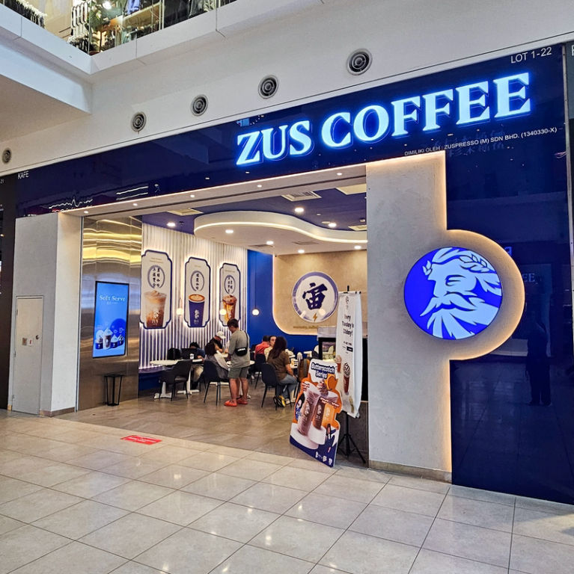
Figure 1: ZUS Coffee Outlet
(Source: Sunwayvelocitymall, 2026)
ZUS Coffee is a Malaysian coffee chain founded in 2019 to promote quality coffee to be more accessible in price and convenient to order digitally (Figure 1). The company has created a business model with digital technology. ZUS Coffee has been expanding quickly in Malaysia and even in other markets in Southeast Asia (ZUS COFFEE, 2026). It is a business model that combines the physical and digital customer experiences. It also offers convenience and consistency of service. Customer experience, product innovation, and operational efficiency are also priorities for the company.

4.2 Justification for selection
ZUS Coffee was chosen due to its focus on affordability, digitalisation and customer convenience. It is a fast-growing brand of coffee from the Southeast Asian region (CAROL, 2025). Its human resource management enables comparisons with Luckin Coffee in different aspects under the fast growth of the organisation.

4.3 People Strategy
ZUS Coffee's approach to people centres on developing a strong team to meet its goals of expanding its stores quickly and maintaining high-quality customer service. The company stresses recruitment, operational training, and skills development to equip employees for store-level duties (Ishak et al. 2026). Digital systems can also be used for communication and coordination of operations. Employee performance is linked to service standards and performance targets. ZUS Coffee aims to build a competent workforce. It provides a consistent service through these practices as the company continues to expand its store locations.

4.4 Implementation Effectiveness
ZUS Coffee's people strategy has enabled the company to grow its business at a fast pace. They identify and train staff for the growing number of stores (Abdull Karim, 2025). Standardisation in operational practices and training helps to ensure uniformity in services provided at the various sites. It also uses technology to enhance coordination and efficiency in its operations. Nonetheless, growth may present some issues for keeping consistent performance and engagement throughout the organisation.

5. An Overview of Luckin Coffee

5.1 Overview
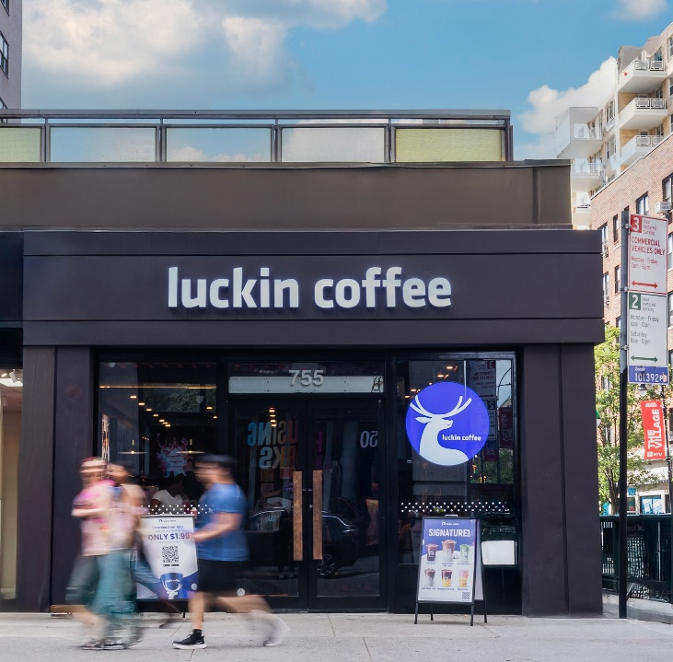
Figure 2: Luckin Coffee Outlet
(Source: Luckincoffee, 2026)
Luckin Coffee is a Chinese coffee chain established in 2017 and based in Xiamen, China. The company runs a technology-driven business model (Luckin Coffee, 2026). Luckin has grown at a fast pace by relying on a vast chain of both direct and partner stores (Figure 2). Their business model is based on low prices, simplicity, product development, and online customer interaction. The company employs technology to aid in store activities and business decision-making. It has had a significant impact on manpower needs in retail and management.

5.2 Justification for Selection
Luckin Coffee was chosen as the object to compare with ZUS Coffee not only for its swift growth, but also for its digitalisation, low price and technology-driven operations. The comparison of the two companies allows a study of the different approaches to people management that help when organisations are growing.

5.3 People Strategy
Luckin Coffee is prioritising human resources to build a team that can operate high-volume stores and use technology. Recruitment is supported through standardised processes. Operational training is provided to build up skills in service and the job. The digital systems support performance monitoring and operational coordination. The company implements productivity and service management measures as well.

5.4 Implementation Effectiveness
Luckin's employee management system has helped the company's rapid growth by establishing uniform processes throughout its wide store network. Luckin Coffee has successfully spearheaded this shift by implementing technological efficiency (Luo, 2026). Structured training contributes to uniform service delivery, and technology coordinates operations and employee performance. These practices help increase operational efficiencies and scalability. However, with growth comes its fair share of challenges such as employee workload, engagement, retention and the need to ensure management of employees is consistent across locations.

6. Comparative Analysis from the Perspective of Meeting Future Organisational Needs
Leadership Comparison
Both ZUS Coffee and Luckin Coffee need leadership systems that can handle the situation of swift business expansion without affecting the consistency of operations. ZUS Coffee demonstrates increasing emphasis on leadership capability, organisational development, succession planning and culture through its talent management roles. Luckin Coffee adopts system management of stores and assesses store managers and staff based on performance (SEC, 2026). Therefore, leadership that has operational control and employee development is a must for both organisations for future regional and international growth.
Recruitment Comparison
Both companies match recruitment to the growth of the organisation. ZUS Coffee hires for various roles to encourage career opportunities within the expanding company. Luckin Coffee officially connects the recruitment plan to the expansion plan and manpower demand. Full-time staff recruitment and assessment is completed in conjunction with HR and Operations managers, with part-time recruitment typically completed at store level. Both companies need to have scalable recruitment systems in place to draw in employees as well as ensure a high level of consistency in their selection process.

Training and Development Comparison
Training is an integral part of both companies' people strategies. ZUS Coffee has an Academy for training and developing operational staff. Existing positions show that there is a structured approach to the induction of new staff and a skills analysis for training. Moreover, they also have a training plan for staff. Luckin Coffee offers in-depth training with the internal training centre, which includes offline and online training, in-house training and training courses. They both contribute to future organisational needs, enhancing employee competencies in the growth of store networks.
Performance Management Comparison
Performance enablement is part of the organisational development and talent management work of ZUS Coffee. It is also responsible for tracking employee performance and making necessary improvements to enhance it. Luckin Coffee's approach is more clearly stated based on performance. It conducts ongoing assessments of store managers and staff, which are tied to job performance and promotion. Both strategies can be used to aid future expansion, but ongoing focus on fair assessment and employee development is important as operations expand.
Employee Engagement Comparison
Employee engagement is seen as a key component in the HR and organisational development process at ZUS Coffee, with specific initiatives in place to enhance culture and employee involvement. Luckin Coffee emphasises recruiting, training, keeping and stimulating employees and values, whether they are stable and committed to work for the continuity of operations. Both companies therefore need to continue to engage people through providing career development, appropriate leadership to support, suitable rewards and growing opportunities for employees to develop with the organisation for future organisational needs.

7. Recommendations

7.1 Recommendations for ZUS Coffee
ZUS Coffee needs to make a greater effort in leadership development and succession planning in order to ensure that employees can meet the challenges of continued regional expansion. The company may create career ladders that align training with promotion opportunities. Frequent employee engagement surveys may be useful in uncovering issues with workload, motivation and retention at various sites. ZUS Coffee should also improve its performance management system by linking operational targets to behaviour and development indicators. Lastly, more investment in digital learning might enable a consistent workforce training program in the growing number of stores and equalise the effectiveness of the training program across stores.

7.2 Recommendations for Luckin Coffee
Luckin Coffee is advised to proceed with building employee competence in parallel with its technology-based business model. Structured leadership programmes could be developed to prepare store managers for greater responsibilities as they expand into overseas markets. It is also important for the company to engage employees more through frequent feedback, recognition and clearer career development. Performance management can integrate operational indicators along with employee development indicators to develop a balanced approach. Besides, Luckin has the potential to grow digital and experiential learning programs to keep service levels high and enhance employee skills in technical, managerial, and customer service areas in its expanding service network.

8. Conclusion
The comparative analysis shows that both ZUS Coffee and Luckin Coffee will be successful in the future, with people management at the core of organisational success. Both companies focus strongly on recruitment, training, performance management, and employee engagement to support rapid expansion and smooth operations. ZUS Coffee focuses more on nurturing its staff as the business expands, while Luckin Coffee's business model is more digitalised and performance-based. Additionally, it pays more attention to staff management. However, both companies recognise a need to build leadership skills as they grow and engage employees to drive their growth.

References
Abdull Karim, N.I., 2025. Zuspresso (M) Sdn. Bhd.
Bos‐Nehles, A., Townsend, K., Cafferkey, K. and Trullen, J., 2023. Examining the Ability, Motivation and Opportunity (AMO) framework in HRM research: Conceptualization, measurement and interactions. International Journal of Management Reviews, 25(4), pp.725-739.
CAROL, K., 2025. BREWING PREFERENCE: A STUDY ON CONSUMER PURCHASE INTENTION TOWARD ZUS COFFEE.
Ishak, L.N.A., Tamby, C. and Hamid, R., 2026. Green practices communication in Malaysian coffee chains: A content analysis of official websites.
Luckin Coffee (2026), Luckin Coffee's Value Proposition, Luckin Coffee Holding Singapore Pte. Ltd., Available at: https://www.luckincoffee.com.sg/about [Accessed on 22 September 2026]
Luckincoffee, (2026). High quality Arabica beans. Luckincoffee. Available at: https://www.luckincoffee.us/ [Accessed on 26 September 2026]
Luo, Y., 2026. Cracking Luckin’s Growth Code: The Brand Ecosystem and User Growth Mechanisms. In SHS Web of Conferences (Vol. 234, p. 02006). EDP Sciences.
Nastase, C., Adomnitei, A. and Apetri, A., 2025. Strategic human resource management in the digital era: Technology, transformation, and sustainable advantage. Merits, 5(4), p.23.
Nguyen, N.P., Hang, N.T.T., Hiep, N. and Flynn, O., 2023. Does transformational leadership influence organisational culture and organisational performance: Empirical evidence from an emerging country. IIMB Management Review, 35(4), pp.382-392.
SEC (2026), Luckin Coffee Inc., SEC, Available at: https://www.sec.gov/Archives/edgar/data/1767582/000110465926035712/lk-20251231x20f.htm [Accessed on 22 September 2026]
Sunwayvelocitymall, (2026). Zus Coffee. Sunwayvelocitymall. Available at: https://www.sunwayvelocitymall.com/directory/zus-coffee-1-22 [Accessed on 26 September 2026]
The Business Times (2025), Malaysia’s ZUS Coffee to add 200 new South-east Asia stores, including six in Singapore, The Business Times, Available at: https://www.businesstimes.com.sg/international/asean/malaysias-zus-coffee-add-200-new-south-east-asia-stores-including-six-singapore [Accessed on 22 September 2026]
World Coffee Portal (2026). 10 stories that broke coffee in 2025: here’s the complete analysis, World Coffee Portal, Available at: https://www.worldcoffeeportal.com/10-stories-that-broke-coffee-in-2025 [Accessed on 22 September 2026]
ZUS COFFEE (2026), There is no ZUS without U, ZUS COFFEE, Available at: https://zuscoffee.com/about-us/ [Accessed on 22 September 2026]

Presentation link : https://canva.link/h1ns3wlfc1c11gx

