Workplace Culture and its Impact on Organization Efficiency

Assignment code: BMSK5003
Student name: IFFAT ALAM
STUDENT NUMBER: 1707070
Lecture name: RICHARD SMALL
Word count:4300

Table of Contents
Introduction 1
1) Potential benefits for personally developing individuals 2
1.1 Continuing professional development: 2
1.2 Organizational Learning and Training: 3
1.3 Continuous Learning opportunity: 4
1.4 Fiedler’s Contingency Theory: 4
1.5 Management by Objectives 5
2) Development vehicles 6
2.1 Examining the expectations and requirements of people. 6
2.2 Managing the career development of people. 6
2.3 Performance Appraisal 7
2.4 Implementation of Performance appraisal 8
2.5 Performance objectives and Management 9
2.5.1 Performance management 9
2.5.2 Performance objectives 10
2.6 Employee relation and succession planning 11
2.7 Support structures within the organization. 12
3) Development of a plan for needs and expectations. 13
3.1 Skills Audit 13
3.2 The personal and professional development plan 13
Conclusion 16
Reference 17

Introduction
Employers prefer to employ the employees with skills and workplace attitude compared to the other candidates for the work responsibility (Alfes et al., 2013). Even the employees should be continuous learners for the development of the learning for own position. Professionalism and achievement of the employees relate to the certain elements and the activities of the individual in the workplace. The professionalism and relationship among the team in the organization create the opportunities for the employees to improve productivity. The employee in the position must be able to manage the workplace attitude and responsibility based on the perception and thinking, values and culture, and personal attributes for managing the employability skill in the workplace (Berman et al., 2015). This is hard enough for employers to maintain the different employees with different skills and perception. Aldi has been providing the options for the employees to be trained and to develop the professionalism for the workplace. Aldi is one of the largest supermarket chains founded in 1946. The company has more than 1,600 stores across the world. The company has been working for the employees for developing their employability skills and the responsibility towards learning. This part of the report will discuss the workplace responsibilities for the development of the employees according to the roles to manage the professionalism and achievement desire in the context of Aldi.

1) Potential benefits for personally developing individuals
Engaging the employees in the workplace for the decision and responsibility leads to the productivity of the employees in different field (Amato and Bubb, 2014). At the same time, personally developing each employee in the company helps the employers to work on the team output. I have been working as an HR executive in Aldi’s one of the branch.
In Aldi, the employers have been working for a clear understanding of the responsibility of the employees to improve their productivity. Even the potential employees are hired in the company with the opportunities for the learning of a particular position in the workplace. Aldi manages the HRM practices that enable the employees to get the facility and benefits from the training and development programs for achievement and career development. More than 30000 employees are employed in Aldi in the UK where the HRM of the company has to maintain and deal with this number of employees according to the responsibility and business objectives.
Aldi has been working under own value and morality for the service. The company values customers and employees. The value of Aldi is related to the development of the employees for the development of the skills and products for the customer’s service. The supportive culture has helped Aldi to maintain the motivation for the employees while developing the professional relationship among the employees. Based on the values and culture, the company manages it support and motivation while developing the options for the employees. The company has developed the system for the developing performance of the employees while providing the training and development programs to benefit an individual person for the improvement of the employability skills. The issues and the systems are related to the development of the employees for the position (Budhwar & Debrah, 2013). Aldi has been working for the development of the system and methods and these are given below:

1.1 Continuing professional development:
Learning of the individual relates to the professional skills and development of the learning (Alfes et al., 2013). Professional development of the individual in the company helps the management and the policy of the company to focus on the activities for the employees to manage and develop their learning and employability skills for the position.
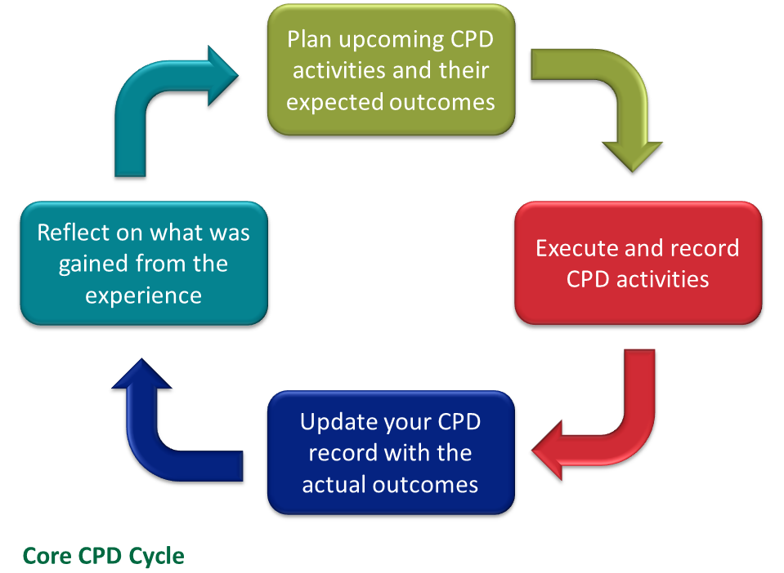
Figure 1 Continuing Professional Development
Source: (Amato and Bubb, 2014)
The continuous professional development should be used for both employers and employee’s point of view to develop the employment relation and to develop the productivity of the employees (Berman et al., 2015). Aldi prefers to improve the skills of the employees continuously for the improvement of the customer’s service. Continuing professional development helps the employers to train the employees in every department personally while influencing them for the workplace attitude (Budhwar & Debrah, 2013). Most of the employers in Aldi are concerned about developing professionalism to train the employees for their career development while using the attachment through communication. Even the activities to the employees have helped the employers of Aldi to work personally with the employees.

1.2 Organizational Learning and Training:
Employee relation of the company leads to the development of the loyalty of the employees (Alfes et al., 2013). For managing the development of the employees personally, the employers will work for the training to benefit the company with the results. Aldi has worked on the development of learning and training to enhance the productivity of the employee. The option for the apprenticeship is the benefit for both employers and employees as this first training approach provides the learning and culture’s information to the employee where the supervisor is able to communicate with the employees (Armstrong & Taylor, 2014). Aldi has provided the apprenticeship opportunities to the new employers to help them understand the roles, and responsibility of the position.
The organizational learning and training under the on-going training and apprentice in the workplace help the employees and individual to manage the learning for the role and responsibility under the culture of the company (Amato and Bubb, 2014). Aldi has developed the opportunities for the apprenticeship based on the different preferences and ability of the different employees to learn and to develop the skills. Thus, the training for the employees has been helping Aldi to have the benefits relate to productivity and operation.

1.3 Continuous Learning opportunity:
Continuous professional development plan refers to the system for achieving the professionalism in the particular area where the continuous learning opportunity provides opportunities for the professional development with the updated knowledge (Berman et al., 2015). Aldi prefers to develop the options for the employees for learning continuously from the different sources including the management and internet.
The continuing learning opportunity from the different sources provides the chances for professional sustainability related to the professional development and the sustainable business performance for the company (Budhwar & Debrah, 2013). Aldi has managed the employee engagement and integration of the employees while helping them to learn from the employers. Based on this system and the methods of continuous learning in Aldi, the learners or the employees have been able to study and identify their strengths and weakness to develop the continuing learning for the professionalism and career development.

1.4 Fiedler’s Contingency Theory:
Employee engagement in the company develops the employee’s performance and responsibility more than autocratic management (Gatewood et al., 2015). Contingency theory in the management refers to the approach and system used by the leaders and managers to maintain the employee engagement for managing the situation to resolve the recent and emerging trends of the company. Most of the large industries prefer the contingency theory to communicate with the employees while integrating the employees for the performance (Jiang et al., 2012). Aldi manages the changing situation by empowering the employees to develop the learning for the position and to engage them for the position.
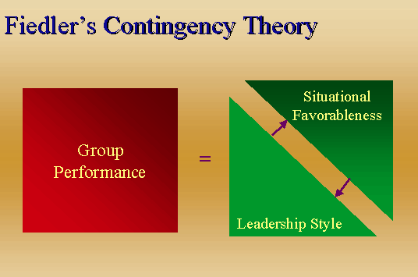
Figure 2 Contingency Model
Source: (Alfes et al., 2013)
The usages of the contingency theory help the employers and employees of the company to maintain the integration, employee engagement, and employee relation (Amato and Bubb, 2014). Aldi has managed the innovative approach to enable the employees for learning for the position and responsibility. At the same time, the employees of Aldi have been able to more professional based on the innovative scenario in the workplace.

1.5 Management by Objectives
Management by objective is the management approach for employers and employees to engage in resolving the situation (Armstrong & Taylor, 2014). The employee of the company needs to have the opportunity for learning to engage in the workplace. Basically, Management by Objective is the term representing the system used by the management or the leaders integrate the employees to make the decision for the situation and changes in the company. For empowering the employees while managing the employee engagement, management by objective has been preferred by the industries in the business field (Berman et al., 2015). Aldi has been developing the leadership supported by the management by the objective to carry the flexible business culture, innovative approach, and opportunities for the employees to work with the leaders closely. The communication has been developed in the workplace for the employees to help them develop their responsibility to make a decision. This will develop the benefit for both to the employers and employees under the system (Budhwar & Debrah, 2013). The employees in Aldi are given responsibility and authority to work with the leaders for the development of productivity.

2) Development vehicles
Accomplishing the business objective and goals, every company needs to develop the performance of the employees and productivity of the leadership (Alfes et al., 2013). The HRM practices and applications used by the management of the company help the employers and employees to work under the environment according to the business objectives. Managing the employee’s effectiveness, every leader and managers of the company use certain methods which are mostly known as the development vehicles for the employees (Berman et al., 2015). Aldi depends on the development vehicles for the employees to manage the performance while using the right vehicles. These are given below:

2.1 Examining the expectations and requirements of people.
The individual in the workplace has own learning choices with different preference for the performance (Amato and Bubb, 2014). The preference for the learning and skills of the employees would lead to a flexible environment where the employers need to manage the requirement of the training for the employees. Based on the expectation of each employee in the workplace, the company should be able to develop and provide the training system while engaging the employees for the performance (Jiang et al., 2012). Aldi has been employing the different employees from different market while focusing and measuring the expectation of the employees from the different techniques. The employee’s review and the system of the feedback are used for planning of the training and development programs for the employees.
While working with the different diversified employees, Aldi has developed the cross-culture management with the communication. Under the 7S including Strategy, Structure, Systems, Staff, (Soft) Skills, Style and Shared Values in the organization, Aldi has developed the usages of technology for the development of the flexible business strategy and system for the employees. Even the changing trends and demands of the customers have affected the styles and structure of Aldi for the development of the service. Thus, Aldi has developed the flexible culture with the right ethical value towards each stakeholder and society to maintain the operation and service. As an HR Executive in Aldi, I prefer to maintain my service and responsibility while focusing on the value and culture of Aldi. At the same time, my responsibility and role under the management of Aldi have been influenced by CSR and ethics that Aldi tends to maintain in the country.

2.2 Managing the career development of people.
Career development is one of the motivational tools that the company uses for encouraging the employees (Armstrong & Taylor, 2014). The leaders of Aldi manage the encouragement to the employees while helping them to work on career development under the HRM practice and the applications. The flexibility of the applied HRM practices in Aldi are given below:
Training and development program and its flexibility: The training and development programs in the company under the supervisor of the employers help the employees to work on the role and to focus on the development of the employability skills and the performance (Budhwar & Debrah, 2013). The flexibility of training in Aldi has helped the employees to focus on the effective roles while managing the responsibility for the position and developing the employability skills under the training and development programs.
Career management: Career development of the employees are managed and enhanced by the career management which motivates the employees for the enrichment of their learning and skills (Alfes et al., 2013). The career management recommends the employees while providing the target and opportunities for the development of the strengths referring to professionalism for the responsibility. Aldi has managed the benchmarking and target for each employee to provide the importance to the career management of the employee while pressuring them for managing the role and employability skills for the position.
PDCA model: PDCA represents the approach or the stages representing the plan–do–check–act which is the iterative four-step management method for the control and continuous improvement (Amato and Bubb, 2014). This is one of the processes of using for reflective practice in Aldi. According to this model, most of the learners and employees of Aldi plan for the learning or identify their problems and identify and test the solutions. The leaders and employees of Aldi are managed to study the results and implement the results for the solutions in the workplace.

2.3 Performance Appraisal
The performance and productivity of the employees are related to the performance appraisal in the company which ensures that the employees are more focused on their own career and performance for the promotion (Armstrong & Taylor, 2014). The performance appraisal refers to the approach used by the HRM to identify and assess the employee’s workplace attitude under the periodic process to investigate their performance, behaviors, workplace activity, and productivity for the position (Berman et al., 2015). In Aldi, the employers maintain the tack for the performance appraisal to identify the objectives for the employees in relation to the KPI or the pre-set criteria performance management for the development of the factors and succession planning in the workplace. Aldi has established the performance appraisal and certain appraisals used in Aldi are given below:
Management by objectives: MBO has been used by the employers to integrate the employees for the high performance and to develop the empowerment and interaction for the performance appraisal (Budhwar & Debrah, 2013). Aldi has been using MBO for the performance appraisal as this is cost effective and provides a clear understanding of the objectives and goals for the employees. Every company should prefer to develop the MBO for the performance management and for the development of the skills while integrating the employees for decision making.
360 Degree Feedback: 360 Degree Feedback is the significant performance appraisal for the employee in the company which helps both employers and employees to get the feedback (Alfes et al., 2013). Under this appraisal, the monitoring and measuring system in the company for the performance will be increased. In this system, the employees of Aldi have been able to get the feedback from each individual that was contacted or communicated by the employee. This type of feedback helps the management to make a better performance appraisal method while integrating all information based on an employee’s ability.
Trait Focussed Appraisals: The trait focused appraisal helps the employers and employee to be the concern of the performance to reinforce the powerful work ethics and work responsibility under the business environment (Buller & McEvoy, 2012). Aldi has used trait focused appraisal once in a year to consider all the attributes and factors of the employees and the company to motivate the employees by collecting the feedback from the different source to provide the appropriate motivation.

2.4 Implementation of Performance appraisal
The performance appraisal of the company should be implemented under the pre-set stages and the system for the employees (Amato and Bubb, 2014). Aldi has developed the stages while providing the responsibility to the employers and top-level management to create and set the smart goals for the employees while evaluating their performance in each step for the completion.

Figure 3 Implementation of Performance Appraisal
Source: (Berman et al., 2015)

The planning for the objective and management of the tools with the monitoring system, the company would be able to implement the performance appraisal (Alfes et al., 2013). The leaders of Aldi prefer to use the various tools for managing and evaluating the performance appraisal for the employees.

2.5 Performance objectives and Management

2.5.1 Performance management
The company must carry the elements of the Performance management, which is the part of the management identifying and planning for the performance, measuring the work activity, evaluating the results and performance of the employees and controlling their actions and workplace behaviors according to the organizational objectives and goals (Buller & McEvoy, 2012). Aldi has developed integrated performance management to measure and develop the overall performance of the employees in every branch. For the development of performance management, Aldi has been using certain methods and these are as follows:
Communication: From the top level to the low level of the management, communication is an essential part that should be managed in the workplace (Amato and Bubb, 2014). The employers of Aldi are given the direction to maintain communication for planning and organizing the employees guide them with the direction for the better performance and expectation of the company.
Collaboration working: The performance management of the company allows the team role and the collaboration working practice to increases the productivity, team communication and performance of the employees (Armstrong & Taylor, 2014). Under the performance management, the employers of Aldi have managed the collaborative working approach for developing the high performance working practice and customer’ service of the employees.
Performance monitoring and reviewing: The performance of the employees is monitored and evaluated under the Performance management to review the accomplishment and the productivity of each employee (Berman et al., 2015). Aldi has directed the employers to maintain the monitoring and reviewing system under performance management while focusing on the performance objective.

2.5.2 Performance objectives
Performance objectives help the employers to create the target, benchmarking and milestones for the employees to accomplish the goals within the time (Jiang et al., 2012). The Performance Objectives of the company relate to succession planning. Aldi has developed the certain performance objectives for the development of the profitability and sustainability and these are discussed below:
Customer-Focused Objectives: The customer’s service and the sustainability of the company always depend on the customer’s satisfaction and customer’s perception (Alfes et al., 2013). The customer-focused objectives for the performance will help the employers in the company to improve the productivity and performance of the employees. For the customer’s service and satisfaction, Aldi has managed the customer’s focused objective in every stage of the production and operation.
Financially Focused Objectives: Funds, investment, and profitability of the company would relate to the sustainable financial resource of the company (Buller & McEvoy, 2012). The company may focus on the development of the financial goals and the growth with the growth projections. Aldi manages the strategy and objectives for improving the labor productivity and customer’s service for the high profitability and financial resources for the company.
Employee-Growth Objectives: The development of the employability skills and employee’s growth are related to the company where the employers will focus on the career-oriented system (Burns & Stalker, 2011). The employees are given the opportunities for the development of the skills in Aldi relating to the current positions for the service.

2.6 Employee relation and succession planning
Professional relationship and working relationship should be ethical for collaborative practice and ethical responsibility (Armstrong & Taylor, 2014). Employee relation should be managed by the employers and employees to maintain the relationship and professionalism. The employee relation in the workplace of Aldi has helped the employers and leaders to maintain the relevant contractual relationship while managing the HRM practices under Human resource management.
The employee relation prefers to create the environment for supporting the employees while managing the loyalty of the employees in the workplace (Kehoe & Wright, 2013). Aldi manages the employee relation to maintain the succession planning to motivate the employee for sustainable business performance and productivity. For the succession planning, the company has been using the Strategies for performance and employee relations and these strategies are given below:
Business management structure and Culture: Business structure and culture of the company carry the practice and the principles for the employees and employer to maintain the professionalism and employee relation in the workplace (Alfes et al., 2013). Aldi has managed the proper chain of command and flexible business culture for the employers and employees to manage the operation and productivity of the employees.
Communication: The channel and process of communication in the workplace help the employers to maintain the communication and employee relationship with the employees (Berman et al., 2015). The employee relationship in Aldi has been able to develop their performance where the proper communication was established in the first place.

2.7 Support structures within the organization.
The management structure and organizational culture must have the proper tools and strategies for handling the opportunities and workplace environment for the employees (Mutua et al., 2012). For the development of the employability skills of the employees, Aldi has developed the workplace environment and opportunities for the employees. These are as follows:
Job analysis and work design: The legal framework and the job analysis of the company will support the management to develop the work design and proper understanding for the employees of the chain of command and responsible authority in the workplace (Armstrong & Taylor, 2014). Aldi manages the clear responsibility of the employees according to the chain of command for the employees under the job analysis and workplace design while developing the legal framework
Training and development: The learning and the employability skill of the employees should be developed where the company must be supportive and flexible enough while providing the options for the employees (Berman et al., 2015). Aldi has developed the training and development program for the employees to train them for the expected performance, workplace attitude, and career objective according to the business policies and busies objectives of the company.

3) Development of a plan for needs and expectations.

3.1 Skills Audit
The development of the career and profession encourages the employees to work on the employability skills and own worth for the position (Snell et al., 2015). A skills audit is the tool encouraging the employee or the individual to identify and study the skills possessing and required for the career. In Aldi, I have been working as an HR Executive. For the career development and achievement. I need to develop my own skills. The skills audit of mine is as follows
Skills that I have | Ratings
Communication and interaction skills
Interpersonal communication skills
Management and Organizing skills
Team leadership and team working skills
Technical skills
Self-management skills
Skills that I need to develop
Conflicts management skills
Problem-solving skill
Decision making skills
Time management skills
Customer’s service skills

3.2 The personal and professional development plan
For the development of the skill, personal and professional development plan has been adopted by the individual in the company (Armstrong & Taylor, 2014). Aldi encourages employees to work on their skills through PDP. I prefer to work on my skills under the personal and professional development plan. The PDP of mine is given below:
Professional skills | Expected results | Implementation of the activities | Actual Outcome | Period
Conflicts management skills | For managing the conflicts, I will be able to manage the conflicts, communication while maintaining the professional relationship with the employees and customers at any point. | Practice from Training and development programs,  Learning from mentors | I can manage conflicts with the employees and customers. But I need to look for the development of the negotiation skills for better results. | 4 months  Review date  30 April 2019
Problem-solving skill | - I will manage the problems while working under the pressure | Observation and practice, training and development programs, | I can manage the problems with analysis. I need to work on analytical ability even more | Review date: 15th June 2019
Decision-making skills | - I will be able to make the right decision after solving the cases | Observation and practice, learning from training and development programs | I can make a decision but I need to work on my observation skill for decision making | Review date: 30 July 2019
Time management skills | - I will be able to manage the time for the performance and responsibility | Training and practice, time management strategies | I can manage the time but I need to work on time management strategies even more. | Review date: 30th June 2019
Customer’s service skills | - I will be able to manage the customer’s service, communication with the customers and manage the customer’s complaints | Practice under trainers, development programs | I can communicate and manage customers. I need to work on management skills for the development of the customer’s service skills | Review date: 30th May 2019

Conclusion
Better position in the company and the career in the right industry require high qualification and employability skills from the employees (Budhwar & Debrah, 2013). Learning and continuous development for the profession of the employee literally shape their skills and strengths for the work responsibility and attitude. The management and the leaders must be able to determine the strengths according to the position of the employees in the workplace to improve their productivity towards the customer’s service (Burns & Stalker, 2011). This part of the context has discussed how personally the development of the employee’s values and employability skill for the position would help the company. The learning of the employee should be supported by the employers of the company while training them to develop their skills and professionalism for the responsibility. The part of the context also discussed how Aldi prefers to manage the communication and collaboration of the employees to identify their ability and skills to improve the abilities for the performance. Every employee should focus on continuous learning for the development of professionalism and effectiveness while managing the responsibility.

Reference
Alfes, K., Shantz, A. D., Truss, C., & Soane, E. C. (2013). The link between perceived human resource management practices, engagement and employee behaviour: a moderated mediation model. The international journal of human resource management, 24(2), 330-351.
Amato, P.A. and Bubb, R., (2014). Choosing the Partnership: English Business Organization Law During the Industrial Revolution. Seattle UL Rev., 38, p.337.
Armstrong, M., & Taylor, S. (2014). Armstrong's handbook of human resource management practice. Kogan Page Publishers.
Berman, E. M., Bowman, J. S., West, J. P., & Van Wart, M. R. (2015). Human resource management in public service: Paradoxes, processes, and problems. Sage Publications.
Budhwar, P. S., & Debrah, Y. A. (Eds.). (2013). Human resource management in developing countries. Routledge.
Buller, P. F., & McEvoy, G. M. (2012). Strategy, human resourcemanagement and performance: Sharpening line of sight. Human resource management review, 22(1), 43-56.
Burns, T. E., & Stalker, G. M. (2011). The management of innovation and Technical presentation skills. University of Illinois at Urbana-Champaign's Academy for Entrepreneurial Leadership Historical Research Reference in Entrepreneurship.
Gatewood, R., Feild, H. S., & Barrick, M. (2015). Human resource selection. Nelson Education.
Jiang, K., Lepak, D. P., Han, K., Hong, Y., Kim, A., & Winkler, A. L. (2012). Clarifying the construct of human resource systems: Relating human resource management to employee performance. Human Resource Management Review, 22(2), 73-85.
Jiang, K., Lepak, D. P., Hu, J., & Baer, J. C. (2012). How does human resource management influence organizational outcomes? A meta-analytic investigation of mediating mechanisms. Academy of management Journal, 55(6), 1264-1294.
Kehoe, R. R., & Wright, P. M. (2013). The impact of high-performance human resource practices on employees’ attitudes and behaviors. Journal of management, 39(2), 366-391.
Mutua, S. M., Karanja, K., & Namusonge, G. S. (2012). Role of human resource management practices on performance of financial cooperatives based in Nairobi County, Kenya. International journal of Humanities and social science, 2(22), 289-297.
Snell, S. A., Morris, S. S., & Bohlander, G. W. (2015). Managing human resources. Nelson Education.

