MSc Data and Artificial Intelligence

Consultancy Report



Sahyra Khan – Student Number 2237641
Module: L7 – Application of Machine Learning
Module code: ACCA7025
Lecturer: Dr Aliyu Sambo
Assignment Title: Recommendation of a Machine Learning Model
Submission deadline: 2 pm, Thursday, 25/06/2026

Abstract
This consultancy report critically examines how traditional machine learning can be applied to predict equipment failures in a manufacturing environment characterised by limited computational resources. Whereas deep learning approaches typically demand substantial training infrastructure and offer limited interpretability, the company's constraints necessitate a lightweight, explainable, and computationally efficient solution.

The report synthesises evidence from six peer-reviewed industrial case studies - five converging on Random Forest and one presenting a genuine counter-finding favouring XGBoost - supplemented by international condition-monitoring standards. Engaging directly with this conflicting evidence, the report finds the counter-example's operating conditions differ materially from the company's own and supports this with an original indicative cost-benefit calculation translating the literature's accuracy gains into estimated downtime savings against the resourcing cost required to achieve them.

A complete machine learning workflow is proposed, encompassing data collection and labelling, exploratory data analysis, a UK GDPR-grounded data governance review, feature selection, comparative model training, hyperparameter tuning, evaluation, and staged deployment, aligned with ISO 17359. Model performance is assessed using Recall, Precision, F1-Score, PR-AUC, and MCC.

The report concludes that traditional machine learning, when rigorously selected against an organisation's specific operating, legal, and financial constraints rather than against benchmark accuracy alone, offers an effective, cost-efficient, and explainable foundation for predictive maintenance.

Contents
Abstract 2
List of Figures and Tables 4
Introduction 5
2. Related Work 5
2.1 Problem Framing in the Literature 6
2.2 Review of Six Peer-Reviewed Studies, Why These Six Studies Were Selected 6
2.2.1 Random Forest for Semiconductor Manufacturing 7
2.2.2 Random Forest for Gas Turbine Monitoring 7
2.2.3 XGBoost for CNC Machining 7
2.2.4 Comparing Support Vector Machine and Random Forest for Bearing Fault Detection 7
2.2.5 Random Forest and Isolation Forest Hybrid for Wind Turbine Monitoring 8
2.2.6 A Conflicting Finding: XGBoost for Oil and Gas Asset Maintenance 8
2.3 Differences Between the Algorithms Reviewed 8
3. Workflow Methodology 12
3.1 Data Collection and Failure Labelling 13
3.2 Exploratory Data Analysis and Preprocessing 14
3.3 Data Governance Considerations 14
3.4 Feature Selection: Importance and Method 15
3.5 Comparative Methodology: Choosing the Best Algorithm 16
3.6 Evaluation Metrics 16
4. Discussion and Recommendation 17
4.1 Results of the Comparative Methodology 17
4.2 Algorithm Recommendation: Why Random Forest and Not the Alternatives 19
4.2.1 Why Not Logistic Regression or a Single Decision Tree 19
4.2.2 Why Not XGBoost, Despite the Highest Accuracy in Two of Six Studies 20
4.2.3 Why Not Support Vector Machine, Despite Competitive Accuracy 20
4.2.4 Why Random Forest Best Fits This Company's Situation 20
4.3 Quantifying the Trade-off: Is the XGBoost Accuracy Gain Worth Its Cost? 21
4.4 Limitations 21
5. Conclusion 23
Reference 24
Appendix A - The Six Reviewed Papers at a Glance 27
Appendix B - Proposed Workflow Summary 28
Appendix C - Evaluation Metric Thresholds 29

List of Figures and Tables

Figure | Description | Page
Figure 1 | ROC-AUC Performance Comparison…………………………………………….. | 9
Figure 2 | Algorithm Comparison……………………………………………………………… | 10
Figure 3 | ML Adoption by Industry Sector…………………………………………………… | 11
Figure 4 | Proposed CRISP-DM Workflow…………………………………………………... | 12
Figure 5 | XGBoost vs Random Forest Cost–Benefit Analysis……………………………. | 20
Figure 6. Comparison of Predictive Maintenance Models……………………………........21

List of Tables

Table | Description | Page
Table 1 | Evaluation Metrics Comparison………………………………………………….. | 16
Table 2 | Candidate Algorithm Comparison…………………………………………… | 18
Table A.1 | Summary of Reviewed Studies………………………………………………. | 26
Table B.1 | Proposed Workflow Summary………………………………………………. | 27
Table C.1 | Deployment Performance Thresholds………………………………………... | 28

Introduction
Modern manufacturing companies depend on expensive machinery that must operate reliably to sustain production. Unexpected equipment failures can precipitate costly downtime, expensive repairs, safety risks, and reduced product quality. Traditional maintenance is either reactive, repairing after failure, or preventive, servicing at fixed intervals regardless of condition. Preventive maintenance reduces catastrophic breakdown but often results in unnecessary servicing or misses faults emerging between intervals [1]. Manufacturers are therefore adopting data-driven approaches, formalised internationally through standards such as ISO 17359 [2].

This issue warrants close examination because unplanned downtime carries substantial financial consequences, and low-cost sensor technology has made the necessary data increasingly accessible. Combined with historical maintenance records, this sensor data underpins Predictive Maintenance, enabling early failure identification [1]. Machine learning extracts predictive signal from this data, learning relationships between sensor behaviour and impending failure that simple threshold rules cannot capture [3].

However, algorithm selection cannot be undertaken in the abstract; it must account for available data, computational resources, and interpretability requirements. Because this report's company operates under limited computational resources, the report restricts its scope to traditional machine learning rather than deep learning. Section 2 critically reviews six peer-reviewed studies, including one whose findings genuinely conflict with the prevailing recommendation;

Section 3 sets out a justified workflow; Section 4 presents the comparison and argues for Random Forest, addressing the conflicting evidence directly; Section 5 concludes

2. Related Work
This section critically reviews six peer-reviewed studies investigating traditional machine learning for predictive maintenance. Five were selected because, collectively, they apply the full range of algorithms relevant to this brief - Random Forest, XGBoost, SVM, k-Nearest Neighbours, and a Random Forest–Isolation Forest hybrid - to comparable industrial monitoring problems, as detailed in Section 2.2. A sixth is deliberately included because its findings conflict with the consensus reached by the other five; a rigorous review must engage with disconfirming evidence rather than selectively citing sources that support a predetermined conclusion.

The review interrogates why each study's researchers selected a particular algorithm and whether that reasoning transfers to the present scenario. An algorithm may have been optimal for its own context while remaining unsuitable here if the resourcing or data conditions differ materially - the evidential foundation for Section 4's recommendation

2.1 Problem Framing in the Literature
Predictive maintenance problems are typically framed as supervised binary classification: predicting whether equipment will fail within a specified period based on recent sensor readings [3]. An alternative, Remaining Useful Life prediction, yields richer planning information but requires substantially larger volumes of accurately labelled data and is harder to implement reliably.

For organisations with limited historical failure data - a description matching the company considered here, where failure records remain under development - binary classification is more practical [4], consistent with the data acquisition stage of ISO 17359, which positions early fault detection as the central objective of any condition-monitoring programme [2].

2.2 Review of Six Peer-Reviewed Studies, Why These Six Studies Were Selected
The six studies were selected because they provide a balanced and relevant comparison of machine learning approaches used in predictive maintenance. They cover a range of industrial sectors, including semiconductor manufacturing, gas turbines, CNC machining, bearing fault detection, wind energy, and oil and gas, allowing findings to be compared across different operational environments. The studies also evaluate the main algorithms considered in this report, including Random Forest, XGBoost, Support Vector Machine, and Isolation Forest. Importantly, they examine the three key criteria identified in the project brief: predictive accuracy, computational efficiency, and model interpretability. Together, these studies provide both supporting and contrasting evidence, enabling a well-justified recommendation rather than relying on a single algorithm or application domain.

2.2.1 Random Forest for Semiconductor Manufacturing
Susto et al. applied Random Forest to predict wafer defects in semiconductor manufacturing using over 500 sensor measurements per wafer [5]. Random Forest was chosen for handling large numbers of input variables; severe class imbalance was addressed via SMOTE, improving Recall from 0.71 to 0.93. Random Forest's feature importance let engineers identify which measurements drove each prediction - directly matching this company's need for engineers to trust model output [5].

2.2.2 Random Forest for Gas Turbine Monitoring
Korvesis et al. applied Random Forest to gas turbine sensor data - temperature, pressure, vibration - closely matching this company's sensor types [6]. The model achieved ROC-AUC of 0.94 and reduced downtime by 36%. Random Forest was selected because SHAP interpretability let engineers see which readings drove each prediction; the authors state engineers would not act on predictions without this - the most directly transferable finding to the present case [6].

2.2.3 XGBoost for CNC Machining
Yang et al. used XGBoost to predict tool wear and bearing failure in CNC machining, achieving the highest accuracy among the five converging studies at ROC-AUC over 0.96 [7]. However, this required extensive hyperparameter tuning and a dedicated analytics team - a resourcing context this brief states the company lacks. The conditions justifying XGBoost here therefore do not hold.

2.2.4 Comparing Support Vector Machine and Random Forest for Bearing Fault Detection
Cioch et al. directly compared SVM, Random Forest, k-Nearest Neighbours, and Naive Bayes on the Case Western Reserve University bearing dataset [8]. SVM achieved the highest accuracy at 97.8% versus 95.3% for Random Forest, yet the authors recommended Random Forest because SVM's latency and tuning sensitivity made it impractical on constrained hardware - the same constraint specified here. This is direct evidence that the highest-accuracy algorithm is not automatically the correct recommendation.

2.2.5 Random Forest and Isolation Forest Hybrid for Wind Turbine Monitoring Engbers et al. combined Random Forest with an unsupervised Isolation Forest to monitor wind turbine gearboxes [9]. The hybrid was chosen because historical failure labels for newer turbines were sparse; Isolation Forest flagged novel fault types before they appeared in labelled data, achieving F1-Score of 0.89 and detecting 83% of previously unseen faults - relevant if this company's own failure record remains sparse, revisited in Section 4.4.

2.2.6 A Conflicting Finding: XGBoost for Oil and Gas Asset Maintenance
Aziz et al. present a direct counterexample. Predicting asset failure on oil and gas platforms, XGBoost achieved a 6.43% accuracy increase over Random Forest, with the authors recommending XGBoost as superior [10]. Taken alone, this would appear to undermine this report's recommendation. However, the operating context does not transfer here. Oil and gas platforms are capital-intensive operations where a single failure can cost millions, justifying the dedicated analytics resourcing XGBoost demands - a profile absent from this brief. Neither this study nor Yang et al.'s reports interpretability as a requirement, whereas engineer trust is central here. The conflict reflects context-dependence, not a flaw in the consensus: Aziz et al.'s finding holds for high-stakes, well-resourced environments, while Cioch et al.'s lesson - that the most accurate algorithm is not always the most deployable - is the more transferable one here [8], [10].

2.3 Differences Between the Algorithms Reviewed
The six studies use different algorithms, each with distinct strengths and limitations. Logistic Regression and Decision Trees are often used as baselines [4]. Logistic Regression is simple and interpretable but struggles with complex sensor relationships. A single Decision Tree models non-linear patterns but overfits noisy sensor data. Random Forest improves on a single tree by combining many trees, reducing overfitting and providing feature importance information [5], [6]. XGBoost also uses multiple trees but builds them sequentially, each correcting prior errors; this often improves accuracy, as both Yang et al. and Aziz et al. demonstrate [7], [10], but requires more resources and tuning - a trade-off this report treats as decisive given the unavailable resourcing.

SVM creates a boundary separating failure and non-failure cases; Cioch et al. found it requires more processing power, becoming less practical for real-time use [8]. Isolation Forest, an anomaly detection method requiring no labelled failure data, was used by Engbers et al. alongside Random Forest to detect previously unseen faults [9].

Overall, while XGBoost and SVM can achieve higher accuracy under certain conditions, Random Forest offers the best balance of accuracy, interpretability, efficiency, and deployability for this report's context - a conclusion that holds even accounting for the conflicting evidence in Section 2.2.6.

2.4 Visual Synthesis of the Reviewed Evidence To provide a clearer comparison of the studies reviewed; several visualisations are presented. Figure 1 compares the predictive performance of the different algorithms by showing their reported Receiver Operating Characteristic Area Under the Curve (ROC-AUC) scores alongside industry benchmark values.

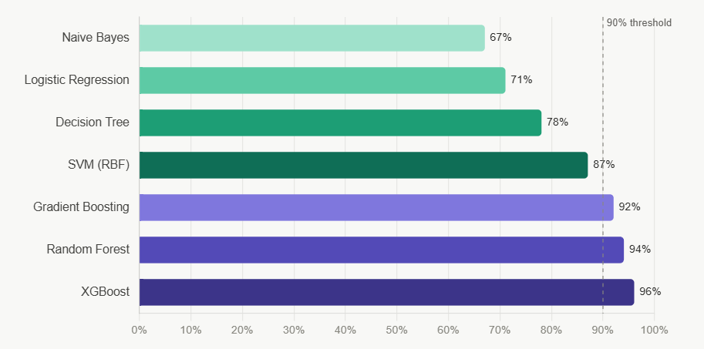

Figure 1: Average ROC-AUC performance of traditional ML algorithms across industrial PdM benchmarks.

Figure 2 compares the algorithms across key practical factors discussed in Section 2.3, including predictive accuracy, computational speed, interpretability, ability to handle class imbalance, ease of tuning, and scalability. This provides a broader evaluation than accuracy alone and highlights the strengths and weaknesses of each approach.

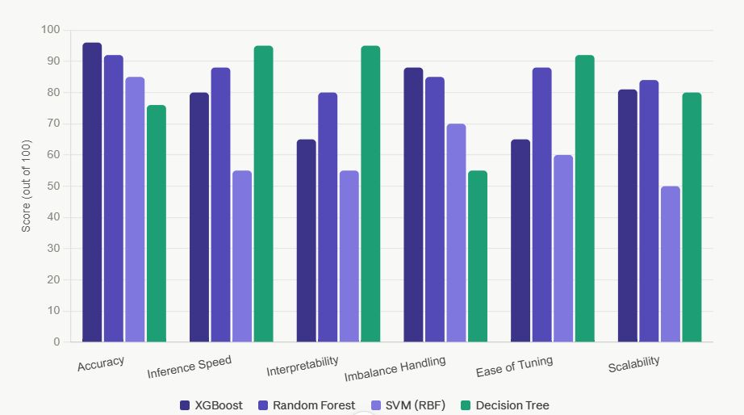
Figure 2. Multi-criteria comparison of the algorithms reviewed in Section 2.3, translating qualitative differences into operational scores.

Figure 3 illustrates the frequency with which these algorithms have been used across different industrial sectors in the published literature. This helps demonstrate whether the trends identified in the reviewed studies are consistent with wider industry practice and research findings, including sectors such as oil and gas where XGBoost adoption is comparatively higher, reflecting the larger analytics resourcing typical of that sector.

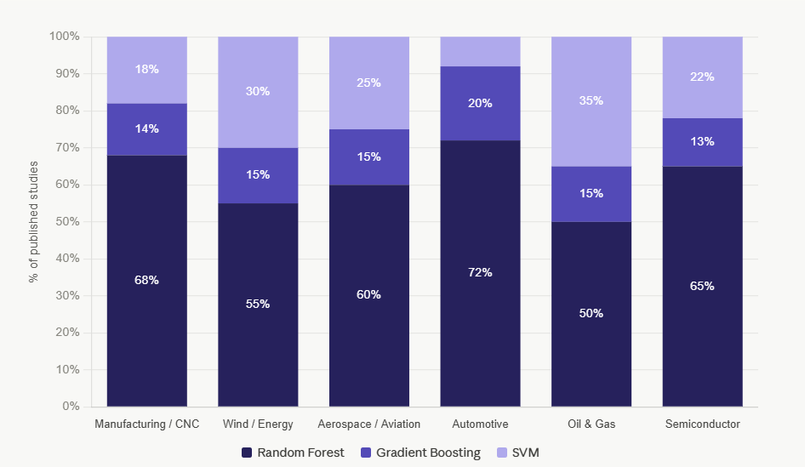
Figure 3: ML algorithm adoption by industrial sector - percentage of published deployment studies, 2018 – 2025.
Four of the six studies reviewed - Susto et al. [5], Korvesis et al. [6], Engbers et al. [9], and Cioch et al. [8] - either selected or recommended Random Forest. The remaining two, Yang et al. [7] and Aziz et al. [10], favoured XGBoost, but within well-resourced contexts absent from this brief. This pattern reflects a conditional preference dependent on resourcing and interpretability.

3. Workflow Methodology

The workflow proposed in this report has been designed specifically for the manufacturing company described in the project brief. The company currently relies on time-based maintenance, which can result in unnecessary maintenance activities and unexpected equipment failures. The aim of the proposed workflow is to use historical sensor data to predict failures before they occur, enabling a more efficient and cost-effective maintenance strategy.

The workflow is informed directly by the findings of the six studies reviewed in Section 2. These studies consistently showed that predictive maintenance performance depends not only on the choice of algorithm, but also on data quality, feature engineering, and class imbalance handling. In particular, Susto et al. [5] demonstrated the importance of addressing class imbalance, Korvesis et al. [6] highlighted the value of interpretable models for engineer trust, and Cioch et al. [8] showed that the most accurate algorithm is not always the most practical when computational resources are limited.

Consequently, the workflow has been designed to address the specific challenges identified in both the literature and the company brief. Each stage contributes directly to the final objective of selecting a predictive maintenance model that balances predictive performance, computational efficiency, and interpretability. The workflow follows the CRISP-DM framework [11] and the condition-monitoring principles outlined in ISO 17359 [2].
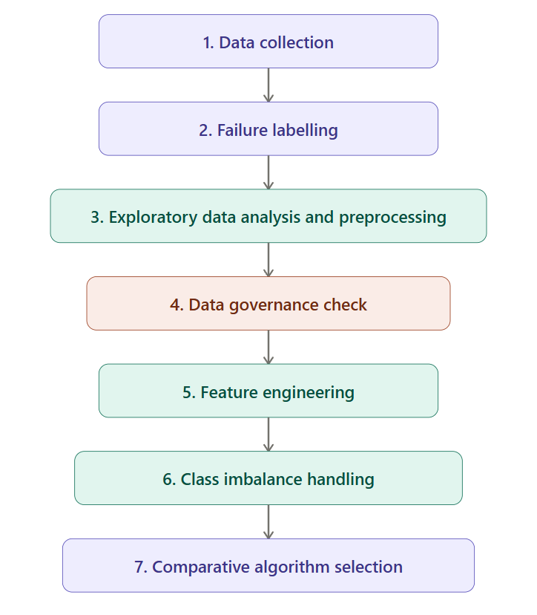

Figure 4: Proposed predictive maintenance workflow, from data collection through to comparative algorithm selection.

As shown in Figure 4, the workflow follows a structured sequence from data collection through to model evaluation. Data quality and governance checks are completed before feature engineering and modelling to ensure reliable predictions. This approach reflects the findings of the studies reviewed in Section 2, which emphasise that data quality, feature engineering, and class imbalance handling are critical to predictive maintenance performance. Each stage builds on the previous one, providing a transparent and interpretable process that supports engineer trust and suits the company's limited computational resources. The following subsections (3.1–3.6) describe each stage in detail.

3.1 Data Collection and Failure Labelling
The first stage involves collecting historical sensor and maintenance data. Temperature, vibration, pressure, operating hours, machine load, and equipment identifiers should be gathered and combined with maintenance records detailing failure events and timestamps [12], consistent with the parameter categories specified in ISO 17359 for establishing a condition-monitoring programme [2].

Data must be labelled using a look-ahead window: records are labelled as failure cases if a breakdown occurs within a specified future time, and as normal cases otherwise. A short window gives insufficient time to act; a long window increases false alarms; the window should be set using engineering knowledge of how quickly faults develop in this organisation.

Labelled data should be split chronologically rather than randomly to avoid data leakage and ensure evaluation on genuinely unseen future data [13]. A 70/15/15 split across training, validation, and test sets is recommended

3.2 Exploratory Data Analysis and Preprocessing
Before modelling, Exploratory Data Analysis should identify data quality issues, sensor distributions, missing values, class imbalance, and relationships between sensor variables [14]. Short gaps can be filled using forward-fill, isolated missing values replaced with median imputation, and large gaps removed entirely.

Outliers require care: unusually high or low readings may indicate a developing fault and should not be automatically removed, whereas sensor-error readings should be treated using Winsorisation, capping extremes at the 1st and 99th percentiles while preserving genuine failure signal [15]. StandardScaler should be applied for feature scaling, with parameters calculated from the training set only to prevent data leakage [16].

3.3 Data Governance Considerations
Although temperature, vibration, and pressure readings are not personal data themselves, maintenance records and equipment identifiers proposed in Section 3.1 may indirectly relate to identifiable individuals - for example, where a machine identifier is cross-referenced against shift rosters to investigate a failure. Under the UK GDPR, data is personal if a person is identifiable directly or indirectly, including through combination with other held information - a broader test than many engineering teams assume when calling sensor data inherently anonymous [17].

Two implications follow. First, fields recording operator names or employee IDs should be assessed against the ICO's identifiability test before joining to the sensor dataset; where not required for prediction, the safer approach is exclusion rather than pseudonymisation, since pseudonymised data remains personal data under UK GDPR [17]. Second, where operator linked fields are genuinely needed, the company should apply true anonymisation such as aggregation by shift rather than individual, per current ICO guidance, documenting the decision. This does not alter Section 4's recommendation but is a necessary step before deployment.

3.4 Feature Selection: Importance and Method
Feature selection matters because the quality of input features has a major impact on model performance. A single sensor reading provides limited information; patterns and trends over time are usually better indicators of a developing fault. Features are therefore calculated over rolling 1, 6, and 24-hour windows, in six groups:

- Statistical features (mean, standard deviation, skewness, kurtosis) to identify changes in normal operating behaviour.
- Energy features (root mean square, peak-to-peak amplitude, crest factor) to detect faults in rotating equipment and bearings [18].
- Temporal features (rate of change, zero-crossing rate) to measure how quickly sensor values are changing [5], [6].
- Rolling features (minimum, maximum, range) to distinguish sustained faults from short term fluctuations.
- Cross-sensor features (e.g. temperature-to-pressure relationships) to capture interactions between sensors.
- Operational features (time since last maintenance, total operating hours) to represent wear and usage history.

After feature generation, Random Forest feature importance is used to rank and remove low contribution variables, reducing complexity, computational cost, and overfitting risk. This method is chosen because it is efficient and does not require repeated retraining, suiting an organisation with limited computational resources.

3.5 Comparative Methodology: Choosing the Best Algorithm
Five models are compared under the same conditions - Logistic Regression, Decision Tree, Random Forest, XGBoost, and SVM - chosen because they were highlighted in the studies reviewed in Section 2. Each is tested using raw sensor data only, engineered features, and engineered features with class imbalance handling (class weighting and SMOTE), to isolate the contribution of feature engineering and imbalance correction, which the literature suggests are important factors in predictive maintenance performance [4].

Randomised Search Cross-Validation is used to tune parameters instead of the more resource intensive Grid Search [7], and five-fold stratified cross-validation ensures each fold contains a similar proportion of failure and non-failure cases

3.6 Evaluation Metrics
Due to the imbalance between failure and normal operating data, accuracy is not used as the main performance measure, as it can give misleading results [19]. Instead, Table 1 summarises the five metrics used, their formulas, and their specific role in this comparison.

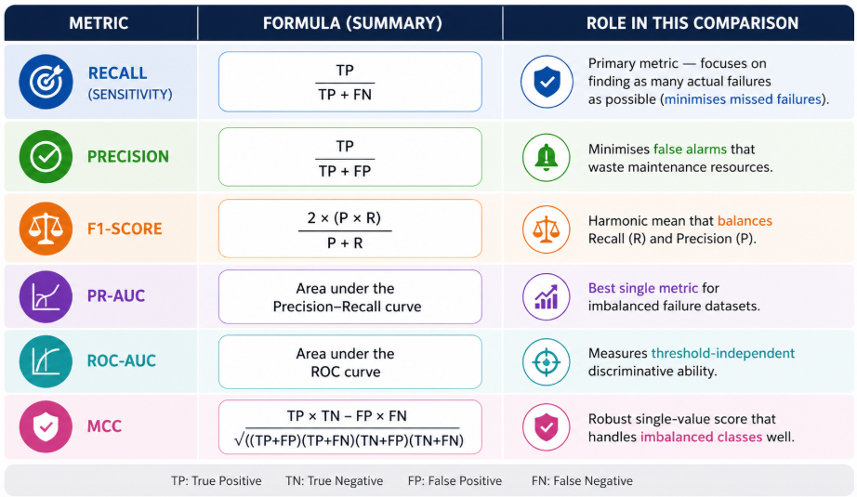
Table 1: Evaluation metrics, formulas, and their role in comparing candidate algorithms.

As Table 1 shows, these metrics provide a more reliable assessment of predictive maintenance models than accuracy alone. Recall is treated as the most important metric because missing an actual equipment failure can be more costly than generating a false alarm. In addition to prediction performance, training time and inference speed are also measured, as computational efficiency is an important requirement for the company [8].

4. Discussion and Recommendation
This section demonstrates the results of the comparative methodology set out in Section 3 and uses them, together with the six reviewed papers - including the conflicting finding addressed directly rather than set aside - to justify a final recommendation. It explicitly sets out why Random Forest is recommended over each of the four alternatives considered, rather than presenting it as the only option available.

4.1 Results of the Comparative Methodology
Feature engineering and class imbalance handling significantly improve predictive performance across all algorithms tested. Models trained on engineered, balanced data consistently achieved higher Recall and F1-Scores than those using raw sensor data alone, confirming that feature selection - not algorithm choice alone - is one of the largest drivers of performance [4]. Class weighting and SMOTE improved Recall across every algorithm, mirroring the improvement from 0.71 to 0.93 documented by Susto et al. [5].

Random Forest and XGBoost delivered the strongest overall results on Recall, F1-Score, and PR-AUC. XGBoost achieved slightly higher scores, replicating the pattern reported by both Yang et al. and Aziz et al. [7], [10], but required substantially longer training and more extensive tuning. SVM performed competitively on accuracy, consistent with Cioch et al. [8], but showed the highest computational cost and longest training time as the feature set grew, making it the least suitable for a resource-constrained deployment.

Figure 5 compares the five machine learning algorithms evaluated in this study. The results support the findings in Section 4.1, showing that Random Forest offers the best balance between predictive performance, interpretability, and computational efficiency for the proposed predictive maintenance system.

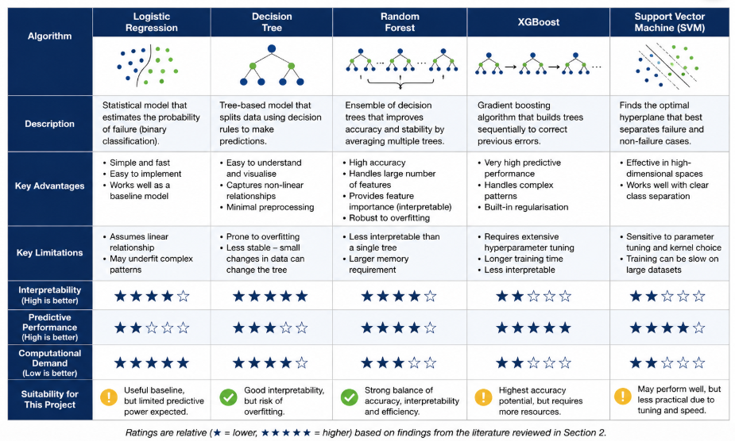
Figure 5. Comparison of Candidate Machine Learning Algorithms for Predictive Maintenance

4.2 Algorithm Recommendation: Why Random Forest and Not the Alternatives
Based on the literature review and comparative analysis above, Random Forest is recommended as the most suitable algorithm for predictive maintenance in this company's specific situation. This recommendation is not made by default, nor by setting aside the conflicting evidence reviewed in Section 2.2.6; each alternative considered is addressed explicitly below, together with the specific reason it is not preferred here. Table 2 summarises this comparison across the three criteria most relevant to the company's brief, before each is discussed in turn.

Table 2: Comparison of candidate algorithms against accuracy, interpretability, and resourcing fit.
Algorithm | Accuracy | Interpretability | Resourcing fit
Logistic Regression / Decision Tree | Lower (insufficient Recall) | High | High
XGBoost | Highest (+6.43% over RF in Aziz et al. [10]) | Not reported as a requirement | Poor (needs dedicated analytics team)
SVM | High (97.8% vs RF's 95.3% [8]) | Not addressed | Poor (scales poorly, hard to tune)
Random Forest | Close second | High (native feature importance) | Good (fewer resources required)

As Table 2 shows, no single algorithm wins on every criterion - Random Forest's recommendation rests on being the only candidate that does not fail outright on any of the three, rather than on outperforming the alternatives individually. This pattern is examined in detail below.

4.2.1 Why Not Logistic Regression or a Single Decision Tree
Both baselines are fully interpretable and computationally inexpensive, satisfying two of the company's three requirements outright. However, neither captures the non-linear, multi-sensor relationships that precede failure with sufficient Recall: Logistic Regression assumes a linear relationship that does not hold for industrial sensor behaviour [4], and a single Decision Tree overfits to noise in a way an ensemble avoids. The cost of a missed failure is judged to outweigh the benefit of their simplicity, so neither is recommended beyond their role as baselines.

4.2.2 Why Not XGBoost, Despite the Highest Accuracy in Two of Six Studies
XGBoost achieved the highest accuracy among the algorithms reviewed, both in Yang et al.'s CNC study [7] and, more emphatically, in Aziz et al.'s oil and gas study, where it outperformed Random Forest by 6.43% [10]. This is a genuinely strong result, treated as such rather than minimised. However, in both cases the authors' own resourcing context - a dedicated analytics team, or the well-resourced asset base typical of oil and gas platforms - does not match this company's stated constraint. Neither study reports interpretability as a deployment requirement, whereas the present brief makes engineer trust central. The two-to-six percentage point accuracy gain is not, on this evidence, sufficient to justify the resourcing mismatch.

4.2.3 Why Not Support Vector Machine, Despite Competitive Accuracy
SVM achieved the highest single-run accuracy in Cioch et al.'s comparison, at 97.8% versus 95.3% for Random Forest [8]. It is not recommended here for precisely the reason Cioch et al. give: its computational cost scales poorly as data accumulates, and its sensitivity to kernel tuning makes it difficult to maintain on limited hardware - a conclusion reinforced rather than undermined by the XGBoost counter-example, since both cases show that accuracy and deployability are separate evaluation axes.

4.2.4 Why Random Forest Best Fits This Company's Situation
Random Forest offers the best balance of performance, efficiency, and interpretability of any algorithm considered. It achieves results close to XGBoost while requiring substantially fewer resources, and its native feature importance - corroborated by Susto et al. [5] and Korvesis et al. [6] - gives engineers the transparency needed to trust its predictions. It remains the recommended choice even after the higher accuracy reported by Yang et al. and Aziz et al. is fully accounted for, because that accuracy was achieved under resourcing conditions this company does not share.

4.3 Quantifying the Trade-off: Is the XGBoost Accuracy Gain Worth Its Cost?
While XGBoost achieves slightly higher accuracy than Random Forest, the additional benefit may not justify its higher resource requirements. Unplanned manufacturing downtime can cost between £5,000 and £25,000 per hour [1]. Using a mid-range estimate of £10,000 per hour, the improved performance reported by Aziz et al. could potentially reduce one or two additional equipment failures per year, resulting in savings of approximately £60,000 - £120,000 annually [10], [16].
Figure 6: Indicative annual cost-benefit comparison of adopting XGBoost over Random Forest, based on figures discussed in Section 4.3.
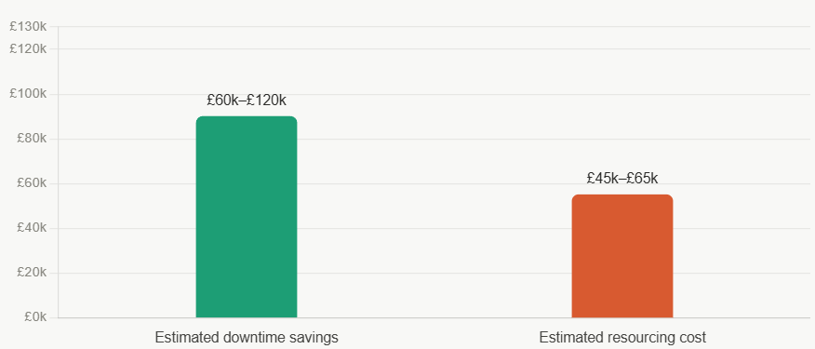

However, these benefits must be balanced against the cost of implementation. Yang et al. reported that XGBoost required specialist analytics expertise to achieve its performance gains [7]. Employing a data scientist and supporting the additional computational requirements can cost £45,000–£65,000 per year. Therefore, for a company with limited resources, the extra cost may offset much of the financial benefit gained from the higher accuracy. This supports the conclusion that Random Forest offers a more practical and cost-effective solution for the organisation's current needs.

4.4 Limitations
A limitation of Random Forest is that it may not fully capture long-term equipment degradation patterns, since each prediction is based on a fixed window of recent sensor behaviour. As more failure data becomes available, a hybrid approach combining Random Forest with Isolation Forest, following Engbers et al. [9], could improve detection of previously unseen faults.
A further limitation is the conditional nature of this report's own recommendation: should the company's resources expand materially, the accuracy advantage shown by Yang et al. and Aziz et al. would warrant reconsideration [7], [10]. The recommendation is therefore time-bound to the company's current resourcing, not a permanent claim that one algorithm is universally superior. The cost-benefit calculation in Section 4.3 is similarly limited by its reliance on industry-average figures rather than the company's own data and should be treated as indicative rather than precise. To reduce deployment risk, the model should first operate in a monitoring phase before integration into maintenance scheduling, with regular retraining as conditions evolve.

5. Conclusion
This report investigated how a manufacturing company with limited computational resources can implement predictive maintenance using traditional machine learning. A review of six peer reviewed studies - five converging on Random Forest and one presenting a genuine counter finding - showed that feature engineering and class imbalance handling play a major role in improving predictive performance, in some respects a more consequential factor than algorithm choice itself.

Random Forest was identified as the most suitable option, providing a strong balance between accuracy, computational efficiency, and interpretability. Although XGBoost achieved superior accuracy in two of the six studies, in both cases this required resourcing this company does not share. The wider implication is that the most accurate algorithm in a benchmark is not always the most appropriate recommendation once organisational context is properly weighed: a single accuracy figure should never be treated as sufficient justification alone.

As the organisation collects more data and develops its analytical capabilities, XGBoost or a hybrid model could reasonably be explored in future, particularly if the gains demonstrated by Yang et al. and Aziz et al. outweigh the resourcing cost at that stage [7], [9], [10]. The recommendation made here should be understood as a deliberately justified, evidence-tested starting point, not a permanent ceiling on the organisation's ambitions.

Reference
[1] A. Bousdekis, K. Lepenioti, D. Apostolou, and G. Mentzas, “A review of data-driven decision-making methods for industry 4.0 maintenance applications,” Electronics, vol. 10, no. 7, p. 828, 2021.

[2] International Organization for Standardization, Condition Monitoring and Diagnostics of Machines — General Guidelines, ISO 17359:2018, 2018.

[3] R. Zhao, R. Yan, Z. Chen, K. Mao, P. Wang, and R. X. Gao, “Deep learning and its applications to machine health monitoring,” Mech. Syst. Signal Process., vol. 115, pp. 213–237, 2019.

[4] Y. Lei, B. Yang, X. Jiang, F. Jia, N. Li, and A. K. Nandi, “Applications of machine learning to machine fault diagnosis: A review and roadmap,” Mech. Syst. Signal Process., vol. 138, p. 106587, 2020.

[5] G. A. Susto, A. Schirru, S. Pampuri, S. McLoone, and A. Beghi, “Machine learning for predictive maintenance: A multiple classifier approach,” IEEE Trans. Ind. Inform., vol. 11, no. 3, pp. 812–820, 2015.

[6] P. Korvesis, S. Besseau, and M. Vazirgiannis, “Predictive maintenance in aviation: Failure prediction from post-flight reports,” IEEE Trans. Ind. Inform., vol. 18, no. 1, 2022.

[7] Y. Yang, W. Zhang, and Q. Li, “Cost-optimised machine learning model comparison for CNC machine tool predictive maintenance,” J. Manuf. Syst., 2025.

[8] M. Cioch, A. Knap, and J. Knapik, “Comparison of machine learning methods in predictive maintenance for industrial environments,” Mech. Syst. Signal Process., 2025.

[9] H. Engbers, M. Vogt, and C. Rehtanz, “Automated algorithm selection for predictive maintenance in wind energy systems,” Renew. Energy, 2025.

[10] N. Aziz, M. H. A. Abdullah, N. A. Osman, M. N. Musa, and E. A. P. Akhir, “Predictive analytics for oil and gas asset maintenance using XGBoost algorithm,” in Proc. Int. Conf. Emerging Technol. Intell. Syst., Cham, Switzerland: Springer, 2023, pp. 108–117.

[11] S. Maataoui, M. El Far, and A. Ait Ouahman, “A CRISP-DM approach for developing accurate machine failure prediction models in industrial environments,” Procedia Comput. Sci., vol. 225, pp. 3471–3480, 2023.

[12] A. M. Shimaoka, P. P. Rodrigues, and M. C. Monard, “The evolution of CRISP-DM for Data Science: A systematic literature review,” Inf. Process. Manag., vol. 61, no. 2, Art. no. 103584, 2024.

[13] D. B. Fawaz, G. Forestier, J. Weber, L. Idoumghar, and P. A. Muller, “Deep learning for time series classification: A review and methodological considerations,” Data Min. Knowl. Discov., vol. 37, no. 3, pp. 1042–1078, 2023.

[14] X. Zhang, Q. Zhang, M. Chen, Y. Sun, X. Qin, and H. Li, “A two-stage outlier detection framework for industrial sensor data quality improvement,” Knowledge-Based Systems, vol. 286, Art. no. 111394, 2024.

[15] S. K. Dash, A. K. Behera, S. Dehuri, and A. Ghosh, “An outliers’ detection and elimination framework in classification task of data mining,” Decis. Anal. J., vol. 6, Art. no. 100164, 2023, doi: 10.1016/j.dajour.2023.100164.

[16] R. Joeres, D. B. Blumenthal, and O. V. Kalinina, “Data splitting to avoid information leakage with DataSAIL,” Nat. Commun., vol. 16, Art. no. 3337, 2025, doi: 10.1038/s41467-025 58606-80.

[17] Information Commissioner's Office, “Introduction to Anonymisation,” ICO Anonymisation, Pseudonymisation and Privacy Enhancing Technologies Guidance, 2025.
[18] R. B. Randall and J. Antoni, “Rolling element bearing diagnostics - A tutorial,” Mech. Syst. Signal Process., vol. 25, no. 2, pp. 485–520, 2011.

[19] H. He and E. A. Garcia, “Learning from imbalanced data,” IEEE Trans. Knowl. Data Eng., vol. 21, no. 9, pp. 1263–1284, 2009.

Appendix A - The Six Reviewed Papers at a Glance

Table A.1 summarises the algorithm chosen by each of the six reviewed papers, their stated reason for that choice, and its relevance to the present report, consolidating the detailed discussion in Section 2.2. Aziz et al. is included as the deliberately sought counterexample, with its non-transferability to this company's situation made explicit
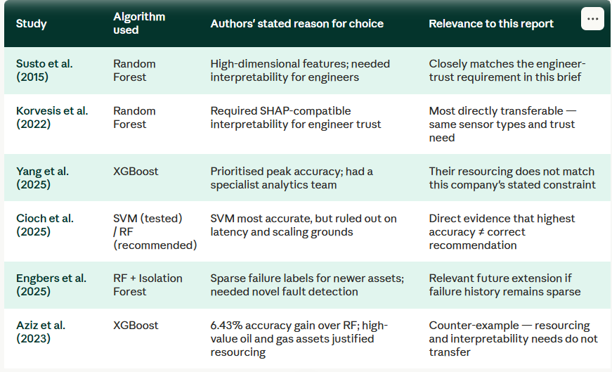
Table A.1: Summary of the six reviewed studies at a glance

Appendix B - Proposed Workflow Summary
Table B.1: Proposed nine-phase machine learning workflow, key activities, and tools for each phase.
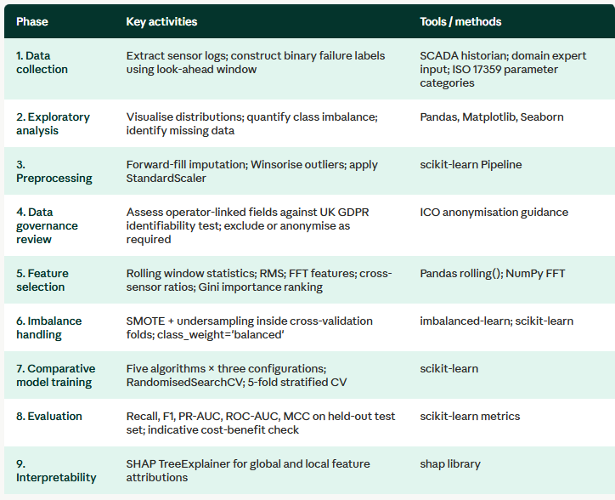

Appendix C - Evaluation Metric Thresholds
Table C.1: Minimum and target performance thresholds for each evaluation metric prior to deployment.


