

LEVEL 4

SEMESTER 2

MODULE CODE: SHSS4078
Adventure: A Risk worth Taking

aSSESSMENT TYPE: aSSIGNMENT
Assessment/Component: 1 (Part A)
COMPONENT WEIGHTING: 40 %
WORD COUNT: 2000 WORDS
MODULE TUTOR: Denise leonard

Assignment:
Complete a logbook recording every activity session you complete during this module and include these as appendices to your submission.

With reference to a critical incident case study that we have examined, identify one key contributing hazard. Evaluate your own personal logged experiences in different activities, of risk management in relation to this identified hazard. You should include a synopsis of the critical incident case study in your appendices.

SUBMISSION DETAILS:

Deadline:
Date: 4th May 2018
Time: 3.00pm
Portal: Turnitin

School of Sport, Health & Outdoor Education

Assessment Feedback Sheet

Student No./Name:Adrian Collins 1708322
Module: SHSS4078
Module Code: Adventure: A Risk Worth Taking

Personal Evaluation – to support your academic progress please complete the section below BEFORE submitting your work.
What do you consider to be the best aspects of this work? |  |  | I think the best aspects of my work has been identifying the control measures that could have been put in place to change the consequences of this incident.
Which aspects do you consider could have been improved in this piece of work? |  |  | I believe my work may lack enough references in my bibliography.
What have you found most satisfying whilst undertaking this submission? |  |  | I found studying the case study and identifying what could have been done better the most satisfying.
ASSESSMENT CRITERIA | Learning  Outcomes |  | GRADE
ASSESSMENT CRITERIA |  |  | Poor  0 – 25% | Unsatisfactory  26-39% |  | Satisfactory  40 – 49% | Good  50 – 59% | Very Good  60 – 69% | Excellent  70 – 85% |  | Exceptional  86– 100% | %
Complete logbook for each session | All |  |  |  |  |  |  |  |  |  |  | 15%
Provide a synopsis of a critical incident case study | All |  |  |  |  |  |  |  |  |  |  | 15%
Identify a specific significant hazard and the risk it poses to undertaking adventurous outdoor activities | 1,2,3,5 |  |  |  |  |  |  |  |  |  |  | 30%
Discuss a range of appropriate measures that might effectively control the identified hazard and consequent risks. | 1,2,3,5 |  |  |  |  |  |  |  |  |  |  | 30%
Appropriate references used and correctly formatted | All |  |  |  |  |  |  |  |  |  |  | 10%
It is expected that students will present work that is proof read, correctly referenced and adheres to the Assessment Checklist. Therefore a range of 0 – 10 marks will be deducted for non-completion of any of the points on the checklist below.
TUTOR COMMENTS:

Submission date:  via Turnitin |  | Return date:  (at least within 4 weeks) |  |  | Tutor: Denise Leonard |  |  |  |  | Mark:

Assignment Checklist

- Please complete the Personal Evaluation section of the Assessment Feedback sheet, add your name and details, and paste the whole of this assignment document into the front of your assignment

- Submission is a single word file, clearly labelled with your name and module code
- Font style - Times New Roman, size -12 for text and 14 for headings
- Ink colour – black only
- Line spacing – 1.5 line spacing and 2cm- 2.5cm page margins
- Quotations more than three lines to be indented 1 line spacing
- One line space between paragraphs, paragraphs must be left aligned
- Pagination (your assignment should have page numbers)
- All tables and figures are internally referenced and have a title
- Word count checked and written at end of text (before references and any appendix)
- Assignment is within 10% of the word limit (excluding references and any appendices)
- All references in the text are included in the reference list
- Correct referencing following the Harvard style, as described in the Palgrave study skills book ‘Cite them Right’.
- Correct spelling using UK English
- Correct use of punctuation
- Grammar and syntax correct- double check anything that has a green line under it
- I have read my assignment out loud to myself and it makes sense and is easy to read
- Somebody else has read my work and it makes sense to him or her!
- I have checked and I have not plagiarised
Failure to follow these guidelines will cost you marks!

Key Hazards of Glenridding and the Control Measures That Were Needed

One of the biggest risks with any adventurous sport that involves using water as a resource is drowning. There are many contributing hazards that can be the cause of drowning amongst participants on an outdoor activity or the instructors that are leading the session. The Glenridding tragedy was a chilling and emotional example of the effects and dangers that water can have on an individual if a session is run incorrectly and key safety procedures are not properly adhered to. This disaster was mainly caused by the effects of cold water shock, complacency and not abiding by health and safety procedures.

The leader of the group had little to no experience in this outdoor pursuit or as a leader of outdoor adventure activities. Without the correct training, this individual was unable to judge the standard of the venue they were using, which means he did not know if it was safe to use and could not dynamically risk assess the change in the environment due to recent cold weather. During our coasteering sessions, a generic and site-specific risk assessment is provided before the activity. This ensures that the individual leading our group understands the risks that are involved in the activity, the hazards that can cause them and the control measures that have been or should be put in place the mange the risks and reduce any chance of harm or illness towards any participants. As well as this, the leaders that are taking us are fully qualified to do so and have had their qualifications checked by the university and are therefor properly trained and prepared to take us on the session. Part of this training includes checking the conditions before the session and ensuring it is safe to use; they would also check upon arrival, that all factors affecting the session are accounted for and taken into account before the decision to continue is made. If these safety and control measures had been put in place before the leader of the Glenridding session had taken his group, it may have been possible for him to make a better-informed decision on if the session should have been taking place in the location it did and under the environmental conditions they were faced with.
As well as lack of experience and preparation from the leader of the session, the adverse weather conditions leading to the extremely low temperature of the water was another key factor in why the session ended in tragedy. Had the leader been competent in dynamic risk assessment and known the area and activity well enough. He would have made note of the weathers affect on the site they were using and decided to change the session or call it off completely. The weather is a prominent hazard as the effect it had on the water at Glenridding would have made the temperature low enough to cause cold water shock and even hypothermia. However, I think that this wasn’t the hazard that caused the incident. I believe that the hazard was lack of preparation and experience due to the leader. Although this could be pinned on the leader himself, the fact that he was able to lead the session without the proper experience and knowledge that he needed was allowed by the school itself. Without gaining appropriate information and certificates that confirmed his qualifications, he was made a leader of a session.

Various control measures could have been put in place to stop this; the school should have thoroughly checked the background of the leader to ensure that he had the qualifications needed to lead such a trip. This would have ruled him out as fit to lead and another professional with the responsible qualifications would have been designated as the correct leader of the session. This would have meant someone with experience of the activity would have had better judgement on the safety of the site they were using. Another measure that should have been put in place is the production and evaluation o proper risk assessments regarding the activity they were doing. If a generic and site-specific risk assessment was provided and fully checked, the leader would have had a specific set of regulations to check when they arrived at the site to see if it was safe to use. During every session we take part in, including our coasteering session, leaders are provided and are familiar with the risk assessments that have been checked by the university to ensure they are aware of the hazards to look out for and avoid during the session. As this was not provided by the school, the leader in place did not know what hazards could have caused harm towards the students and therefor did not know how to manage or avoid them. Another control measure that should have been of paramount importance is sending out consent forms to all parents regarding the nature of the activity and what would specifically be involved during the session. Even with a fully trained and experienced instructor this should be a priority before any adventurous activity. Parents should know the full plan of the activity they are consenting to their children taking part it in, as well as what qualifications the instructor has. This allows them to decide whether they deem the session safe or not for themselves before the child is put in any danger.

After evaluating the events leading up to the tragedy and the lack of preparation and thought that went into the session. I would say the biggest contributing hazard was lack of experienced staff and preparation for the activity. This could have been avoided or managed better by the school itself hiring suitably trained staff, better risk assessment preparation and knowledge and sufficient safety training and management. I believe that if these factors had been different and were carried out more professionally and carefully, the incident may have been avoided or at least not fatal as there would have been a leader who could have better planned and assessed the situation that the group found themselves in, if it had happened at all.

Glenridding Synopsis
a party of twelve students were taken to Glenridding for an activity of plunge pooling by three members of staff from Lancashire High School. The children were year eight and included Max Palmer. The weather during the activity was cold and wet and was held at rock pool in a mountain stream. As Max entered the water he emerged in a panic. A member of staff entered to rescue him but resulted in the same fate. Hi s mother also entered and began to panic, she was then rescued by another student. The pair of them suffered mild hypothermia and were airlifted to hospital. Max Palmer was pronounced dead at the scene after being found 150 metres below the pool.
Portfolio

Before  Session | The generic risk assessment I had prepared before the session examines the risks that we are faced with as a group. The risks are then rated how severe the outcome could be using a key provided. Once the severity noted, I had listed who was susceptible to the risks and what examples of hazards can cause them. After identifying all possible hazards, I thought of control measures that could be put in place to reduce the severity and manage the risks as best possible. When I had provided all possible control measures I marked the severity of the risks after the control measures had been put in place. This works effectively as a generic risk assessment as it enables users to understand the risks that are involved in the activity and what control measures can be used to decrease the risk of them happening. | 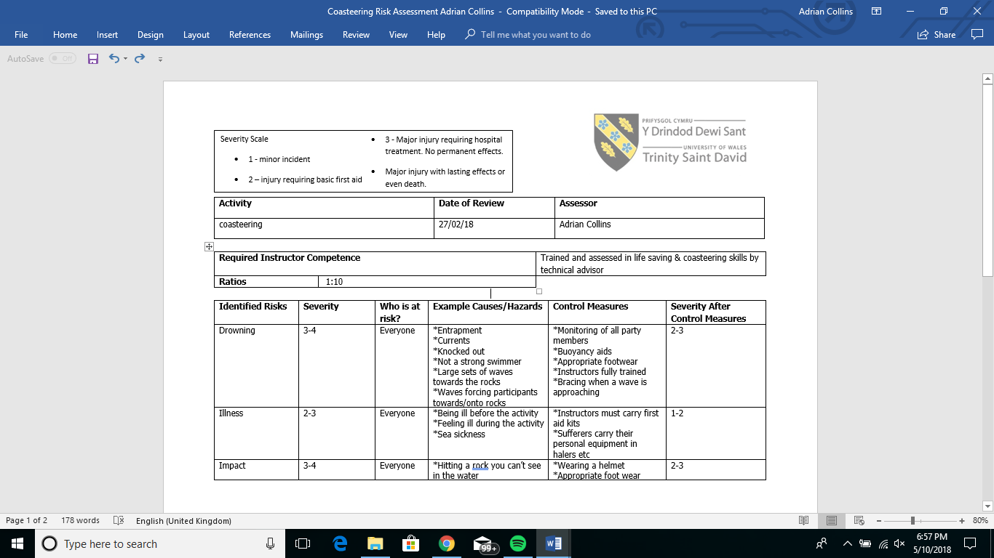  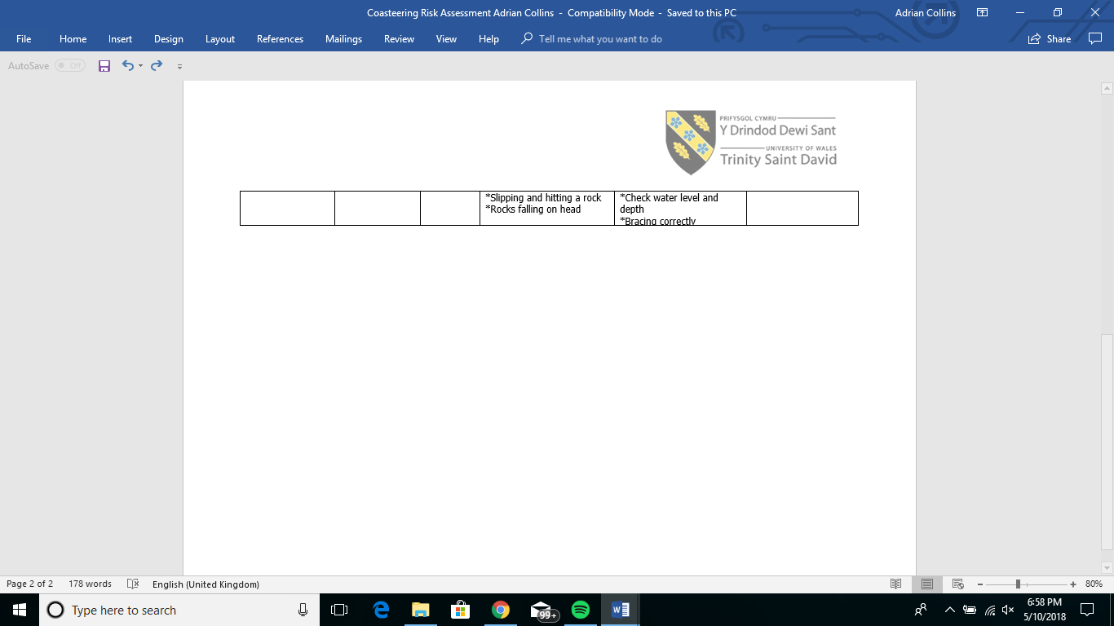
 | Site specific risk assessment provided for St Nons. | 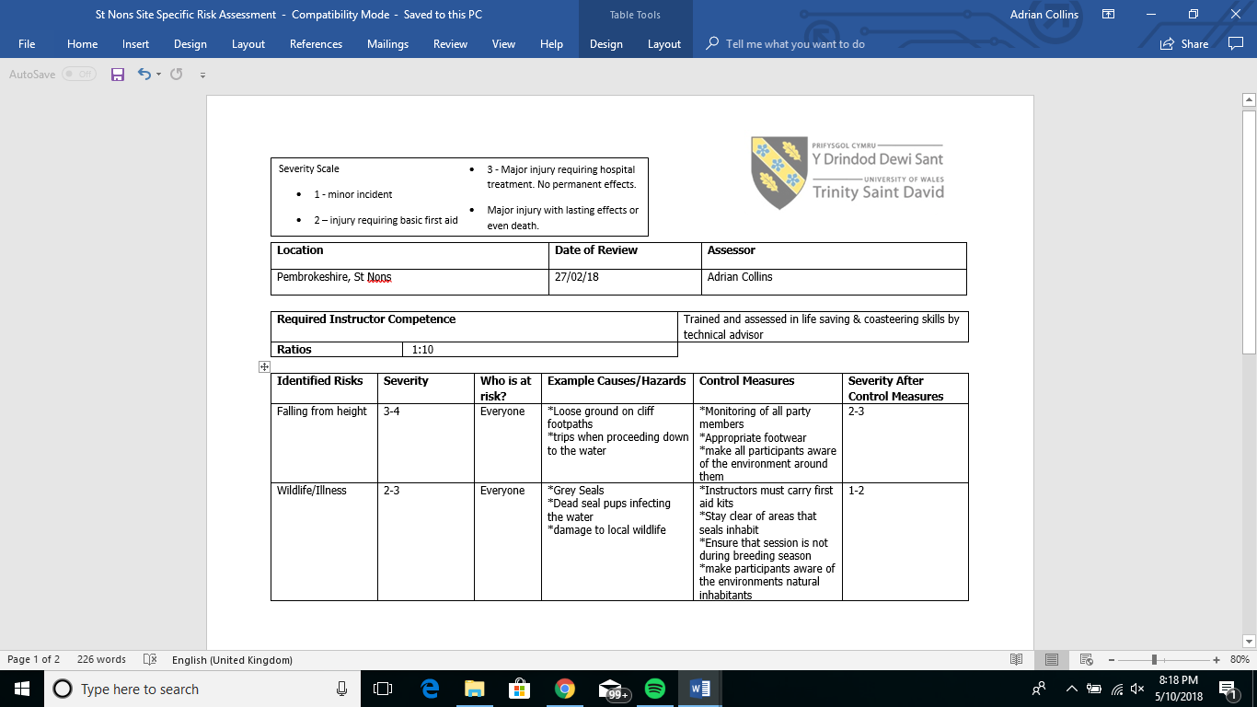  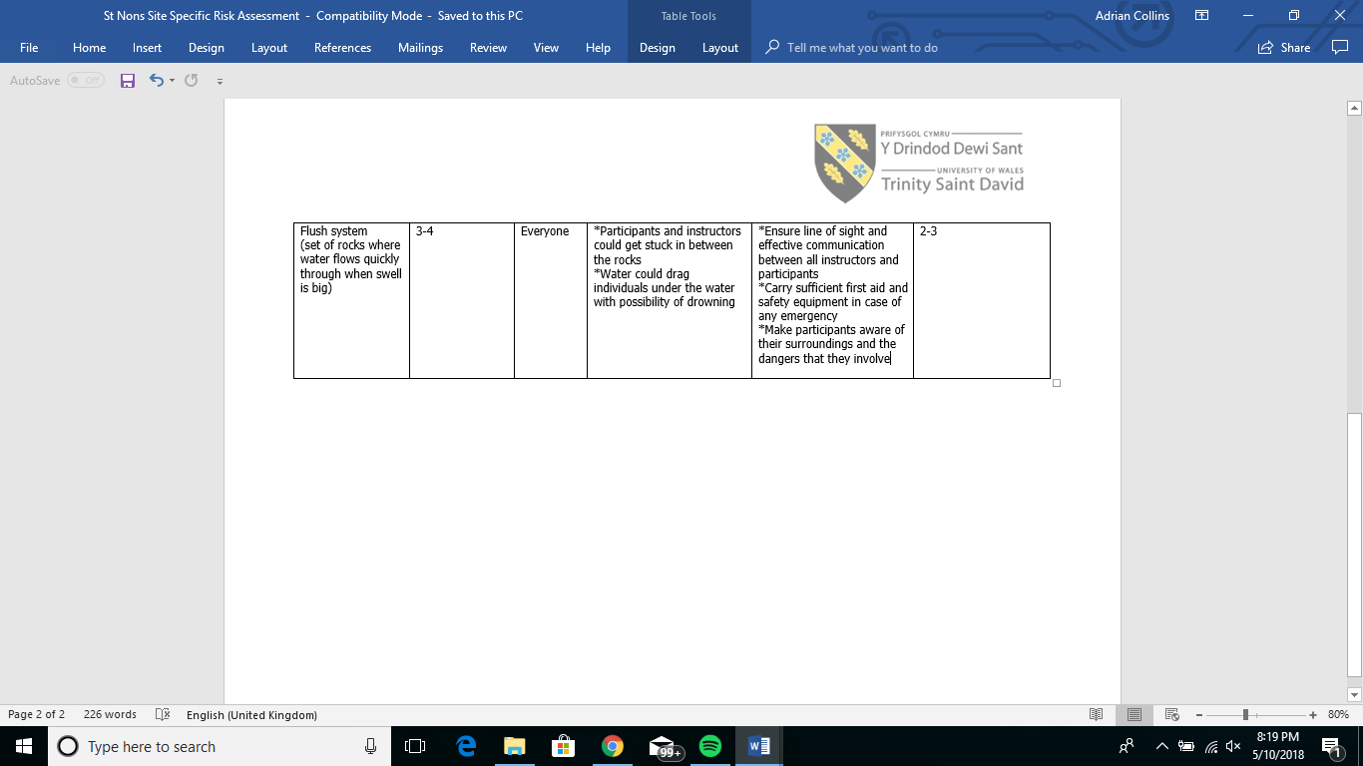
 | Legislation | Leave no trace  Parking is permitted by the Nunnery, but modest changing and minimal disturbance is required.  Accidents must be reported to senior instructors and tutors.
 | NGB awards needed by instructors | FSRT  RLSS Level One: Water Safety Awareness  RLSS Level Two: Environment Specific  RLSS Level Three: In Water Rescue  Coasteering Training and Assessment  NUCO Level 2 Activity First Aid
Chart Datum – a charted display of water depths usually derived from the phase of the tide
Beadlet Anemone – a anemone that is one colour with no patterns, has a broad base and is found on the coasts of Britain and Ireland.
Coastguard – are involved in supporting search and rescue missions at sea to help prevent injury and fatalities.
Wave Period – usually measured in seconds, a wave period is the time between wave sets.
Spring Tide – the tide that occurs after a full moon
Neap Tide – Occur when the sun and moon are at perpendicular angles to Earth. Occurs twice a month

 | Key techniques used in activity | Shallow Water Entry – approach the water low and gently push forward across the surface. Keep arms stretched out to minimise your body going under the surface of the water.  Deep Water Entry – step forward clearly into a safe body of water with arms crossed against your chest, legs and feet together, straight body and looking forward.
 |  | Health and safety of site and activity
 | Health and safety of site and activity | All relevant PPE was checked before the activity and kept safe in a dry bag travelling to and from the venue. It was then thoroughly washed and left to hang in the dry room.
Dynamic risk assessment
Weather was checked beforehand and was as forecasted.
Tides and wave period were also checked and did not change during session.
 |  | I think I performed well as Sam and I led a tutor from Norway on his first coasteering session, starting small and gradually getting bigger with our jumps we discussed the aspect of the activity and similarities in sports in Norway whilst exploring the wildlife, types of stone and landscape of St Non’s.
 | Any near misses or accidents | NA

References

Marlin.ac.uk. (2008). MarLIN - The Marine Life Information Network - Beadlet anemone (Actinia equina). (online) Available at: http://www.marlin.ac.uk/species/detail/1561 (Accessed 5 May 2018).

Ntslf.org. (2018). Chart datum & ordnance datum | National Tidal and Sea Level Facility. (online) Available at: http://www.ntslf.org/tides/datum (Accessed 6 May 2018).

Nationalcareersservice.direct.gov.uk. (2016). Coastguard | Job profiles | National Careers Service. (online) Available at: https://nationalcareersservice.direct.gov.uk/job-profiles/coastguard (Accessed 8 May 2018).

Oceanservice.noaa.gov. (2017). What are spring and neap tides?. (online) Available at: https://oceanservice.noaa.gov/facts/springtide.html (Accessed 08 May 2018).

Strauss, D. (2007). Wave period. (online) Coastalwatch.com. Available at: https://www.coastalwatch.com/surfing/176/wave-period (Accessed 8 May 2018).

