Name: Ellie Jones
Number: 2205758
Programme: BA Hon Graphic Design
Module: ADAD 4019/C Ways of perceiving

Word count: 1,606

Powers of Percipience
This Exhibition will surround themes such as mental health and psychology, we will be displaying pieces that reflect these elements in many different ways thought-out the years, this line-up will reflect art overtime and depict how it has changed and moulded into something new.

The Exhibition “Powers of Percipience” will be held by ‘Wonderspaces’ which is located in Austin Texas. They are an interactive and immersive visual learning space used for displaying larger pieces of art from all around the world.

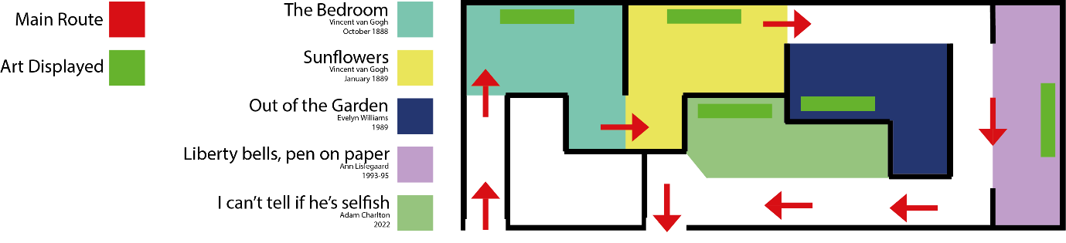

The location is very modern in the way their share their exhibits, there are projectors showing films and recording from each paintings time period and shows the audience how that piece of art came to into creation. This is also to provide an in depth looks at the art so that you can see each individual brush stroke and understand how each piece was painted & generated. We will also include the physical canvases alongside the digitalized versions to show a deeper understanding to the art itself. As well as that we will have the information about each piece being displayed on the wall next to the art there will also be a free audio book style literature that each visitor will have access to, along with a customary headset so that they can listen and interact with each piece while they make their way through the exhibition.

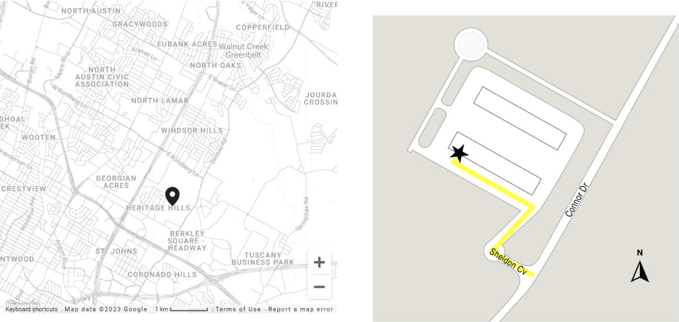
- 1205 Sheldon Cove, Suite 2-A, Austin, TX 78753

The first piece shown is Vincent van Goghs ‘The Bedroom’, this was created in October 1888 using a range of techniques that originated in oil paints, he mainly used natural appearing pigments which is seen as his signature colours in modern day. In the 1888 they were discovering new textile in the industry and materials and so for Van Gogh to be using these he was and still is seen as a pioneer of oil paint in the early beginning.
The ‘Bedroom’ is perceived as an intimate and quiet atmospheric environment where visitors can see and understand the mental strive and surrounding that van Gogh had to live though, on the other hand it could be perceived as a more serene setting where he could visualise a place in his mind a truly paint from the heart. The painting itself was created while he was in an asylum, the painting reflected his thoughts of what a room would look like while he was there. Bold but unstable with uneven levels as well as oversized features as seem here.

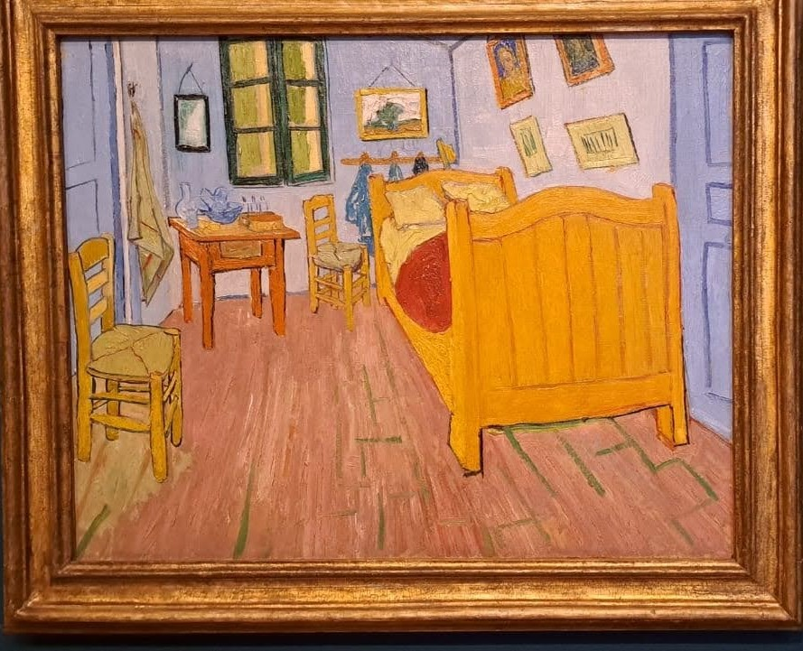
(Van Gogh Vincent, 1888)
During the time that Vincent van Gogh painted this piece (1888) there was a big movement in the art community which was known as the “les nabis art movement” (ART TERM, 2023)
This movement was based in France and was led by young French artists at the time attempting to transition from impressionism and academic art to abstract art, symbolism, and the other early movements of modernism. Effects of this movement can be seen is Van Goghs paintings, especially in this piece as it appears shifted and more like a reflection rather than a true illustration of his environment.

The next art piece shown is another painting by Vincent van Gogh, this is arguably one of the most iconic and well-known pieces even among people who don’t have that much knowledge about the arts. This piece is of course named ‘Sunflowers’. Painting in January of 1889
There are a few different paintings of the sunflowers seven to be exact, each are slightly different, with some vases having a thin blue line around the base and different colour tones. The reason for this is unknown and even more peculiar this small detail did not appear on all versions. Gogh didn't enjoy painting the flowers in full bloom he preferred when the flowers were wilting or close to death. He believed it added to the drama of the painting and represented how not all things last forever, it was also noted that the colour change that was used reflected his mood at the time. The collection of sunflower paintings was some of his later paintings in life and him flet that he could represent himself better with these than what he created earlier on in life. Originally, he preferred self-portraits but overtime these become more and more distorted and abstract which could be held accountable to the ‘les nabis art movement’ as previously mentioned.
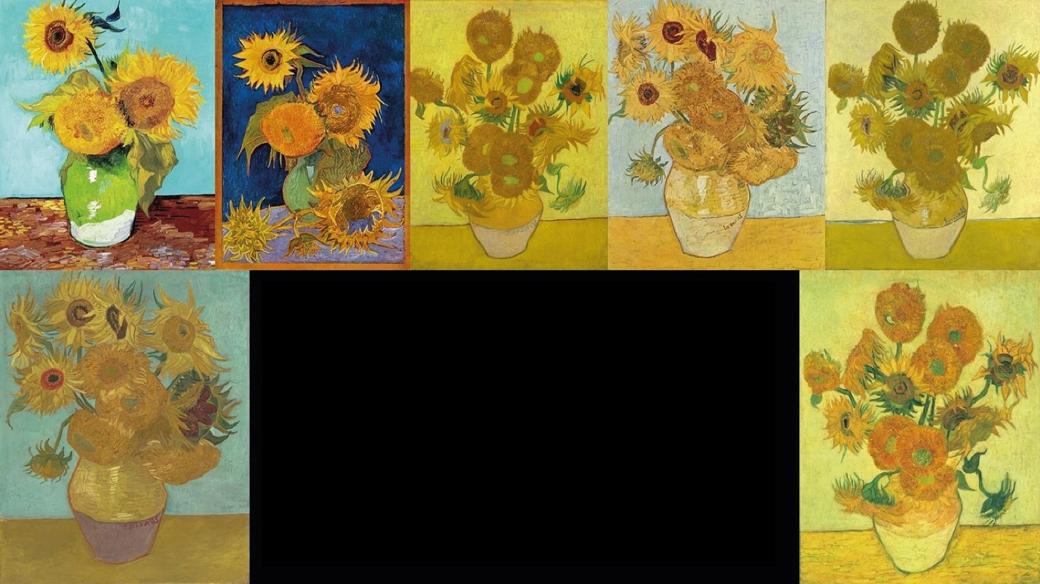
(Van Gogh Vincent, 30th September 2022)
As you can see each of these sunflower paintings are unique in their own ways, its almost like you can see the progression and wilting process taking place in front of your own eyes. The colours used changes drastically especially when you compare the first and seventh painting, the first one is more vibrant and lighter while the last one is more washed out but oddly enough more detailed, this could be because as previously mentioned be favoured painting the wilting and dying flowers rather than the fresh ones.
Here’s an honourable mention, that would be displayed alongside these pieces: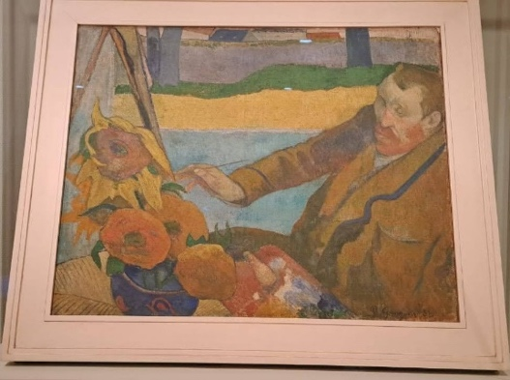
(Van Gogh Vincent, October 1888)

This self-portrait illustrates the gap between his past and present showing the sunflowers painted in January 1889, and his older original style pieces form earlier on in his artistic journey. “Art is to console those who are broken by life.”, (FRENCH RIVIERA guide, N/A) In modern interpretation this could be taken as a way to relive stress and create a world in which you feel yourself and can decide your own potential and future.

Our third piece shown was painted and finalised by Evelyn Williams who in 1989 crafted a piece named ‘Out of the Garden’. Williams was a sculptor, painter, and draughtsman, who grew up in London and made that her home late in life. While creating these spectacularly intricate artworks she did not receive the recognition which she deserved all her life. But the people who truly loved her pieces and understood the underlaying messaged beneath the surface cherished her work and classed it as highly valued. In the mind of a sculpture and female abstract artists as being regarded as someone who forged a path for female artists and produced pieces that truly spoke to the soul and had meaning behind each stroke. Here pieces are primarily inspired by dream like scenes and scenarios where not everything makes sense and it’s up to the audience to choose what they see in some way. This makes her art extremely personalised and can be interpreted in many different ways to individuals. A quote from Van Gogh that I find relevant to this piece as followed,

This artist's work also has similar values to surrealism, which "aims to revolutionise human experience. It balances a rational vision of life with one that asserts the power of the unconscious and dreams". (ART TERM, 2023) The artist shows the gap between real and make-believe and helps put the audience in that mind set of uncertainty.

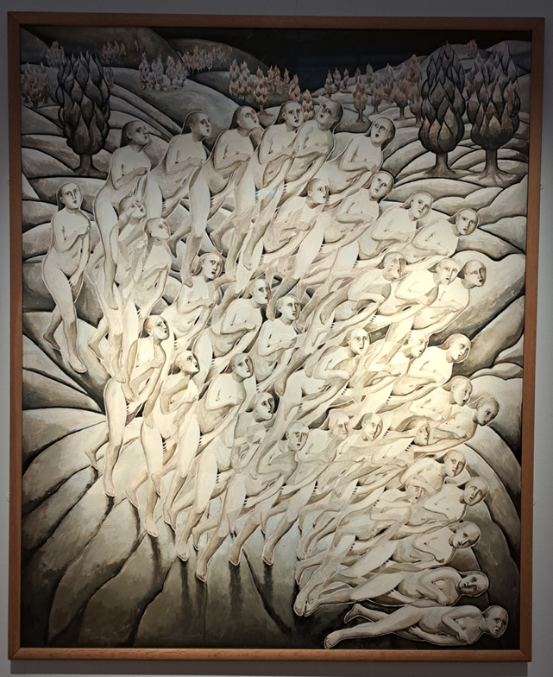
(Williams Evelyn, 1998)
Our fourth exhibit is a piece produced by Ann Lislegaard, her work made around 1993-95 was called ‘Liberty bells’. Lislegaard is considered as a contemporary style artist who primarily works with the art of 3D models and introspective pieces.
For this piece which is considered as ‘the liberty bells series’, Lislegaard was placed into a hypnotic like state where she was guided by the hypnotist though a labyrinthine & mase type scenarios where in each stage she produced there illustration below. This was considered as something that “Blurs the lines between the spaces where art is created and where it is shown”. (Lislegaard Ann, 1993-1995)
This piece inspired unfiltered creativity and raw potentials as far as the mind can visualise, and it shows that creating something beautiful doesn’t always require thought.
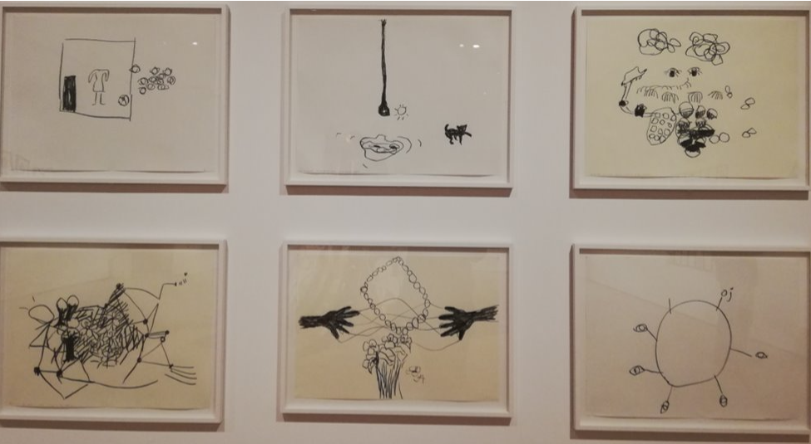
(Lislegaard Ann, 1993-1995)
It appears that there is no cohesive theme or visuals, and instead relies completely on interpretation and the backstory of the first-hand experience Ann Lislegaard participated in while illustrating.
Our final piece of the exhibition circles back to modern day art, as in 2022 a piece was created by the name of “I can't tell if he's selfish” painted by Adam Charlton. This art piece is very different to the others included in the exhibition visually, but I feel carries the same message of percipience and escapism.

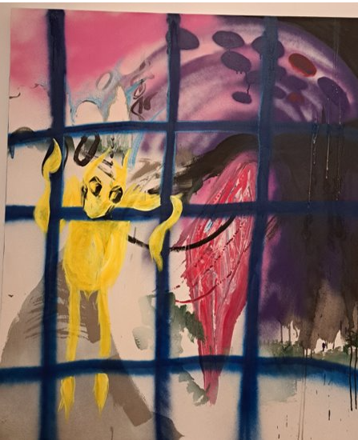
(Charlton Adam, 2022)

This painting was created using the mediums of mixed media acrylics, spray paints, oil pastels and wax. While creating this piece Charlton focused primarily on the emotion of the painting and how the audience would respond to him message. This is clearly seen by the emotion of the subject (yellow humanoid) appearing although it’s trapped in some form of cage. On Charlton’s official website he states that “I make art about my life- I am indiscriminate about what my art is about. Sometimes I draw to music, sometimes self-observation guides me.” (On Your Face, 2021)
Also, during my research into the style used I uncovered something called ‘neo expressionism’ which was prominent during the 1970s and is still used to this day as a street art style inspiration for many creators, It carries elements of the subconscious mind and although not much detail is included, your still able to decipher what the primary message of the piece is.

This idea of emotion on canvases is the overall based for this exhibition and I believe that all the artists and art selected here has some form of connection to each other and flows well. This exhibition will hopefully intrigue many new people into the world of art and mental health and how they can easily play into each other’s roles in life.

Bibliography for Powers of Percipience

PHOTOS
Charlton Adam: I can’t tell if he’s selfish (2022) [Glynn Vivian exhibition 2023]. 2023 – Part of permanent collection

Lislegaard Ann: Liberty bells (1993-1995) [Glynn Vivian exhibition 2023]. 2023 – Part of permanent collection

Van Gogh Vincent (October 1888) The Bedroom [Oil paints] Available at: https://www.vangoghmuseum.nl/en/collection/s0047V1962 (Accessed: 22/04/2023)

Van Gogh Vincent (January 1889) Sunflowers [Oil paints] Available at: https://www.vangoghmuseum.nl/en/collection/s0031V1962 (Accessed: 22/04/2023)

Van Gogh Vincent (30th September 2022)The sunflowers of Vincent van Gogh [Oil paints] Available at: https://www.google.com/search?q=all+7+sunflower+painting+by+vincent+van+gogh&sxsrf=APwXEdd-DYqb5_5T4WzJYv8e6c7NrqaqRw:1682194797959&source=lnms&tbm=isch&sa=X&ved=2ahUKEwjsiYD7p77-AhURUsAKHTd5D0QQ_AUoAXoECAEQAw&biw=1280&bih=601&dpr=1.5#imgrc=l0kPwITNaCB1ZM (Accessed: 22/04/2023)

Williams Evelyn: Out of the Garden (1989) [Glynn Vivian exhibition 2023]. 2023 – Part of permanent collection

RESEARCH ART TERM, (2023) NABIS. Available at: https://www.tate.org.uk/art/art-terms/n/nabis (Accessed: 23/04/2023)

ART TERM, (2023) TATE. Available at: https://www.tate.org.uk/art/art-terms/s/surrealism (Accessed: 24/04/2023)

Charlton Adam: I can’t tell if he’s selfish (2022) Glynn Vivian, Swansea. (2023 – Ongoing)

FRENCH RIVIERA guide (N/A) FRENCH RIVIERA PAINTINGS. Available at: https://frenchrivieraguide.com/infos/paintings/vincent-van-gogh-quotes.html# (Accessed: 23/04/2023)

Lislegaard Ann: Liberty bells (1993-1995) Glynn Vivian, Swansea. (2023 – Ongoing)

On your face (2021) Adam Charlton. Available at https://onyourfacecollective.org/Adam-Charlton (Accessed:23/04/2023)

Sotheby’s (10th August 2023) THE MOST FAMOUS ARTWORKS IN THE WORLD. Available at: : https://www.sothebys.com/en/videos/up-close-with-vincent-van-gogh-thebedroom#:~:text=The%20painting%20of%20the%20bedroom,and%20his%20portrait%20of%20Gauguin (Accessed: 22/04/2023)

Study.com, Nelson Cami (20/05/2022) Les Nabis Art, Artists and Ideology. Available at: https://study.com/learn/lesson/les-nabis-art-movement-history-ideology-style.html#:~:text=The%20Les%20Nabis%20art%20movement%20lasted%20from%201888%20to%201900,in%20the%20early%2020th%20century (Accessed: 22/04/2023)

The Art POST Blog (9th December 2019) Bedroom in Arles by van Gogh: 5 things to know about the painting. Available at: https://www.theartpostblog.com/en/bedroom-in-arles-van%20gogh/#:~:text=MEANING%20OF%20BEDROOM%20IN%20ARLES,birth%20to%20a%20new%20painting (Accessed:22/04/2023)

Wonderspaces, (2023) Wonderspaces. Available at: https://www.wonderspaces.com/ (Accessed: 22/04/2023)

Williams Evelyn: Out of the Garden (1989) Glynn Vivian, Swansea. (2023 – Ongoing)

