

LCBB4005: THE GLOBAL BUSINESS ENVIRONMENT
Assessment: 01

Student Name: Elena Ivanova Goranova
Student ID: 2122365

Table of Contents
1.0 Introduction 2
2.0 Organizational Profile of Tesla 3
3.0 Challenges of external and internal business environments that Tesla Inc. faces while trading across the globe 3
3.1 SWOT analysis of Tesla 4
3.2 PESTLE analysis 6
3.3 Assessing the automobile industry’s attractiveness using Porter’s model 7
3.4 Tesla’s Value Chain analysis 9
3.5 Competitive advantage based on their core values on sustainability 10
4.0 Conclusion 11
References 11

1.0 Introduction
Global business environment has become volatile than ever before due to the change in internal and external dynamics (Philips and Mathew, 2021). Events such as the covid-19 pandemic, Brexit issues, and economic downturns have made realities hard for automobile industry. Although sustainable automobile company such as Tesla’s share value has increased, the viability of the business in the UK is still questionable (Seiklucki, 2018). Therefore, this study measures the impact of global business environment creating challenges and possibilities for Tesla, one of the leading electric manufacturers in the world. Section two describes the organization profile whereas section three illustrates the discussion. Finally, section four concludes the discussion with possible recommendations.

2.0 Organizational Profile of Tesla
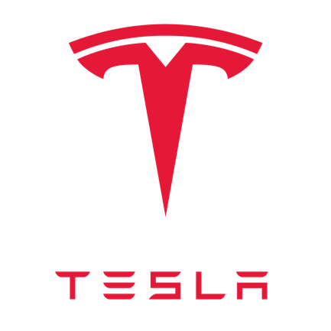
Figure 1: Logo of Tesla Inc.
Texas-based clean energy and electric vehicle producing company Tesla, Inc. is one of the most innovative companies of the 21st century. In addition to producing electric vehicles, Tesla also makes residential and grid-scale battery energy storage systems, solar-tile roofs, solar panels, and related items (Tenhundfeld et al., 2020). Over $1 trillion in worth, Tesla is the world's most prized business and the world's most valuable car manufacturer. Plug-in electric vehicles will account for 16 percent of worldwide sales in 2020, while battery electric vehicles will account for 23 percent. Tesla Energy, a subsidiary of the company, manufactures and installs solar power systems in the United States. As for battery energy storage systems, Tesla Energy had deployed 3,99 gigawatt-hours of capacity by the year 2021, making it a worldwide leader in this field (Liu, 2021).

3.0 Challenges of external and internal business environments that Tesla Inc. faces while trading across the globe
To assess the external and internal business environment, there are many sophisticated tools and techniques (Moktadir et al., 2018). SWOT analysis will help to determine what are the strengths Tesla occupies to remove barriers, weakness, and threats while capturing the market opportunities. PESTLE will help to assess the external environment whereas porter’s model will be used to assess the UK automobile industry’s lucrativeness.

3.1 SWOT analysis of Tesla
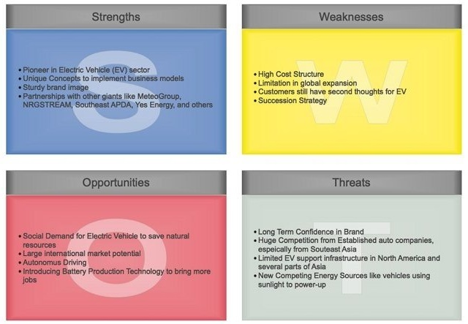
Figure 2: Testla's SWOT Analysis (Declerck and Clarysse, 2022)
1. Strengths
- Power Efficacy - As a pioneer in electric vehicles, Tesla relies on durable energy sources like solar power (Huang et al., 2022).
- Collaboration - Large corporations such as Yes Energy and Southwest APDA are partnering with Tesla. They boost Tesla's global market development and clean energy goals (Chen and Perez, 2018).
- Highly advanced and innovative - The design of Tesla's automobiles is excellent. They went to considerable lengths to ensure that their electric vehicle was as pleasant as possible for its users throughout the design and construction phases.
- Durable Brand Value - People in the market have confidence in the company and expect it to provide products that are both beneficial for the environment and profitable.
2. Weakness
- Limited Existence - A highly competitive automobile market has fueled both Tesla's foreign and local development.
- Premium Product Offering - Tesla is a household name in the field of renewable energy. In terms of the downsides, they may run into a lack of affordability and client faith in electric vehicles (Hess and Andiola, 2018).
- No Succession Policy - Tesla's CEO, Elon Musk, is often regarded as a one-man show and the company's brand face. Tesla's chief executive, Elon Musk, has a full plate as it is.
3. Opportunities
- Automatic Driving Technology (ADT)- Autopilot has made Tesla a household brand because to its safety, ease, and comfort. Consumers and investors alike may rely on it as a reputable source of market data. Autopilot work by Tesla is always developing (Ahmad and Khan, 2019).
- Eco-friendly cars - Electric vehicles are becoming more popular as people become more concerned about the environment and want to reduce their use of gasoline-powered vehicles.
- Improved technology for production- Currently, Tesla has ambitions to build its own battery cells. This has the potential to be a game-changer for the company in terms of lowering production costs (Huang et al., 2022).
v. Threats
- Intense Competition - Volkswagen and BMW are becoming Tesla's main competitors as they do substantial research into electric cars powered by renewable energy sources. (Bai et al., 2020).
- Novel technologies - In autos, there are novel ways of using energy. Competition may lead to higher costs of operation and reduced profit margins.
- Sustainability - The long-term profitability of a renewable energy vehicle producer is essential. A lack of EV service infrastructure in North America and many Asian nations poses a huge threat to Tesla's future success (Declerck and Clarysse, 2022).

3.2 PESTLE analysis
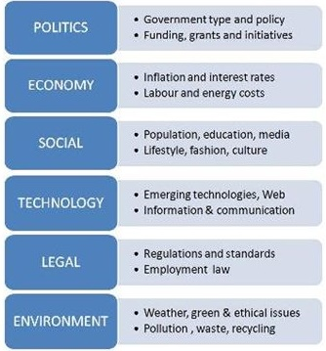
Figure 3: Tesla's PESTLE Analysis (Braunfels, 2021)
i. Political & legal factors: Political changes may have a direct influence on Tesla Motors' market operations. One of the most significant political influences on the business is environmental management legislation, which encourages the development of more environmentally friendly vehicles by establishing high emission standards (Liu, 2021). Globalization and liberalization, which have resulted in substantial new entries into the UK automobile sector and a few new entrants into the worldwide auto manufacturing market, are the second crucial component. Carbon tax and other green policies are implemented via a variety of green legislation, including the introduction of energy loan programs and pressure on the creation of environmentally friendly automobiles.
ii. Economic: One of the things to keep in mind is the growth of the economy. Fuel prices are driving up the operating costs of these vehicles, putting further pressure on the alternative energy industry. Consequently, there is a higher need for more fuel-efficient vehicles than ever before.
iii. Social: Social factors have a role in environmental concerns, habits, and preferences for "eco" friendly products. A person's social standing is determined by the sort of automobile they drive. The new generations are now concerned about sustainable energies to protect the environment.
iv. Environment: Creating environmentally friendly or fuel-efficient automobiles has been a competitive issue for several automakers in recent years. As society grew more conscious of the consequences of environmental factors, such as climate change, "changes" in activities and organizations' products and services followed (Wang and Zhang, 2021).
v. Technological: Innovative new technology has helped Tesla gain a foothold in the American car sector. There will be many more projects like Tesla's in the future that show how new technology can break down energy restrictions. The introduction of hybrid and all-electric cars by other manufacturers has raised the level of competition in the market.

3.3 Assessing the automobile industry’s attractiveness using Porter’s model
Porter’s five forces model has been utilized to determine the attractiveness of the automobiles industry in the UK. As shown in figure 4, the automobiles industry in the UK is very lucrative three out of 5 dimensions show favorable position for an existing company competing in the UK market (Wang et al., 2021)
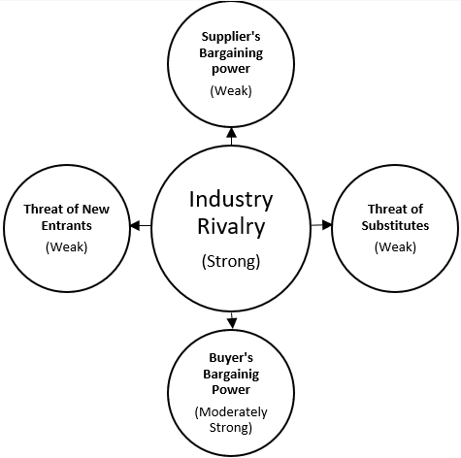
Figure 4: Assessing Automobiles Industry of the UK (Wang and Zhang, 2021)
i. Strong Competition: There are few well-known enterprises and getting started is difficult. It would also be quite costly to exit the market. The industry has grown and has a devoted following of customers. Competition for market share has so been stepped up.
ii. Low supplier’s bargaining power: Due to their modest size, suppliers in the car industry have minimal negotiation power. However, the rules governing these materials providers have been created by the automotive manufacturers. Raw materials are available and switching suppliers is not a problem for firms like Tesla, Nissan UK, Ford, BMW, VW, and Toyota (Teece, 2018).
iii. Low threat of new entrants: It's difficult for new automotive firms to get into the market because of the hefty expenditures connected with building a brand. Initial project costs will be high due to the requirement to build up a distribution network, procure manufacturing facilities, and hire qualified staff.
iv. Low threat of substitutes: It's possible to go about using a cab, public transit, a train, or an aircraft as a replacement. Owning a car, on the other hand, offers an accessibility and convenience that none of these alternatives can match. If you miss a train or bus, you'll have to wait until the next one comes by.
v. Moderately strong buyer’s bargaining power: According to Mas (2018), most customers are tiny individuals that purchase one car at a time. A fleet of automobiles may be purchased by both government entities and private businesses. These customers have the power to negotiate cheaper costs. Customers of any size may simply switch to a different brand. Changing from one brand to another or from one means of transportation to another does not incur any significant expenditures.

3.4 Tesla’s Value Chain analysis
As figure 5 shows, Tesla Inc. performs a wide variety of primary as well as secondary activities. It’s primary activities include inbound logistics management, operations management, outbound logistics such as solar power unit storage, vehicle storage, direct delivery, marketing activities, and after sales activities.
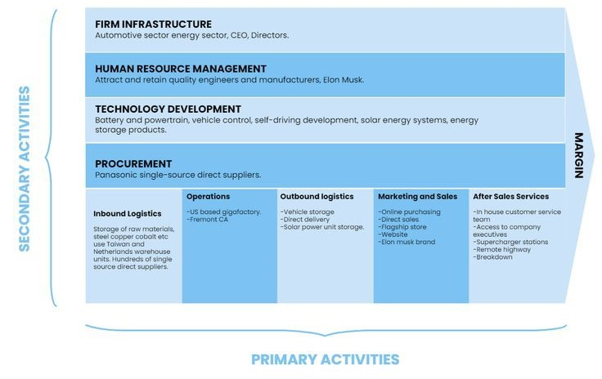
Figure 5: Tesla Value Chain Analysis (Hess and Andiola, 2018)
Tesla’s secondary activities include firm infrastructure including CEO, board of directors, human resources management aiming at employing skillful, quality, and innovative personnel, and sustainable technology development.

3.5 Competitive advantage based on their core values on sustainability
The abovementioned discussion clarifies that Tesla has several dimensions that work as the building block of its competitive advantage. The company has successfully focused on sustainable business model that led them to generate some innovative business ideas. The first dimension is quality that is the company’s prime concern. As shown in figure 6, Tesla model 5, 3, and X are the best cars in the world providing the most mileage and backup time than any other brand (Khan, 2021).
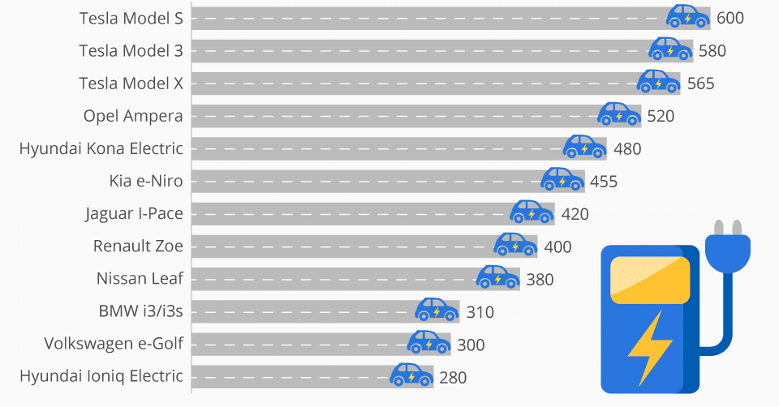
Figure 6: Electric Cars Providing Mileage (Khan, 2021)
Tesla has focused on its key resources to build an innovative business model different from others. It has ensured viability, sustainability, profitability and focused on the following key core values that have built up the competitive edge.
- A sophisticated battery supply chain
- A web of supercharger networks
- Skillful, and innovative personnel
- Over-the-air updates to Tesla’s software
- Quality products with environmental concerns.
- Efficient branding strategy
- Artificial intelligence and self-driving mechanisms
- Focusing on green

4.0 Conclusion
This report has focused on the attractiveness of UK automobile industry, and the impact of internal and external factors on an automobile brand. This study has discussed the business model of Tesla, no one electric vehicle producer in the world. Through extensive analysis of SWOT, PESTEL, Value chain, the study suggests that Tesla should focus on its key resources to enhance its core position in the UK market. Also, the threats and challenges that it has been facing right now should be eradicated if they ensure viability and sustainability in its business operations.

References
Ahmad, S. and Khan, M., 2019. Tesla: Disruptor or Sustaining Innovator. Journal of Case Research, 10(1).
Bai, C., Dallasega, P., Orzes, G. and Sarkis, J., 2020. Industry 4.0 technologies assessment: A sustainability perspective. International journal of production economics, 229, p.107776.
Braunfels, N.S.J., 2021. Tesla motors: disrupting the automotive industry (Doctoral dissertation).
Chen, Y. and Perez, Y., 2018. Business model design: lessons learned from Tesla Motors. In Towards a Sustainable Economy (pp. 53-69). Springer, Cham.
Declerck, T. and Clarysse, B., A social media analysis of the perception of Tesla Motors and the impact of their business model.
Hess, M.F. and Andiola, L.M., 2018. Fraud risk brainstorming at tesla motors. Issues in Accounting Education, 33(2), pp.19-34.
Huang, H., Chau, K.Y., Iqbal, W. and Fatima, A., 2022. Assessing the role of financing in sustainable business environment. Environmental Science and Pollution Research, 29(5), pp.7889-7906.
Khan, M., 2021. A critical analysis of Elon Musk’s leadership in Tesla motors. Journal of Global Entrepreneurship Research, pp.1-10.
Liu, S., 2021, March. Competition and valuation: a case study of Tesla Motors. In IOP Conference Series: Earth and Environmental Science (Vol. 692, No. 2, p. 022103). IOP Publishing.
Mas, S.M., 2018. Tesla Motors. SWOT analysis and corporate strategy. GRIN Verlag.
Moktadir, M.A., Ali, S.M., Kusi-Sarpong, S. and Shaikh, M.A.A., 2018. Assessing challenges for implementing Industry 4.0: Implications for process safety and environmental protection. Process safety and environmental protection, 117, pp.730-741.
Philips, W. &amp; Mathew, G., 2021. Pestle Analysis: Factsheets. CIPD. Available at: https://www.cipd.co.uk/knowledge/strategy/organisational-development/pestle-analysis-factsheet#gref [Accessed April 4, 2022].
Sieklucki, G., 2018, June. An investigation into the induction motor of tesla model S vehicle. In 2018 International Symposium on Electrical Machines (SME) (pp. 1-6). IEEE.
Teece, D.J., 2018. Tesla and the reshaping of the auto industry. Management and Organization Review, 14(3), pp.501-512.
Tenhundfeld, N.L., de Visser, E.J., Ries, A.J., Finomore, V.S. and Tossell, C.C., 2020. Trust and distrust of automated parking in a Tesla Model X. Human factors, 62(2), pp.194-210.
Thomas, V.J. and Maine, E., 2019. Market entry strategies for electric vehicle start-ups in the automotive industry–Lessons from Tesla Motors. Journal of Cleaner Production, 235, pp.653-663.
Wang, N., Tang, L. and Pan, H., 2019. A global comparison and assessment of incentive policy on electric vehicle promotion. Sustainable Cities and Society, 44, pp.597-603.
Wang, Y., Qin, S. and Zhang, C., 2021. Tesla’s Supply Chain Vulnerabilities in the Chinese EV Market. Frontiers, 2(4).
Xu, M., Cui, Y., Hu, M., Xu, X., Zhang, Z., Liang, S. and Qu, S., 2019. Supply chain sustainability risk and assessment. Journal of Cleaner Production, 225, pp.857-867.

