4.0 Results (1,030 words)

4.1 Introduction
This chapter aims to analyse and provide the results from the online survey’s findings, following the collection of primary data as detailed in the methodology chapter. Within this chapter, the findings will be displayed numerically via graphs and percentages which is a much clearer way to demonstrate the outcomes.
Two surveys were sent out, one to the public the second to serving police offices in Merthyr Tydfil. One semi structured interview was carried out, to gain background information on the Merthyr Tydfil police station and the force. The data can be used to achieve the objective and answer the question ‘Should it be mandatory for all police officers in Merthyr Tydfil to carry a taser?’

Two surveys were sent out via email which is quick and able to reach a large selected population. The surveys consisted of multiple-choice questions, all questions were answered on the surveys, the data captured was analysed to assist in identifying any themes or patterns, through a systematic method of data analysis (Popenoe et, al., 2021) the analysed data will then be compared to the information in the literature review chapter.

4.2. Online Public survey Findings (Appendix i)
The sample size was small, with a total of 29 responses from the public. This was expected, as it is widely recognised that there is a low response from the public with answering questionnaires. This fact was mentioned in the limitations section of this work. However, there are enough responses to obtain the primary data required.

4.2.1

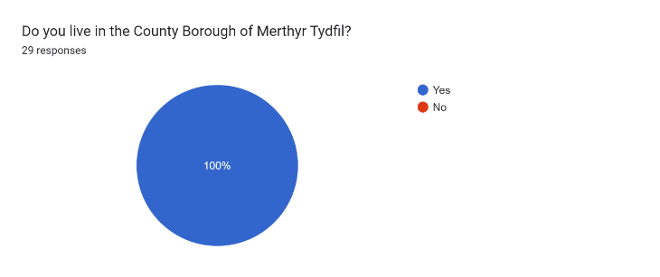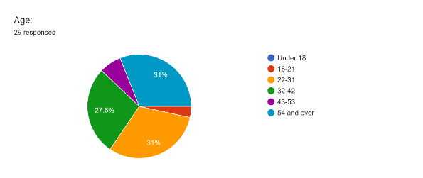
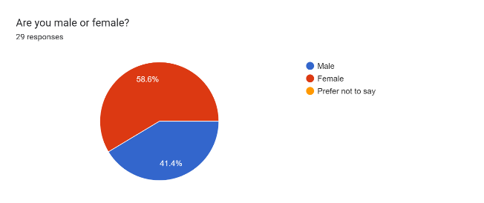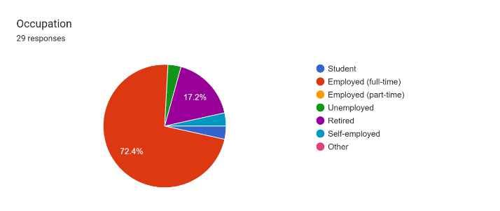
Demographics - The first four public questions were aimed at identifying the demographics of the respondents and help understand the sample group.
The data states that 100% of the respondents were Merthyr residents, 89.6% were 22 and over, with more females responding at 58.9% then males at 41.4%, out of all the respondents 72.4 % were employed, giving a good general mix of demographics.

4.2.2
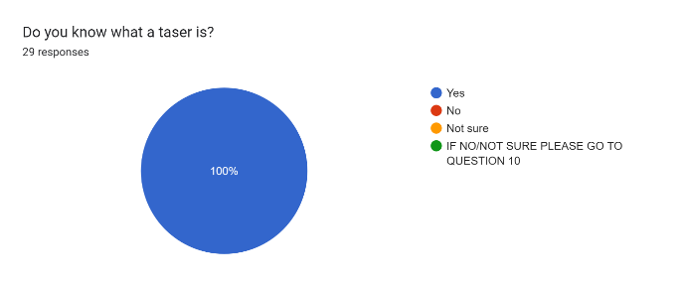
Tasers - 100% of respondents knew what a taser was, this question was asked to ensure all respondents knew what the questions posed were related to.

4.2.3
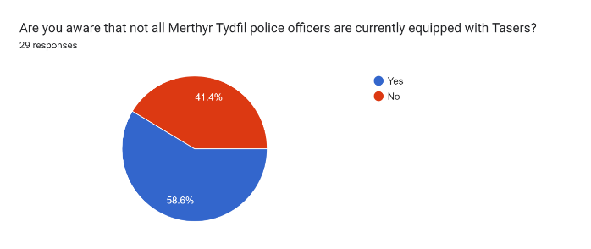
56.6 % of the public knew that not all police officers were issued tasers, but 41.4% didn’t know that all police officers in Merthyr Tydfil were not issued tasers.

4.2.4
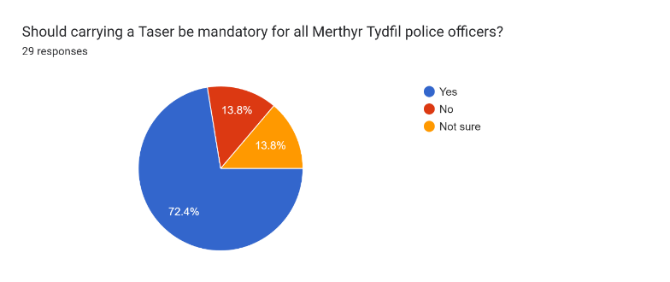
The graph shows that 72.4% of the public said that it should be mandatory to carry tasers, although the majority of the public want officers to carry tasers there was a smaller proportion 37.6% that disagreed.

4.2.5
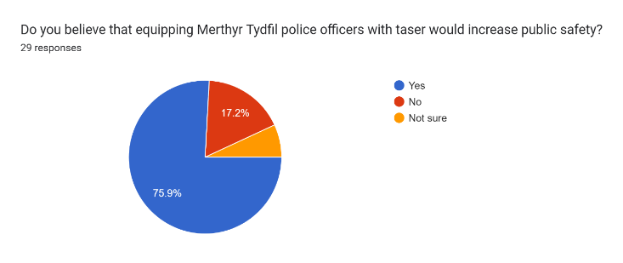
75.9% said that equipping police officers with a taser would increase public safety.

4.2.6
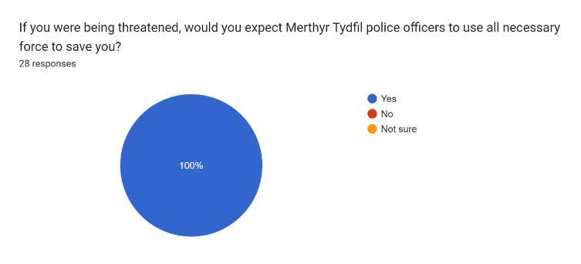
100% of respondents said that, if threatened they would expect Merthyr Tydfil officers to use all necessary force to save them.

4.2.7.
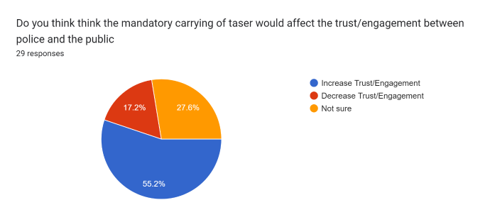
55.2% of respondents said that carrying tasers would affect the trust/engagement between police and public, but 44.8% said that engagement would decrease, or they were unsure.

4.3. Online Police survey Findings (Appendix iii)
The sample size was fair with eighteen respondents that equates to 50% of all front-line officers in Merthyr Tydfil.

4.3.1.
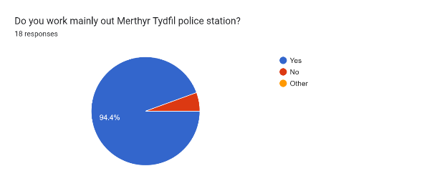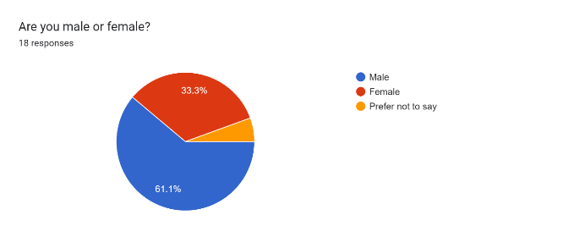
Police Demographics – 94.4% they work mainly in Merthyr Tydfil, as we have seen a number of police officers are called out of the area on a number of occasions per month.

4.3.2
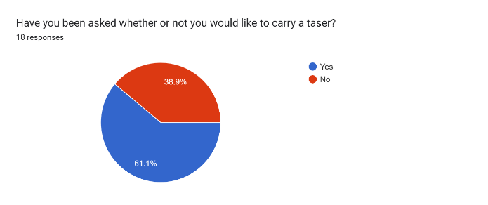
61.1% stated they had been asked to carry a taser but 38.9% said that they had not been asked to carry a taser whilst on duty.

4.3.3
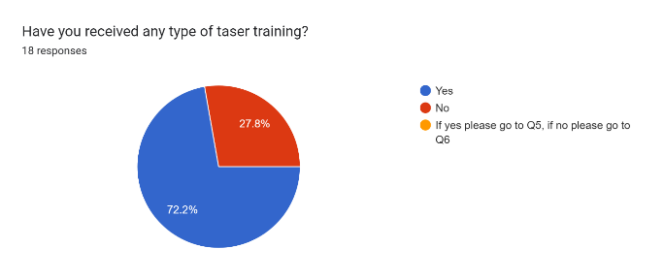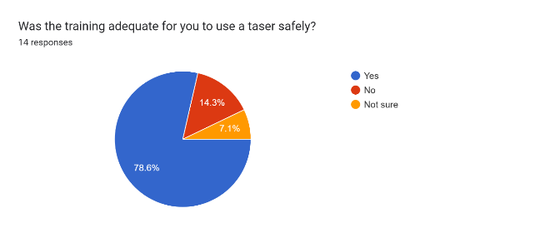
Taser training – 72.2% of the officers had received training 28.8% had not, out of those trained officers 78.6 % said they where happy with the training but 21.4% did not find it adequate

4.3.4
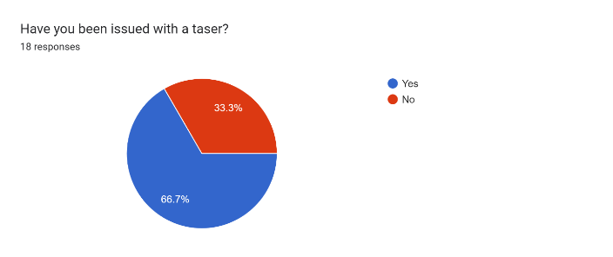
66.6% of officers in Merthyr Tydfil have been issued with a taser, but 33.3% have not.

4.3.5
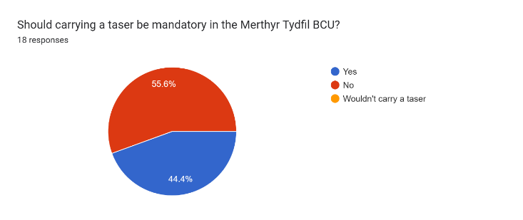
44.4% police officers said that it should be mandatory for all officers to be issued with a taser, while 55.6% felt that it should not be mandatory.

4.3.6
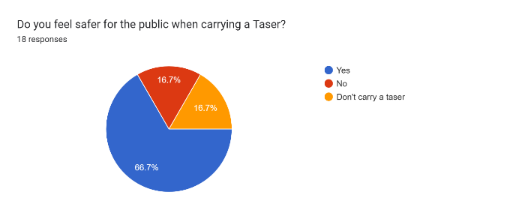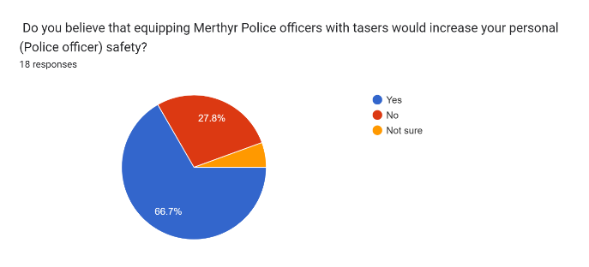

66.7% of police officers in Merthyr Tydfil said that the public and the officers would be safer if they carried a taser.

4.3.7
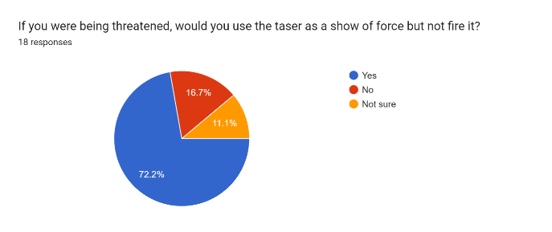

72% of Merthyr Tydfil police officers said they would use a taser as a show of force but would not fire it.

4.3.8
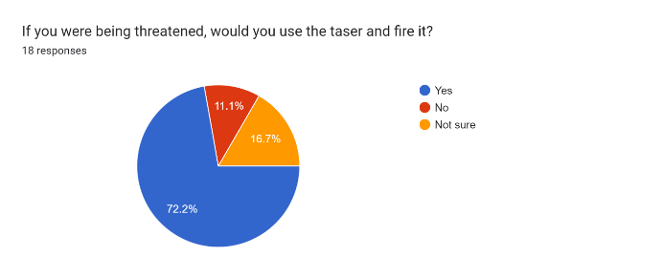
72.2% of Merthyr Tydfil police officers would use a taser by firing it if they felt threatened.

4.3.9.
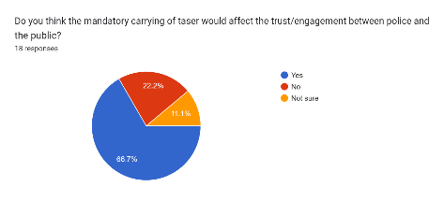
66.7% of Merthyr Tydfil police officers said that carrying a taser would affect the engagement of the public with police officers.

5. Comments
There were a number of comments made including:

Public
“All police officers should be issued tasers, not only in Merthyr Tydfil”.
“I thought that they all carried a taser already”.
“Theres probably not enough budget to buy everyone a taser”.
“Police should be given all the tools they need to protect us the public”.

Police
“I don’t want to use a taser as it produces too much paper work”.
“I would rather the old ways of communication”.
“Police officers to be given the right to choose whether or not they carry taser”.

6.0 Interview (Appendix iii)
Data was needed to find out how police officers working in the Merthyr Tydfil area operated within the South Wales Police Force, and this qualitative data would be used with the surveys returned from the public and police officers.

The interview revealed there are 16 tasers at Merthyr Tydfil charged and ready to use, there are 36 front Line officers split into response teams, consisting of 24 Males, 12 Females and three female special officers. These officers can be called away from Merthyr Tydfil and help out in surrounding areas to include Aberdare and Pontypridd. There are around 24 - 28 times per month where officers are called to assist in these other areas, that’s almost every day of each calendar month, leaving the Merthyr Tydfil area very poorly covered by available police officers.

There are five teams deployed in a rolling shift pattern over 24 hours with between 6 – 8 police officers, this number drops when accounting holiday and sickness levels.

7.0 Analysis and Results
The survey’s results provide valuable information and perspectives of the police officers and the public of Merthyr Tydfil on the mandatory issue of tasers to police officers in Merthyr Tydfil. Overall, the findings suggest the public, who were all residents of Merthyr Tydfil were aged over 22 and employed, all knew what a taser was. Most of the public knew that not all officers were issued tasers as standard, although a high percentage 72.4% said that they should be issued to officers, which reflects the findings contained within the literature review chapter, where it stated ‘findings from a poll conducted in 2016 demonstrated 71% of the public were in favour of police carrying taser’ (Squires, 2017). This was repeated in 2019 where ‘72% of the public agreed’ (Police Federation 2019). Although there is a high percentage of members of the public who feel that issuing tasers to officers said this would increase public safety, it has to be acknowledged that using the “taser first” approach found that officers were likely to miss opportunities to de-escalate the situation using their other skills. Quinton and Tuffin (2007) go further and suggest the best method for the public’s perception on safety is through neighbourhood policing, such as police on the streets interacting with the public.

All the officers who responded to the questionnaire, worked in Merthyr Tydfil, but were regularly requested to assist in other local towns to help and support fellow officers. Most police officer respondents had received training to use the taser, but a high proportion found the training inadequate, previous literature suggests that there is a major issue with training as it prioritised police safety and legal protection before public safety (UCL, 2023). After the training, 66.6% of officers working in the Merthyr Tydfil area, were issued a taser yet statistics for the police forces across England and Wales shows only 17,000 from a total of 125,000 officers, just 13.6%, were issued a taser from 2018 (Home office, 2022). Therefore, comparatively, Merthyr Tydfil has a larger proportion of officers taser-trained than when compared to the numbers across England and Wales.

There was low support for taser issue among police officers at just 44.5%, however, 55.6% said they didn’t want to carry one in the first instance. Some of the reasons attributable to this decision, could be related to comments about the inadequate training and excessive paperwork required if a taser is deployed in the line of duty.
It could also be attributable to the officers’ feelings of the negative impact on the public’s perception and relations with the police. However, these opinions are contrary to officers acknowledging that both they and the public would be safer if they did carry them, especially with a 27% increase in attacks on police officers resulting in injuries (Police Federation, 2019). This appears to agree with the literature that highlights the police and public deserve to be protected, advising tasers are a tool that can do that (Policing insight, 2023). Many officers suggested that they would carry a taser but not fire it, using it as a deterrent rather than a non-lethal weapon.

8.0 Bibliography

Home Office (2022). Police use of force statistics, England and Wales: April 2021 to March 2022. [online] GOV.UK. Available at: https://www.gov.uk/government/statistics/police-use-of-force-statistics-england-and-wales-april-2021-to-march-2022/police-use-of-force-statistics-england-and-wales-april-2021-to-march-2022.
Police Federation (2019). Police officers and the public support Taser roll out. [online] www.polfed.org. Available at: https://www.polfed.org/news/latest-news/2019/police-officers-and-the-public-support-taser-roll-out/.

Policing Insight. (2023). The truth about TASER: How do TASER energy devices protect officers and subjects alike? [online] Available at: https://policinginsight.com/feature/the-truth-about-taser-how-do-taser-energy-devices-protect-officers-and-subjects-alike/

Popenoe, R., Eklöf, A.L., Stenwall, E. and Jervaeus, A. (2021). A practical guide to data analysis in general literature reviews. Nordic Journal of Nursing Research, [online] 41(4), pp.175–186:
https://org/10.1177/2057158521991949.
‌
Quinton, P. and Tuffin, R. (2007). Neighbourhood Change: The Impact of the National Reassurance Policing Programme. Policing, [online] 1(2), pp.149–160. https://doi.org/10.1093/police/pam024.

South Wales Police UK (2023). WWW.South Wales Police UK. available at:
https://www.south.wales.police.uk/police-forces/south-wales-police/areas/stats-and-data/policies-and-procedures/use-of-police-powers/.

Squires, P., 16 Mar 2017, Handbook of Community Safety and Crime Prevention. Tilley, N. & Sidebottom, A. (eds.). Abingdon, UK: Routledge, p. 32-53 22 p.
Research output: Chapter in Book/Conference proceeding with ISSN or ISBN › Chapter

The European Convention of Human Rights (1998): Use of force in law enforcement and the right to life. The role of the Human Rights Council>Three SWP Special Officers the first to be authorised to carry Taser following legislation change. https://www.south-wales.police.uk/news/south-wales/news/2023/ion-jan/three-swp-special-officers-the-first-to-be-authorised-to-carry-taser-following-legislation-change/

UCL (2023) Complex Picture Emerges Around Disproportionate Use of Taser in Some Communities. (Online) UCL News. Available at: https://www.ucl.ac.uk/news/2023/dec/complex-picture-emerges-around-disproportionate-use-of-taser-in-some-communities.

8.0 Appendix
Appendix i Public Survey
Appendix ii Police Survey
Appendix iii Interview

Appendix i

Should it be made mandatory for all Merthyr Tydfil police officers to carry tasers?

Questions/Survey: Public
1 Do you live in the County Borough of Merthyr Tydfil?
O YES
O NO.

2) Which age group are you in
0-16, 17-21, 21-31, 32-42, 43-53, 54 plus

3) Are you male or female?
O Male
O Female
O Prefer not to say

4) What is your Occupation?
O Employed
O Unemployed
O Student
O Other

5) Do you know what a taser is?
O YES
O NO.
O Not sure
(If No go to question 10)

6) Are you aware that not all Merthyr Tydfil (MT) Police Officers are issued with taser?
O Yes
O Not sure
O No

7) Should carrying a taser be mandatory in the MT Police force?
O Yes
O Not sure
O No

8) Do you believe that equipping MT Police officers with taser would increase public safety?
O Yes
O No
O Not sure

9) Do you believe that equipping MT Police officers with taser would increase your personal safety?
O Yes
O Not sure
O No

If you were being threatened, would you expect MT police force to use all necessary force to save you?
O Yes
O No
O Not sure
Coments
……………………………………………………………………………………………………………………………………………………………………………………………………………………………………………………………………………………………………………………………………………………………………………………………………………………………………………………………………………………………………………………………………………………

Thank you

Appendix ii

Questions/Survey: Police
Should it be made mandatory for all Merthyr Tydfil police officers to carry tasers?

1) Do you work mainly out of the Merthyr Tydfil Police Station?
O Yes
O No
O Other

2) Are you male or female?
O Male
O Female
O Other

3) Have you been asked whether or not you would like to carry a taser?
O YES
O NO

4) Have you received any type of Taser training?
O Yes
O No
If yes please go to Q5, if no please go to Q6

5) Was the training adequate for you to use a taser safely?
O Yes
O No
O Not sure

6) Have you been issued with a taser?
O Yes
O No

7) Should carrying a taser be mandatory in the MT Police force?
O Yes
O No
O Wouldn’t carry a taser

8) Do you feel safer for the public when carrying a Taser?
O Yes
O No
O Don’t carry a taser

9) Do you believe that equipping MT Police officers with taser would increase your personal
(Police officer) safety?
O Yes
O No
O Not sure

10) If you were being threatened, would you use the taser as a show of force but not fire it?
O Yes
O No
O Not sure

11) If you were being threatened, would you use the taser and fire it?
O Yes
O No
O Not sure

12) Do you think the mandatory carrying of taser would affect the trust/engagement between police
and the public
O Yes
O No
O Not sure
Comment: ………………………………………………………………………………………………………………………………………………………………………………………………………………………………………………
Thank you
Appendix iii

Semi structured Interview questions and answers
A senior member of staff gives information on Merthyr Tydfil Police Force, gathered by interview, a number of set questions were asked to so how the police worked in Merthyr Tydfil Police Force.

Question: How many front-line officers are there in Merthyr Tydfil police force:
Answer: There are 36 front line response officers assigned to Merthyr Tydfil

Question: How many Males Officers:
Answer: There are 24 male officers and 12 female officers

Question: How many Special Officers:
Answer: 3 female special officers at present.

Question: Anyone else that are deployed to the front-line Including volunteers:
Answer: None at present.

Question: How many police officers are deployed on each shift (Should be, including holiday and sickness absentees).
Answer:
Team 1 - 6 officers

Team 2 - 6 officers

Team 3 - 8 officers

Team 4 - 10 officers

Team 5 - 6 officers

Question: Do the Merthyr Tydfil Police Force only police Merthyr Tydfil County Bough Council area:
Answer: No, the police officers from Merthyr are sent to other areas in Mid
Glamorgan, such as Aberdare and Pontypridd.

Question: If no how many times a month would MTPF be called to another area:
Answer: Roughly 24/28 times per month

Question: How many tasers are held at the Merthyr Tydfil Police station:
Answer: There are 16 charged and available at all times

