Micro Power Generation
M7X01638
James nEUCKER
2017
Contents
Introduction 3
Principles of how wave energy can be utilised to generate electricity 4
Power Take Off Systems 6
Wave Profile Devices 9
Oscillating Water Columns 11
Wave Capture Devices 12
Submerged Pressure Differential 13
Critical evaluation of the technology available for energy generation 13
Analysis of the factors that should be considered when evaluating the different technologies suitability 15
Costs and environmental issues 20
Conclusion 21
Works Cited 22

Figure 1 : Power Take Off Schematic 6
Figure 2 : Air Turbines for WEC 7
Figure 3 : Hydraulic Turbines for WEC 7
Figure 4 : Hydraulic Oil Cylinder Schematic 8
Figure 5 : Wave Profile Devices 10
Figure 6 : Oscillating Wave Column 11
Figure 7 : OWC with Turbine Generator 11
Figure 8 : Wave Capture Device 12
Figure 9 : Submerged Pressure Differential WEC 13
Figure 10 : WEC Design Analysis Bar Chart 15
Figure 11 : Mean Wave Power over the past 11 years 15
Figure 12 : Mean Wave Power 2016 16
Figure 13 : Depth of Seabed West coast of Scotland 16
Figure 14 : Mean Water Depths for Scotland 17
Figure 15 : Annual cycle of mean wave power North Scotland 17
Figure 16 : Annual mean wave power cycle for West of Orkney 18
Figure 17 : Annual mean output of 750kW Pelamis in Orkney 18
Figure 18 : Comparison of different WEC Power Output from 2016 Orkney mean wave power 19
Figure 19 : Power output comparison for small scale scheme 19

Table 1 : Capture width lengths of different wave energy converters 10
Table 2 : WEC Design Analysis 14
Table 3 : 2017 Tariff 20
Table 4 : Max feed-in revenue 20
Table 5 : Pelamis Operating cost UK Predictions 21

Equation 1 : Power of Wave 4
Equation 2 : Law of Conservation of Energy 5
Equation 3 : Prime Mover Power 5
Equation 4 : Maximum power by Point Absorber 9
Equation 5 : Boyles law 12

Introduction

The purpose of this assignment is to create a report that assess the viability of using potential wave energy to generate electricity for an estate situated on the North-West coast of Scotland. Within the report evaluations of the principles of how the potential wave energy technology will generate power, a critical evaluation of the range of technology that is available for use, an evaluation of the potential problems that could arise from the application of each type of wave energy technologies and the cost analysis of the potential technologies and what environmental impacts they will have on the local environment.
This report will include the principles used to generate power from WEC to allow the reader of the report information of how the technology is utilised to generate power from wave energy. This will be completed as wave energy technology is relatively new when compared to more established renewable energy systems.
To select the correct technology for use there must be initial research completed to establish what environmental conditions the technology will be operating in. Gathering the relevant information on the surrounding environment will allow for potential technologies to be judged against their application in the chosen location. The research into the operating environment will also highlight issues that may arise with installation and commissioning, planned and unplanned maintenance and the decommissioning and removal of the technology at the end of the assets lifecycle.
Extracting energy from marine sources has been well researched and practically explored to some extent, with Marine Renewable Energy Systems being established for many years, most marine schemes that are operational as of 2017 are tidal based extracting energy from tidal ranges.
0.5 GW of commercial marine energy generation capacity is in operation and another 1.7 GW under construction, with 99% of this accounted for by tidal range.
(World Energy Council, 2016)
With 99% of the marine energy generated from tidal sources due to the tidal range of a given location being predictable for both magnitude and frequency, tidal sources have a high level of predictability and have been developed and implemented to a far greater extent than wave energy technology. When compared to established tidal schemes, wave energy power generation is yet to prove its overall efficiency, reliability and overall cost leading to wave energy technologies being considered high risk and the technology is still in the research and development stage.
e.g. by the EU with 68% of the funds being directed to technology development
(Andreas Uihlein, 2016)
The global power potential represented by waves that hit all coasts worldwide, has been estimated to be in the order of 1 TW (1 terawatt = 10 ¹² W)
(Falnes, 2007)
As an estimated utilised power percentage (all marine sources);
$$\frac{Tidal Power+Wave Power}{Theoretical Available Marine Energy}=\frac{(2.2 × {10}^{9})}{(1 × {10}^{12})}=0.0022$$
$$0.0022 ×100=0.22\%$$

Principles of how wave energy can be utilised to generate electricity

The location of the potential site for the wave energy technology will be within the Lord Brooke Estate on the West coast of Scotland. As the location is known the wave climate of the area can be analysed to find technologies that are best suited to the location.
The North-West of Scotland has a wave climate that is mostly influenced by the North Atlantic events where the effects of wind on the ocean surface generate the swell that results in the wave formations closer to the coast. The energy of marine waves is dissipated when the wave breaks where the kinetic energy of the wave is lost due to frictional losses from the generation of high turbulence, sound and bubble generation. The aim of wave technology is to obtain the mechanical energy of the wave before it has reached an amplitude where the wave begins to break.
The power of a wave can be calculated using;
$$P= \frac{ρg^{2}}{64π} H_{m0}^{2}T_{e }≈ \left(0.5 \frac{kW}{m^{3} ∙ s}\right) H_{m0 }^{2} Te$$
Equation 1 : Power of Wave
(Herbich, 2000)
Where;
$$P=Power flux (per metre of wave height)$$
$$ρ=Fluid density$$
$$g=Gravitational acceleration$$
$$H_{m0}^{2}=Significant wave height$$
$$T_{e}=Wave energy period$$

Equation 1 is used to establish an approximated value for the power flux of an ocean wave with the power flux being the rate at which energy is transferred through the surface of the wave. Assuming the salinity and density of the sea water result in a density of 1025kg/m³, the approximation of 0.5 can be shown by;
$$\frac{ρg^{2}}{64π}= \frac{1025 ×{9.81}^{2}}{64 × π}=490.6050717$$
Which can be taken as 0.5 to give a result in Kw, the above result would produce a value for P in watts.
The challenge with any energy recovery system is increasing the efficiency of the system when converting the energy in its original state into a state that can be utilised. In an ideal isolated system, the energy recovery would be 100%.
Energy can neither be created nor destroyed; energy can only be transferred or changed from one form to another.
(Lower, 2016)
$$∆U=Q+W$$
Equation 2 : Law of Conservation of Energy
(Lower, 2016)
Where;
$$∆U=change in internal energy$$
$$Q=Applide heat$$
$$W=Work done by the system on the surrounding atmosphere$$
Since losses in any real-world system from friction, heat, sound and electrical resistance make up a proportion of the work done by the system, the ideal efficiency of 100% will not be achieved. If a wave energy recovery system could absorb 80% of the flux and had an efficiency rating of 0.75 and the original wave had a significant wave height (peak to trough) of 1.5 metres with a wave period of 10 seconds, the power converted can be calculated as;
$$P≈0.5 × {1.5}^{2} ×10$$
$$P ≈11.25 kW/m$$
$$P ≈11.25 ×1.5$$
$$P ≈16.875 kW$$
$$16.875 ×0.8 =13.5$$
$$13.5 ×0.75=10.125 kW$$
Wave Energy Converters allow the kinetic energy of a wave to be converted into electrical energy through the rotation of a turbine. The type of turbines used in WEC are connected to permanent magnet synchronous generators that use permanent magnets that rotate to induce alternate current as the flux of the magnet alternates with each rotation of the shaft, each rotation involves the North and South pole passing the stationary armature counting as a single cycle, the number of completed cycles is directly related to the RPM or the angular velocity of the shaft.
$$\frac{P}{120}$$
$$P=Number of Magnetic Rotor Poles$$
$$120=Number of Pole Passes of Armature$$
The power that is transferred through the generator is a function of the torque and revolution of the shaft.
$$Pm=Tm ×RPM$$
Equation 3 : Prime Mover Power
$$Pm=Mechanical Power (Watts)$$
$$Tm=Torque \frac{N*m}{rads}$$
$$RPM=Revolutions per minute$$
For a larger electrical output, the torque must be increased. The rotation of the turbine can be powered by Hydraulic or Pneumatic systems which varies with the design and type of WEC.

Power Take Off Systems

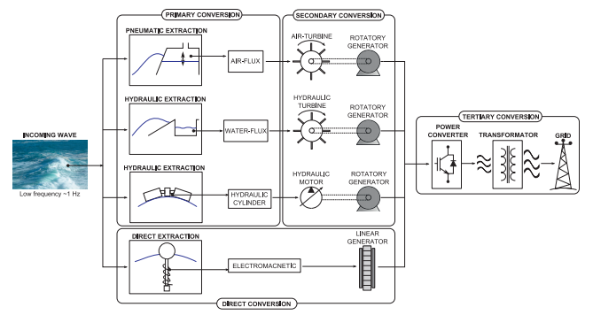
Figure 1 : Power Take Off Schematic
(López, 2013)
The turbine that are used for Hydraulic, water-flux and air-flux are designed specifically to allow the greatest amount of energy to be converted from the primary conversion to the secondary conversion where the electrical energy is generated.
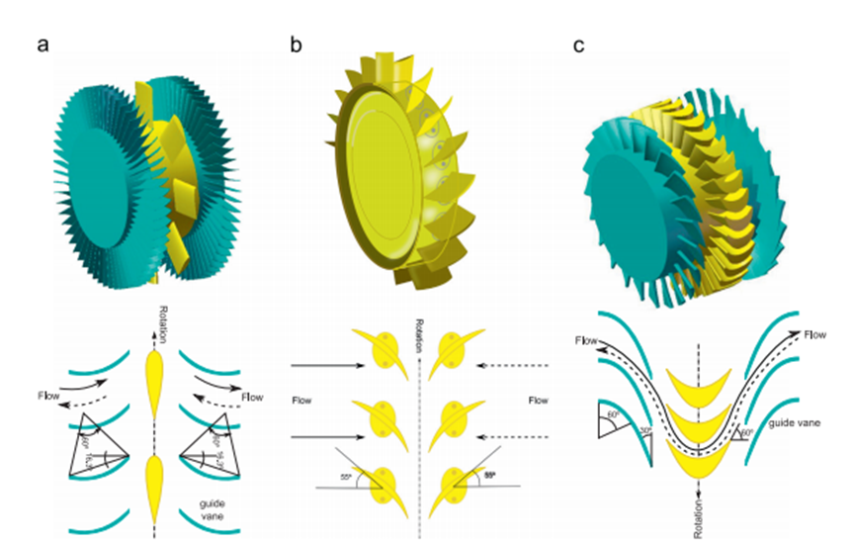
Figure 2 : Air Turbines for WEC
(López, 2013)
- Wells air-turbine, allows for high speed rotation when low air flow is available and the torque that is generated form the rotation is not dependent on the direction of the airflow onto the turbines blades.
- Dennis-Auld air-turbine, has solidity allowing for greater efficiency than the Wells turbine.
- Impulse air-turbine, reacts to flow in the same way as the Wells turbine but has variable pitch to aid with changes in airflow.

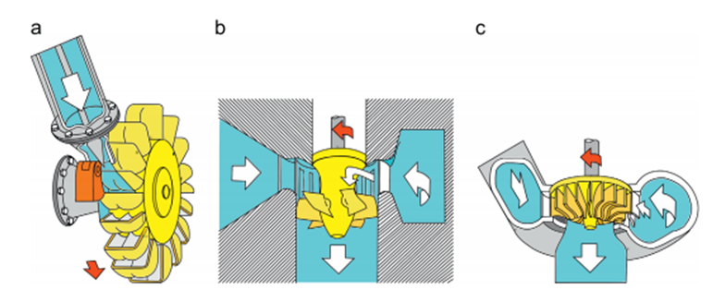
Figure 3 : Hydraulic Turbines for WEC
(López, 2013)
- Pelton turbine, mainly used for high head schemes where the piezometric head is greater than 50m.
- Kaplan turbine, widely used in WEC as they have a high efficiency when operating in a medium to low head pressure 10-50m
- Francis turbine, not generally used in the current WEC technologies as a high head is required.

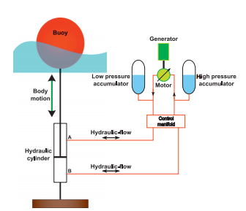
Figure 4 : Hydraulic Oil Cylinder Schematic
(López, 2013)
The Hydraulic oil cylinder system allows energy from multiple wave oscillations to generate high pressure within the accumulators that can be utilised when demand requires power generation. With any high pressure hydraulic system, the equipment is expensive and component failures result in the system going offline.

Wave Profile Devices

Wave profile devices are situated on the surface of the sea and generate power from the changing level of the peak and the trough of the wave. Wave profile devices can be split into two categories, point absorbers and linear absorbers.
Point absorbers size relative to the length of the wave is relatively small and a linear absorbers size compared to the wave length is generally greater. The power generated from point absorbers occurs when the vertical height of the system relative to the seabed increases, this kinetic movement is then used to generate power. Point absorbers work best when the system is close to resonance, for example once the amplitude and frequency of the incoming waves is close to the maximum extension (heave) and operating frequency of the point absorber the efficiency at which the system oscillates is improved.
The operating efficiencies of the point absorber that consist of two floating bodies with no fixed dead weight allow the efficiency of the system to remain at a higher value for longer than a fixed-point absorber as the operating frequency can be met over a greater range of wave amplitude due to the fixed mooring line preventing wave overtopping to some extent. However, the fixed mooring may be subjected to high dynamic loading stresses during high amplitude waves resulting in damage.
To calculate the maximum power that can be absorbed by a point absorber the following equation can be used;
$$P_{max}= \frac{F_{d}^{2}}{8C}=JL_{max}$$
Equation 4 : Maximum power by Point Absorber
(Yi-Hsiang Yu, 2013)
Where;
$$F_{d}=Excitation force$$
$$C=Radiation damping$$
$$J=Wave energy flux$$
$$L_{max}=Absorption Width$$
The absorption width or capture width is defined as;
the width of the incoming wave-front that has the same power as that being absorbed by the device.
(FARLEY, 2012)
The absorption width of the incident wave is not relative to the size of the WEC as the energy carried by the wave can vary with the waves height, length and period making it difficult to calculate the most efficient array of point absorbers, when multiple devices are to be used. The Point absorbers generally use compressed air to generate rotation of the generator shaft.
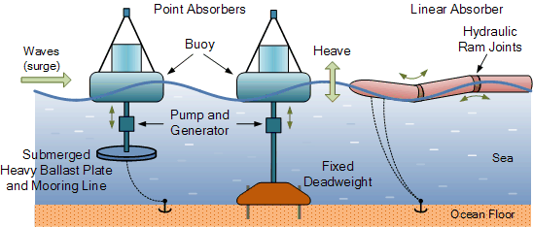
Figure 5 : Wave Profile Devices
Linear or Line absorbers typically absorb greater amounts of energy when compared to other technologies as the energy of the wave is absorbed along the longer length of the WEC where point absorbers only react for a shorter distance. Linear absorbers also allow for the energy reduction of the wave as it passes across the length, this is completed by a control system that increases the resonance reaction of the initial section as the wave passes with high energy and this reaction resonance is decreased for each section to maximise the amount of energy absorbed as the waves energy local to the WEC decreases because of absorption.
Mode of absorption | Theoretical ultimate capture width (percentage of wavelength)
Offshore heaving body (Single) | 16%
Offshore surging or pitching (Single) | 32%
Offshore heaving-and-surging or heaving-and-pitching | 48%
Line absorber of length = wave length (current Pelamis) | 50%
Line absorber of length = twice the wave length (ultimate Pelamis) | 75%
Table 1 : Capture width lengths of different wave energy converters
(PelamisPower, 2017)
The power absorption for the linear WEC is known to be greater than the individual point absorbers as the Linear WEC absorbs more energy from multiple waves across its length rather than the capture width of the single point absorbers, however the linear point absorbers require greater initial capital to purchase and maintain, compared to individual point absorbers. Failure of a single point absorber that is part of an array can be replaced costing far less than replacing a failed linear absorber. Linear WEC use a hydraulic system to power the generator and as a hydraulic system is in use it is common for an accumulator to be used to store the hydraulic fluid under pressure to allow for generation when the WEC is not in motion.

Oscillating Water Columns

An oscillating water column is a wave energy converter that uses the movement of the sea to compress a volume of air that is trapped in the column, once the compressed air has passed through the turbine and the trapped air within the column has reduced to the atmospheric pressure a valve opens to draw in a volume of air equal to the volume of water that drains from the device when the water level surrounding the device.
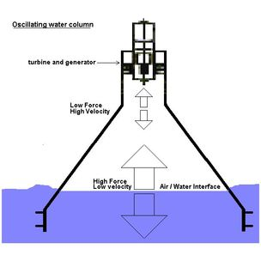
Figure 6 : Oscillating Wave Column
Oscillating wave columns are designed with a conical shaped internal cavity that enables a large volume of water that has low velocity to compress a volume of air that is pressurised and released through the tapered end of the column with high velocity to power the turbine which then powers a generator to convert the kinetic power to electrical energy.
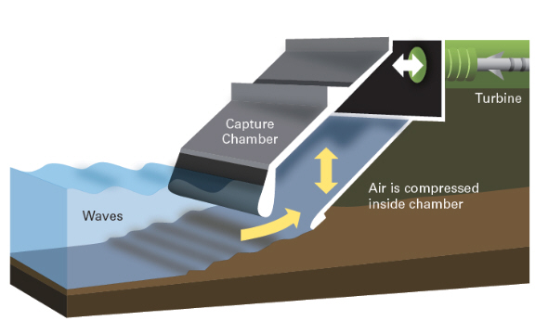
Figure 7 : OWC with Turbine Generator
The OWC column can convert energy when the correct conditions are present with efficiency of 0.75. This efficiency is affected by the available wave size and frequency, as waves that do not create a complete seal or have a long enough period to allow the water volume within the OWC to decrease reduce the compression effect experienced by the air within the chamber. The compression of the air in the capture chamber follows the principles of Boyles law as the compression cycle is Isothermal with the temperature remaining constant;
$$P_{1 }V_{1}= P_{2 }V_{2}$$
Equation 5 : Boyles law
Where;
$$P_{1}=Initial Pressure$$
$$V_{1}=Initial Volume$$
$$P_{2}=Compressed Pressure$$
$$V_{2}=Compressed Volume$$

Wave Capture Devices

Wave capture devices are used close to the shore where a sea swell with uniform velocity relative to the seabed encounters a decreasing water level as the sea meets the shore line, as the water level decreases the bottom of the swell slows due to friction and the top of the swell maintains the initial velocity. As the swell reaches the lower water depths the amplitude increases, this change in wave height is what the wave capture device uses to generate power, with the wave capture device using the change in piezometric head pressure of the fluid that has entered at a higher point than the surrounding sea level to power a turbine that generates electrical energy.
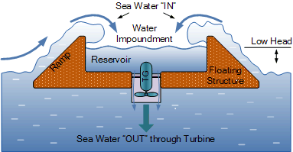
Figure 8 : Wave Capture Device
The image above shows the cross-sectional profile of the device that floats whilst remaining partially submerged, the structure has sides that are sloped to increase the amount of water that enters the reservoir. The efficiency of WCD is far lower than other available technologies due to the energy loss from the incident wave hitting the WCD and only a portion of the volume of the water entering the reservoir.

Submerged Pressure Differential

The Submerged pressure differential WEC is constructed in a similar way to the fixed-point absorber where the device is fixed to the seabed and generates electricity when the pressure directly above the device increases and decreases when a wave passes over the WEC. The submerged WEC uses the increased pressure caused by passing waves to compress a volume of air that is trapped in the top section of the device whilst pushing this section towards the seabed. Once the wave has passed and the following trough reduces the head pressure of the water above the WEC allowing the top section of the device to rise.
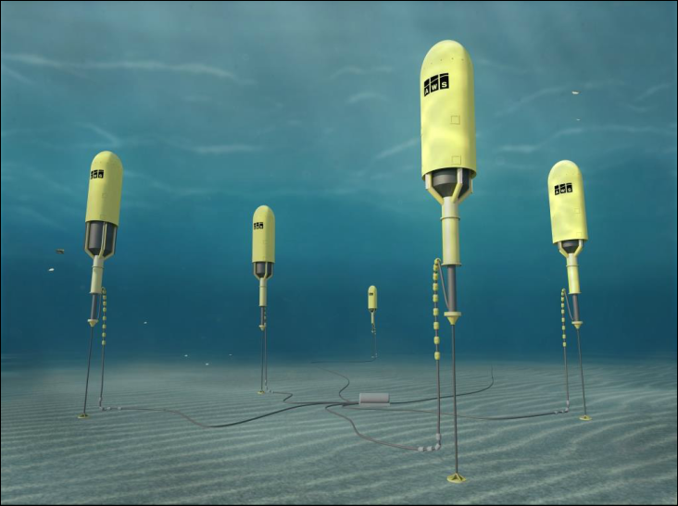
Figure 9 : Submerged Pressure Differential WEC
The compressed air within the device is then used to power a generator to create electrical power.

Critical evaluation of the technology available for energy generation

Point absorbers offer the potential for power generation when the device is subjected to sea swells from any direction. The device if placed off the North-west coast of Scotland would be subjected to mainly sea swells from the West and the ability to absorb waves from various directions would not increase the generation potential when compared to other technologies that rely on swell of a set direction. If multiple point absorbers were to be used to create an efficient array the energy converted could be multiplied by the number of point absorbers used and the cost of connecting the array to the grid could be less per point. An advantage of using multiple point absorbers is that when planned or unplanned maintenance is required a single point absorber can be taken offline and worked on with the remaining point absorbers remaining online decreasing the arrays total annual down time. Point absorbers are widely used relative to other WEC technologies and as this is the case the cost of maintenance may be lower as the number of available contractors and information is higher when compared to other less utilised technologies.
Linear WEC would be well suited to the selected environment due to the WEC’s capability to convert energy efficiently when subjected to a dominant directional swell, in this case incoming swell from the west. The efficiency of this technology is known to be high, combined with the WEC storing energy within its hydraulic system allows for energy to be converted with lower intermittency. For a small-scale scheme the ability of the system to generate power with greater consistency when operational would benefit the consumer. The hydraulic system used in linear WEC would require frequent maintenance as high pressure hydraulic systems are prone to pressure losses from component and connection failure. Losses of hydraulic fluid on land would result in high clean-up costs, with this system operating at sea the cost would be increased also the financial penalties put in place by the Scottish Environment Protection Agency SEPA would be substantial. As this scheme would require a single linear WEC the down time of the whole system would be greater when compared to an array of point absorbers due to the frequency of the maintenance scheduling if failure occurs within the Linear WEC the whole scheme would be offline.
Oscillating wave columns can be fixed to the shore or moored offshore with a fixed shoreline column only generating power when the tide is within a range that allows the complete compression of the trapped volume of air within the device, if complete compression is not achieved the efficiency of the system is greatly reduced. The cost of connecting a fixed system to the grid would be far less than other systems as the connecting cables would remain on land. A floating Oscillating wave column would not have this issue as the device is situated on the surface of the water which allows complete compression during. If the floating WEC is not properly moored there is potential for the device to be overturned which would result in the compression cavity filing with water and the device would have to be refilled with air to right the system. Connection to the grid would be higher than a fixed shoreline.
Wave capture devices are relatively simple devices when compared to other WEC’s as the only mechanical parts are the turbine and the generator which reduces the required maintenance and down time of the device. The system is simple, but it required the correct sea conditions to operate efficiently and the intermittency of this type of WEC may be greater than other available technology, if the device is located off-shore the connection cost will be high with low power conversion due to the low head hydraulic turbine operating infrequently.
The Submerged pressure differential WEC will require high cost to initially moor the devices beneath the water as specialist would be required to carry out the work. The device itself can be connected underwater then charged with the air that will be compressed. These WEC are generally installed in arrays which allows for reduced grid connection cost per device and increases the online power conversion time of the whole array. As the devices are submerged the potential for the scheme to gain planning permission may be increased as the devices would not impact on the views from the coast which may be a major concern for residents.
 | Point Absorber (array) | Linear WEC | Oscillating Water Column | Wave capture devices | Submerged pressure differential (array)
Operating Time | 5 | 3 | 2 | 2 | 5
Maintenance Cost | 4 | 2 | 3 | 4 | 2
Planning Permission | 3 | 3 | 2 | 2 | 4
Grid Connection | 3 | 2 | 4 | 3 | 3
Breakdown  (offline) | 4 | 2 | 4 | 5 | 4
Operating Conditions | 4 | 4 | 3 | 2 | 4
Total | 23 | 16 | 18 | 18 | 22
Table 2 : WEC Design Analysis

Figure 10 : WEC Design Analysis Bar Chart

Analysis of the factors that should be considered when evaluating the different technologies suitability

The conditions of the environment that the chosen technology will be operating in must be analysed to ensure that the technologies have an operating range that can with-stand the energy of the average wave and the maximum storm wave of the location.
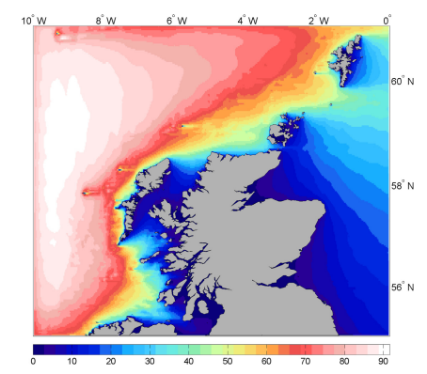
Figure 11 : Mean Wave Power over the past 11 years
(G.Lavidas, 2017)
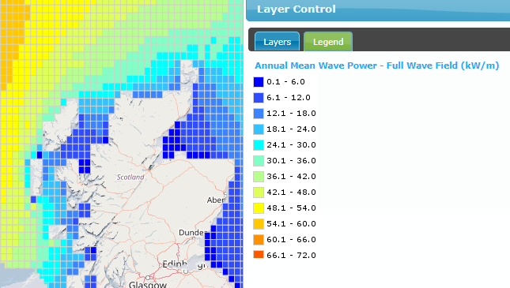
Figure 12 : Mean Wave Power 2016
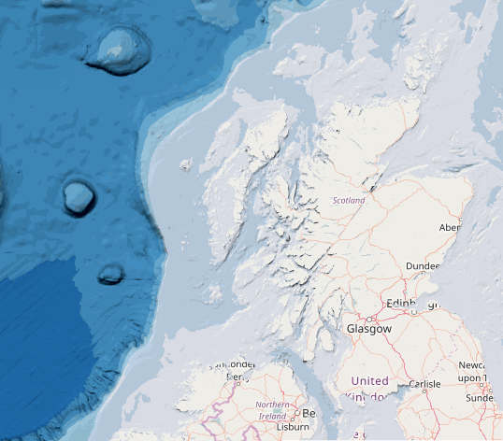
Figure 13 : Depth of Seabed West coast of Scotland

(marine.gov.scot, 2017)
Figure 6 shows the average mean wave power over the last eleven years with Figure 7 showing the mean wave power from 2016, what is noticeable is that the presence of the Outer Hebrides acts as a blocker for the North-West coast of the mainland with the refracted waves continuing to the North-West coast. The mean wave power for the coast in question is between 0.1 (kW/m) and 36 (Kw/m).
The energy flux decreases exponentially with depth so that 95% of the energy is contained in depths above one fourth of the average wave length.
(WATERS, 2008)
The primary source of the sea swells that would be captured by the device are generated in the North Atlantic with the swell propagating from the west.

Figure 14 : Mean Water Depths for Scotland
(Neill S. P., 2016)
When a comparison is made between the mean water depths and the mean wave power what is noticeable is that as the water depth reduces so does the mean power of the waves in that area, as the scheme in consideration is a small scheme this will not be a major influence on the location selection as the cost of deep water installation would be too large for consideration.
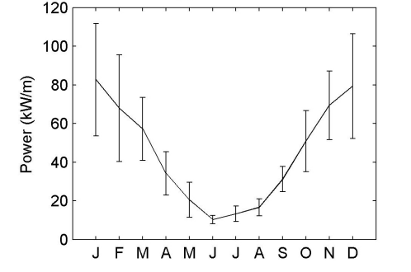
Figure 15 : Annual cycle of mean wave power North Scotland
(Neill S. P., 2013)

Figure 15 shows that during the summer months the power of the waves that occur in the North of Scotland drop, this is caused by the predominant weather conditions during the summer months originating from the south west with the land mass of Ireland and Southern Britain disrupts the migration of the sea swells to the North of Scotland. During the Winter months the predominant weather conditions originate in the North Atlantic and the sea swells generated must overcome very little resistance to migrate to the North West of Scotland. This may prove beneficial as the amount of energy required during the winter months in the Northern hemisphere is higher and at a premium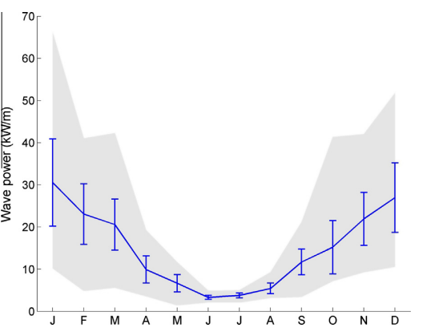
Figure 16 : Annual mean wave power cycle for West of Orkney
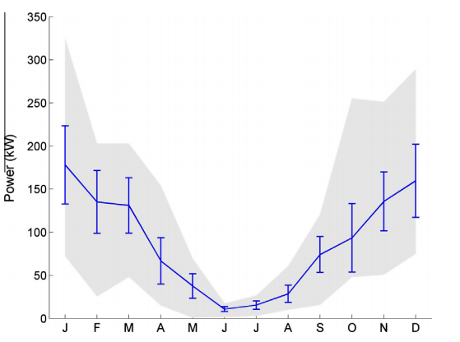
Figure 17 : Annual mean output of 750kW Pelamis in Orkney
(Neill S. P., 2016)

Figure 16 shows the mean wave power cycle for the area to the West of Orkney which further North compared to the North-West. Shaded in grey is the range of wave size and its expected the range for the North-West coast would be similar, knowing the upper limit of the range will enable the operators to establish potential shut down periods to prevent damage to the WEC during extreme conditions.

Figure 18 : Comparison of different WEC Power Output from 2016 Orkney mean wave power

Figure 19 : Power output comparison for small scale scheme

Costs and environmental issues

For calculating the overall CAPEX and OPEX of a WEC array there is currently a lack of data as the WEC schemes that are in place have not been built frequently enough to allow for a reliable estimate to be given for a new scheme as the operational WEC in place currently are still at the experimental stage. As this is the case the construction of WEC has not been completed frequently enough to ensure there is sufficient skill available to efficiently construct the equipment.
To place a WEC at sea the owner of the scheme would firstly have to seek permission from the crown estate as it owns the rights to the majority of Britain’s coastline and a rent would have to be agreed for the lifespan of the scheme. Once permission is granted and a feasibility study has been completed the under-water ground works could start which would be costly due to the nature of the work and highly specialised contractors and equipment would have to be used and would most likely be from the oil and gas industry where the skills and equipment are used for offshore drilling and construction.
The cost of the WEC would consume the largest portion of the initial CAPEX with another large portion taken by the cabling costs of connecting the WEC to the switching gear on land and then to the grid which would also require a one-off payment. Once the WEC is connected service charges must be paid to ensure that regular metering checks take place on time to ensure the whole system meets the compliance standards set by the connection provider.
An estimate of revenue potentially gained can be calculated for each type of WEC excluding the wave capture device as the wave crest height data was not available.
Hydro scheme (kW)
0-100 | 7.78
100-500 | 6.24
500-2000 | 6.24
2000-5000 | 4.54
Table 3 : 2017 Tariff
(ofgem, 2017)
Using the feed in tariff for 0-100(kWh) schemes, an average wave period of 20 seconds and no time offline the following estimates were calculated.
 | Linear | Offshore heaving-and-surging | Offshore surging or pitching | Offshore heaving body
Period 20(s) | 26053.8 | 25011.6 | 16674.4 | 8337.2
Period * 3 | 78161.3 | 75034.8 | 50023.2 | 25011.6
kWh | 4689675 | 4502088 | 3001392 | 1500696
Revenue (£) | 364856 | 350262.5 | 233508.3 | 116754.2
Table 4 : Max feed-in revenue

 | Current (2010) | 2020 | 2030 | 2050
CAPEX | 4000-7000 £/kW | 2500-4000 £/kW | 2000-2500 £/kW | 1500-2000 £/kW
O+M cost | 1.5-4.0 p/kWh | 1.0-2.5 p/kWh | 0.5-1.5 p/kWh | 0.3-1.0 p/kWh
Array Load | 25-35% | 35-40% | 37-42% | 40-45%
Availability | 75-85% | 90% | 90-95% | 95-98%
Overall COE | 17-40 p/kWh | 9-18 p/kWh | 7-10 p/kWh | 5-8 p/kWh
Table 5 : Pelamis Operating cost UK Predictions
(The Energy Technologies Institute, 2013)

Conclusion

Figure 18 is a comparison calculated using the Power generation graph (Figure 17) and multiplying the values by the wave capture width values from Table 1. What is noticeable from the graph is the potential for the Pelamis to generate more power when subjected to higher power waves, this is due to the Pelamis having a greater wave capture width than the other WEC. Figure 19 shows the power output of the same WEC at a smaller scale of 50kW to fit the project brief. From this data it can be assumed that the Linear wave profile device would yield the highest amount of energy when located in the selected environment and the device has the potential to store a supply of energy for generation after the environmental conditions change.
Further consideration should be given to the amount of time the scheme would spend offline due to maintenance and breakdowns when the information becomes available. Currently the design aspect and positioning of potential WEC schemes has been completed using Computational methods where a 2D mathematical model is constructed using the finite difference method and is used to analyses the potential performance of WEC’s.
Table 5 shows a prediction made by the Energies and Technologies Institute that as the number of linear wave profile devices increases the overall cost of energy generation will come down due to refinement in the construction and maintenance of a WEC scheme.
The changes in wave power during the year has been termed the North Atlantic Oscillations (NAO), when installing a Wave Energy Converter scheme of any type in the North Atlantic the seasonal reductions in available wave energy must be met with other sources of energy which should be considered if this scheme is to be used as a main source of energy for the estate.

Works Cited
Andreas Uihlein, D. M. (2016). Renewable and Sustainable Energy Reviews. New York: Pergamon.
Falnes, J. (2007). A review of wave-energy extraction. Trondheim: Marine Structure.
FARLEY, F. J. (2012). Far-field theory of wave power capture. Southampton: The Royal Society.
G.Lavidas. (2017). International journal or marine energy. International journal or marine energy, 64-83.
Herbich, J. B. (2000). Handbook of Coastal Engineering. Michigan: McGraw-Hill.
López, I. (2013). Review of wave energy technologies and the necessary. Renewable and Sustainable Energy Reviews, 422.
Lower, S. (2016, 01 18). http://www.chem1.com. Retrieved from http://www.chem1.com: http://www.chem1.com/acad/webtext/energetics/CE-2.html#SEC1
marine.gov.scot. (2017, 12 08). http://marine.gov.scot/maps/425. Retrieved from http://marine.gov.scot/maps/425: http://marine.gov.scot/maps/425
Neill, S. P. (2013). Wave power variability over the northwest. Bangor: researchgate.
Neill, S. P. (2016). The wave and tidal resource of Scotland. : www.elsevier.com, 5.
ofgem. (2017, 12 11). https://www.ofgem.gov.uk/environmental-programmes. Retrieved from https://www.ofgem.gov.uk: https://www.ofgem.gov.uk/environmental-programmes/fit/fit-tariff-rates
PelamisPower. (2017, 09). https://www.pelamiswave.com/power-capture/. Retrieved from www.pelamiswave.com: https://www.pelamiswave.com/power-capture/
The Energy Technologies Institute. (2013). Cost of Energy Projections. Loughborough: The Energy Technologies Institute.
WATERS, R. (2008). Energy from Ocean Waves. UPPSALA: UNIVERSITATIS.
World Energy Council. (2016). World Energy. London: World Energy Council.
Yi-Hsiang Yu, Y. L. (2013). Reynolds-Averaged Navier–Stokes simulation of the heave performance. Golden: Elsevier Ltd.

