Effective teamworking for Wilko Company
2020
Andreea Esanu (1713835)
Lecturer name: Husam Helmi
5/6/2020
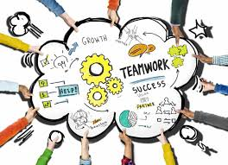

Effective team working for Wilko Company
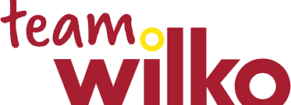

Students name
- Andreea Esanu - group leader – 1713835
  - Benefits of team working
- Claudiu Ciobanu - 1818260
  - Stages of team development
- Corneliu Baba – 1906079
  - Team roles
  - Managing conflict
- Dragos Sorica – 1906082
  - Successful team development

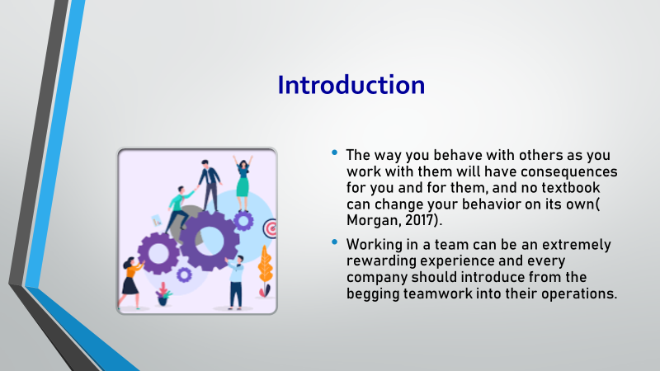

As a group of four people, we paid close attention to the transition points between each member`s portion of task. We want to present to you the key points of introducing the teamwork in your company such as benefits of team working, stages of team development, team roles, managing conflict and successful team development.
My name is Andreea Esanu, I am the group leader and I will talk about what kind of benefits that your company would benefit from o well developed teamwork.

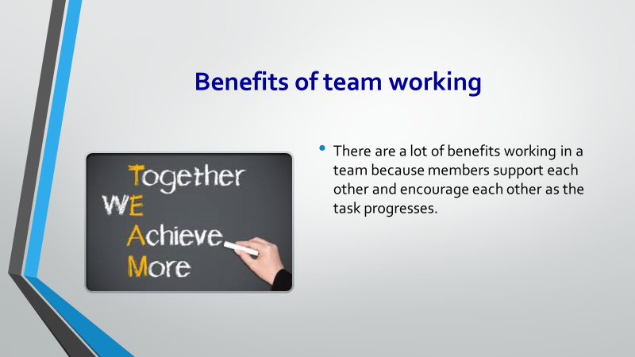

Planning and active participation increase the chances for outstanding team performance (Maund et al, 2017). Teams can achieve extraordinary results if people with different skills and knowledge will work together to produce a creative solution. Together team members can achieve more, they can develop good relationships and friendships because they respect, trust and care for each other. I think that if Wilko Company will introduce teamwork in their operations they will have happy teams of passionate people all doing everything they can to make the stores as good as they can possibly be, whether they work directly with customers or support the teams who do.

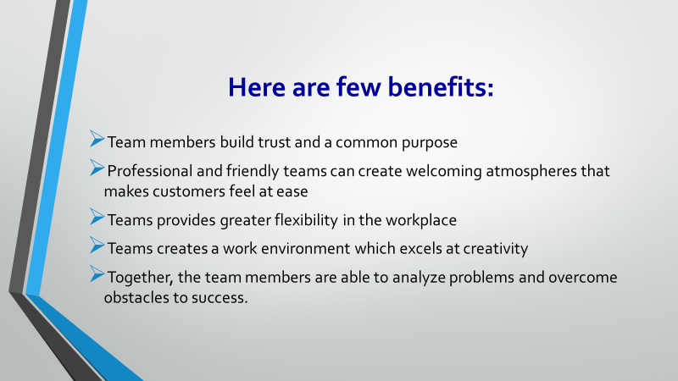

It is important to give formal recognition for employee achievements, especially when they work in teams. Teamwork offers differing perspectives and feedback. Good teamwork structure provides your organization with a diversity of thought, creativity, perspectives, opportunities, and problem solving approaches (Wehbe, 2017). Most of today`s jobs involve interacting with others, and as I said in above slide, teamwork creates a welcoming and flexible atmosphere, leading the business to success. And it is not about only the cashiers that has to work in team, also there are managers to lead, teams to train, people to reward, deliveries to arrange, admin to handle, and they are all part and parcel of keeping every Wilko store running smoothly.
All businesses needs to know that teamwork is important and essential in order to accomplish the overall objectives and goals of their organization. As I said, Wilko Company, will have to focus more on teamwork to benefit from great results and good customer feedback.

And to have a better understanding about teamwork, I will continue with stages of team development, presented to you by our team colleague, Claudiu Ciobanu.
Stages of team development
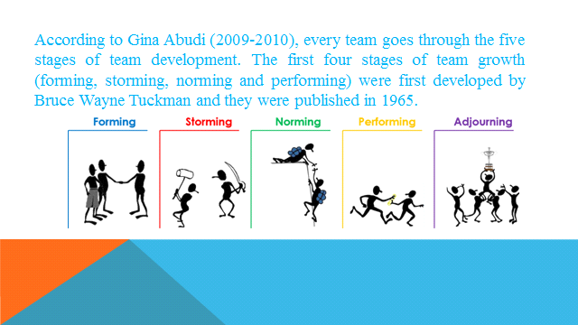

The theory of Bruce W.T. was known as ‘’Tuckman’s Stages” and this theory was designed based on a research where he analyzed the dynamics of a team. He thought that for a team which wants to develop these stages are without whom in order to see that these are functioning efficiently to bring excellent results and to accomplish the goal(s) of the team.

The theory of Bruce W.T. was known as ‘’Tuckman’s Stages” and this theory was designed based on a research where he analyzed the dynamics of a team. He thought that for a team which wants to develop these stages are without whom in order to see that these are functioning efficiently to bring excellent results and to accomplish the goal(s) of the team.

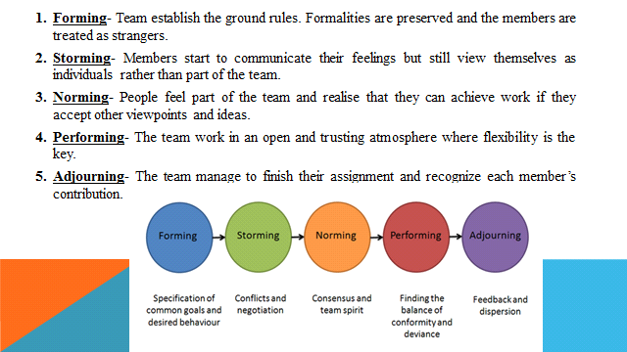

1.Forming- A team of people comes collectively to accomplish a shared purpose. Their initial success will rely on their familiarity with every other's work style, and the readability of their assigned mission. As a team leader, your purpose is to help the team members get to recognize each different whether or not you offer group constructing things to do or simply a listening ear.
2.Storming- May exist any disagreement about the mission and the vision and ways to approach the trouble or task are regular at this stage of development. This confusion is mixed with the fact that individuals are nonetheless getting to understand each other, getting to know to work with every other, and growing acquainted in the process and verbal exchange of team members. As a team leader you need to assist your group chief members and clarify each of these assignments so that the team succeeds.
3.Norming- The team has consciously or unconsciously formed working relationships that are enabling development on the team’s objectives. The participants have consciously or unconsciously agreed to abide by using certain team norms, and they are turning into practical at working together. As a team leader, ask for periodic updates from the team. Regularly test the team's progress at agreed-upon intervals and fundamental steps on the path to a successful conclusion
4.Performing- Relationships, group processes, and the team’s effectiveness in working on its goals are syncing to convey about a efficiently functioning team. This is the stage at which the actual work of the crew is progressing. As a team leader, ask for periodic updates from the team. And help them to solve any troubles and provide input if needed. You need to make it clear that the members are communicating with all in the different stages of the process.
5.Adjourning- This is the stage that was added by Tuckman in 1977 in which he said that the team has carried out its mission or purpose and it is time for the team members to pursue other goals or projects. As a team leader, make positive impact to the group schedules and ending ceremony. Even if they debate about the project and talk about how the team may want a higher success, you will make a favor it you want to mark a clear ending to the project with appreciation.

The next point of this presentations includes two subjects: team roles and managing conflict, presented by our team member Corneliu Baba.
        - Team roles

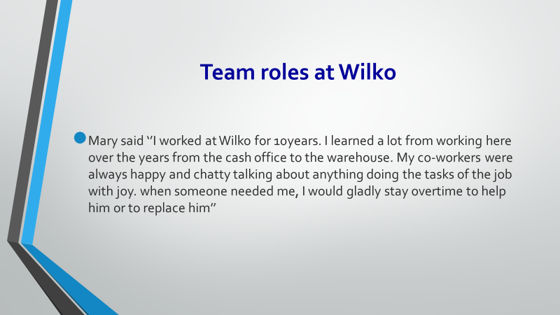

From what Mary says it is understood that she is a good team worker as well as her colleagues. due to the friendly helpful attitude and adaptability she has grown professionally learning new skills in many sectors of the company where the environment at work it is very enjoyable.
According to Belbin team roles theory model, Mary`s co-workers seam to be analogically framed at (RI) Resource Investigator team roles. From the description being sociable, gregarious, positive, enthusiastic. And also a (TW) Team Worker team roles as likeable and unassertive. In this sentence Mary can be included as a (CO) Coordinator being a good two-way communicator and self-disciplined in approach. And also a team worker being likeable and popular.

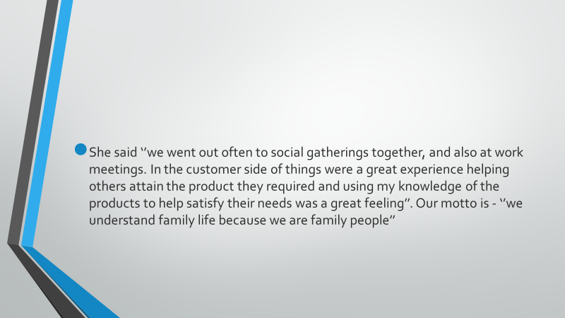

Group work can be seen from what she says is very good, proving building skills. Their participation in group work meetings and friendly private meetings shows their willingness to improve work skills career development and sociability towards colleagues and with the company. Their attitude towards customers and the motto they have shown a group that has reached the Norming and Performing levels on Tuckman's model of team building system. They have showed standard’s set, co-operation, helpfulness, openness, successful performance and acceptance.
In this slide, according to Belbin team roles model theory, Mary is (CO) Coordinator being a good two-way communicator and self-disciplined in approach and as well as a (TW) Team Worker “likeable, popular, unassertive: the cement of the team” loyal to the team unit, most active internal communicator.

        - Managing conflict

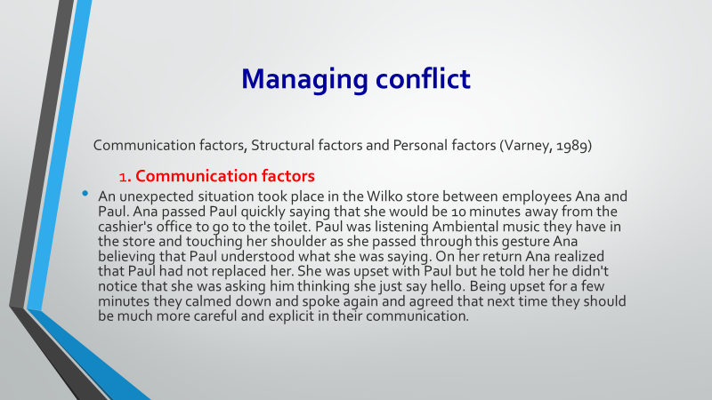

This is a specific case of conflict based on communication factors. Ana had insufficient sharing of information being in a hurry and not checking if Paul understood what she was saying. Both had differences in interpretation and perception. and Paul poor listening skills and precarious attention. But in the end they settled the conflict by communicating sincerely and clearly, and agreeing that next time they should be more explicit and clear when communicating.

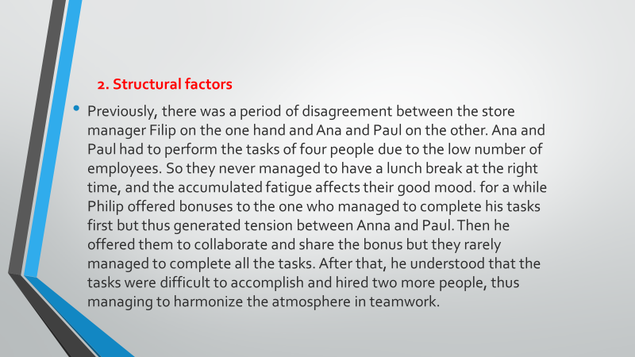

In this section we are dealing with conflict based on personal factors. Ana and Paul having self-esteem in relation to the newcomers. Mark's personal needs did not enable him to get involved and Victoria had high goals in search of a better job. Noticing the situation the manager positioned them in such a way as to avoid each other until they get used to each other. The accommodation made them befriend and collaborate happily in the work tasks they received.

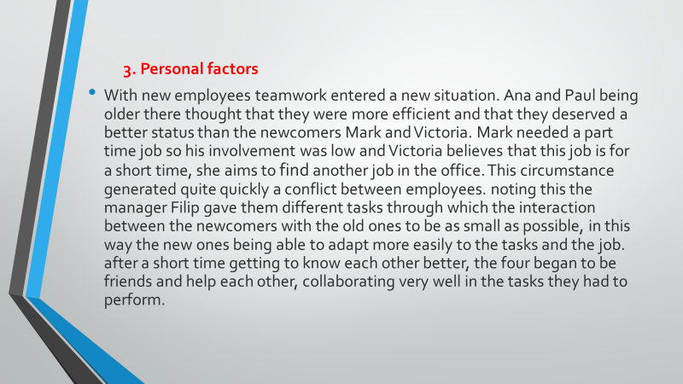

It is obvious that this conflict was caused by structural factors, due to the fact that the number of employees was low. The lunch break being short and the fatigue generated by too many tasks made the employees tired and stressed. The manager tried through competition and then through collaboration to stop the conflict, but in the end he realized that compromising to hire more people is the solution.

And, we have reached the last part of this presentation, where our teammate Dragos Sorica will present some criteria of a successful team.

Successful team development
For some people, working in a team can be easy but others may find it difficult because each of us have different thinking, a different character and different perceptions and ways to see the things.

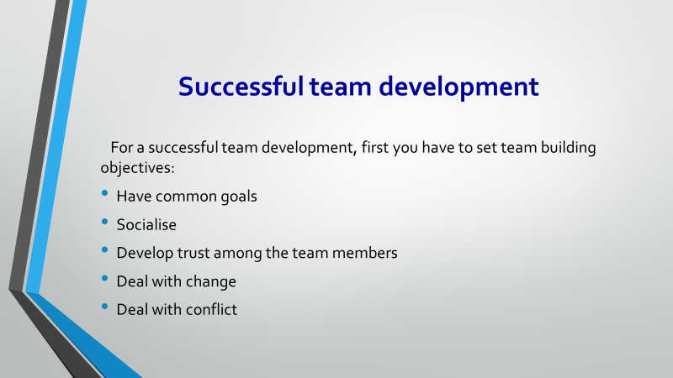

Have common goals- Make sure that every team member understand completely the goals of the team and the mission and vision of the project
Socialize- Communicate better as a team communication is the key of a successful team development. When every member of a team understand how to express their own ideas and collect all the information needed to finish a project, the is working completed effective. In a team project, interpersonal relationships are especially important because all team members must respect each other to help complete the project.
Develop trust among team members- If you want to have a good collaboration between the team members you need to increase the trust between each other. When team members feel they`re working in tandem toward common goals and objectives, fears of backbiting and undermining take a back seat to creativity.
Deal with change- Be prepared for the worst-case scenario, or the smallest event, that could require a change of direction or plan if so just adapt the team members to the changes that are made.
Deal with conflict- Displaying tolerance for failure in decision making is an effective way for a leader to drive extraordinary long-term results. One must realize that failure, due the poor decision making, is only temporary. If used correctly, tolerance for poor decision making will allow learning for future success. Intolerance, on the other hand, will drive behaviour that is offensive in nature and will harm future decision making.

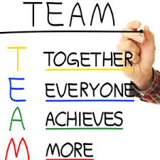
Learn to work as a team – T.E.A.M. means everyone achieves more

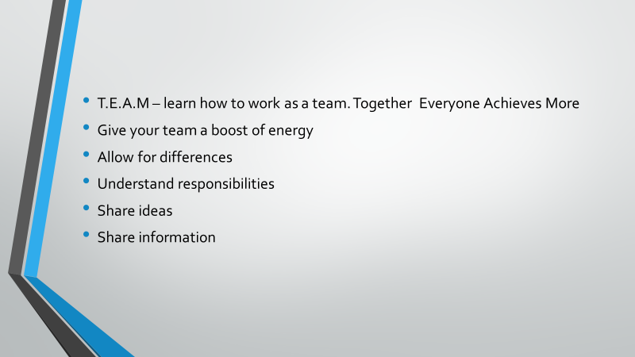

Give your team a bust of energy- as a team leader you need to encourage your team to be a TEAM and motivate the members at every stage of team development.
Allow for differences- accept that individuals are not the same, everyone think differently and have different perspective about a topic and they need to accept each other and collaborate together.
Understand responsibilities- understand each other contribution to the team of each member and make sure that you learn what are the needs of your team in order to be successful.
Share ideas- you need to share with the entire invasion if you want to improve task completion, goals achievements and to bring success for a team.
Share information- if the team members are open to each other in sharing information it becomes a great opportunity to succeed. The information between the team members needs to be transparent if each member of the team understands the needs of the group it is easier for the team to succeed.

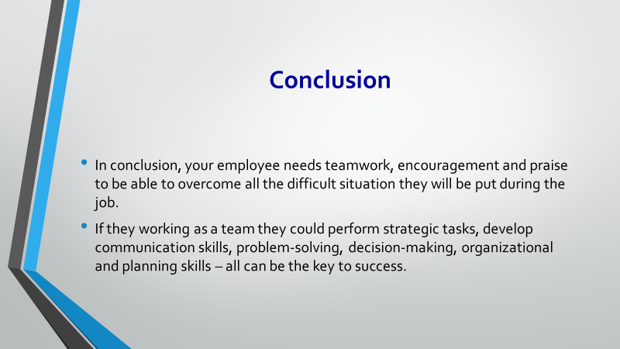

In conclusion, I want to thank you for your time and throughout this presentation, we have provided theories, suggestions, and examples outlining the foundational steps of building a healthy team, and I hope that we made ourselves understood and that you will make good changes in your company.



