ETW Report by Sumairaa Fiddah

Table of Contents

Introduction…………………………………………………………………………..….……….…2

Models of Communication.….…………………………………………….………..….……2

Shannon and Weaver 1948/49…………………………………….…………………….…2

Schramm (1954)……………………………………………………………………………………3

Berlo (1964)………………………………………………………………………………………….3

Communication Skills……………………………………………………………………………4

Verbal

Non Verbal

The Advantages and Disadvantages of Technology in Communication

Conclusion

Reference List

1.0 Introduction
Communication is a process of how individuals share and exchange information between one another. There are several ways to communicate; verbally, non-verbally, signs, symbols, written and behaviours.
There can be a wide range of communication barriers, to name a few; cultural and language barriers, not listening properly, having different styles of communicating and lack of trust and transparency. Poor communication can lead to several problems, but it is important to quickly understand what might have gone wrong and how to make things right.

- Models of Communication

2.1 Shannon and Weaver (1948/49)
The Shannon and Weaver model is a one-way communication model framework which lets you think about how a message might be misconstrued or misinterpreted during the process of when it’s sending and received. It was formed by Claude Shannon and Warren Weaver whilst they worked at Bell Telephone Laboratories. (Michelle, 2019) I have included the framework below:-
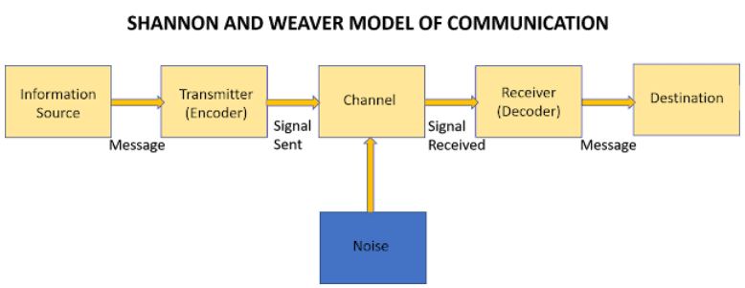

As seen above, the sender creates the source of information which is given in the initial message. The ‘Encoder’ then sends the signals, which is transmitted through a ‘Channel’. They found that there was noise disturbance when in the ‘Channel’ which could have affected the message. and then received by the ‘Decoder’. The Receiver decodes the message from the signals which sends the message to its destination. However, as this was a linear theory there were no feedbacks to show if the final message was the same as the initial message.
We considered this concept when looking at the case study ‘Maria and Pedro’. When Maria was speaking to Pedro, there were some loud noises from a nearby building site which potentially caused disturbance to her message. When she said the word ‘chicken’, Pedro heard differently and thought she said ‘kitchen’.
In a work environment, there might be specific terminology used amongst colleagues. However, despite speaking in the same language to customers, the terminology can be seen as a barrier because it can cause some confusion to customers. This is because it’s not entirely understood by the customers – ‘receivers. (Skillsyouneed, 2011)
For instance, if two elderly couple were seeking to make wills before their passing, the solicitor may start using legal jargon and abbreviations which can cause confusion to them. In this case, miscommunication can be avoided by the solicitor speaking to the customers using basic and simple English. If they do use jargon or abbreviation, then they should expand on what these terminologies mean. Poor communication can lead to unhappy customers and complaints about mis-sold goods.

  - Schramm (1954)
Schramm’s Model of Communication was developed in 1954 and had its beginnings within the Shannon-weaver show. It has the similar concept of an ‘Encoder’ and ‘Decoder’ but is a full circuit and has an ‘Interpreter’ in between the message being sent. It says that communicating typically works two-ways when the message is travelling between the sender and recipient. The premise for this model demonstrates that a message should be reasonably acknowledged correctly between the sender and receiver (Smith, 2022). Below is a diagram of this model.
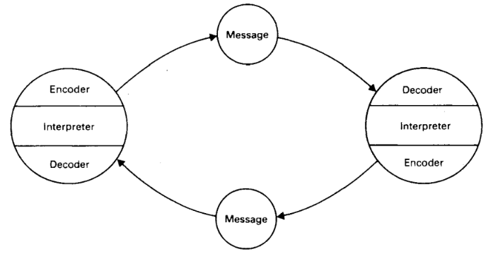
This is a two-way communication method; it enables individuals to clarify and clear any misunderstandings. So, considering the case study ‘Maria and Pedro’, when the noises were interfering his ability to hear what Maria has said, Pedro ought to have asked Maria to repeat what she had said to him. Or he should have repeated what she said so she can tell him if he heard correctly.
Robinson and Robinson (1982) said that numerous components can lead to a listener’s inability to grasp what the speaker is saying. At my place of work, I often speak on the phone to customers who are logging complaints about their finance providers. Most of the time customers are upset and they start talking in detail about their full situation; from what went wrong, how they complained, what the finance provider did and why they still remain unhappy. As there is a lot of information to gather and dissect. I repeat what they have told me to ensure I haven’t misunderstood or left anything out. This is the perfect way to make sure I have all the information I need in order to investigate their case.

  - Berlo (1964)
Berlo’s model consists of a SMCR framework. This is an abbreviation for ‘Sender’, ‘Message’, ‘Channel’ and ‘Receiver’. What differentiates Berlo’s model is that it considers the emotional aspect of communicating (Juneja, 2015). I have included below the SMCR model.
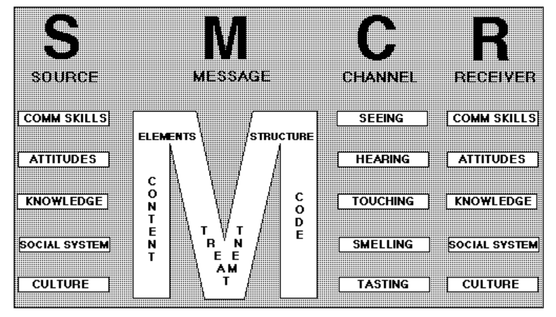
Similar to Shannon and Weaver, Berlo’s SMCR model is one -way and doesn’t have any feedback. The sender is the originator of the ‘Source’ of information. They use various elements to create that message; such as communication skills, attitude, knowledge, social and culture. These can influence the sender and cause a barrier, for example if they’re speaking a different language, if they’re not interested, if the sender is using different words to what the receiver is familiar with. (Juneja, 2015)
In this model, the message is then structured by taking into consideration the content of the message, how it should be portrayed to the receiver, are there any key information that needs to be included. The ‘Channel’ in this model varies from ‘Seeing’, ‘Hearing’, ‘Touching’, ‘Smelling’ and ‘Tasting’. Finally, the ‘Receiver’ has the same patterns as the ‘Source’. This might not work successfully as the sender and receiver may not be on mutual grounds and have differences.(Juneja, 2015)
In the case study ‘The Professor and The Village People’; the professor lived in a large house near a little village. The professor didn’t really engage much with villagers as he had nothing in common with them and majority of them were uneducated.
One day his house went on fire whilst he was asleep, when he woke up, he realised what had happened and ran into the village. He kept shouting “the edifice is being consumed by a great conflagration!” The villagers were completely confused and just stared at him and walked away. The professor was frustrated that they didn’t understand his cry for help, he then returned to his home which was entirely destroyed.
The next day he returned to the village to ask why they didn’t help him. They told him that if he had told them in simple terms his house was on fire then they would’ve helped him. Had the professor tailored his communication based on the villager’s level of knowledge and vocabulary, he would’ve had help for them. In this case study, Berlo’s model would not be successful as the villagers did not have common grounds with the professor.
An example in the real life world would be a doctor expecting a patient to understand medical terminology and how medicines worked. If the doctor doesn’t explain to the patient in simple language, they will not understand what their diagnosis is and which type of treatment or medication they need. This could end in an unfortunate ending of a patient being seriously unwell.

3.0 Communication Skills
3.1 Verbal
According to a Physician Communication expert, active listening starts with using all of an individual’s senses. He says that 8% of communication is about the content and the rest is to do with one’s body language and tone of voice (Cohn, 2017).
Having strong communication skills in verbal and written form are both very important, especially in a work environment. This is because an individual will need to demonstrate their professionalism when speaking to customers or service users. They will need to show empathy, attentiveness and helpfulness when speaking and writing.
Tone and pitch are equally as important, because using certain words may convey the message in a better way. For example, in my current role I have to investigate complaints, therefore I need to show empathy, this is both when I am writing to the customer or when I am speaking to them over the phone. I adjust my tone of voice according to the conversation, if someone is very upset then I can’t be too enthusiastic, I will have to lower my tone of voice to level down to their emotions.
Even when communicating over the phone, when an individual sits upright and smiles, it makes a huge difference to when they might be slouching down on a chair. It’s common in a call centre environment ‘to smile when you dial’.
3.2 Non-Verbal
A non-verbal communicating researcher called Albert Mehrabian, discovered that only 7% of communication is through words, 38% is to do with vocal tones and sounds, and 55% is through signs, such as body language, facial expressions, and gestures. (Mehrabian, 1971)
In case study ‘A day with the Chief’ the salesman is initially intimidated to meet the CEO because of what he’s colleagues told him about her. He was expecting the CEO to be rude and dismissive. But when the CEO spoke to him in a welcoming and friendly manner, the salesman assumed he could get comfortable and start being very open with the CEO. He demonstrated his feelings and thoughts by his actions, such as loosening his tie and sitting in a relaxed manner. He also started speaking negatively about his manager and demanding they should have increased wages. Focusing mainly on his non-verbal communication, he forgot her seniority just because she was behaving kind towards him. The salesman was not correct in the way he started behaving differently.
During my time with my previous employer, the company’s HR advisor never smiled and always stayed isolated. This made her seem very closed and unapproachable. This was not a good thing because she was the only person who managed HR enquiries. Therefore, when employees had concerns they would hesitate to speak to her because they had the impression she would not care about what they had to say. In a position such as a HR advisor, it is a people centred role, so the individual ideally should be friendly, responsive, and sociable.

3.3 Listening
Listening isn’t the same thing as active listening. An individual can listen to a speaker and not digest a word of what they heard the speaker say. Alternatively, an individual can listen to a speaker, absorb key information, and understand the message fully.
To actively listen to someone, individuals must pay full attention and only have their focus on what the speaker has to say. Distractions such as using electronics, watching programmes, or even interrupting and completing what the speaker is trying to say, can enable them to misunderstand the message or not understand anything at all.
Empathetic listening is when individuals put themselves in the speaker’s position to show they understand and care about how the speaker might feel.
In 1980’s there was a study about active listening; that the listener needs to get close to the speaker by showing they can see their view just by the words they’re saying. It suggests to the speaker they understand how important the issue is to the speaker and even if they disagreed to what was being said, they still acknowledge the speaker’s feelings are valid towards the issue. (Rogers et al., 1987)
In case study ‘Max the Multi-Tasker’, Max failed to listen to what the client told him on the phone. At the time of the phone call when his client changed the party date; he was already dealing with another client. Instead of asking the client to call him back, without checking his diary, he quickly told the client she can have the party for the new date. Max was distracted and didn’t actively listen to the client and was distracted. He assumed the date was free, but in actual fact he booked two parties for the same date. This resulted with an unhappy loyal client and potentially negative reputation.

- The Advantages & Disadvantages of Technology in Communication
Some of the advantages of technology in communication is that it is a faster way to communicate. Individuals can communicate professionally and personally with anyone, anywhere across the world, in real time. This is useful because you don’t always have to be present face to face to discuss things. There might be circumstances which make it difficult to have face meetings, therefore speaking via phone calls, emails, video calls or instant messaging can be more convenient. It’s also easier to share information and media documents, these can be sent from one another by an instant ‘send’ button.
The disadvantages of technology in communication can be that not everyone is tech savvy. Some people might prefer the good old fashion way of communicating, in person and receiving letters. In addition, if individuals do not have access to the internet or a good internet connection, it can make it difficult for them to receive emails and messages or engage via video calls. By communicating through online platforms, some users might find this less personal and not as effective than communicating in person.

- Conclusion
In conclusion, verbal and non-verbal communication are equally important and go hand in hand. When it comes to a working environment, communication is paramount; whether this is between colleagues, customers, internal or external stakeholders. When communicating, sometimes barriers may impact the delivery of the message, this is when information can get misinterpreted and cause conflicts.
When a team is lacking the ability to communicate effectively with each other they will soon realise their productivity and results are not what they should be. Typically, when this happens, it can be sensed by external stakeholders, which can lead to finding themselves in trouble with senior stakeholders and having a negative reputation. It is almost like a dominos effect; which is why it is so vital to ensure everything is manageable from the beginning.
During our group work in this module, we faced several communication barriers and difference of opinions. We had to share our opinions and decide what was the best option going forward. Without communicating how we felt, we would not have been able to work together in a pleasant environment. If we did not sort out our internal issues it would have most likely affected our productivity.

- Reference List

Michelle, S. (2019). Shannon and Weaver’s Model of Communication. [online] Blogspot.com. Available at: https://michellemathiasfsp.blogspot.com/2018/11/shannon-and-weavers-model-of.html.
Skillsyouneed (2011). Barriers to Effective Communication. [online] Skillsyouneed.com. Available at: https://www.skillsyouneed.com/ips/barriers-communication.html.
Cohn, K. (2017). Developing Effective Communication Skills. Journal of Oncology Practice, [online] 3(6), pp.314–317. doi:10.1200/jop.0766501.
Smith (2022). What Is Wilbur Schramm Model Of Communication. [online] Quick Answer. Available at: https://www.quickanswer.blog/what-is-wilbur-schramm-model-of-communication/#What_is_the_Schramm_Model_of_Communication.
Juneja, P. (2015). Berlo’s Model of Communication. [online] Managementstudyguide.com. Available at: https://www.managementstudyguide.com/berlo-model-of-communication.html.
Mehrabian A. (1971). Silent messages. Belmont, California: Wadsworth Publishing Company.
academia.edu/23744443/Albert_Mehrabian_Silent_Messages
Rogers, C., Farson, R., Newman, R., Danzinger, M. and Cohen, M. (1987). ACTIVE LISTENING Excerpt from Communicating in Business Today. [online] Available at: https://wholebeinginstitute.com/wp-content/uploads/Rogers_Farson_Active-Listening.pdf.

