

BMHP5015
Change makers: Building your Personal Brand for Sustainable Employment

Component 1

Student Name: Sunitha Peeter
Student Number: 2421161
Tutor Name: Dr.Robert Nartowski
Submission Date: 10-26-2026

Task 1 – Personal Brand
Write about your own person brand and how you could develop this to enable you to reach your employment goals (250 words- Minimum of 2 referenced sources)
My personal brand combines primary care administration, customer service, experience in health-related client management, and proficiency in six languages: English, Urdu, Hindi, Malayalam, Tamil and Arabic. I am currently studying for a BSc in Health and Social Care at the University of Wales Trinity Saint David. Moreover, I am working as a part-time receptionist and administrator at Poplar Primary Care.
My experience in the position of receptionist at ZS Engine Specialists Limited included dealing with customer queries, data entry, file management, and inventory processing. Through operating Style & Grace Boutique, I acquired skills in organisation, marketing and service delivery.
Gorbatov et al. (2019) argue that personal branding can support career success by strengthening employability. For a health and social care employer, my unique value is the combination of language skills, patient-facing administration, and diversified experience across different service settings. Nevertheless, personal branding must show people's real abilities rather than create a false image of the professional (Gorbatov et al., 2024).
I aim to become a health and social care practitioner and utilise my administrative background to strengthen my professional profile. I analysed my CV on the CV360 tool (as shown in Figures 1 and 2), and I used the feedback to update my profile for greater personal brand visibility (Figure 3). Going forward, I will reassess my CV and complete relevant training to strengthen my personal brand development (López‐Carril et al., 2025).
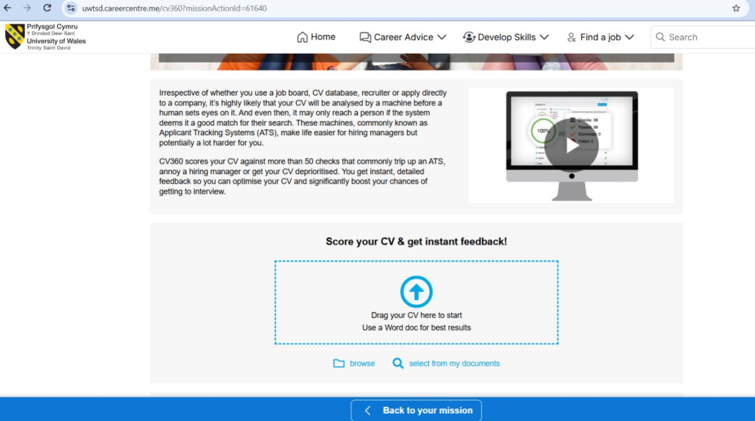
Figure 1: CV360 CV assessment page
(Source: Self)
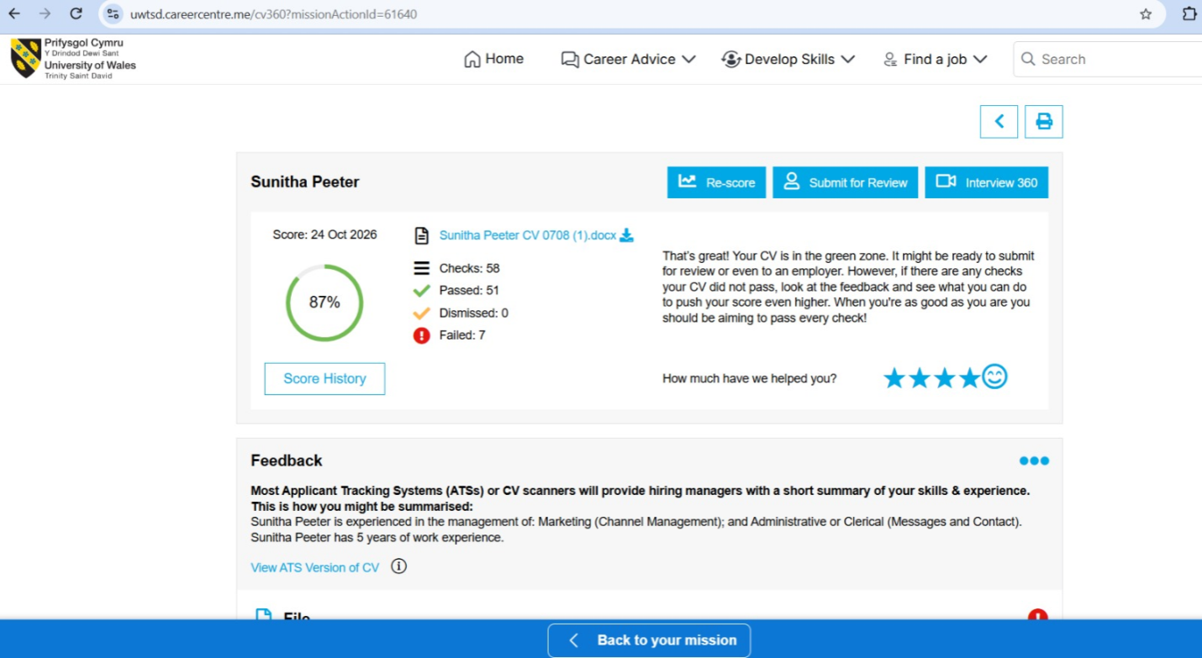
Figure 2: CV360 assessment results
(Source: Self)
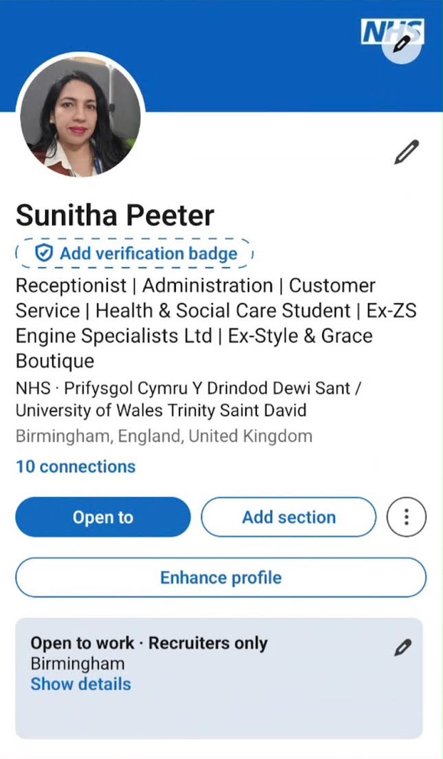
Figure 3: Updated LinkedIn profile
(Source: Self) - Linkedin
Task 2 - Network Map and Rationale
Create a map of your own network considering career, support, social and community dimensions. Additionally you should provide a supporting rationale explaining and critically assessing this (250 words-Minimum of 2 referenced sources).

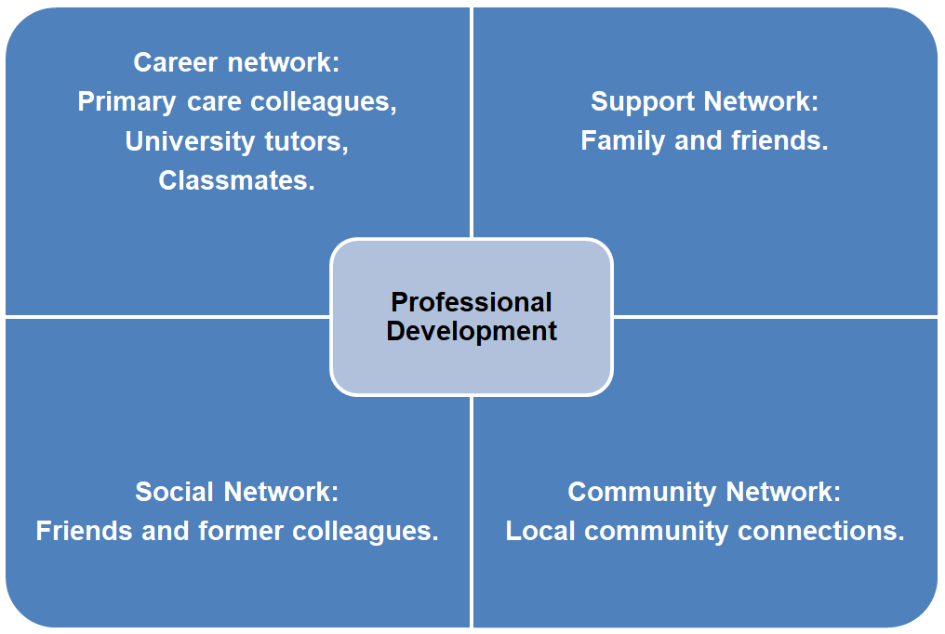
Figure 4: Network map
(Source: Self-created)
My network can be described as hybrid because it combines close ties that provide support with wider ties that offer access to valuable information. My network includes professional, social, support, and community connections that can help me achieve my goal of working in health and social care. My teachers and fellow students support my studies and help me understand professional expectations. I can expand my connections by contacting those who work in the field.
Social capital refers to resources obtained from networks and relationships (Edgerton and Roberts, 2014). Bonding social capital is gained through close relationships with friends and family. Bridging social capital may be derived from people like classmates and former colleagues, beyond my immediate circle. Meanwhile, linking social capital is related to interactions with professionals who provide further assistance, like university careers professionals.
One limitation is the fact that my current network of contacts has more connections in management than in clinical care. I need to expand contacts in the health and social care profession and look for relevant work experience. Granovetter (1973) argues that weak ties can provide access to information beyond close social circles. I will therefore build linking connections by attending university careers events, asking tutors about placements, requesting informational conversations with practitioners, and connecting with relevant professionals through LinkedIn.

Task 3- Blog
Write a blog exploring a current topic or issue of your choice within the health and social care sector in the UK. The purpose of this is to inform a specific target audience of your choosing (400 words) Referencing of your sources of information is not a compulsory requirement but could be beneficial.
Eliminating Language Barriers in Primary Care in the UK
Target audience: Patients and families using GP services in the UK.
Imagine trying to explain a new symptom to a GP, but struggling to find the English words. You may leave an appointment unsure about a diagnosis, medicine or next step. This can be extremely challenging for those who lack proficiency in English. The 2021 Census for England and Wales found that 880,000 people could not speak English well (Office for National Statistics, 2022). A GP appointment requires patients to explain their concerns, understand the advice they receive and make informed decisions based on that advice. It can be an issue for those who are not comfortable with English.
What is the significance of language barriers?
Some patients rely on family members to interpret their sensitive medical information. Ultimately, these problems can jeopardise the patient's privacy, safety, and willingness to give informed consent. The NHS suggests the use of professional interpreting services in situations where patients need interpretation assistance. Children should not be used as interpreters (NHS England, 2025).
What is the role of healthcare providers regarding language needs?
Healthcare practitioners should take the following steps:
Determine what languages the patients speak.
Ensure the availability of qualified interpreters when needed.
Inform the patients about ways to ask for language assistance.
Train the personnel to communicate effectively with all patients.
Patients should not have to depend on relatives when it is important to understand medical information. Translation programs can assist in basic communication, but can cause errors. Such apps should not substitute an interpreter in case of important medical communication. Healthcare providers should arrange a qualified interpreter when needed so that patients can understand information and make informed decisions about their care.
Where can patients get assistance?
Patients needing language support need to communicate with their GP's practice while booking an appointment. They can ask whether an interpreter is available for their language. Patients should also inform administrators in case of their discomfort with reading in English.
Building a more inclusive healthcare system
Language should not be an obstacle for any individual receiving medical services. Providing better interpreting services, access to written information, and developing staff awareness can help in reducing these barriers. Each patient should have an opportunity to communicate their health-related choices and decisions.
(Read full Blog)
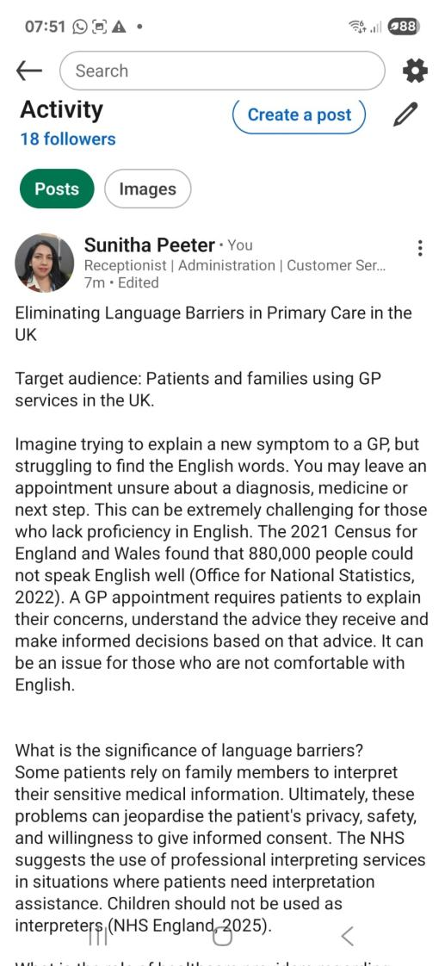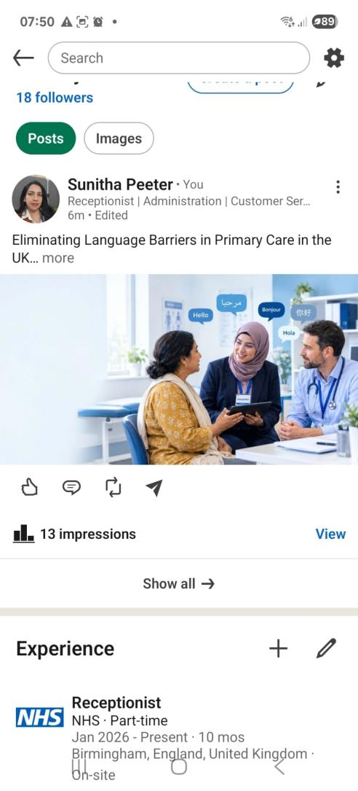
Figure 5 and 6: LinkedIn Blog (Source: Self) - Linkedin
Task 4- NHS Equality, Diversity and Inclusion Quiz (250 words equivalent)
- What is the primary goal of the NHS Equality, Diversity, and Inclusion Improvement Plan?
- (Answer in one or two sentences.)

The plan aims to improve equality, diversity, inclusion and belonging for NHS staff by addressing discrimination and unfair treatment in workplace behaviour, policies, practices and culture.

- How does the NHS EDI Improvement Plan propose to tackle the gender pay gap?
- (Answer in one to two sentences.)
The plan includes implementing the Mend the Gap recommendations for medical staff, extending relevant recommendations to senior non-medical staff, analysing pay gaps by protected characteristic, and improving access to flexible working.

- What is meant by the term ‘intersectionality’ as used in the NHS EDI Improvement Plan?
- (Answer in one to two sentences.)
The concept of intersectionality is used to understand the interconnections between different types of oppression based on such factors as gender, race, and disability.

- Why is it important for the NHS to create a psychologically safe work environment?
- (Answer in one to two sentences.)

A psychologically safe workplace allows staff to speak up, raise concerns and report mistakes without fear of retaliation. Staff can then learn from their mistakes, and workplace well-being helps improve patient safety.

- How does the NHS EDI Improvement Plan suggest improving the experience of internationally recruited staff?
- (Answer in one to two sentences.

The plan calls for appropriate induction and support for internationally recruited staff, including pastoral support and fair access to training, development and career opportunities.

- What role does leadership play in advancing EDI objectives according to the NHS Improvement Plan?
- (Answer in one to two sentences.)

The plan expects leaders to set measurable EDI objectives and be accountable for progress through leadership appraisal and organisational assurance processes.

- Identify one way the NHS EDI Improvement Plan aims to reduce health inequalities within the workforce.
- (Answer in one to two sentences.)

The plan calls for organisations to develop an improvement plan to address workforce health inequalities, including action to reduce bullying and improve civility and staff wellbeing.

- Why does the NHS EDI Improvement Plan emphasise the importance of collecting and analysing data on protected characteristics?
- (Answer in one to two sentences.)

Workforce data helps identify disparities, determine where action is needed, and monitor whether interventions improve staff experience and equality.

- Explain how flexible working policies can contribute to equality and inclusion in the NHS workforce.
- (Answer in one to two sentences.)
Flexible working means creating an opportunity for employees to combine their work life with personal duties and thus eliminating barriers faced by caregivers, parents, and disabled workers.
- What is one strategy mentioned in the NHS EDI Improvement Plan to combat bullying and harassment in the workplace?
- (Answer in one to two sentences.)
The plan calls for action to reduce bullying and harassment, including reviewing workforce data, setting reduction targets, enabling staff to speak up, and supporting those affected.

Task 5- A Letter to Yourself
Think of a time in the past when you may have been experiencing issues or difficulties, and after considering what you have learned in this module about emotional intelligence and resilience, write a letter to your younger self explaining how these attributes were important at that time and perhaps how developing these areas could have been useful (300 words)

Dear Younger Me,
There was a week when my work responsibilities and a university assignment deadline fell close together, leaving me feeling tired and worried about completing both. I tried to manage everything at once instead of planning my time and asking for support when I needed it.
Looking back, I could have benefited from developing emotional intelligence to understand my feelings and respond to difficult situations calmly. According to Goleman (1998), there are five components of emotional intelligence. When I feel overwhelmed, I can identify the source of stress, rank urgent tasks, and refrain from reacting hurriedly. I can also communicate openly with instructors or supervisors about doubts concerning my obligations and deadlines.
Resilience is also important, because difficulties can provide opportunities for learning and adjusting. Masten (2001) explains that resilience can come from simple adaptive skills and supportive relationships. As my younger self, you should remember that being a strong person does not mean that you have to cope with everything alone. Understanding how others feel can help me to respond with greater care and empathy.
Progress involves taking things slowly and doing them methodically. Managing my emotions can help me to be a good listener, respond with respect, and support colleagues or clients. Although I will not always be capable of eliminating stress, I will have a chance to take a healthier approach to experiencing it and seeking assistance if needed.
Trust your ability to improve through practice! If you have a good understanding of who you are and know how to seek assistance, you will be able to deal with difficulties you will encounter in the future.
Best wishes,
Your future self

Task 6- GANTT Chart (200 words equivalent)
Compile a Gantt chart which illustrates the tasks you have to complete to achieve your future employment goals.

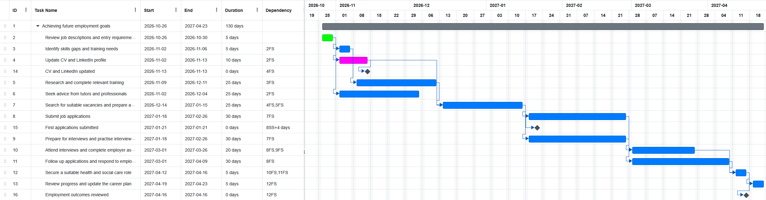
Figure 7: Gantt chart
(Source: Self-created)
I will assess job descriptions to determine the skills, experience in a direct care area, and digital skills I will require for the job. Then, I will modify my CV and LinkedIn to highlight my experience in the field of primary care, my knowledge of several languages, and my training.
My experience in the primary care field allows me to learn from my colleagues and understand the particular responsibilities and expectations of a health and social care practitioner. I will utilise this opportunity so that my future employment goals benefit from a deeper and personalised understanding of my work areas.
From December 2026 to February 2027, I will undertake any appropriate courses available. I will also start networking through the university and my present place of work. By January 2027, I will begin looking for available jobs and sending resumes.
My achievements will be evaluated based on a course completion timeline, an updated CV, certificates for training if necessary, new business connections, and job applications submitted. By April 2027, I will review my progress and make adjustments to the plan if there are any changes in job opportunities.

Task 7- Making Changes- Report
You are the manager of a care home and want to make changes in a workplace. Identify one specific change that you want to implement and write a brief report on how this is going to be achieved considering the necessary skills needed and addressing possible barriers to success. Relevant change models can be highlighted (350 words Minimum of - 3 referenced sources).
Introduction
This report proposes introducing a standardised handover checklist for staff in a nursing home. This proposal aims to minimise errors and enhance the continuity of care.
Problem Statement
Inconsistent handovers may cause staff members to miss critical information about the residents’ health, their care needs and outstanding tasks. The implementation of a clear, standardised checklist would ensure that workers exchange indispensable information, while supporting the existing records of care delivery.
Proposed Change
Lewin’s Change Model provides a framework for implementing changes in an organisation (Hussain et al., 2018). In the unfreeze stage, management reviews the current handover processes and consults staff members regarding the communication issues. During the change stage, the manager will present a checklist containing changes in the health of residents, care needs, outstanding tasks, and safeguarding concerns. At the refreeze stage, the checklist will form part of regular handover procedures. The manager will review the completed checklists and assess the change using measurable indicators, such as checklist completion rate and reduction in communication errors.
Barriers and Solutions
Staff resistance may arise if employees see the checklist as extra paperwork or feel that current handovers already work well. The manager should explain how missed information can affect residents, while involving staff in designing the checklist, and trial it with a small team before wider use.
Time pressure and staffing shortages may lead staff to complete the checklist hurriedly or skip it during busy shifts. The checklist should be brief, fit the existing handover process and focus on essential information. The manager can test the time needed during the trial and adjust the format using staff feedback. This should be introduced in a supportive and transparent manner so that staff members can share their concerns and suggestions (NICE, 2014).
Conclusion
The manager will review the checklist completion rates; staff feedback received after the implementation of the changes, and reported communication errors. NICE (2021) highlights the importance of proper record-keeping and information sharing procedures in care homes.

Reference List
Edgerton, J.D. and Roberts, L.W. (2014). Cultural capital or habitus? Bourdieu and beyond in the explanation of enduring educational inequality. Theory and Research in Education, 12(2), pp.193–220. doi:https://doi.org/10.1177/1477878514530231.
Goleman, D. (1998). What makes a leader? Harvard Business Review, [online] 76(6), pp.93–102. Available at: https://pubmed.ncbi.nlm.nih.gov/10187249/ [Accessed 16 Oct. 2026].
Gorbatov, S., Khapova, S.N. and Lysova, E.I. (2019). Get noticed to get ahead: The impact of personal branding on career success. Frontiers in Psychology, 10. doi:https://doi.org/10.3389/fpsyg.2019.02662.
Gorbatov, S., Oostrom, J.K. and Khapova, S.N. (2024). Work does not speak for itself: Examining the incremental validity of personal branding in predicting knowledge workers’ employability. European Journal of Work and Organisational Psychology, 33(1), pp.40–53. doi:10.1080/1359432x.2023.2276533.
Granovetter, M.S. (1973). The strength of weak ties. American Journal of Sociology, [online] 78(6), pp.1360–1380. Available at: https://www.jstor.org/stable/2776392 [Accessed 16 Oct. 2026].
Hussain, S.T., Lei, S., Akram, T., Haider, M.J., Hussain, S.H. and Ali, M. (2018). Kurt Lewin's change model: A critical review of the role of leadership and employee involvement in organisational change. Journal of Innovation & Knowledge, 3(3), pp.123–127. doi:https://doi.org/10.1016/j.jik.2016.07.002.
López‐Carril, S., Glebova, E., Bae, D. and González‐Serrano, M.H. (2025). Social media as a teaching‐learning tool to enhance students’ professional profile: The case of LinkedIn. European Journal of Education, 60(1). doi:https://doi.org/10.1111/ejed.12862.
Masten, A.S. (2001). Ordinary magic: Resilience processes in development. American Psychologist, 56(3), pp.227–238. doi:10.1037//0003-066x.56.3.227.
NHS England (2025). NHS England » improvement framework: Community language translation and interpreting services. [online] England.nhs.uk. Available at: https://www.england.nhs.uk/long-read/improvement-framework-community-language-translation-and-interpreting-services/ [Accessed 16 Oct. 2026].
NICE (2014). NICE guidance. [online] NICE. Available at: https://www.nice.org.uk/guidance [Accessed 16 Oct. 2026].
NICE (2021). Overview | safeguarding adults in care homes | guidance | NICE. [online] www.nice.org.uk. Available at: https://www.nice.org.uk/guidance/ng189 [Accessed 16 Oct. 2026].
Office of National Statistics (2022). Language, England and Wales: Census 2021. [online] GOV.UK. Available at: https://www.ons.gov.uk/peoplepopulationandcommunity/culturalidentity/language/bulletins/languageenglandandwales/census2021 [Accessed 16 Oct. 2026].

Appendix
Drive link: 5015 C1

