

Task 1 – Reading Task Template
Upload your photo of your A3 in-class notes here:
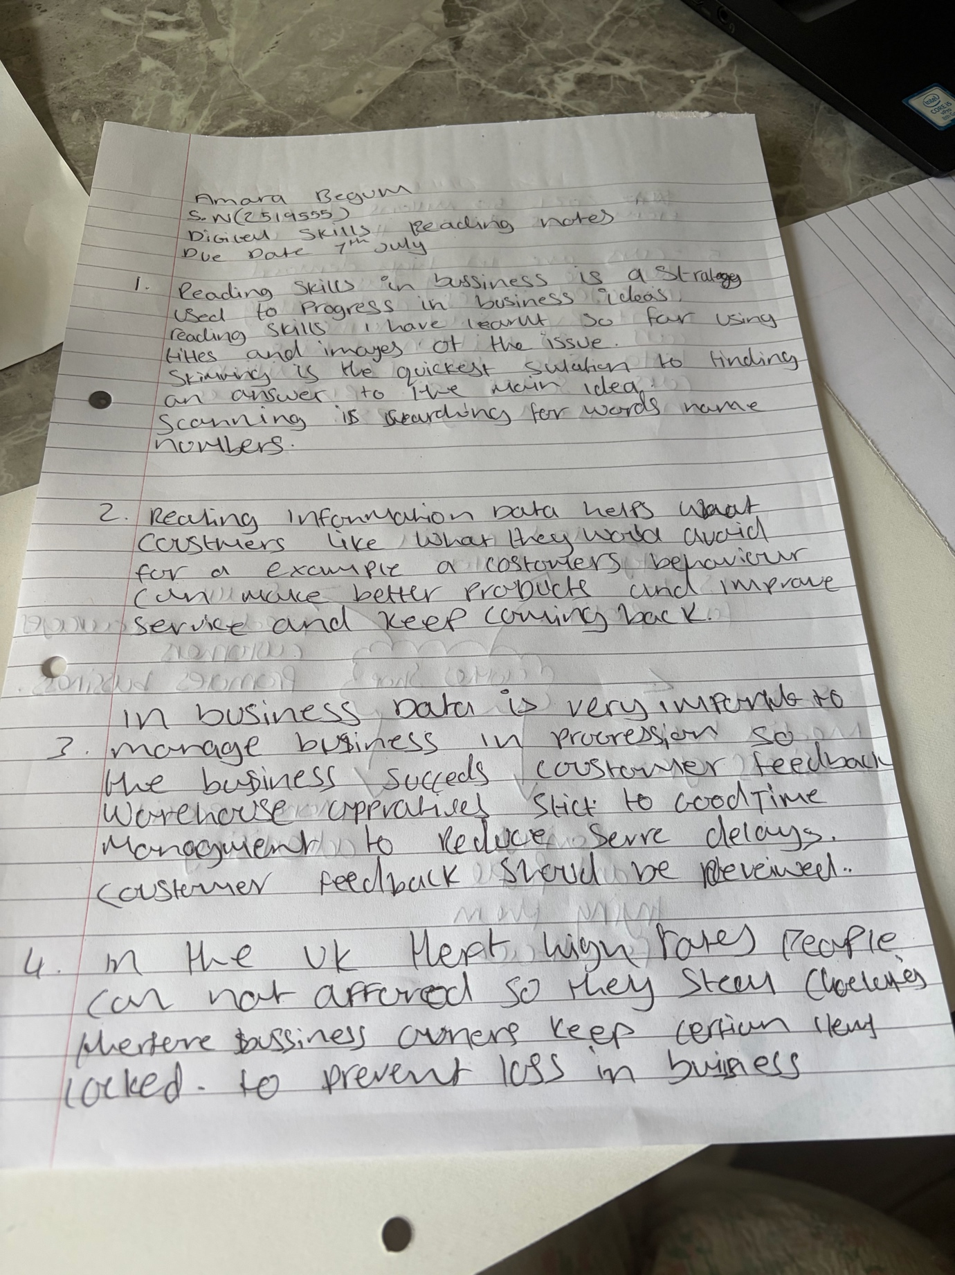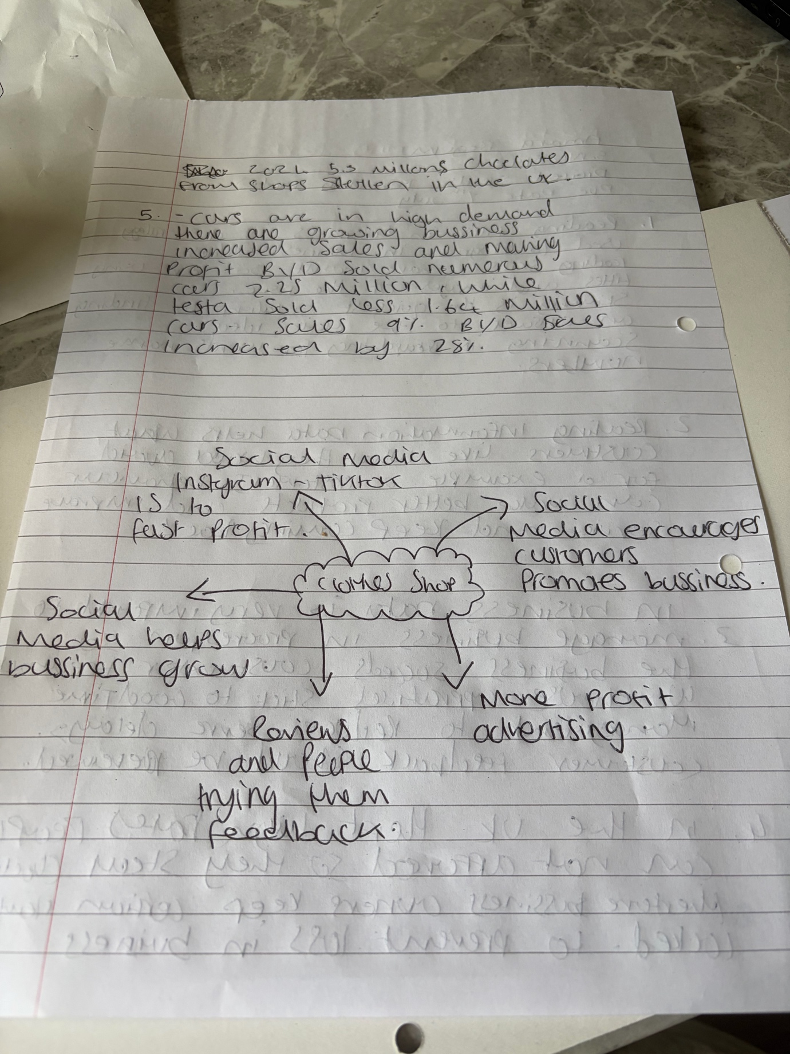

1. Answer these questions using the sentence starters below
a. What is the main idea of the text?
The main idea is that clothes business
b. What are two key points?
One key point is Profit making
Another key point is losses in business
c. What part of the text did you find most important? Why?
The most important part is social media decision making advertising
d. Was anything unclear or difficult to understand?
I was not sure about non
e. How did your group help you understand the text better?
My group helped me by group discussions help better understanding and better decision making
3. One sentence reflection
Question: What did you find challenging about this task?
The hardest part was different everyone’s different opinion

