Student Name: Isabella Horrillo-Bula
P Number: 1803063
Programme of Study: BA Fine Art
Module: Ways of Perceiving (ADAD4010)
Word Count: 1538
Tutor's name: Robert Jones and Ryan Moule
Psychology Curated Piece
This is a curated piece about Psychology. This project is going to be about the memory. Curation is selecting pieces of work that have a common link that go into an exhibition. Psychology is the study of the mind and human behaviour and has been around from the ancient civilizations. The type that humans know now is modern psychology started in the 15th century. This type started to become more popular during the 19th century. There has been more development about the human mind in the last century then the previous one. The most notable are Sigmund Freud, Edward Bernays, etc.
Memory is not permanent because your brain makes your memory fade with time. In 1901 Sigmund Freud wrote about how forgetting is a part of everyday life. In the paper he writes about forgetting the name of Signorelli when thinking it was Botticelli and Boltraffio, until a stranger tells him the real name of the artist. Also, memory can get rid of useless things like when you cannot remember a name. Nevertheless, subconscious memory can make you remember when another person tells you. Freud recognised this by the fact that he says that when ‘the correct name was imparted to me by an outsider I recognized it at once without any hesitation.’ (Freud and Strachey, 1975, p. 2).
In Criminal Psychology eyewitness testimony can be unreliable for multiple reasons ranging from misidentification to the police and prosecutors manipulating the witness. The more time passes the memories of the crime you witnessed fade and it becomes easier for the police to manipulate you as, it is relying ‘on the assumption of precise visual memory.’ (Simon et al. 2003, p. 7). Police manipulation can cost the life of the wrongfully convicted such Walter Snyder. He lost his chance to go to the Olympics as a boxer and seven years of his life. In 2005 a study in Sweden examined the description given to the police from witnesses about the assassination of Anna Lindh and the surveillance footage and ‘description of age, height, and body build were largely inaccurate.’ (Bull et al. 2006, p. 89).
Profiling maybe a science where you study psychology before becoming a profiler. However, it can be a guessing game depending on how much information the profiler gets before a profile. The profile is never a 100% right because there is always some information that is missing or is unknown at the time. The more the profile is updated the more information is found during the investigation. The profiles are made by humans which make them liable to having errors in them. The Police should take profiles into account but not just only focus on the unsubs that the profile highlights, because of that a guilty person could get away with a crime ‘because he does not fit the inaccurate profile that has been developed.’ (Kocsis and Coleman, 2001, p. 338).
There are down falls to the way that profilers work because the police can misuse their profile of the unsub. The profile is only half of the picture because it can cause ‘innocent individuals for investigation without any corroborating evidence.’ (Kocsis and Coleman, 2001, p. 336). If an innocent person gets arrested, then the real criminal gets away with whatever the crime was. Sometimes the police focus on an unsub because they have one or two common characteristics and they ignore the full picture. A profile that is wrong can ignore a suspect that is high on the list just because it does not match the characteristics of the profile.
The pieces of work are mainly photos are of wrongfully convicted people. The photos are photos from different sources. Two of the photos are from The National Registry of Exoneration. There are two photos from The Innocents by Taryn Simon. The last two are mugshots. The first one was a composite portrait of mugshots and the last one is a contemporary mugshot. The works are linked to memory and wrongfully convicted criminals. The memory part is a running theme in this exhibition as each of the convicted have been sent down due to the police manipulating the victims into identifying them.
On the left wall the photo are Francis Galton’s composite portraits of criminals. In 1885 Francis Galton used the mugshots of different people and overlaid it to create a composite photo of what a criminal looks like. He said that you can tell who is a criminal and who will become a criminal because they have similar features in their faces. It caused innocent people go to jail. The technique did not work, and it fell into disuse. A hundred years later Freud used it as a sample for ideal type. This is a way that the police could misuse identification because some criminals have the same features, but also have different ones.
Looking on to the right wall there are two photos. The first of the two photos is of Ron Williamson in a baseball field in Norman, Oklahoma. This photo was taken by Taryn Simon for her 2003 project called The Innocents. He and a friend were arrested and convicted for the Rape and Murder of a barmaid in a club in Ada, Oklahoma six years after the fact. The reason that the photo was taken in the baseball field was that he was ‘drafted by the Oakland Athletics before being sentenced to death.’ (Simon et al. 2003, p. 84). He lost 11 years of his life when he was in prison. In 1999 he and his friend were exonerated.
The second photograph next to the previous image is also a photo By Taryn Simon. The photo is of Frederick Daye in his alibi location ‘where 13 witnesses placed’ (Simon et al. 2003, p. 10) him at the same time the crime was being committed. He was in the photo array because of a polaroid photo taken when he was stopped ‘for a minor violation.’ (Simon et al. 2003, p. 10). The prosecution took the case with false statements and many unanswered questions and leads. He was convicted by an all-white jury for rape, kidnapping and vehicle theft. The police manipulated the victim’s memory into believing that he committed the crime.
Looking back to the wall by the entrance, the photo there is a mugshot of Rosean Hargrave that was taken in 1991 in Brooklyn when he was 17. He was sent to prison because a New York cop created false and misleading evidence to charge him of Murder. He was sent to prison for 30 years for a life sentence and he spent 23 years before the judge had his conviction vacated because of the mess that the corrupt cop created. This is one of five convictions overturned because of the disgraced cop. The cop distorted all the forensic evidence which was never tested in the original case. Due to mistaken identity he lost a great deal of his life from his imprisonment.
Going to the back of the galley through the arch and turning to the left is the Photo of Marvin Anderson taken from The National Registry of Exoneration where you learn all about his case. You can also learn about it from the Innocent Project website. This photo is just a portrait of Anderson. He was in prison for 38 years even though DNA evidence proves that he was not the criminal that committed the crime. However, due to the police manipulating the victim and his shoddy lawyer he was convicted of Rape, Abduction, Sodomy and Robbery. When the Innocent Project took on the case, they spent years trying to prove his innocence due to the DNA evidence being destroyed.
Finally, when turning to look to the right from the arch the photo that is there is the Portrait of Kenneth Wyniemko taken from The National Registry of Exoneration. This is the last photo of the exhibition. He was accused of Rape, Armed Robbery, Breaking and Entering because he looked a bit like the composite sketch that the victim helped create. He was then charged with 15 counts of Rape, Armed Robbery, Breaking and Entering. The police started to concentrate on him because of the composite sketch. Although the victim described the suspect as taller than him. When in jail another inmate lied to the police about Wyniemko confessing to get a shorter sentence. However, DNA evidence found years later from the case excluded him as a suspect and he was freed.
In conclusion, the exhibition was all about how memory cannot be relied upon because when someone looks back at the memory they are not seeing it as a something that was witnessed but as if they were looking as a third person. The people in the photos that were in this project were all wrongfully convicted because they were misidentified as the suspect because of memory. While the Project is about memory it is also about the wrongfully convicted because all the ideas in this show were about how innocent people go to prison for no fault of their own. This exhibition is to show people about how injustice can happen to anyone by someone saying that they saw a similar person to the one indicted.
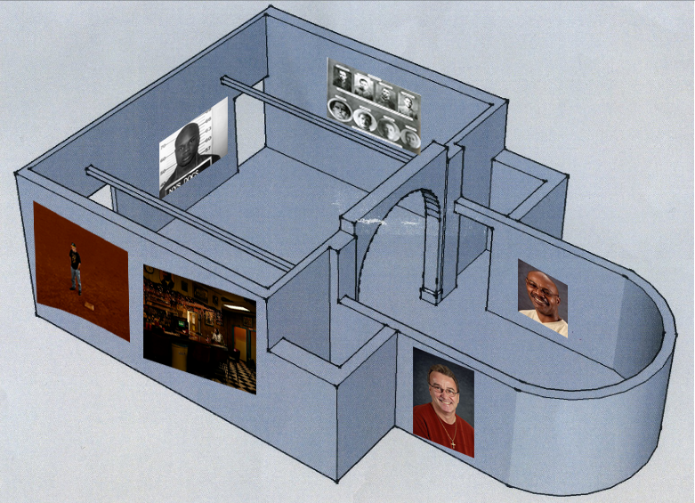
Figure 1. Photos of Wrongly convicted people (1. Composite Portraiture. (Sir Francis Galton, 2019); 2. Ron Williamson (Gagosian Gallery, 2004); 3. Frederick Daye (Gagosian Gallery, 2004); 4. Rosean Hargrave (Bolton, 2015); 5. Marvin Anderson (The National Registry of Exonerations, 2019a); 6. Kenneth Wyniemko (The National Registry of Exonerations, 2019b).

Bibliography
Bernays, E.L. (1928) Propaganda. New York, NY, US: Horace Liveright.
Bull, R.H., Cooke, C., Hatcher, R., Woodhams, J., Bilby, C. and Grant. T (2006) Criminal psychology: A beginner’s guide. Oxford, England: Oneworld Publications.
Durrant, R. (2013) An introduction to criminal psychology. Abingdon, England: Routledge, Taylor & Francis Group.
Freud, S. (1920) A general introduction to psychoanalysis. New York, NY, US: Horace Liveright. http://dx.doi.org/10.1037/10667-000.
Freud, S., and Strachey, J. (1975) The psychopathology of everyday life. Harmondsworth, England: Penguin Books.
Kocsis, R.N., Coleman, S. (2001) ‘The unexplored ethics of criminal psychological profiling’ in Godwin, G.M. (ed.) Criminal psychology and forensic technology. A collaborative approach to effective profiling. Boca Raton, FL, USA: CRC Press.
Simon, T., Neufeld, P. and Scheck, B. (2003) The innocents. New York, NY, US: Umbrage Editions.
The Balance Careers (2019) How to be a Criminal Profiler. Available at: https://www.thebalancecareers.com/how-to-be-a-criminal-profiler-974847 (Accessed: 1st April 2019).

List of Figures
- Composite Portraiture. Sir Francis Galton (2019) Francis Galton and Composite Portraiture. Available at: http://galton.org/composite.htm (Accessed: 4th April 2019).
- Ron Williamson. Gagosian Gallery (2004) Taryn Simon, The Innocents. Available at: https://gagosian.com/exhibitions/2004/taryn-simon-the-innocents/ (Accessed: 4th April 2019).
- Frederick Daye. Gagosian Gallery (2004) Taryn Simon, The Innocents. Available at: https://gagosian.com/exhibitions/2004/taryn-simon-the-innocents/ (Accessed: 4th April 2019).
- Rosean Hargrave. Bolton D. (2015) ‘Brooklyn man freed after spending 23 years in prison for a crime he didn't commit’, Independent, 16th April. Available at: https://www.independent.co.uk/news/world/americas/brooklyn-man-freed-after-spending-23-years-in-prison-for-a-crime-he-didnt-commit-10180665.html (Accessed: 4th April 2019).
- Marvin Anderson. The National Registry of Exonerations (2019a) Marvin Anderson https://www.law.umich.edu/special/exoneration/Pages/casedetail.aspx?caseid=2995 (Accessed: 4th April 2019).
- Kenneth Wyniemko. The National Registry of Exonerations (2019b) Kenneth Wyniemko https://www.law.umich.edu/special/exoneration/Pages/casedetail.aspx?caseid=3769 (Accessed: 4th April 2019).

