The Global Business Environment

Environmental Analysis of Automobile Industry

Student Name : Gabriel Ciprian Muntean
Student Id: 2009466

Table of Contents
Introduction 3
SWOT Analysis of Rolls Royce 3
Strengths 4
Weaknesses 4
Opportunities 4
Threats 5
PESTLE analysis of Rolls Royce 6
Political Factors 6
Economic Factors 6
Social Factors 7
Technological Factors 7
Legal Factors 7
Environmental Factors 8
Porter’s Five Forces of Rolls Royce 8
Threats of New Entry 8
Threats of Substitutes 9
Bargaining Power of Suppliers 9
Bargaining Power of Buyers 9
Current Rivalry 10
Conclusion 10
References 11

Introduction
The automobile industry is considered one of the most dynamic industries throughout the globe having massive billions of turnovers each year. Robust innovation and massive demands of this industry have made this industry as one of the most competitive industries in the world. Many major players are doing business in this industry such as Rolls Royce, Jaguar, Tesla, Toyota, Mercedes Benz, and many more. So, the internal and external forces of this industry are massive for which surviving in this industry is more challenging than any other industry in the world. As most of the countries have their own automobile industry, global trade among these brands is more competitive (Rothaermel, 2017). In this context, this report is going to illustrate the strengths, weaknesses, opportunities, and threats which are otherwise known as SWOT analysis. Later on, the report will include the PESTLE analysis in favour of Rolls Royce and finally, the Porter’s Five Forces model of Rolls Royce will be explained to show the competitive pressure in the automobile industry.

SWOT Analysis of Rolls Royce
Automobiles, such as bikes, cars, and public transportation systems, are one of society's most significant building components. The automobile industry comprises several companies that collaborate on promotion and marketing, vehicle sales, manufacturing, research & innovation, and designing. In terms of profit and sales, it is the dominant economic industry (Davies, 2017)
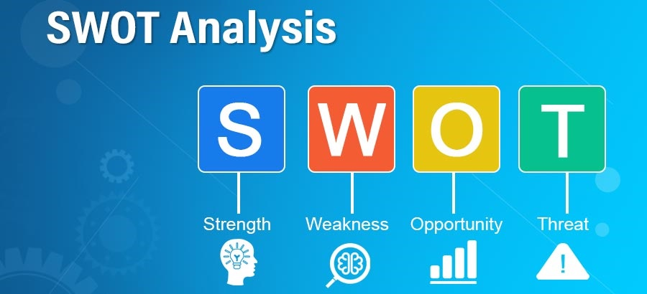
Figure 1: SWOT analysis of Rolls Royce (Davies, 2017).

Strengths
Cheaper Manufacturing Units: Some of the world's most well-known vehicle firms have relocated their manufacturing operations to rising Asian nations such as India and China. It has enabled them to take advantage of low labour costs as well as decreased production and material costs. By doing so, they can sustain a high level of profitability. (Milburn, 2019) Rolls Royce Automobile Company is a good example where this strength can be found.
The Demand for Luxury Vehicles: Demand for lavish vehicles from brands like Chrysler, Bharat Benz, Daimler, and Rolls Royce is rising. Demand increases sales and profits for the company.
VFM Vehicle: With competitive pressures in the automotive industry, global markets are demanding VFM (value for money). The term VFM refers to a vehicle's ability to give higher mileage, fuel savings, and a low-cost range. (Zhikang, 2017) Rolls Royce enjoyed this strength.

Weaknesses
Vehicle Regulations: Sometimes in some nations, foreign automobiles are prohibited from entering due to rules regarding vehicle registration, licensing, and taxation. Rolls Royce has also this weakness.
Customers’ Bargaining Power: There is a lot of competition in the industry, and all competitors are trying to sell their items. Buyers now have a wide variety of choices from which to pick, and customers have the power to buy whatever they want. (William, 2018) Like other competitors, Rolls Royce faces this problem.
Recalling Vehicles: As a result of product failure, automobile firms are required to remove defective automobiles from the marketplace. The brand's costs would rise even more if it did not follow standards.

Opportunities
Prioritising OEM: Rather than working in isolation, OEMs should consider collaborating with industry professionals and producers. So, they're looking for partners and suppliers from all over the world to join their platform. (Shaw and Shaw, 2019) They'd be able to get their products in front of more people all over the world, which would help their business grow even faster. Rolls Royce has the opportunity to prioritize OEM.
Changing Lifestyle: Technology and digitalization have made people happier and more relaxed. That's why automakers build pleasant and secure cars. It has improved sales of cars and vehicles, which is beneficial for the business. Rolls Royce is a good example to change lifestyle.
Alliance: A strong partnership of automotive companies through mergers & acquisitions would be beneficial. It would reduce competitive conflict. If they collaborate next to each other, they can outspend their competitors and gain more market share. (Ajupov, 2016) Rolls Royce can create alliances with other automobiles industry like Chrysler, Daimler, and Volvo.

Threats
Economic Recession: Shutdown, travel restrictions have all reduced auto company sales. The covid-19 pandemic has hindered economic growth. Unemployment and uncertain economic conditions have reduced customers' purchasing power. (YANG, 2017) Like other company Rolls, Royce faces this threat.
Competition: The automotive industry has become extremely competitive, and companies are using various strategies to gain a competitive advantage. The weakening economy has made it harder for businesses to succeed.

PESTLE analysis of Rolls Royce
The car industry is primarily engaged in the business of manufacturing and marketing self-propelled vehicles. By making it possible for customers to travel large distances for employment, shopping, and leisure purposes. The PESTEL analysis on the automobile basically describes the changes that can take place where the external factors are creating an impact on the industry.
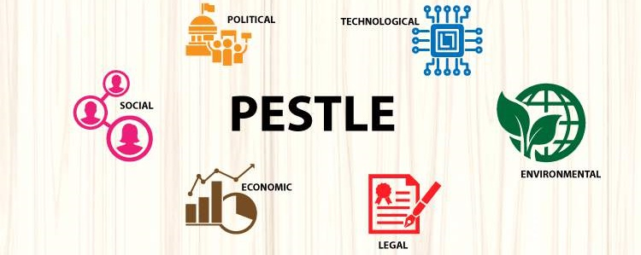
Figure 2: PESTLE analysis of Rolls Royce (Pearce and Robinson, 2013)

Political Factors
Every company that conducts international business has to consider the political impact on the business. And with PESTEL analysis one can identify the issues.
- In most countries, governments have issued regulations regarding the safety of passengers. Their license may get cancelled if one fails to fulfil the requirement.
- Rolls Royce is a multinational company, various political reasons are prevailing in other countries that directly affect its sales. The unstable condition in the European market had a major effect on the company (Pearce and Robinson, 2013).

Economic Factors
The lifestyle depends on the economy. Therefore, it also has an impact on the automobile industry. Here are some economic issues:
- As the income level goes up of the consumers in a particular country the buying capability and also the demand increases in that country
- Rolls Royce operates in the premium segment in a society so its customers are usually high-end people.
- Change in exchange rates does not affect the company much (Amason, 2017).

Social Factors
The socio-cultural situation has a major impact on production, designs, models. The PESTEL analysis can find the sociological issues.
- For a particular consumer segment car is not just a vehicle. they consider the car as their social status. Considering the customer demand and trend is a point a company should focus on.
- Rolls Royce is a brand that is widely known across the world, for its staple designs and beautiful automobiles. Owning Rolls Royce means a lot in the case of social status (Doner et al., 2017).

Technological Factors
In the automobile industry, technological advancement has a major impact by all means. Here are some technical issues:
- Safety is the main concern in the case of technological modifications, even in the case of new designs as well. Self-driven car is currently capturing the market slowly.
- Rolls Royce is working on the aerospace segment. This new technology they are working on is mandatory for them to stay in the market (Zhikang, 2017).

Legal Factors
Law and regulation differ from country to country. So, in case of going global any business should take in account the legal situations of that country.
- Tax law, environment law is the most important factor an automobile industry should consider first if it wants to go international.
- Many countries have shifted from BS4 to BS6 which had a major impact on Rolls Royce. The change was spread in a long time but still it had a major effect on it.

Environmental Factors
Ecological issues have become a major deal for the automobile. The PESTEL analysis can identify the environmental issues:
- The environmental issue is nowadays a bigger deal for the automobile industries as a significant amount of carbon emissions are happening because of cars.
- Rolls Royce is still working towards attaining maximum use of these renewable sources.
- To reduce the ecological footprint, engines have grown more modern, incorporating hybrid technology and emitting minimal emissions (Milburn, 2019).

Porter’s Five Forces of Rolls Royce
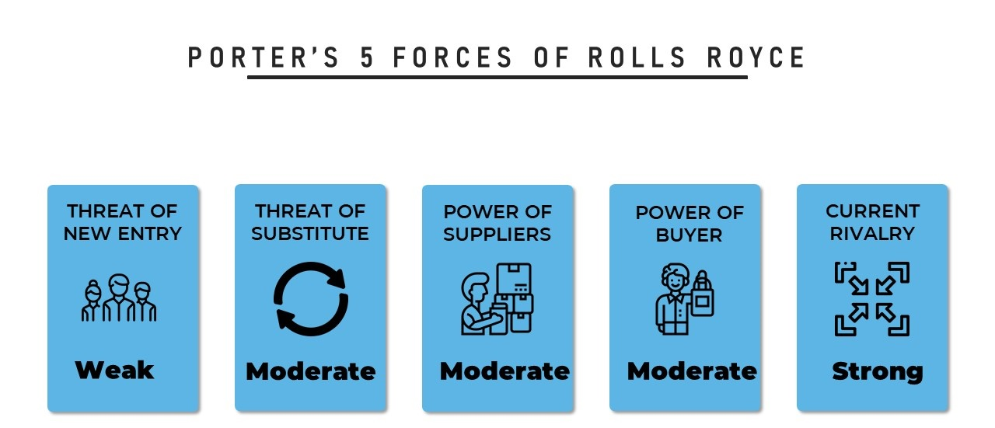
Figure 3: Porter’s Five Forces of Rolls Royce (Self Made)

Threats of New Entry
In the automobile industry threat of new entrants is low as there are lots of renowned companies in the market that captured the market. For buying a car, the consumer uses complex buying behaviour whereas they are highly involved in the purchase and they posses’ significant differences between the brands (Doner and Noble, 2021). Hence, it is difficult for a new entrant to capture the market easily. Since Rolls Royce is already occupied a strong position in the market and has a loyal customer base; so, it is difficult for a new entrant to tackle this company in the market resulting threat of new entrants being weak.

Threats of Substitutes
In automobile companies, there prevails moderate force of substitute products as there are many alternatives of the car such as train, public transportation, and bicycles. But these substitutes may not be appropriate or available in every situation (Hoang and Zawada, 2019). Furthermore, switching costs are low because, while consumers can switch to utilizing these substitutes, but it is difficult for them while still paying off their car loans. Hence, Rolls Royce company faces the moderate force of the threat of substitutes in its business conducts as the consumer can switch from Roll Royce’s products to train, public transportation, and bicycles. But these substitutes are not available or appropriate in every situation hence resulting in a moderate force of substitutes.

Bargaining Power of Suppliers
In the automobile industry, there prevails moderate bargaining power of suppliers. There remains moderate overall supply having moderate force, the moderate population of suppliers having the moderate force, and “low-forward-vertical-integration” having weak force (Hoffman and Kaplinsky, 2019). Though suppliers have a strong negotiating force, it is constrained by a company such as Rolls Royce. It is because there remains a moderate population of suppliers and moderate total supply. The majority of the suppliers use “low-forward-vertical-integration” and so the companies can't control sales and the distribution of their products to Rolls Royce Company. Moreover, their bargaining power also lessened because of the use of Rolls Royce's vertical integration. Hence, there remains moderate bargaining power of suppliers.

Bargaining Power of Buyers
In the automobile industry, there prevails the modest bargaining power of customers. There remains moderate shifting cost and the size of individual purchase is also moderate, and the number of substitutes is also moderate. The Rolls Royce company deals with moderate shifting costs which are the aftermath of shifting from one company to another. In that case, it is easier for a customer to switch the brand (Hoffman and Kaplinsky, 2019). Moreover, Rolls Royce company's product is moderate in terms of price and revenue; So, a tiny change in the demand of the customer can create a good impact on Rolls Royce. On the contrary, moderate availability of substitutes renders the customers to move away from Rolls Royce. To sum up, there prevails moderate force of bargaining powers of consumers

Current Rivalry
In the automobile industry there prevails strong rivalry amongst various brands. Every brand tries to come up with innovation, new designs and tries to minimize the cost to attract new customers and to enlarge their market base (Hoang and Zawada, 2019). Rolls Royce company faces strong rivalry in the market as there are already many renowned giant automobile companies like Ford, Ford, Land Rover, BMW, Jaguar, Audi, Nissan, General Motors, etc. that are coming up with innovations and attractive designs. Hence, The Rolls Royce company is facing heavy competitive rivalry.

Conclusion
So, after describing all the analysis, it is seen that the strength of Rolls Royce is robust innovation in this industry which has made the company gain a more competitive edge than its rivals. However, the vehicles regulation and customer bargaining power are the weaknesses of the brand although the company is overcoming its weaknesses through its opportunities through the introduction of OEM vehicles and the changing lifestyle of industry customers. The increasing competitor is the threat of this brand. In terms of external environmental factors, the company is facing several forces from the political, economic, social, technological, legal, and environmental factors. Talking about Porter’s five forces, the threat of new entry is weak whereases the threat of substitute product, bargaining power of supplier and buyers are moderate. Most importantly, the current rivalry among the existing competitors is very strong in this industry.

References
Ajupov, A.A., Kurilova, A.A., Kurilov, K.Y. and Bogatirev, V.D., (2016). Prospects of automobile industry development. Asian business 11(11), p.168.
Amason, A., (2017). Strategic Management. 15th ed. New York: Routledge.
Davies, N., (2017). AUTOMOBILE INDUSTRY. 8th ed. [Place of publication not identified]: ROUTLEDGE.
Doner, R.F., Noble, G.W. and Ravenhill, J., (2021). The Political Economy of Automotive Industrialization in East Asia. Oxford University Press.
Hoang, P. and Zawada, D., (2019). Business and management. Victoria, Australia: IBID Press.
Hoffman, K. and Kaplinsky, R., (2019). The Automobile Industry. Driving Force, pp.73-112.
Milburn, A., (2019). Automobile industry.
Pearce, J. and Robinson, R., (2013). Strategic Management. 13th ed. Richard D. Irwin, Inc.
Rothaermel, F., (2017) Strategic Management. 3rd ed. McGraw-Hill Publishing.
Shaw, A. and Shaw, A., (2019). SWOT Analysis of Automobile Industry | SWOT & PESTLE Analysis. [Online] SWOT & PESTLE Analysis. Available at: <https://swotandpestleanalysis.com/swot-analysis-of-automobile-industry/> [Accessed 2 January 2022].
William, J., (2018). Automobile Industry and SWOT analysis of automobile industry.
YANG, H., FENG, Z. and XIE, D., (2017). SWOT Analysis and Suggestions on Development of Automobile Industry. Management Research.
Zhikang, L., (2017). Research on Development Strategy of Automobile Reverse Logistics Based on SWOT Analysis. 174, pp.324-330.

