

Name: Sophia Pitter
Student number:2409134
Module code: BMHP5014
Module: Changemakers: Creativity and Value Creation
Lecturer: Raheela Shaikh
Assignment Title: Component 1: Online Portfolio of Set Exercises

Task 1 – Concept Map
Create a concept map that outlines the relationship between creativity, value creation, and health and social care improvement. Within the concept map explain how these concepts interact in a health and social care context (250 words).
Please refer to week 1 content

Explanation
In health and social care, creativity allows specialists to retort successfully to multifaceted challenges for example increasing demand, restricted resources, and various patient requirements. Creativity includes making new thoughts and reconsidering old-style ways of providing care. A main secondary idea related to creativity is co-production, where service users dynamically contribute in determining services. For instance, including patients in designing care plans promotes more tailored and effective support.
Creative thinking leads to novelty, for example the launch of virtual GP consultations. This innovation subsidises straight to value creation, which in health and social care extends beyond monetary efficiency. A secondary idea in value creation is patient-centred value, concentrating on results that matter most to service users. Virtual consultations make value by enhancing admission, dropping waiting times, and augmenting suitability, mainly for individuals with mobility problems or those living in remote zones.
Value creation supports health and social care improvement, where facilities become safer, more available, and maintainable. A main secondary idea here is continuous improvement, supported by screening results and collecting feedback from patients and personnel. For example, examining use information and patient fulfilment aids improve digital facilities and discourse inequalities in access.
These ideas interrelate in a continuous cycle: creativity drives novelty, novelty generates value, and value leads to enhancement. Feedback from enhanced facilities then inspires more creativity. This interconnected affiliation is vital for evolving resilient, person-centred health and social care systems (World Health Organization, 2016).

Task 2 - Self-Reflection of Group Activity
Complete a self-Reflection on the Convergent/Divergent paperclip class activity using a reflective model (250 words, 1 source)
Please refer to Week 2 content.

Self-Reflection using Gibbs’ Reflective Cycle
All through the convergent and divergent thinking activity, our group utilised paper clips to design simple earrings and bracelets projected for service users in health and social care settings.
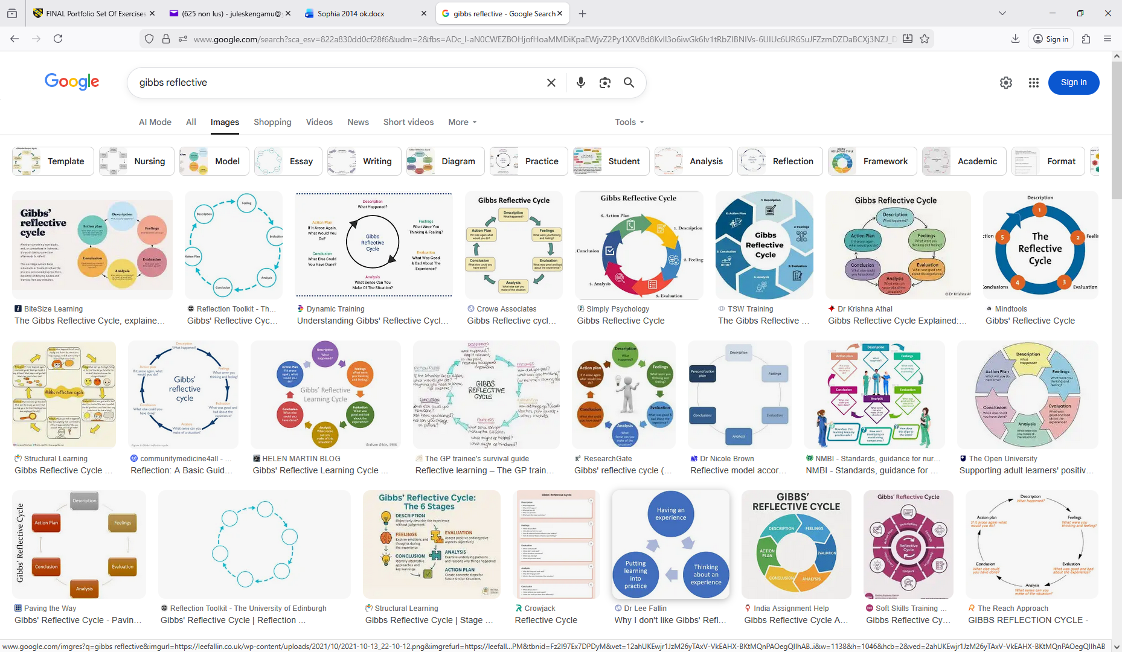
Description: The duty fortified us to first create many creative thoughts (divergent thinking) and then select real, safe plans (convergent thinking). I subsidised thoughts regarding lightweight plans and supported accumulating the last products.
Feelings: Primarily, I felt ambiguous regarding how creative I might be with limited constituents. Though, as the debate developed, I felt more assured and involved. I as well became more mindful of the accountability involved when designing objects for vulnerable persons.
Evaluation: A constructive aspect was active collaboration and open communication, which permitted us to examine different viewpoints. The activity highlighted possible health benefits, for example encouraging creativity, social contact, and a sense of success for service users, which may support psychological wellbeing and decrease loneliness. Though, there were also health risks, counting sharp edges that might cause wound, small parts posing a sharp risk, and the likelihood of allergic reactions to metal constituents.
Analysis: This activity proved the significance of risk assessment in health and social care settings. Creative activities need to balance therapeutic value with safety reflections. Conferring to Gibbs’ model, planned reflection aids people learn from involvement and enhance future practice (Gibbs, 1988).
Conclusion: I learned that creativity in care environments need to always consider personal needs, protection, and infection control.
Action Plan: Henceforward events, I would smooth sharp edges, select hypoallergenic constituents, and perform an elementary risk assessment before usage.

Task 3 - Case Study of a UK innovation
Write a concise case study analysis of an innovative project or initiative within the NHS or UK social care. Focus on how creativity was used to drive change and the value it created for patients or service users (400 words, 2 sources).
Please refer to Week 3 content

Case Study Analysis: Shared Lives – Creative Innovation in UK Social Care
The Shared Lives plan in adult social care characterises a distinct and innovative model in the United Kingdom, utilising creativity not in the artistic logic but as a creative re-imagining of by what means support may be provided to adults with care requirements. Somewhat than depend on established or residential care, Shared Lives ties adults who need support with appropriate carers who open their homes and daily lives to them, allowing care receivers to live in family-like environments and contribute in community life. This community innovation challenges old-style service provision by productively using ordinary family systems and relations to deliver tailored care that encourages autonomy and social inclusion (Shared Lives Plus, 2024).
Creativity in the Shared Lives model is obvious in in what way it reframes care support as shared life involvements, somewhat than a set of responsibilities carried out by specialists. This creative reframing discourses the extremely human factors of wellbeing that standard established settings frequently oversee, for example belonging, expressive relations, and independence. By inserting individuals into ordinary homes, the model adopts wealthier social networks and better everyday choice for service users, elements recognised to be directly related to quality of life and wellbeing. Thus, Shared Lives re-imagines the caring setting as a lived community somewhat than a medical or bureaucratic environment, thus driving essential transformation in practice culture (Purcell et al., 2025).
The value formed for service users is both qualitative and quantitative. Appraisals and support from Shared Lives Plus and connected research recommend that this model may lead to enhanced individual results for adults with learning disabilities, autism, mental health requirements, and elder persons counting improved autonomy, social connectedness, and total life fulfilment. Additionally, there is indication that it may be a cost-effective substitute to orthodox residential care, from time to time projected to save local authorities among £8,000 to £30,000 per individual yearly by dropping dependence on more costly care placements and supporting individuals to remain joined in their community setting (Shared Lives Plus, 2024).
To drive broader transformation, Shared Lives as well relies on organisational creativity, for example promoting leadership, building joint systems with social workers and commissioners, and evolving mechanisms for joint learning and staff support. These creative organisational approaches are vital in scaling the novelty beyond small local positions, addressing blockades for example restricted awareness amongst specialists and challenges in staffing of carers (Purcell et al., 2025).
In brief, Shared Lives represents how social care may be changed by creative re-thinking of service provision, concentrating on relations, lived experience, and community attachment. Its innovative use of family-based assignments not just improves the wellbeing of service users but as well provides a sustainable substitute that places human self-respect and choice at the core of social care.

Task 4 - Research Task
Identify a current issue in health and social care (e.g. e.g., mental health stigma, access to care for vulnerable populations). Find two pieces of academic research (journal articles) that explain the reason for this problem. Paraphrase the findings of each article (300 words, 2 sources).
Please refer to week 4 content.

Current Issue in Health and Social Care: Access to Care for Vulnerable Populations.
An important current issue in health and social care is access to care for vulnerable populations, which comprises low-income persons, racial and ethnic minorities, elder adults, and those deprived of additional insurance. Vulnerable populations frequently face systemic barriers: fiscal, topographical, and organisational that restrict their capability to get essential healthcare facilities. Study has constantly revealed that inequalities in access subsidise to poorer health results and augmented unmet need amongst these groups.
The research Monitoring the Impact of the Medicare Fee Schedule on Access to Care for Vulnerable Populations by Trude and Colby (1997) studied how changes in the Medicare fee schedule affected use amongst vulnerable recipients. The study found that application of payment changes was linked with divergent levels of healthcare usage that might not be completely described by health position; particularly, groups deprived of private or public additional insurance, persons with low revenues, and African Americans faced decreased access to surgical facilities in some parts following fee changes (Trude and Colby, 1997). This proposes that policy mechanisms, counting repayment structures, may impact access for the most disadvantaged and underlines financial and systemic barriers in formal health systems.
Likewise, the volume Underserved and Socially Disadvantaged Groups and Linkages with Health and Health Care Differentials examines wider clarifications for inadequate access: socially deprived and underserved groups frequently experience intensified challenges related to macro-level policies and micro-level socio-economic situations that impact care use (Kronenfeld, 2019). This body of study highlights these barriers are not only individual but engrained in structural inequality, counting limited accessibility of culturally proper facilities, discrimination in care locations, and inflexible organisational practices.
Reflecting on this matter underlines the necessity for health and social care systems to give priority to equity over targeted policy reorganisations, for example enhancing funding for community-based care, and addressing socioeconomic causes that constantly hinder access for vulnerable people.

Task 5 - Podcast
Record a two-minute Podcast introducing your idea for component 2 using https://www.rev.com/onlinevoicerecorder The MP3 audio must be downloaded and embedded as a file (see guidance video on how to do this here: https://www.youtube.com/watch?v=D21isId0agw) or an accessible OneDrive link if using a chromebook (make accessibility – anybody) before inserting into your portfolio. Check the accessibility of the link before submitting.
Please refer to week 4 & 6 content.

Task 6 - NHS Leadership Framework Analysis
Write a short summary (200 words) explaining the key components of the NHS Leadership Framework. Then, choose one component and describe (150 words) how a leader might use it to encourage creativity and improve care in the NHS (2 sources).
Please refer to week 7 content.

Summary of the NHS Leadership Framework
The NHS Leadership Competency Framework sets out the central leadership abilities projected of board members and senior leaders all over NHS systems and provider bodies (counting integrated care boards and trusts) to support first-class, equitable care provision.
The Framework includes six competency fields that reproduce NHS values and guide leadership behaviour:
- Driving high-quality and sustainable results, which efforts on providing safe, efficient care and continuous improvement.
- Setting approach and providing long-term change, highlighting strategic scheduling and usage of evidence.
- Promoting equality and inclusion, and dropping health and personnel inequalities.
- Providing robust governance and assurance, certifying ethical, responsible decision-making.
- Generating a sympathetic, fair and positive culture, which prioritises emotional care and comprehensive leadership.
- Building reliable relations with associates and communities to allow collaborative working and co-production of facilities (NHS England, 2024).
These areas serve as both a developing tool for individual leaders and a standard for staffing and assessment. Jointly, they aim to embed NHS values for example working together for patients, sympathy, admiration, and enhancing lives while strengthening leadership behaviours that drive organisational culture, performance and results. By positioning abilities with results and organisational objectives, the Framework encourages leadership that is evidence-informed, reasonable, and patient-centred.

Selected component: Generating a Sympathetic, Fair and Positive Culture
The area “Generating a sympathetic, fair and positive culture” efforts on leadership behaviours that stand-in emotional safety, inclusivity, and commitment amongst personnel and stakeholders. A leader using this element could prioritise systematic, structured opportunities for personnel to share understandings, worries and propositions for example reflective rounds or “safe space” settings where team members feel stimulated to speak up deprived of fear of punishment. By obviously acting on feedback and rejoicing perfections, the leader strengthens faith and signs that contributions are appreciated. Embedding elements like Freedom to Speak Up Guardians and approving transparent, respectful challenge further improves a transparent culture where learning from mistakes is stimulated somewhat than punished. Such practices not just enhance morale of personnel and their retention but as well create creative thoughts for care development, because people feel trusted and psychologically safe to propose innovations. Eventually, this generates a more adaptive, reactive NHS setting where frontline perceptions contribute to healthier care results and a culture of continuous improvement (NHS England, 2024)

Task 7 - Self-Reflection Journal Entry
Write a short journal entry about what you learned in this module. Focus on how your understanding of creativity and value creation withing H&SC has changed and how it has informed your professional practice (200 words).
Please refer to week 9 content.

This module on Creativity and Value Creation has importantly transformed my comprehension on how innovation is applied in health and social care. At the start, I observed creativity mostly as creating new thoughts or activities for service users. Though, currently, I understand that creativity as well includes problem-solving, enhancing methods, and evolving practical resolutions that improve results, effectiveness, and patient experience.
I have learned that value creation in health and social care is not just regarding saving money but as well concerning enhancing quality, convenience, protection, and person-centred care. Creativity may be employed to address tangible challenges for example access barriers, communication problems, and service inequalities. Small changes, for example adapting communication approaches, enhancing care paths, or launching helpful community initiatives, may generate meaningful value for both service users and specialists.
This module has also underlined the significance of teamwork, reflective practice, and understanding the desires of various people when developing innovative resolutions. Currently, I know that creativity must constantly be evidence-informed, safe, and associated with ethical and professional standards.
Within my professional practice, this learning will stimulate me to think more practically, contribute thoughts for service development, and effort on generating positive, person-centred value that enhances care experiences and health results.

Reference List
Gibbs, G. (1988) Learning by Doing: A Guide to Teaching and Learning Methods. Oxford: Oxford Polytechnic.
Kronenfeld, J.J. (ed.) (2019) Underserved and Socially Disadvantaged Groups and Linkages with Health and Health Care Differentials. Emerald Publishing. [Accessed 14 February 2026].
NHS England (2024) NHS leadership competency framework for board members. NHS England. Available at: https://www.england.nhs.uk/long-read/nhs-leadership-competency-framework-for-board-members/ (Accessed: 18 February 2026).
Purcell, C., Manthorpe, J. and Malley, J. (2025) The challenge of scaling-up social work innovations: A case study of Shared Lives schemes in England, British Journal of Social Work, 55(2). Available at: https://academic.oup.com/bjsw/article/55/2/725/7950793 (Accessed: 6 February 2026).
Shared Lives Plus (2024) “A leading innovation in social care” – New research on Shared Lives. Available at: https://sharedlivesplus.org.uk/2024/10/03/a-leading-innovation-in-social-care-new-research-on-shared-lives/ (Accessed: 6 February 2026).
Trude, S. and Colby, D.C. (1997) ‘Monitoring the Impact of the Medicare Fee Schedule on Access to Care for Vulnerable Populations’, Journal of Health Politics, Policy and Law, 22(1), pp.49–71. [Accessed 14 February 2026].
World Health Organization (2016) Framework on integrated, people-centred health services. Geneva: WHO. Available at: World Health Organization publications. Accessed: 7 February 2026.

