Did humanity’s health improve or decline after the move to agriculturalism?

By Sarah Marshall
1502416

Dissertation submitted in partial fulfilment of a B.A (Hons.) in Archaeology with Forensic Studies.

University of Wales Trinity Saint David

May 2018

Abstract

The Neolithic transition is when people moved from the subsistence strategies of a hunter-gatherer to that of an agriculturalist (Radovic & Stefanovic, 2013). Three main case studies are mentioned throughout, these are the Hadza, !Kung and for archaeology the Danube Gorge area, specifically Lepenski Vir. By looking at the !Kung and Hadza the difference in diet can be seen and the hunter-gather groups have a much more varied and nutritious diet than the agricultural groups. When looking at life expectancy and birth rate both were higher within agricultural groups past and present. The hunter-gatherer !Kung are free of many nutritional and stress-related diseases but they suffer from many infectious diseases. Results of both anthropological and archaeological data show that oral and biological health is better in the hunter-gatherer populations than agriculture. Life expectancy and birth rate are higher within the agricultural groups than the hunter-gatherer groups.

Acknowledgements

I would like to acknowledge my friends for helping me with the math. My family for listening to me rant and reading through my work making sure it makes sense. The study skills support at the University of Wales Trinity Saint David’s Lampeter for looking through my work. And finally, Ros for answering my endless questions and providing me with article ideas when I was really stuck.

Figures

Figure 1 Danube Gorge area showing Lepenski Vir and Vlasac (Boric & Stefanovic, 2004) 3
Figure 2, Gross wear amongst the Hadza based on the 2015 study (Crittenden, et al., 2017) 7
Figure 3 Amount of Caries Amongst the Hadza, based on 2015 study (Crittenden, et al., 2017) 8
Figure 4 Amount of caries by group, mean average between men and women, based on 2015 study (Crittenden, et al., 2017) 8
Figure 5 A Hadza man straightening an arrow with his teeth (Berbesque, et al., 2012) 9
Figure 6 Survivor rate for, A) hunter-gatherers, B) forager-horticulturalists, C)Acculturated hunter-gatherers and D) The Average of each group (Gurven & Kaplan, 2007) 15
Figure 7 Changes in age-specific mortality patterns, with ratio before contact and after contact, improved conditions (Gurven & Kaplan, 2007) 17
Figure 8 The number of individuals, with sex and age found at A) Lepenski Vir, B) Vlasac (Boric & Stefanovic, 2004) 19
Figure 9 remains of a male age 18 from Vlasac, with a projectile point wound (Roksandic, 2006) 30

Tables

Table 1, Average rate of tooth wear at Lepenski Vir scored 0-4, separated by tooth and period (Radovic&Stefanovic, 2013) 11
Table 2 Number of people in D3-19 and D3+, with the juvenility index for each period (Agarwal, et al., 2015) 22

Contents

Abstract i
Acknowledgements ii
Figures iii
Tables iv
Chapter 1: Introduction 1
Chapter 2: Teeth and Diet 4
Chapter 3: Population Density 14
Chapter 4: Biological factors 24
Chapter 5: Conclusion 31
References 33

Chapter 1: Introduction

The Neolithic transition is when people moved from the subsistence strategies of a hunter-gatherer to that of an agriculturalist (Radovic & Stefanovic, 2013). It is often called the agricultural revolution (Radovic & Stefanovic, 2013). It was a time when people stopped adapting to nature and started making their environment adapt to them (Radovic & Stefanovic, 2013). What followed is population growth, the introduction of new challenges and diseases as well as a new food source. This paper analyses the consequences of this transition by looking at both archaeological and anthropological data. Three main case studies are mentioned throughout, these are The Hadza, The !Kung and for archaeology the Danube Gorge area, specifically Lepenski Vir.
The different aspects of health are outlined in each chapter using studies that have been done on dental pathologies of human remains from Lepenski Vir and The Hadza population. This allows for a full analysis of dental aspects of health as well as a brief outline of the different subsistence of each group. Population density is used to outline the fertility rate, mortality rate and life expectancy. Finally, the biology of populations is analysed to look at what sort of injuries each was likely to get and how well these injuries healed in agriculturalist and hunter-gatherer populations, in addition to examining what type of diseases and illnesses they had.
One of the anthropological case studies is the Hadza who live in small groups with mobile camps near the shores of Lake Eyasi in Northern Tanzania (Barone, et al., 2016). They are considered one of the last remaining true hunter-gatherer populations today and even then, only 200-300 of them are purely hunter-gatherers with little to no contact with the modern world or nearby farming populations (Hunting with the Hadza 2017). There are only about 150 people who live on a mostly hunter-gatherer diet (Crittenden et al., 2017). The use of the word ‘mostly’ is because no Hadza is thought to have a completely one hundred percent hunter-gatherer diet, they are too close to the villages for this to be the case (Crittenden et al., 2017). Their location is thought to be in the same area that hominids originated from; because of this and their chosen lifestyle, they offer a more intact view of health amongst hunter-gatherers both early and extant (Basaglia, et al., 2014).
Another anthropological case study is the !Kung who live in isolated areas in Botswana, Angola and Namibia (Shostak, 1990, p. 4). They call themselves ‘Zhun or Twasi’ which means the ‘real people’ (Shostak, 1990, p. 4). This population was forced to change to a more agricultural subsistence in the 1970’s when the South African government created a reservation for them on the border of Botswana (!Kung 1980). It meant that the 800 !Kung that were left were forced into an area that was half the size of their original territory (!Kung 1980). The results from the !Kung will likely show more stress compared to others that had more of a natural transition.
There are several sites that are considered critical for the Neolithic transition within the archaeological record. Here we will focus mainly on the sites at Danube Gorge, specifically Lepenski Vir. The Danube Gorge area, also known as iron gates (Bartosiewicz, et al., 2000), is situated between Serbia and Romania (Boric & Stefanovic, 2004) and has a long record of human occupation from Mesolithic to Neolithic (Bartosiewicz, et al., 2000).
Danube Gorge is a system of gorges in the Danube River (Radovic & Stefanovic, 2013). It is different from the surrounding areas as it has what is considered a microclimate, meaning that the surrounding terrain and bedrock protect the gorge areas from the climate (Radovic & Stefanovic, 2013). Due to this many plant species categorised as relic species still survive there (Radovic & Stefanovic, 2013). The protection offered by the bedrocks could have been part of what drew many Mesolithic and Neolithic people to the area as it would have protected them as well (Radovic & Stefanovic, 2013) The sites were first discovered in the 1960’s as a rescue operation (Boric & Stefanovic, 2004). Sites found here are Lepenski Vir, Vlasac, Padina, and HajduČka Vodenica; overall there were nearly 500 skeletal remains that have been dated between 9500-5500 BC (Radovic & Stefanovic, 2013).
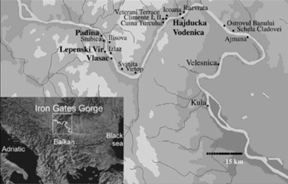
Lepenski Vir, the main site looked at in this paper, is in the second upper gorge, as seen in figure 1 (Boric & Stefanovic, 2004). It is mostly inaccessible as it is on top of a 500m steep hill that is very narrow (Radovic & Stefanovic, 2013). Radiocarbon dating shows that the Mesolithic population occupied the site from 9400-7400 BC (Radovic & Stefanovic, 2013). There was evidence that some of the individuals found at the site dating to the Mesolithic and Neolithic occupation were of non-local origin (Radovic & Stefanovic, 2013). Evidence of domestic animals did not appear until about 5950 Cal BC (Radovic & Stefanovic, 2013).
Figure 1 Danube Gorge area showing Lepenski Vir and Vlasac (Boric & Stefanovic, 2004)

Chapter 2: Teeth and Diet

This chapter will look at the oral health of both hunter-gatherers and agriculturalists, from both the archaeological record and modern examples, to compare the status of health of these two populations. The factor that affects oral health the most is diet, so although this chapter will be mainly focused on teeth to get a full picture of what their health was we need to examine aspects of their diets as well.
The transition from a hunter-gatherer lifestyle to one of agriculture has been associated with a decline in oral health, due to an increased consumption of carbohydrates (Crittenden et al., 2017). Diet is one of the most common causes for dental decay, but other factors can also influence it, such as a person’s oral microbiome, how often they feed, dental wear, female hormones and many more (Crittenden et al., 2017).
Dental caries, periodontal disease and tooth wear are the most common issues identified with teeth that have been found both in past and present (Waldron, 2009, p. 239). Dental hypoplasia is also found amongst some archaeological remains (Bush & Zvelebil, 1991, p. 131). Dental decay, also known as dental caries, is essentially the destruction of enamel and dentine caused by excess acid production (Hillson, 1996, p. 269). It was discovered during an experiment called the Vipeholm experiment that one of the main contributing factors that cause dental caries is sugar (Hillson, 1996, p. 269).
Tooth wear is caused by grinding actions such as chewing food and using teeth as tools; tongue and cheeks can also affect it and it can occur during sleep (Hillson, 2005, p. 214). It has occurred intensively in past populations and is considered a physiological process (Couture, et al., 2012).
Hypoplasia is seen as lines or bands on a tooth (Waldron, 2001, p. 130). There are four conditions, which it could be related to stress, Cribra Orbitalia, periostitis and Harris’s lines (Waldron, 2001, p. 130). Periodontal disease, like caries, comes under the category of dental chronic non-communicable diseases (CNCDs) (Hujoel 2009).
Some scholars argue that when people shifted from a hunter-gatherer diet to an agricultural diet with more complex carbohydrates, this had a range of effects on human health, for example, deficiencies in diet and caries (Radovic & Stefanovic, 2013). Hunter-gatherers are generally characterised as being mostly free of dental caries and periodontal disease (Hujoel, 2009). Studies done on the Zulu have never turned up any results that show periodontal disease (Hujoel, 2009). However, the Zulu’s transition showed an increase in periodontal disease and diabetes (Hujoel, 2009).
In the past, hunter-gatherer societies mostly gathered, and an emphasis on hunting only appeared in the high altitudes (Adam, et al., 2003). Some groups of Eskimos that have less cultural contact, had great dental health and a high immunity to caries (Hujoel, 2009). A study revealed that the Eskimo community showed a 144-fold increase in the number of dental caries that were present after their transition to agriculture (Hujoel, 2009). The adoption of agriculture and the development of staple crops that are high in carbohydrates led to an increase in the number of caries present in agricultural populations in general (Hujoel, 2009).
The hunter-gatherer diet includes mostly wild plant foods and game animals (Crittenden et al., 2017). In general, the diet of a hunter-gatherer involves food that is high in nutrients of minerals, proteins, and vitamins, which is a healthy diet when compared to that of an agriculturalist, which is extremely starchy and usually high in calories (Krenz-Niedbala, 2014).
A breakdown of the diets of hunter-gatherer Australian aborigines was 50% protein, 40% fat and only 10% carbohydrates (Adam, et al., 2003). Their diet included kangaroo, freshwater fish, shellfish, crocodile, yams, turtles, birds, figs, and honey (Adam, et al., 2003).
In the case of the Hadza, they eat birds, honey and bee larvae (Berbesque, et al., 2012). Based on the current criteria this group of people would be considered underweight, as their body mass index would have been 13-19 (Adam, et al., 2003). The plant foods that they eat are baobab fruit, multiple types of berries, figs, drupes, legumes and varying species of tubers (Berbesque, et al., 2012).
The hunter-gatherer !Kung population eat more plant-based foods than they do meat, in fact, nine species of plant provide three-quarters of their diet (Adam, et al., 2003). These species include tsibean, tubers with seeds, tsa plant, and one of the most important is the mongongo nut as it is around all year through all seasons (Adam, et al., 2003). More specifically the hunter-gatherer !Kung diet is described as rich in nutritional quality and adequate in quantity (Shostak, 1990, p. 201). Nevertheless, when agriculture was adopted nearer to this group the cattle herd ate the gathered food and the noise scared the game away. The agricultural !Kung diet was also more carbohydrate based, making their health decline (Shostak, 1990, p. 215). The groups who had an almost exclusively carnivorous diet had barely any caries (Hujoel, 2009).
With the Hadza, those living near or in the village have a mixed diet, of both hunter-gatherer and traded, purchased and donated foods (Crittenden et al., 2017). The men in the village hunt some of the bush foods, though they do not have as much choice as those living in the bush, they usually get some game birds, squirrels, dik dik, baboon and hyrax (Crittenden et al., 2017). The women in the village tend to gather baobab and palm fruit, other species of berry, and a mixture of herbs (Crittenden et al., 2017). Evidence from Europe shows that the diet during the Neolithic era through to the medieval era did not change much, the main foods being einkorn, emmer, bread wheat, millet, hulled grow barley, peas, rye, spelt, lentils and oats (Macintosh, et al., 2016).
A study conducted by Crittenden et al in 2015 with the Hadza population aimed to examine their teeth as some of them are currently in the middle of the transition to agriculture (Crittenden , et al., 2017). They were categorised into three groups: the bush, who live a primarily hunter-gatherer lifestyle; intermediate, who have a mix of both hunter-gatherer and agriculturalist lifestyle, and agricultural or village, who live off an agricultural diet (Crittenden et al., 2017). A breakdown of the kilocalories of the Hadza’s hunter-gatherer’s diet is, 46-53% percent foraged foods, 11-15% honey and larvae, 32-35% hunted game, and 0-8% agricultural products (Crittenden et al., 2017).
The study was conducted over a ten-day period and involved 37 women and 38 men all age 18 and above (Crittenden et al., 2017). Before the analysis was started, the participants cleaned their teeth for two minutes, with a pre-pasted toothbrush then rinsed with water (Crittenden , et al., 2017). Any fissures found in the teeth were then cleaned with a dental sickle scaler; this was done to get better visuals and for laser fluoresces analysis of the crown (Crittenden et al., 2017).
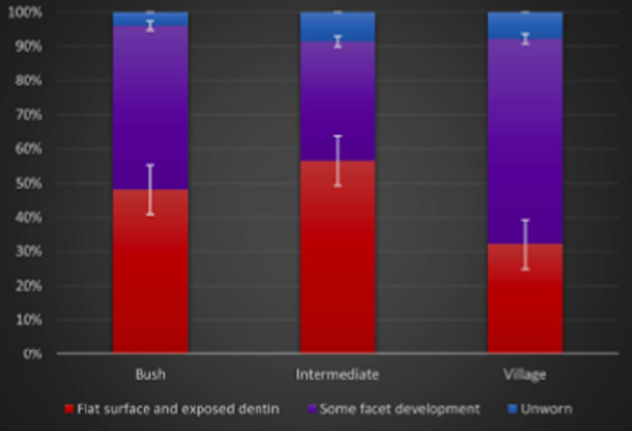
Out of the 75 people who participated, 73 had enough teeth to examine the gross wear; the results are seen in figure 2 (Crittenden et al., 2017). When looking at the different wear rates between the three groups there does not appear to be a significant difference (Crittenden et al., 2017). However, when looking at the amount of flat surface and exposed dentine in the bush group you can see that it is near 50% whereas in the village group it is nearer 30%. The teeth with the flattest surface and exposed dentine are in the intermediate group with it being nearer to 60%. The number of unworn teeth is highest, but only just, in the intermediate group, and the group with the least unworn teeth is the bush group. There was an increase in the amount of wear with age, but that is to be expected cross-culturally (Crittenden et al., 2017).
Figure 2, Gross wear amongst the Hadza based on the 2015 study (Crittenden , et al., 2017)
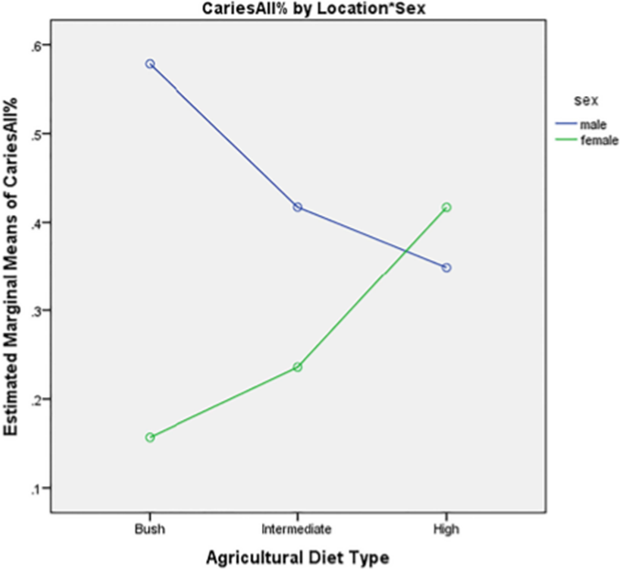
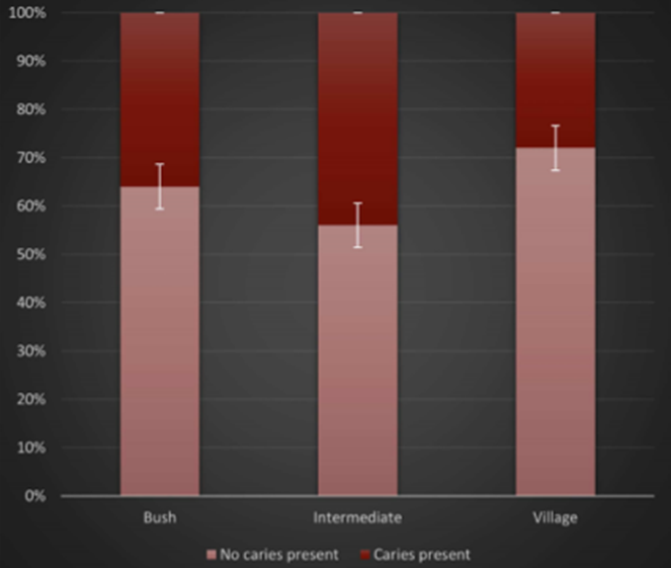
When it comes to looking at the number of caries a group had they used two methods, first is visual diagnosis and the second uses a diagmodent classic dental laser (Critenden et al., 2017). The bush group consisted of 12 women and 13 men, the village group comprised 19 women and 6 men, and finally, the mixed group, which will be called intermediate, included 7 women and 18 men (Crittenden et al., 2017). Figure 3 shows that there is a difference in the number of caries in the bush population which has under 40%, and the village population which has 30%. The intermediate population had the highest percentage of over 40% though the difference is not massive. These results are similar to those found amongst the hunter-gatherer !Kung people where tooth decay is absent as they have so little sugar and very few refined carbohydrates in their diet (Shostak, 1990, p. 320)
Figure 3 Amount of Caries Amongst the Hadza, based on 2015 study (Crittenden , et al., 2017)
There was a large difference between the sexes and the number of caries present in each group (Crittenden et al., 2017). The women, as seen on figure 4, appear to have a low caries count in both the bush and the intermediate population, but there seems to be a large spike in the number of caries amongst women in the village population this being the only group where the men have fewer caries than the women. Men have their highest caries count in the bush population and then it dramatically declines in the intermediate and continues to decline in the village group.
Figure 4 Amount of caries by group, mean average between men and women, based on 2015 study (Crittenden , et al., 2017)
The group with the best overall oral health in this study, was women in the bush group whose diet was mostly wild foods (Crittenden , et al., 2017). The group with the worst oral health overall was the men living in the bush (Crittenden et al., 2017). One possible reason that has been suggested to explain this difference is the average age of men and women (Berbesque, et al., 2012).
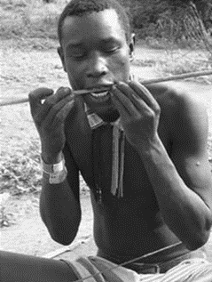
Women in the bush also have fewer cases of periodontal disease (Crittenden et al., 2017). One reason for this is dietary differences within the group: the women seem to eat more tubers than the men, and tubers contain high quantities of grit and fibre which could act to rub against the bacteria and work like a toothbrush in that sense to get rid of it (Berbesque, et al., 2012).
When looking at antemortem tooth loss, again men in the bush group have the most (Berbesque, et al., 2012). It has been suggested that the reason for this is that men use their teeth as tools to grip the shaft of arrows, as seen in figure 5. Another suggestion is that men eat larger amounts of honey, and the consumption of honey is linked with caries (Berbesque, et al., 2012). The Hadza eat the whole contents of the hive, and the wax from it appears to keep the honey stuck to the teeth (Crittenden , et al., 2017). This means that the sugars and plaque bacteria will be stuck to the teeth for long periods of time stopping other foods from removing them (Crittenden, et al., 2017).
Figure 5 A Hadza man straightening an arrow with his teeth (Berbesque, et al., 2012)
The Hadza do sometimes use a small branch from the Salvadora persica plant to brush their teeth. It has been discovered that this plant has antimicrobial properties that help defend against oral pathogens (Crittenden, et al., 2017). The !kung also use a plant to brush their teeth (Shostak, 1990, p. 320). Though we do not know if the Mesolithic or Neolithic population brushed their teeth at all, we do have enough skeletal remains to make evaluations on the past populations.
Caries have only been found in 2% of Palaeolithic and Mesolithic populations, however, in some parts of the world, there has been an increase in dental caries since the agricultural revolution (Crittenden et al., 2017). Effects of caries depended largely on a diet based on maize, rice, wheat and other similar foods (Crittenden , et al., 2017).
A study conducted by Radovic and Stefanovic on the dental remains at Lepenski Vir reveal a lot about the health of the population during three stages, Mesolithic, transition and Neolithic (Radovic & Stefanovic, 2013). The study only used the 500 teeth that could be linked to specific individuals (Radovic & Stefanovic, 2013). There were 32 adults, 17 of which were males, 13 females and 2 unidentified sexes (Radovic & Stefanovic, 2013). From the Mesolithic era, there were 8 people, 1 female, 6 males and 1 unidentified sex (Radovic & Stefanovic, 2013). There were 15 from the transition, 6 females, and 9 males (Radovic & Stefanovic, 2013). From the Neolithic, there were 9 people, 7 females, 1 male, and 1 unidentified sex (Radovic & Stefanovic, 2013).
For this study four main features of oral health were examined: prevalence of linear enamel hypoplasia, which can tell a researcher about any physiological stress, and any growth disturbances; rate of dental wear, which can tell a researcher what types of food they had and any other uses for teeth such as tools; dental caries; and antemortem tooth loss (Radovic & Stefanovic, 2013).
Linear enamel hypoplasia went from being moderate during the Mesolithic and transition, to low during the Neolithic (Radovic & Stefanovic, 2013). Out of the population at Lepenski Vir during the Mesolithic 14 out of the 38 studied had evidence of linear enamel hypoplasia, which is over 36% (Radovic & Stefanovic, 2013).
The population during the transition phase that had linear enamel hypoplasia is not that much different from Mesolithic with 16 out of 48 showing signs which is just over 33%; but these results seem high compared to the Neolithic which showed just over 15% with 9 showing signs out of 58 teeth (Radovic & Stefanovic, 2013). The most common age that linear enamel hypoplasia started was two years old; the only ones that started later were at the age of six and all of these were during the transition period (Radovic & Stefanovic, 2013).
Linear enamel hypoplasia can be used as a stress marker, but it cannot tell a researcher exactly what caused the stress (Radovic & Stefanovic, 2013). The results outlined here imply that there was a decrease in childhood stress from the Mesolithic to the Neolithic (Radovic & Stefanovic, 2013). Throughout the transition phase, based on the number of lines per tooth, the stress of individuals increased while childhood stress decreased (Radovic & Stefanovic, 2013).
There are multiple theories as to why children appeared to have more stress during the Mesolithic (Radovic & Stefanovic, 2013). One of these is the living conditions: they would not have had a permanent house and the hunter-gatherer diet meant that there was not a large amount of food security (Radovic & Stefanovic, 2013). Another theory is that because of the age that most of the stress appears, between two and six years old, this could be linked to weaning (Radovic & Stefanovic, 2013).
Table 1, Average rate of tooth wear at Lepenski Vir scored 0-4, separated by tooth and period (Radovic & Stefanovic, 2013)
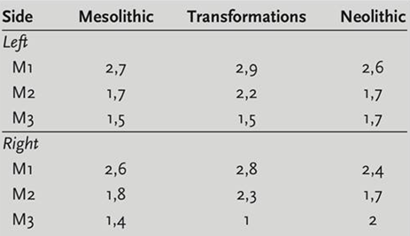
The degree of wear rates was recorded on a scale of zero to four, zero being no evidence of tooth wear and four being total destruction (Radovic & Stefanovic, 2013). The number of teeth that could be used for this part of the study was 133 (Radovic & Stefanovic, 2013). As can be seen in table 1 the amount of tooth wear is high during each period. When the scores for each period are added it is clear to see that the period with the most wear is the transformation, followed by the Neolithic. The Mesolithic being the one with the least wear pattern identified.
The link between tooth wear and diet is a common study that has been done for many populations all over the world and has been used to reconstruct a population’s behaviour and diet (Radovic & Stefanovic, 2013). With the degree of wear in the Lepenski Vir archaeological record being high throughout all periods it suggests that there was no significant change in the diet or the method via which they prepared the food (Radovic & Stefanovic, 2013).
Other studies done on pre-historic fishing communities from California have revealed that sand grinds down the surface of teeth (Radovic & Stefanovic, 2013). The tooth wear seen at Lepenski Vir was the same as what was found in California, but this was partially expected due to the closeness of the sandy shore (Radovic & Stefanovic, 2013). The site of Lepenski Vir did not only include human remains but had a large number of fish bones, likely from where the people who lived there consumed them (Radovic & Stefanovic, 2013). This reason for tooth wear appears to be the same in all periods conveying that the diet did not change much with the adoption of a more sedentary agriculturalist lifestyle that was the Neolithic (Radovic & Stefanovic, 2013).
Dental caries were rarely seen at Lepenski Vir despite them being the most common pathological condition found within the archaeological record, it was only found in 7 out of 500 teeth (Radovic & Stefanovic, 2013). There were no dental caries found amongst the Mesolithic population (Radovic & Stefanovic, 2013). However dental caries were found in the transition with 1 female, and 2 females of non-local origin from the Neolithic (Radovic & Stefanovic, 2013). The amount of caries seen at Lepenski Vir leads to the conclusion that a low carbohydrate diet was consumed that is low in abrasive foods (Radovic & Stefanovic, 2013). The highest amount of dental caries were found in the Neolithic, and the only 2 females that had dental caries from that period were of non-local origin (Radovic & Stefanovic, 2013). It is likely that they had a different diet earlier in their life that led to dental caries, although this is something that cannot yet be proved (Radovic & Stefanovic, 2013).
Ante-mortem tooth loss like dental caries are rarely seen at this site, only 8 out of 524 teeth (Radovic & Stefanovic, 2013). Also, like dental caries, there is no evidence of antemortem tooth loss in the Mesolithic (Radovic & Stefanovic, 2013). All the antemortem tooth loss was recorded in the Neolithic population, one male and female and three other females of non-local origin (Radovic & Stefanovic, 2013). Since dental caries is one of the main reasons for antemortem tooth loss these results are not surprising (Radovic & Stefanovic, 2013).
Overall, based on a global population study, the average amount of caries for each group is as follows, 1.7% for hunter-gatherer populations, 4.8% for mixed or transitioning populations, and 8.6% for groups that live solely on an agriculturalist diet (Radovic & Stefanovic, 2013). The common theory as to why there was such a large increase on the global scale is the production of sugar and products high in carbohydrates, which are now more involved in the diets of many groups around the globe (Radovic & Stefanovic, 2013).
In conclusion, when looking at all the data based solely on oral health, hunter-gatherers appear to be in better shape. Based on the Anthropological data women hunter-gatherers have fewer caries than the men. Men are better off in an agricultural society. There were also no caries in the Mesolithic period.
When looking at the wear patterns, both the anthropological and archaeological data show the least amount of wear in the hunter-gatherer populations, though with the archaeological record it did not increase by much during the Neolithic. This increase might be seen more or less when looking at a population that is more landlocked as most of the wear at Lepenski Vir was attributed to sand and a fish diet. There was no antemortem tooth loss seen in the Mesolithic but in the Hadza group, the men had less antemortem tooth loss in the village. When weighing all this data the better oral health is to be found in the hunter-gatherer groups.

Chapter 3: Population Density

This chapter will look at the life expectancy and birth rate of both hunter-gatherer and agriculturalist populations, in order to get an idea of what the population density might be. When looking at these two aspects it is very difficult to give an average based on archaeological data as the remains found at sites, like Lepenski Vir, are only a small portion of the population that lived there (Boric & Stefanovic, 2004). Therefore, this chapter will be focused mostly on anthropology as that is where the most data on this topic has been collected.
The anthropological data for this study is limited as there are not many hunter-gatherer groups left (Gurven & Kaplan, 2007). Those that are left are not big enough to get all the demographic data on people of all ages (Gurven & Kaplan, 2007). Those that do exist are interrupted by infectious diseases and interactions with colonists, miners and other cultures (Gurven & Kaplan, 2007). The lifespan of the human species tends to have a general pattern that it follows throughout all time periods (Gurven & Kaplan, 2007). This pattern is, a decrease in mortality from infancy through to childhood, followed by a constant mortality rate until the age of forty where it begins to rise (Gurven & Kaplan, 2007).
A large number of the !Kung population die in the prime of their life, with only 20% of those born reaching the age of 60 (Shostak, 1990, p. 313). When they become adults, or what is considered middle age in their population, they tend to be in good physical condition due to their lifestyle (Shostak, 1990, p. 88). One woman that Shostak took interest in, called Nisa, had four children, two of whom died, and she also had a miscarriage (Shostak, 1990, p. 88). This number of children is a regular occurrence in a majority of hunter-gatherer groups, with the average fertility rate being four to eight children per woman (Gurven & Kaplan, 2007). Neither the death or the miscarriage is an uncommon occurrence within the !Kung tribe, it is so common that women know that when they give birth to several children, at least one of them will die before adulthood (Shostak, 1990, p. 304).
The two surviving children of Nisa still died before her, the son died at an age that was acceptable for him to have his own children and the daughter died just as she was becoming a woman (Shostak, 1990, p. 311). This was during the gatherer-hunter part of their lifestyle when they began to live a more settled life more children were born, and it was said to be easier on the elder population, however, mothers still expected at least one of their children to die (Shostak, 1990, p. 217).
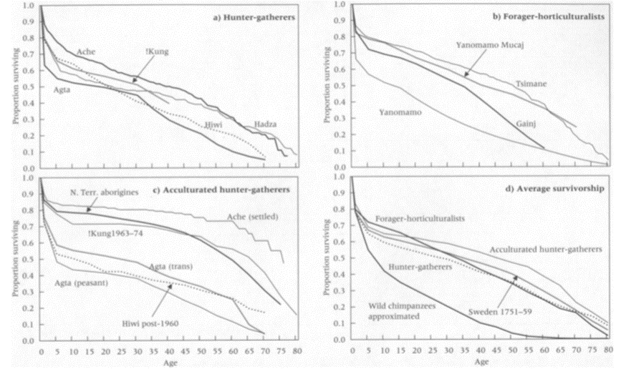
Gurven and Kaplan (2007), did a study on life expectancy and survivorship amongst different populations (Gurven & Kaplan, 2007). They separated the groups into three categories, these are Forager-horticulturalists; representing those who have practiced horticulture or agriculture for many generations; acculturated hunter-gatherers, who have only recently started practicing horticulture and have been exposed to modern amenities such as medicine and markets, and finally hunter-gatherers (Gurven & Kaplan, 2007). For the purpose of their study, they used the Siler competing model, which has three components of mortality (Gurven & Kaplan, 2007). Declining mortality from birth through to childhood, then constant mortality through a majority of the lifespan, until an older age when mortality increases (Gurven & Kaplan, 2007).
Figure 6 Survivor rate for, A) hunter- gatherers, B) forager-horticulturalists, C) Acculturated hunter-gatherers and D) The Average of each group (Gurven & Kaplan, 2007)
Figure 6 shows the results of their study. As can be seen even amongst the different hunter-gatherer groups there are variations in survivorship. When looking at the line that represents the !kung in the hunter-gatherer group the line is at 0.8 with age of zero and there is steep decline until the age of five where it lands on 0.6-0.7 it steadily declines until the age of about forty where it stops at 0.4, there is no other data present for anyone above that age.
Comparing this to the !Kung line under acculturated hunter-gatherers where at the age of zero the line is closer to 0.9 there is still a sharp decline directly after this until the age of about ten where it drops to 0.7 followed by a steady number of people of the same age until it starts to steadily decline. The data for this graph goes beyond eighty years, suggesting an increase in life expectancy within this group because of the change.
This increase in life expectancy could be for many reasons but considering the group of accultured hunter-gatherers has access to some modern medicine it is likely that this is a main contributing factor. As can be seen in figure 6 and supported by other studies, some of the agricultural groups have very similar mortality rate to that of hunter-gatherers (Atkinson & Volk, 2013). Settled life is also less stressful on the elder population which could affect their life expectancy (Shostak, 1990, p. 178).
Another group that appears to have a higher life expectancy after they settled is the Ache (Gurven & Kaplan, 2007). The Ache that are settled have an age at adult death that is seven years more than the pre-contact Ache group (Gurven & Kaplan, 2007). It is thought that when they settled, the conditions that they lived in was better than before, these numbers correlate that (Gurven & Kaplan, 2007).
On average the number of children born that survive to the age of fifteen varies across different groups, 57% hunter-gatherer group, 64% forager-horticultural group, and 67% accultured hunter-gatherer group (Gurven & Kaplan, 2007). After they reach the age of fifteen only some will reach the age of forty-five, with 64% of the hunter-gatherer groups, and 61% forager-horticulturalists, the highest percentage is 79% for the accultured group (Gurven & Kaplan, 2007). The number of years that a person is expected to live after 45 varies between the groups, with it being 20.7 years hunter-gathers, 19.2 years forager-horticulturalists, and 24.6 accultured hunter-gatherers (Gurven & Kaplan, 2007).
Accultured groups appear to be better off with the life expectancy and the amount of population there is. This could be because they have access to modern medication or education. Diet is likely to contribute to this but based on the previous chapter the diet of hunter-gatherers was better than the other groups so it’s more likely that the medication was a factor. In past populations, they did not have the medication that we have today, so their transition would likely have had similar results to the forager-horticultural group rather than the accultured group. In the study done here, the forager-horticulturalist group had the lowest percentage after fifteen years and the lowest life expectancy after forty-five. Since stress can play a large role in the life expectancy, going back to the previous chapter individual stress increased during the Neolithic and childhood stress decreased (Radovic & Stefanovic, 2013). The numbers in this study on modern tribes could be emphasising this idea of stress with their life expectancy.
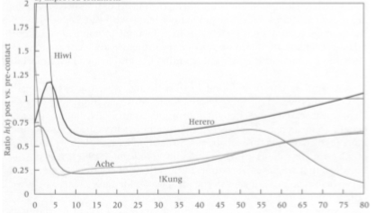
Figure 6 also tells us the age that mortality is the highest. In most of the populations, the mortality rate is at its lowest during reproductive maturity and then increases at a steady but constant rate, before rising again with the older people usually starts between thirty and forty years (Gurven & Kaplan, 2007). The accultured group have the highest increase in mortality after fifty-five (Gurven & Kaplan, 2007). One reason for this patterning is that certain causes of death are reduced, such as violence, during certain periods (Gurven & Kaplan, 2007). In the case of the accultured group, age-related deaths are more frequent than other causes (Gurven & Kaplan, 2007).

Figure 7 Changes in age-specific mortality patterns, with ratio before contact and after contact, improved conditions (Gurven & Kaplan, 2007)
In figure 7 the line representing the !kung shows greater improvement after contact for infants and young children as well as the elderly. One reason for the large improvement we see with infants is that before contact infanticide amongst the !Kung was a common practice (Shostak, 1990). Infanticide is not exclusive to the !Kung, it has been seen throughout time and all around the world (Halcrouse, et al., 2008). There was some improvement in health for adults but not as much as there was for the more delicate age groups. For many modern hunter-gather groups similar results can be seen in figure seven which uses the Herero and Ache. After initial contact, the mortality rate increased for infants but for late childhood and adults, it decreased to one fourth and one-third of what it was before contact (Gurven & Kaplan, 2007). Similar results were found in studies done on the effects of sedentism, in that there was a decrease in child mortality (Gurven & Kaplan, 2007).
Amongst the Ache group, the reduction in mortality rate is linked to reductions in homicide, forest-related incidents and availability of medical care (Gurven & Kaplan, 2007).The !Kung have a similar result to the Ache, but their survival rate increased for all ages (Gurven & Kaplan, 2007). Though the survival rate increases, they do complain about the scarcity of meat and other food, a documentary done about them raised the issues of only having mealie meal and it is not enough to feed their families, they start to complain about hunger (!Kung 1980).
On average, hunter-gatherer groups have a population growth of 1% per year (Gurven & Kaplan, 2007). However, multiple groups show a mortality and fertility rate that lead to a negative population growth or one that does not change (Gurven & Kaplan, 2007). Whereas with forager-horticulturalists their total fertility rate is 6.2 and their growth rate exceeds 2% a year (Gurven & Kaplan, 2007).
Not many studies have been done within the archaeological record on population density, birth or death rates. Remains found at a site are usually only a small portion of the population that lived there, and dating can be hard. There are multiple biases that can affect the archaeological record, these are: preservation of human remains differs depending on age group as some remains are more fragile than others; there are only partial examples from cemeteries and selectivity that effects the formation of mortuary examples (Larsen, 1995).
It is commonly thought that Palaeolithic people had a life expectancy of 15 to 20 years, and it was not until agriculture came about that this increased to 25 years, but evidence suggests that the age was older for both (Gurven & Kaplan, 2007). There are a number of prehistoric sites with life tables that support this view, however, ageing the remains from these sites can be difficult (Gurven & Kaplan, 2007) and some sites like Lepenski Vir have remains that are classed as unknown age (Boric & Stefanovic, 2004).
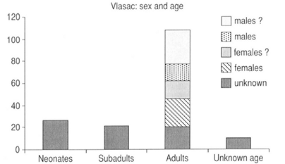
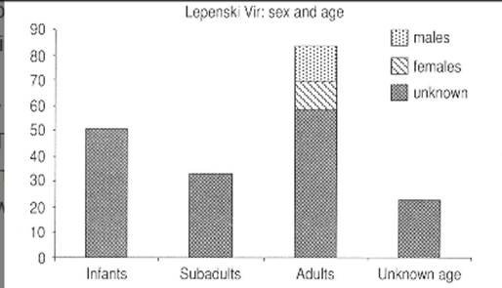
The theory of the Neolithic demographic transition is that it was a two-part process (Bocquet-Appel, 2014). The first stage is the population increases due to an increase in fertility rate (Bocquet-Appel, 2014). The second stage is that the death rate eventually increases to that of the birth rate until the population stopped growing and started decreasing (Bocquet-Appel, 2014).
Figure 8 the number of individuals, with sex and age found at A) Lepenski Vir, B) Vlasac (Boric & Stefanovic, 2004)
Boric and Stefanovic (2004), analysed infant burials at Vlasac and Lepenski Vir, though they do not separate them into time periods (Boric & Stefanovic, 2004). The remains that they analysed are underneath floors and housing structures. These would usually be seen in the Neolithic leading to the belief that the study is done on a Neolithic population rather than Mesolithic. The most intensive period of occupation at Vlasac was during the Mesolithic whereas for Lepenski Vir it was during the transition (Macintosh, et al., 2016).
Their results can be seen in figure 8. At Lepenski Vir there are a large number of adults and infants. In this case, infants and neonates are considered any individual below the age of 1 year old (Boric & Stefanovic, 2004). Many of the infants found at Vlasac were found with an older adult female, some in the pelvic area, some near the shoulder, this is interpreted to represent a mother and child who died while pregnant, during or just after birth (Boric & Stefanovic, 2004). At Lepenski Vir the infants tended to be buried separately to the adults, this could mean either not as many women were dying at childbirth or that they had cultural differences (Boric & Stefanovic, 2004). Despite a large number of infant burials, it’s assumed that it is not a result of infanticide like, with modern populations, the evidence for this is that there appeared to be a lot of care taken when burying the infants (Boric & Stefanovic, 2004).
A large number of infants and subadults is an indicator of the birth rate at Lepenski Vir, birth rate rises when there is food stability and people consider it safe to do so. Stefanovic (2006) theorises that at Lepenski Vir they were ‘Domesticating Birth’ which led to higher birth rates (Stefanovic, 2006). The idea is that the houses at Lepenski Vir were built in a way that hot bricks could be placed inside a hearth type area that would then heat up the house (Stefanovic, 2006). There was evidence that this was possible, and they did find hearths inside the houses, it was also interpreted that infants were buried underneath the floors of houses that they were born in (Stefanovic, 2006). These houses became ‘maternity wards’, a place for giving birth and neonatal care (Stefanovic, 2006). The heat and the safety of being inside during this delicate time would have stopped the baby from dying of hypothermia and related illnesses (Stefanovic, 2006). However, if this is the case and theory leads to the belief that because of this care routine that infants would have survived then it is at odds with the evidence of many infants found at the site.
Due to the vast amount of settlements mixed with human skeletal remains, Çatalhöyük, is a site where archaeologists have been able to estimate the population size (Agarwal, et al., 2015). By looking at the vast structures at the site the peak population that was reached was estimated between 3500-8000 during the Neolithic (Agarwal, et al., 2015). The occupation of Çatalhöyük is separated into three groups, early, middle and late (Agarwal, et al., 2015). The early period was a small population in 7100 BC, the middle period is considered its peak time, it occurred between 6610-6250 BC, and finally late period, when the population began to decline, was between 6410-6150 BC, the site is thought to have been abandoned in 6000BC (Agarwal, et al., 2015).
Agriculturalists within the archaeological series tend to have a lower mean age at death than hunter-gatherers, because of this it can be said that an increase in mortality, birth rate and declining life expectancy happened with the shift (Larsen, 1995), this can be seen at Çatalhöyük. Harpending and Sattenspiel (1983) showed that there is a link within archaeological skeletal assemblages between the mean birth rate and age at death (Harpending & Sattenspiel, 1983). The link was that if the mean age of death is low then there is likely going to be a higher birth rate (Harpending & Sattenspiel, 1983). If we apply this to Çatalhöyük where 34% of the population was between the ages 0-3 and 23% was between 3-19 with the remaining 42% being adults, the large number of juveniles suggests that the life expectancy is going to be low in this population (Agarwal, et al., 2015). Going back to figure 8, the high number of infants at Lepenski Vir would also indicate a low life expectancy but at Vlasac there would be a higher life expectancy as there is a low number of infants.
Bocquet-Appel (2002) estimates a juvenility index as a base for fertility rate (Bocquet-Appel, 2002). It was based on the ratio of juveniles relative to the overall sample, it was first done for Europe and North America (Bocquet-Appel, 2002). In relation to Çatalhöyük with the ratio of death between 3-19 (D3-19) and death 3+ (D3+) the results can be seen in table 2 (Agarwal, et al., 2015). The early period is when the transition to agriculture happened, the low juvenility index during the early and late period is an indication of low fertility rates (Agarwal, et al., 2015), this would support the same evidence found from modern groups when fertility decreases at first to then increase. There is an increase in fertility in the middle period, suggesting that longer agriculture was practiced the more people adapted in the long term to become healthier, this increase is also followed by more houses showing that the peak in population size during the middle period is due to a rise in fertility rates (Agarwal, et al., 2015). The decline in the late period has been linked to lack of resources and land use, people likely migrated elsewhere (Agarwal, et al., 2015).
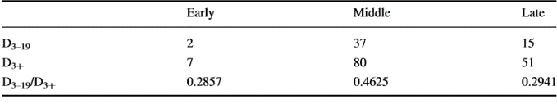
Table 2 Number of people in D3-19 and D3+, with the juvenility index for each period (Agarwal, et al., 2015)

When the same method is applied to Lepenski Vir and Vlasac based on death subadults/ death adults. The results are based on figure 8, at Vlasac the number of adults is 115, and the subadults are 20, giving a juvenility index of 0.1739. At Lepenski Vir the number of adults is 85 and the number of subadults 30, giving a juvenility index of 0.35294.
The juvenility at Vlasac is low but at Lepenski Vir it is high, if these are representations of agricultural groups then the fertility rate can be different within the same subsistence group. Though it has not yet been studied one reason for this difference could be that Lepenski Vir had a larger population than Vlasac, so they had different rates. Since a large population is linked with agriculture it could mean that after the transition fertility rates rose, this is supported with results from studies done on modern populations.
This data supports the idea that a growing population would have a higher number of younger individuals compared to adults (Larsen, 1995). Other evidence of this is Iowa, Illinois, where the birth rate shows an increase just before and during the adoption of agriculture (Larsen, 1995). It is thought that one of the reasons fertility and birth rate increased was the introduction of softer and easily digestible foods (Larsen, 1995). These types of foods meant that babies could wean quicker, so women had shorter intervals between births (Larsen, 1995).
Studies were done in North America that compares agriculturalists and hunter-gatherers showed this increase in birth rate and its effect on their mortality curve (Larsen, 1995). A hunter-gatherer mortality curve tends to rise quickly as age increases, but an agriculturalist mortality curve is flatter showing the younger population (Larsen, 1995).
When looking at both modern hunter-gatherer populations and those of the past, the mortality rate for the past is lower until the age of two, but by the age of 45, the mortality rate is seven times larger than that of the extant hunter-gatherer groups (Gurven & Kaplan, 2007). This difference could be linked to warfare, or systematic bias in the data samples (Gurven & Kaplan, 2007).
In conclusion, within hunter-gatherer groups, the elderly are in better health, but the life expectancy is shorter. When looking at just the demography of the population as an indicator of health it appears that the agriculturalists were better off. Though during the initial transition when people are adapting, mortality rate seems to spike, in the long run, agriculture was better. They had a better life expectancy and lower infant mortality rate in both agricultural and archaeological remains. If the theory of ‘Domesticated birth’ is to be believed then the Neolithic had better medical knowledge, the agriculturalists of modern populations had more access to modern medication which helped them.

Chapter 4: Biological factors

This chapter looks at the data available to interpret health based on what type of diseases each population had, what injuries may have occurred and with some of the data how well they dealt with the injuries. Not many studies have been done specifically to compare these factors. Though many of the diseases coincide with nutrition and sedentism with a growing population.
Modern hunter-gatherer populations have less Chronic non-communicable diseases (CNCDs), such as heart disease (Hujoel, 2009). It was only after the transition to agriculture that these diseases started to be seen within these populations (Hujoel, 2009).
Comparison of health was done between the settled Kikuyu and the Hunter-gathers Masai (Adam, et al., 2003). The Kikuyu had pulmonary disease whereas the Masai often had intestinal stasis and arthritis (Adam, et al., 2003). Pulmonary disease is a severe lung disease often caused by smoke (WebMD, 2018).
When people within the !Kung population had injuries, when it was an open wound they used to put salt on them in order to help clean it (Shostak, 1990, p. 95). Saltwater does help prevent infections as it kills off certain bacteria, it can also help with the healing as it dries the wound out (society, 2016). Salt as a cleaning product is still used in modern medication as it works so well, however, if it is used excessively it can make a wound worse and cause infection (society, 2016). Within hunter-gatherers in general, it is thought that if they are a mobile group and an individual becomes ill or injured, they would need to recover quickly, as the residential band will need to move on in search of more food resources (Hill, et al., 2007).
At the time of the study when the !Kung were predominantly hunter-gatherers they were free of many diseases related to stress and nutrition (Shostak, 1990, p. 201). However, their overall health is not that good (Shostak, 1990, p. 201). One of the most common causes of death for the !Kung is infectious and parasitic diseases, such as Influenza, pneumonia, bronchitis, gastroenteritis, rheumatic fever, tuberculosis and in the rainy season cases of malaria are seen (Shostak, 1990, p. 201). Although tuberculosis is spread through air particles it is more commonly spread through bovids found in animals through their milk (Waldron, 2001, p. 67). This means it would have been more common within agricultural groups (Waldron, 2001, p. 67). In other populations like the Agta and Yanomamo, these diseases are believed to be absent during their forager phase (Gurven & Kaplan, 2007). Men appear to be more vulnerable to diseases, as they are going out and hunting, therefore, being exposed to more risks (Shostak, 1990, p. 201).
The older population within hunter-gatherer !Kung were free of medical issues that are common in other cultures (Shostak, 1990, p. 320). These include atherosclerosis, hearing loss, hypertension, and stress-related ulcers and colitis (Shostak, 1990, p. 320). In fact, most !kung that are age 60 and above are still independent but more than half do have physical problems that are age-related (Shostak, 1990). These are partial loss of vision, walking difficulties, respiratory diseases like tuberculosis, Chronic Bronchitis and Emphysema (Shostak, 1990, p. 320). Measles infection is not something that affects hunter-gatherer groups of any age as they are generally too small but after sedentism and population growth it is more prevalent (Waldron, 2001, p. 57).
When agriculture came about the animals contaminated the water that the !Kung drank, this created many water-borne diseases (Shostak, 1990, p. 215), such as cholera (Gaard, 2014). Animals also brought large quantities of flies which led to many new afflictions, such as Venereal disease (Shostak, 1990, p. 215).
Faecal studies of the Hadza show that they have low resting metabolic rates compared to a nearby forager-horticultural group called Twasi (Barone, et al., 2016). This implies that the Hadza have low immune stress, likely caused by low pathogen burden (Barone, et al., 2016). The larger the diversity of gut microbiome the healthier an individual is likely to be and the Hadza have one of the most diverse gut microbiomes that have been seen in modern humans (Hunting with the Hadza 2017). Many of the species found in the Hadza are extinct within the modern world (Hunting with the Hadza 2017).
Within agricultural population the age of maturity, classified as the first menarche, has declined to a lower age, this has been linked to child health (Gawlik, et al., 2011). Gawlik and friends (2011) claim that it is a response to positive environmental cues with energy balance (Gawlik, et al., 2011). The assumption of this study is that reproductive system maximises the amount of offspring equalising the benefit of more births against maternal mortality (Gawlik, et al., 2011). If this is the case then the lower age and higher birth rates would suggest that at least for children agriculture was more beneficial (Gawlik, et al., 2011).
Many of the deaths before agriculture and the government were caused by the people themselves as they had no law against homicide and when tempers flared people died (Shostak, 1990, p. 217). However, in the archaeological evidence violence was seen in both hunter-gatherer and agriculturalist populations.
Physical anthropologists can often make interpretations about when a population changed to Neolithic lifestyle (Jackes, et al., 1997). They can tell by the appearance of smaller skeletons that are heavily diseased (Jackes, et al., 1997).
Growth rate and stature, of people within a population can be an indicator of health (Bush & Zvelebil, 1991, p. 53). The growth rate is affected by nutritional stress and diseases; however, studies of growth rate is limited as children will need to be available for study which is not always the case with archaeological assemblages (Bush & Zvelebil, 1991, p. 53). In Europe, people appear to become shorter during the early Neolithic, but in the late Neolithic people began to get taller again (Bush & Zvelebil, 1991, p. 133). The average male during the Mesolithic was 167.7 cm tall whereas, in the Neolithic 167.3 cm tall, the females showed similar results with Mesolithic being 155.6 cm and Neolithic being 154.1 cm (Bush & Zvelebil, 1991, p. 133). Some populations show no change between hunter-gatherers and agriculturalists (Larsen, 1995). Based on the hypothesis that stature is affected by nutrition, then after the initial transition, there was more nutritional stress than before. It did eventually get sorted the longer people stuck with agriculture.
In central Europe, one of the first Neolithic groups were called Linear Band Keramic (LBK), and skeletal evidence from this group show high physiological stress and pathogen loads within the younger population, specifically the children (Macintosh, et al., 2016). This suggests that early life conditions for the LBK was probably difficult (Macintosh, et al., 2016). Because of the early life conditions of the LBK population, it is expected that their adult body size would be smaller than those found in the Iron Gates, research on German LBK populations supports this (Macintosh, et al., 2016).
Comparing the populations of agriculturalists and hunter-gatherers at Vlasac and Lepenski Vir, those from the hunter-gatherer groups had the larger body size, this was more pronounced in the men (Macintosh, et al., 2016). Late Mesolithic men would have been taller and heavier than the Neolithic, it was the same for the women (Macintosh, et al., 2016). Neolithic men have the lowest estimated stature and body mass out of those in other agricultural groups (Macintosh, et al., 2016). This implies that the initial transition was unhealthy leading to the low stature, but later Neolithic groups were not as bad, so they were likely healthier (Macintosh, et al., 2016). Supporting this is an analysis of long bones from prehistoric America showing growth deficiencies within the agricultural groups compared to the hunter-gatherer population (Larsen, 1995).
There is evidence of sexual dimorphism when it comes to body mass and stature, in both Mesolithic and Neolithic populations (Macintosh, et al., 2016). The larger difference being in the Neolithic population, at Vlasac on average men are 176.6 cm tall whereas women are 163.2 cm tall (Macintosh, et al., 2016). Though the height difference between the two does suggest different levels of health, these heights would not be present in a population with high nutritional stress, or a population that lacks the opportunity for catch up growth (Macintosh, et al., 2016). With reference to Vlasac, the largest sexual dimorphism was found during the Mesolithic with men being 128% the body mass of women this difference was likely caused by dietary differences (Macintosh, et al., 2016).
Within hunter-gatherer assemblages men seem to have it easier than women, however, they are more likely to be injured during a hunt and some of these injuries like a compound fracture could be fatal (Waldron, 2001, p. 57). An example of some of the breaks that hunters might get is with a Neolithic hunter known as Otzi, the Iceman, he had fractures on several of his ribs on both sides likely caused from a fall (Spindler, 1994, p. 179).
There is a connection between nutritional quality and bone mass or thickness in tubular bones, like the femur and metacarpals, but the mechanical environment also plays a role (Larsen, 1995). Stout (1983) did a comparison of past hunter-gatherers and agriculturalists in North and South America based on bone remodelling (Stout, 1983). The results showed larger rates of remodelling in agriculturalists than in hunter-gatherers, this could be a result of overproduction (Stout, 1983).
At Vlasac, the skeletal remains have large quantities of osteomalacia, with it affecting 15% of males and 25% of females (Bush & Zvelebil, 1991, p. 130). There is also evidence of Rickets in 44% of the children, both are signs of either vitamin D or Calcium deficiencies, which are integral nutrients within fish (Bush & Zvelebil, 1991, p. 130). This is peculiar as they did consume fish, at Vlasac and Lepenski Vir (Bush & Zvelebil, 1991, p. 130). It can also be caused by parasitic infection, which in some cases can cause impairment of the kidneys and intestines, therefore, reducing their function to absorb the nutrients (Bush & Zvelebil, 1991, p. 130).
Within the Mesolithic assemblages, postcranial pathologies reveal degenerative conditions, commonly arthritis (Bush & Zvelebil, 1991, p. 130). The areas that this affects the most is vertebral column, shoulder, upper arm, and the foot (Bush & Zvelebil, 1991, p. 130). The areas that it is seen in suggests that this is likely caused by hunting activities (Bush & Zvelebil, 1991, p. 130). Osteoarthritis is seen by osteophytes on joint margins called lipping, and in extreme cases porosity on a joint surface (Agarwal, et al., 2015). Osteoarthritis in all eras affects women more than men (Ammerman, 2003). Pathologies from the Neolithic show a reduction in arthritis, this is possibly linked to a reduced workload during the Neolithic (Bush & Zvelebil, 1991, p. 130).
During the Mesolithic, there are large amounts of Cranial Parotic Hyperostosis (Bush & Zvelebil, 1991, p. 130), also known Osteoporosis which is a bone disease that weakens the bone and makes it fragile (NHS, 2016). It has been found in cave sites ertebølle and Franchthi (Bush & Zvelebil, 1991, p. 130). Hyperostosis on its own is commonly caused by nutritional stress and happens in populations that rely on a more cereal-based diet (Bush & Zvelebil, 1991). Cribra Orbitalia is also commonly found in the Mesolithic population (Bush & Zvelebil, 1991, p. 130), and was found at Lepenski Vir (Boric & Stefanovic, 2004). Cribra Orbitalia appears on the bone as sieve-like lesions in the orbital roof and is caused by bone marrow, which produces blood, expanding (Krenz-Niedbala, 2014). The most likely explanation for this is iron deficiencies like anaemia, and other nutritional stress (Bush & Zvelebil, 1991, p. 130). Iron deficiencies are more likely to be seen in agricultural populations because their diets are based largely on maize and cereals which lack iron (Larsen, 1995). There is evidence that infectious disease could be a factor as well as sedentism and larger populations (Bush & Zvelebil, 1991, p. 130).
Comparisons of both non-specific and specific infectious diseases show that they are more common in populations that are more settled (Larsen, 1995). This is seen in evidence of agricultural societies that are more settled than hunter-gatherers and have more of these diseases (Larsen, 1995). These types of diseases have also been seen in more settled hunter-gather groups, meaning that it is less to do with subsistence and more with sedentism (Larsen, 1995).
Warfare and violent deaths have been seen in skeletal assemblages throughout all time periods (Larsen, 1995). However, analysis and reports of remains from hunter-gatherer and agriculturalists show an increase in violent deaths with the agriculturalists (Larsen, 1995). This increase is likely because of population size and resources (Larsen, 1995). Within the archaeological and anthropological record, it has been recorded that unsegmented hunter-gatherers have low levels of warfare, likely because they are egalitarian societies and lack the social organisation to partake in warfare (Roksandic, 2006). Of the 17 segmented hunter-gatherers, 16 show evidence of warfare (Roksandic, 2006).
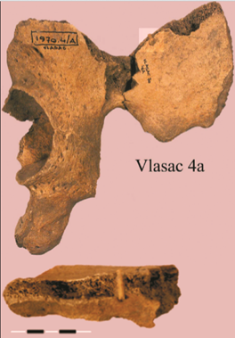
In the Danube Gorge area, there is evidence of projectile points that have been embedded in the bone (Roksandic, 2006). Figure 9 shows a projectile point embedded in the iliac fossa of the pelvic bone, caused by what is probably a Mesolithic arrow (Roksandic, 2006). This type of injury could be caused by war, the sex and age of the individual would match this, however, it also matches the sort of wound that could occur as a hunting accident (Roksandic, 2006). There is also evidence of fractures on the arm caused by raising the arm above the head in a defensive move (Roksandic, 2006). It was found in a female which leads to the belief that it is unlikely a sign of warfare and possible domestic violence or an accident (Roksandic, 2006). These are both wounds found on individuals from the Mesolithic, there is no more or less trauma found on Neolithic groups (Roksandic, 2006).
Figure 9 remains of a male age 18 from Vlasac, with a projectile point wound (Roksandic, 2006)
In conclusion, based on the biological factors, hunter-gatherers were healthier. Hunter-gatherers of both the past and present had less infectious diseases and were mostly free of stress-related diseases. Hunter-gatherers had a larger variability of microbiome. However, the age of the first menarche did go down which shows that the agricultural population had some better health benefits. A lot of the issues that are seen within the initial transition to agriculture are not seen after it has been active as a mode of subsistence for a while, further study of the long-term effects would be needed to prove this.

Chapter 5: Conclusion

Hunter-gatherer groups both past and present are mostly free of dental caries and periodontal disease. Within agricultural groups in the past caries and periodontal disease is seen within the Neolithic populations but still rarely, within present-day agricultural groups, it is seen more often. By looking at the !Kung and Hadza the difference in diet can be seen and the hunter-gather groups have a much more varied and nutritious diet than the agricultural groups, whose diet mostly consists of maize and wheat.
The 2015 study on the Hadza showed that their oral health varies within the three groups. The group representing the mixed diet; the intermediate group, had the most worn teeth out of the other two groups. The village group had the least worn teeth, and the bush group fell in the middle. The results were the same when it concerned caries. This indicates that as people become more adapted to the agricultural lifestyle, their health improves.
The archaeological evidence has similar results, but the amount of stress was also recorded. The stress levels based on the teeth showed that during the transition, individual stress increased but going into agriculture childhood stress decreased. Meaning that agriculturalist lifestyle was the healthier choice for children.
When looking at life expectancy and birth rate both were higher within agricultural groups past and present. Within the !Kung hunter-gatherer population most die in the prime of their life but those that do survive until adulthood are healthy. The elders within agricultural populations did have an easier life compared to those of the hunter-gatherers. Their infants began to have higher survival rates after contact. On the other hand, they do have fewer food resources now than they did before contact. Within the forager-horticultural groups, life expectancy was less than that of the hunter-gatherers and accultured hunter-gatherers. Within the Neolithic populations, it appears that they had a better understanding of medical care, specifically infant aftercare and birthing. Fertility in both past and present rose with agriculture. However, all of this leads to an increase in population which can cause issues on its own.
Hunter-gatherer groups had fewer CNCDs. The hunter-gatherer !Kung are free of many nutritional and stress-related diseases, but they suffer from many infectious diseases. Though in other groups the number of infectious diseases increased with agriculture. The proximity of animals with people has led to an increase in tuberculosis and other animal caused diseases. Within the archaeological record, the stature of people decreased with the initial transition but then increased after agriculture had been around for a while. Arthritis was more common during the Mesolithic than the Neolithic. There is a general increase in violent deaths after the adoption of agriculture, and though this was not seen at Lepenski Vir it has been seen at other sites.
Overall, the initial health of agriculturalists both past and present appears to be worse than the health of the hunter-gatherers. However, several studies led to the belief that after agriculture had been around for a while health began to improve.

References
!Kung. Series 1. N!ai: The Story of a !Kung Women. 1980
Adam, F., Walker, A. & Walker, B., 2003. Nutrition, Diet, Physical activity, smoking, and Longevity: from Primitive hunter-gatherers to present passive consumer- How far Can we go?. Nutrition, Volume 19, pp. 169-173.
Agarwal, S., Beauchesne, P., Bos, B., Garofalo, E., Glencross, B., Haddous, S., Hago ,L., Hillson, S.,Knüsel, C., Larsen, C., Pearson, J.,Pilloud, M., Ruff, C & Sadvari, J., 2015. Bioarchaeology of neolithic Catahoyuk: Lives and Lifestyle of an early farming society in transition. Journal of World Prehistory, Volume 28, pp. 27-69.
Ammerman, 2003. The Widening Harvest, The Neolithic Transition in Europe: Looking back. Looking Forward. Boston: Archaeological Institute of America.
Atkinson, J. & Volk, A., 2013. Infant and Child Death in the Human Environment of Evolutionary Adaption. Evolution and Human Behaviour, 33(3), pp. 182-192.
Barone, M., Biagi, E., Brigidi., P., Candela, M., Consolandi, C., Crittenden, A., Fanelli, F., Fiori, J., Henry, A., Mezzullo, M., Rampelli, S., Schnorr, S & Turroni, S ., 2016. Faecal Metabolome of the Hadza Hunter-Gatherers: A Host-Microbiome Integrative View. Scientific Reports (Nature Publisher Group), Volume 6, pp. 1-8.
Bartosiewicz, L., Bonsall, C., Cook, G., Harkness, D., Lennon, R., Mcsweeney, K & Scott, M., 2000. Stable Isotopes, Radio Carbon and the Mesolithic-Neolithic Transition in the Iron Gates. Documenta Praehistorica, Volume 27, pp. 119-132.
Basaglia,. G. Biagi, E., Brigidi, P., Candela, M., Centanni., Consolandi, C., Crittenden, A., DeBellis, G., Fiori, J., Gotti, R., Henry, A., Luiselli, D., Mabulla, A., Marlowe, F., Peano, C., Rampelli, S., Schnorr, S., Severynini, M &Turroni, S., 2014. Gut Microbiome of the Hadza Hunter-Gatherers. Nature Communications.
Berbesque, J., Johnson, G., Mabulla, A., Marlowe, F., Paun, I & Thompson, P., 2012. Sex differences in Hadza Dental wear Patterns. Human Nature: an Interdisciplinary Perspective, Volume 23, pp. 270-282.
Bocquet-Appel, J., 2002. The paleoanthropological traces of the Neolithic demographic transition. Current Anthropology, Volume 43, pp. 638-650.
Bocquet-Appel, J., 2014. Demographic transition. Encyclopedia of Global Archaeology New York: Springer, pp. 2093-2100.
Boric, D. & Stefanovic, S., 2004. Birth and Death: infant burials from Vlasac and Lepenski Vir. Antiquity, Volume 78, pp. 526-547.
Bush, H. & Zvelebil, M., 1991. Health in past societies, Biocultural Interpretations of Human Skeletal Remains in Archaeology context. England: Tempvs repartum.
Couture, C., D'incou, E. & Maureille, B., 2012. Human tooth wear in the past and the present: tribological mechanisms, scoring systems, dental and compensations. Archives of oral biology, Volume 57, pp. 214-229.
Crittenden, A., Mabulla, A., Moonie, S., Peterson, M., Sorrentino & Ungar, P., 2017. Oral health in Transition: the Hadza Foragers of Tanzania. PLoS One, Volume 12.
Gaard, V., 2014. Vester Gaurd: water borne diseases. [Online]
Available at: http://www.vestergaard.com/global-challenges/waterborne-diseasses
[Accessed 06 may 2018].
Gawlik, A., Hochberg, Z. & Walker, R., 2011. evolutionary fitness as a function of pubertal age in 22 subsistence-based traditional societies. International Journal of Pediatric Endocrinology, Volume 2011, pp. 2-9.
Gurven, M. & Kaplan, H., 2007. Longevity Among Hunter-Gatherer groups: a cross-cultural examination. Population and Development Review, Volume 33, pp. 321-365.
Halcrouse, S., Livingstone, V. & Tayles, N., 2008. Infant Death in Late Prehistoric Southeast Asia. Asian Perspectives: Journal of Archaeology for Asia and The Pacific, Volume 47, pp. 371-405.
Harpending, H. & Sattenspiel, L., 1983. Stable Population and Skeletal age. American Antiquity, Volume 48, pp. 489-498.
Hill, K., Hurtado, A. & Walker, R., 2007. High Adult Mortality amongst Hiwi Hunter-gatherer: Implications for Human Evolution. Journal of Human Evolution, Volume 52, pp. 443-454.
Hillson, S., 1996. Dental Anthropology. London: Cambridge University Press.
Hillson, S., 2005. Teeth. 2nd ed. United States: Cambridge Manuals in Archaeology.
Hujoel, P., 2009. Dietary carbohydrates and Dental-systematic Diseases. Journal of dental research, Volume 88, pp. 490-502.
Hunting with The Hadza. Series 1, Episode 1., BBC. Hunting with The Hadza. 2017
Jackes, M., Lubell, D. & Meiklejohn, C., 1997. Healthy but Mortal: Human Biology and the first farmers of western Europe. Antiquity, Volume 71, pp. 639-659.
Krenz-Niedbala, M., 2014. A biocultural perspective on the transition to agriculture in central europe. Anthropologie, Volume 52, pp. 115-132.
Larsen, C., 1995. Biological changes in human Populations with Agriculture. Annual Review of Anthropology, Volume 24, pp. 185-213.
Macintosh, A., Pinhasi, R. & Stock, J., 2016. Early Life Conditions and Physiological stress Following the transition to farming in Central/ Southeast Europe: Skeletal Growth Impairment and 6000 years of Gradual Recovery. PLoS One, Volume 11.
NHS, 2016. NHS: Osteoporosis. [Online]
Available at: https://www.nhs.uk
[Accessed 6 may 2018].
Radovic, M. & Stefanovic, S., 2013. The Bioarchaeology of the Neolithic transition: Evidence of Dental Pathologies at Lepenski Vir (Serbia). Documenta Praehistorica, Volume 40, pp. 74-83.
Roksandic, M., 2006. Violence in the Mesolithic. Praehistorica, Volume 33, pp. 165-182.
Shostak, M., 1990. Nisa: The Life and Words of a !Kung Woman. London: Earthscan Publications.
society, W. c., 2016. Wound Care society. [Online]
Available at: http://woundcaresociety.org/salt-water-make-wounds-heal-faster
[Accessed 6 may 2018].
Spindler, K., 1994. The Man in the Ice. Great Britain: Phoenix.
Stefanovic, S., 2006. The Domestication of Human Birth. Documenta Praehistorica, Volume 33, pp. 159-164.
Stout, S., 1983. The application of Histomorphometric Analysis to Ancient Skeletal Remains. Anthropos, Volume 10, pp. 60-71.
Waldron, T., 2001. Shadows in the Soil: Human bones and Archaeology. Gloucestershire: Tempus Publishing.
Waldron, T., 2009. Palaeopathology. New York: Cambridge Manuals in Archaeology.
WebMD, 2018. WebMD: Lung diseases overview. [Online]
Available at: https://www.webmd.com/lung/lung-diseases-overview#1
[Accessed 6 may 2018].

