Name Cameille M
Student Number Sandal

Human Evolution and the Origins of Modern Human Behaviour

Practical exercise 2021

Please indicate your response clearly

Looking at faces 1
Look at the following images and then compare them to the list below. Indicate clearly (circle or highlight) the name of the early hominin skull you believe this to be.
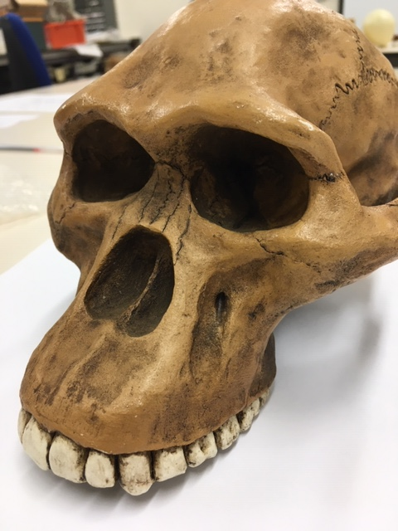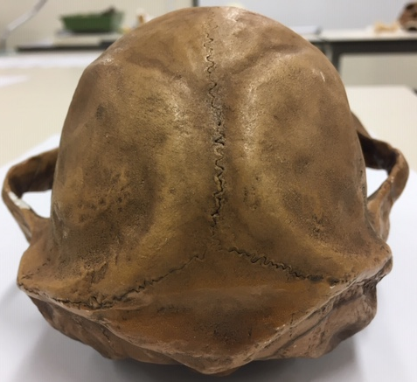

Chimpanzee

Australopithecus afarensis

Australopithecusafricanus

Australopithecus robustus

Homo habilis
Looking at faces 2
Look at the following images and then compare them to the list below. Indicate clearly (circle or highlight) the name of the early hominin skull you believe this to be.
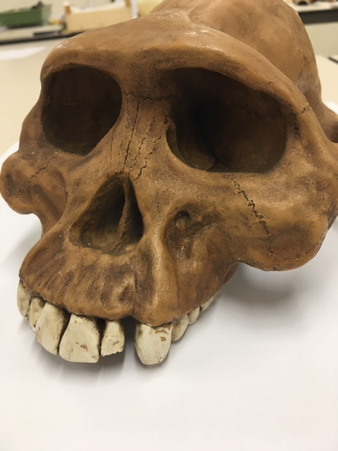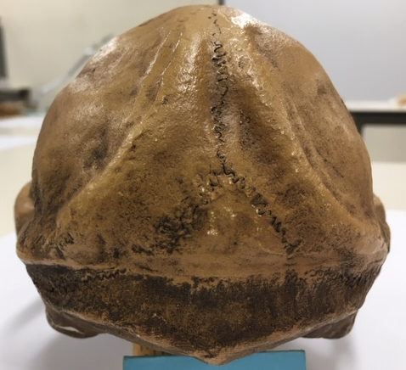

Chimpanzee

Australopithecus afarensis

Australopithecusafricanus

Australopithecus robustus

Homo habilis

Looking at faces 3
Look at the following images and then compare them to the list below. Indicate clearly (circle or highlight) the name of the early hominin skull you believe this to be.
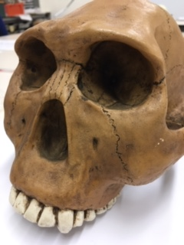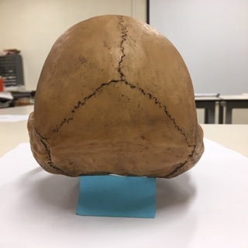

Chimpanzee

Australopithecus afarensis

Australopithecusafricanus

Australopithecus robustus

Homo habilis
Maxilla (upper jaw): Identify the species these belong to
A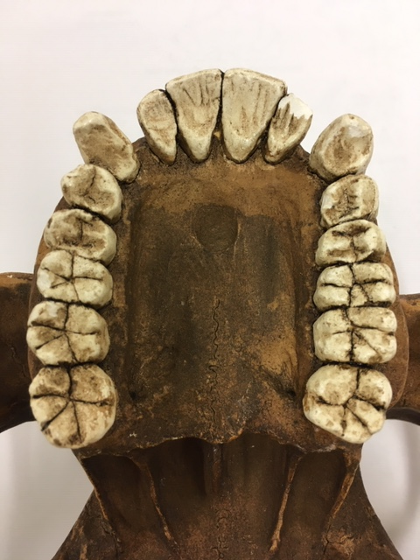B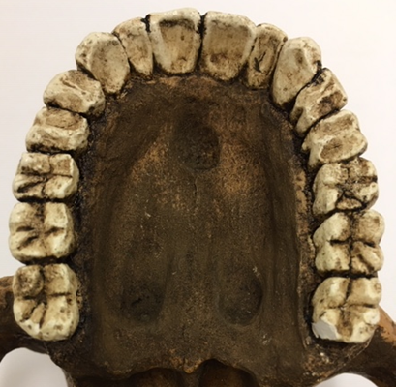
A) Austhralopithecus afarensis B) Australopithecus africanus
Top row left Chimpanzee, Middle Australopithecus afarensis, Right modern human
Lower row Left Australopithecus africanus, Right Australopithecus robustus
Indentify the skull to genus and species level
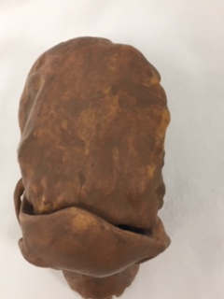
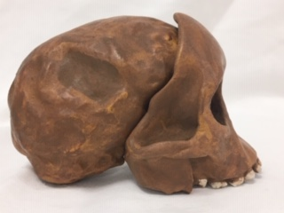
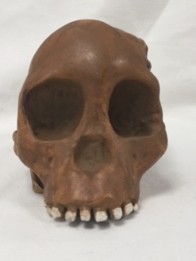
Answer Taung Child (Australopithecus africanus)
Indentify the skull to genus and species level
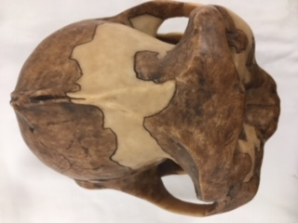
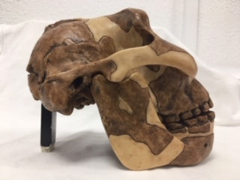
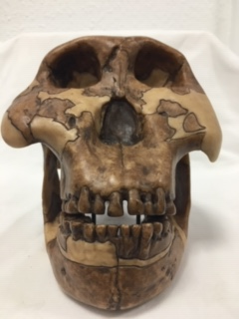
Answer Australopithecus boisei
Identify the hominin skull to genus and species level
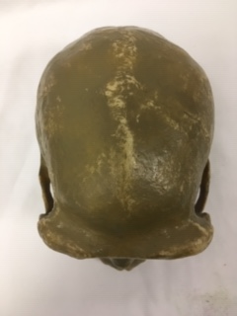

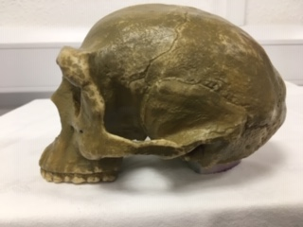

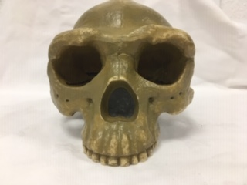
Answer Homo erectus
Indentify the skull to genus and species level
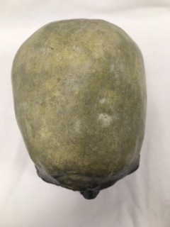
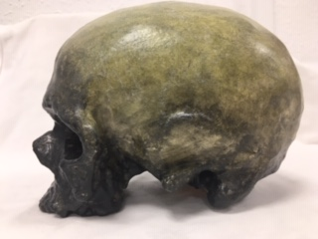
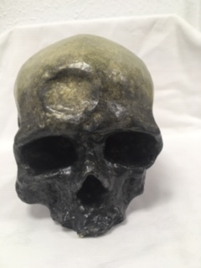
Answer Homo Sapiens
Identify, compare and contrast these two mandibles. Use the illustration below to help if you need to.
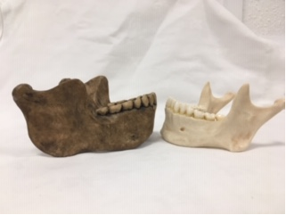
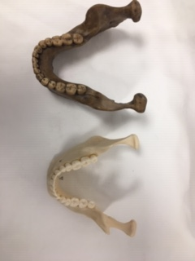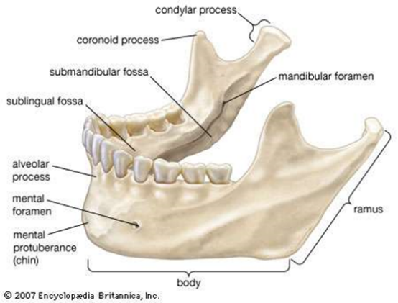

Answer The right jaw is a lot larger than the left jaw. The right jaw also has a longer ramus then the left one, it also has a larger condylar process. The body is also longer from the jaw to the chin, and on the right jaw the chin doesn’t exist or is not as prominent than the one on the left. The left jaw also has a more curved jaw space behind the teeth than the one on the right and has more of a curve between condylar process and coronoid process. I believe the jaw on the right is Homo heidelbergensis and the jaw on left is a modern day human.
Stone tools and tool technology: How to tell a stone is worked.
What suggests this has been worked?
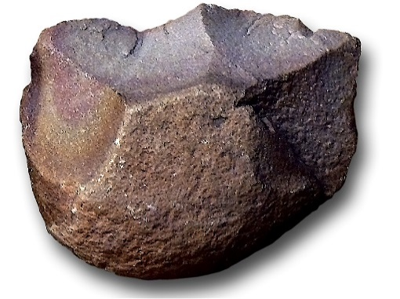
Answer This old stone tool shows that it has been worked because of the lack of uniformity to the surface which would not appear unless the stone was struck repeatedly with another stone to create flints and scaring. It looks like the stone has been repeatedly struck which would not have a natural explanation.

Features of stone tool flaking: identify features 1-5
1. Striking platform
2. Flaking Scar
3. Positive blub perucssion
4. Scarring
5. Reports
Stone tools and tool technology: Stone tools not to scale
Below left: Oldowan Below Right: Acheulean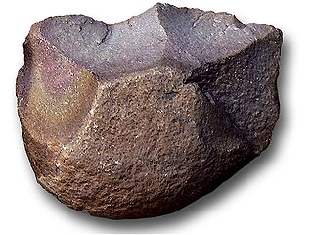 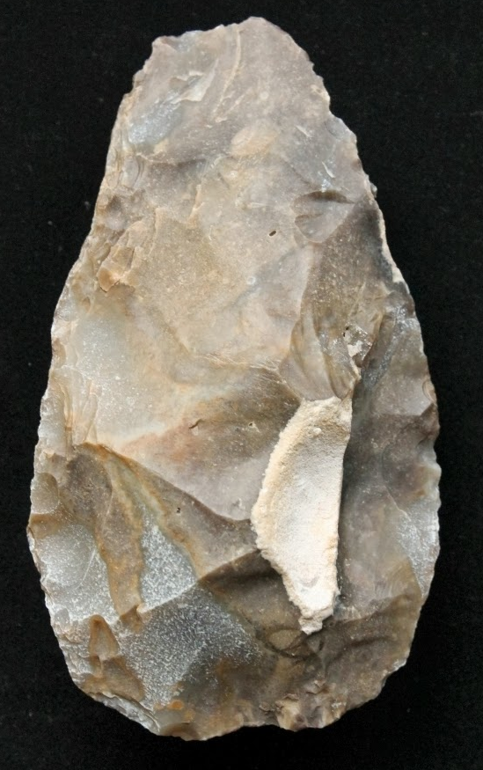
Images taken from https://images.search.yahoo.com

Task: Compare and contrast these two stone tools
Looking at oldowan and Acheulean you can see a couple differences such as the amount of flaking and material that has been removed from the original stone. The Acheulean stone tool shows a more symmetrical teardrop shape with plenty of matting around the edges. While the oldowan tool has less edges with a lot more cortex while the Acheulean has a much smaller amount. The flakes on the oldowan are generally larger.

