
ECONOMICS OF SUSTAINABILITY
Assignment 2

Nia-Mai Hopcroft
2003405
Nia-Mai Hopcroft (2003405)

Content Page

- Introduction
  - The reason of this report
  - What is the World Economic Forum?

2.0 Main Findings
2.1 Over the next 10 years what are the risks?
2.2 The Seventeen Sustainable Development Goals
2.3 The risks on global efforts on sustainable development:
2.3.1 Climate Change
2.3.2 Population

3.0 Recommendations

4.0 Conclusion

5.0 Reference List

6.0 Appendices

Introduction

  - The purpose of this report

The reason of this report is to examine the risk report generated by the world economic forum (2023) yearly and come across how the following ten years will look. This report will analyse the impact of these risks on global effects through sustainable development and how to move forward in future. From researching how this will impact the sustainable development and hand-picking knowledge learnt from the annual risk report in Chapter 2, recommendations will be made and assessed on how the government can move forward and make their sustainable goals to improve the future of our world from years of annual risk reports and discussions made to finalise these decisions for future.

1.2. Who is the World Economic Forum

World Economic Forum meetings take place annually to discuss major issues affecting political, social, economic, and environmental areas around the world. A large numb er of officials and representatives from the public and private sectors are involved in the World Economic Forum, as are renowned CEOs, famous personalities, government officials, spiritual leaders, union leaders, etc. A stakeholder theory underpins the WEF's mission, which first began in 1971. (Gordon, 2023) The World Economic Forum produces a report will all the risks that might affect the world which could involve high risk threats about the economy or issues which countries need to alert the governments for what might happen and authorize time to come up with solutions and ways to prevent such high-risk events happening such as war.

2.0 Main findings

2.1 What is the risk outlook for next 10 years?

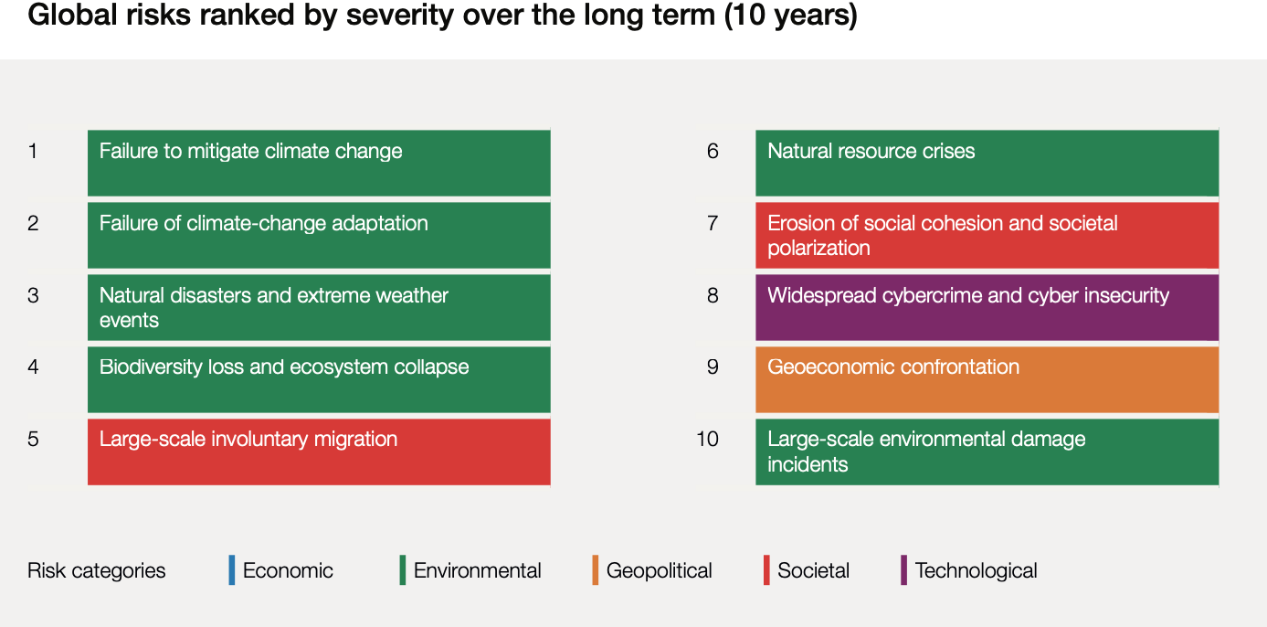
Figure 1.1

In this report created by the World Economic Forum there are many different risks in speculation for years to come which can be concerning for future reference. There is no shock that there are many different risks around the world which affects the environment and population, these risks have been around for many years, and they will continue to around for a long time if the governments around the world don’t do something to fix these issues. As expected, one of the main issues present is the environment. The environment is such a big impact all over the world with many different issues arising for example, climate change. In some views we can say that each country should work on their issues within their country first before helping other countries for example each government analysing their issues within population or other factors like economic, environmental, and societal.

The most serious risks on a global scale are failure to mitigate climate change and failure to adapt to climate change, followed by natural disasters and extreme weather events as well as loss of biodiversity and ecosystem collapse. (WEF 2023) From the diagram above we can see how the failure to mitigate climate has caused many issues for our world six out of 10 risks were environmental on the diagram above which shows something needs to be done about climate change and solve these environmental issues.

2.2 The Seventeen Sustainable Development Goals

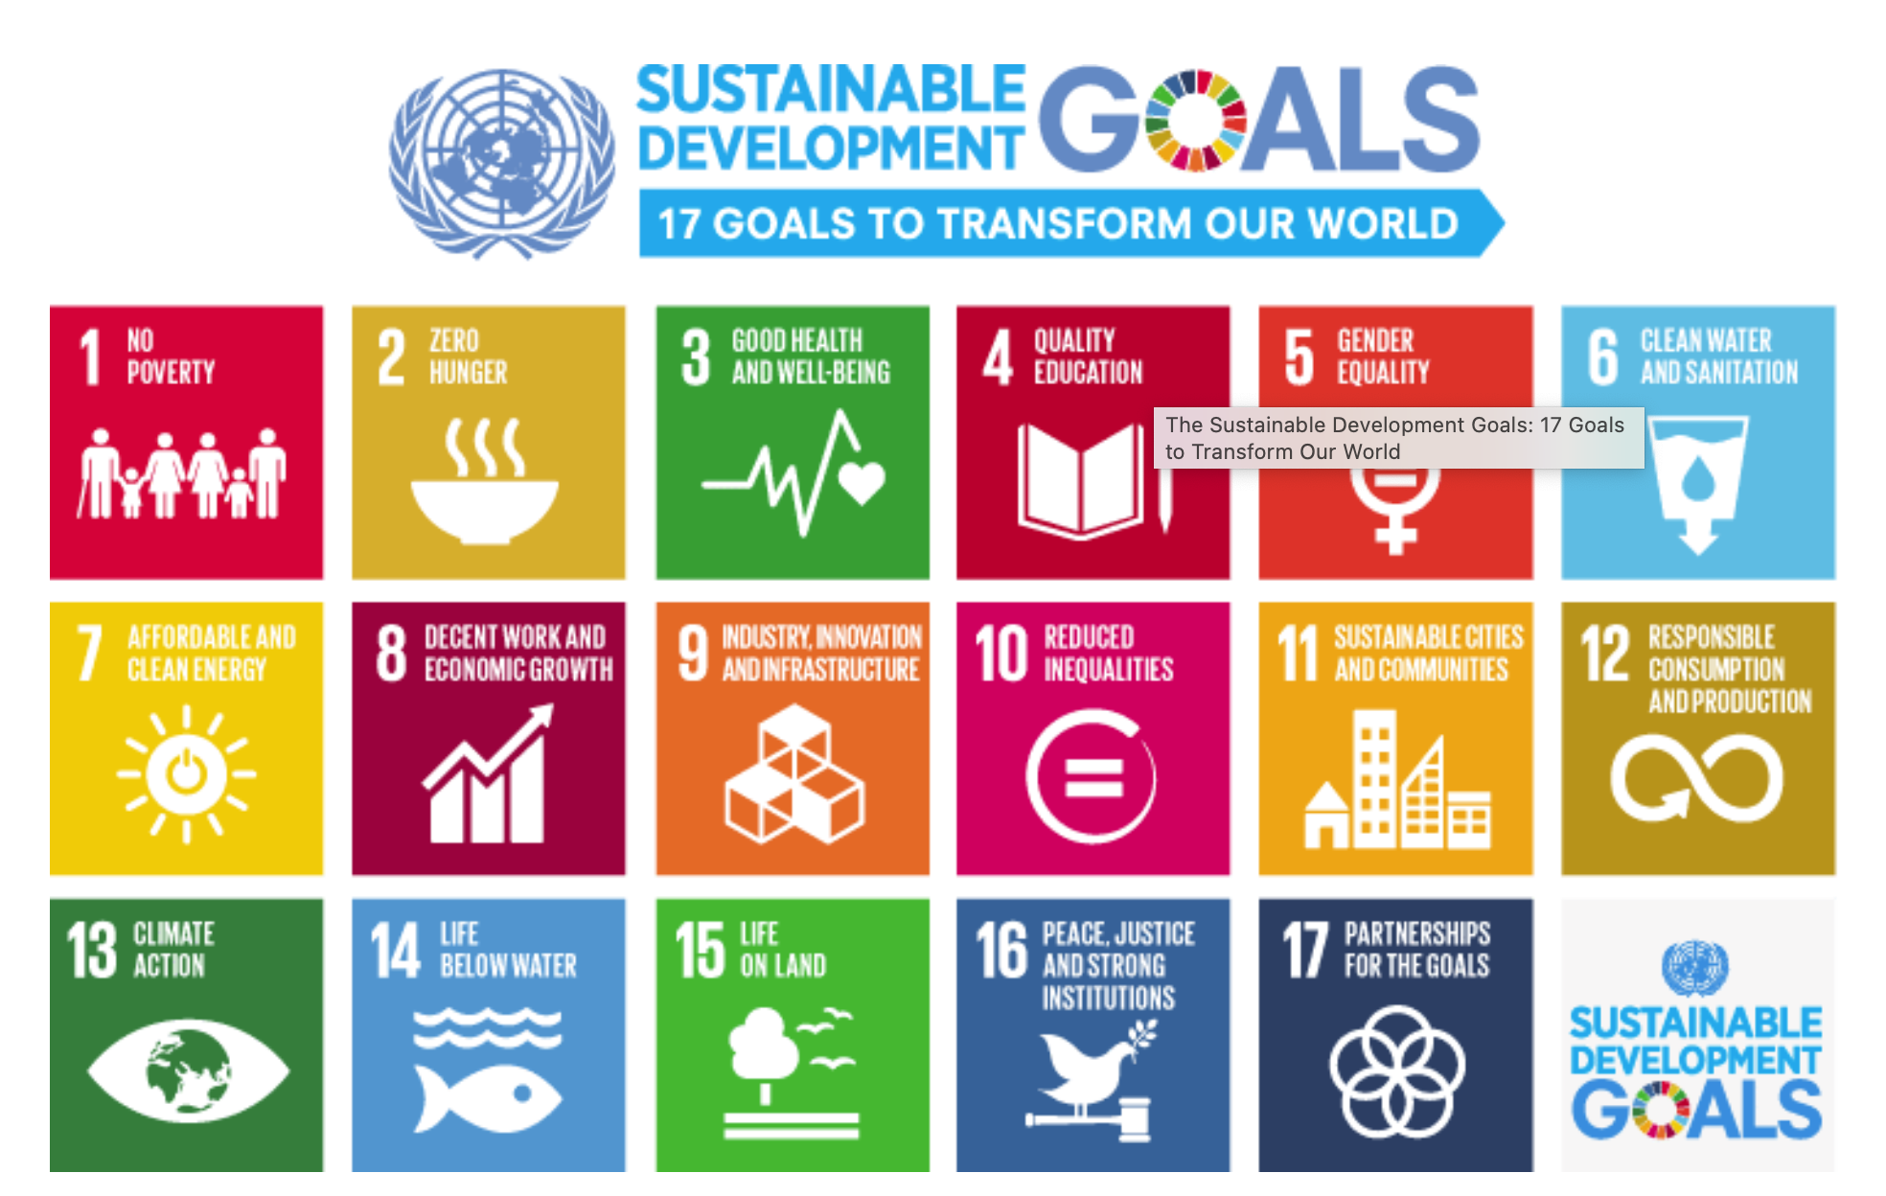
Figure 1.2

An agreement was reached by the 193 members of the United Nations (UN) in 2015 that aims to create a sustainable future for all of humanity. A key aspect of the historic agenda is the identification of 17 Sustainable Development Goals (SDGs) that aim to make the planet and humanity a better place by 2030. It aims to improve local economies while addressing social needs, such as poverty and sanitation. (Geograpic, 2022) As you can see from the diagram above there are many different goals from zero hunger, poverty issues, education, clean water, climate action, sustainable cities.

2.3 Impacts on global efforts on sustainable development:

After reading chapter 2 from the World Economic Forum and analysing the diagram above figure 1.1 it is clear that one of the biggest risks shown is climate change and a sustainable goal created was climate action with other goals present to improve the environment. The two risks which are very present are climate change and population, these risks are affecting the world the most and using the sustainable goals we can see no poverty and climate action.

2.3.1 Climate Change

The chosen risk which is one of the biggest risks to our world is climate change failing and increasing the risk on our planet every day. There are many different aspects towards climate change from extreme weather issues and many more. The climate is often confused with the weather, but the differences lie in the fact that climate is measured over a long period of time, while weather can change day by day or year by year. Temperature and rainfall averages, as well as wind patterns, make up the climate of an area. It is important to remember that climates differ from place to place. (Geographic, 2022)

Climate Change is a very important topic happening in our world where governments of each country need to do more about however anything about the environment gets ignored by the government and they think about more important things like taxation or world peace.
A narrow band of stable temperature has characterized human civilization until recently. Having unmoored ourselves from our past by burning fossil fuels, it is as though we have transplanted ourselves onto another planet. As a result of the high levels of carbon dioxide in the atmosphere, it has been hotter than it has been in at least 125,000 years. (Oliver Milman, 2021)

As a result of heat waves and droughts, there have already been mass mortality events (an individual hot day in Australia killed more than 45,000 flying foxes in 2014 alone) There have been extinctions of entire species caused by sea level rise and heavy storms. The most at-risk ecosystems in the near term are the Arctic Sea ice, warm-water coral reefs, and terrestrial ecosystems. (WEF 2023) There are many different examples of climate change affecting our planet from different countries however nothing has been done to improve this which is why in 10 years’ time from the WEF report it is a very high risk.

Several types of disasters are becoming more dangerous due to the increase in temperatures, including storms, heat waves, flooding, and droughts. Changing climate patterns create wetter and drier days because of a warmer atmosphere that stores, retains, and releases more water. Twenty weather and climate disaster events occurred in the United States in 2021, according to the National Oceanic and Atmospheric Administration - including severe storms, flooding, drought, and wildfires. (Denchak, 2022)

From examples we can see that the climate issues do affect the environment in a scarily way and we should be more aware of the risk of climate change and what we can do as a country to reduce the risk of climate change and how it is a global health risk. “It is possible for North America and Europe to suffer from extreme winter weather as a result of weakening of the high-altitude winds known as the polar jet stream. There are many scientists these days who think that Arctic warming is causing the jet stream to stall, causing more extreme weather year-round, by affecting large zones of high-pressure air to block weather systems like those that bring extreme heat.” (Olinger, 2020)

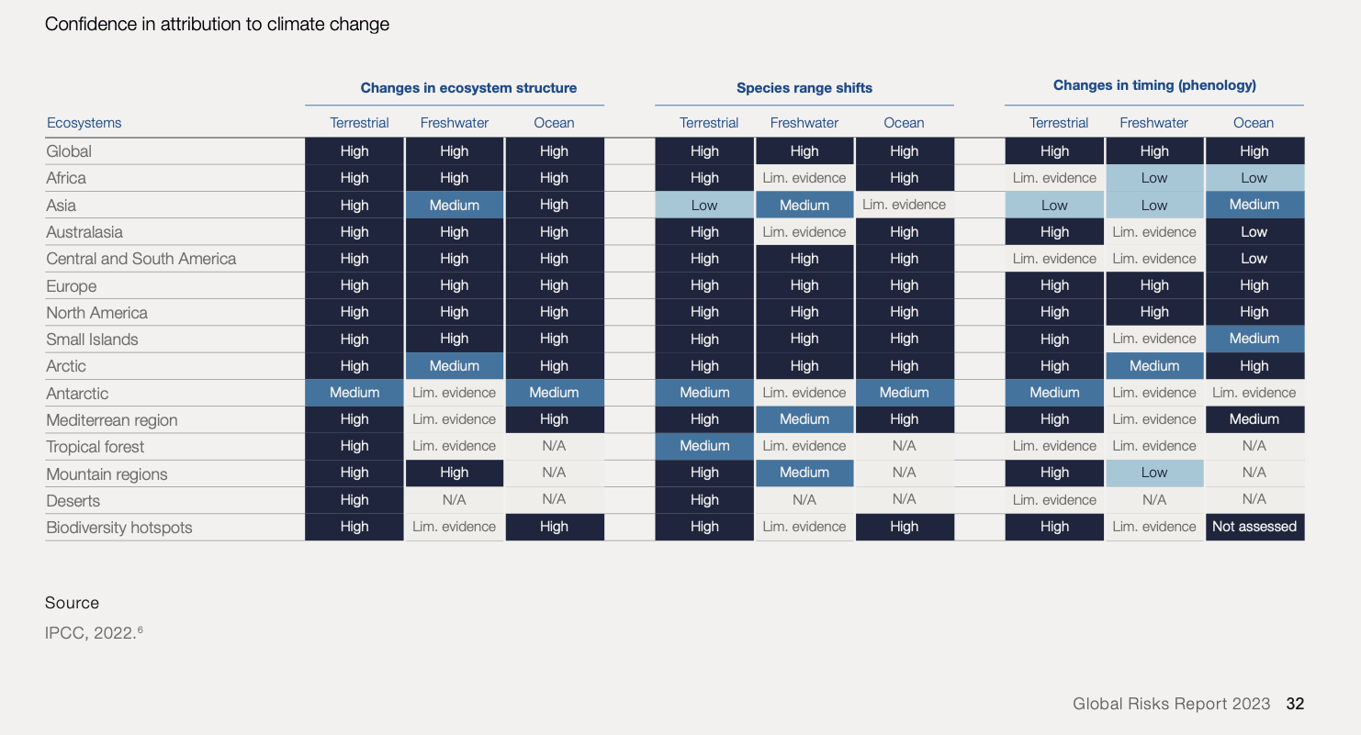
Figure 1.3

Stated in the diagram above we can see how badly climate change affects each continent and globally. From changes to ecosystem structure, species range shifts and changes in timing all add up to the causes of climate change and how badly it is affecting this world. All data shown above shows how high the impacts of climate change is affecting different ecosystems and what should be done to improve it. Incentives from the government to increase domestic production and decrease dependency on imports in response to supply and geopolitical challenges might be at the expense of ecosystem preservation. (WEF 2023)

Climate Change has such an impact on our environment and us as a world and the government should take a closer look into what can be done to improve the environment by analysing the WEF report over the next ten years and hopefully will improve climate change and make solutions for the world to follow to save our planet.

In other ways we can say climate change decreased during the Covid-19 pandemic. If we think about it the whole world going into lockdown and only essential individuals working and the world being on stand-still we would have helped the environment tremendously. During the Covid-19 pandemic we had to stay indoors and not travel unless it was essential which would have helped our environment in many different ways from working at home which would mean that being were not travelling into work e.g., into offices in big cities which would be saving us pollution. Ozone levels worldwide soon decreased as a result of COVID-related declines in NOx. The pandemic inhibited the atmosphere's capacity to cleanse itself of another significant greenhouse gas, methane, by limiting NOx emissions, which proved good in clearing up air pollution. (Rasmussen, 2021)

Climate change is all about the environment, A theorist called Rachel Carson is a scientist which looks at pesticides affecting the environment and asked an important question “Do humans have the right to control nature?” which is a brilliant question and could cause many different opinions however it can be recognised that humans shouldn’t be able to control nature and humans are destroying our planet and causing climate change and if we don’t stop and realise what we are doing to this planet until it’s too late which is why the WEF makes the 10 year plan to figure out what can be done. Rachel Carson once said “It is important to notice how DDT and other chemicals are passed from one organism to another through food chains. DDT is applied to fields of alfalfa; the alfalfa is later cooked and fed to hens; they lay eggs containing the chemical. It is also possible to feed cows hay that contains residues in the range of seven to eight parts per million. There will be about three parts per million of DDT detected in milk, but sixty-five parts per million could be detected in butter made from this milk.” (Bradford, 2018) Using Rachel Carson and the WEF diagrams we can see that climate change is very serious and the use of pesticides within farming affecting the environment is concerning.

2.3.2 Population

From the figure 1.1 we can see that population is a risk from the World Economic Forum. Population is a very important topic which is affecting the world and how we live in it for example our world is overpopulated, and we are struggling to cope with this, and this means that we build more and more on land to compensate with our over populated world which destroys our nature. Approximately 70 years ago, in 1952, it numbered 2.5 billion; in 70 years, by 2092, it will number a massive 2.5 billion more. A major demographic trend that has been dominating for decades and will continue for many years is global population growth. (Herrmann, 2022)

Climate change and environmental damage are linked to population growth. With his famous 1798 book, An Essay on the Principle of Population, Thomas Robert Malthus argued against overpopulation. In his opinion, increasing food production had only a temporary effect on human wellbeing. In response to greater wellbeing, the population would have more children, leading to an increase in population growth and famine. (Cameron, 2021) Thomas Malthus does have a point here the more our world is populated the more we struggle to cope with demand of the supply chain of food. We have to build more and more and take away our wildlife and land to grow our own food which linking back to Rachel Carson and what she said about pesticides affecting the environment just proves something does need to be done within population and climate change.

There has been a widespread neglect of the issue of biodiversity loss caused by human population growth. Almost one million species are now in danger of extinction, according to a major UN report released in 2019. Human activities have severely impacted approximately one third of the land and a quarter of the ocean. (Nater, 2022) In relation to Rachel Carson’s question of if humans should control nature, we can argue that humans are killing our species and that is why so many of them are either extinctic or in danger of extinction which is upsetting for our planet which also link back to the SDG of life on land which should have more awareness and more needs to be done to help this.

In Malthus' view, a large population would lead to a shortage of food, resulting in several people dying. His theory was that this correction would consist of Positive (or Natural) Checks and Preventative Checks. Malthusian catastrophe occurred as a result of these checks, reducing the population to a sustainable level. (Malthus, 2021)

With reference to figure 1 from the WEF report of overpopulation we can look at different countries and how they have tried to reduce the population growth. Growing urbanization, increasing educational levels, and low poverty have been contributing to India's slowing growth rate over the past few decades. It appears that the fertility rate has already dropped below replacement level, with urban fertility already below 1.7 children per woman, based on a government survey of 22 major states conducted in 2017. (Chadrashekhar, 2019)

Another example would be China, China's one-child policy, which prohibited couples from having more than one child for more than 35 years, partly contributes to the decline in population. It was common for women caught violating the policy to be forced to undergo abortions, to be fined heavily, or to be evicted. (Yeung, 2023)

3.0 Recommendations

A recommendation for climate change is something that seriously needs more attention however it gets pushed aside every time, it is destroying our planet and in future we might not be able to live on earth because of how badly we have treated it which shows society is damaging our environment. Another recommendation to think about would be looking at other countries and how they deal with population for example China limiting the number of children they have however it wouldn’t work in all countries like America banning abortions in certain states would be an issue regarding population. We could say we can learn from the pandemic and look at ways we helped the environment there however it did affect the whole population of catching coronavirus which sadly resulted in deaths which reduced the population. The WEF report and Sustainable development goals shows that it does need to be improved in future and the report looking at the next ten years is worrying if governments around the world don’t find solutions to fix these issues.

4.0 Conclusion

To conclude this report, it is obvious that more needs to be done by the government to reduce climate change and the population. It is clear that climate change needs to be spoken about more and we need to look at how other countries control their population as an example China limiting how many children they have.

Reference list

Bradford, Alina (March 2018) Rachel Carson: Life, Discoveries and Legacy. Received from https://www.livescience.com/62185-rachel-carson-biography.html

Chandrashekhar, Vaishnavi (December 2019) Why India Is Making Progress in Slowing Its Population Growth. Received from https://e360.yale.edu/features/why-india-is-making-progress-in-slowing-its-population-growth

Denechak, Melissa (May 2022) Are the Effects of Global Warming Really that Bad? Received from https://www.nrdc.org/stories/are-effects-global-warming-really-bad

Gordon, Jason (March 2023) World Economic Forum – explained. Received from https://thebusinessprofessor.com/en_US/economic-analysis-monetary-policy/world-economic-forum-definition

Herrmann, Micheal (July 2022) The Global Population Will Soon Reach 8 Billion—Then What? Received from https://www.un.org/en/un-chronicle/global-population-will-soon-reach-8-billion-then-what

Nater, Olivia (November 2022) Eight reasons to be concerned about our population reaching 8 billion. Received from https://populationconnection.org/blog/eight-reasons-to-be-concerned-about-8-billion/

National Geographic (May 2022) Climate Change. Received from https://education.nationalgeographic.org/resource/climate-change/

National Geographic (May 2022) sustainable development goals, received from https://education.nationalgeographic.org/resource/sustainable-development-goals/

Olinger, Ashley (April 2020) A crash course on climate change, 50 years after the first Earth Day. Received from https://www.nytimes.com/interactive/2020/04/19/climate/climate-crash-course-1.html

Oliver Milman et al (October 2021) The climate disaster is here. Received from https://www.theguardian.com/environment/ng-interactive/2021/oct/14/climate-change-happening-now-stats-graphs-maps-cop26

P. Cameron, Michael (January 2021) Curb population growth to tackle climate change: now that’s a tough ask. Received from https://theconversation.com/curb-population-growth-to-tackle-climate-change-now-thats-a-tough-ask-153382

Rassmussen, Carol (November 2021) Emission Reductions from Pandemic Had Unexpected Effects on Atmosphere. Received from https://climate.nasa.gov/news/3129/emission-reductions-from-pandemic-had-unexpected-effects-on-atmosphere/
Thomas Malthus (July 2021) what is the malthusian theory of population? Received from https://www.economicsonline.co.uk/managing_the_economy/what-is-the-malthusian-theory-of-population.html/

World Economic forum (2023) The Global Risks Report 2023. Received from https://www3.weforum.org/docs/WEF_Global_Risks_Report_2023.pdf

World Economic forum (2023) The Global Risks Report 2023. Received from https://www3.weforum.org/docs/WEF_Global_Risks_Report_2023.pdf

World Economic forum (2023) The Global Risks Report 2023. Received from https://www3.weforum.org/docs/WEF_Global_Risks_Report_2023.pdf

Yeung, Jessie (January 2023) China’s population is shrinking. The impact will be felt around the world. Received from https://edition.cnn.com/2023/01/18/china/china-population-drop-explainer-intl-hnk/index.html

