HOW TO CREATE AND MAINTAIN AN EFFECTIVE TEAM.



One of the many ways for a business to organize employees is in teams. Teamwork is intrinsic to the overall success of an organisation A team is made up of two or more people who work together to achieve a common goal. Teams are becoming more common in the business world today. Effective teams can lead to increased employee motivation and business productivity.

A team is different from an ordinary work group. Work groups are mainly for members to share information and make decisions so that each member can achieve his or her individual work goals. On a team, the members not only share information but also share responsibility for the team's work. The idea behind teams is synergy. With synergy members can accomplish more together than they could on their own. synergy happens in the workplace when two or more people working together produce a better outcome than if they did it alone.
Linda Ray (2014) is an award-winning journalist who has been writing for over twenty years covering business magazines and newspapers. In one of her articles she wrote that you should always set goals for your company that everyone can get behind. Synergy is much more likely to occur when everyone is aiming for the same goal. This encourages people to find ways to overcome their differences when they have a common objective. At the same time, you’ve got to make sure that everyone will be rewarded for their efforts, whether it’s bonuses or increased hours, the goal should have something in it for everyone to push them into that synergetic mode.

It takes great leadership to build great teams. Leaders who are not afraid to make the difficult decisions and establish standards of performance that are constantly being met. This can be in the workplace, professional sports, or your local community, team building requires a keen understanding of people, their strengths and what gets them excited to work with others. Team building requires the management of egos and their constant demands for attention and recognition – not always warranted. A leader who can consistently build high performance teams is worth their weight in gold.

Rosalind Cardinal (2015) has suggested five steps to building a productive and effective team.

Step 1: Establish leadership.
If your employees trust your judgement, they will work effectively even when you’re not around. Before you can start team building, you need to develop the right kind of leadership skills.

Step 2: Establish relationships with each of your employees.
Try to learn more about each member of your team, their skill sets, how they are motivated and their likes and dislikes.
As well as this, try to include all team members in the decision-making process where possible.

Step 3: Build relationships between your employees.
As your team starts to cooperate more, examine the way they work together and take steps to improve communication, cooperation and trust amongst the team. If there are any conflicts, try to resolve them amicably. Listen to both sides of the argument and act as a mediator.

Step 4: Foster teamwork.
Once you have established relations with and between your employees, it’s time to help them work together effectively. Encourage your team to share information, both amongst themselves and within the wider organisation. Also, try to communicate more clearly and honestly with your team.

Step 5: Set ground rules for the team.
You can begin officially establishing your team through creating team values and goals, as well as evaluating team performance alongside individual performance. Be sure to include your team in this process, so they know what’s required and agree with it.
Team building is one of the most important responsibilities a manager has. It isn’t something that can be achieved in a short time. It is an ongoing organic process that you a will have to facilitate and guide.

"Coming together is a beginning. Keeping together is progress. Working together is success" ~ Henry Ford

Team building is very important if you wish to extract the best out of your workforce. Employees are urged to work smarter and not just harder, in an effort to deliver the desired results. Individual brilliance does not singlehandedly decide the fate of an entire project. Almost always, it is the joint efforts or the lack of the whole team that eventually decide the success or failure of a project. In such cases, team building in the workplace becomes absolutely essential for a number of reasons.

To achieve the best mix for bringing out the best in your team, offer motivating, fun activities and competitions, rather than corporate methods.

. Team involvement in a charity activity
. Physical activities and challenges
. Outdoor events and activities
. Simple Team Building Exercises in the Workplace
. Conduct Employee Feedback Activities
. Promote Informal Addressing
. Organize a Day Trip:
. Celebrate Each Other's Success

THE FIVE DYSFUNCTIONS OF A TEAM

Patrick Lencioni is an American writer of books on business management, particularly in relation to team management. He is best known as the author of The Five Dysfunctions of a Team. "Lencioni's model provides useful insights about team dynamics and has some advantages over the other models. The model is straightforward, identifies many of the reasons why teams fail, and offers practical advice on how to build high-functioning teams.

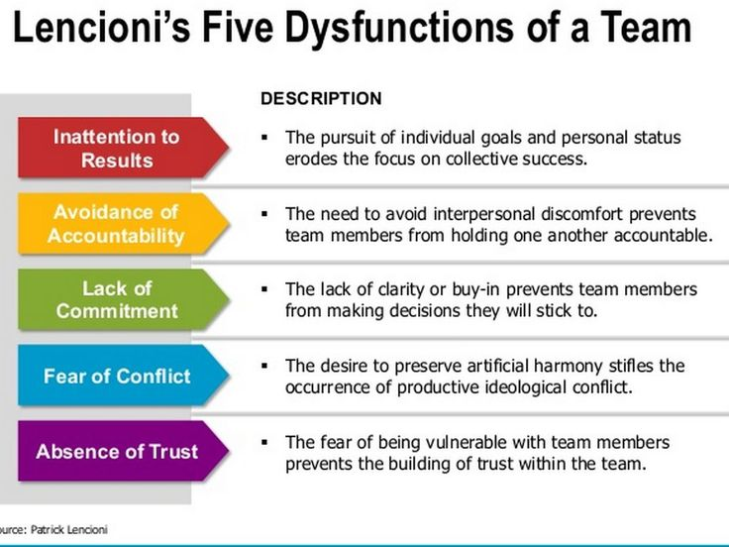

These five dysfunctions can be examined to mitigate team problems by using many different methods and theories known as team dynamics which were created by some very intelligent individuals. We will be discussing a few of these theories now. Belbin’s approach on team roles and how to pave the way for success is one of the most recognised and a benchmark for many organisations.

By assessing the behavioural contribution individuals make to your teams, rather than an abstract psychometric test which will tell you about their personality, Belbin looks at how people actually behave in the workplace and which roles they are best suited to take on in a team environment - we call these Team Roles.

1.BELBINS TEAM ROLE.

2.TUCMANS THEORY.

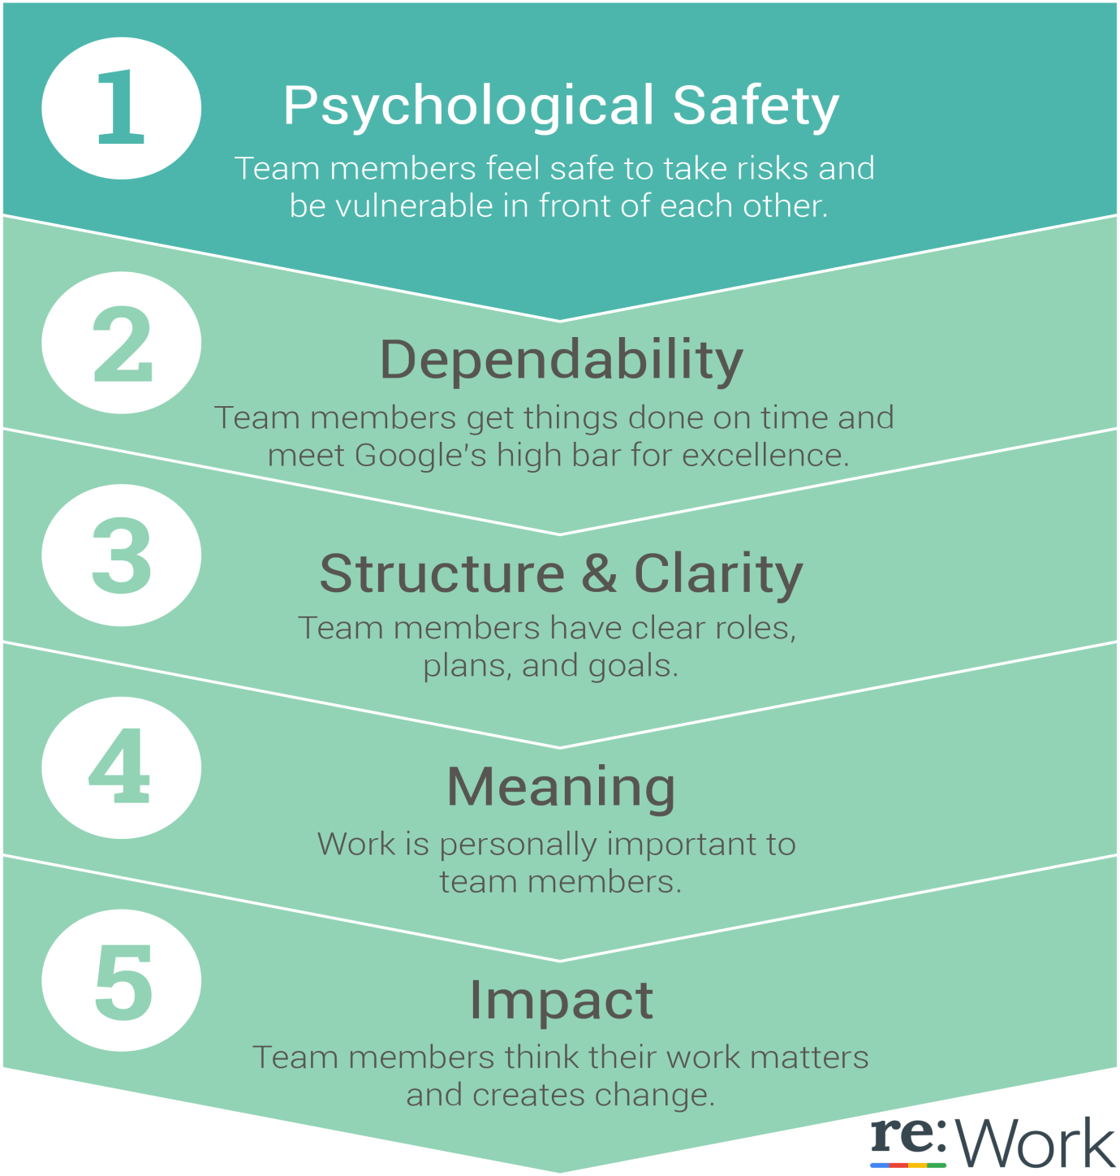
PROJECT ARISTOTLE

Who is on a team matters less than how the team members
interact, structure their work, and view their contributions

Google wanted to know what makes its best teams work so well, so it launched “Project Aristotle.” What they found out, by studying more than 100 groups within the organisation for over a year, reinforced an old idea: In addition to teams’ having clear goals and an understanding of projects within a larger context, it’s mutual respect that’s key to success.
This is Googles findings.

From their research they found that the most important factor for an effective team is psychological safety.

Psychological safety” is paramount. This is the ability of group members to connect with each other on a personal level and to feel comfortable enough to ask questions and float ideas.
Psychological safety calls for open communication and empathy in the workplace , sports and community.

REFERENCES

Cardinal , R (2016) The Resilient Employee: The essential guide to coping with change and thriving in today's workplace , Kindle Edition

Lencioni ,P (2002) The Five Dysfunctions of a Team: A Leadership Fable (J–B Lencioni Series) , Wiley : New York

http://www.thinkingcollaborative.com/stj/project-aristotle-understanding-successful-groups/ (2018)

https://woman.thenest.com/create-synergy-workplace-8443.html (2018)

