Elizabeth Bowskill (1601312)
1601312@studnet.uwtsd.ac.uk

A Quantative study of why mature students returne to eduaction

Business Inquiry and Research (BMSP5007)

Dr Alex Bell

May 2019

Introduction
The purpose of this report is to ascertain the reasoning for mature students to return to education. Moreover, the reason for this chosen study is due to the fact that I, myself am a mature student and have returned to education to gain a higher qualification. Additionally, by completing this report is a way of establishing if other mature student have the same or similar views for returning to education as myself. Furthermore, the method that was used in collecting the data was the Quantitative approach. The term Quantitative means “relating to numbers or amounts” (University, 2019). This methodology will allow me to clarify the reason as to why mature students return to education and answer my question. The information was sent out and collected using Survey Monkey tool online. This questionnaire was sent to 10 different individuals who are older than 25. Furthermore, the tool that was used in reviewing the information is a software package that is used to analyse statistical data. Additionally, I will attach a copy of my questionnaire at the end of this report.

Procedure
The Quantitative approach is often utilised as a traditional method of ascertaining the answers that the researcher needs to know. The researcher is objective, factual and frequently repeats the measures to ensure the correct answer. Moreover, the characteristics consist of ordinal or cardinal this provides a high level of accuracy and precision. “They cross analytic levels, from the most micro of micro levels – like the constituent elements of thought, judgments, and sentiments – to the most macro of macro levels – like planets in speculative contrasts of future human populations” (Ryan, 2019). This ensures that the end result is factual whereas when conducting a Qualitative research the end result would be perceptive. When gaining the data for my Quantitative research the method that I used was through the medium of a questionnaire. In producing this questionnaire, I used an online tool called Survey Monkey. Survey monkey is an online development software that allows for growth and change when compiling your questionnaire (Monkey, 2019). Through this tool I was able to create and send the questionnaire online, which is an environmentally sustainable way of contacting people. Once I had received all of the results from the questionnaire, I was able to use another computerised tool called SPSS (Statistical Package for the Social Sciences). This SPSS platform “offers advanced statistical analysis, a vast library of machine-learning algorithms, text analysis, open-source extensibility, integration with big data and seamless deployment into applications” (IBM, 2019 ). Furthermore, by entering the data into the SPSS tool I was able to compare and contrast the data in a systematic way by utilising the frequency tables, graphs and cross tabulations.

Data Presentation and Findings

Overview
The purpose of this report is to identify the reasoning for mature student in returning to education. Below is shown the main reasons for this. The data shows that 8 out of the 10 students are parents. Furthermore, all students either agreed or strongly agreed that their reasoning for returning to education is to further their knowledge base through the medium of qualifications. Moreover, this then show that they are either returning for an undergraduate course or a postgraduate course. Furthermore, in conjunction to having children it can also be considered that having children is the reasoning for gaining a higher qualification to gain a higher paid job to provide a better future for their children. The data shows that 3 individuals agree that their reasoning for returning is to gain a better qualification, in addition to the 3 who strongly agree. I have used the wording as gaining a “better qualification” as the individual may already have a high qualification that they have found to be not as useful in the working environment. This however is down to personal perception. Additionally, this chart shows that there is a mixed view of the statement “fulfilling all educational needs when younger is the better option”. The chart shows that there were 6 participants who disagreed, 1 strongly disagreed, 1 strongly agreed and 2 who were undecided.

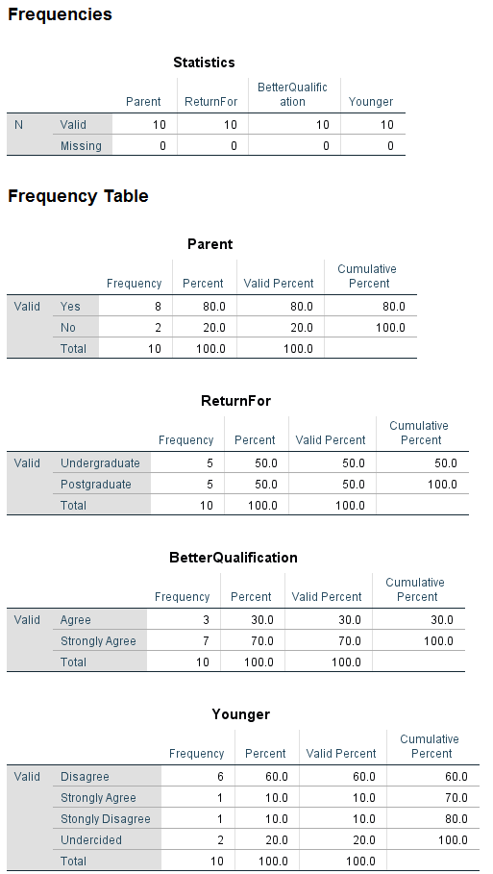

Age verses Better Quolification
Crosstabbulation is a form of displaying relationships between 2 variables. The table below show the age variable in relation to the reason of returing to education to gain a better quolification. Moreover, the students in the cattogary of 45-54 age has a score of 100% as their reasoning within their strongly agree section. Additionaly, overall 30% strongly agreed that their reasoning was for a higher quolification in relation to the 70% strongly agree. This crosstabulation shows that there is a 100% reason to returne to education when one is a mature student and this is for a better quolification. This can be diriven through the reasoning to gain a higher job possitioning within the work force.
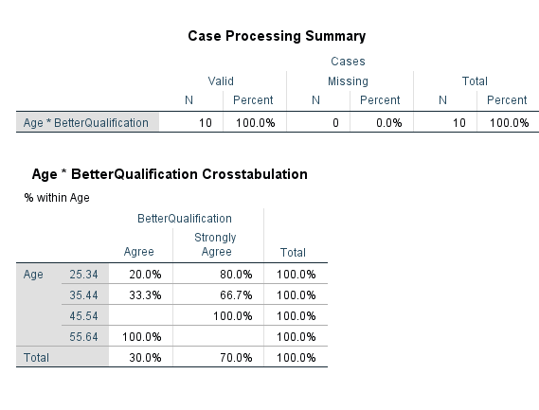

Full time compared to Part time
The Pie Chart below show the percentages of the mature students that have returned to education in a full time or a part time copasity. Pie charts show data in a circular graph and are a productive way of braking data down into managable pices. Moreover, this pie chart shows that 40% of the mature students returned to education in a part time copacity. This could be due to working along side their education or due to family comitments. Futhermore, there is a 60% ratio of the students that returned full time. These statistics in this small reserch copacity show that mature students favour retuning to education in a full time medium.

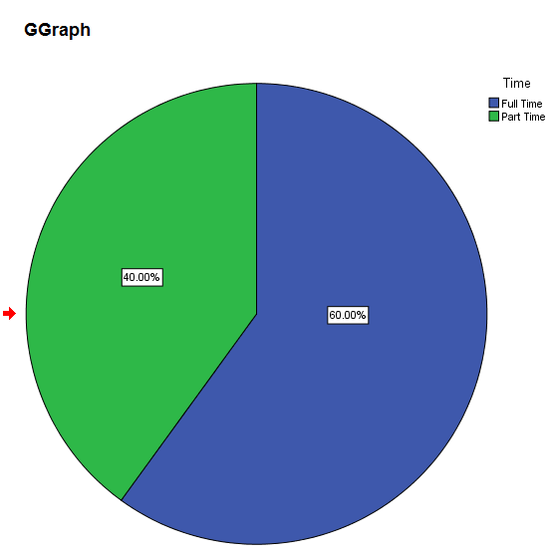

Current Education level compared to Better Qualification
When comparing the level of education of mature students previous to them returning to education it is clear to see that there is a range of levels of education that the participants currently hold. However, there is a clear line displaced in the fact that all participant either agree or strongly agree that they have returned to education for a better qualification.
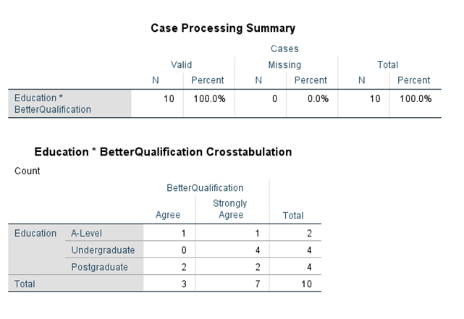

Age verses the Statement of “Younger is Better”
While many people are seen to return to education to gain a better qualification as seen in the previous graphs and charts. There is a question as to whether or not they perceive completing their education at a younger age to be more of an advantage. As seen in the graph below, which shows the age range in relation to the statement “fulfilling all educational needs when younger is the better option” there is a mixed reaction. By using the graph it allows for a visual view of the participants answerers. The graph shows that the participant who strongly agreed with the statement is a younger individual whereas the 6 who disagreed and the 1 who strongly disagreed are older individuals. When comparing these answerers it is opening up further questions as to the reason why. However, this would require further research into the subject.

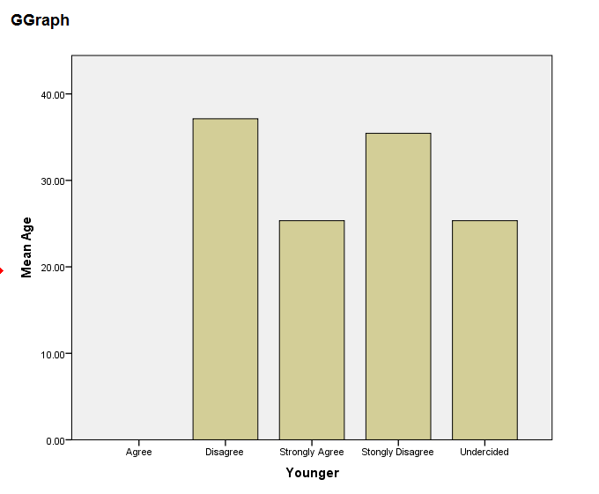

Conclusion/Reflection
In conclusion to this report the findings show that irrelevant of gender and current level of education, mature students do return to education to gain higher qualifications. However, in reflection, this is only a small research project, to better ascertain the truth of this project a larger scale study would need to be completed. As stated previously I would have liked to complete another study to ascertain the answer as to why there is a mixed age group who have different views on the statement “fulfilling all educational needs when younger is the better option”.
In further reflection on this method of acquiring data I have found that there is an unmistakable strength in this methodology. This method shows clear and defined answers to any question a researcher purposes. However, there is a draw back to this way of seeking answers, this is through human error. An example of this is; should the wrong number be inputted the data will then be compromised. In addition to this, unlike the Qualitative method the Quantitative does not allow for human interpretation there is only right or wrong there is no grey. Due to this I have found that I prefer the Qualitative methodology.

References
IBM. (2019 ). IBM SPSS software. Retrieved from IBM: https://www.ibm.com/uk-en/analytics/spss-statistics-software
Monkey, S. (2019). Survey Monkey. Retrieved from Survey Monkey: https://www.surveymonkey.com/
Ryan, M. (2019). Core Concepts in Sociology. (M. Ryan, Ed.) Hoboken: John Wiley and Sons Ltd.
University, C. (2019). Meaning of quantitative in English. Retrieved from Cambridge Dictionary : https://dictionary.cambridge.org/dictionary/english/quantitative

