
Applied Leadership and Management in the Workplace
Module Assignment Submission
Student Name: | Natalie O’Sullivan
Student Number: | 2328789@student.uwtsd.ac.uk
Module No: | BMSK4013
Module Title: | Management Communication

Statement of Confirmation of Authenticity
By making this submission, the student declares that this is the work of the student named above. The work has not, in whole or in part, been knowingly presented elsewhere for assessment, or where assessment has been built on a previous assessment, this has been identified. Where materials have been used from other sources it has been properly acknowledged. If this statement is untrue, the student acknowledges that an assessment offence has been committed.
Attention is drawn to the plagiarism and unfair practice policies of both the University and of

Table of Contents
Management Communication Introduction 1
Communication Cycle and Communication Models 2
Communication Cycle 2
Shannon & Weaver Communication Model 3
Schramm Communication Model 4
Berlo Communication Model 5
Critical assessment of the communication models 6
The importance of tone, language & formality 7
Modes of communication 7
Relating these to my workplace 8
Communication scenarios 9
Relating scenarios to my workplace 9
Using the wrong approach 10
Verbal and written communication 11
Written communication 11
Verbal communication 12
Motivation Theories 13
Intrinsic & Extrinsic motivation 13
Maslow's Hierarchy of Needs 14
McLelland’s Need Theory 15
McGregor’s X-Y Theory 16
Critical Assessment and Comparison of Motivation Theories 17
Applying McGregor’s X-Y theory in my workplace 17
Factors that affect motivation 18
What motivates me in my workplace? 18
Workplace Conflict 19
Professional conflict resolution strategy: Mediation: 19
Personal Communication 21
Appendices 23
Appendix A 23
Appendix B 24
Appendix C 25
References 26

Management Communication
Introduction

The report discusses the intricacies of management communication in the workplace, emphasising its impact on interaction dynamics and conversation cycles.

It outlines how selecting appropriate tone, language, and formality, can be significantly effective with colleagues. The discussion extends to written forms such as e-mails or reports used by professionals.

It delves into theories behind employee motivation questioning why individuals are more inspired at work than others, highlighting that employee happiness is a significant factor.

Conflicts may arise unpredictably, despite initiative-taking measures taken for their prevention. Reassurances are given for potential resolution strategies to manage these effectively.

Recognising individual differences, acknowledging that colleagues perform differently, and discovering personal strengths and weaknesses, can lead to better working environments.

1
Communication Cycle and Communication Models
Communication Cycle

Illustration of the Communication Cycle:
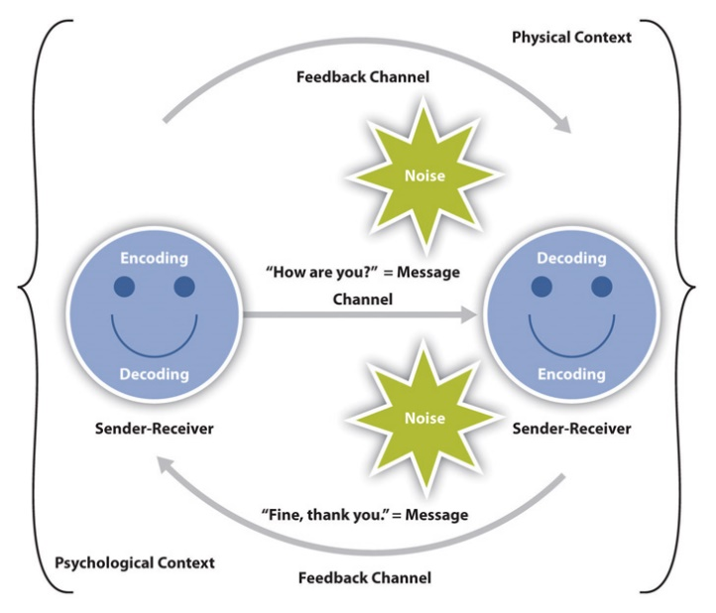
g (University of Minnesota, n.d.)
24, 2023

Description
The communication cycle results from countless scholars' efforts and research, reflecting its critical role in analysing human interaction and communication.
This process reinforces clear expression and understanding among individuals.

Explanation
A Manager (sender) relayed a project update (message) during a Teams call (channel). Colleagues (receivers) from diverse cultures, and assorted familiarity, interpret this update through their unique skill sets and approaches.

Advantages & Disadvantages
The communication cycle promotes clarity, feedback, and mutual understanding, fostering effective communication.
Problems can arise during encoding/decoding, as noise or distractions can distort messages causing misunderstandings, Workplace Hero UK (2023).
The model would thrive in my workplace, as my organisation promotes feedback for continuous improvement.
2
Shannon & Weaver Communication Model

Illustration of the Shannon & Weaver communication model:

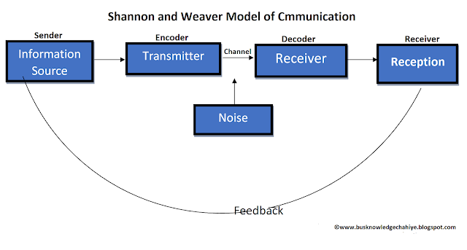
(Shannon & Weaver, 1949)

Description
The Shannon and Weaver Communication Model portrays the communication process as a straightforward journey.
This model emphasises how clear signals are vital for good communication, whilst highlighting unwanted interference (Shannon & Weaver, 1949).

Explanation
The supervisor (sender) shares updates on a working process (encoded message) during a meeting (channel), but ambient interference (noise) confuses words and sentences. Details are obscured (decoding), leading to confusion by Team members (receivers),who demand the briefing be reiterated.

Advantages & Disadvantages
The Shannon & Weaver Communication Model provides a clear structure to understand communication elements and the importance of reducing noise.
It can oversimplify complex interactions, and neglect feedback considerations (Foulger 2004; Shannon & Weaver 1949).

The Model would not suit my organisation, as it lacks a feedback method, that my organisation encourages.
3
Schramm Communication Model

Illustration of the Schramm communication model:

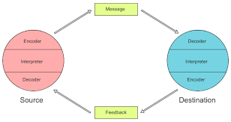
(Schramm, 1954)

Description
The Schramm Communication Model highlights mutual understanding in communication. The model supports consistent feedback, ensuring clarity and comprehension, via a circular flow structure (McCabe 2009).

Explanation
A customer calls (encoder), the call handler listens to the complaint (message), understands it (decodes), and forms a response (feedback). This cyclical pattern exemplifies this communication model.

Advantages & Disadvantages
This emphasises feedback and acknowledges communication as an interactive process, promoting benefits through understanding.
Significant external aspects like context and cultural impacts are overlooked. This hampers the model's practical application to signify communications according to Foulger (2004).

The Model would not suit my organisation due to its focus on a one-way communication process, that does not meet my companies core values.

4
Berlo Communication Model

Illustration of Berlo's SMCR (Source, Message, Channel, Receiver) communication model:
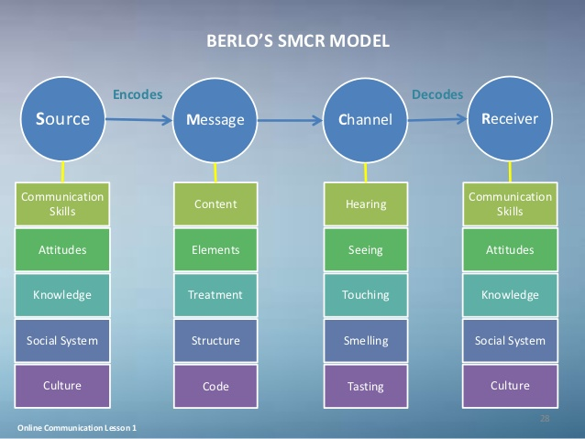
(Berlo, D. K, 1960)

Description
David Berlo's Model of Communication dissects the communication process into Source, Message, Channel, and Receiver. The source creates a message that is sent via a chosen channel to be interpreted by the receiver.

Explanation
A teacher (source) explains Mathematics (message) using visual aids (channel) to students (receivers). The efficiency of this communication rests on how the teacher delivers the message and the existing knowledge/mindset that students have.

Advantages & Disadvantages
The Model emphasises the crucial SMCR roles – offering in-depth analysis distinct to each element (Berlo, 1960).
It skips feedback loops and doesn’t consider noise, elements that other models incorporate into their structure (Smith, 2020).

5
This Model would not suit my organisation, due to its potential shortcomings in handling cross-cultural communication differences.

Critical assessment of the communication models

Key components of contemporary communication, feedback, and engagement are emphasised in the Communication Cycle.

Berlo's SMCR model is less flexible because it lacks feedback.

Schramm's concept introduces context and shared experiences.

The Shannon & Weaver model, which emphasises noise, is too linear for intricate relationships.

Although they all have advantages in terms of structure and clarity, some lack context or feedback, reducing their usefulness in today’s demands.

6
The importance of tone, language & formality

Formality
Dress codes, language use, and behaviours contribute positively to respectfulness, clarity, and efficiency at work. It fosters clear communication channels and enhances professional standards in the workplace (Chang & Cortina, 2023).

Language
Professional vocabulary and tone are important for clear communication, minimising misunderstandings, fostering respect, and promoting productivity. This facilitates effective collaboration and conflict resolution, boosting efficiency and morale.

Structure
Aids in efficient workflow and decision-making, by providing clear organisational hierarchies, defining roles, and providing clear responsibilities. Structured environments reduce confusion, harmonise collective efforts, and reinforce productivity (Frontiers, 2023).

Content
Content refers to accurate, meaningful, and pertinent communication and information materials. Clarity and comprehension pave the way for efficient teamwork and objective accomplishment.

Tone
The tone used conveys feelings and attitudes. It plays an essential role in shaping how others understand messages - crafting either a positive or negative environment. Setting the right tone builds respect and teamwork whilst boosting spirits.

Modes of communication
Communication incorporates verbal cues via spoken words, non-verbal signals through body language and eye contact, written exchanges through emails/documents, and digital interaction using messaging apps or virtual meetings.
These formats are essential for ensuring effective collaboration and understanding among employees.

7
Relating these to my workplace
I use sophisticated language to foster a sense of professionalism and precision. I deliver clear, significant content to aid comprehension while promoting encouragement. I communicate through various communication channels based on the significance of each message.

8
Communication scenarios

Crisis communication
Apply formal language, in a clear and structured format, with concise content, maintaining seriousness when communicating incident-related announcements. This ensures safety is paramount during such situations.

Team motivation
Using uplifting and inspiring language communication, highlights and acknowledges work and dedication, to celebrate successes. The content should encourage efforts to achieve success, by using motivational quotes to boost morale.

Conflict resolution
Applying formal language, a respectful tone, clear structure, and constructive content is significant when dealing with conflicts, where open dialogue and mutual respect are vital.

Delivering unwelcome news
Using formal language, a serious tone, clear structure, and empathetic content is vital when communicating unwelcome news. Showing understanding and extending support mechanisms, can alleviate tension.

Relating scenarios to my workplace
- My focus would be on disseminating accurate information through official updates promptly for clarity during crisis communication.

- I would incorporate a visual presentation to capture the audience's attention, detailing focus on future goals, to motivate and inspire the team.

- My approach to conflict resolution would be collaborative, involving concerned parties, in achieving a fair and amicable solution.

- I would express regret and sincerity to my colleagues when delivering unwelcome news, to initiate trust and confidence.

9
Using the wrong approach
This can lead to misunderstandings, negative emotions, and a breakdown in trust. It is essential to master and apply the correct tone to ensure a clear understanding, enhance a positive work environment, and ensure better performance.

10
Verbal and written communication

Written communication

This is vital for maintaining clarity, accuracy, and professionalism. It aids efficacy and productivity, providing a formal transaction of communications. Detailed information through structured writing ensures alignment ensuring peers are thoroughly knowledgeable (Sanchez, & Guo, 2005).

Below is a table of the written communication tools I adopt in the workplace, how I use these, and their advantages/disadvantages:

Comm Method | How They Are Used | Advantages | Disadvantages
Emails | For formal interactions | Provides a clear, documented trail | Can be burdensome if overused
Reports | Offer detailed evaluations for decision-making | Supports informed decision-making | Time-consuming to produce
Newsletters | Promote corporate news, fostering community spirit | Fosters a sense of community | Risk being ignored if published too often
Internal Chat Platforms | Stimulate collaboration | Enhances collaboration and responsiveness | Potential distractions and information overload

Advice & Recommendations

Each method serves a distinct role tailored to different situational needs. Efficiency relies on the use of balancing clarity and engagement against organisational convenience, providing transparent written communications.

11
Verbal communication

Verbal communication allows instant engagement, promotes cooperation, and accurately expresses feelings through voice nuances. Verbal interaction boosts team efficiency while minimising confusion from miscommunication, promoting an efficient work atmosphere (Explore Psychology, 2023).

Below is a table of the verbal communication tools I adopt in the workplace, how I use these, and their advantages & disadvantages:

Communication Method | How They Are Used | Advantages | Disadvantages
In-person Meetings | For detailed discussions and decision-making | Allows for in-depth conversations | Time-consuming, may suffer from low participation
Phone Calls | For quick responses, especially during emergencies | Provide immediate, direct communication | Lack non-verbal cues
Digital Conferences | For remote participation with visual aids | Enhance understanding with visual engagement | Technical issues can hinder the continuity
Informal Dialogues | Casual chats within an informal workspace | Foster teamwork and spontaneous idea exchange | Lacks documentation, increasing miscommunication

Advice & Recommendations

The choice between different modes depends upon the situation, achieving balance amongst swift responses, clear information transmission, and engaging audience interest.

12
Motivation Theories

Motivation drives individuals' goals, shaped by wants, needs, and ambitions. It may be intrinsic - fuelled by personal contentment, or extrinsic - propelled by external incentives. This motivation determines the effort needed in goal pursuit (Ryan & Deci, 2000).

Intrinsic & Extrinsic motivation
Intrinsic motivation engages in activities due to internal satisfaction and personal reward, by curiosity or self-improvement. Extrinsic motivation conducts tasks for external money or praise rewards.

Intrinsic tends to encourage deeper engagement and extend interest over a prolonged period, while extrinsic suits short-term objectives for immediate incentives (Ryan & Deci, 2000).

13
Maslow's Hierarchy of Needs

According to Maslow's 1943 hierarchy of requirements, people must first take care of their lower-level basic needs before addressing higher-level growth needs.
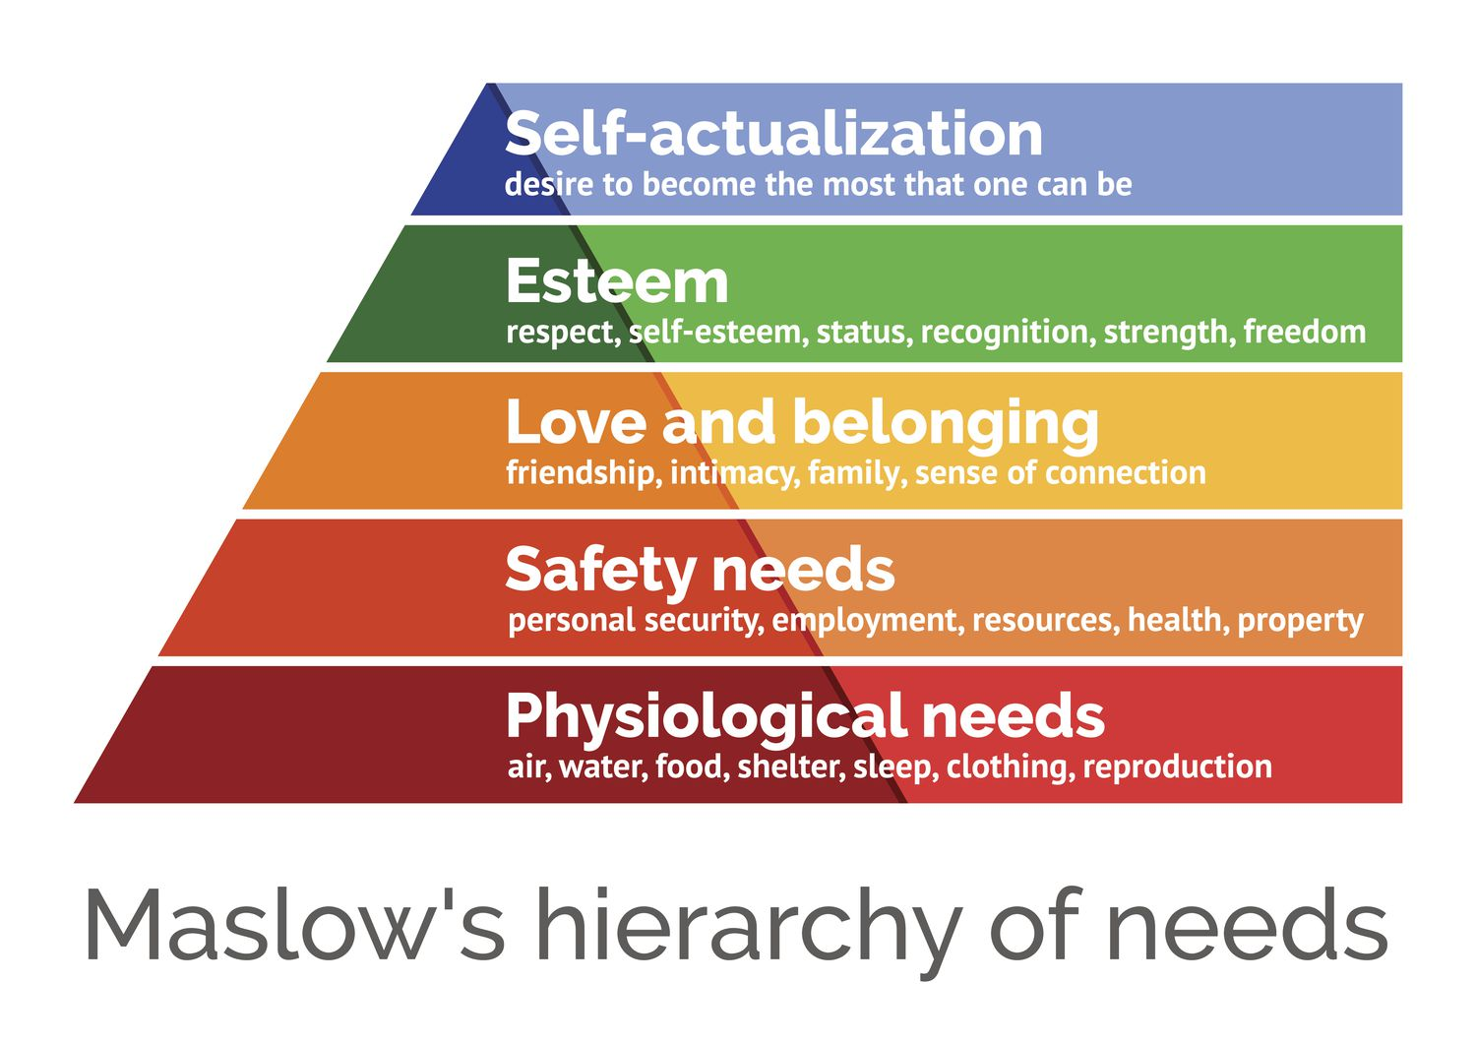
(Maslow, A. H, 1943)

A pyramid with five levels, representing distinct categories of human needs, is a common way to portray Maslow's Hierarchy of Needs. From lowest to highest, the levels are:

- Physiological needs: Necessities for life, including food, water, shelter, warmth, and air.

- Safety needs: Security-related demands, such as protection from physical injury, job security, health, and financial stability.

- Love and belonging: Connections with friends and family, being part of a community, and developing close relationships are significant factors in social needs.

- Esteem needs: Revolve around feelings of accomplishment and self-respect, and acknowledgment from others.

- Self-Actualization Needs: The drive to reach one's potential and partake in endeavours that promote personal development and happiness.

14
McLelland’s Need Theory

David McClelland’s Need Theory, known as the Three Needs Theory, proposes that individuals are primarily driven by one of three needs.

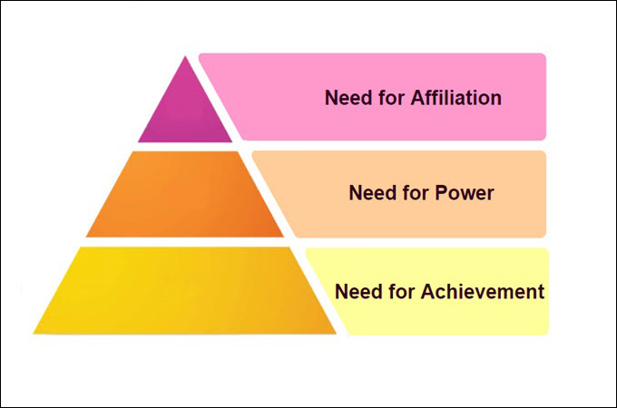
(McClelland, D. C,1961)

The three needs include:

- Need for Achievement (nAch): Possessing a need for achievement to excel and succeed in tasks.

- Need for Power (nPow): A need for power, aiming at controlling others while enjoying competition and authority.

- Need for Affiliation (nAff): People influenced by affiliation prioritise social connections over competition, value harmonious relationships, and work well in teams.

These motivational drivers help organisations align tasks effectively with employees' desires, enabling better motivation, using tailored management strategies.

15
McGregor’s X-Y Theory

Douglas McGregor's Theory X and Y provide distinct models for employee motivation. The theories deviate based on different assumptions that managers have about their workforce, which shape leadership techniques significantly.

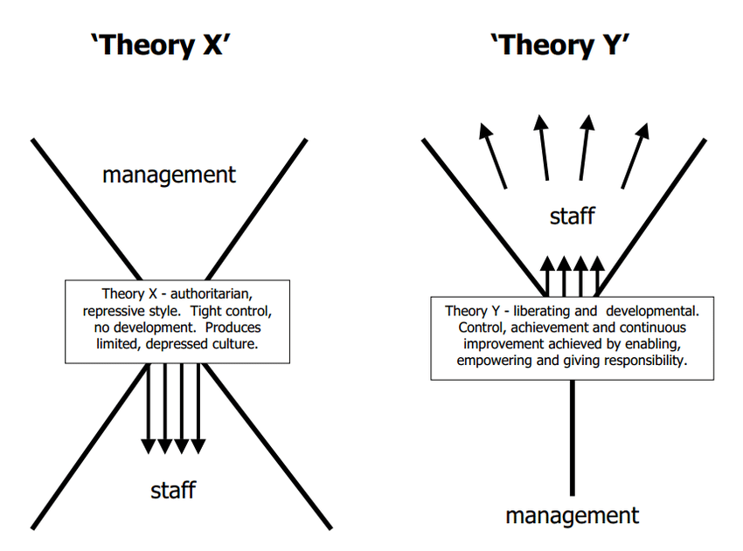
(Gerstner, C. R., & Day, D. V, 1997).

- Theory X: Suggests employees lack enthusiasm and need strict control measures to meet organisational goals effectively, by employing authoritative management styles via external sanctions or rewards, as motivation.

- Theory Y: Suggests that workers with dedication to goals can exercise self-direction, self-control, and problem-solving abilities, adopting a participative management approach inspired by intrinsic motivations.

16
Critical Assessment and Comparison of Motivation Theories

Maslow's Hierarchy of Needs, McGregor's X-Y Theory, and McClelland's Need Theory offer three different ideas of motivation. Maslow (1943), McClelland (1961), and McGregor (1960) all highlight the importance of a hierarchy of needs; McGregor (1960) distinguishes between authoritarian and participative management.

Similarities: They all include workplace incentives for employees.
Disparities: Maslow is hierarchical, McGregor focuses on managerial style, and McClelland is a specialist.
Relevance: McClelland and McGregor are still relevant in today's workplaces.
Strengths and Weaknesses: McClelland's theory is practical but limited, Maslow's theory is basic but rigid, and McGregor's theory simplifies behaviour while fostering empowerment.

Applying McGregor’s X-Y theory in my workplace
Applying McGregor's Theory Y means valuing employees' opinions and giving them a sense of autonomy. This encourages drive and creativity; however, it fails individuals who require more guidance and are more aligned with Theory X.

My ability to tailor a management style to employees' demands is essential for my success.

17
Factors that affect motivation

- Job Satisfaction: Engagement and creativity are fuelled by a person's satisfaction and interest in their work. This increases employee dedication and output (Deci & Ryan, 2000).

2. Reward & Recognition: Incentives, pay, and rewards are important sources of motivation. Incentives motivate employees to work harder (Locke & Latham, 2002).

3. Work Environment: Stress and burnout decrease in a favourable work environment. Sufficient resources, and a comfortable location, enhance well-being, productivity, and a supportive atmosphere (Maslach & Leiter, 1997).

4. Leadership Style: Clear communication, support, and acknowledgment encourage effective leadership, which increases motivation. Loyalty and performance are fostered by leaders who encourage and assist their teams (Bass, 1985).

5. Job Security: Eases tension and frees workers to concentrate without worry. According to Herzberg (1968), job security is essential for preserving motivation and dedication.

6. Acknowledgment & Feedback: Accomplishment acknowledgment and feedback support positive behaviours and progress. According to Herzberg (1968), motivated workers are content when they feel appreciated.

7. Career Development Opportunities: Professional development and career promotion inspire workers. Motivation is fuelled by career development, improving abilities, knowledge, and future employability (London, 1983).

8. Work-Life Balance: Maintains health, lowers burnout, and raises job satisfaction. Maintaining motivation requires a work-life balance, including flexible work opportunities (Greenhaus & Powell, 2006).

These factors meet workers' psychological and physical needs, boosting engagement, job satisfaction, and performance.

What motivates me in my workplace?
Professional growth opportunities, recognition, and a positive, collaborative work environment, enhance my continuous improvement and success. 18
Workplace Conflict

Disagreements stemming from different personalities, values, interests, or aspirations are known as workplace conflicts. Poor communication, unfulfilled expectations, or perceived injustices, affect teamwork, morale, and productivity.

Example
The negative impact on a work team's efficiency and morale is due to a member, Alex’s failure to meet deadlines. Unpunctuality leads to unfair colleague workloads, increased stress due to miscommunication, and a sense of dissatisfaction within the group.

- Failing Project Deadlines: Alex's late submission of a project causes his manager to re-assign tasks to colleagues, or colleagues work longer hours to meet deadlines.

- Communication breakdown: Alex inconsistently communicates delays, causing last-minute chaos and rising stress levels amongst staff.

- Unequal workload: Teammates feel unjustified pressure picking up Alex’s surplus duties, leading towards grudges, and decreased cooperation within group dynamics.

Professional conflict resolution strategy: Mediation:
'The Peace-Maker Approach' - an unbiased third party meditates between involved parties, (Alex & his manager), encouraging open conversation to help each side understand others' perspectives to find common ground for dispute resolution.
This involves four steps:

- Preparation- Mediators understand individual viewpoints.

- Joint sessions – Take place during planned discussions.

- Problem-solving- Both parties truly comprehend each other's problems, enabling them to identify viable solutions together.

- Agreement- Parties reach a mutual understanding of the measures implemented, (Alex to enhance his performance efficiency and communication approach, with Manager support). 19
Success

Sharing information and understanding increases productivity while maintaining team harmony. Reliability is achieved through regular monitoring, fostering a cooperative workspace, and enhancing peer relationships.

20
Personal Communication

I produced a questionnaire to seek feedback on my personal communication style, to identify areas for improvement.

A colleague has completed the questionnaire, please refer to Appendix A.

Strengths and Weaknesses

Ratings taken from the questionnaire describe how I express ideas and engage with others:

Strengths

Empathy: (5) I am highly empathic, understanding those around me.

Openness: (5) I am open to constructive criticism and willing to adopt improvements.

Clarity: (4) I convey messages promoting easy comprehension.

Conciseness: (4) I communicate briefly without compromising on necessary details.

Feedback:(4) I give nurturing yet effective feedback.

Weaknesses

Responsiveness: (2) I need to address queries/worries more rapidly.

Active Listening: (3) I could boost interactions through active listening techniques.

Adaptability:(3) I need to modify my communication style to better suit certain contexts and people. 21
From the above response, I have completed a Personal Development Plan and GAP analysis, to identify strengths and areas for improvement, whilst setting objectives for personal/professional growth. Please see Appendix B and Appendix C.

22
Appendices

Appendix A Communication Style Feedback Questionnaire

Please rate the following statements based on your experience with my communication style. Use the scale below:
- – Strongly Disagree 2 – Disagree 3 – Neutral 4 – Agree 5 – Strongly Agree

- Clarity:
- The information communicated by Natalie is clear and easy to understand.
- 1 2 3 4 5

- Conciseness:
- Natalie concisely provides information without unnecessary details.
- 1 2 3 4 5

- Active listening:
- Natalie actively listens and responds appropriately to my input during conversations.
- 1 2 3 4 5

- Responsiveness:
- Natalie responds to questions and concerns promptly.
- 1 2 3 4 5

- Empathy:
- Natalie demonstrates empathy and understanding during our interactions.
- 1 2 3 4 5

- Feedback:
- Natalie provides constructive feedback that is helpful and encouraging.
- 1 2 3 4 5

- Adaptability:
- Natalie adapts their communication style to fit the needs of different situations and individuals.
- 1 2 3 4 5

- Openness:
- Natalie is open to feedback about their communication style and shows a willingness to improve.
- 1 2 3 4 5 23
Appendix B

Personal Development Plan:
Natalie O’Sullivan, Staff Id: 603126
Senior Business Change Manager, April 2024.
What are your career goals? | What skills do you need to improve? | Benefits | What action will you take? | How will you measure this? | Monitoring & Evaluation | Deadline
Become an area manager. | Strategic thinking, Decision-making. | Personal growth, implementing my expertise | Complete strategic thinking training and shadow my manager. | Feedback from my manager during weekly/monthly check-ins. | Monitor my skills against area manager aims & objectives | 24 months
 | Responsiveness | Stronger relationships and deadlines are met. | Set times to check emails/messages and use calendar slots as reminders. Assess productivity | Track response times and ensure 90% of responses are within 24 hours over the next 3 months. | Monitor and review weekly response times and adjust accordingly | 3 months
 | Active listening | Enhanced understanding of others' feelings and fewer instances of miscommunication | Attend active listening skills sessions,  summarise & reflect on key points during conversations. | Implement this technique 5 times per week, seeking colleague feedback | Track interactions and examine responses weekly/monthly | 6 months
 | Adaptability | Better engagement with diverse groups, increased communication flexibility | Observe peers communicating in diverse settings, to implement positive improvements. | Gather colleague input and observe communication in different situations for 6 months | Collect feedback monthly & implement necessary changes. Review and analyse success. | 6 months

24
Appendix C

GAP Analysis

 | Area | Present condition | Ideal condition | Improvement
1. | Time management | Not responding to mailbox promptly | Have an up-to-date mailbox | Set time to respond to emails/messages daily
2. | Organisation | Dealing with numerous tasks at once | Dealing with one task at a time | Prioritise and organise workload to deal with critical work first
3. | Conversing | Nervous talking to diverse cultural and social groups | Confident talking to colleagues from diverse backgrounds | Remain composed, and project a positive attitude.

25
References

Bass, B.M. (1985). Leadership and performance beyond expectations. New York: Free Press.

Berlo, D. K. (1960). The process of communication: An introduction to theory and practice. Holt, Rinehart, and Winston.

Chang, Y., & Cortina, J. M. (2023). What should I wear to work? An integrative review of the impact of clothing in the workplace. Journal of Applied Psychology. Retrieved from https://read.qxmd.com/read/38059956/what-should-i-wear-to-work-an-integrative-review-of-the-impact-of-clothing-in-the-workplace

Deci, E.L., & Ryan, R. M. (2000). The “what” and “why” of goal pursuits: Human needs and the self-determination of behavior. Psychological Inquiry, 11(4), 227-268.

Explore Psychology. (2023). Verbal communication: Understanding the power of words. Explore Psychology. Retrieved from https://www.explorepsychology.com/verbal-communication.

Foulger, D. (2004). Models of the communication process. Retrieved from http://davis.foulger.info/research/unifiedModelOfCommunication.htm

Frontiers. (2023). How team structure can enhance performance: Team longevity’s moderating effect and team coordination’s mediating effect. Frontiers in Psychology. Retrieved from https://www.frontiersin.org/articles/10.3389/fpsyg.2023.00889/full

Gerstner, C. R., & Day, D. V. (1997). McGregor's Theory X/Y and Job Performance: A Multilevel, Multi-source Analysis. Journal of Management, 23(4), 637-654. Retrieved from https://www.jstor.org/stable/44113685

Greenhaus, J. H., & Powell, G. N. (2006). When work and family are allies: A theory of work-family enrichment. Academy of Management Review, 31(1), 72-92.

Herzberg, F. (1968). One More Time: How do You Motivate Employees? Harvard Business Review. 26
Locke, E. A., & Latham, G. P. (2002). Building a practically useful theory of goal setting and task motivation. American Psychologist, 57(9), 705-717.

London, M. (1983). Toward a theory of career motivation. Academy of Management Review, 8(4), 620-630.

Maslach, C., & Leiter, M. P. (1997). The truth about burnout: How organizations cause personal stress and what to do about it. San Francisco: Jossey-Bass.

Maslow, A. H. (1943). A theory of human motivation. Psychological Review, 50(4), 370–396. https://doi.org/10.1037/h0054346

McCabe, D. (2009). Communication Models. Academic Press.

McClelland, D. C. (1961). The Achieving Society. Princeton, NJ: Van Nostrand.

McGregor, D. (1960). The Human Side of Enterprise. New York: McGraw-Hill.

Ryan, R. M., & Deci, E. L. (2000). Intrinsic and extrinsic motivations: Classic definitions and new directions. Contemporary Education Psychology, 25(1), 54-67. https://doi.org/10.1006/ceps.1999.1020

Sanchez, & Guo. (2005). The importance of effective communication in the workplace. Journal of Computer-Mediated Communication, 12(2), 456-478. Retrieved from https://academic.oup.com/jcmc/article/12/2/456/4583009

Schramm, W. (1954). How Communication Works. Communication in Modern Society.

Schramm, W. (1954). The process and effects of mass communication. University of Illinois Press.

Shannon, C. E., & Weaver, W. (1949). The Mathematical Theory of Communication. University of Illinois Press.
27
Smith, J. (2020). Communication theories: Understanding Berlo's SMCR model.
Journal of Communication Studies, 12(3), 45-59.

University of Minnesota. (n.d.). The communication process [Image]. In Communication in the real world: An introduction to communication studies. University of Minnesota Libraries Publishing. Retrieved May 25, 2024, from https://open.lib.umn.edu/communication/chapter/1-2-the-communication-process/

Workplace Hero UK. (2023). Understanding the building blocks of communication:
The communication cycle. Retrieved from https://www.workplacehero.co.uk

28

