

Assessment 1 – Reading Task Template
Upload your photo of your A3 in-class notes here:
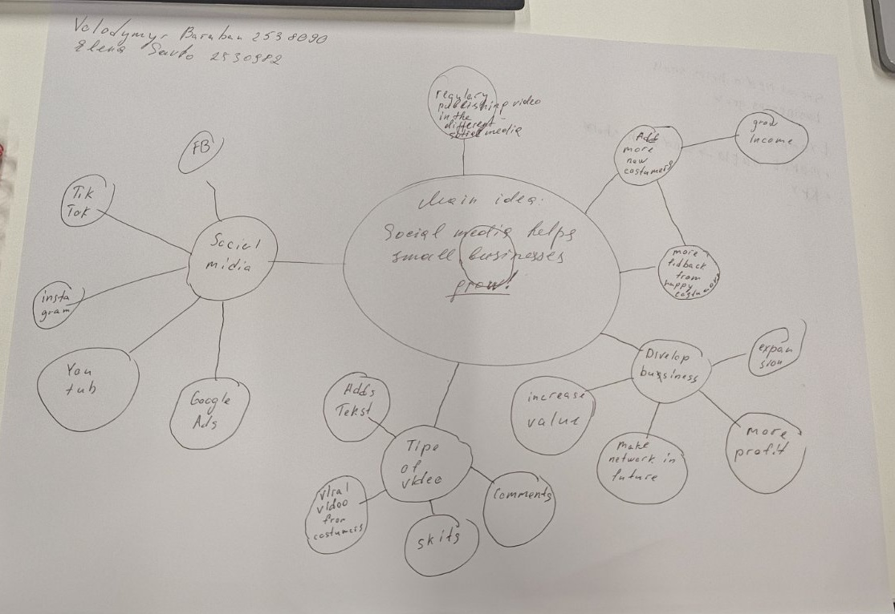

1. Answer these questions using the sentence starters below
a. What is the main idea of the text?
The main idea is that, regardless of the type of business you run, social media can make your brand awareness and thanks to that successful.
b. What are two key points?
1 Content about your business should be engaging, thanks to funny moments, an ironic voiceover, upbeat music, or other attention-grabbing elements.
2 The key point is when happy customers share information about your business on social media, creating a viral trend.
c. What part of the text did you find most important? Why?
The most important part the text is the words expert Faye Martin about awareness brand. Because the more people know about your business, the more new customers you will be able to get and earn more.
d. Was anything unclear or difficult to understand?
There were a few unfamiliar words in the text. Everything else was clear.
e. How did your group help you understand the text better?
My group explained the meaning of unknown words to me. This help me to understand text clear.

2. One sentence reflection
Question: What did you find challenging about this task?
It was difficult to single out the main idea that made all these people’s businesses successful.

