ASSIGNMENT
Module Name: Software Solutions for Business
Module Code: ACCA4026

Student Name: Emad Muhith
Student ID: 2516011
Lecturer Name: Anum Paracha

Table of Contents

Task 1: E-Commerce Website Builders / Software Solutions 4
Introduction 4
Shopify: Features and Benefits 4
Wix eCommerce: Features and Benefits 4
Comparison and Conclusion 5
Task 2: Mind Mapping of Contemporary Software Applications 5
What is Mind Mapping 5
Benefits of Mind Mapping in Business Operations 6
Mind Map: Contemporary Software Applications 6
Conclusion 7
Task 3: Office Applications 7
Part A: Explanation of Office Software Solutions 7
1. Microsoft Word 7
2. Microsoft PowerPoint 8
3. Microsoft Excel 8
4. Microsoft Access 9
Conclusion 10
Part B: Practical Testing 10
1. IF Function in Microsoft Excel 10
2. Pivot Table in Microsoft Excel 11
Task 4: Communication and Collaboration Applications 12
Part A 12
1. Communication Application: WhatsApp 12
2. Collaboration Application: Google Docs 13
Part B 14
1. Communication Application Feature – WhatsApp 14
2. Collaboration Application Feature – Google Docs 15
References 16

Task 1: E-Commerce Website Builders / Software Solutions

Introduction
E-commerce web publishers are computer software that allows individuals and companies to design, administer, and operate online stores without possessing technical or computer knowledge. These sites are integrated to allow one to create websites, manage products, accept payments, and deal with customers. In the current digital economy, e-commerce constructors are very instrumental in ensuring that companies develop an online presence in a prompt and effective manner. The two popular modern-day e-commerce solutions include Shopify and Wix, which provide intuitive user interfaces and effective features that suit various kinds of users.

Shopify: Features and Benefits
Shopify is an online shopping software, which is completely hosted and aimed at online sales. It enables its users to create and customise their online stores with a large variety of professionally designed templates [1]. It has a lot of important characteristics, and one of them is its convenient usage because it does not presuppose knowledge of coding. Shopify features in-built inventory management, order processing, and safe payment gateways with many payment methods such as credit cards and digital wallets.
Its other significant aspect is its scalability. Shopify is suitable for both small and large businesses, enabling them to operate and grow their business with the help of various pricing packages and other adaptive features like analytical tools and reporting. It also has a wide selection of app stores where one can add third-party features such as marketing, shipping, and customer support.
Shopify is characterised by the following key advantages: reliability, security, and good customer support. It is also a hosted solution, and therefore, the user does not have to worry about maintaining the server or updating the software. It can, however, include the cost of subscription on a monthly basis and transaction charges, which can be a constraint to small businesses with a low budget.

Wix eCommerce: Features and Benefits
Wix is an online website creator, and it creates e-commerce features as well. It has been known to have a drag-and-drop interface, hence it is very user-friendly to beginners. The users are able to create attractive sites without any trouble of typing the content and adding images and buttons to the page.
Wix eCommerce is characterised by product management, online payment safety, and customised stores [2]. It also comes with in-built marketing attributes such as email campaigns and SEO optimization, which assist companies in acquiring and maintaining clients. Moreover, Wix offers a wide range of templates that are specific to various industries, and users can use them to make their own websites unique and professional.
Wix eCommerce has such advantages as flexibility in design and simplicity in customization. It is especially appropriate for small businesses and individuals who value visual creativity. Nevertheless, Wix might not be as scalable and with as sophisticated e-commerce functionalities as Shopify is, which is why it would not suit a large-scale business or a fast-growing one.

Comparison and Conclusion
Both Shopify and Wix are good e-commerce solutions, yet they are designed to meet the needs of different users. Shopify is more concerned with the e-commerce functionality, which features some advanced tools, scalability, and strong performance for businesses that want to grow. On the other hand, Wix eCommerce is user-friendly and can be configured regarding design, which is beneficial to those who are beginners and do not need a large-scale business.
Finally, these platforms cannot be compared because they will depend on the needs of a particular user. Shopify might be the choice of businesses that want to have a comprehensive and scalable e-commerce platform, whereas Wix could offer a suitable option to those that want to see a simple and visually customizable system. The two platforms show how contemporary e-commerce constructors facilitate the task of establishing and operating online shops within the online market.

Task 2: Mind Mapping of Contemporary Software Applications

What is Mind Mapping
Mind mapping is a graphical method that is applied in the representation of information in an ordered and imaginative manner [3]. It entails using a central concept as the centre of a diagram and extending it to other related topics by the use of keywords, images, and relationships. This approach is similar to the way the human brain has been found to process and connect ideas naturally, and hence, comprehend complex information easily. Mind maps are popular in education and the business world since they are considered to simplify vast portions of information and provide it in a clear and graphical form.

Benefits of Mind Mapping in Business Operations
Mind mapping has a number of benefits in the business setup, especially in planning, brainstorming, and decision-making.
Planning: Mind mapping enables the business to plan projects and strategies in a better way since large objectives are broken down into small, manageable tasks. It enables the managers to visualise the timelines, resources, and workflows in an organised way. This enhances organisation and makes sure that there is no detail left out.
Brainstorming: Mind mapping is an excellent tool in that it helps to think creatively. In brainstorming, ideas are generated and interconnected with one another promptly and inexplicably [4]. The visual format stimulates free thought and allows taking into consideration various opinions, which results in more innovative solutions.
Decision-Making: Mind maps have been used in the decision-making process as they clearly illustrate the options, benefits, and possible results. Visualisation of information helps the decision-makers make a comparison of the alternatives and discover associations between variables. This will result in better and more informed decisions.

Mind Map: Contemporary Software Applications
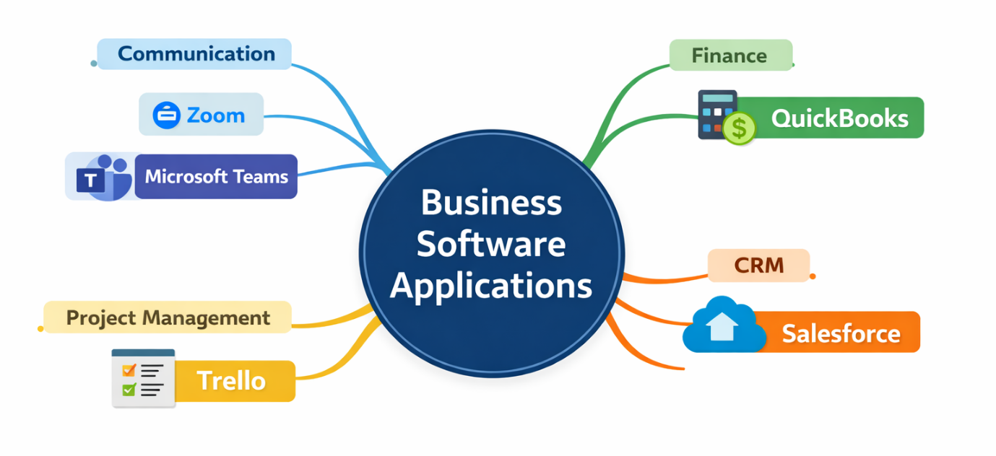

Conclusion
Mind mapping is a strong tool that can be used to improve learning, creativity, and structuring in business activities. It makes good planning available, promotes brainstorming in innovative ideas, and enhances the process of decision-making by visually organising information. The mind maps applied to the organisation of modern software applications prove that the digital tools that businesses depend on in their daily operations should be understood and managed in a better way.

Task 3: Office Applications

Part A: Explanation of Office Software Solutions
Office applications are crucial programmes that are employed in contemporary organisations to generate documents, analyse data, display information, and control databases. Some of the most popular office software packages are Microsoft Word, Microsoft PowerPoint, Microsoft Excel, and Microsoft Access. All these applications have their purpose and have distinct features, advantages, and drawbacks.

1. Microsoft Word
Microsoft Word is a popular word-processing programme used for creating, editing, and formatting written records.
Features: Microsoft Word has a large variety of functionalities that improve the creation of a document [5]. These also contain higher text formatting features like font type, line spacing, paragraph alignment, and customization of page layout. It has inbuilt document templates such as resumes, reports, and letters that save time for the end user. Word also has features like spell checking, grammar checking, and auto-correct, which enhance the accuracy of writing. The other notable ones are the features of inserting tables, images, charts, and hyperlinks, and collaboration tools such as track changes and comments to allow the pieces to be edited by a group.
Benefits: The ease of use of Microsoft Word is one of the key advantages of the programme since it is appropriate to both amateurs and professionals. It enables users to create documents of professional standards with efficiency. The templates and formatting systems make the process of writing papers in a blank easier and less time-consuming. Moreover, its collaboration capabilities involve teamwork, allowing more than one user to check and edit documents at the same time. It is also a flexible means of communication and documentation because it can be compatible with different file formats.
Limitations: Microsoft Word has limitations despite having its strengths. It is not suitable to use in complicated graphic design projects as compared to specialised publishing software like Adobe InDesign. These huge documents, which have massive formatting, may prove to be cumbersome. Also, more advanced features might need some form of training, and the software is usually subscribed to at a fee, which might be too expensive for everyone.

2. Microsoft PowerPoint
Microsoft PowerPoint is a presentation programme, through which one can develop visual slideshows to communicate and share information.
Features: PowerPoint gives an opportunity to create a visual presentation with the help of slides containing text, images, charts, video, and animation [6]. It has a wide range of themes and templates that can guarantee consistency in design. Users have the option of using transitions between slides and animations of objects in slides to make them more appealing to the eye. Multimedia integration can also be used during a PowerPoint presentation, where users are able to incorporate audio and video media. Other features that assist in making the presentations effective are presenter view and slide show controls.
Benefits: The main advantage of PowerPoint is that it allows the presentation of information in a clear and attractive way. It increases the interest of the audience using images and multimedia. The software is user-friendly and is generally accessible, thus it is a common tool of learning and the business world. The process of creating is made easier through templates and design tools, whereas additional features, such as presenter notes, make the process of presentations more effective.
Limitations: Nevertheless, there are also limitations to the use of PowerPoint. Excessive application of effects and animation may end up taking the attention and diminishing the presentation's effectiveness. It could promote too much dependence on bullet points and, hence, less interactive communication. Also, when presentations are not designed in a proper manner, they become less effective. It also has a subscription just like Word, and in sharing files between versions and platforms, compatibility problems can also take place.

3. Microsoft Excel
Microsoft Excel is an efficient spreadsheet software that is applicable in the organisation, analysis, and visualisation of data.
Features: Excel has a lot of capabilities in dealing with numerical, as well as text, data. It enables users to make a spreadsheet with rows and columns, calculate data with the help of formulas and functions (IF, VLOOKUP, etc.), and examine and interpret the data with the help of such tools as pivot tables and charts. Excel also provides data sorting, filtering, and conditional formatting functions that can assist users in interpreting large datasets. More advanced features are the data analysis tools, macros, and automation features, which enhance efficiency and accuracy.
Benefits: Excel is very useful in the management and analysis of data. It allows the user to perform complex calculations in a very short time. The trend and pattern identification is facilitated by the capability to visualise data using charts and graphs [7]. Excel is a very useful skill for a person since it is mainly used in many industries such as finance, operations, accounting, and many more. It is flexible, and the user can make tailored spreadsheets to their requirements.
Limitations: Excel has limitations, as much as it possesses benefits. It may be complicated to initiate, particularly with the use of sophisticated formulas and functions. Big data can decrease the speed of operation, and inaccurate results can be generated due to an error in formulas. Also, Excel is not a complete database management system, thus not necessarily appropriate for managing very large or complex data structures.

4. Microsoft Access
Microsoft Access is a database management system that is used to store and manipulate a significant amount of structured information.
Features: Microsoft Access enables one to build databases that are composed of tables, queries, forms, and reports [8]. Data is stored in tables, and this is retrieved and manipulated through queries to the tables. Forms are a user-friendly data entry interface, and reports enable a user to create data in the form of reports to analyse. The relationships between tables are also supported by access, and this facilitates the maintenance of data integrity. It also works with other Microsoft Office applications and thus allows sharing and analysis of the data.
Benefits: The primary advantage of Access is the possibility to handle a great amount of data in an efficient and systematic way. It is especially suitable for small to medium-sized business organisations that require a database solution that is not as complex as those found in enterprise-level solutions. The access offers mechanisms of automation of tasks and report generation, which enhances productivity. Its application with other Microsoft Office applications increases its functionality and usability.
Limitations: Microsoft Access, however, has a number of limitations. It is inappropriate in the case of very large and enterprise-level databases in comparison with systems such as SQL Server. There are performance problems that may arise as a result of multi-user access. It is also less popular, and the learning curve is more difficult than other office applications, which could be a constraint to user familiarity and support.

Conclusion
Finally, Microsoft Word, Microsoft PowerPoint, Microsoft Excel, and Microsoft Access are also indispensable office applications that assist in the different business aspects. The applications have their own characteristics and advantages to enhance productivity and efficiency within organisations. Nevertheless, they possess limitations as well, which should be taken into account by the users when choosing a correct tool to perform a certain task. The knowledge of these applications will assist individuals and businesses in applying them in contemporary workplaces.

Part B: Practical Testing

1. IF Function in Microsoft Excel
The data set has 3 columns, including Student ID, Marks, and Results. The marks column will include the numbers that will indicate the scores of students. This dataset is aimed at determining the passing and failing of each of the students according to their marks through a logical function in Excel.
Formula used:
=IF(B2>=50,"Pass","Fail")
A condition is evaluated with the help of the IF function. In this situation, the formula will be used to determine whether the scores in column B are more than or equal to 50. In case the condition is true, the outcome would be Pass, and in case the condition is false, the outcome would be Fail. The formula is run over all the rows, and the results of the student are classified automatically.
The table demonstrates that the students are classified into Pass and Fail according to their marks. This shows how Excel can be used in automated decision-making processes and minimise manual errors when working with data.
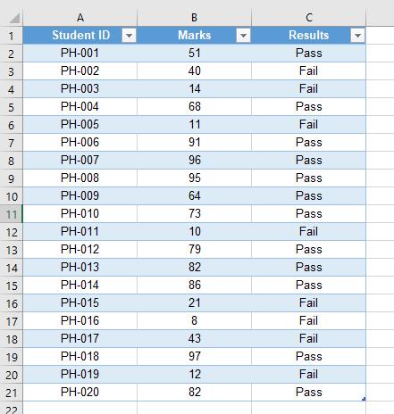

2. Pivot Table in Microsoft Excel
The Pivot Table was created using the same data set. It contains student results (Pass/Fail), which is an opportunity to analyse the number of students who passed and the number of students who failed.
The Pivot Table was made using the dataset by first selecting the dataset and then selecting the Pivot Table option under the Insert tab. The results field was put in the rows section, and the Student ID in the values section, in order to determine the number of students per category.
The Pivot Table is a summary of the contents that presents the total number of students who passed and failed. The findings have revealed that 12 students achieved, and 8 students failed, of the total 20 students. This is the way Pivot Tables can be used to analyse and summarise data quickly.
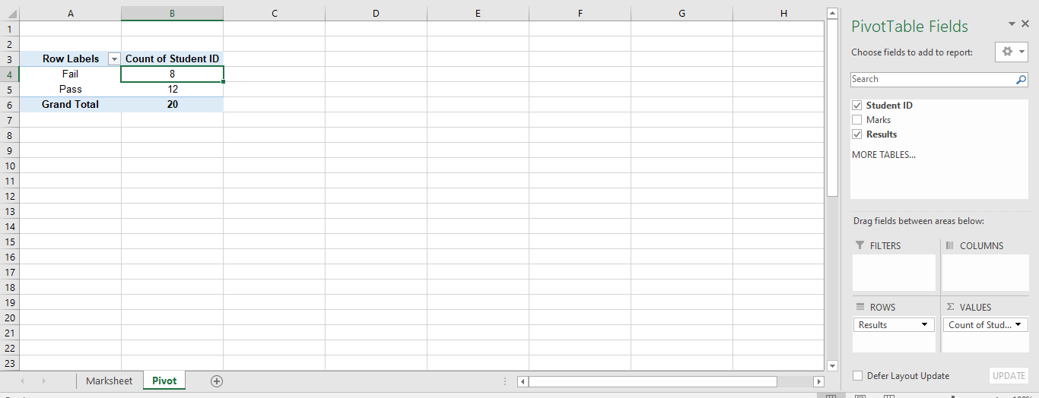

Task 4: Communication and Collaboration Applications

Part A

1. Communication Application: WhatsApp
Overview: WhatsApp is a popular communication application that allows its users to send messages, voice and video calls, and share media via the internet. It can be accessed on smartphones and desktops, and hence it can be used during personal and business communication. In most organisations, quick communication happens through WhatsApp because its use is simple and has gained widespread use.
Features: WhatsApp comes with various features that facilitate successful communication. These are instant messaging, voice, and video calls, and they can send multimedia files, which can include images, videos, and documents [9]. It also favours group chats, where several users can converse at a time. End-to-end encryption is another important feature that makes the messages private and secure. Moreover, WhatsApp offers status updates, voice notes, and sharing of locations, which will improve the interaction of the users.
Benefits: WhatsApp is easy to use and this is one of its strengths. It has a user-friendly interface that can be used by any user regardless of their experience. It is also economical because it utilises the use of internet data as opposed to the traditional SMS or the call costs. WhatsApp is a real-time communication tool; therefore, it is critical in making decisions fast in a business setting. Moreover, owing to the popularity it has gained worldwide, there are fewer clients and staff members who do not know the platform, hence training is not necessary.
Limitations: WhatsApp has certain limitations in the professional world, although it has the following advantages. It does not have the sophisticated elements that apply to formal business communication, including structured project tracking or document management. It may turn out to be hard on the side of managing big groups of people, particularly when the discussions cannot be structured. As well, it can be subject to data privacy and professionalism concerns, as it is mostly created as a personal communication tool as opposed to an enterprise.
Short Analysis: In general, WhatsApp is a very effective tool to use in informal communication within a team or with clients in a quick manner. Nonetheless, it cannot be called a full-fledged solution to structured business communication. In conjunction with other tools, organisations usually employ it to find a compromise between convenience and professionalism.

2. Collaboration Application: Google Docs
Overview: Google Docs is a web-based collaborative tool that enables users to create, edit, and share documents in real-time [10]. It belongs to the Google Workspace and is quite common in schools and workplaces. Teamwork and collaboration are crucial factors in its usage because it can be used by a number of users at the same time.
Features: Google Docs consists of a vast number of collaboration-enhancing features. Users are able to edit documents in real-time, where the changes are reflected. It also offers commenting and suggestive features, which enable members of a team to read and give comments effectively. There are also cloud saving services on the platform, which means that there is no lost work. Moreover, Google Docs has document sharing features that have customizable permissions as to who can view or edit documents.
Benefits: Real-time collaboration is one of the most significant advantages of Google Docs, which enhances the effectiveness of collaboration and productivity in a team. There is an option of having several users working on the same document at various locations without the need to have emails sent with attachments, and the problems of version control. Cloud-based application features enable one to access it using any device that is connected to the internet. It is also open source and can be used by individuals, hence it is cost-effective for both businesses and students. Moreover, it is integrated with other services provided by Google, and this increases its functionality.
Limitations: Nevertheless, Google Docs does not lack limitations as well. It is also largely dependent on the internet, which could be a disadvantage to those with lower connectivity. It does not have many advanced qualities of formatting and design as traditional word processors, such as Microsoft Word. Besides, the privacy issue might also occur during the storage of sensitive information on cloud-based systems.
Short Analysis: Google Docs is an effective teamwork and document-sharing tool that provides effective collaboration. Although it might not be as advanced as the desktop applications, its live collaboration and accessibility make it very useful in the current work environment.

Conclusion
To summarise, WhatsApp and Google Docs are two significant reforms of the current business tools for communication and collaboration. WhatsApp is the fastest and most convenient way to communicate, whereas Google Docs gives an orderly way to collaborate as a team and create documents. The two tools play a significant role in enhancing productivity, though they are best utilised when combined with other specialised applications in a business context.

Part B

1. Communication Application Feature – WhatsApp
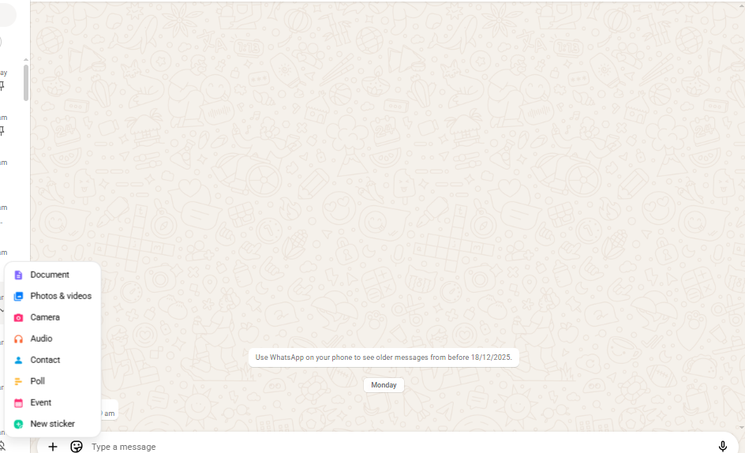
WhatsApp is a document-sharing feature that was used in this test. The user had chosen the attachment feature in the chat interface and then the option to send a file, which was a document. This quality enables users to exchange various formats of files, like PDF documents, Word documents, and images, via chat.
This goes to show that WhatsApp is not a mere messaging service, but it also has file-sharing capabilities that can be used to communicate. It is particularly appropriate in a business where there is a need to exchange documents quickly. It is a very easy and effective process, and one can easily send files in real time in just a few steps.

2. Collaboration Application Feature – Google Docs
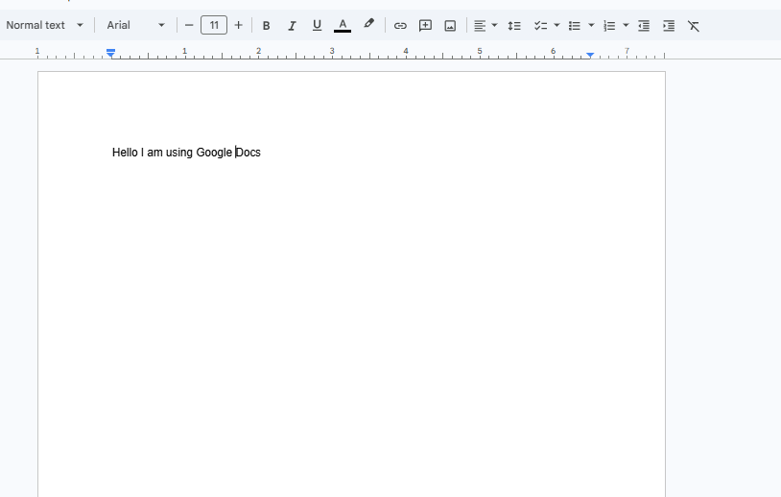
The feature of document creation and editing of Google Docs was utilised in this test. A document was generated, and one typed text into the document interface. Google Docs automatically saves, thus none of the work is lost.
This characteristic brings out the cooperative aspect of Google Docs since a number of people can work on the same document at a given time. It does not require manual saving of files or forwarding of various versions through email. The platform has real-time updates, hence it is quite efficient in teamwork and collaboration.

References

[1] R. Rai, P. Chettri, and L. Chettri, “E-Commerce and Its Software,” Sustainable Business, pp. 696–726, 2020, doi: https://doi.org/10.4018/978-1-5225-9615-8.ch031.
[2] T. Akhtar, “Website Platform Selection for Online Shop,” www.theseus.fi, 2021. https://www.theseus.fi/handle/10024/411922
[3] N. Basri and S. Syamsia, “The Effect of Applying Mind Mapping Method in Writing Descriptive Text,” Langua: Journal of Linguistics, Literature, and Language Education, vol. 3, no. 2, pp. 36–56, Oct. 2020, doi: https://doi.org/10.5281/zenodo.4087103.
[4] P. C. Shih, D. H. Nguyen, S. H. Hirano, D. F. Redmiles, and G. R. Hayes, “GroupMind,” Proceedinfs of the ACM 2009 international conference on Supporting group work - GROUP ’09, 2009, doi: https://doi.org/10.1145/1531674.1531696.
[5] A. Jalil, F. Rosa, R. Affandi, A. Aziz, N. Hadi, and A. A. Ridho, “Literature Review: Exploration of Features Microsoft Word,” International Applied Science, vol. 3, no. 1, pp. 28–32, 2024, doi: https://doi.org/10.32528/ias.v3i1.474.
[6] C. F. de Wet, “Beyond Presentations: Using PowerPoint as an Effective Instructional Tool,” Gifted Child Today, vol. 29, no. 4, pp. 29–39, Oct. 2006, doi: https://doi.org/10.4219/gct-2006-8.
[7] R. G. Aykroyd, V. Leiva, and F. Ruggeri, “Recent developments of control charts, identification of big data sources and future trends of current research,” Technological Forecasting and Social Change, vol. 144, pp. 221–232, Jul. 2019, doi: https://doi.org/10.1016/j.techfore.2019.01.005.
[8] M. Abourezq and A. Idrissi, “Database-as-a-Service for Big Data: An Overview,” International Journal of Advanced Computer Science and Applications, vol. 7, no. 1, 2016, doi: https://doi.org/10.14569/ijacsa.2016.070124.
[9] R. Bueno-Roldán and A. Röder, “WhatsApp? Opportunities and Challenges in the Use of a Messaging App as a Qualitative Research Tool,” Uni-marburg.de, 2022. https://archiv.ub.uni-marburg.de/es/2024/0243
[10] R. Attebury, J. George, C. Judd, and B. Marcum, “Google Docs: A Review,” Against the Grain, vol. 20, no. 2, Nov. 2013, doi: https://doi.org/10.7771/2380-176x.2736.

