Management Assignment 1 2018 –
Corporate strategy of Adidas


OCTOBER 2018

MODULE NAME: STRATEGIC MANAGEMENT M3X9111
Name: TIAN ZHENYU
Student Number: 1800541

Table of Contents
1 Executive summary 3
2 Introduction 5
2.1 Background of the organization 5
2.2 Definition of major concepts 5
2.2.1 Strategy 5
2.2.2 Business level strategy 6
2.2.3 Competitive advantage 6
2.3 Strategic models 6
2.3.1 Porter’s generic strategies 6
2.3.2 The strategy clock 7
3 Corporate strategy of Adidas 8
4 Implement of differentiation strategy 9
5 Cons and pros of Adidas’s strategy 10
5.1 Brief comparison between Nike and Adidas 10
5.2 Advantages of Adidas’s strategy 10
5.3 Disadvantages of Adidas’s strategy 10
6 Conclusion 11
6.1 Recommendation 11
7 Reference 11

List of Figures

Figure 1:Porters’ generic strategies 5
Figure 2:Bowman’s strategy clock 6
Figure 3:Key R&D metrics 8
Figure 4:Adidas’s strategy: Creating the New 8

1 Executive summary
This report aims to figure out the major concepts and models of strategy management and makes use the case of Adidas, a famous multinational sports lifestyle products producer, to illustrate the features of differentiation strategy and explain its advantages and disadvantages of this strategy. From the analysis, this report finds that differentiation strategy helps Adidas to have great consumer loyalty but it can make it lose certain group of consumers to due to its limited design and high product price. Therefore, this report suggests Adidas to diversify its product design and improve its customized service to make people learn more about its differentiation.

2 Introduction

2.1 Background of the organization
Adidas is set up in 1949 and it is named after its founder, Adolf Adi Dassler. At the beginning, Adidas is not registered with the name of Adidas but the name called Adidas AG. It is firstly founded by Adolf Adi Dassler and his brother, but several years later, his brother establishes a new brand, which is also a well-known sports brand in nowadays, called Puma. Adidas is famous for its slogans that impossible is nothing and adidas is all in. Besides, it has three different logos, which stand for three different series of products, including performance series, originals series and neo series. According to its annual reports in 2017, its sales increases by 15% and the operating profits also increases by 31%. To be more specific, its earning per share increase to 2.6 euro and the EPS in 2016 is 2 euro. Furthermore, among its 7 sales regions, only Russian market has experience decrease in sales due to the negative attitudes of Russian consumers and the close of stores in Russia. While, other six markets, such as North America, Great China, Latin America and Japan, all experience great improvement and increase in its annual sale. This information all indicates that Adidas has healthy and positive market performance. Furthermore, according to its annual report (2017), Adidas owns over 50,000 employees, more than 2,500 own-retailed stores and around 13,000 mono-brand franchise stores. This indicates that Adidas never stops its steps in expanding its business in the global market.

2.2 Definition of major concepts

2.2.1 Strategy
Porter(1989) points out that a diversifies company has two levels of strategy, including business unit strategy as well as corporate strategy. Porter(1989) defines corporate strategy as the combination of the goals that enterprises fight for and the methods or ways that enterprises use to achieve their goals. This definition is regarded as the representatives of the traditional recognition on enterprises’ strategy and its emphasizes three features of corporate strategy, that is the scheduling, overall and long term in nature. While, business unit strategy is made by different departments or units in the enterprise which aims to help them achieve different goals of different department. This strategy is common in the large size firm. Canadian scholars Mintzberg(1989) states that it is not correct to view the corporate strategy as the result of rational planning since many successful corporate strategy is produced in the circumstance of no planning in advance. Then, he claims that strategy is a series of decisions or work methods. While, Thomson(1998) points out that the strategy can be the plans that made in advance or the action to adapt the latest situation. Johnson et al（2011）define the strategy as the guide or direction for enterprises to allocate their resources in the long term in order to make enterprises better meet the expectation of their stakeholders. Basing on the review on the previous literature’s definition on strategy, This report defines strategy as the method or plan to guide the development and operation of the enterprises to better achieve its business goal.

2.2.2 Business level strategy
According to Dess(1981), more and more scholars emphasizes the significance to distinguish the difference between corporate level strategy and business level strategy. Dess(1989) claims that corporate strategy guides the enterprise to understand what business that enterprises are supposed to enter while business level strategy is a strategy that can guide enterprises to better compete with its competitors in a particular business. Basing on the review on the previous literature, this report define business level strategy as the plan or methods that used to achieve a better perform results when they are competing with competitors in the same business.

2.2.3 Competitive advantage
Competitive advantage is also an essential concept raised up by the Porter. Porter (1989) defines it as a position that allows corporation to obtain higher return compared to its competitors in the same business. Besides, competitive advantages can be divided into three types, including cost advantages, differentiation advantages and focus advantages. This report defines the competitive advantage as the sustainable and unique advantages that enterprises shows when they are competing with other competitors in the market.

2.3 Strategic models

2.3.1 Porter’s generic strategies
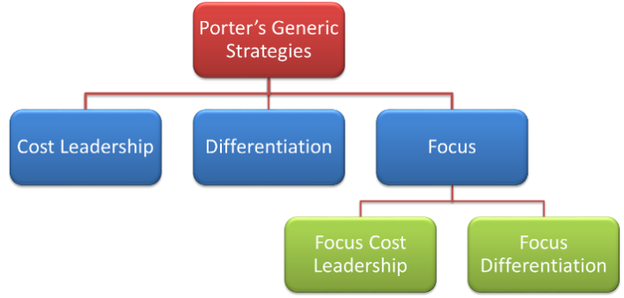
Figure 1:Porters’ generic strategies
Porter’s generic strategy model is brought up by Porter in 1980. Porter claims that there are three competitive strategy for enterprises, including cost leadership, differentiation and focus. Cost leadership requires enterprises to establish high efficient manufacture line and focus on the cost reduction to help enterprises to achieve cost advantages in the market. Easyjet is a good example of implementing cost leadership strategy. Differentiation strategy requires enterprises to provide unique and different service or products to different consumption groups. Caterpillar is a good example of implementing differentiation strategy. Porter points out that the implement of differentiation strategy is sometimes controversary since it is hard to expand its market share at the first and the enterprises have to undertake expensive cost of implementing differentiation. Focus strategy requires enterprises to focus on certain groups of consumers or certain market in the world. This can make enterprises to focus on certain service or business and improve the efficiency of such production. During the process of implementing focus strategy, enterprises can better reduce its cost or make its products different others to better achieve the differentiation.

However, these three strategies have their own drawbacks. For cost leadership, it is hard for enterprises to maintain its low cost in the long term hence it is hard for enterprises to achieve sustainable development with cost leadership strategy. Besides, low cost often makes it connect with worse quality hence it is also hard for enterprises to improve consumer loyalty. For differentiation strategy, it is hard for enterprises to achieving true and meaningful differentiation and as mentioned previously, it is also possible to result in higher cost. For focus strategy, the significant drawback is that it is hard for company to expand its market share.

2.3.2 The strategy clock

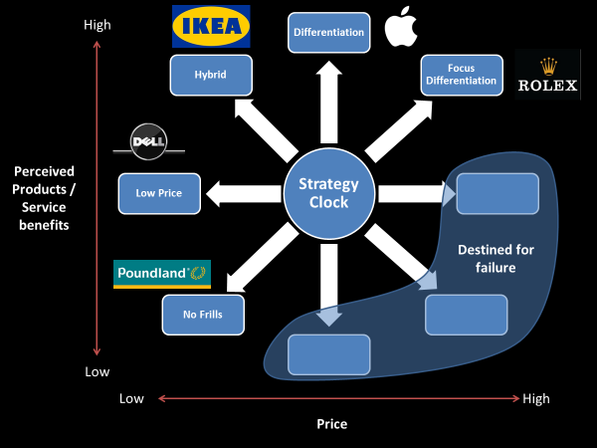
Figure 2:Bowman’s strategy clock

Bowman’s strategy clock helps managers to understand the changing requirement of their markets and the decision that they can make to achieve competitive advantages (Johnson et al ,2011). As the clock shows, there are five different strategies, including no frills, low price, hybrid, differentiation and focus differentiations. No frills strategy is low price with low perceived product benefits (Rui & Xiang, 2007). Lidl is a good example that implements no frills strategies. It offers many products that only cost 1 euro but the quality of its products is also not satisfying. Hybrid strategy requires enterprises to achieve both of low price and differentiation (Rui & Xiang, 2007). This can help company to achieve greater sales volumes and set entry barriers for other enterprises due to its pursuit of differentiation. Ikea is a good example of implement hybrid strategy. Ikea’s products are quite cheap and its simple classical style design makes it clear to be distinguished from other brands. Differentiation strategy requires enterprises to provide products different from the products provided its competitors (Li, 2008). These differences can come from the branding, marketing and other product features. Apple is a good example that implements differentiation strategy since its operation system, IOS and its unique design make it different from others. Besides, its high price make it target at those consumers with high income and great enthusiasm in technology. Furthermore, its IOS system also meet the demand of those enterprises have strict requirement on the protection of privacy. Focus different strategy urges enterprises to provide high perceived product benefits(Fu, 2008). Luxury products usually make use of this strategy. From the strategy clock, it is also easy to understand that the success of the implement of one strategy has close relationship with the match of price and the perceived benefits that consumers can obtain from buying it. Therefore, if one strategy makes corporate to produce a product with high price but cannot offer unique benefits or expectation to the consumers, then this strategy is likely to fail at the end.

3 Corporate strategy of Adidas

According to the annual report of Adidas, this report identifies the corporate strategy of Adidas as differentiation. Differentiation strategy makes the products of one company have significant difference with the products of other company (Hugo, 2009). There are four types of differentiation strategy overall speaking, including product differentiation, service differentiation, image differentiation and human resource differentiation. Different strategy needs enterprises to have high level R&D ability (Yağci et al, 2006). The implement of this strategy can help enterprises to improve the consumer loyalty, construct the barrier for entry and increase the profitability. However, it also has some disadvantages. First, it may lose some potential consumer since some consumers may choose the products from some company that have implemented cost leadership strategy (Zhu et al, 2003). These consumers are not that sensitive with the differences made by these company but are sensitive with the change of price. Therefore, they are more likely to choose those products with lower price but less differences. Second, it is more difficult to make a successful difference. Many enterprises have made great effort to be innovated or make some differences. Hence, it is more and more difficult to come up with a successful difference now (Das & Joshi, 2007). Third, due to lack of protection on difference, it is hard for the public to sense the differences. When the production of one products come to the mature stage, it is not difficult for enterprises to imitate the design or other features of the products (Greenstein & Mazzeo, 2006). Therefore, once the products with differentiation appears, a lot of similar products come out as well, which can make consumers to feel its differentiation.

4 Implement of differentiation strategy
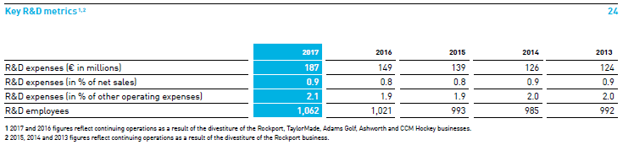
Figure 3:Key R&D metrics

First, Adidas as a famous sports brand, pays highly concerned to the usage of technology in its products. It has made great effort in developing new technologies for a better footwear. Until now, Adidas has owned more than 700 patents, which makes it as the leader in the technique sportswear industry.

Second, Adidas pays high attention to the innovation in its products. The innovation comes from diverse aspects. As mentioned in the annual report of Adidas, creating the new is their strategy plan from now to 2020. Besides, Adidas’s employees are of great diversity, which is favorable for it to make the differences in achieving its long-term goal. Furthermore, Adidas makes use of open resource to increase their innovation as well. To be more specific, Adidas constructs many design space and creation club for those urban cities to share their innovation ideas in sports. Second, they also increase the interaction and communication with other enterprises in the same sports industry to exchange and share own core competence. Third, cooperating with the best athlete in the world to advocate the public to starts the sport life with Adidas.
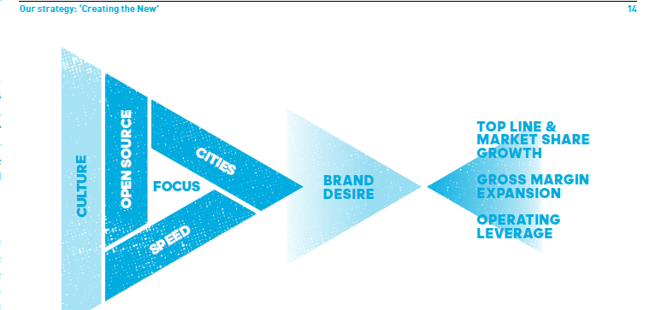
Figure 4:Adidas’s strategy: Creating the New
Third, Adidas can offer different and customized service, which can is favorable for consumers to get high level perceived products. First, it constructs many different platforms for consumers to increase the brand acknowledge of Adidas in the key cities. Green light run is very successful activities that organized by Adidas. Second, it provides private tailor service for the consumers that firstly book their new series products.

5 Cons and pros of Adidas’s strategy

S: Great brand awareness; great R&D ability | W: Limited style, weak appearance design, expensive
O: The increase of health awareness of the public  Great consumer loyalty | T: The advent of new brands
( SWOT analysis of Adidas)

5.1 Brief comparison between Nike and Adidas
Compared to Adidas, Nike is more focus on the diversity of design instead of the innovation in technology. It introduces more than 400 products per year but Adidas does not introduce new products so frequently (He, 2009). Furthermore, Nike’s products are much cheaper than the products of Adidas, which makes Nike are more attractive for those consumers that are sensitive with the price.

5.2 Advantages of Adidas’s strategy

As mentioned above, the implement of differentiation strategy is much easier for enterprises to improve their consumer loyalty. Adidas has made a lot of the methods to provide a unique service for its consumers, such as running activities, private tailor and design hub ( Annual Report, 2017). These actions can help consumers to learn more about Adidas’s corporate culture and develop more solid consumer loyalty. Second, it is more difficult for other enterprises to enter the market of technology sportwear to compete with Adidas. Adidas has invested a great of money in the R&D and it has more than 700 patents (Ming and Hu, 2014). Hence, it is hard for those to compete with them. Third, due to the special position in the market, Adidas also has more negotiation ability with its suppliers compared to the common enterprises in the industry, this can help its to make greater margin profits, which also accounts for Adidas’s increase of revenue and improvement of profitability in these years(Animesh et al, 2011). Fourth, since Adidas does not introduce new product as frequently as Nike, it is much easier for consumers to recognize its features and make the products of Adidas easy to be identified, which can save advertising fees.

5.3 Disadvantages of Adidas’s strategy
Due to its concentration on its technology route, Adidas’s production cost is higher than others in the industry. Then, the price of Adidas’ products is higher than others. This can make its lose the market of low-end consumers. Second, the preference of consumers continues to change and more and more consumers seek for the fashion design of the sportwear instead of the technology. Hence, it is difficult for Adidas to catch up with the continuing change of market due to its differentiation strategy.

6 Conclusion
This report explains the major concepts and model of corporate strategy. Besides, it also makes use of the case of Adidas to better illustrate the features of differentiation strategy, its advantages and disadvantages.

6.1 Recommendation
After the analysis of Adidas condition, this report have several suggestions on its current strategy. First, Adidas is supposed to increase the diversity of its products to meet the demand of continuing changing consumer demand. Second, Adidas can think of more diversity advertising methods to make more consumers in different ages to know about Adidas. Third, Adidas can continuously strengthen its ability to provide customized products and can make customization a great light point of Adidas’s service.

7 Reference

Adidas(2017). Annual Report. Available at: https://www.adidas-group.com/media/filer_public/6a/69/6a690baa-8430-42c5-841d-d9222a150aff/annual_report_gb-2017_en_secured.pdf. Accessed on: November 20, 2018]

Animesh, A., Viswanathan, S., & Agarwal, R. (2011). Competing "creatively" in sponsored search markets: the effect of rank, differentiation strategy, and competition on performance. Information Systems Research, 22(1), 153-169.

Banker, R. D., Mashruwala, R., & Tripathy, A. (2014). Does a differentiation strategy lead to more sustainable financial performance than a cost leadership strategy?. Management Decision, 52(5), 872-896.

Das, S. R., & Joshi, M. P. (2007). Process innovativeness in technology services organizations: roles of differentiation strategy, operational autonomy and risk-taking propensity. Journal of Operations Management,25(3), 643-660.

Dess, B. G. G. . (1981). Corporate-level strategy, business-level strategy, and firm performance. The Academy of Management Journal, 24(4), 663-688.

Fu, L. (2000). A differentiation focus strategy provoked by changing environments: the american life insurance industry approaching asian americans. Management Research News, 24(1/2), 1-20.

Guardian (UK). . Nike and adidas show cautious support for eco-friendly dye technology.

Greenstein, S., & Mazzeo, M. (2006). The role of differentiation strategy in local telecommunication entry and market evolution: 1999–2002. Journal of Industrial Economics, 54(3), 323-350.

Habib, A., & Hasan, M. M. (2017). Business strategy, overvalued equities, and stock price crash risk. Research in International Business & Finance, 39, 389-405.

He, B. (2009). Comparison on the domestic and foreign sporting goods enterprises value china taking nike,adidas and lining as example. Fujian Sports Science & Technology.

Li, C. B., & Li, J. J. (2008). Achieving superior financial performance in china: differentiation, cost leadership, or both?. Journal of International Marketing, 16(3), 1-22.

Hugo, A. R. R. (2009). The concept of corporate strategy. Innovar Revista De Ciencias Administrativas Y Sociales, 19(35), 167-169.

Porter, M. E. (1989). From Competitive Advantage to Corporate Strategy. Readings in Strategic Management. Macmillan Education UK.

Ming, Y., & Hu-Ke, S. I. (2014). Competitive intelligence of adidas sports patent. Shandong Sports Science & Technology.

Tan, J., Luo, Z. Y., School, D. B., University, S., School, B., & University, C. (2017). Managers' turnover,competitive strategy and corporate social responsibility——a research from perspective of strategy coupling. Journal of Shanxi University of Finance & Economics.

Rui, M. J., & Xiang, L. I. (2007). Differentiation,cost leadership and value innovation:an economic explanation of the enterprise competitive advantage. Research on Financial & Economic Issues.

Sun, L. Y., & Pan, W. (2011). Differentiation strategy, high-performance human resource practices, and firm performance: moderation by employee commitment. International Journal of Human Resource Management, 22(15), 3068-3079.

Yağci Tuncer L, Arinç, S., Karabay Oğütçü E, Ertuğrul M, Nergiz, S., & Okur, E., et al. (2006). Corporate leverage and product differentiation strategy. Journal of Business, 79(6), 3175-3206.

Zehir, C., Can, E., & Karaboga, T. (2015). Linking entrepreneurial orientation to firm performance: the role of differentiation strategy and innovation performance ☆. Procedia - Social and Behavioral Sciences,210, 358-367.

Zhu, Y., Chu, Z., & Chen, L. (2003). Gaining competitive advantage for travel agencies with differentiation strategy. Industrial Economics Research.

