

Module Name: Digital Skills for Personal and Professional Growth
Module Code: BMSW4008
Assignment Name:Evidence of Learning (E-Portfolio)
Student Name: Eva Rosca
Student Number:2411522
Lecturer:Philippa Fitzgerald
Deadline:20/06/2025

AI Acknowledgement

I confirm that I have not presented any AI-generated materials as my work.

SoloFit Studio
Questionnaire analysis

Solofit Studio is a private one-on-one premium fitness studio in Cardiff that offers personalised sessions with a certified trainer. This one-to-one gym studio offers a clean and hygienic private workout atmosphere where The session includes a customised workout and personalised meal plan. The other features include certified trainers on appointment, fitness assessment and tracking, tech integration, membership tiers, ultra-premium options such as unlimited sessions, meal delivery, pick and drop, membership tiers and time flexibility
To check the feasibility, market research has been conducted among 25 respondents with a structured closed-end questionnaire consisting of 10 questions to understand their opinions, concerns and preferences, the data has been analysed and the key insights gained have contributed to the business plan, website, SEO and marketing strategy. Out of them, 4 key significant questions have been selected for detailed analysis. The chosen questions are about willingness to prefer a one-on-one fitness studio, the most attractive features, premium pricing, and the preference for mobile app integration. The type of gym reveals the demand for the Solofit, and the preferred services can share insights about customer perceptions and expectations. The response for premium pricing can reveal the pricing strategy to be adopted and the response on tech integration can support the design of the marketing strategy.

Key questionnaire analysis

Preference for one-on-one fitness studio
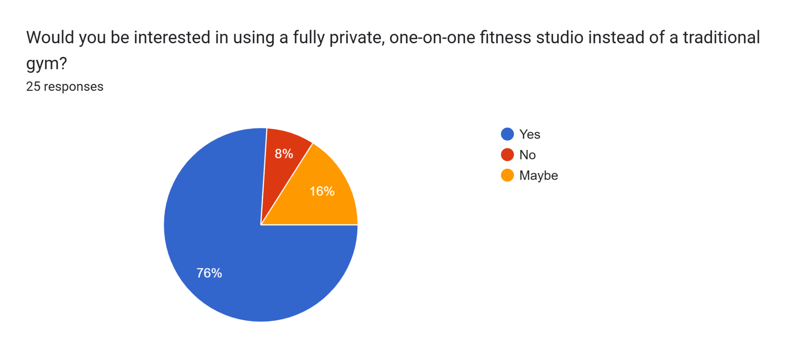

The objective of the question was to identify the type of fitness centres respondents prefer. The pie chart reveals that 76% prefer a one-on-one fitness service over a traditional gym. Only 8% said they do not prefer a private gym at all. This indicates the demand and potential for the private fitness studio that offers a personalised service within a private space under the service of a certified trainer. The overwhelming response is a clear indication of the rising demand for personalised gyms with specialised services (Raziel, 2024) and supports the Solofit concept. Considering the market potential, 11.5 m people have gym membership and it is high among GenZ. (Campbell, 2025) Cardiff is the proposed location of Solofit and Cardiff comes in the 6th position with 65 points in the survey of wellness index by Mirafit 2025 which has 50 gyms within the city which shows the environment is positive with a growth potential. (Devaney and Devaney, 2025)

Most appealing features

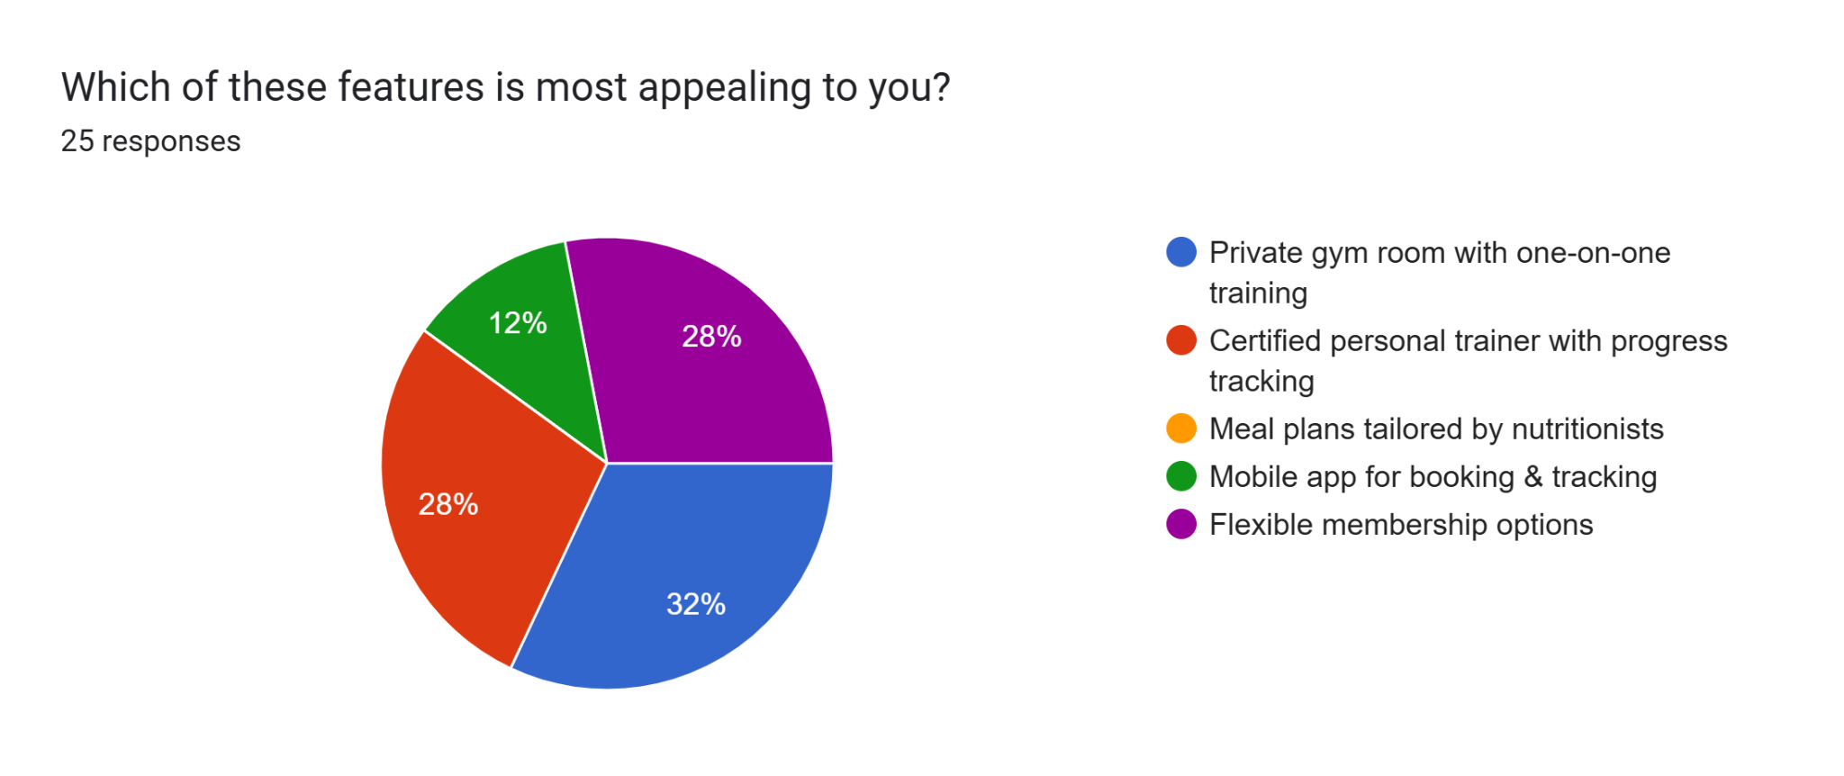

The objective of the question is to identify which product features customers find more attractive. Private gym rooms with one-to-one training were selected by 32% as the most attractive feature while the availability of certified personal trainers with progress tracking and flexible membership options was preferred equally by 28% of respondents. The third highest is a mobile app for booking and tracking. Personalisation is the critical success factor with technological integration and flexibility in membership. The information helps to design tailor-made features to enhance the member experience in terms of personalisation. Philip Kotler in modern marketing customers expects the brands to understand their needs individually not as a demographic category. (Kotler, 2024) . The analysis shows respondents prefer personalisation, privacy, and focus services which can give better results. additionally, the setup will enhance customer engagement and loyalty

Premium pricing strategy
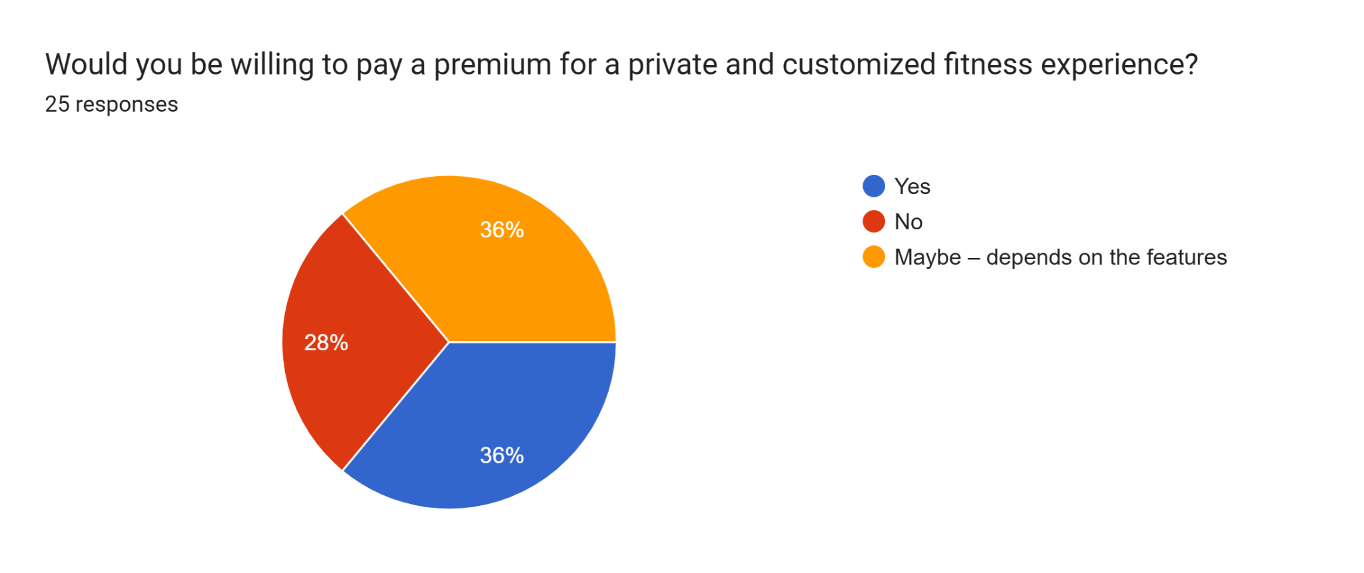
The objective of the question is to identify the percentage of respondents who value customised experience over the price and assess the possibility of premium pricing through value-added services. The pie chart highlights that 36% are comfortable with premium pricing as they give priority to service rather than pricing but 36% are comfortable with premium pricing depending on the features offered by the company which means there is a possibility of customised premium pricing by offering value-added services and quality services. It is a clear indication of price sensitivity but if it comes with appealing features customers are willing to accept premium pricing. Only 28% marked their disagreement over premium pricing. It is crucial to assess how the price of their products aligns with the value that customers ascribe to them(Muhammad, Widyaningsih and Andriana, 2024). In short, it is ideal to start with flexible pricing standards and premiums to attract customers whose demands perceptions must justify the pricing

Technology integration
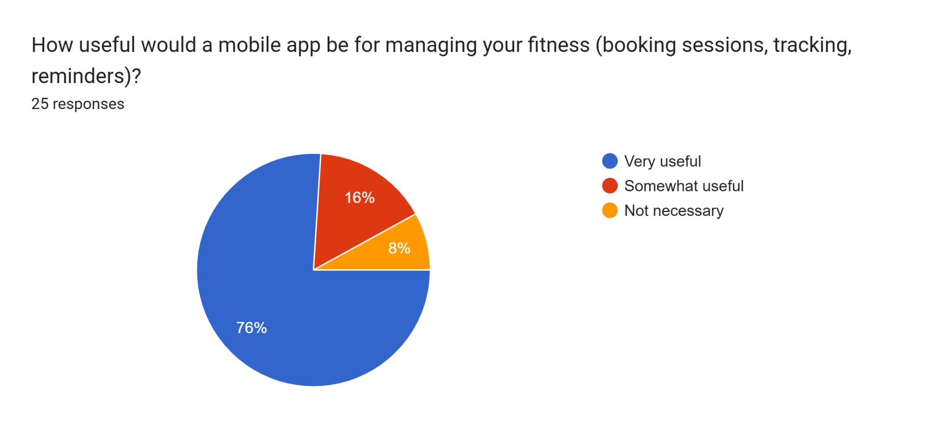
The objective of the question is to identify the level of preference for having a mobile app to track progress and communication. The overwhelming response shows that 76% consider a mobile app very useful for managing the fitness process through booking sessions, tracking, reminders, etc. The market is witnessing a massive digital transformation. The Customers believe using data-driven insights enables them to see continuous progress, which is highly essential in health and fitness (Metcalfe, 2022)
The analysis helped to optimise the proposition, based on the analysis customers value privacy and individual focus and therefore the most appealing feature of Solofit would be the one-to-on training with certified trainer support together with technological integration to track the progress. It is identified that people are willing to pay for value for money and therefore Solofit has to ensure the indivdualised needs are identified and addressed. The brand has to be committed to offering a tailored experience in a healthy, hygienic and positive environment in a private gym studio with premium pricing with premium experience.
Regarding the website and marketing materials, 76% are highly positive about having a mobile phone app to book, track and communicate which indicates there is a high potential for online marketing and social media marketing. User-generated content such as social media posts, can act as a marketing tool. (Yadav, Joshi and Rahman, 2015) The website can feature a simple UX with easy booking, details of services, mobile app sync, room details and a trainer list. A chatbot service will also be provided. Marketing content can focus on customisation, privacy health and hygiene, a positive environment, personal trainers and personal meal plans. The availability of chatbots and mobile apps will also be highlighted as instant and accurate responses enhance customer satisfaction (Clement, 2025)
The SEO- Search Engine Optimisation strategy is the method to optimise the content and improve the website's position in search results(Melinn, 2024) to register on Google My Business, and Google Maps, ask for reviews, and Yellow Pages, to target local customers in Cardiff with the keywords “gym near me” personalised training” certified trainer service” clean fitness room”. The contents for marketing can be regular social media updates on solo fitness sessions, individual meal plans, benefits of trainer sessions” Technology and facilities alone cannot bring innovation and success but quality of service and effective team work are also inevitable to sustain these elements (Elsey, 2022)

Reference list
- Campbell, D. (2025). Healthy but lonely gen Zers drive UK gym membership to record high. [online] The Guardian. Available at: https://www.theguardian.com/society/2025/apr/03/gen-z-record-rise-uk-gym-membership-report [Accessed 19 Jun. 2025].
- Clement, M. (2025). The Role of AI Chatbots in Enhancing Customer Satisfaction in Service-Based Businesses . [online] ResearchGate. Available at: https://www.researchgate.net/publication/390873562_The_Role_of_AI_Chatbots_in_Enhancing_Customer_Satisfaction_in_Service-Based_Businesses [Accessed 19 Jun. 2025].
- Devaney, A. and Devaney, A. (2025). Revealed: The Best UK Cities for Wellness and Fitness in 2025. [online] Sustain Health Magazine. Available at: https://sustainhealth.fit/lifestyle/best-uk-cities-for-wellness-and-fitness-in-2025/#google_vignette [Accessed 19 Jun. 2025].
- Elsey, W. (2022). Council Post: Why It’s Not About Tech But People In Business. [online] Forbes. Available at: https://www.forbes.com/councils/forbesbusinessdevelopmentcouncil/2022/12/08/why-its-not-about-tech-but-people-in-business/ [Accessed 20 Jun. 2025].
- Kotler, P. (2024). A Lifetime in Marketing: Lessons Learned and the Way Ahead, by Philip Kotler. [online] American Marketing Association. Available at: https://www.ama.org/2024/03/12/a-lifetime-in-marketing-lessons-learned-and-the-way-ahead-by-philip-kotler/ [Accessed 19 Jun. 2025].
- Melinn, C. (2024). What is SEO, and how does it work? [online] Digital Marketing Institute. Available at: https://digitalmarketinginstitute.com/blog/what-is-seo [Accessed 20 Jun. 2025].
- Metcalfe, C. (2022). Can fitness apps be as effective as a personal trainer? BBC News. [online] 3 Jan. Available at: https://www.bbc.com/news/business-59651335 [Accessed 19 Jun. 2025].
- Muhammad, Widyaningsih, A. and Andriana, D. (2024). Pricing Strategy and Service Quality Improvement to Optimize Customer Satisfaction: a Systematic Literature Review. International Journal of Business Law and Education, [online] 5(2), pp.2827–2837. doi:https://doi.org/10.56442/ijble.v5i2.935
- Raziel, B. (2024). Anthony Geisler: Boutique Gyms Are Thriving in a Post-Pandemic World. Forbes. [online] 5 Aug. Available at: https://www.forbes.com/sites/zengernews/2024/07/02/boutique-gyms-surge-amid-shifting-post-pandemic-landscape/ [Accessed 19 Jun. 2025].
- Yadav, M., Joshi, Y. and Rahman, Z. (2015). Mobile Social Media: The New Hybrid Element of Digital Marketing Communications. Procedia - Social and Behavioral Sciences, [online] 189, pp.335–343. doi:https://doi.org/10.1016/j.sbspro.2015.03.229.

Appendix

Screenshot of response of remaining questions

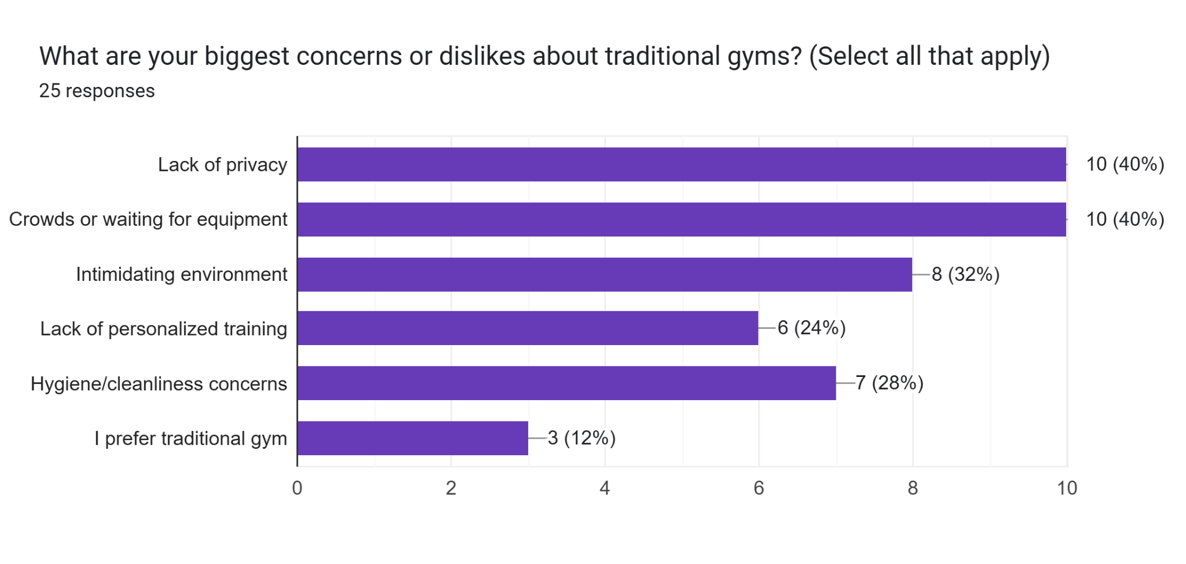
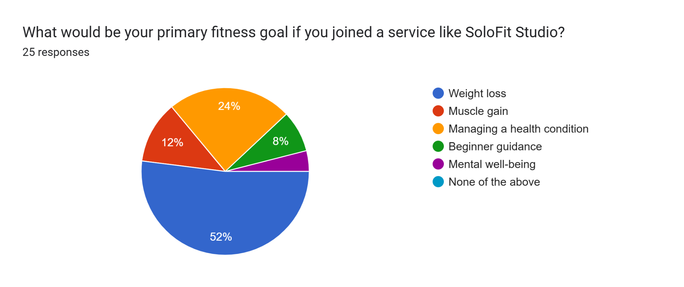

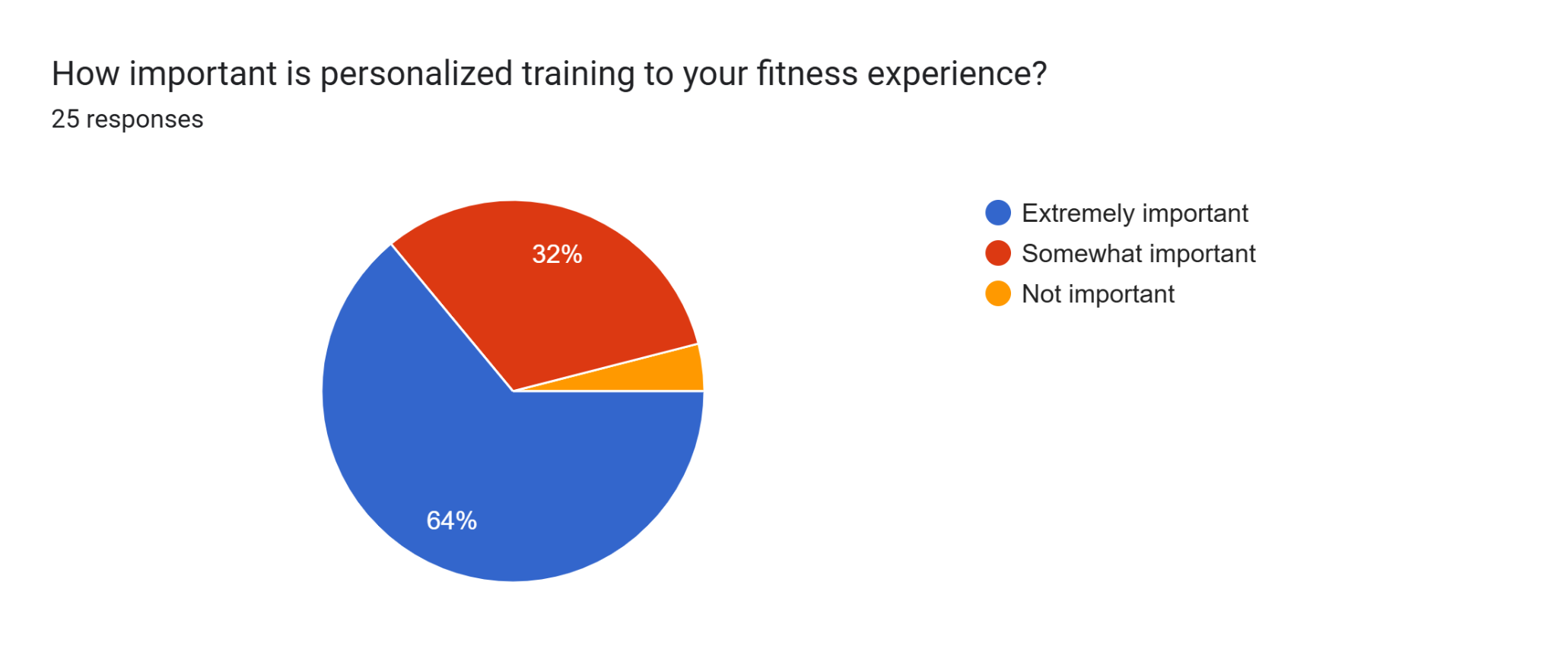

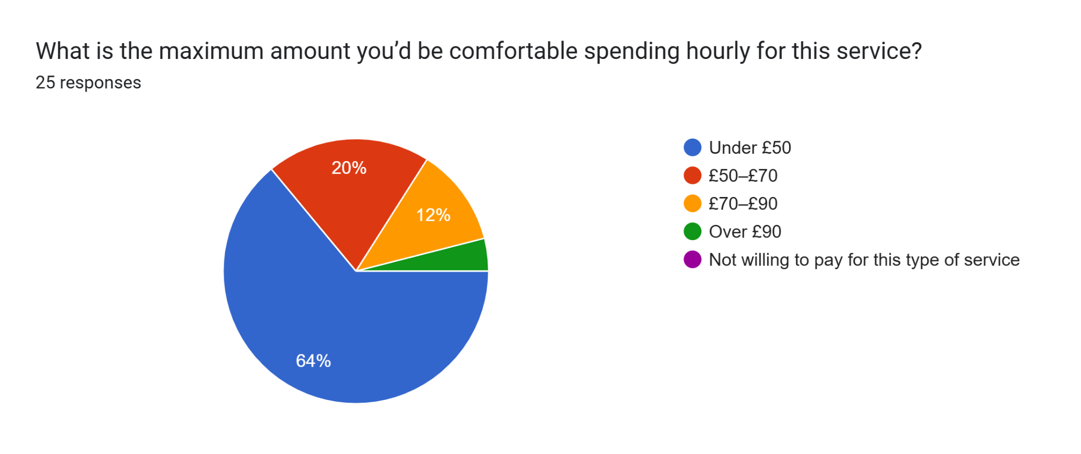

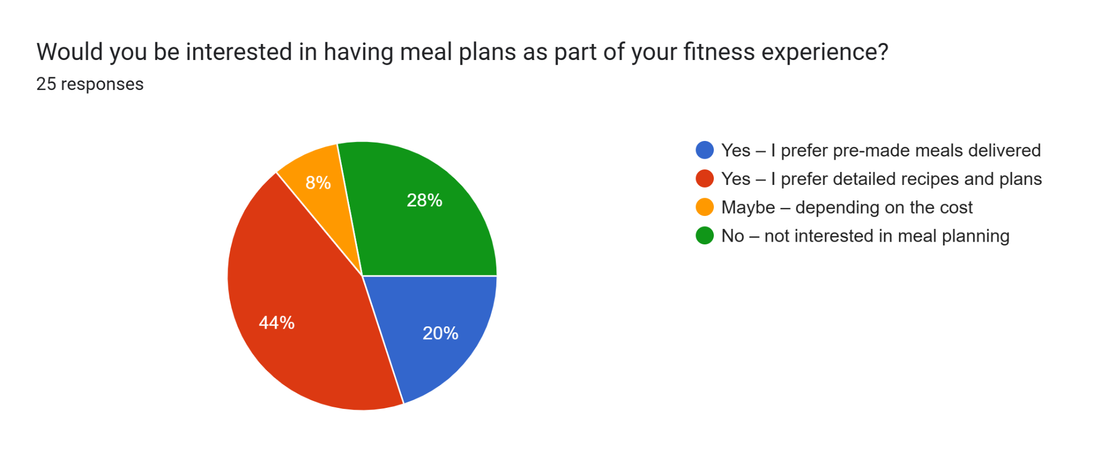
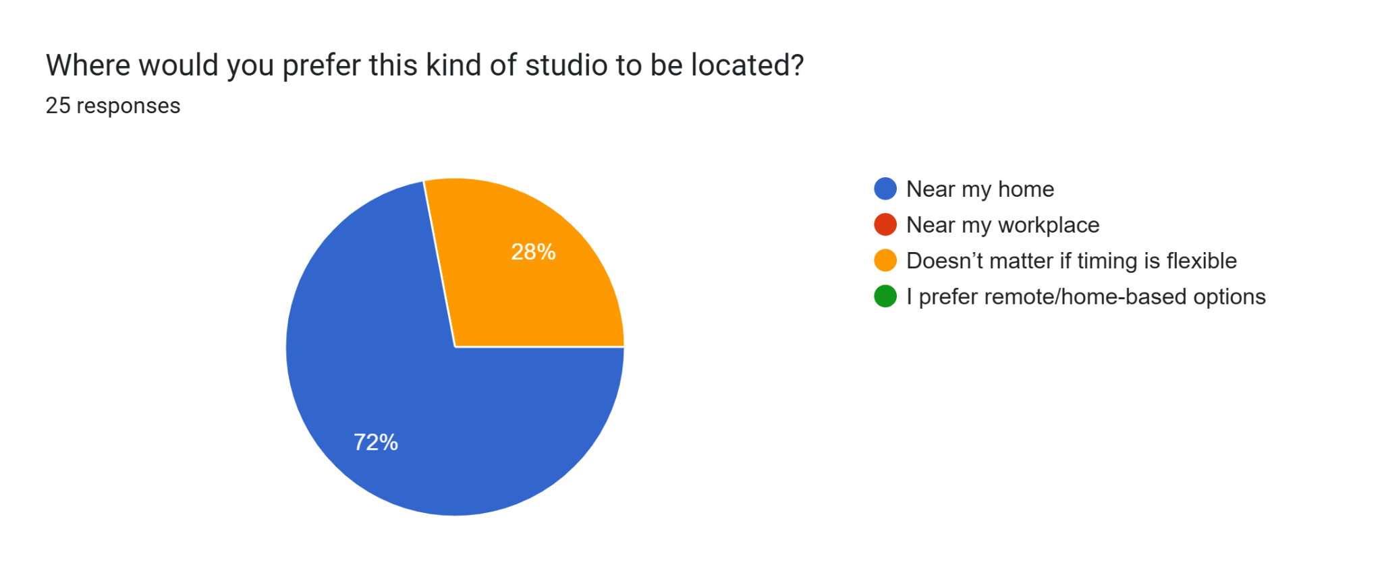

Website design

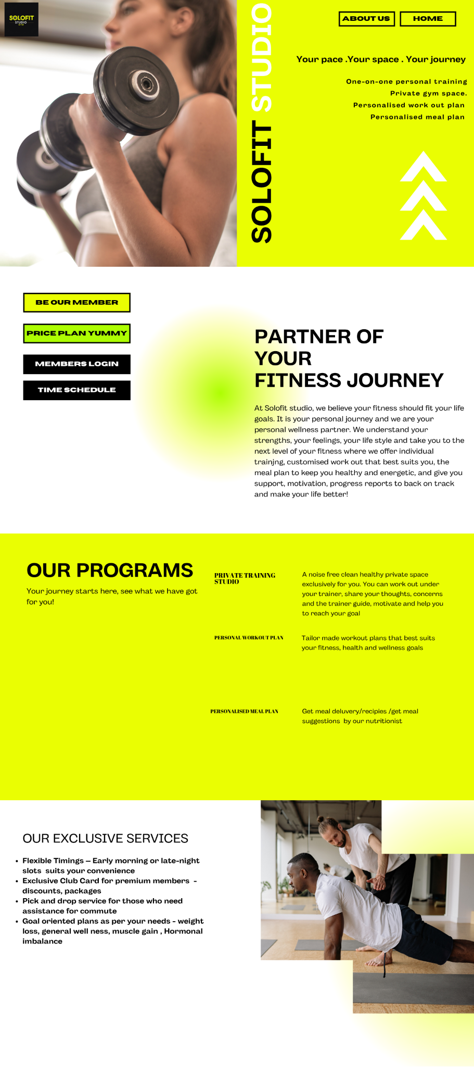
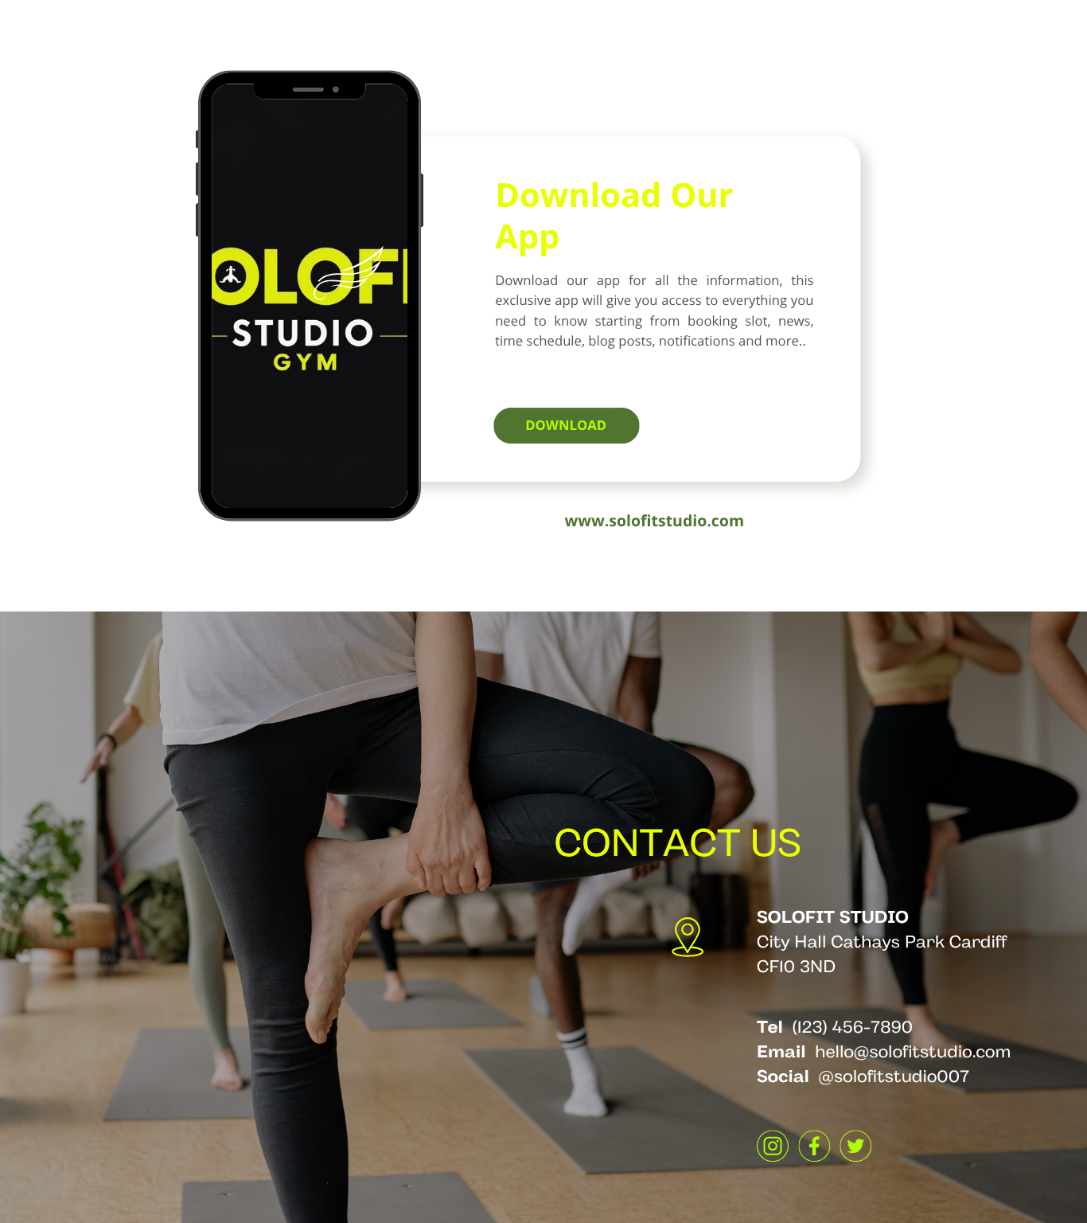

Marketing materials



Microsoft Excel is a spreadsheet programme by Microsoft in 1985 to create, analyse and visualise data. The primary usage of the software is for data entry and management, calculations, data analysis, data visualisation, financial purposes, budgeting, and data dashboard, and it can be said that Excel is a versatile tool for data management. The latest version of Excel is Microsoft 365 for Office. (Microsoft, 2025) . Excel is one of the most useful software which is significantly used even at the school level to corporations worldwide a. (Statanalytica,2024). In short, Excel is one of the most important software programs in the current job market, where digital skills are essential to perform various day-to-day functions. Mastering Excel increases one's productivity and efficiency. Proficiency in Excel can help a person to secure and sustain in their job role, especially in finance, marketing, data analytics etc Further, the software functions and features are continuously getting updated and more and therefore upskilling is continuously needed. The software is relevant since its introduction and still stays competent among similar products because of its ability to automate data and its adaptability further supports it relevance. Professionals, payment and school children are using this software for various purposes, starting from basic functions like addition, subtraction to complex data analytics (Charlesworth, 2024)
In an era that witnessed a technological transformation and data analytics, Excel is still surviving because of its efficiency in simple data analytics functions like tables, chart preparation, lookups, pivot tables, etc.. There might be a huge number of powerful complex data analytical tools, but excel stands out because of its versatility, cost effectiveness and flexibility. It is part of the office suite and widely available and used all around the world and it effectively collaborates and updates and with modern technology such as real time collaboration, Artificial Intelligence tools, python. In short , excel is evolving not backing out for any complex software similar to excel For example Power by is a similar data analytics tool to handle big data sets but when it comes to the smaller data set, it is always Excel. (Microsoft , 2024)

The business professionals are using Excel in a variety of ways ,using Excel for data entry, managing large databases, details of daily operations, employee details etc and the Excel helps to get a picture without any complexity. Also, the financial analysis has been prepared in Excel and the data-driven insights help in critical decision-making. The data and charts presented in simple format help to stay on track and identify crucial information thus it helps with budgeting and financial planning,
Since it is possible to link Microsoft Excel and charts to programs like Word and PowerPoint which helps to document information better. (Michael.M, 2023). Excel is not limited to professionals. It is helpful on a personal level as well. For example, people can prepare a “to-do “ list, update health goals, students can plan their study schedule etc. (Washburn, 2023) Even a small shopkeeper can utilise this software to update their daily income, expense, daily cash flow, stock etc and utilise this software for small financial planning. Using formulas helps to forecast. It also helps with forecasting figures and there is no shortage of tasks which cannot be performed with this software. It allows collaboration which means collaboration with team members in the same workbook is possible,(Lenovo, 2021)
Further, the organisation of data is a significant task performed by Excel. The software can organise a wide range of data. For example, the current business plan Solofit Studio can effectively utilise this feature by organising the daily attendance, logistics, and data of gym members, consultants, dieticians, trainers, purchases, sales etc daily, sorting, filtering, using formulas to forecast and making the daily analysis easier. The highest and lowest turnover projections helped to prepare the budget forecast better to start the Solofit studio. This will further help the business with cost management, inventory management, logistics, updating miscellaneous expenses etc
One of the major uses of Excel is project management. The creation of a Gantt chart to set timelines and milestones and track the progress and deadlines. (Microsoft, 2025)
Finally, the most used feature of Excel is simple calculation, such as addition, subtraction and the chart and formatting function helps users to convert tables to charts such as pie charts, bar charts, line graphs etc and differentiate tables and graphs with its simple formatting options such as colour highlight, font highlight, etc. The basic usage needs only minimal training. (Alexander.G, 2021) which helps everyone to get excel in Excel and improve their efficiency and competency in variety of ways

 | Jan | Feb | Mar | Apr | May | Jun | Jul | Aug | Sep | Oct | Nov | Dec | Total
Membership Fees | £30,000 | £22,000 | £24,000 | £23,000 | £30,000 | £20,000 | £25,000 | £24,000 | £30,000 | £30,000 | £30,000 | 25000 | £313,000
Coaching Revenue | £10,000 | £1,000 | £1,000 | £1,000 | £1,000 | £1,000 | £1,000 | £1,000 | £1,000 | £1,000 | £1,000 | 1000 | £21,000
Purchases | £5,000 | £6,600 | £7,200 | £7,500 | £7,800 | £7,500 | £7,200 | £6,900 | £7,800 | £8,100 | £7,200 | £8,700 | £87,500
Rent | £2,000 | £2,000 | £2,000 | £2,000 | £2,000 | £2,000 | £2,000 | £2,000 | £2,000 | £2,000 | £2,000 | £2,000 | £24,000
Wages | £11,000 | £9,000 | £9,000 | £9,000 | £9,000 | £9,000 | £9,000 | £9,000 | £9,000 | £9,000 | £9,000 | £9,000 | £110,000
Marketing | £600 | £600 | £600 | £600 | £600 | £600 | £600 | £600 | £600 | £600 | £1,000 | £1,000 | £8,000
Supplies | £10,000 | £1,900 | £2,000 | £2,100 | £2,000 | £2,000 | £1,900 | £1,800 | £2,100 | £2,100 | £2,000 | £2,300 | £32,200
Other Expenses | £500 | £500 | £500 | £500 | £500 | £500 | £500 | £500 | £500 | £500 | £500 | £500 | £6,000
Total Income | £40,000 | £23,000 | £25,000 | £24,000 | £31,000 | £21,000 | £26,000 | £25,000 | £31,000 | £31,000 | £31,000 | £26,000 | £334,000
Total Expenses | £19,100 | £20,600 | £21,300 | £21,700 | £21,900 | £21,600 | £21,200 | £20,800 | £22,000 | £22,300 | 21700 | £23,500 | £257,700
Net Profit/Loss | £20,900 | £2,400 | £3,700 | £2,300 | £9,100 | -£600 | £4,800 | £4,200 | £9,000 | £8,700 | £9,300 | £2,500 | £76,300

The financial assessment reveals that the business is currently running on a profit but showing a decline in the income

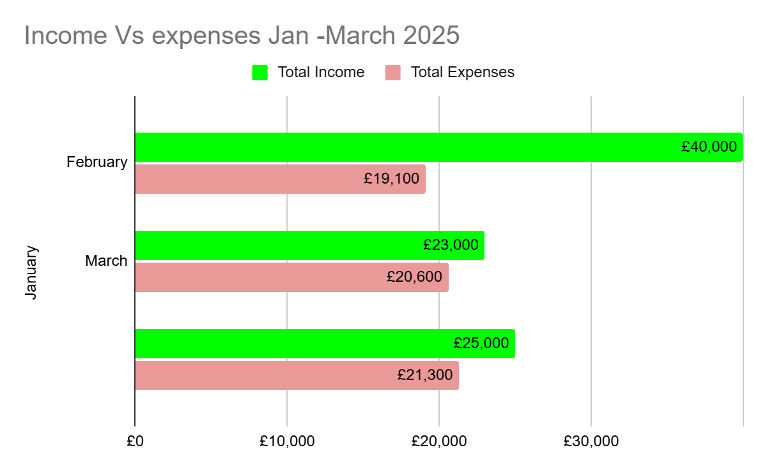

Reference list
- Charlesworth, L. (2024). What is microsoft excel used for and is it still relevant? [online] Kaplan.co.uk. Available at: https://kaplan.co.uk/blog/features/is-microsoft-excel-still-relevant [Accessed 20 Jun. 2025].
- Gillis, A. (2021). What Is Excel? Everything You Need to Know - Definition by WhatIs.com. [online] SearchEnterpriseDesktop. Available at: https://www.techtarget.com/searchenterprisedesktop/definition/Excel [Accessed 20 Jun. 2025].
- Lenovo (2021). Mircosoft Excel: What are some benefits of using Microsoft Excel? | Lenovo UK. [online] Lenovo.com. Available at: https://www.lenovo.com/gb/en/glossary/microsoft-excel/ [Accessed 20 Jun. 2025].
- Microsoft (2025a). AI Assistant for Excel. [online] AI Assistant for Excel. Available at: https://appsource.microsoft.com/en-us/product/office/wa200005401?tab=overview [Accessed 20 Jun. 2025].
- Microsoft (2025b). Free Online Spreadsheet Software: Excel | Microsoft 365. [online] Microsoft.com. Available at: https://www.microsoft.com/en-in/microsoft-365/excel#Key-features [Accessed 20 Jun. 2025].
- Prof. Michael McDonald (2023). 200+ Excel Formulas and Functions. [online] BPB Publications. Available at: https://www.google.co.in/books/edition/200+_Excel_Formulas_and_Functions/QBbAEAAAQBAJ?hl=en&gbpv=1&dq=why+excel+is+important&printsec=frontcover [Accessed 20 Jun. 2025].
- StatAnalytica.com (2020). What are The Uses of Excel in Our Daily Life? [online] Statanalytica. Available at: https://statanalytica.com/blog/uses-of-excel/ [Accessed 20 Jun. 2025].
- Washburn, E. (2023). 5 Ways To Get Started Using Microsoft Excel. Forbes. [online] 5 Apr. Available at: https://www.forbes.com/sites/emilywashburn/2023/04/05/5-ways-to-get-started-using-microsoft-excel / [Accessed 20 Jun. 2025].

