DS 1 Template

My Screenshots/Photos
- Please add 4–6 screenshots or photos of your digital life.
- You can use your phone or laptop.
- For each screenshot, write one or two sentences explaining what it shows.

Screenshot/Photo 1
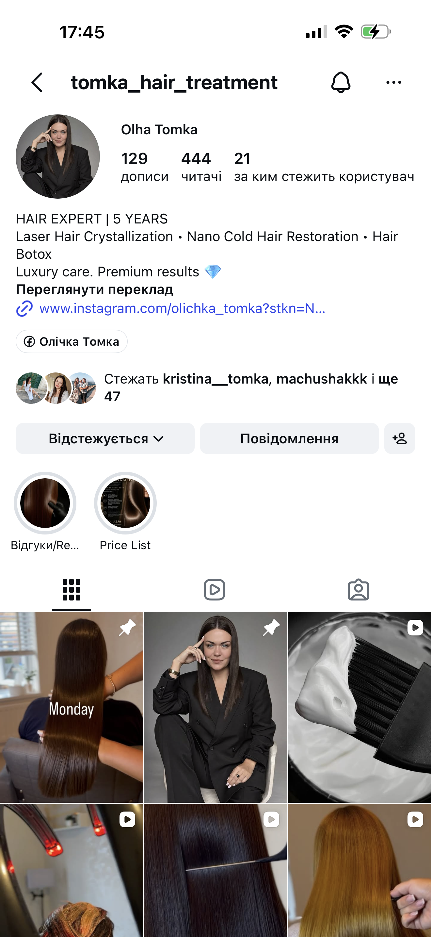
This is my business Instagram page for hair treatments. I use it to show my work, attract
new clients and arrange appointments.

Screenshot/Photo 2
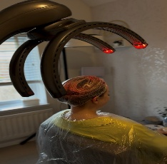
This photo shows a Climazon, a heating device I use during hair treatments. I use it to control the heat and treatment time for my clients.

Screenshot/Photo 3
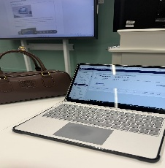
I use my laptop at university to access Moodle. It helps me read course materials, download assignment templates and submit my work.

Screenshot/Photo 4
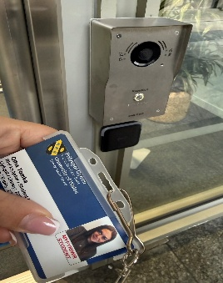
I use my student card to enter the university building by tapping it on the card reader. This electronic system makes access quick and easy.

Screenshot/Photo 5
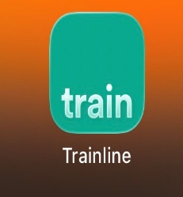
I use the Trainline app on my phone to buy train tickets and check train times. It helps me plan my journeys to university in London.

Screenshot/Photo 6
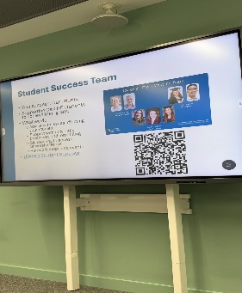
I use the classroom screen to follow presentations during university lessons. It helps me read information and understand the topics we discuss.

My Short Reflection
- Write 5–8 simple sentences about your digital life.
- You can use the sentence starters below if helpful.
I use digital tools every day for work, study and travel. I use Instagram to share my daily life, advertise products and promote my hair treatments. I feel confident when I create posts and videos for my followers. I use my laptop and Moodle to read course materials and complete assignments. I use Trainline to buy train tickets and plan my journeys to university. I want to improve my skills in Microsoft Word and Moodle. Digital tools help me save time and organise my day.

Sentence starters
- I use digital tools to …
- I feel confident when I …
- I want to improve …
- I often use these tools: …
- I sometimes feel nervous about …
- I hope this module will help me …
- Digital skills are important for me because …
You can write more if you want.

Submission Checklist
Before you submit, please check:
​​​ ☐ I added 4–6 screenshots
☐ I wrote short sentences for each screenshot
☐ I wrote my short reflection
☐ My work is my own
☐ My file opens correctly
​​☐ My file opens correctly

