Torsion of Shafts
Mechanics and Dynamics (ACHA4026)
Frankie Brown
2500730

University of Wales Trinity Saint David
School of Engineering
Motorsport Engineering BEng
Submission Date: 4 January 2026

- Introduction
Torsion occurs when a material begins to twist once a torque is supplied to it. The shear modulus describes the level of material stiffness when the material is facing shear stresses.
During this experiment, the torsional action of a circular rod is investigated using an apparatus. When adding calculated torques to the rod, it will allow you to record the angle of twist. The relationship between the shaft geometry angle of twist and the level of torque applied can be calculated via the torsion equation. The torsion equation is TL/J= Gθ.
This experiment was conducted to calculate values of the shear modulus of the rod. After the experiment was conducted, the values were then compared to textbook values.

- Experimental Procedure

For this experiment, a torsion apparatus was used. This apparatus was used to assist in determing the shear modulus of the different materials used.

Thumbscrews were first fitted to the work panel to ensure it maintained its vertical position, which can be seen in Figure 1. This was done to ensure that the apparatus maintained the correct position and movement was limited during the experiment process.
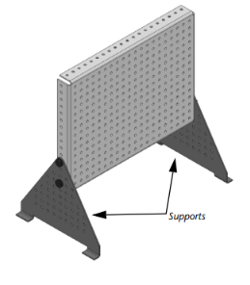
Figure 1, Vertically mounted work panel

Then, the first specimen, which was steel, was fixed onto the apparatus. This was done by first loosening the grub screws via the loosing tool, then the steel specimen was inserted through the fixed chuck and pushed through to the rotating chuck. This can be seen in Figure 2. Once the steel rod was correctly aligned in the apparatus, the grub screws located on the fixed chuck could then be tightened lightly to avoid damaging the steel rod.
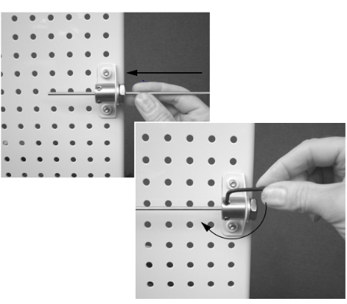
Figure 2, Fitting a Specimen

The rotating chuck was zeroed before any experimenting began. The grub screws located on the rotating chuck could now be loosened to allow the torque arm to move without effecting the steel rod. Then, the scale located on the torque arm was adjusted to ensure it was in line with the 0 degrees point located on the cursor. This was done while steadily holding the torque arm at zero. This can be seen in Figure 3. 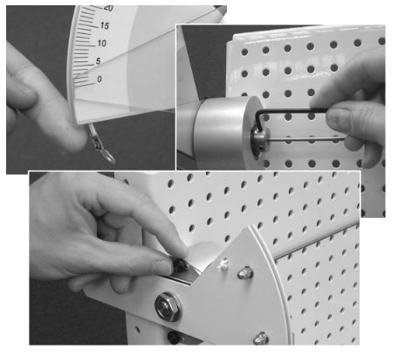
Figure 3, Setting the Scale to Zero on the Rotating Chuck

The torque arm was then fitted with a weighted hangar where it was fitted onto the hook. The masses we manually chose were then added onto the hangar, the masses were added in small increments after every reading. This then caused the specimen to receive a torque to the gravitational pull on the hangar from the mass that was applied.
Once each load had been applied to the apparatus, the angular displacement had to remain still before any readings could take place. The angular deflection was then read from the scale located on the torque arm.
Once all the measurements for the steel rod had been made, the rod could then be removed from the apparatus. The process could then be repeated using the two different materials which were Brass and Aluminium.

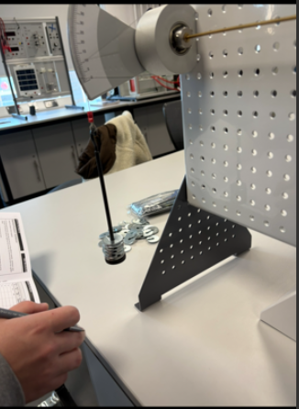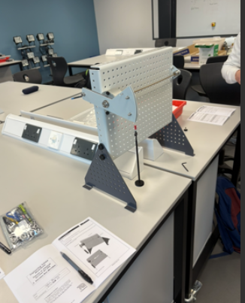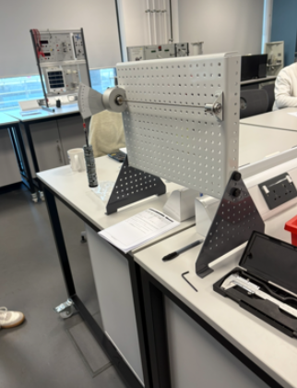
Figure 4, Live experiment images taken in laboratory

- Results
Steel rod experimental results (raw)
Applied mass (g) | Twist Angle (degrees)
100 | 3.5
200 | 6.0
300 | 8.7
400 | 11.5
500 | 14

L= 0.34m D= 3.1mm

Brass rod experimental results (raw)
Applied Mass (g) | Twist Angle (degrees)
100 | 6.0
200 | 12.7
300 | 18.5
400 | 24.5
500 | 30.7

L= 0.34m D= 3.1 mm

Aluminium rod experimental results (raw)
Applied Mass (g) | Twist angle (degrees)
100 | 8.7
200 | 16.5
300 | 24
400 | 32.7

L= 0.34m D= 3.1 mm

- Analysis
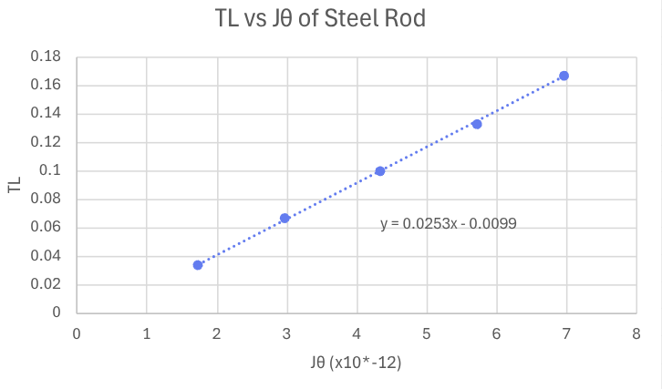




These three graphs show a relationship between the Torque Load (TL) and Jθ for the different rods used. A linear trend appears with all three materials which indicate that TL is proportional to Jθ. These linear relationships from the graphs all follow the theory of torsion where it is predicted that a proportional relationship occurs between the torque applied and the twist angle with the elastic region.

- Conclusion
From the graph gradients, it shows that the steel rod contains biggest gradient increase, the brass rod has the second biggest increase followed by the aluminum rod. These results were expected due to steel having the higher shear modulus meaning it has the highest level of resistance to torsional deformation and aluminum having the lower shear modulus (lowest level of resistance to torsional deformation) .Experimental uncertainties are likely to have occurred due to the non-zero interceptions within the graphs. From this, It concludes that the different rods were used within their elastic limit and agree with the theory of torsion.

After conducting research, the data aligns with the theory of torsion which states that the torque is directly proportional to the product of the shear modulus, angle of twist and the polar second moment of area via the equation TL=GJθ. Validation can be made from these findings from the book by Callister and Rethwisch (2020) stating that torque is directly proportional to the product of shear modulus, Polar second and angle of twist, provided the material stays within the elastic limit.

Engineering Mechanics literature. Hibbler (2017) also supports this relationship theory. This source states that the applied torque must be proportional to the angle of twist when circular shafts are subjected to torsion. The gradient difference between the three materials experimented on can be attributed to variations in shear modulus in the different materials instead of any errors in the experiment.

- Evaluation
While conducting the experiments, multiple steps were taken to minimise the risk of errors, leading to improvement experimental reliability. A key error source could potentially be from reading the experimental measurements from the scale at a non-eye level height, this potential error was eliminated by ensuring that every reading was taken at an eye level height.
Another potential error could have been from identifying the incorrect value from the scale. The risk of error was lowered by ensuring the scale remained still before any values were recorded.
It was also ensured that the wire on the apparatus was a straight to reduce the risk of inaccurate shear modulus calculations due to the wire extension being affected.
The environment that the experiment was conducted in could have a big impact on the experimental results, the risk of the results being affected were reduced by conducting the experiment in a laboratory with little air movement compared to being outside or in a large room.

- Further work

Given a longer experimental period and larger resources, the experiment could have been improved, leading to further reliability in the results.
One of the key improvements would be to use digital scales instead of a physical scale, leading to higher accuracy in reading the results and lowering the risk of human error from misreading the scale.
Another way the experiment could have been improved is by conducting multiple trials of each measurement and then calculating an average to ensure human error is mostly eliminated.
With larger resources, the experimental procedure could be conducted in an advanced temperature-controlled room, ensuring the wire isn't affected by the temperature that is in room and is kept at a neutral temperature.

- References

Callister, W.D and Rethwisch, D.G (2020) Materials science and engineering: an introduction. 10th edn. Hoboken, NJ: Wiley.

Hibbeler, R.C. (2017) Engineering mechanics: mechanics of materials. 10th edn. Harlow: Pearson Education.

TecQuipment Ltd. (2012) Engineering Science Worksheets: Torsion of Circular Sections Kit ES5- Specimen Rod Material. Unpublished Laboratory workbook. TecQuipment Ltd.

