ANDRAS SZUCS 1915302 Group1
ETW Assignment
The definition of communication: Communication is the process of understanding and passing information from oneself to someone else. In another way it is a process of conveying and sharing ideas, opinions, facts, values between people and organizations.
The methods of communication can be verbal or nonverbal, visual or written. During verbal communication we use language to deliver information throughout speaking. Also sign language can be use transfer the information.
The importance of communication in the workplace in management an unavoidable subject. The good communication lead to more efficient work, effectively supporting the product what the company makes and also tasks are accomplished throughout that.

This report will show ideas and information about communications how does it work what are the ways it used, and how and when. What channels have been used to transmit the information. Also elaborating the communication models, what types models are exist, how they work, when they work, where they work, in a certain situation which model working well, which one is the right to use in the given case.
SECTION 1
How communication can be made effective in a business organisation.
Communication can be made effective in a business organisation more ways.
Regular meetings help keep informed the colleagues about the organisation life. Can be on daily, weekly, monthly etc. An example of this communication from the workplace inserted here: (The hotel where I am working, the management called for a meeting all team members. Due to unprecedented circumstances, the working hours has been changed and the hotel manager announced the management’s future plan what is affecting all of us.)
By e-mail the person can reach easily colleagues, passing useful information without they have to leave their department physically.
Telephone is the fast way to reach out each other in case of inquiry or need to get important information.
How communication works between Management and Employees and to what purpose e.g.
The communication between Management and Employees needs to work on the regular basis, giving and receiving feedback from team members departmental meetings, one to one meeting. The purpose of it to increase the company`s capacity the quality of product and the efficiency

Tone/choice of language/level of formality.
Very important to find the right level of voice tone. If the person tries to convey the right message with not right voice tone the message may will not be delivered. In this section there is an example showed Mary December’s case, what was an in class exercise. The task was to send her an e-mail in a polite and diplomatic way. In that situation I am the Director of Communications company observed that, one of my supervisor Mary December has difficulty with non-verbal communication, her non-verbal skills sometimes sending the wrong message. The report attached in the Appendices
Active listening
The structure of active listening
1.We sense and receive the information
2.We interpret the information.
3.We subsequently evaluate that information (separating out fact from opinion
4.Eventually we response.
The process of listening generally has five parts: receiving, understanding, evaluating, remembering, and responding. Active listening is a communication technique that requires the listener to provide feedback on what they heard from the speaker.

The model of active listening barriers shown below on the diagram on this page.
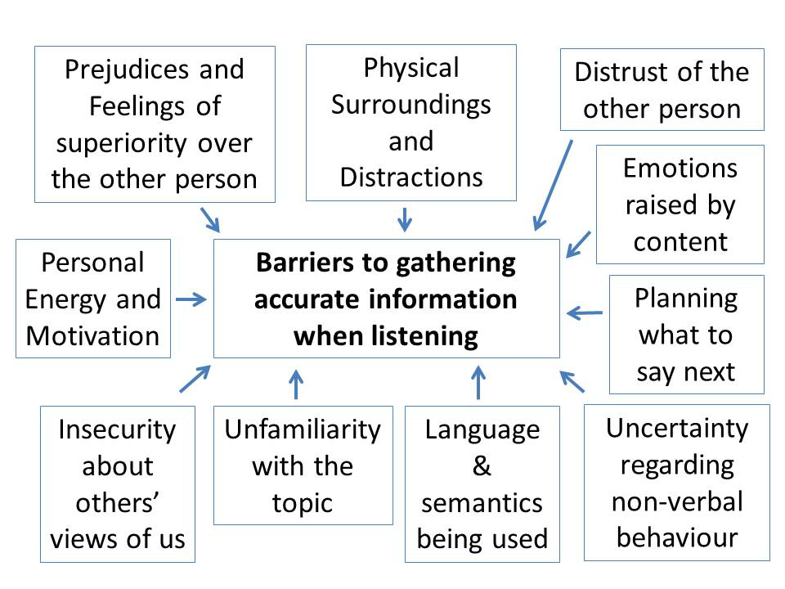
Our own feelings of superiority can mean that we don’t believe the other person will say anything important and so we don’t attend to what they are telling us.
Our physical surroundings can distract us: noise, others’ conversations and environments which are too cold or too hot can mean that our attention is drawn away from what the other person is saying and towards how we can change our environment.
Our distrust of another person can mean that we don’t believe they will be saying anything that is true, so we pay little attention to it.
If we get emotional (upset or angry) about the content of what the other person is saying, then we may well miss information which is relevant but becomes ‘hidden’ or is initially seen as irrelevant.
Planning what to say next is common, but if we concentrate on this, then we will not be attending properly to what the other person is saying. By the time we have prepared our response, we are usually ready to give it, and may have a tendency to interrupt the speaker.
There are times when we can be communicating with someone whose non-verbal behaviour is unfamiliar or about which we are uncertain – especially if they come from another culture. If that is the case, then we may be focusing on trying to understand the non-verbal behaviour more than the content of the message.
We might not understand the language or the words being used, especially if English is not our native language. If so, then there will be gaps in our information.
The same is true with technical subjects: if we don’t understand the words relevant to a particular topic, then there will be gaps in our understanding.
If we are insecure about others’ views of us, then we will spend our time worrying about what others are thinking of us, rather than actually taking time to understand the information being given to us.
Finally, if we are tired or have no energy or motivation to gather information, then we will be less likely to do so. Instead, we will find it much easier to get distracted.
Source moodle

Proxemics/Kinesics
On the model below, if the person A considered the leader, usually the personal distance related to emotional distance

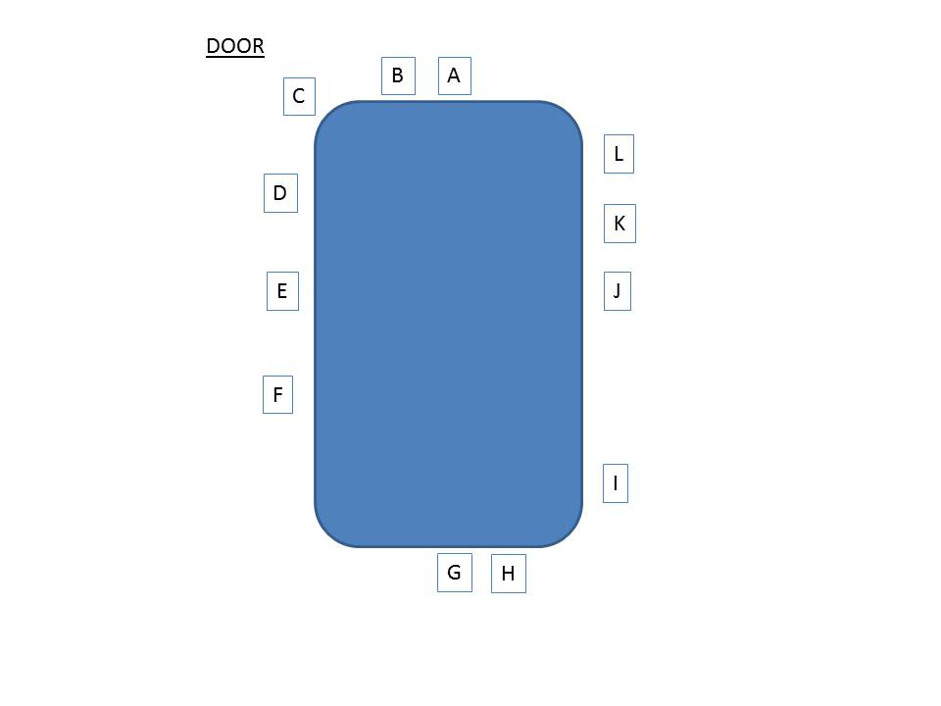
(SOLER)
-Square sitting position
-Open posture
-Lean forward
-Eye contact
-Relax

Personal awareness-(KEYS)
Know yourself
Evaluate the professional context
Your communication interactions with others
Step back and reflect

SECTION 2

Relevant Theories(Shanonn and Weaver,Schramm and Berlo)
In this section will be shown three communication models
with details
1.Shanonn and Weaver Model of communication
This model of communication was created in 1948 when Claude Elwood Shannon wrote an article called "A Mathematical Theory of Communication" in Bell System Technical Journal with Warren Weaver.
Shannon was an American mathematician whereas Weaver was a scientist.The Mathematical theory later came to be known as Shannon Weaver model of communication or"mother of all models"This model is more technological than other linear models.
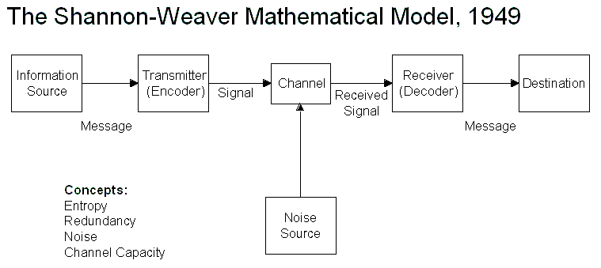
Berlo SMCR Model of Communication
In 1960, David Berlo developed Berlo’s Sender-Message-Channel-Receiver (SMCR) model of communication from Shannon Weaver’s Model of Communication (1949). He described factors affecting the individual components in the communication making the communication more efficient.
The model also focuses on encoding and decoding which happens before sender sends the message and before receiver receives the message respectively.
Berlo’s Model has mainly, four components to describe the communication process. They are sender, message, channel and receiver. Each of the component is affected by many factors.

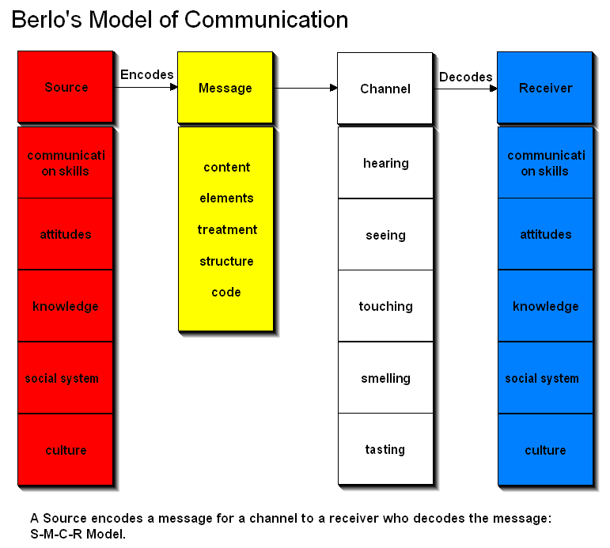

Schramm's Model of Communication
Schramm’s model of communication has its roots from the Shannon weaver model. This model was proposed in 1954.
Information is of no use unless and until it is carefully put into words and conveyed to others. Encoding plays a very important role because it initiates the process of communication by converting the thought into content. When the information reaches the recipient his prime responsibility is to understand what the speaker intends to convey. Unless and until the second party is able to understand or decode the information what the sender wants to communicate, the message is actually of no use. Thus encoding and decoding are two most important factors of an effective communication without which information can never flow between two individuals. Schramm’s model also revolves around the above principle. According to the Schramm’s model, coding and decoding are the two essential processes of an effective communication.
He also emphasizes that the communication is incomplete unless and until the sender receives a feedback from the recipient. Imagine a person sharing his thoughts with his friend and his friend not responding to him. Is the communication complete? NO. Schramm believed that communication is actually a two-way process between the first party and the second party.

Sender
M↓ ↑M
Receiver
M - Stands for message
Schramm believed that an individual’s knowledge, experience and cultural background also play an important role in communication. Individuals from diverse cultures, religion or background tend to interpret the message in different ways.
To conclude according to this model of communication when a sender passes on the information to the receiver, the receiver must interpret it in the desired form the sender wants and give him the feedback or respond accordingly. Any communication where the sender does not get the feedback, the communication is not complete and thus ineffective.

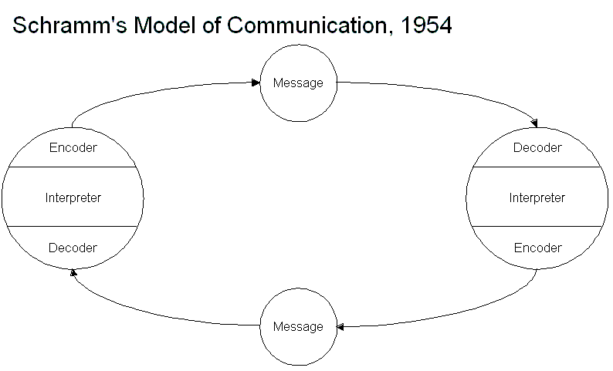

COMMUNICATIONS MODELS

Section 3
In this section I will explain the importance of effective communication on my workplace.

The hotel where I am working, the management called for a meeting all team members. Due to unprecedented circumstances, the working hours has been changed and the hotel manager announced the management’s future plan what is affecting all of us. Before he started his briefing, he explained that they had video meeting with the regional management and the headquarters. Based on the acquired details the meeting has been hold. THERE IS AN ATTEMPT BY EVERYONE TO USE 'ACTIVE LISTENING' (SEE SECTION 1 ABOVE) . The member were listening throughout the meeting carefully because the information what has been told shaping all worker`s future. HOWEVER THERE ARE DIFFIUCLTIES. THESE MAY BE EXPLAINED USING A COMMUNICATIONS MODEL – EG SHANNON AND WEAVER (SEE SECTION 2 ABOVE) During the meeting there where many times interruption, because the deck phones were ringing many times, the members had to communicate with other team members whom worked in their department. Some worker arrived later to the meeting due to their departmental responsibilities, they have received less information than others thus at the end misunderstanding happened. At the end of the meeting, the hotel manager asked the group about how they feel, are they satisfied with the information. Some people have more question about future plan, other members who joined the meeting later, were asking for information what they have missed of the meeting when they were not there. The hotel manager summarized the main points of the meeting and also recap the first part what some worker missed after he wanted to be sure everybody understood the situation. At the end of the meeting, the team answered the management`s questions, and also gave a feedback to the hotel manager how they feel. The members left the meeting room and they passed the information what they heard to other team member who did not attend the meeting. As many member who has been on the meeting as many way interpret the information that was heard on the meeting. The next day some member remembered differently the information what has been told on the meeting. Some of them started to argue and each side insisted to the fact they know the information correctly what was told on the meeting. The relation become stressful between some members as an impact of the meeting. The situation started to spiral out of control, at this point the line manager stepped in the situation. He reassured everyone about the current situation, at the same time he asked the people to listen more carefully each other in the future to avoid miscommunications and also asked to show more patience in between members.

Conclusion
In the case study above Shannon and Weaver communication Model can be used. The members tried to listen throughout the meeting, to tell it another way there was an attempt by everyone to use “Active listening”. However, throughout the meeting the deck phones were ringing, (Noise)what is caused disturbance and distracted the focus of members. As a result of this situation the information did not go through properly due to the disturbing circumstances. The members who have been taken part in the meeting interpreted the information differently, thus the next day they remembered differently what they heard on the meeting.
THIS IS A VERY RICH COMMUNICATIONS STORY – WHAT KIND OF COMMUNICATIONS MODELS COULD YOU USE TO ANALYSE IT – OR SUGGEST IMPROVEMENTS.

ARE THERE ISSUES OF ACTIVE LISTENTING HERE?
References
Google search engine, Google Scholar Moodle, In class exercise material
Appendices
- Scans of in-class exercises – e.g., Maria and Pedro; business email to Mary
December; written case study exercises
- Relevant articles and illustrations
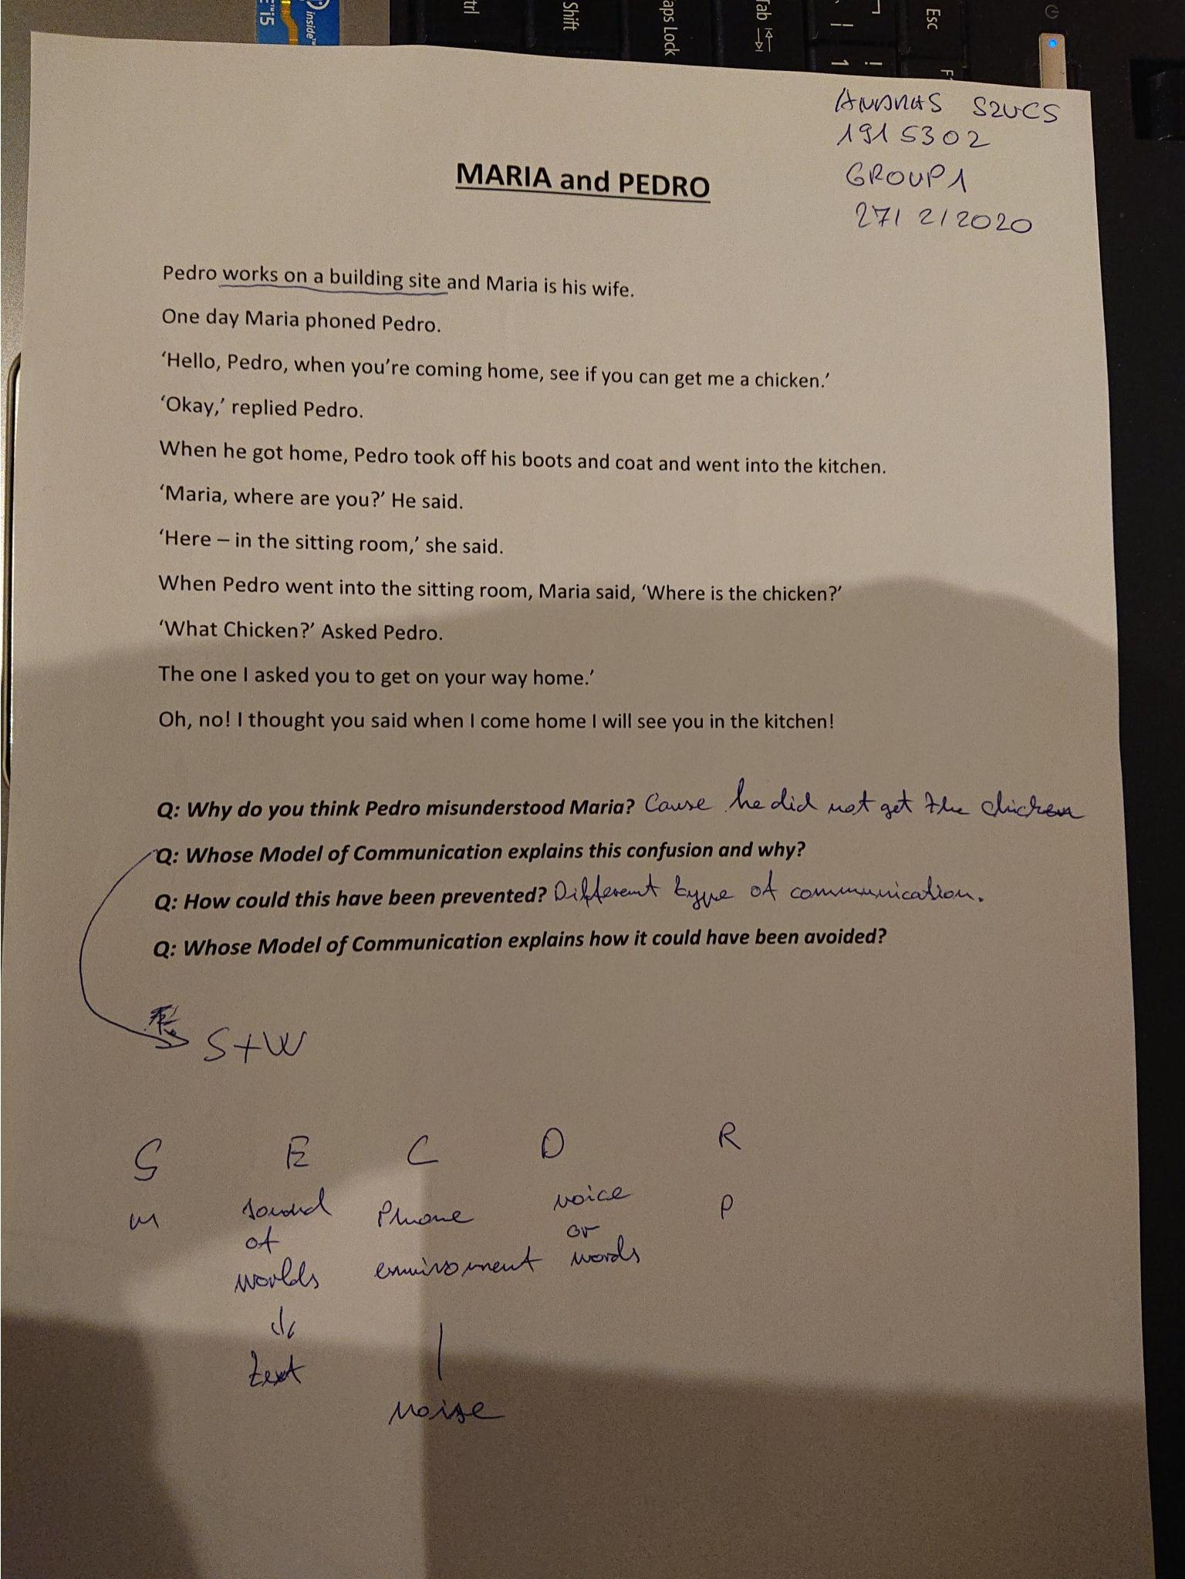
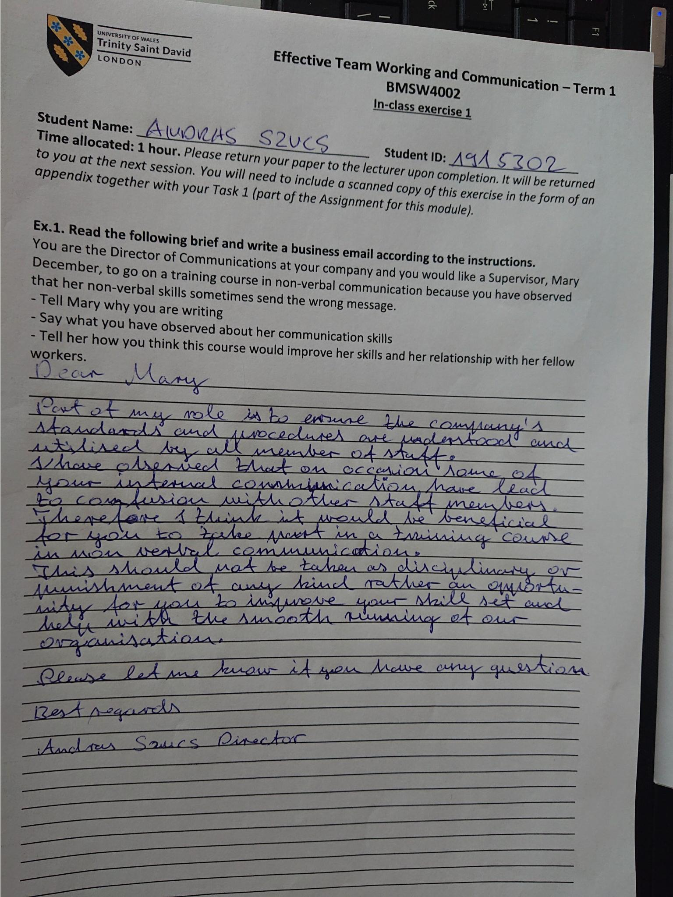

DISCUSS THE LIST BELOW IN PROSE FORM NOT AS BULLET POINTS

