

Course Title: MBA - International Business
Term 1

Module Name: Marketing Management
Module Code: LCMB7024

Student Name: Hitarth Girishbhai Sorathiya
Student ID: 2506577

Lecturer’s Name: Dr. Laila Maazouz
Word Count: 2657/2500

Table of Contents
1. Introduction 3
2. Task 1: Critical Analysis of the Macro Marketing Environment 4
2.1 Overview of the Macro Environment and Its Relevance to Marketing Strategy 4
2.2 Selection of Two External Macro Marketing Actors 5
2.3 Critical Analysis of Each Actor 5
2.3.1 Technological Factors 5
2.3.2 Environmental Factors 7
3. Task 2: Strategic Responses of Pioneering and Follower Organisations 8
3.1 Pioneering Organisations’ Strategic Responses 8
3.1.1 Application of Ansoff’s Growth Matrix 9
3.1.2 Application of Porter’s Generic Strategies 10
3.2 Follower Organisations’ Strategic Responses 10
3.2.1 Application of Ansoff’s Growth Matrix 11
3.2.2 Application of Porter’s Generic Strategies 11
4. Conclusion 12
5. References 13

1. Introduction
Purpose and Focus of the Report
This report aims to critically analyse how the macro marketing environment impacts organisations that are in the global Electric Vehicle (EV) industry. With the constantly changing strategic marketing approaches, Tesla and BYD are two companies that need to adapt to evolving market boundaries with the help of sustainability, innovation and digital transformation processes (Anastasiadou and Gavanas, 2022). The report reciprocates the tenets of strategic marketing management, which focuses on the active study of the external forces to determine opportunities, as well as reducing the risks that may influence competitive positioning and long-term development.

Importance of Analysing the Macro Marketing Environment
The macro marketing environment includes external forces that an organisation has no control over and that influence the market forces and decisions. These factors, which include technological, environmental, political, economic, social and legal, are important in understanding the marketing strategies in accordance with external realities (Chernykhovskaya, 2024). In the case of EV manufacturers, such analysis offers information about the changes in consumer behaviour and regulatory forces, as well as innovative changes that re-establish mobility.

Structure and Scope of the Report
The report will be organized into two overall analysis tasks. In Task 1, a critical assessment of the marketing macro environment applying PESTEL framework will be offered, where the special emphasis will be paid to technological and environmental aspects affecting the EV industry (Arribas-Ibar, Nylund and Brem, 2021). Task 2 analyses the reaction of the pioneer and follower organisations to these macro forces in a strategic manner. Tesla and BYD are the innovator and follow-on firm respectively.

2. Task 1: Critical Analysis of the Macro Marketing Environment

2.1 Overview of the Macro Environment and Its Relevance to Marketing Strategy

Macro marketing environment is composed of general external forces that affect every organisation in an industry that includes; political, economic, social, technological, environmental, and legal forces. These forces are the drivers of business opportunities and threats which are in most cases beyond the control of a firm (Anastasiadou and Gavanas, 2022). An examination of these external factors allows the marketer to make a sound strategic decision and adjust to the dynamics. The macro environment is critical in the Electric Vehicle (EV) industry when it comes to setting marketing objectives in line with global sustainability objectives, consumer behaviour trends, and regulatory, enabling policies that facilitate clean energy and carbon reduction projects.

PESTEL Framework
PESTEL framework is a systematic analysis of the external macro environment that is divided into six dimensions, namely: Political, Economic, Social, Technological, Environmental, and Legal. It aids the marketers in determining the influence of global trends and other external forces on performance and strategy formulation in markets. The application of PESTEL allows firms to foresee upcoming challenges, analyse opportunities and integrate strategic intentions with the environmental realities (Arribas-Ibar, Nylund and Brem, 2021). The PESTEL model is priceless in the framework of the EV industry in terms of evaluating the extent to which the technological innovation, government incentives, environmental laws, and the social mindset regarding sustainability affect strategic marketing and positioning.

2.2 Selection of Two External Macro Marketing Actors
In this analysis, two external macro marketing actors, namely Technological and Environmental factors have been chosen because of their considerable interdependence on the global EV industry.

Technological Actor
The EV revolution is based on technology. The automotive world is changing because of the development of new battery technologies, artificial intelligence (AI) penetration, and autonomous driving systems (Fedotov, 2022). EVs are innovation-driven and in this regard, the International Energy Agency reports that the world invested more than USD 480 billion in EV-related technology in 2023. In the case of manufacturers such as Tesla and BYD, market leadership, production efficiency, and possible differentiation all depend on technological capability.

Environmental Actor
The main motivation of EV adoption is environmental issues. The issues of climate change, air pollution, and natural resources depletion have put pressure on governments and consumers to embrace alternatives that are environmentally friendly. There have been regulatory efforts like the Paris Agreement and EU Green Deal that have expedited the process of switching to low-emission vehicles (Fedotov, 2022). Also, consumer environmental consciousness has increased pressures on the mobility solutions that should be sustainable.

2.3 Critical Analysis of Each Actor

2.3.1 Technological Factors
The EV industry is characterised by technological innovation that presents opportunities and challenges to the pioneers and the followers.

Impact on Tesla (Pioneer): Tesla has established itself as the leading organisation in the technological disruption as the pioneering organisation. Its proprietary battery cells 4680, sophisticated software architecture and Autopilot AI systems are examples of technological leadership (He and Hu, 2024). Through vertical integration and periodic updates via the air, Tesla keeps increasing product functions and customer satisfaction. The above capabilities enable Tesla to charge high prices and a well-established brand image of innovation.

Impact on BYD (Follower):
BYD is a follower, and it is thus a strategic adjustment to the trends set by the pioneers such as Tesla. Rather than pursuing radical innovation, BYD invests in cost-effective manufacturing and incremental innovation: for instance, its Blade Battery technology is more cost-effective and extends the range of safety and durability (He and Hu, 2024). The strategy will enable BYD to grasp price-sensitive markets especially in Asia and emerging economies. However, the reliance on the current technological standards and slower recognition of the brand across the entire world is challenging.

Opportunities and Threats:
The innovations in technologies provide both companies with a chance to create new models, grow their charging systems, and develop digital ecosystems. Nevertheless, they also cause the threat of new entrants like Rivian, Lucid Motors, and even conservative automobile manufacturers switching to EVs (He and Hu, 2024). Investment in innovation is necessary, and this should continue to keep the company relevant in the market.

Strategic Implications:
To pioneers such as Tesla, technological superiority is a crucial aspect of differentiation and first-mover advantage. To followers such as BYD, scalability and competitiveness are guaranteed through the use of the adaptive innovation and cost leadership strategies (Higueras-Castillo et al., 2023). Both have to match technological strategy and marketing communication to emphasize on value creation and sustainability benefits.

2.3.2 Environmental Factors
The consumer demand and the global policy are influenced by the environmental dynamics, especially the climate change and environmental sustainability, which have a direct impact on EV market strategies.
Impact on Tesla (Pioneer):
The company has a mission statement, which is to hasten the process of the world switching to sustainable energy, and it depicts that Tesla is highly tied to environmental requirements. The increasing environmental awareness has helped the company to develop a brand that is associated with zero-emission creativity (Higueras-Castillo et al., 2023). Gigafactories of Tesla use renewable energy and various programs of the circular economy, including battery recycling. This positioning by the environment boosts brand equity and helps Tesla to promote its marketing message of environmental care

Impact on BYD (Follower):
BYD has also acted in response to environmental pressures by manufacturing electric buses in large quantities, as well as affordable passenger EVs, to appeals to mass markets with lower emissions per vehicle. Its combination of three aspects of battery supply chain and renewable energy generation (solar and storage systems) proves the holistic sustainability strategy (Higueras-Castillo et al., 2023). However, BYD has to deal with environmental scrutiny in other parts of the world that are not that strict on environmental regulation and improve on global transparency to improve its environmental image.

Opportunities and Threats:
The international trend towards being carbon neutral presents immense expansion opportunities to EV manufacturers. Tax rebates, subsidies, and infrastructure investments are all offered by governments across the world to promote the use of EVs (Hull et al., 2024). Nevertheless, environmental policy is also a threat since companies have to adhere to the changing requirements on battery disposal, resource extraction, and lifecycle emissions.

Strategic Implications:
In the case of Tesla, environmental leadership supplements premium positioning and influence of the global market. In the case of BYD, prioritising low prices and geographical sustainability projects contribute to the increase of volume and competitive stability (Hull et al., 2024). The two organisations need to incorporate environmental marketing in their strategic plans, which conforms to the trends of a green brand and consumer behaviour in the name of sustainability.

3. Task 2: Strategic Responses of Pioneering and Follower Organisations
The Electric Vehicle (EV) market is marked with the fast pace of innovations, a high level of rivalry, and never-ending technical development. In this dynamic environment, organisations use various strategic strategies as pioneers or followers. Innovation Tesla is a pioneer introducing breakthrough innovation and sets the consumer expectations, and as the innovations are refined, other players, including BYD, become followers (Ivanova and Moreira, 2023). This is because with the help of models such as Ansoff Growth Matrix and Porters Generic Strategies, one can understand their strategic reactions in order to know how each of them has been able to stay competitive in the face of external threats and opportunities.

3.1 Pioneering Organisations’ Strategic Responses
Pioneering organisations refer to organisations that present innovations, technology or ideas that change the way things are done in industries and establish new competitive standards. Tesla is the quintessential company in the Electric Vehicle (EV) sector, which has transformed the world car markets by being innovative, a brand and a sustainability leader (Ivanova and Moreira, 2023).
Responding to External Challenges and Opportunities
Pioneers are exposed to serious outside pressures, among them technological uncertainty, heavy capital investment and changing regulations. Nevertheless, these challenges also offer the opportunities of innovations and differentiation (Ivanova and Moreira, 2023). The strategic reaction to such external pressures of Tesla, particularly to technological and environmental ones, was to market itself as a sustainable mobility leader. It has ever-going research and development (R&D) to create more efficient batteries, longer range cars, and lower manufacturing prices. Also, the international environmental policies that encourage carbon neutrality have given Tesla an advantage in the market (Jagani, Marsillac and Hong, 2024).

3.1.1 Application of Ansoff’s Growth Matrix
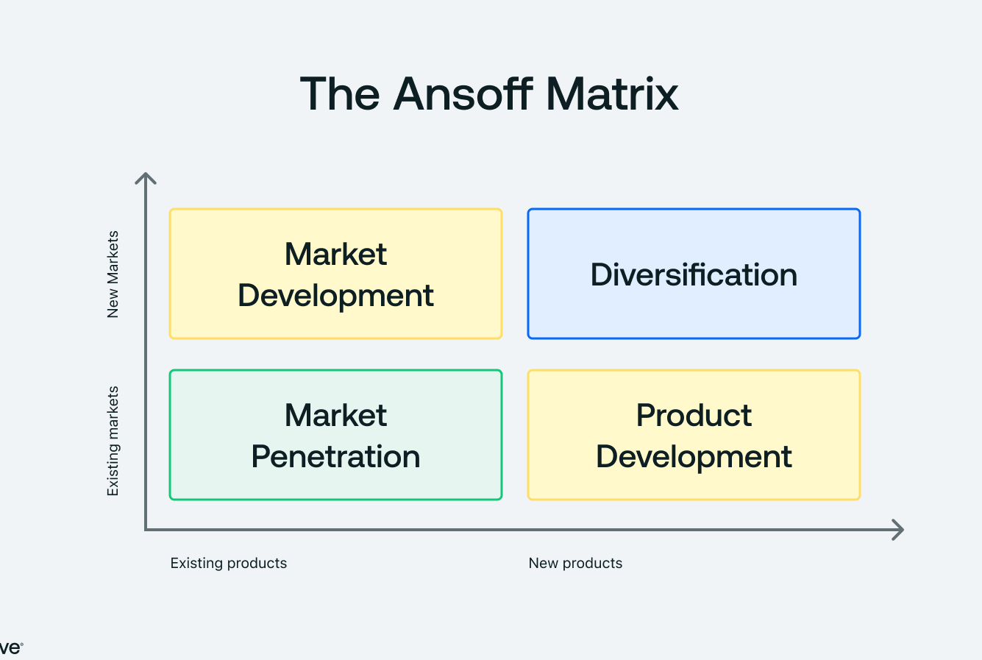
Figure: Application of Ansoff’s Growth Matrix
Source: (Jagani, Marsillac and Hong, 2024)

Based on the Growth Matrix of Ansoff, Tesla focuses mainly on product development and market development strategies. It is constantly innovating its EV models under product development, including luxury sedans (Model S), to mass-market cars (Model 3) and futuristic ones such as the Cybertruck (Jagani, Marsillac and Hong, 2024). Such innovations are backed by regular updates of software and self-driving capabilities that make user experience more enjoyable and develop the continuous customer involvement.
Regarding market development, Tesla is expanding geographically to emerging markets like China and India, harnessing rising government subsidies of electric mobility. It has Gigafactories on continents and this guarantees them efficient management of supply chain, local production and responsiveness to the market (Ryghaug and Tomas Moe Skjølsvold, 2023).

3.1.2 Application of Porter’s Generic Strategies
The approach of Tesla corresponds to the differentiation and focus models of Porter. Tesla stands out because through its high-quality innovation, advanced technology, and unique design, the vehicles stand out of the ordinary automakers (Ryghaug and Tomas Moe Skjølsvold, 2023). The battery manufacturing, software development and direct sales vertically integrated business model make it more quality-controlling and customer-experience-focused.
Nevertheless, differentiation demands unremitting innovation and scalability. Tesla is under pressure as followers provide cheap alternatives in the ever-increasing competition (Ryghaug and Tomas Moe Skjølsvold, 2023). To maintain its innovative status, the company needs to proceed with the battery technology development, focusing on renewable energy ecosystems, and branding itself as a beacon of technological and environmental achievement.

3.2 Follower Organisations’ Strategic Responses
Follower organisations move to the market after pioneers have laid a ground, and they can learn through the initial innovations, reduce the risks and streamline operations. The companies that have been successful in following strategies include BYD, Hyundai and Volkswgen in the Electric Vehicle (EV) industry (Ryghaug and Tomas Moe Skjølsvold, 2023). These companies take advantage of market awareness, economies of scale, and technological customization to create scale and remain competitive despite similar innovators such as Tesla.
Adapting to External Challenges and Opportunities
The followers work in a climate that has been influenced by technological changes, changing consumer tastes and preferences and strict environmental laws. Improving on the innovation and commercialisation of existing technologies to access wider market is the focus of followers as opposed to pioneers who incur the initial cost of innovation (Alotaibi, Omer and Su, 2022). An example is BYD a major Chinese electric vehicle manufacturer that takes advantage of government subsidies and strong demand of electric vehicles in the domestic market of cheap cars. Due to concentrating on low-cost production and cooperation with strategic alliances, BYD has become one of the leading EV manufacturers in the world. Furthermore, the followers are advantaged by the experience of the pioneers, who have successes and failures that they can use to optimise designs, minimise production mistakes, and enhance marketing positioning (Alotaibi, Omer and Su, 2022).

3.2.1 Application of Ansoff’s Growth Matrix
Using the Growth Matrix developed by Ansoff, such follower companies as BYD have their primary growth strategies as market penetration and diversification. Market penetration is an approach through which BYD enhances its share based on the competitively priced models and the development of distribution networks in China, Europe, and Latin America (Yeğin and Ikram, 2022). In the meantime, BYD works on the conversion of internal combustion engine (ICE) machines into EVs in its current markets as a part of its so-called ID series, thereby maintaining the loyalty of its customers and still attracting consumers concerned with the environment.
Regarding the diversification, BYD also invests in the other related industries of battery manufacturing, electric buses, and energy storage that make the supply chain more efficient and allow the company to have stable revenues (Yeğin and Ikram, 2022).

3.2.2 Application of Porter’s Generic Strategies
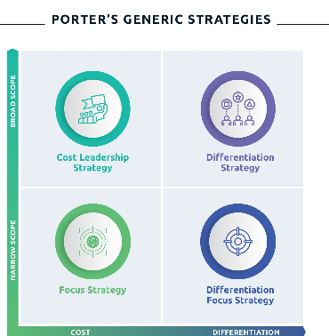
Figure: Application of Porter’s Generic Strategies
Source: (Zaino et al., 2024)

Cost leadership and broad differentiation are common in follower organisations as per the generic strategies of Porter. BYD attains cost leadership by means of vertical integration in producing its own batteries and electronic parts to reduce the level of dependency (Zaino et al., 2024). BYD, on the other hand pursues extensive differentiation with reliable and high-quality EVs which combine high-quality technology with low prices.
These plans enable the followers to serve mass-market consumers instead of the attention of the pioneers to premium ones. Nevertheless, to be competitive, a constant investment in research, digitalization, and brand loyalty is necessary (Zaino et al., 2024).

4. Conclusion
The report has critically examined competitive strategic marketing reactions of first-mover and followers organisations in the Electric Vehicle (EV) industry in terms of how macro-environmental forces, especially technological and environmental forces, influence competitive forces. The analysis indicated that environmental scanning that is steered by the PESTEL framework is critical in the identification of the external opportunities and threats that shape the long-term marketing strategies and organisational sustainability. Such innovative companies like Tesla are also pioneering, and they can show that innovation, differentiation, and active adaptation allow firms to achieve technological change and re-create the expectations of the market. Using the Growth Matrix created by Ansoff and the Generic Strategies created by Porter, Tesla approach identifies the need to be constantly developing its products, expanding its geography and technology development in order to keep up with the leadership on the market. On the other hand, the example of follower organisations such as BYD is how strategic imitation, cost leadership, and diversification can effectively turn innovation into solutions that can be applied at any scale to mass markets. The comparative analysis shows that both innovators and imitators have an impact on the development of the industry but in diverse strategic directions. Whereas pioneers cause chaos and introduce new standards of performance, followers refine innovations, make them cheaper, and more available in the market. Altogether, the research highlights the importance of strategic relevance of ongoing environmental scanning and responsive marketing in maneuvers within the fast-changing EV conditions.

5. References
Alotaibi, S., Omer, S. and Su, Y. (2022). Identification of Potential Barriers to Electric Vehicle Adoption in Oil-Producing Nations—The Case of Saudi Arabia. Electricity, [online] 3(3), pp.365–395. doi: https://doi.org/10.3390/electricity3030020.

Anastasiadou, K. and Gavanas, N. (2022). State-of-the-Art Review of the Key Factors Affecting Electric Vehicle Adoption by Consumers. Energies, [online] 15(24), p.9409. doi: https://doi.org/10.3390/en15249409.

Arribas-Ibar, M., Nylund, P. and Brem, A. (2021). The Risk of Dissolution of Sustainable Innovation Ecosystems in Times of Crisis: The Electric Vehicle during the COVID-19 Pandemic. Sustainability, 13(3), p.1319. doi: https://doi.org/10.3390/su13031319.

Chernykhovskaya, N. (2024). Theoretical Framework for Electric Vehicle Adoption: Strategic Market Entry. Cineca.it. [online] doi: https://hdl.handle.net/20.500.14247/23999.

Fedotov, P. (2022). Critical analysis of the electric vehicle industry. Exchanges: the Interdisciplinary Research Journal, [online] 10(1), pp.43–56. doi: https://doi.org/10.31273/eirj.v10i1.362.

He, X. and Hu, Y. (2024). The Decision-Making Processes for Consumer Electric Vehicle Adoption Based on a Goal-Directed Behavior Model. World Electric Vehicle Journal, 15(9), p.386. doi: https://doi.org/10.3390/wevj15090386.

Higueras-Castillo, E., Singh, V., Singh, V. and Liébana‐Cabanillas, F. (2023). Factors affecting adoption intention of electric vehicle: a cross-cultural study. Environment, Development and Sustainability, 26. doi: https://doi.org/10.1007/s10668-023-03865-y.
Hull, C., Giliomee, J.H., Visser, M. and Booysen, M.J. (2024). Electric vehicle adoption intention among paratransit owners and drivers in South Africa. Transport Policy, [online] 146, pp.137–149. doi: https://doi.org/10.1016/j.tranpol.2023.11.015.

Ivanova, G. and Moreira, A.C. (2023). Antecedents of Electric Vehicle Purchase Intention from the Consumer’s Perspective: A Systematic Literature Review. Sustainability, 15(4), p.2878. doi: https://doi.org/10.3390/su15042878.

Jagani, S., Marsillac, E. and Hong, P. (2024). The Electric Vehicle Supply Chain Ecosystem: Changing Roles of Automotive Suppliers. Sustainability, [online] 16(4), p.1570. doi: https://doi.org/10.3390/su16041570.

Ryghaug, M. and Tomas Moe Skjølsvold (2023). How policies and actor strategies affect electric vehicle diffusion and wider sustainability transitions. Proceedings of the National Academy of Sciences of the United States of America, 120(47). doi: https://doi.org/10.1073/pnas.2207888119.

Yeğin, T. and Ikram, M. (2022). Analysis of Consumers’ Electric Vehicle Purchase Intentions: An Expansion of the Theory of Planned Behavior. Sustainability, 14(19), p.12091. doi: https://doi.org/10.3390/su141912091.

Zaino, R., Ahmed, V., Alhammadi, A.M. and Alghoush, M. (2024). Electric Vehicle Adoption: A Comprehensive Systematic Review of Technological, Environmental, Organizational and Policy Impacts. World Electric Vehicle Journal, [online] 15(8), p.375. doi: https://doi.org/10.3390/wevj15080375.

