Curtis James Rees
2003711
Change Makers Assignment 2

Link for e-portfolio
https://curtisrees72.wixsite.com/changemakers--creati

Task 1
When designing and developing a design idea it is important to carry out research on as many aspects as possible. This will help identify areas of weakness as well as helping the design process. When carrying out research there are different types of research methods for example, quantitative analysis. This involves analysing data that is numbers-based – or data that can be easily “converted” into numbers without losing any meaning. [1]
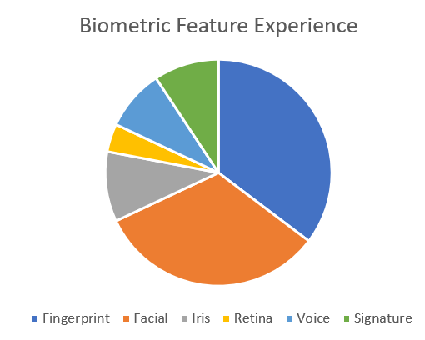

Figure 1

The design idea is to have a security door with wireless lock through OTP as well as biometric unlocking. With one of the main features of the door having a biometric feature it was important to see what peoples experience was with this feature. Participants were asked about the biometric features and which would be best suited in the case of a security system for a door. It was used to better understand which technologies participants liked most and which ones they liked least.
Participants were generally knowledgeable about a numeral of physical biometrics technologies. Thirty-five-point-three percent (35.3%) of the respondents had shared knowledge of how fingerprints are used. Thirty-two-point-seven percent (32.7%) were vast in facial scan. This is not surprising considering their commonness in personal devices and in our everyday lives (e.g., smartphones or migration at an airport). Both of these technologies have been used to protected personal devices and is increasingly become common in our daily lives. For example, the vast widely held of personal devices (e.g., smartphones and tablets) now make use of fingerprint and facial recognition so such a common usage is expected. Ten percent (10%) were having knowledge in Iris, 4% were vast in Retina.
This was very useful information to have and had a large impact on my decision of which biometric system to use. When consuming this data its important to think about where the people are from and what ages the people are. As mentioned previously the people who answered the questions have been in contact with all the different types of biometric features.

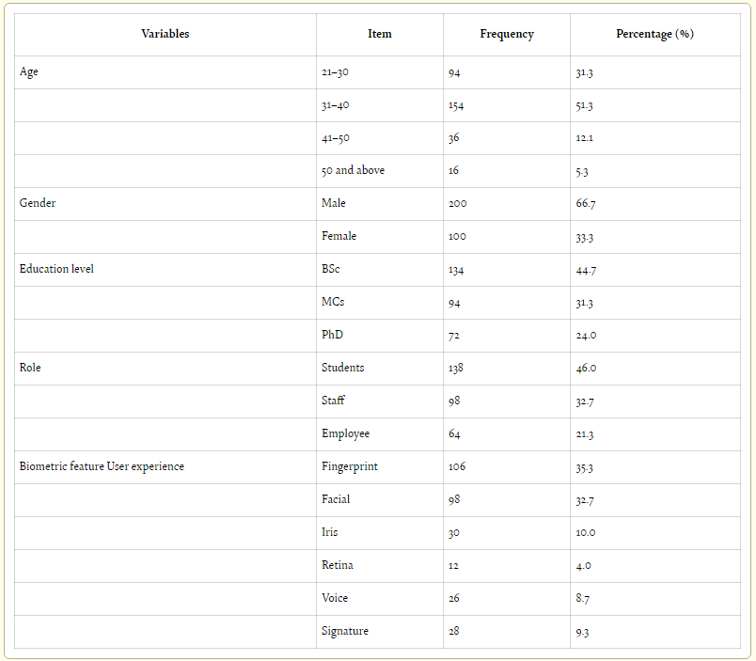
Figure 2 [2]

Figure 2 shows the organisation of data which has previously been showcased in the pie chart. Its important when asking people questions that you don’t just ask a specific group of people all similar ages and education level. By adding different variables to the people who were asked, it creates more valuable and accurate results. As figure 2 shows variables such as age, gender, education level and more were asked to the participants. This helps create a better understanding of the results and supply a reasoning to certain trends in the results.
This quantitative method of research was very useful for my design idea and really helped me choose which biometric feature would work best in my security door. By having a biometric feature most liked in general means that the product will appeal to more people and be more successful.

Task 2

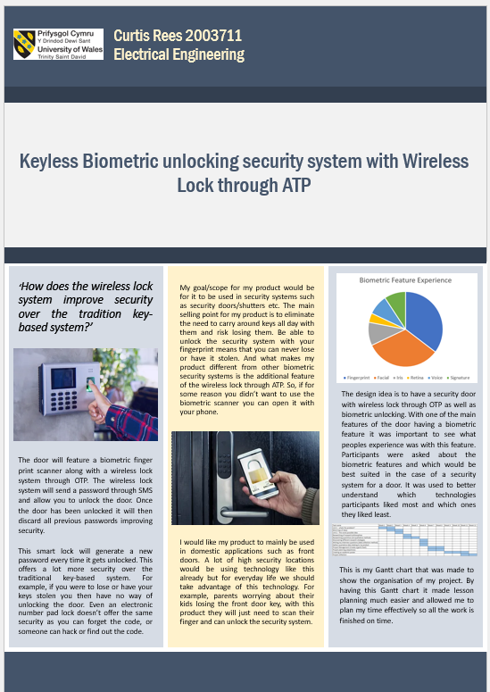

Task 3
Throughout this project I have used many different skills and techniques. From research skills, using quantitative and qualitative methods, to design and innovative skills. I am going to use this opportunity to develop these skills and improve my innovative ideas. In addition to those skills, I believe that my management skills have been improved in many ways. Learning how to develop Gantt charts which organise all the different tasks and allow you to plan your time according to your tasks really help give the project structure and improve the quality of the work. It also helps avoid mistakes and forgetting any small details throughout the project.
I believe my project has a positive impact and contributes to society in many ways. This security system can be used in many different ways. My intended use is for it to be used on security doors, which can be widely used from commercial security to domestic security. However the product can be used on other security systems like lockers, safes, shutters and many more. I believe the skills I have learned could also positively impact society, whether that’s through my own company, designing new innovative products or working for someone providing good management.
Some of the main risks to the security system would be the hygiene issue that biometric systems are associated with however, to avoid this we have installed an additional security system being the wireless lock through ATP. By having both the systems it means the problems associated with one of the security systems will be resolved by the option of using the other security system and vice versa. Biometrics hacks may have greater consequences- Biometric reveals the part of an individual's identity, if it gets stolen, then it can be used to falsify legal documents, passports, or criminal records, which can do more damage than a stolen credit card pin or number. Unlike passwords, credit cards, or other documents, you can't replace physical identifiers. If someone has managed to get the photos of your iris, you can't get another eye. [2] To prevent this being an issue we will have to ensure all data is kept secure and apply to the latest privacy laws.

Bibliography

[1] | D. J. a. K. Warren, "gradcoach," - 12 2020. [Online]. Available: https://gradcoach.com/quantitative-data-analysis-methods/. [Accessed 28 12 2022].
[2] | "javatpoint," [Online]. Available: https://www.javatpoint.com/biometrics-issues-and-concerns#:~:text=Biometrics%20hacks%20may%20have%20greater,credit%20card%20pin%20or%20number.. [Accessed 5 1 2023].
[3] | E. T. L. a. A. E. S. Taban Habibu, "intechopen," 27 07 2022. [Online]. Available: https://www.intechopen.com/chapters/80525. [Accessed 29 12 2022].



