

Lean Logistics Towards Net Zero
By
Donata Nagliute
2512677
Degree Apprenticeship in Logistics and Supply Chain Management
27th November 2025
Study and Research Skills (ACMA4021)

Abstract
This report will look at how Lean Logistics practices can support the achievement of Net Zero goals in the logistics sector, with Coloplast as a case study. The report explains the concept of logistics and Net Zero, and the report will look at how Lean Logistics makes supply chain processes run more smoother while minimising waste. Supporting the reduction of greenhouse gas emissions. In addition, the report will define Lean strategies, including optimising transport routes and minimising unnecessary shipments. Drawing on recent academic literature and industry data, the report evaluates the benefits and challenges of applying lean practices with environmental sustainability objectives whilst assessing their impact on Coloplast’s progress towards Net Zero. By looking at Coloplast’s sustainability actions and industry standards, the report shows the main benefits and challenges of using lean logistics.
Table of Contents

1. Introduction 1
2. Literature Review 2
2.1 Global Policy and Net Zero Commitments 2
2.2 Concept of Lean Logistics 2
2.3 Benefits and Challenges 3
3. Case study: Coloplast and Lean Logistics 5
4. Discussion 7
5. Conclusion 10
References 11

Introduction
Logistics can be defined as the process of planning, implementing, and controlling the efficient, effective flow, storage and delivery of goods, services, and related information from the point of origin to the point of consumption (Mangan, Lalwani and Calatayud, 2021, p.274a). Logistics has evolved into an important contributor to greenhouse gases, and this is what makes sustainability one of the most prevailing challenges in business. This has led an increasing number of organisations to commit to Net Zero targets, where they balance the emissions that they produce with those that can be absorbed from the atmosphere, resulting in net zero total emissions. The UK Government's Net Zero Strategy target is 2050 to achieve the Net Zero progress, but with an emphasis on reducing emissions within the transport and logistics sector by working more effectively and creatively (Gov.UK, 2021a).
Afum, Agyabeng-Mensah and Baah (2024, p.1564a) define lean logistics as when a logistics company has the ability to create, use and run systems that reduce wasted time and save resources. Furthermore, they offer that some of the key practices include Kaizen, JIT (just in time) and value stream mapping, getting employees to red flag problems and working with partners to remove waste. They conclude that it comes to lean logistics, the main goal is process optimisation, cost saving and an increase in productivity, making operations more efficient.
Using the company Coloplast Ltd as a case study, this report will investigate to what extent and lean logistics can contribute to reaching the turning point of Net Zero within logistics operations. Terms and concepts related to lean will be introduced, the advantages and disadvantages of lean logistics for sustainability will be explained. And how this has influenced Coloplast’s Net Zero journey will be discussed.

Literature Review

Global Policy and Net Zero Commitments
An international agreement that has prompted this movement to Net Zero in transport is an ambitious international contract, the Paris Agreement, which brought together 196 countries and commenced in 2015 (United Nations, 2015a). The goals of this agreement are to keep the global average temperature well below 2°C and to pursue efforts to achieve a warming level of no more than 1.5°C above pre-industrial levels (United Nations, 2015b). Following this global commitment, the UK is enshrining into law a pledge to be net zero by 2050 (Gov.UK, 2021b). And this is important for innovation and efficiency in the transport and logistics industry. This pledge encourages UK companies to follow the commitments of the Paris Agreement to lower their carbon emissions. To achieve the targets laid out, companies are encouraged to use technology, work more efficiently and process environmentally friendly supply chains.

Concept of Lean Logistics
Lean logistics applies lean manufacturing and lean principles to the logistics and supply chain process. This aims to eliminate waste and maximise value to the customer. The focus is upon improving the flow of goods, information and resources to create value and eliminate unnecessary activities. (Chable, Fierro, Martinez and Campos, 2024, p.72)
Lean logistics exists within the lean manufacturing philosophy and comprises continuous improvement (Kaizen), just-in-time (JIT), value stream mapping, employee involvement, and waste reduction in the supply chain. Ongoing development is a review of logistics processes to locate areas for progress in efficiency and effectiveness. JIT is an inventory management strategy that delivers products at the exact time they are required, reducing inventory levels and storage costs, and resulting in less waste (Mangan, Lalwani and Calatayud, 2021, p.39b).
Lean logistics has been closely related to environmental sustainability in recent years (Afum, Agyabeng-Mensah and Baah, 2024, pp.1556-1557b). And Afum, Agyabeng-Mensah and Baah (2024) further explain that when companies reduce waste in key areas such as transportation, packaging and storage, they use less fuel and energy, which helps reduce carbon emissions.
Lean logistics can be improved with IoT (Internet of Things) and data analysis by viewing the current position of shipments. By using this information, allocate resources more efficiently. In addition, by utilising these tools, organisations can optimise better paths, eliminate delays and react promptly, minimising economic and environmental impacts. With the result of minimising both economic and environmental impacts (VP and Kutty, 2025, p.573a). Both are critical factors in companies such as Coloplast, who may wish to consider employing lean principles to lower their carbon footprint to support Net Zero ambitions.

Benefits and Challenges
Ugarte, Golden and Dooley (2016, p. 99) offer that waste reduction and enhanced energy efficiency are the main benefits of utilising lean logistics methodologies. They continue that reducing unnecessary transport, packaging and inventory pays off by saving money, reducing wastage, saving fuel and reducing carbon emissions.
Just-in-time inventory, as well as value stream mapping, can both help cut waste and costs, which can then be reinvested in greener schemes or upgrading technology (Solorzano, Quispe and Endara, 2025, p.4). Lean logistics encourages a close collaboration between suppliers and partners. Partners, working together to maximise sustainability across the supply chain through continuous improvement initiatives, working together for environmental performance, and sustainability across supply chains (Ghasemibojd, Franchetti and George, 2025, p.13a). McKinsey & Company (2024) support this theory, adding that global companies strongly support Net Zero goals, and by adopting lean and digital tools can cut emissions by up to 30%.
Implementing lean logistics can be challenging for companies with limited resources, because it requires investments in staff training and technology (VP and Kutty, 2025, p.579b). Lean practices can have potential trade-offs, especially when it has not been managed carefully, because repeated smaller shipments can raise emissions (Ugarte, Golden and Dooley, 2016, p. 106). Additionally, it can be difficult for one to measure the environmental impacts of a lean effort, especially in a global supply chain, where data may not be available (Ghasemibojd, Franchetti and George, 2025, pp.7-10b). This is why new standards for measuring emissions are needed to solve many of the current issues (ISO, 2023). This indicates that lean thinking needs to be complemented by sustainability strategy and digital thinking to achieve Net Zero goals.

Case study: Coloplast and Lean Logistics
Coloplast is a global manufacturer of medical devices with a majority of plastic components, what a responsibility to not only deliver safe products to customers but also to seek out new technologies and materials that will support the company's sustainability work (Coloplast, no date). Coloplast is continuously working to improve sustainability within production, transportation and distribution to improve service for the customers. As shown in Figure 1, Coloplast's global revenue amounts to around DKK 27 billion. The annual rate of organic revenue growth is around 8%. Major product lines include Ostomy Care, Continence Care, Advanced Wound Care, Interventional Urology and Voice and Respiratory Care. 70% of sales are in Europe, and emerging market sales grew by 15% in 2009. At an international level, Coloplast had to have both efficient and sustainable logistics systems to deliver their products (Coloplast, 2024a).
Figure 1:
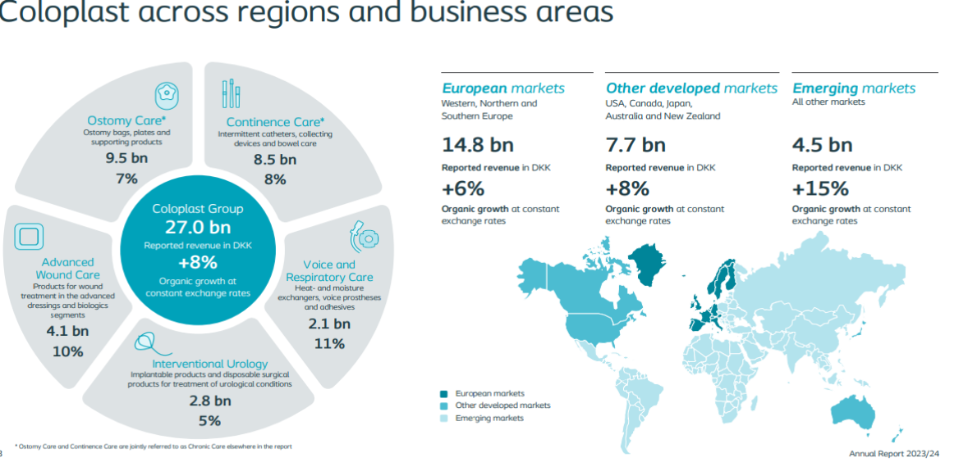
(Source: Coloplast, 2024)
Since 2020, Coloplast has made commitments toward targets which support the Paris Agreement's goal of limiting global warming to 1.5 degrees Celsius and therefore limit greenhouse gas emissions per year. Coloplast are setting science-based targets and publishing reports on how it will increase the use of renewable energy in logistics to reduce carbon dioxide (CO2) emissions through a product's life cycle (Coloplast, 2024a).
Lean logistics is one part of Coloplast's efforts to meet Net Zero objectives. This includes reducing energy consumption and associated emissions from inventory management using just-in-time logistics, as well as inventory and storage reduction. In addition, Coloplast uses digital technologies as including IoT and data analytics to track deliveries in real time (improve delivery routes and make immediate responses). Through collaboration with both logistic providers and suppliers, Coloplast works to ensure the environmental expectations are being met throughout the entire supply chain (Coloplast Charter, 2024a).
Customers are also encouraged to support the company's commitment to sustainability. For instance, the company cautions clients to only order as much as they need, and to avoid waste and overflow inventory. Also, around 75% of Coloplast’s packaging material is currently recyclable, and Coloplast has partnered up with DPD to make their transports more environmentally friendly (Coloplast Charter, 2024b).
As per Coloplast’s UK (Carbon Reduction Plan), there is a commitment for achieving net zero Scope 1 and Scope 2 emissions by 2040 with specific improvement targets for logistics and supply chain. The company will pursue this objective through greater utilisation of renewable energy, optimising transport and collaborating with suppliers to deliver sustainability targets (Coloplast, 2023).
Coloplast's vision is similar to many major organisations trying to achieve Net Zero. For example, the Greener NHS program, which recognises the need for partnership across the supply chain to achieve the aims of net zero in the long term (NHS England, 2020).

Discussion
The report shows that lean logistics can be used as a method for achieving Net Zero goals within the logistics industry. The literature review and the case study of Coloplast highlight that lean logistics can support Net Zero goals through process improvements and waste reductions. In addition, lean practices such as JIT delivery, route optimisation and suppliers working together, as used by Coloplast, may also reduce carbon emissions, according to the UK Government's Net Zero Strategy (Gov.UK, 2021c).
One possibility is that lean processes like just-in-time (JIT) inventory, value stream mapping, and digital monitoring can do more than reduce costs and they can also lower emissions. For example, Coloplast use JIT and real-time tracking to cut out in-process inventory and generate the benefit for delivery efficiency that directly reduces emissions (Coloplast, 2024b).
As shown in Figure 2 from Coloplast's annual report 2024/25, the company achieved a 41% reduction in Scope 1 and 2 emissions and increased recyclable packaging to 76%. At the same time, Scope 3 emissions per product increased by 1%, showing ongoing challenges in reducing emissions (Coloplast, 2025a).
Figure 2
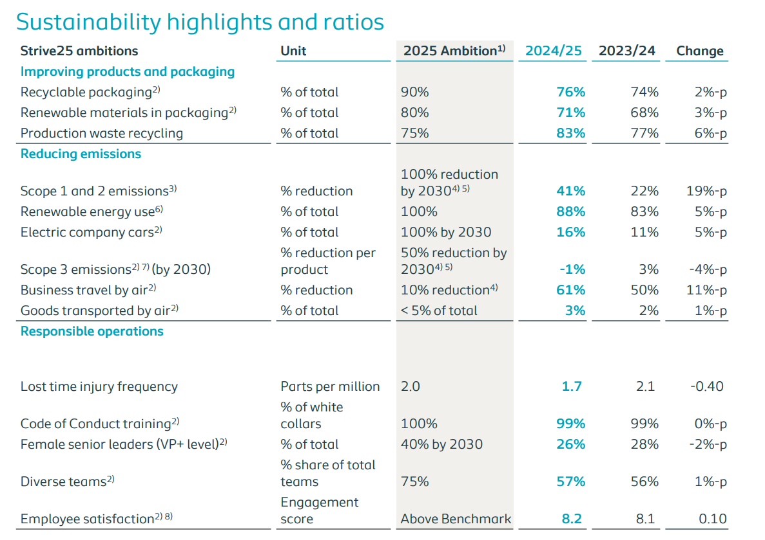
(Source: Coloplast, 2025)
To get a fuller picture, it is useful to compare Coloplast’s approach with other companies in the same sector. Hollister Ltd have also set a Net zero target for 2050 and reports similar challenges in reducing Scope 3 emissions. Their carbon reduction plan shows that transport and distribution alone account for around 1,965 tCO2e of Scope 3 emissions (Hollister, 2024). This suggests that indirect emissions are hard to measure and are a wider industry problem. Both companies focus on renewable energy and efficiency, but Hollister places additional focus on ISO 14001 certification. This suggests that lean logistics is helpful, but probably not enough on its own. It must be completed by digital tools, clearer data systems to move closer to Net Zero progress.
While the Coloplast 2024/25 Annual Report shows decreases in CO2 emissions in logistics and an increase in the usage of recyclable packaging (Coloplast, 2025b). Consideration should be given to how much of this improvement truly comes from lean logistics. The report notes ongoing issues and challenges in measuring Scope 3. Due to operational complexities, supplier collaboration., supplier collaboration is not always straightforward, and data clarity is proving to be a challenge. All of this suggests that while lean logistics helps, real progress toward Net Zero will probably require a stronger combination of lean methods and digital tools.
Figure 3 from Coloplast's annual report 2024/25 climate change illustrates how climate risks and negative impacts show up across different parts of the company value and extend across short, medium and long-term horizons. This visual highlights the complexity of managing emissions and their impact on downstream partners. Improvement in one area may not be enough if other parts of the value continue to generate risks (Coloplast, 2025c). This supports the idea that lean logistics works best when combined with wider sustainability and digital strategies (Ghasemibojd, Franchetti and George, 2025, pp.13-14c).

Figure 3
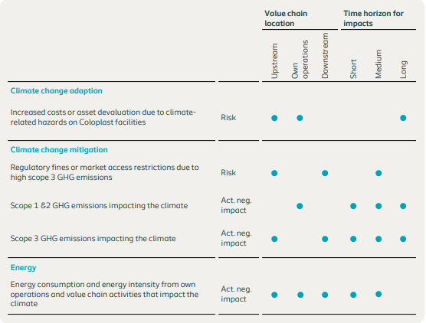
(Source: Coloplast, 2025)
Lean logistics can be challenging, it requires investments in technology and staff training, which may be difficult for smaller companies to afford. When lean systems are used without proper planning, additional problems may arise, such as repeated smaller deliveries. This would lead the higher transportation emissions. This means that lean logistics must be integrated into the sustainability and digital strategy (Ghasemibojd, Franchetti and George, 2025, pp.13-14d).
Teamwork with the supply chain is very important. The literature review and the Coloplast case study make clear that collaboration with suppliers, delivery partners and customers works to improve results. Coloplast requests customers to order only what is needed, this minimises waste and supports lean logistics across the supply chain (Coloplast, 2024b).

Conclusion
This report has investigated how lean logistics can contribute towards Net Zero ambitions within the logistics industry, providing evidence by using the example case study of Coloplast. The results indicate that lean principles, including the use of just-in-time inventory, minimising waste and digitalisation, can help companies to increase efficiency as well as their green performance. Coloplast’s experience shows that integrating lean logistics with sustainability initiatives and supply chain partnerships can lead to progress in reducing emissions.
But developing lean can also require investment in technology, staff training. In addition, even a change in corporate culture may be difficult for smaller companies. However, with an integrated approach, Coloplast’s experience proves that lean logistics can indeed play a significant part in achieving Net Zero targets.
In conclusion, lean logistics offers a practical way to balance efficiency with environmental responsibility. Further progress to Net Zero will depend on continued innovation and sustainability targets.

References
Afum, E., Agyabeng-Mensah, Y. and Baah, C. (2024) ‘Lean logistics and corporate green practices: messianic methodologies for achieving business excellence in the logistics industry via green stakeholder satisfaction’, International journal of lean six sigma, 15(7), pp. 1555–1579. Available at: https://doi.org/10.1108/IJLSS-01-2021-0008 (Accessed: 28 October 2025).
Alejandro-Chable J.D., Salais-Fierro T.E., Saucedo-Martinez J.A. and Cedillo-Campos M.G. (2024) ‘A New Lean Logistics Management Model for the Modern Supply Chain’, Mobile networks and applications, 29(1), pp. 70–81. Available at: https://doi.org/10.1007/s11036-022-02018-1 (Accessed: 22 October 2025).
Coloplast (2023) Schedule B9 - Carbon Reduction Plan and Guidance. Available at: https://www.coloplast.co.uk/Global/06_Spot%20Images/04%20Jan%202023_Carbon%20Reduction%20Plan%20UK_signed%20by%20DKNAAH.pdf (Accessed: 02 November 2025).
Coloplast (2024) Annual Report. Available at: https://www.coloplast.com/siteassets/investors/results-reports--presentations/annual-reports/07_2024_annual_report_2023-24.pdf (Accessed: 03 November 2025).
Coloplast (2024) Sustainability at Coloplast. Available at: https://prod-corporate.coloplast.com/siteassets/sustainability/cp_sustainability_brochure_a4_landscape2.pdf (Accessed: 02 November 2025).
Coloplast (2025) Annual Report. Available at: https://www.coloplast.com/siteassets/investors/results-reports--presentations/annual-reports/11_2025_annual_report_2024-25.pdf (Accessed: 19 November 2025).
Coloplast (no date) Sustainability/It’s all about balance. Available at: https://www.coloplast.com/sustainability/ (Accessed: 02 November 2025).
Coloplast Charter (2024) Sustainability. Available at: https://www.coloplastcharter.co.uk/our-services/sustainability/ (Accessed: 02 November 2025).
Deysi Llanos-Solorzano, Yenipher Dayana Barboza-Quispe and Ruben Felipe Vidal Endara (2025) ‘Case Study: Implementation of Lean Logistics at Inversiones Karmont S.A.C for Enhancing Distribution Productivity’, Engineering proceedings, 83(1), p. 17. Available at: https://doi.org/10.3390/engproc2025083017 (Accessed: 05 November 2025).
Ghasemibojd, F., Franchetti, M.J. and George, B. (2025) ‘Green lean six sigma for sustainable development: a systematic review of evolution, challenges, and future pathways’, Clean technologies and environmental policy [Preprint]. Available at: https://doi.org/10.1007/s10098-025-03281-y (Accessed: 05 November 2025).
Gov.UK (2021). Net Zero Strategy: Build Back Greener. Available at: https://www.gov.uk/government/publications/net-zero-strategy (Accessed: 22 October 2025)
Hollister (2025) Carbon Reduction Plan. Available at: https://www.hollister.co.uk/-/media/files/pdfs-for-download/uk/hollister-carbon-reduction-plan-2024.pdf (Accessed: 19 November 2025).
ISO (2023) Towards a net-zero logistics sector. Available at: https://www.iso.org/contents/news/2023/01/a-net-zero-logistics-sector.html (Accessed: 01 November 2025).
Mangan J., Lalwani C. and Calatayud A. (2021) Global logistics and supply chain management. Fourth edition. Hoboken, NJ: John Wiley & Sons, Inc.
McKinsey & Company (2024) Decarbonizing logistics: Charting the path ahead. Available at: https://www.mckinsey.com/capabilities/operations/our-insights/decarbonizing-logistics-charting-the-path-ahead (Accessed: 01 November 2025).
NHS England (2020) Delivering a ‘Net Zero’ National Health Service. Available at: https://www.england.nhs.uk/greenernhs/publication/delivering-a-net-zero-national-health-service/ (Accessed: 02 November 2025).
Sahla VP, Noora Mohamed Kutty. (2025) ‘Asian Journal of Management and Commerce’, Exploring the intersection of lean practices and sustainability: A bibliometric perspective, 6(2), pp. 573-579. Available at: https://www.doi.org/10.22271/27084515.2025.v6.i2f.722 (Accessed: 10 November 2025).
Ugarte, G.M., Golden, J.S. and Dooley, K.J. (2016) ‘Lean versus green: The impact of lean logistics on greenhouse gas emissions in consumer goods supply chains’, Journal of purchasing and supply management, 22(2), pp. 98–109. Available at: https://doi.org/10.1016/j.pursup.2015.09.002 (Accessed: 22 October 2025).
United Nations (2015) 7. d Paris Agreement. Available at: https://treaties.un.org/pages/ViewDetails.aspx?src=TREATY&mtdsg_no=XXVII-7-d&chapter=27&clang=_en (Accessed: 27 October 2025).

