MARKETING PLAN
Student Name:Vasile Pitirici
Student ID: 2213442
Module: Marketing Essentials BMIH4005
Lecture’s name: Christopher Wilkin
Word Count [Component A: Marketing Plan]: 1264

Table of Contents

Component A: Marketing Plan 2
Introduction 2
Situation Analysis 2
5 C’s 2
Company 2
Customers 3
Competitors 3
Collaborators 3
Climate 4
Marketing Mix 4
Objectives 5
Strategy 5
Tactics 6
Action 7
Control 7
Conclusion 7
References 9
Appendices 13
Appendix 1: SWOT Analysis 13
Appendix 2: Segmentation and Targeting 13
Appendix 3: Perceptual positioning map 14
Appendix 4: Bowmans strategy clock 14
Appendix 5: PESTLE Analysis 15
Appendix 6: Marketing Mix 15
Appendix 7: Communication Mix 16
Appendix 8: Gantt Chart 16
Appendix 9: KPI Metrics 17

Component A: Marketing Plan

Introduction
The “purpose of the marketing plan” is to outline an effective business strategy for Hilton Hotel for acquiring new customers and increasing its profit margin. This report is being prepared for Hilton Hotel in the UK in order to provide strategic marketing solutions to the company in the competitive marketplace. It will focus on the situational analysis which will include 5 C’s of the company to understand the current market position appropriately. This report will also consist of 4 P's of marketing mix, macro analysis, STP and Ansoff matrix to cover the critical business areas of the brand in an effective manner.

Situation Analysis

5 C’s

Company
It has been identified from the SWOT analysis that global exposure and the professional etiquettes of staff members are strengths of Hilton Hotel. Ethical issues of Hilton Hotel have limited its market share by increasing its debt in the foreign market (Chrie.org, 2023). The company can use its market opportunities such as the merger and acquisition to strengthen its position in the UK market. [Refer to Appendix 1]
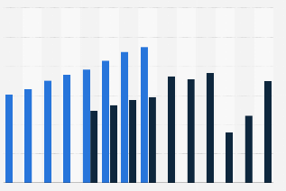
Figure 1: Hilton Hotel Annual Revenue Worldwide
(Source: Statista.com, 2023)

Customers
The customers of Hilton Hotel will be business professionals from all genders and individuals that prefer an ambitious lifestyle. It has been reported that 480 hotels of Hilton in the UK have recorded 97000 guests in 2021 (Hilton.com, 2023). The segmentation and positioning of the company has been provided based on the performative values of Hilton Group in the UK market. [Refer to Appendix 2]
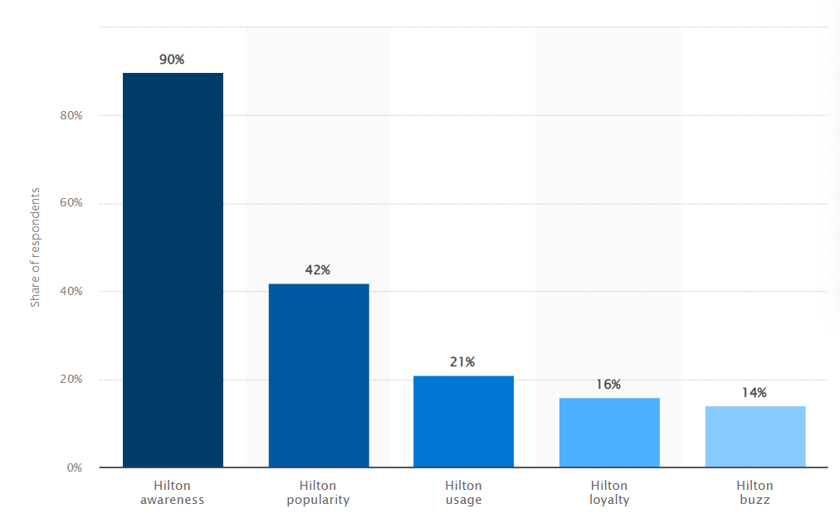
Figure 2: Hilton Brand Profile in the UK
(Source: Statista.com, 2023)

Competitors
The competitors of the Hilton Hotel have been determined based on the market position of the company in the UK market. Hyatt, Marriott, IHG, Holiday Inn are some of the competitors of Hilton Hotel in the competitive marketplace (Globaldata.com, 2023). The market value of the company has been analysed by implementing Bowman’s strategy clock in an appropriate manner. [Refer to Appendix 3 and 4]

Collaborators
Hilton can participate in the B2B marketplace to enhance hotel security, housekeeping staff outsourced to another company and wholesale purchase of food products. It has been reported that the new hospitality B2B marketplace has allowed hotel industries to enhance the automobile, food service, and energy resources (ecommercetimes.com, 2023). Partnership can Hilton Hotel to overcome the barriers that are posed by the competitors in the niche market. Hilton Hotel has partnered with Waldorf Astoria, Conrad Hotels & Resorts, Hampton by Hilton and LXR Hotels & Resorts (Hilton.com, 2023).Therefore, Hilton Hotel can partner with “The Royal National Hotel” to gain exposure to the UK market effectively. Franchise options can be available based on the market performance of the company such as Marriott International and IHG hotels & Resorts.

Climate
The analysis that can be driven for the PESTLE analysis is that the economic, and technological value of the UK market impacts positively in the market operation of the Hilton Hotel. UK’s GDP has increased 0.2% which suggests that it will impact positively on the market operation of the hospitality industry (Ons.gov.uk, 2023). Therefore, using the technological integration in the hospitality industry with the flourishing economy will help in increasing profit margin for the company. [Refer to Appendix 5]
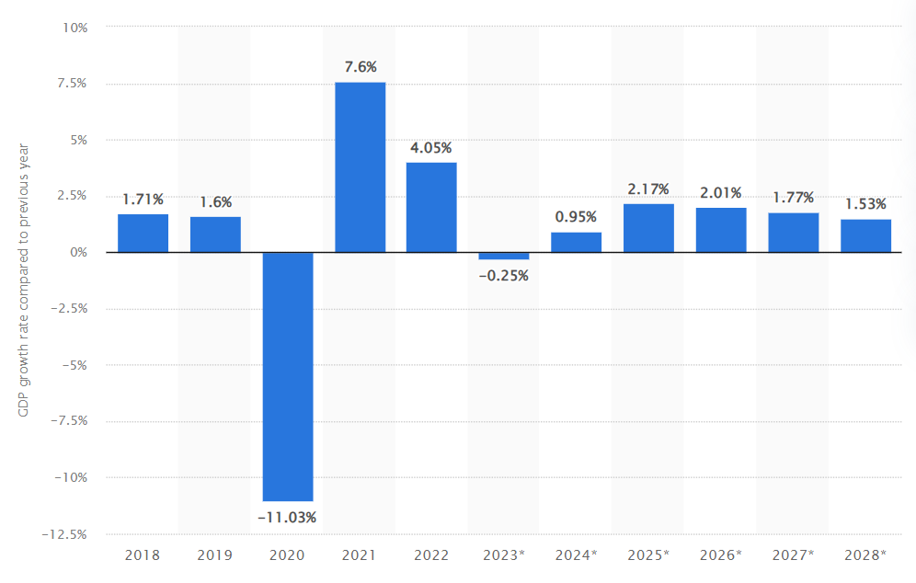
Figure 3: Estimated growth of GDP in the UK
(Source: Statista.com, 2023)

Marketing Mix
The marketing mix of Hilton Hotel has been provided based on the market value of the UK regarding the hospitality industry. According to Hanaysha et al.(2021), marketing mix consists of place, promotion, price and product. The product value is luxurious hotels where the price has settled based on the UK economy by using “social media marketing” of the company. [Refer to Appendix 6]

Objectives
Specific | To increase the annual profit of Hilton Hotel by strengthening the customer base
Measurable | To measure the departmental performance by analysing the performance of staffs
Achievable/Attainable | To achieve the business goal by implementing regulating tactics such as AI technology
Realistic/Relevant | To keep the performance value of staffs realistic by maintaining a healthy work life balance
Timed | To accomplish the goal within the quarter half of the year
Table 1: SMART objectives
(Source: Self-created)

Strategy
Hilton Hotel already has a strong value proposition targeting its customers which has helped the company to target its audience appropriately. Therefore, changes will be avoided in regard to the value proposition of the company in the UK market.
Hilton Hotel will use the business strategy of Ansoff Matrix to grow its business in the UK market in an effective manner. As stated by Clarissia (2020), Ansoff matrix framework supports the business growth by increasing the profit margin of a company. The company will be focusing on the product development of the company which include refurbishing rooms, food facility and technological integration programme. Price of the hotel rooms and accommodations needs to be changed in regard to the product segment in the marketing mix.
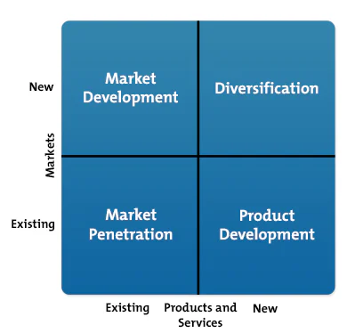
Figure 4: Ansoff Matrix
(Source: Clarissia, 2020)

Tactics
The communication mix strategy has been implemented to address the marketing channels of Hilton Hotel in the competitive marketplace of the UK. It has been identified from the situational analysis that the company has ethical issues regarding the practice of hotel staff. In this case, public relations will be used as a communication channel where press conferences will play a significant role to gain publicity and increase customer base.
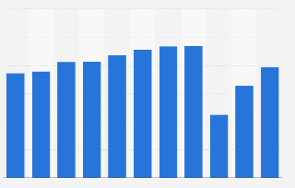
Figure 5: Hotel Industry Market Size in the UK
(Source: Statsita.com, 2023)
Hilton Hotel uses “social media marketing” (SMM) to gain publicity as a form of direct selling to maintain the annual budget of the company. Hilton’s SMM has helped the company to expand its business around 113 countries to create a virtuous cycle (Talbot, 2019). The SMM marketing strategy can be improved with the help of influencer marketing. Previously, the company lacked direct engagement from customers and missed the virtuous use of brand presence. Personal selling, direct marketing and sales promotion have been introduced to strengthen the market position of the company. Therefore, it will increase the profit margin of the company and help in gaining competitive advantage over the course of time. [Refer to Appendix 7]

Action
The marketing channels have been provided based on the detailed Gantt chart to understand the time period of marketing activities. Sales promotion, public relation and directing marketing will require the majority of the time based on the business strategy of the company. It will help Hilton Hotel to gain its market position and increase market profitability over the course of time. [Refer to Appendix 8]

Control
The KPI metrics will be measured based on the long-term goals of the company in the competitive marketplace. The company will be focused on gaining customer recognition through its service value which will be resulting in positive attitudes towards the brand. Hilton Hotel will increase its profit and strengthen its market position based on the technological integration aspect of the company. [Refer to Appendix 9]

Conclusion
It can be summarised that the marketing plan has helped in determining the conceptual areas of Hilton Hotel in an appropriate manner. However, the company can face challenges regarding the competitive marketplace of the hospitality industry and economic downturn. It can impact the annual revenue of the company along with brand reputation. The recommendations for the company include appropriate use of the marketing channels and the implementation of the influencer marketing. Appropriate implementation of technological tools can enhance the accommodation of guests by enhancing the service of Hilton Hotel. Therefore, using the appropriate tools based on the macro environment of the UK can support the marketing plan of the company in an appropriate manner.

References
Chrie.org, (2023), Hilton Hotel Worldwide: A case study exploring corporate social responsibility and stakeholder Management Available at: https://www.chrie.org/assets/docs/JHTC-case-notes/JHTC-vol-5/JHTC_Vol5Issue4_Noonan_case.pdf [Accessed on: 20th October, 2023]
Clarissia, S.M.S., (2020). A study on Ansoff Matrix Technique: As a growth strategy and an adaptive learning technique adopted in the leading brand of products. BIMS Journal of Management, 18.
Cnbc.com, (2023), Hilton Worldwide Holdings Inc Available at: https://www.cnbc.com/quotes/HLT [Accessed on: 20th October, 2023]
Ecommercetimes.com, (2023), Hilton Hotels Unveils B2B Marketplace Available at: https://www.ecommercetimes.com/story/hilton-hotels-unveils-b2b-marketplace-3467.html#:~:text=The%20new%20hospitality%20B2B%20marketplace,hotel%20companies%20in%20the%20world. [Accessed on: 20th October, 2023]
Globaldata.com, (2023), Hilton Worldwide Holdings Inc: Competitors Available at: https://www.globaldata.com/company-profile/hilton-worldwide-holdings-inc/competitors/ [Accessed on: 20th October, 2023]
Gov.uk, (2023), THE DATA PROTECTION ACT Available at: https://www.gov.uk/data-protection [Accessed on: 20th October, 2023]
Hanaysha, J.R., Al Shaikh, M.E. and Alzoubi, H.M., (2021). Importance of marketing mix elements in determining consumer purchase decision in the retail market. International Journal of Service Science, Management, Engineering, and Technology (IJSSMET), 12(6), pp.56-72.
Hilton.com, (2023), HILTON Available at: https://www.hilton.com/en/corporate/ [Accessed on: 20th October, 2023]
Hilton.com, (2023), Hilton Is Ready for Europe’s Travel Revival with Sustained Growth in Europe and UK Available at: https://stories.hilton.com/emea/releases/travel-revival-spurs-hilton-growth-in-uk-europe [Accessed on: 20th October, 2023]
Hilton.com, (2023), Hilton Named Most Valuable Hotel Brand by Brand Finance Available at:https://stories.hilton.com/releases/brand-finance-hilton-most-valuable-hotel-brand#:~:text=Brand%20Finance%20has%20named%20Hilton,before%20the%20COVID%2D19%20pandemic. [Accessed on: 20th October, 2023]
Legislation.gov.uk, (2023), Copyrights, Designs and Patents Act 1988 Available at: https://www.legislation.gov.uk/ukpga/1988/48/contents [Accessed on: 20th October, 2023]
Legislation.gov.uk, (2023), Environment Act 2021 Available at: https://www.legislation.gov.uk/ukpga/2021/30/contents/enacted [Accessed on: 20th October, 2023]
Linkedin.com, (2023), AI in Hospitality: The Impact of Artificial Intelligence on the Hotel Industry Available at: https://www.linkedin.com/pulse/ai-hospitality-impact-artificial-intelligence-hotel-industry-s%C3%A1bio/ [Accessed on: 20th October, 2023]
Ons.gov.uk, (2023), Carbon emissions produced by the British tourism industry Available at: https://www.ons.gov.uk/aboutus/transparencyandgovernance/freedomofinformationfoi/carbonemissionsproducedbythebritishtourismindustry [Accessed on: 20th October, 2023]
Ons.gov.uk, (2023), Economic activity and social change in the UK, real-time indicators: 9 June 2022 Available at: https://www.ons.gov.uk/economy/economicoutputandproductivity/output/bulletins/economicactivityandsocialchangeintheukrealtimeindicators/9june2022 [Accessed on: 20th October, 2023]
Ons.gov.uk, (2023), GDP quarterly national accounts, UK: April to June 2023 Available at: https://www.ons.gov.uk/economy/grossdomesticproductgdp/bulletins/quarterlynationalaccounts/apriltojune2023 [Accessed on: 20th October, 2023]
Ons.gov.uk, (2023), Internet users, UK: 2020 Available at: https://www.ons.gov.uk/businessindustryandtrade/itandinternetindustry/bulletins/internetusers/2020 [Accessed on: 20th October, 2023]
Ons.gov.uk, (2023), Overview of the UK population: January 2021 Available at: https://www.ons.gov.uk/peoplepopulationandcommunity/populationandmigration/populationestimates/articles/overviewoftheukpopulation/january2021 [Accessed on: 20th October, 2023]
Ons.gov.uk, (2023), Unemployment Available at: https://www.ons.gov.uk/employmentandlabourmarket/peoplenotinwork/unemployment#:~:text=The%20UK%20employment%20rate%20was,%2Dtime%20self%2Demployed%20workers. [Accessed on: 20th October, 2023]
Sec.gov, (2023), HILTON HOTELS CORPORATION Available at: https://www.sec.gov/Archives/edgar/data/47580/000110465907059886/a07-20270_1defm14a.htm [Accessed on: 20th October, 2023]
Statista.com, (2023), Hilton brand awareness, usage, popularity, loyalty, and buzz among hotel customers in the UK in 2022 Available at: https://www.statista.com/forecasts/1335684/hilton-hotels-brand-profile-in-the-uk#:~:text=All%20in%20all%2C%2021%25%20of,likely%20to%20use%20Hilton%20again. [Accessed on: 20th October, 2023]
Statista.com, (2023), Market size of the hotel industry in the United Kingdom from 2013 to 2022, with a forecast for 2023 Available at: https://www.statista.com/statistics/1364712/hotel-industry-market-size-uk/ [Accessed on: 20th October, 2023]
Statista.com, (2023), Revenue of Hilton Worldwide Holdings from 2009 to 2022 Available at: https://www.statista.com/statistics/297760/revenue-of-hilton-worldwide-holdings-inc/ [Accessed on: 20th October, 2023]
Statista.com, (2023), United Kingdom: Real gross domestic product (GDP) growth rate from 2018 to 2028 Available at: https://www.statista.com/statistics/263613/gross-domestic-product-gdp-growth-rate-in-the-united-kingdom/ [Accessed on: 20th October, 2023]
Talbot, P (2019), Inside Hilton's Marketing Strategy Available at: https://www.forbes.com/sites/paultalbot/2019/05/23/inside-hiltons-marketing-strategy/?sh=72e649f51be9 [Accessed on: 20th October, 2023]
Tapper, J (2023), French and German tourists turn their back on Brexit Britain Available at: https://www.theguardian.com/politics/2023/apr/08/french-and-german-tourists-turn-their-back-on-brexit-britain [Accessed on: 20th October, 2023]
Theglobaleconomy.com, (2023), United Kingdom: Political stability Available at: https://www.theglobaleconomy.com/United-Kingdom/wb_political_stability/#:~:text=Political%20stability%20index%20(%2D2.5%20weak%3B%202.5%20strong)&text=The%20latest%20value%20from%202021,to%20compare%20trends%20over%20time. [Accessed on: 20th October, 2023]

Appendices

Appendix 1: SWOT Analysis
Strengths  - Worldwide recognition (hilton.com, 2023)  - Strong customer base  - Professional workers  - Technological integration | Weaknesses  - Lack of flexibility  - Limited global share (Cnbc.com, 2023)  - High debts
Opportunities  - Social media marketing  - Expansion into developing countries  - Mergers and acquisition (Sec.gov, 2023)  - In depth focus on research and development | Threats  - Competitive marketplace  - Economic downturn  - Ethics related issues (Chrie.org, 2023)

Appendix 2: Segmentation and Targeting
Segmentation | Targeting | Positioning
Geographic: London, UK  Demographic: Middle and senior aged professionals with high level of income belonging to upper social class  Psychological: Ambitious individuals, business professionals | Men and women that participate in business who like expensive hotels with professional etiquettes | The luxury brand will be positioned based on the “canopy” lifestyle of upper-class individuals through social media marketing

Appendix 3: Perceptual positioning map
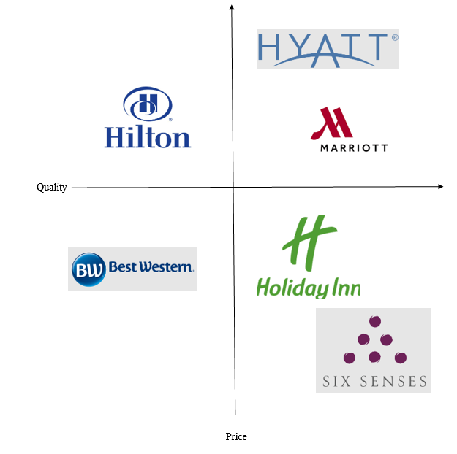

Appendix 4: Bowmans strategy clock
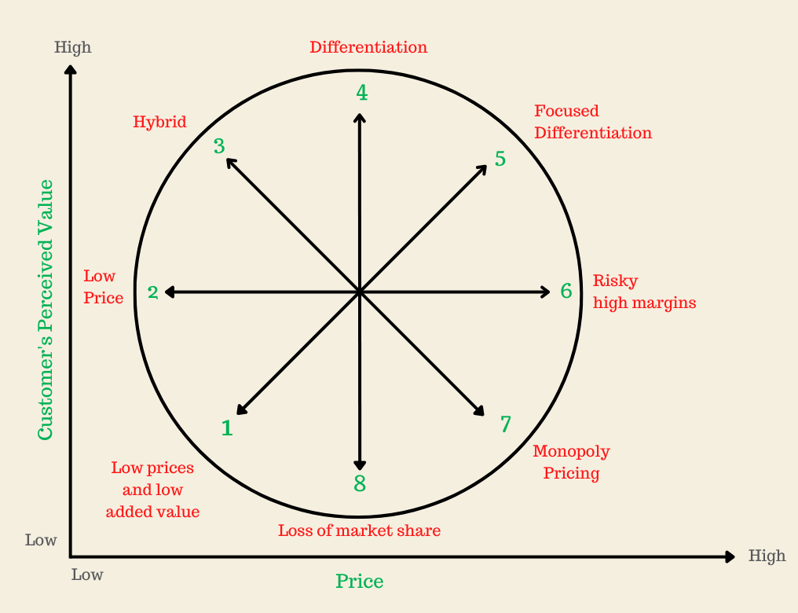

Appendix 5: PESTLE Analysis
Political | - “Political stability rate” is 0.54 points (theglobaleconomy.com, 2023)  - Brexit has impacted on the luxury hotel business regarding the demand of staffs (Tapper, 2023)
Economic | - GDP has increased by 0.2% in quarter of 2023 (Ons.gov.uk, 2023)  - “Employment rate” is 75.5% in 2023 (Ons.gov.uk, 2023)
Social | - “Social progression rate” is 26% as of in July, 2022 (Ons.gov.uk, 2023)  - “Demographic population rate” is 66.8 million (Ons.gov.uk, 2023)
Technological | - Incorporation of AI has enhanced service quality of hotels by 89% (Linkedin.com, 2023)  - “Internet usage rate” has reached 92% (Ons.gov.uk, 2023)
Legal | - “Data Protection Act (2018)” has maintained the confidentiality of business and customers (gov.uk, 2023)  - “Copyrights, Designs and Patents Act (1988)” has provided provisional information to businesses (legislation.gov.uk, 2023)
Environment | - Carbon emission rate is 10.4 kg CO2e (ons.gov.uk, 2023)  - “Environment Act (2021)” has protected environment in terms of Sos in the UK (legislation.gov.uk, 2023)

Appendix 6: Marketing Mix
Place | London, UK
Product | Luxurious hotels
Price | £90 to £450 based on room and accommodation
Promotion | Social media marketing

Appendix 7: Communication Mix
Advertising | Social media, experimental and influencer
Personal selling | Building a strong social media presence on all social media platforms
Public relation | Press conference to gain publicity and increase customer base
Direct marketing | Use of leaflets, catalogues and in-person selling
Sales promotion | Discounts on holiday bookings

Appendix 8: Gantt Chart
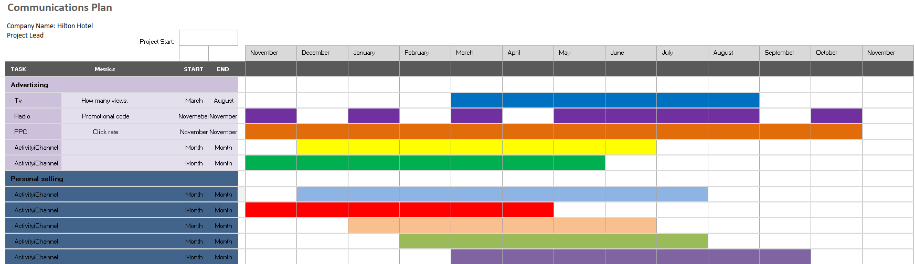
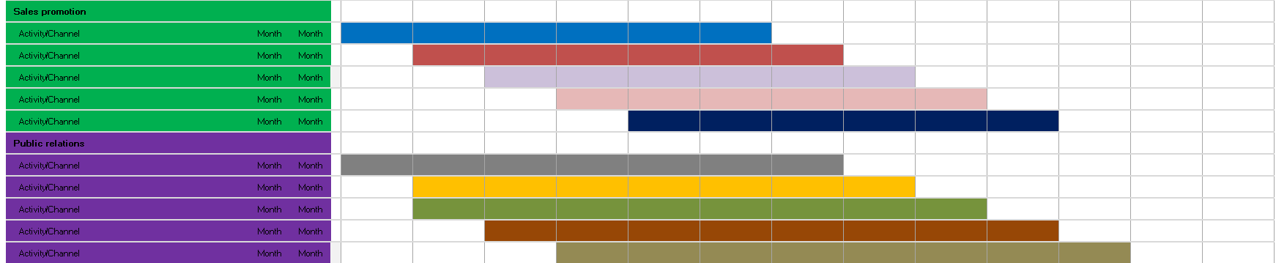
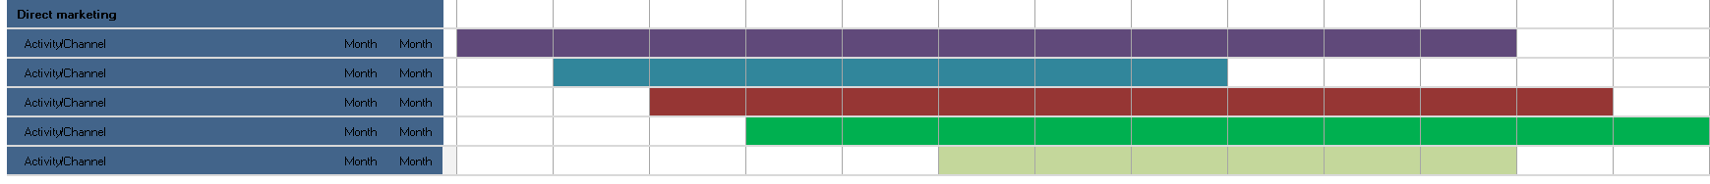

Appendix 9: KPI Metrics
Parameters | KPIs | Metrics
Objective | Increase customer base and annual revenue of the company | Measure performance of daily business activities
Focus | High-level perspectives | Low-level perspectives
Timeframe | Long-term goals | Used for short-term goals
Scope | Increasing profits | Cover a wide range of departmental activities
Relevance | Strengthening market position and gaining market exposure | Measure milestones that are set to achieve business goals

MARKETING PLAN
Student Name:Vasile Pitirici
Student ID: 2213442
Word Count [Component B: Presentation]: 440
Table of Contents

Component B: Presentation 2
Slide 1: Segmentation and Targeting 2
Slide 2: Marketing Mix 2
Slide 3: Ansoff Matrix 3
Slide 4: Communication Mix 3
Slide 5: Action Plan 4
Slide 6: References 5

Component B: Presentation

Slide 1: Segmentation and Targeting
Segmentation | Targeting | Positioning
Geographic: London, UK  Demographic: Men and women who are aged between 25-65 and related to business  Psychological: Individuals that prefer sophisticated lifestyle | Men and women that are travel often regarding businesses | Hilton Hotel will position itself based on the brand’s reputation
SN: The STP has been provided to outline the target audience of Hilton Hotel in the UK market. It has been reported that 89% of business professionals in the UK prefer luxurious hotels (Wrathall, 2023)

Slide 2: Marketing Mix
Place | London, UK [Preferably metropolitan cities of the UK]
Product | Luxurious furnishings, higher quality accommodations, professional room service options
Price | £90 to £450 based accommodation facilities
Promotion | Social media marketing, press conference and direct marketing
SN: The marketing mix has been provided to understand the 4 P’s of marketing that Hilton Hotel will be using to gain competitive advantage. The market size of hospitality industry has reached 53.8 billion in the UK (mintel.com, 2023)

Slide 3: Ansoff Matrix
- Hilton Hotel will use Ansoff Matrix as the business strategy to increase its profit margin.
- Ansoff Matrix helps in understand the current market position of a company and help in focusing the areas for business profitability (Sukma et al. 2019)
- Hilton Hotel will be using the product development stage to increase its profit by strengthening its market position.
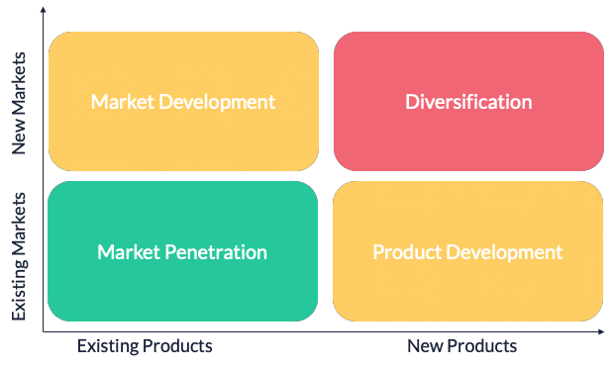
Figure 1: Ansoff Matrix
(Source: Sukma et al. 2019)
SN: Hilton Hotel will be focusing on the product development of the company which include refurbishing rooms, food facility and technological integration programme. According to Sukma et al. (2019), Ansoff Matrix can help a company to gain insights regarding the market for its fundamental growth.

Slide 4: Communication Mix
Advertising | Influencer marketing
Personal selling | Social media marketing
Public relation | Press conference
Direct marketing | In-person selling
Sales promotion | Holiday coupons

SN: As stated by Chifu and Simons (2023), communication mix helps in understanding the importance of communication channels regarding a company. Therefore, the appropriate implementation of suggested communication channels will help Hilton Hotel to gain competitive advantage.

Slide 5: Action Plan
- The action plan is focused on the marketing communication channels of Hilton Hotel.
- Action plans clarify the use of resources and required time to reach business goals (Grafakos et al. 2020)
- It will help in gaining competitive advantage by increasing annual profit positively.
Figure 2: Action Plan
(Source: Self-created)
SN: Action plan will help in outlining the marketing plan of Hilton Hotel in the UK market. The benefits of action plan are that it has provided an opportunity of reflection regarding the marketing activities of a company (Grafakos et al. 2020)

Slide 6: References
Chifu, I. and Simons, G., (2023). Rethinking Warfare in the 21st Century: The Influence and Effects of the Politics, Information and Communication Mix. Cambridge University Press.
Grafakos, S., Viero, G., Reckien, D., Trigg, K., Viguie, V., Sudmant, A., Graves, C., Foley, A., Heidrich, O., Mirailles, J.M. and Carter, J., (2020). Integration of mitigation and adaptation in urban climate change action plans in Europe: A systematic assessment. Renewable and Sustainable Energy Reviews, 121, p.109623.
Mintel.com, (2023), UK Hotels Market Report 2022 Available at: https://store.mintel.com/report/uk-hotels-market-report [Accessed on: 20th October, 2023]
Sukma, D., Lubis, P.H. and Utami, S., (2019). Analysis of Marketing Strategy of Minyeuk Pret Using STP, Ansoff Matrix, and Marketing Mix.
Wrathall, C (2023), The big hotel openings of 2023 Available at: https://www.ft.com/content/b0f5a2f9-9b31-406e-972b-7856341134f9 [Accessed on: 20th October, 2023]

