A critical evaluation of the role of digital innovation in professional practice
Introduction
UNESCO (2024) defines ICT as a range of “technical tools and resources used to transmit, store, create, share or exchange information”. It is therefore expected that with the increase of technological innovations, ICT should only be developed into educational opportunities where it enhances the learning and improves the education outcomes (Aikyo et al 2018).
ICT (information communication technology) is an important part of adult learning as it allows for social inclusion and economic competitiveness (Galacher, Osbourne and Cloonan 1999 cited in Morgan-Klein and Osbourne 2007). The lives of citizens in the 21st century is governed by the use of technology and therefore education and all aspects of learning must keep up with the pace in order to develop the employability of their students (Enomoto, Warner and Nygaard 2018).
This assignment will look at the impact of technology within community based lifelong learning. Community-based learning is where a wide variety of learning opportunities are delivered in community venues however the exact definition is hard to establish as this can vary by venue, activity, and outcome (McTier and McGregor 2011). Lave and Wenger (1998 cited in Learning Theories 2023) discusses a form of community-based learning as ‘Communities of Practice’ where an element of social learning takes place through groups of people who meet on a regular basis and share the same ideas or passion for something and then learn how to do something better by communicating with each other. This element of communication can take place in informal settings such as coffee shops or even community venues.
The role of creativity and digital innovation
Jarvis (2007) builds on the idea of community education by suggesting that there are three distinct forms, which includes extra-mural forms of education, education for action or development and education in the community. Jarvis (2007) mainly discussed the idea that community education stems from the use of community schools where adult education providers are using the schools’ resources such as their ICT classrooms in order to teach adults.
Harkavy et al (2016) builds on the idea of universities using school buildings as this provides a two-prong approach, by firstly, the universities providing guidance and support to schools and secondly to be able to provide engagement opportunities for the wider community such as parents, grandparents and anyone living in the community.
Morgan-Klein and Osbourne (2007) develops the idea of community learning which is an element of informal learning or non-certified learning, however, notes that historically it has failed to attract funding. D’Amico et al (2017) notes that as many as 40% of students enrolled in colleges in the USA are studying non-certified courses and agreed with Morgan-Klein and Osbourne (2007) that these courses attract inconsistent funding but are equally important as these programmes can change quickly to meet learner or industry need.
Community learning can be seen as highly valuable to students in a professional and personal manner (Astin and Sax 1998 cited in Kaplan 2020). Kaplan (2020) also notes that skills obtained during non-traditional learning such as community learning are highly valued by certain employers. Colley, Hodkinson, and Malcolm (2003 cited in Morgan-Klein and Osbourne 2007) note that community-based education is often positive as it is seen as an alternative and accessible to mainstream education. This often allows participants to develop additional ‘softer skills’ such as emotional intelligence, social intelligence, and communication. These skills are often underrated and underappreciated among those who are or have been traditionally disadvantaged in the labour market (Kolko 2019 cited in Race 2020). Those who are of lower incomes are less likely to have any form of further education and those that do are more likely to have accumulated more debt and a more likely to work part time during their studies also (Vickerstaff 2007). Avdic and Gartell (2015) also note that where students work while studying this could have further adverse impacts on their studies which include high rates of dropouts and prolonging studies, however advantages outweighed the disadvantages and students increased their relative earnings after graduation.
Jarvis (2010) discusses learning regions and learning cities as a form of community education and with the advent of ICT creates opportunities for a learning city that transcends traditional boundaries (DfEE 1998 cited in Jarvis 2010). Longworth (1999 cited in Jarvis 2010) suggests that learning cities can be comprised of several different networks including the traditional educational systems as well as adult and vocational education, local government, and voluntary organisations. Learning cities were first established in the 1990’s as a way sustain life-long learning, however, it can be argued that one major disadvantage is that someone living in a smaller community or rural community may not have the same opportunities as someone living in a larger city (Jarvis 2010).
Kepez (2018) examines the design of community buildings and the impact on education, especially for those living in cities and discusses how the learning environment can have a positive impact on learning based around humanistic design. Mazuch and Rona (2005) writes about humanistic building design and how, by putting building end users at the heart of building design has positive impacts such as by using a form of colour therapy to induce relaxation, which in turn give the students a better position to learn in, however this study was mainly conducted through prisons and hospitals so while it gives some examples of humanistic design that can be applied to education establishments some caution should be aired.
Minton (2005) has noted that the biggest change in the 21st century has been the investment in Information Communication Technology (ICT) and this has developed into Computer Assisted Learning (CAL). Morgan-Klein and Osbourne (2007) develop this concept further and argue the case for Virtual Learning Communities (VLC’s), which include resources for students and video conferencing abilities to eliminate the need for in person teaching, however historically, video conferencing has been rejected by teachers due to technical issues including the unreliable connections and low bandwidth which could be frustrating for both teachers and learners (Pechey 2006 cited in Morgan-Klein and Osbourne 2007).
There are some benefits of distance learning through online learning such as the learner can complete the work as and when it is convenient for them, However the disadvantages outweigh the benefits, which can include isolation, frustration, and lack of motivation from the students (Czerwionka, Klebl and Schrader 2010).
Race and Pickford (2007) argue that young people known as ‘digital natives’ are very familiar with technological integration, however teachers and older students are now known as ‘digital immigrants’ and struggle with some aspects of digital technology in the classroom. This is supported by Reece and Walker (2007) who discuss concerns of teachers using ICT in the classroom, firstly they discuss confidence as the new and upcoming ICT resources require the teacher to develop new skills in order to use the technology effectively. However, secondly, they also discuss the availability of technology in the classroom, while most educational buildings are now equipped with ICT resources such as a projector, some classrooms, may not have suitable equipment.
However, it is now national policy in many European countries to have a suitable ICT infrastructure in classrooms across the country which includes the availability of ICT equipment as well as access to the internet, however in some countries such as France and Poland have extended their ICT policy to include those students on lower incomes where they provide laptops and Wi-Fi access in students homes (Gil-Flores, Rodriguez-Santero and Torres-Gordillo 2017), however this only applies to children’s learning and cannot be applied to adult learning. Parsons et al (2008) discusses ICT use among organisations supporting adults with learning disabilities and suggests that many organisations will purchase ICT resources for adult service users and while the benefits are recognised, the implementation is usually “under-funded and unplanned” Aspinall and Hegarty 2001 cited in Parsons et al 2008). Despite continued staff training in order to support the adults to use the equipment and the most up to date equipment being available, ICT use in some organisations can be very patchy (Parsons et al 2008).
Minton (2005) also discusses the idea of learner and teacher competence in relation to ICT and advises that it is best practice to check the students’ level of knowledge prior to teaching anything relating to ICT as the skills required for effective ICT use in the classroom has increased. Huddleston and Unwin (2007) also write in support of learner competence by suggesting that formal education providers often have ‘learning resource centres’ to support learners with the use ICT and help build students skills but also to provide the use of ICT such as loan computers in order for students to complete their assignments.
The internet and world wide web has brought a positive impact to the lives of citizens which includes easier access to education, health and financial services (Pancham and Millham 2018). Morgan-Klein and Osbourne (2007) argue that there is a digital divide as the initial cost for ICT equipment is often a barrier for some disadvantaged people. Morgan-Klein and Osbourne (2007) originally noted this in third world countries such as countries in Africa. However, the digital divide is still very evident in the UK with 10% of the adult population in the UK being “internet not-users” (ONS 2018). However, the digital divide is still present in the older population living in rural areas, Hodge et al (2016) discusses that older people are still limited in accessing the internet and as a result there is “limited internet proficiency among older people resulting from lower education and socio-economic backgrounds”.
Dow-Fleisner et al (2022) also note that the Covid-19 pandemic exacerbated the digital divide in rural areas in Canada by suggesting that during the onset of the pandemic, internet bandwidth speeds increased in urban areas to account for the increased internet traffic, however stalled in rural areas so accessing essential services such as health care increased the levels of health inequality in rural areas. Connolly et al (2018) also discuss mental health inequalities of armed forces veterans using mental health apps to manage symptoms of PTSD, where some were more likely to use applications on a personal computer rather than a smartphone application, however, veterans living in more rural areas were more likely to suffer from additional mental health complications such as an increased risk of suicide so would have greater benefit from using a mental health smartphone app, however, there are lower rates of smartphone usage in rural areas and often connection issues that impact health outcomes (Connolly et al 2018).
Poverty also has an impact on the digital divide where austerity as a result of the 2008 financial crash had increased levels of poverty and increased competition for local jobs and again this was exacerbated by Covid-19 where new technologies were used to engage otherwise digitally isolated communities (Mayo 2022). Pancham and Millham (2018) also discusses the digital divide and suggests that one way to mitigate the digital divide is the use of telecentres such as internet café’s, where a user is required to pay a small fee to use the telecentre, however it can be argued that even a small fee of around $3 USD was still unaffordable for those clients that Pancham and Millham (2018) surveyed.
In conclusion, ICT (Information communication technology) is now entrenched in the lives of the UK citizens, and it allows for social inclusion as shown during the COVID-19 pandemic when people kept in touch via the internet and also allows for economic competitiveness (Galacher, Osbourne and Cloonan 1999).
In regard to community-based learning, the exact definition can vary often by venue and activity (McTier and McGregor 2011). However, community learning can be a mix of informal and non-certified learning, but historically it has attracted inconsistent funding (Morgan-Klein and Osbourne 2007).
It is also worth noting that many teachers still may lack confidence in using ICT in their lessons, but despite their best efforts, they may still face a lack of availability such as a computer or projector in their classroom (Reece and Walker 2007).
The digital divide also has an impact on adult learning, for instance the initial cost and the continuing payments for some people due to levels of poverty can be a barrier to accessing education and ICT (Morgan-Klein and Osbourne 2007). However there is also a digital divide between those who live in urban areas versus those living in rural areas, Connolly et al (2018) noted that patients living rurally and using smart phone apps in order to manage their heath had poorer outcomes than their urban counterparts.

Selection and justification of appropriate teaching tools/resources
For this assignment I have chosen to use Mentimeter. Mentimeter is a form of a Student Response system, Student Response Systems (SRS) increase active response in the classroom and replaces traditional methods such as whiteboards and pen and paper as students can now use their own devices (Moorhouse et al 2020).
Mentimeter was chosen for this activity as the aim of this activity was to gain a form of qualitative feedback from learners as well as to aid verbal discussion around feedback of activities during a service user consultation based around the LIFE (Liberty, independence, Freedom and Empowerment) Project within Thrive WA. The activities that the students were evaluating ranged from coffee mornings, arts and craft sessions through to non-certified courses through UWTSD’s Widening Access Courses. Service user feedback and consultation is an important part of the LIFE project in order to steer the relevant learning and activities.
Kelly (2009) supports evaluation and suggests that evaluation of the curriculum and learning is essential for change and development, However Beresford (2012) argues that service user participation is essential, however feedback traditionally, is often limited to those who are the most assertive and confident within the classroom. Moorhouse et al (2020) suggests that using technology such as mentimeter allows the anonymous capture of data from all students.
This activity fits into the SAMR (Subsititution, Augmentation, Modification and Redefinition) framework for embedding technology (JISC 2022). This activity fits within both the augmentation category and the modification category. Previous to using mentimeter, a similar activity was carried out using pens and flipchart paper where participants had to write on the flipchart paper answers to consultation questions. This activity was chosen in this way as mentimeter has some level of privacy in order to attract better and honest responses from the service users (Moorhouse et al 2020) and therefore it is a direct substitute with some functional improvement and as a result provides some enhancement for the students. However, is can also be classed as a form of modification with allows for significant task redesign. This activity was significantly redesigned by using software as the software allowed for additional options such as word clouds which both collated the data and provided feedback and thus is form of digital transformation (JISC 2022).
Kurt (2023) also discusses the SAMR model and gives an example of the augmentation stage where an example of survey tools is used to gather a wide range of opinions and data, therefore a surey conducted via mentimeter would be classed as augmentation, however Kurt (2023) also argues that collaboration tools that allow for collective creation can be classed as the modification stage. This activity was designed for collective collaboration by using mentimeter to suggest different activities and used to plan future activities, but this allowed for quieter members of the group to air their opinions and then it stimulated discussion during the activity that allowed for further responses and ideas that were raised by discussing each item in turn.
Hamilton, Rosenberg and Akcaoglu (2016) discusses analysis of the SAMR model, and reports that while there are a few examples of how to interpret the four hierarchical levels of SAMR, the actual use and interpretation is down to the user which can vary between users. They further explain that technology is best integrated when teachers are within the modification and redefinition category, however, ignores individual circumstances and takes the availability of technology for granted.
This lesson and evaluation feeds into the humanistic theory of learning, according to John Dewey (n.d. cited in Simply Psychology 2024) supports this by suggesting that when students are able to communicate their ideas, they are able to consider the perspectives of other students. So therefore, by consulting students and allowing them to share their ideas fits in the humanistic theory of learning. However, student consultation takes the humanistic theory of learning a step further by suggesting that students learn best when their interests are piqued and therefore a consultation can allow for the development of ideas and interests to allow future teaching sessions to be geared to the interests of the students. Reece and Walker (2007) also develop this further by noting that in the humanistic theory of learning by suggesting that where adult education is concerned, the teacher has now become the facilitator of learning.
The Welsh Government (2017) has created professional standards for education in Wales and is designed to be used for further education but can be used within work-based learning providers and voluntary and community sector organisations. The professional standards can be classed as a series of personal commitments teachers make. This lesson fits into the following professional standards:
In my practice and with others, I demonstrate commitment to learners, their learning, safety and well-being, this consultation has provided learners with an opportunity to identify any learning needs and will allow for future planning to remove any remaining barriers.
In my practice and with others I value and promote diversity, equality of opportunity and inclusion. This activity has allowed students to give their opinions and to challenge any issues and barriers that they might have. The use of mentimeter in conjunction with in-class discussion also allows for inclusion as students can give their opinions anonymously (Moorhouse et al 2020).
In my practice and with others I demonstrate dignity, courtesy and respect towards others. This activity is a consultation designed to listen to the opinions of others. This will be used to develop future activities around the responses. In using mentimeter, as well as an in-class discussion has created an opportunity for all to have an equal opportunity to be heard.
In my practice and with others I plan and deliver effective learning, teaching and assessment. This activity has allowed me to collate the responses and to be able to plan effective teaching and learning in future activities. The LIFE project also provides safe learning environments which allows students to become active participants and are free to collaborate effectively which fits into the Humanistic theory of learning, where students learn more when their interests are piqued.
Application of the chosen learning tool
This lesson was conducted using mentimeter and was designed as an evaluation session for past activities and lessons.
Firstly, I visited Mentimeter.com and I logged into my account on the website. Once I logged in, I was directed to my home page to create a new presentation as shown below.
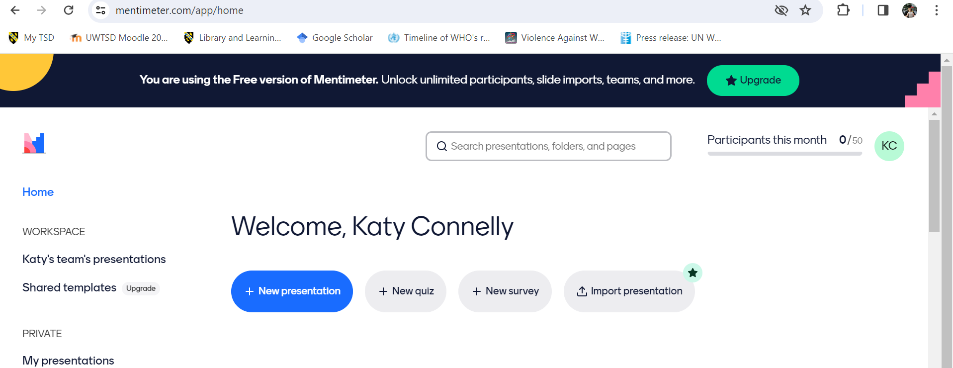

Once I had clicked on the new presentation icon, the website took me to the page, as shown below. I then chose different interactive slides, depending on what the question asked. As I was using the free version of mentimeter, I was limited to the number of activities to choose from.
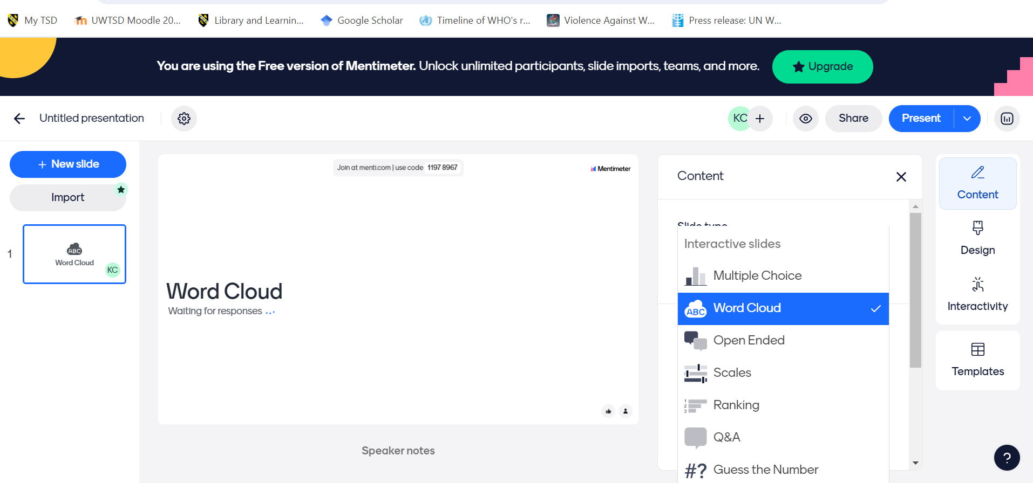
I repeated the steps shown above until I had completed the presentation with the relevant questions for the evaluation part of the lesson. I used word clouds and open-ended questions throughout the presentation. I also included instructions slide, which showed the access code, website and QR code so that the participants could scan it using their personal mobile phones. This is shown in the image below. The questions presented to the participants will be shown, in the order of delivery, further down in this section.
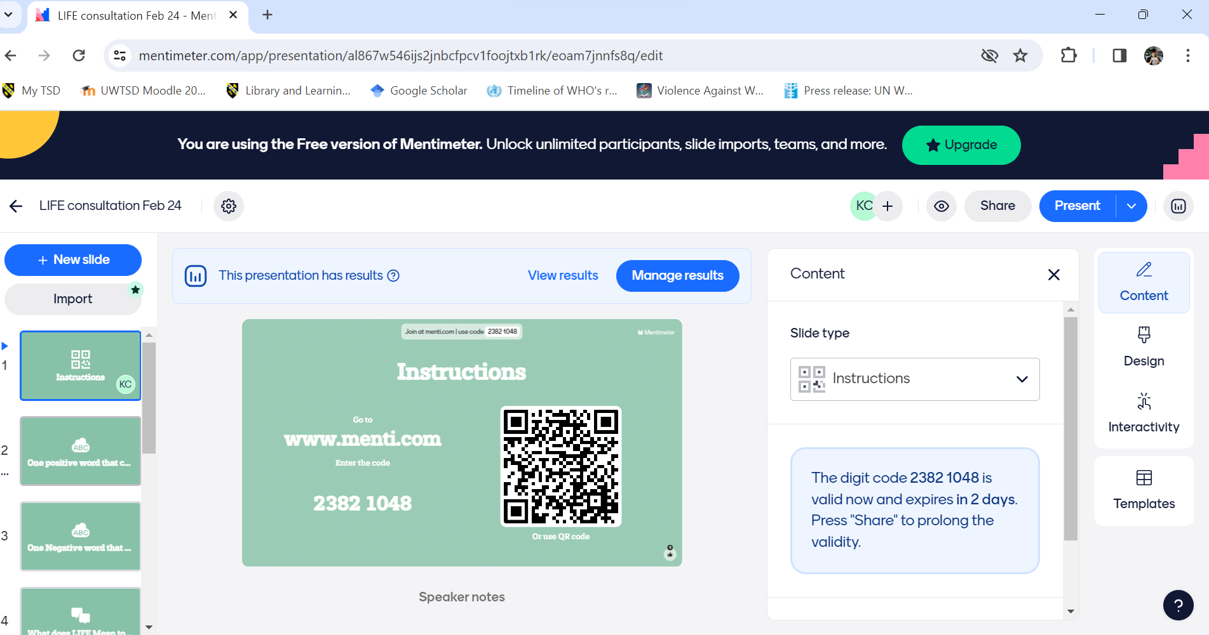

Once I had finalised the presentation for that part of the lesson, I clicked the presentation icon, the below screen was displayed on my laptop and was projected onto the smart screen during the lesson.
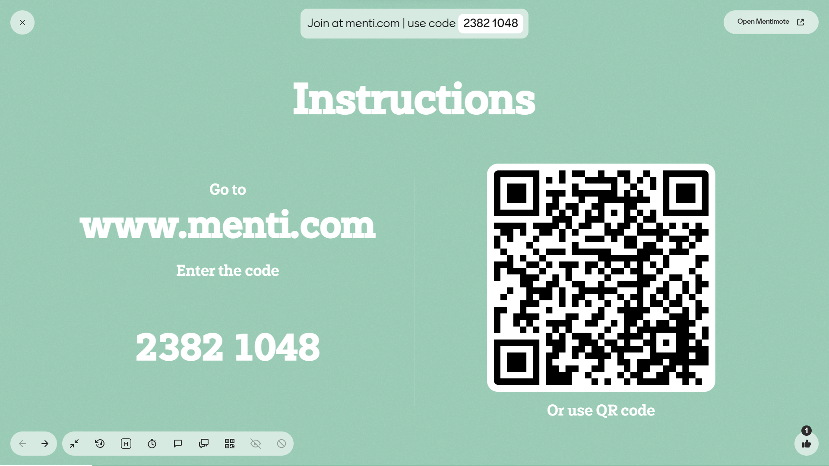
The following questions were displayed during the activity and they are in the order of delivery. The LIFE (Liberty, Independence, Freedom and Empowerment) project is designed to offer different opportunities for service users to attend various different activities, including learning opportunities in order to improve mental health, resilience, self confidence and independence. This project is something that I manage within my current job role. The following questions may have some answers that are redacted as all the participants are survivors of domestic abuse and their confidentiality must be protected.
Six participants took part in this activity using their own mobile phones. They were advised before we started that they would require the use of the internet during the activity and were given the option of either using their own data plans or using the free guest Wi-Fi to complete this activity.
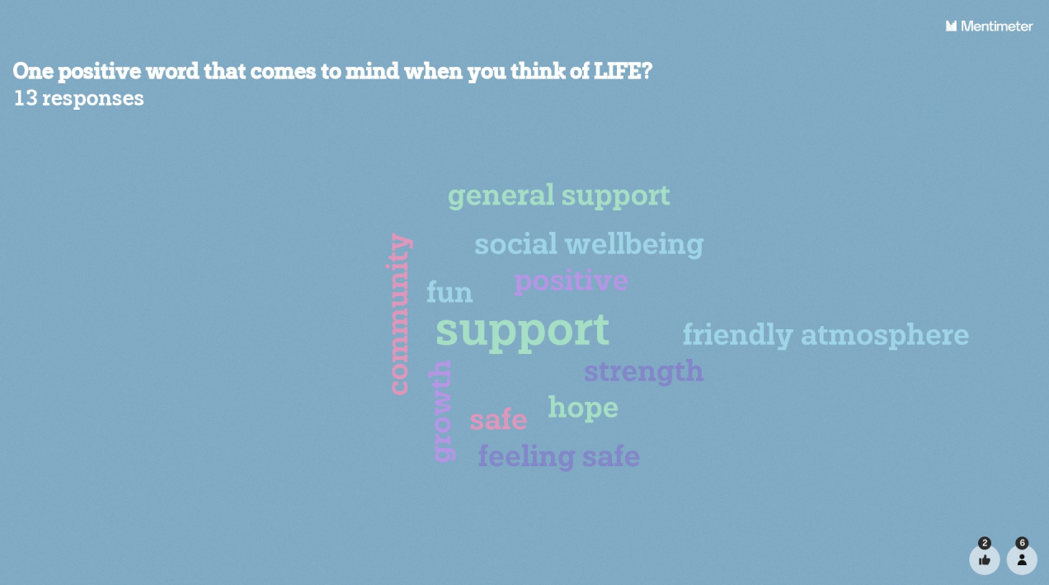
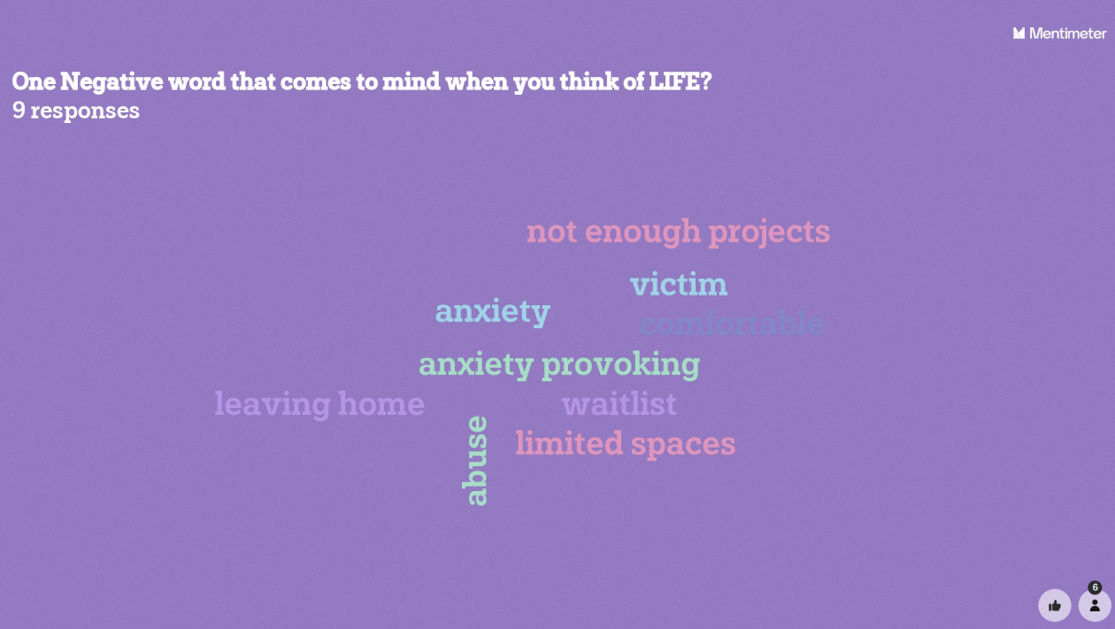
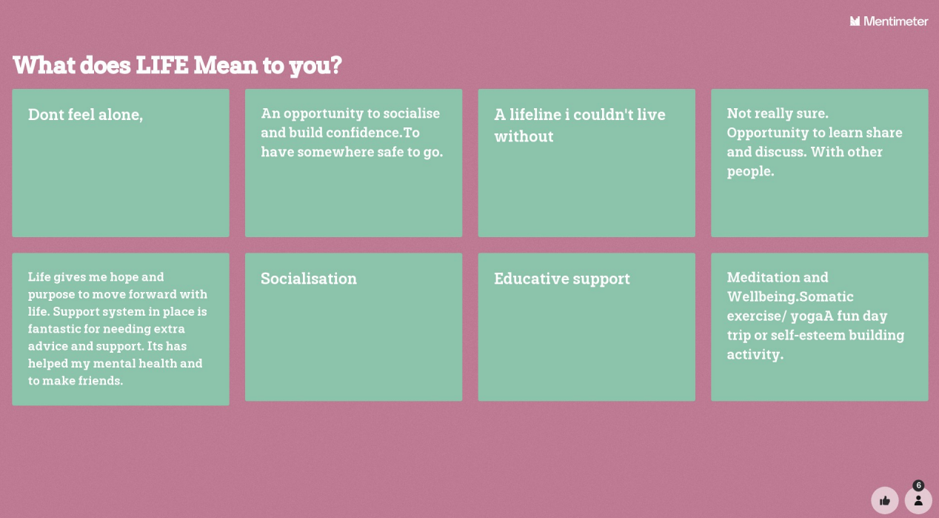
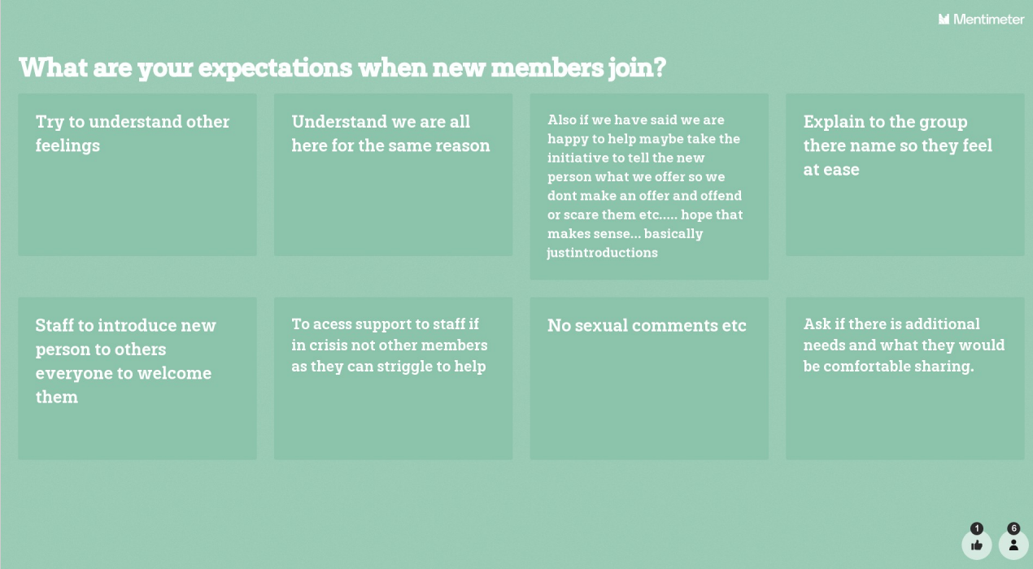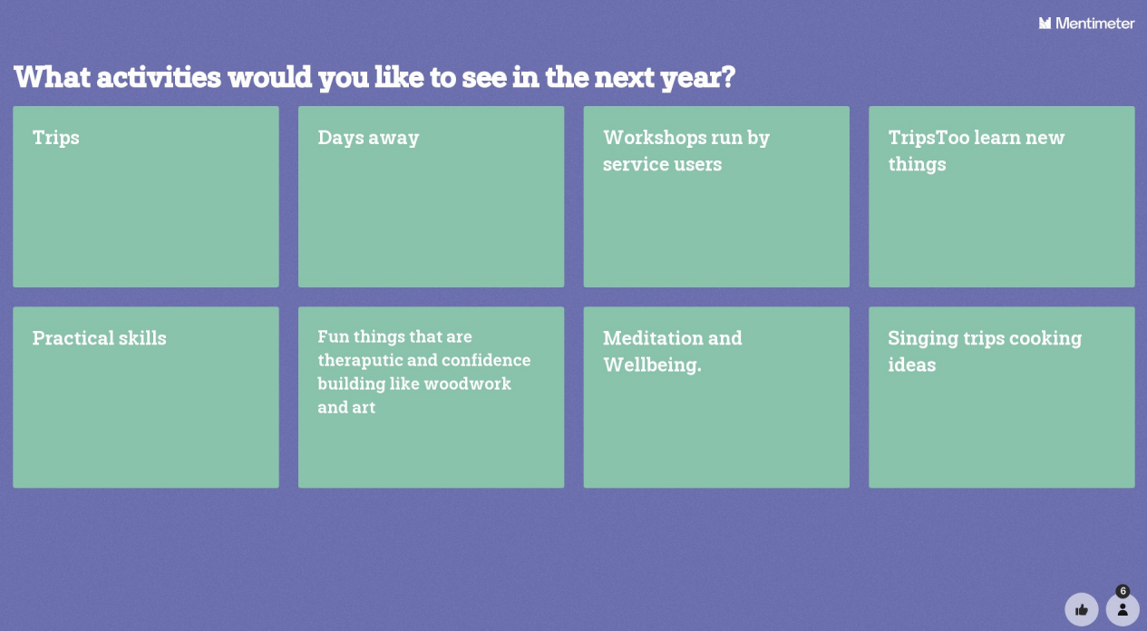
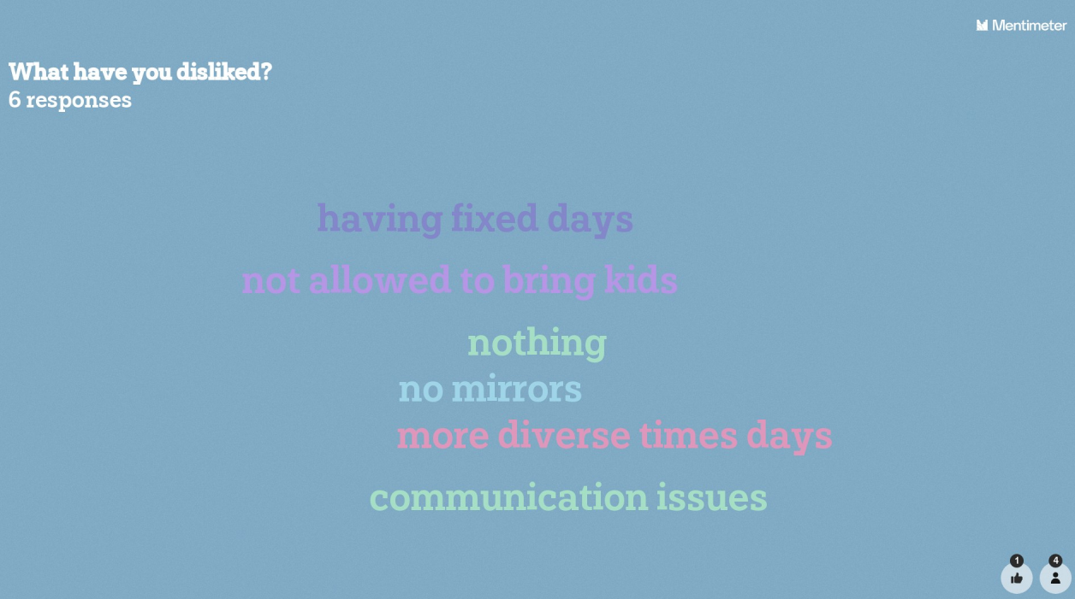
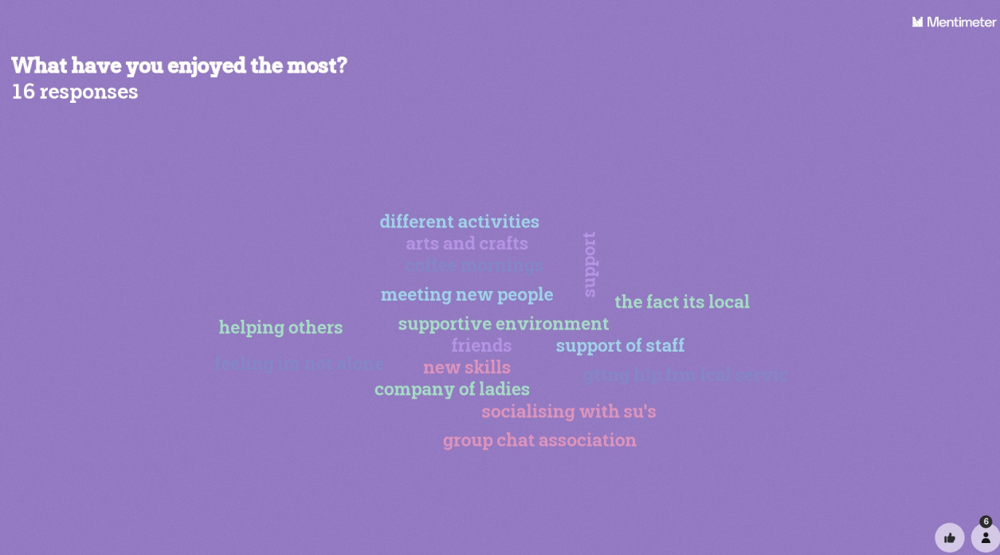
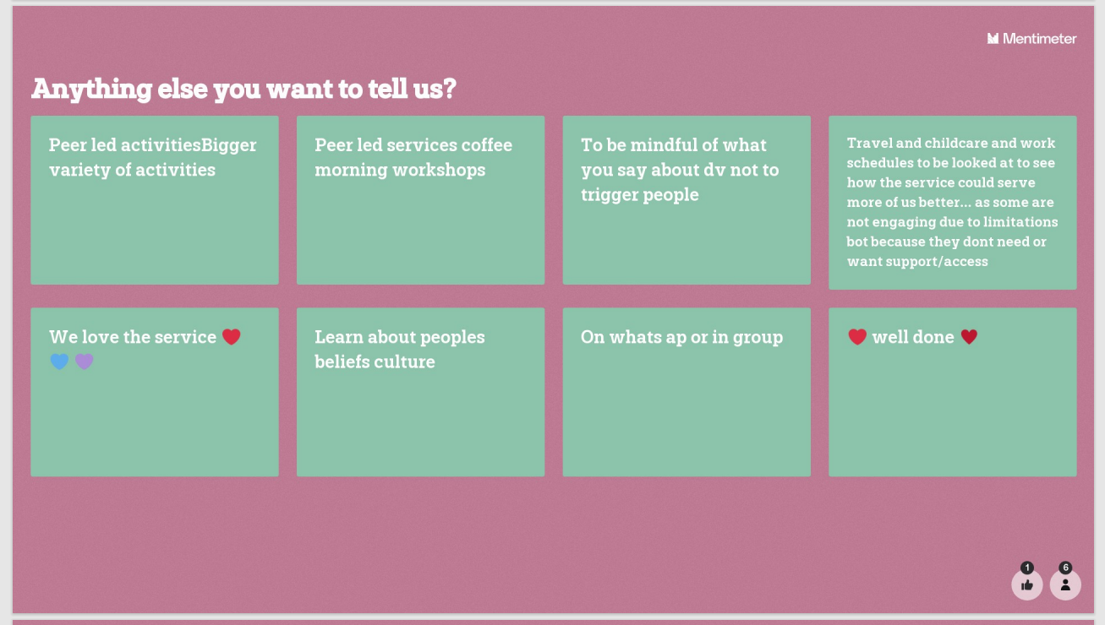
During this activity, participants were allowed multiple responses throughout. However, these answers are only a small subsection of the responses. Before I moved each slide on, I presented the answers to the participants. This ensured that everyone had their say in an anonymous way, however also allowed me to discuss points that were raised, including the project being run only on set days and what we’re looking to do about it. I also informed the participants when the answer “learn about peoples beliefs culture” appeared that this was something that that we were working on which included working with one of our service users who is Muslim, which would incorporate the peer led workshops to design a peer led coffee morning to allow our coffee morning to celebrate Eid later on in the year.

Lesson Plan Template



Lesson Plan

Topic: Evaluation of LIFE Activities |  | Class: Thrive WA LIFE Members
Date: 18/01/2024 | Length of lesson: 90 Minutes |  | Number of students: 6
Resources required:
Wi-Fi Internet
Personal devices for the students
SmartScreen projector
Laptop with menti-meter
Aim of Lesson
To evaluate previous LIFE Activities and plan future LIFE activities
Learning Outcomes – The Learners Should Be Able To:
- The learners should be able to outline their likes and dislikes about previous activities.
- The learners should be able to describe an activity that they would like to do in the future.
- The learners should be able to appraise past activities.
Previous student knowledge required for the session:
Learners should have previously attended at least one LIFE activity or be aware of the project in order to offer feedback on some of the questions, but this is not essential as the lesson also asks students for ideas for the future.
Anticipated difficulties (if applicable):
The students who attend the different activities range in age anywhere from their early twenties to those in their mid-seventies. All students have varying knowledge of using technology and all have different personal devices due to poverty levels with some having devices that cannot connect to the internet at all due to cost. Another anticipated difficulty is the students being able to connect to the internet using their own devices through a data package and for this reason, throughout this lesson the wifi password and loaner laptops will be readily available.
Professional Standards (where are these being met within the session)
In my practice and with others I will demonstrate commitment to learners, their learning, safety and well-being. This is achieved through this consultation by assessing learners starting points and will be using the results to formulate progression options for the learners.
In my practice and with others I will value and promote diversity, equality of opportunity and inclusion. This has been achieved by including the learners in the evaluation process and this advocates for inclusion as this survey allows for students to feedback ideas such as organising activities around school and flying start.
In my practice and with others I will demonstrate dignity, courtesy, and respect towards others. This is achieved by listening to the students’ views, opinions, and ideas for future activities.
In my practice and with others I will plan and deliver effective learning, teaching, and assessment. This is has been achieved through this consultation session as I will be using the results to plan future teaching sessions.
In my practice and with others I will build positive and collaborative relationships. This has been achieved through this consultation activity as it is working to build and maintain a relationship with the learners and get appropriate feedback.
In my practice and with others, I will enable learners to share responsibility for their own learning and assessment. This consultation has empowered learners to take responsibility for their own learning and has enabled me to set targets for future activities and learners to set their own personal targets.
I my practice and with others, I will critically reflect on own values, knowledge and skills to improve learning. Throughout this consultation, I can critically appraise my own work as a result of feedback from the learners.

Lesson Detail:

Stage | Focus | Strategy | Time
Introduction  Development  Plenary/conclusion | Introduce the consultation activity.  Instruct students on how to use mentimeter  One Positive word that comes to mind when you think of LIFE?  One Negative Word that comes to mind when you think of LIFE?  What does LIFE mean to you?  What activities would you like to see in the future?  What are your expectation when new members join?  What have you disliked?  What have you enjoyed the most?  Anything else you want to tell us? | Slide 1 of mentimeter website.  Verbally instruct students on how to use their mobile phones to scan the QR code or how to visit the website and enter the code.  Slide 2  Slide 3  Slide 4  Slide 5  Slide 6  Slide 7  Slide 8  Slide 9 | 10 Minutes  10 Minutes  5 Minutes  5 Minutes  5 Minutes  5 Minutes  10 Minutes  5 Minutes  5 Minutes  15 Minutes

Assessment Strategies: when and how are they included within the lesson?
This lesson is a form of Formative assessment. This is a consultation about previous learning opportunities and will allow for future ideas and building the project around what the students wish to learn in the future.

Informal reflection (to be completed after the session)

This lesson went well, I felt the students got into the activity, despite some initial reluctance and hesitancy to join in as this was a new activity for them and all managed to have their say and feedback.
The students were also able to discuss some issues that were bothersome for them anonymously and share their honest views so that this can influence future activities.

Evaluation and Reflection
For the purposes of this evaluation and reflection, I will be using the Gibbs (1998) reflective cycle.
Description
This lesson was conducted as part of a service user consultation within Thrive WA. This session was used to evaluate the LIFE Project. In preparation for this session, I developed a nine-slide questionnaire using a free mentimeter account, using both word clouds and open-ended questions as the number of functions was limited with evaluation questions such as “What have you disliked?”, “what have you enjoyed the most?” and “Any ideas for future activities”. I set this up on the SmartScreen within the training room.
I made sure to include an instruction slide on the presentation and once we were ready to begin the session, I explained to the six participants what we were going to do, including how to sign into the guest Wi-Fi network and how to scan the QR code to bring the questions up on their device. Once I had made sure that everyone had signed into the website, I moved onto the first question, I allowed 5-10 minutes per question and allowed verbal feedback throughout. I also assisted the participants when they had technical issues. This session took around 90 minutes to allow participants to say what they wanted both verbally and through the question answers.
Feelings
Prior to the session I was feeling quite nervous as this would be the first time, I would be doing anything like this with my service users and I wasn’t sure if they would have the equipment needed to take part such as a mobile phone and mobile data available. I was also apprehensive about the students’ technical availabilities as for lots of them this would be the first time that they used a programme such as this one and they range in age from their mid-twenties to early seventies, so all had differing technical abilities.
During the session, the students showed a little apprehension at the start which made me nervous, however once I had delivered the instructions and they realised how easy it was to connect, they all got into the activity, and this made me feel relieved.
After the session I felt inspired by the answers as this consultation event will pave the way for future learning opportunities for the service users.
Evaluation
This consultation went well as the participants were able to air their feelings and ideas anonymously which was important to them as there was a number of issues that needed to be shared publicly, but no one wanted to bring this up as they felt that they would be blamed by other people. However, this method, also allowed for the more mundane topics to be shared without that taking up too much time. The mundane topics included transport and childcare. This allowed for open discussion about the participants opinions and ideas, including day trips and yoga exercise.
There was an issue with participants as a number had a few technical issues, including accidentally closing down their browsers and not being able to return to the questions and one person joined late so they weren’t able to have their say on earlier questions, so this was mitigated by finishing the question slides and starting again so if I repeated this exercise I would ensure that all participants are available prior to starting the session and any latecomers will be asked to wait until the session had finished to repeat the task.
Analysis
It is important to get feedback on teaching styles and this is something that Reece and Walker (2007) suggests that students when giving feedback either verbally or written would be fearful of giving honest answers and even when written feedback is returned anonymously, students believe that handwriting can be matched which will have an impact on their success.
Kelly (2009) notes that evaluation of the curriculum should be an essential element of change and development in education. This is also supported by McKinlet and Yiannoullou (2012 cited in Beresford 2012) which states that the government has made service user involvement and feedback essential. Beresford (2012) does mention that while service user participation is well-meaning it has limitations as feedback often comes from the most assertive and confident of the group which often exacerbates existing inequalities.
This consultation forms part of an element of co-production. Co-Production can be defined as “the role that service users can play in the service delivery process” (Benjamin and Brudney 2018). McCarry et al (2018) examined the use of co-production within domestic abuse services and noted that women in their study valued a peer support group, very similar to the LIFE project, however explored issues relating to confidentiality due to the small community. Benjamin and Brudney (2018) support McCarry et al (2018) by suggesting that using the voluntary participation of the service users is a fundamental concern of the charity sector and has found that when service users play an active part in co-production, they are generally more motivated and demonstrate higher levels of trust and control (Fledderus and Honingh 2016 cited in Benjamin and Brudney 2018).
Moorhouse et al (2020) mention that Student Response Systems (SRS) like mentimeter can replace traditional methods of responses and maximise participation of students who wouldn’t otherwise participate as responses are anonymous, however one major benefit of using an SRS is that it can be used as a formal evaluation tool, however, Moorhouse et al (2020) mention that the use of this tool may stop the organic conversation and planning with fellow students, however where possible I will ensure that there is enough time for organic conversation in addition to using SRS tools.
Conclusion
This was a successful activity in order to get good evaluation of previous activities. Using mentimeter allowed for both written answers from the quieter participants and allowed for conversation around the answers. The feedback from the student focus group afterwards was quite positive with one participant, who was in her 70’s, noting that she learnt something new. The rest of the participants also noted that they were impressed by the activity and were able to share ideas anonymously, while also having productive conversations.
Action Plan
For the future, I will research additional student response systems and how to integrate them on a regular basis within my teaching practice, I will aim to do this by the summer of 2024.
I will also collate the results of this consultation and plan future activities such as day drips with the service users of the LIFE project. This will be done by the summer of 2024.

References
Aikyo, M. et al., 2018. An Introduction to Technology Based Innovations in Higher Education. In: K. Enomoto, R. Warner & C. Nygaard, eds. Innovative Teaching and Learning Practices. Oxfordshire: Libri Publishing, pp. 12-18.
Avdic, D. & Gartell, M., 2015. Working while studying? Student aid design and socioeconomic achievement disparities in higher education. Labour Economics, 33(33), pp. 26-40.
Benjamin, L. M. & Brudney, J. L., 2018. What do Voluntary Sector Studies Offer Research on Co-Production. In: T. Brandsen, T. Steen & B. Verschuere, eds. Co-Production and Co-Creation Engaging Citizens in Public Services. Abingdon: Routledge, pp. 49-61.
Beresford, P., 2012. The Theory and Philosophy Behind User Involvement. In: P. Beresford & S. Carr, eds. Social care, Service Users and User Involvement. London: Jessica Kingsley Publishers, pp. 20-34.
Connolly, S. L. et al., 2018. Veterans' Attitudes Towards Smartphone App use for Mental Health Care: Qualitative Study of Rurality and Age Differences. JMIR mHealth and uHealth, 6(8), pp. e10748-e10748.
Czerwionka, T., Klebl, M. & Schrader, C., 2010. Lecturing Tomorrow: Virtual Classrooms, User Centred Requirements and Evaluative Methods. In: M. Ebner & M. Schiefner, eds. Looking Toward the Future of Technology- Enhanced Education: Ubiquitous Learning and the Digital Native. Hershey: Information Science Reference, pp. 353-372.
D'Amico, M. M. et al., 2017. A National Analysis of Noncredit Community College Education: Enrollment, Funding, Accountability, and Contextual Issues. Community College Journal of Research and Practice, 41(4-5), pp. 288-302.
Dow-Fleisner, S. J. et al., 2022. Internet access is a necessity: a latent class analysis of Covid-19 related challenges and the role of technology use among rural communiry residents. BMC Public Health, 22(1), pp. 845-845.
Enomoto, K., Warner, R. & Nygaard, C., 2018. The Why, What and How of Innovative Teaching and Learning in Higher educatio. In: R. Enomoto, R. Warner & C. Nygaard, eds. Innovative Teaching and Learning Practices in Higher Education. Oxfordshire: Libri Publishing, pp. 1-12.
Gil-Flores, J., Rodrigues-Santero, J. & Torres-Gordillo, J.-J., 2017. Factors that explain the use of ICT in secondary-education classrooms: The role of teacher characteristics and school infrastructure. Computers in Human Behaviour, Volume 68, pp. 441-449.
Hamilton, E. R., Rosenberg, J. M. & Akcaoglu, M., 2016. The Substitution Augmentation Modification Redefinition (SAMR) Model: a Critical Review and Suggestions for its Use.. Tech Trends, Volume 60, pp. 433-441.
Harkavy, I., Hartley, M., Axelroth Hodges, R. & Weeks, J., 2016. The History and Development of a Partnership Approach to Improve Schools, Communities and Universities. In: H. A. Lawson & D. van Veen, eds. Developing Community Schools, Community Learning Centres, Extended Service Schools and Multi-Service Schools. International Exemplars for Practice Policy and Research. New York: Springer International, pp. 303-321.
Hodge, H., Carson, D., Carson, D. & Newman, L., 2017. Using Internet Technologies in Rural Communities to access services: The views of older people and service providers. Journal of Rural Studies, Volume 54, pp. 469-478.
Huddleston, P. & Unwin, L., 2007. Teaching and Learning in Further Education Diversity and Change. 3rd ed. Abingdon: Routledge.
Jarvis, P., 2010. Adult Education and Lifelong Learning: Theory and Practice. 4th ed. Abingdon: Routledge.
JISC, 2022. Applying the SAMR model to aid your digital transformation. [Online]
Available at: https://www.jisc.ac.uk/guides/applying-the-samr-model-to-aid-your-digital-transformation
[Accessed 15 02 2024].
Kaplan, L., 2020. Community-Based Learning and Identity Status. In: C. Winterbottom, J. S. Nicholson & F. D. Richard, eds. Community-Based Transformational Learning: An Interdisciplinary Inquiry into Student Experiences and Challenges. London: Bloomsbury Academic, pp. 63-79.
Kelly, A. V., 2009. The Curriculum. 6th ed. London: Sage Publications.
Kepez, O., 2018. The Steelcase Active Learning Centre as a Community Design Centre. In: K. Enomoto, R. Warner & C. Nygaard, eds. Innovative Teaching and Learning Practices in Higher Education. Oxfordshire: Libri Publishing, pp. 179-199.
Kurt, S., 2023. SAMR Model: Substitution, Augmentation, Modification, and Redefinition. [Online]
Available at: https://educationaltechnology.net/samr-model-substitution-augmentation-modification-and-redefinition/
[Accessed 16 02 2024].
Learning Theories, 2023. Communities Of Practice (Lave And Wenger). [Online]
Available at: https://learning-theories.com/communities-of-practice-lave-and-wenger.html
[Accessed 27 01 2024].
Mayo, M., 2022. Changes in Community Life. In: R. Evans, E. Kurantowicz & E. Lucio-Villegas, eds. Research on the Education and Learning of Adults. Boston: Brill, pp. 191-204.
Mazuch, R. & Rona, S., 2005. Creating Healing Environments: Humanistic architecture and therapeutic design. Journal of Public Mental Health, 4(4), pp. 48-52.
McCarry, M. et al., 2018. The Potential for Co-production in Developing Violence against Women Services in Wales. Social Policy and Society, 17(2), pp. 193-208.
McTier, A. & McGregor, A., 2011. Integrating employment and skills: the role of community-based learning. Policy Studies, 32(1), pp. 73-90.
Minton, D., 2005. Teaching Skills in Further and Adult Education. 3rd ed. London: Thomson Learning.
Moorhouse, B. L., Kohnke , L., Pun, J. & Hafner, C. A., 2020. Using Mentimeter to Elicit Student Responses in the EAP/ESP Classroom. RELC Journal: A Journal of Language Teaching and Research, 51(1), pp. 198-204.
Morgan-Klein, B. & Osborne, M., 2007. The Concepts and Practices of Lifelong Learning. Abingdon: Routledge.
Office for National Statistics, 2018. Exploring the UK’s digital divide. [Online]
Available at: https://www.ons.gov.uk/peoplepopulationandcommunity/householdcharacteristics/homeinternetandsocialmediausage/articles/exploringtheuksdigitaldivide/2019-03-04
[Accessed 10 02 2024].
Pancham, J. & Millham, R., 2018. Affordable Access to Internet and ICT: A Solution via Telecentres. In: S. Takavarasha Jr & C. Adams, eds. Affordability Issues Surrounding the use of ICT for Development and Poverty Reduction. Hershey: IGI Global, pp. 90-110.
Race, P., 2020. The Lecturer's Toolkit: a practical guide to assessment, learning and teaching. 5th ed. London: Routledge.
Race, P. & Pickford, R., 2007. Making Teaching Work: Teaching smarter in Post-Compulsory Education. London: Sage Publications.
Reece, I. & Walker, S., 2007. Teaching, Training & Learning. 6th ed. Tyne and Wear: Business Education Publishers Limited.
Simply Psychology, 2023. Jerome Bruner’s Theory Of Learning And Cognitive Development. [Online]
Available at: https://www.simplypsychology.org/bruner.html#Scaffolding-Theory
[Accessed 23 01 2024].
Simply Psychology, 2024. John Dewey On Education: Impact & Theory. [Online]
Available at: https://www.simplypsychology.org/john-dewey.html
[Accessed 16 02 2024].
The University of Edinburgh, 2020. Gibbs' Reflective Cycle. [Online]
Available at: https://www.ed.ac.uk/reflection/reflectors-toolkit/reflecting-on-experience/gibbs-reflective-cycle
[Accessed 01 12 2023].
UNESCO, 2024. Information and communication technologies (ICT). [Online]
Available at: https://uis.unesco.org/en/glossary-term/information-and-communication-technologies-ict
[Accessed 11 02 2024].
Vickerstaff, S., 2007. Education, Schools and Training. In: J. Baldock, N. Manning & S. Vickerstaff, eds. Social Policy. Oxford: Oxford University Press, pp. 381-406.
Welsh Government, 2017. Professional Standards for Further Education Teachers and Work-Based Learning Practitioners in Wales, Cardiff: Welsh Government.

