A Mixed-Methods Study of Vocal Educators’ Perspectives on the Use of Artificial Intelligence in Vocal Education: Exploring Hopes, Concerns, and Strategies for Effective Integration

Wende Ann Donahue
Student ID: 2333885

Module 3, BMPF7326D
Voice Study Centre, University of Wales Trinity Saint David
27 July 2025
Word Count: 6525

TABLE OF CONTENTS
I. PROJECT PROPOSAL 5
A. Project Title 5
B. The Context 5
C. The Justification 5
D. The Intended Impact 6
E. The Outlined Intention 6
F. The Ethics and Insider Research 6
G. Personal Learning Outcomes 7
H. Project Timeline 7
REPORT 8
I. INTRODUCTION 8
II. LITERATURE REVIEW 9
A. What is AI? 9
B. Educators’ Perceptions 10
C. Purpose of this Study 14
III. RESEARCH METHODOLOGY 15
A. Research Design 16
B. Phase 1 16
C. Phase 2 18
D. Data Collection 18
E. Ethics and Insider Research 18
F. Data Analysis 19
IV. FINDINGS AND ANALYSIS 20
A. Phase 1: Questionnaire Findings 20
B. Phase 1: Quantitative Analysis 23
C. Phase 1: Open-ended Survey Responses 26
D. Phase 2: Interview Findings and Analysis 27
V. DISCUSSION 28
A. Theme 1: AI as a Tool in Teaching, not a Replacement for Human Teachers 29
B. Theme 2: Concerns on Ethical and Practical Aspects of AI Use 30
C. Theme 3: Encouraging AI Adoption Among Vocal Educators 31
VI. STUDY LIMITATIONS 32
VII. CONCLUSION 32
VIII. REFERENCES 35
Appendix A: Search Table 46
Appendix B: Inclusion/Exclusion Criteria 48
Appendix C: Types of Artificial Intelligence 49
Appendix D: Attitudes Towards Artificial Intelligence Scale (ATTARI-12) 51
Appendix E: Questionnaire 53
Appendix F: Semi-Structured Interview Questions 59
Appendix I: Journals 85
Appendix J: Technology Used 90
Appendix K: Phase 1 Data (redacted) 91
Appendix L: Interview Transcripts (Redacted) 125
Appendix M: Codes (Total: 105) 155
Appendix O: Themes (Total: 7) 157

LIST OF TABLES AND FIGURES

Table 1: AI Opportunities and Concerns (Ghimire et al., 2024, p. 6) 11
Table 2: ATTARI-12 (Stein et al., 2024) 17
Table 3: Likert Scale Items 22
Table 4: Descriptive Statistics 24
Table 5: Comparison (Woodruff et al., 2023) 24
Table 6: Education Level Versus AI Acceptance 25

Figure 1: Educators’ AI Perceptions (Woodruff et al., 2023, p. 16) 10
Figure 2: Pre- (left) and Post-study (right) Word Clouds (Uzumcu and Acilmis, 2024, p. 1117) 12
Figure 3: Student Performance Findings (Gai, 2025, p. 7) 13
Figure 4: SWOT Analysis (Gai, 2025, p. 8) 14
Figure 5: Job Description 20
Figure 6: Highest Level of Education 21
Figure 7: Number of Years Working as a Voice Educator 21
Figure 8: Technology Used 22
Figure 9: Likert Scale Results 23
Figure 10: Spearman Correlation Matrix 25
Figure 11: Thematic Map 28

- PROJECT PROPOSAL

- Project Title

A Mixed-Methods Study of Vocal Educators’ Perspectives on Artificial Intelligence in Vocal Education: Exploring Hopes, Concerns, and Strategies for Effective Integration

- The Context

Artificial Intelligence (AI) is emerging as a valuable tool in vocal education with the potential to expand opportunities for educators and students (Khaydarov, 2024). While research focusing on vocal educators is limited, existing studies on educators indicate a gradual adoption of AI, influenced by pedagogical concerns, psychological barriers, and the limited availability of learning tools tailored to their needs (Barrera Castro et al., 2025). Given my background in both software development and vocal education, I am interested in how AI might support and enhance vocal education. This study explores vocal educators’ perspectives on AI, including their hopes, concerns, and views regarding its use, to identify strategies for the meaningful integration of AI into vocal education.

- The Justification

There is a pressing need for research to determine how best to create an ethical and credible space for AI in vocal education, as the majority of research to date has been conducted from a computer science perspective with minimal input from vocal educators (Ovcharenko et al., 2020). Given AI’s technical origins, it is unsurprising most research comes from that discipline; yet, AI’s practical integration into vocal education requires interdisciplinary collaboration among vocal educators, voice scientists, and AI programmers—exploring AI’s potential while ensuring applications are developed to align with user expectations and needs (Bauer, 2023; Huriye, 2023). To address this gap, this study seeks to identify strategies for AI to become an effective and ethical tool in vocal education by examining vocal educators’ perspectives.

- The Intended Impact

This study aims to understand vocal educators’ AI needs and concerns to provide actionable strategies for AI tool creation and implementation that complement teaching practices and support educators. Additionally, the study aims to foster a dialogue on ethical concerns and pathways for AI adoption by vocal educators.

- The Outlined Intention

This study will employ an explanatory sequential mixed-methods design, combining quantitative and qualitative elements from two consecutive phases—a quantitative phase 1 informing the focus of a qualitative phase 2 (Ivankova et al., 2006).

Phase 1 will consist of an electronic questionnaire containing Likert-scale, multiple-choice, and open-ended items administered to 10 to 20 vocal educators over the age of 18 recruited via social media. The validated Attitudes Towards Artificial Intelligence Scale (ATTARI-12) will be utilised, along with additional vocal education relevant questions (Stein et al., 2024). Phase 2 will involve semi-structured interviews with 2 to 5 volunteers from phase 1 using interview questions developed based on key findings from phase 1. Data will be interpreted using descriptive statistics and thematic analysis. Additionally, I will conduct a literature review focusing on AI in music and vocal education.

- The Ethics and Insider Research

Participants will provide informed consent by reviewing and agreeing to information provided online before beginning the questionnaire. All data will remain anonymous and confidential, and participants may withdraw from the study at any time. This project has undergone ethical review by the University of Wales Trinity Saint David ethics committee.

As a peer to the vocal educators, this will be considered insider research, requiring careful examination of objectivity and subjectivity (Greene, 2014). To mitigate potential bias, triangulation will be employed through a mixed-methods design incorporating a validated Likert scale, semi-structured interviews, literature review, and reflexive journaling.

- Personal Learning Outcomes

- Learn how to design and implement valid and reliable research instruments.
- Learn how to communicate research findings effectively to diverse audiences.
- Learn how to use thematic analysis.
- Improve academic writing skills.

- Project Timeline
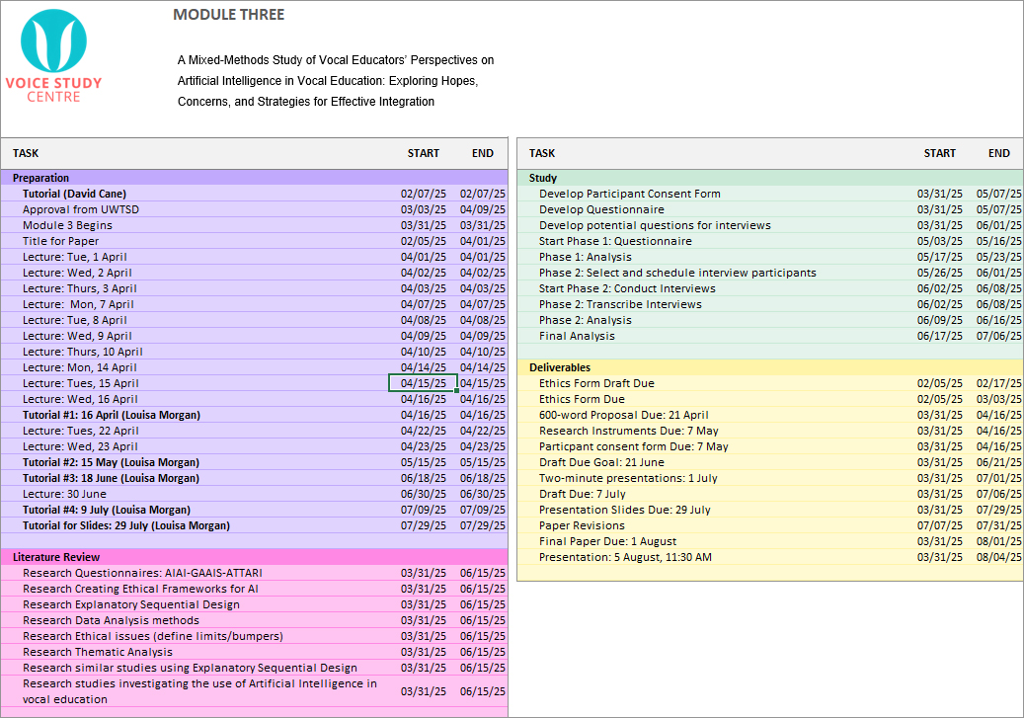

REPORT
A Mixed-Methods Study of Vocal Educators’ Perspectives on the Use of Artificial Intelligence in Vocal Education: Exploring Hopes, Concerns, and Strategies for Effective Integration

- INTRODUCTION

Artificial Intelligence (AI) is emerging as a valuable tool in vocal education with the potential to expand opportunities for educators and students (Khaydarov, 2024). While initial studies on educators indicate a gradual adoption of AI, influenced by pedagogical concerns, psychological barriers, and limited availability of tools customised to meet educators’ needs, research specifically focused on vocal educators remains scarce (Barrera Castro et al., 2025). Additionally, AI research in music and vocal education has predominantly been conducted from a computer science perspective with minimal input from vocal educators (Ovcharenko et al., 2020). Given AI’s technical roots, it is unsurprising most research originates from that discipline; however, ensuring AI’s practical integration into vocal education requires interdisciplinary collaboration between vocal educators, voice scientists, and AI programmers, exploring AI’s potential while developing AI applications that align with user expectations and needs (Bauer, 2023; Huriye, 2023).

To address this scholarly gap, this study examines vocal educators’ perspectives, including their hopes and concerns, to identify actionable strategies for the effective and ethical integration of AI into vocal education. With AI's increasing prevalence in our culture, understanding perceptions is essential for addressing concerns and identifying societal needs (Stein et al., 2024). Given my background in both software development and vocal education, I am interested in exploring how AI might support and enhance teaching practices.

As part of this research assignment, I have identified the following Individual Learning Outcomes (ILOs) to strengthen my research knowledge and progress towards publication:
- ILO1: Learn how to design and implement valid, reliable research instruments.
- ILO2: Learn how to communicate research findings effectively to diverse audiences.
- ILO3: Learn how to use thematic analysis.
- ILO4: Improve academic writing skills.

- LITERATURE REVIEW

Given the limited research in this emerging field, this study adopted a narrative literature review approach to evaluate existing literature (Sarkar and Bhatia, 2021; Sukhera, 2022; Liu and Guo, 2025).

The literature search strategy used keywords in Google Scholar, Google, and the University of Wales Trinity Saint David (UWTSD) online library, using an iterative approach to refine keyword combinations and strengthen results (Aromataris and Riitano, 2014). Backward snowballing—examining cited sources—and forward snowballing—identifying studies citing the selected literature—were employed (Jalali and Wohlin, 2012a) (Appendix A: Search Table).
Inclusion/exclusion criteria focused on AI in education, particularly music or vocal education, prioritising recent research studies, and using the CRAAP test (Currency, Relevance, Authority, Accuracy, and Purpose) (Blakeslee, 2004) (Appendix B: Inclusion/Exclusion Criteria). With emerging and established researchers in this field publishing via non-traditional outlets, evidence from grey literature—including PhD dissertations, conference proceedings, online videos, and websites—was incorporated alongside available peer-reviewed literature.

- What is AI?

Artificial Intelligence is a technology that allows computers to simulate human intelligence and problem-solving skills (IBM, 2024). First theorised by Alan Turing in 1950, AI has rapidly evolved over the last two decades due to advancements in machine learning—algorithms self-improving through experience—and neural networks—algorithms inspired by the human brain—leading to today’s availability of AI-driven personal assistants, search engines, and proofreading tools (Fang et al., 2018; Keita, 2023). AI is classified into three categories: Narrow, General, and Superintelligence, with all currently available tools falling in the Narrow AI category—designed to focus on one specific function at a time (Appendix C: Types of Artificial Intelligence) (Khan, 2021). General AI—comparable cognitive abilities to humans—and Artificial Superintelligence—intellect beyond human capacity—are hypothetical at this time (Fang et al., 2018; Tenser, 2025).

- Educators’ Perceptions

Although AI is rapidly evolving, many industries have been slow to adopt AI due to concerns about job displacement, ethics, privacy, and non-transparent development (Grassini, 2023; Konidena et al., 2024). In education, teachers’ varying comfort levels with technology, perceived complexity of AI-driven systems, and limited teacher training can lead to scepticism and hesitance (Woodruff et al., 2023; Walter, 2024; Barrera Castro et al., 2025). Despite these challenges, AI tools are increasingly being integrated into education, assisting in generating lesson plans, detecting learning disorders, and facilitating personalised learning (Bransen, 2024; University of San Diego, 2024). With AI’s growing prevalence in education, it is important to understand educators’ perspectives, particularly their needs and concerns (Stein et al., 2024; Cheng et al., 2025).

To examine educators’ perceptions in adopting AI, Woodruff et al. (2023) conducted a large-scale study of 4528 educators in primary and secondary education across the United States and Puerto Rico. Using close-ended questions, 58% of respondents reported a positive AI opinion and openness to its use in curriculums, 17% indicated a negative AI perception, and the remainder reported a neutral opinion (Figure 1: Educators’ AI Perceptions).

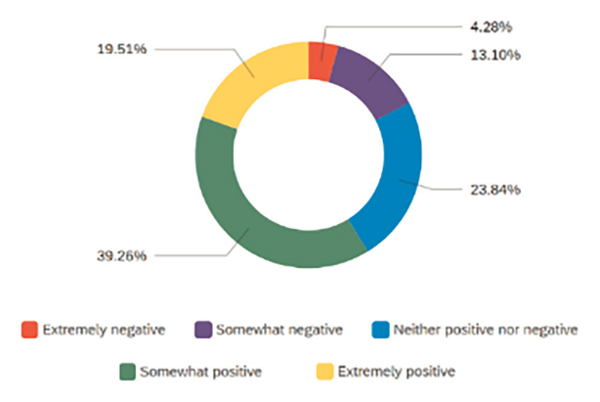
Figure 1: Educators’ AI Perceptions (Woodruff et al., 2023, p. 16)

However, the study relied solely on quantitative methods, limiting its ability to uncover the reason behind educators’ opinions or their pedagogical needs related to AI, a gap the present study endeavours to address (Woodruff et al., 2023; Lim, 2024b).

Ghimire et al. (2024) offered a broader view using a mixed methods approach to explore concerns and opportunities driving perceptions regarding AI integration in a study with 116 educators using Likert-scale items, free-form text entries, and optional interviews. Participants’ concerns included “focus on product over process” and “incorrect or fabricated results,” while opportunities included “automate mundane tasks" and "personalised teaching" (Table 1: AI Opportunities and Concerns).

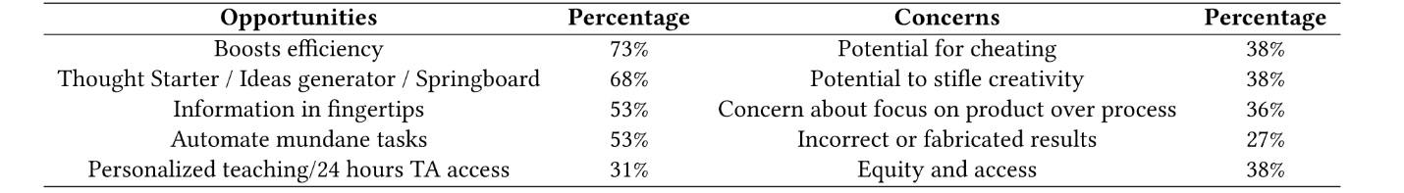
Table 1: AI Opportunities and Concerns (Ghimire et al., 2024, p. 6)

One theme revealed educators were more receptive to utilising AI tools with advanced students, but expressed concern introductory-level students would not develop adequate subject understanding (Ghimire et al., 2024).

Ghimire et al. were able to uncover deeper pedagogical and ethical concerns influencing AI adoption; however, the study did not recommend strategies for changing perspectives or integrating AI into curriculums (Shannon-Baker, 2016; Ghimire et al., 2024).

In a study exploring how experience shapes perception, Uzumcu and Acilmis (2024) examined how exposure with AI-driven music tools influenced educators’ views and comfort levels. A word cloud was generated to represent the frequency of terms stated by participants visually. Initially, the word “robot” was among the most frequently cited words along with “technology” and “innovation”, while after AI exposure, words such as “technology” and “computer” were prevalent (Figure 2: Pre- and Post-study Word Clouds). The most striking item was the appearance of the word “ease” once teachers understood better how AI functions, demonstrating a perceptual shift towards AI following hands-on experience (Uzumcu and Acilmis, 2024).

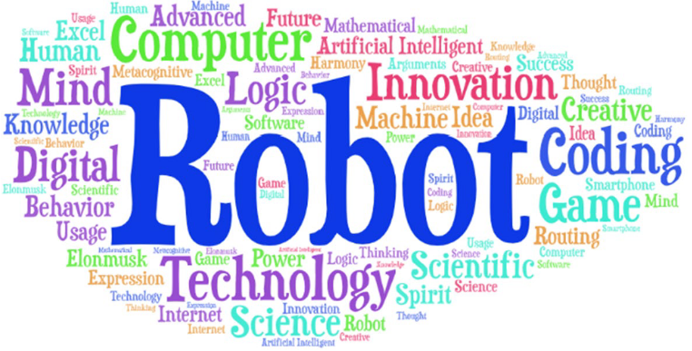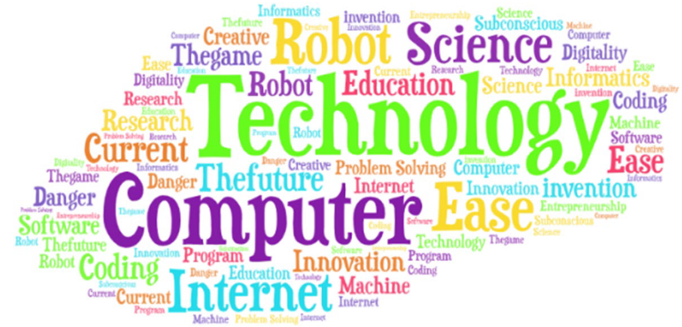

Figure 2: Pre- (left) and Post-study (right) Word Clouds (Uzumcu and Acilmis, 2024, p. 1117)

Building on these findings and methodological strategies, the present study examines vocal educators’ perceptions of AI to uncover the reasons behind their attitudes and identify strategies that address ethical and pedagogical concerns, laying the groundwork for subsequent investigations into the practical use of AI tools in vocal education (Grassini, 2023).

In one study testing AI tools in vocal education, Sing Like Me and Flow Machines were the focus of Gai’s (2025) 6-month study involving 267 vocal students. The tools aimed to refine diction, breathing, intonation, and overall expressiveness through personalised lessons. Student progress was assessed using performance metrics and a structured SWOT (Strengths, Weaknesses, Opportunities, and Threats) analysis, revealing consistent improvement in the students who used the AI tools compared to the control group who did not, stabilising by the fifth and sixth months (Figure 3: Student Performance Findings).

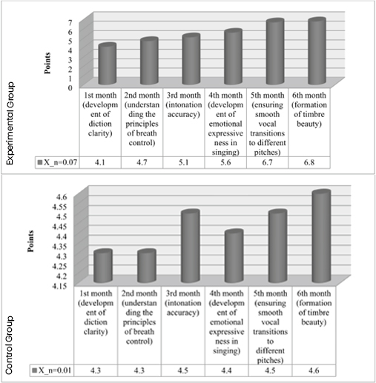
Figure 3: Student Performance Findings (Gai, 2025, p. 7)

SWOT analysis highlighted positives such as lesson individualisation and vocal range expansion, and negatives including limited technical proficiency and privacy concerns related to data visibility (Figure 4: SWOT Analysis). The study demonstrated measurable improvements through AI-supported instruction and addressed AI adoption challenges, while raising questions about pedagogical integration of digital tools without undermining human-led instruction (Gai, 2025).
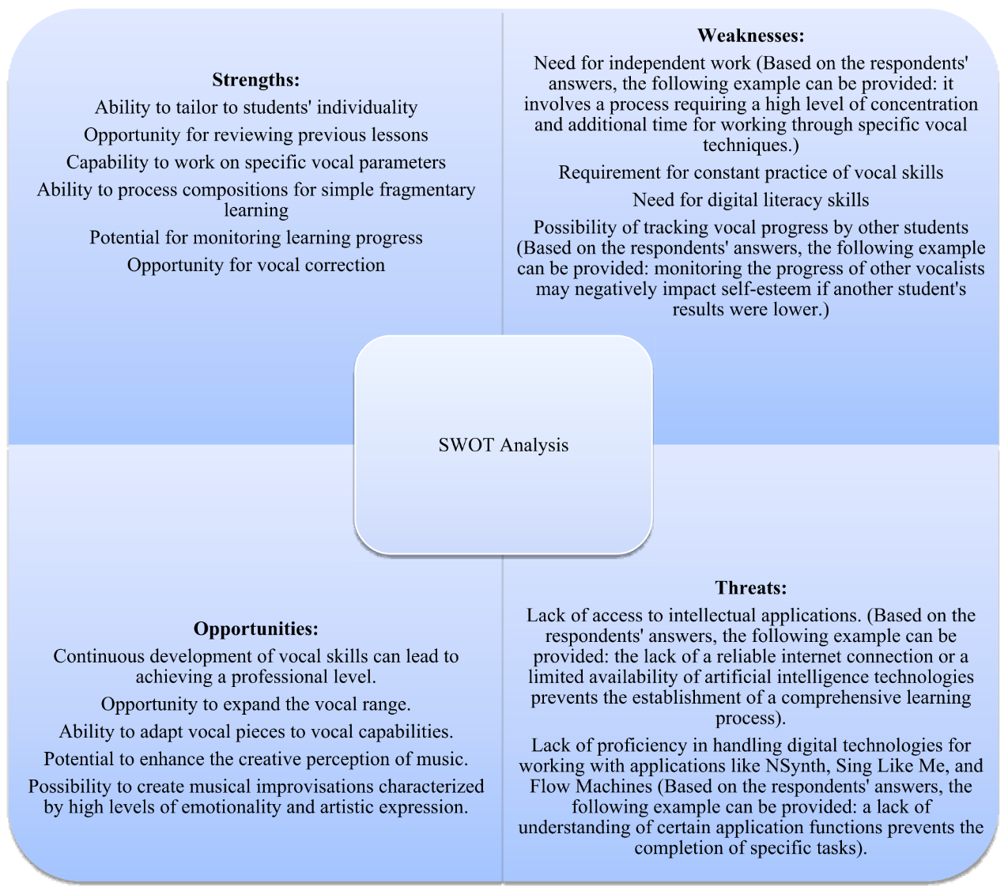
Figure 4: SWOT Analysis (Gai, 2025, p. 8)

While Gai (2025) demonstrated AI integration into vocal education can be effective, the study focused on existing AI applications rather than understanding educators’ perspectives or examining integration strategies. The present study addresses this gap by exploring vocal educators’ perceptions, identifying ways AI tools can support and align with their instructional needs.

- Purpose of this Study

While current research highlights AI’s efficiency gains and pedagogical benefits in education, the limited studies on AI in vocal education create a knowledge gap to be addressed (Liu and Guo, 2025; Uzumcu and Acilmis, 2024; Zhang et al., 2024). Understanding vocal educators’ perspectives—whether they see AI as an assistive tool or a potential disruptor—is essential for ensuring its ethical and practical integration into vocal instruction (Grassini, 2023). This requires proactively developing ethical frameworks, training resources, and pedagogical strategies aligned with vocal instructors’ needs (Barrera Castro et al., 2025; Cheng et al., 2025). Without comprehensive research, vocal educators risk integrating new methods without adequate preparation or delaying adoption, slowing the progress of pedagogical innovation (Ghimire et al., 2024).

This study explores vocal educators’ perspectives on AI use in vocal education, examining their hopes and concerns to recommend actionable strategies for effective integration by addressing the research questions:
- What are vocal educators’ perspectives on integrating AI into vocal education?
- How can AI be ethically and effectively integrated into vocal education and meet the needs of educators?

To support the work-based nature of these questions, it was essential to adopt a methodological approach capable of exploring practitioners’ perceptions and uncovering the reasons behind them.

- RESEARCH METHODOLOGY

Before conducting research, researchers must establish their theoretical framework, referred to as a paradigm—a set of shared beliefs shaping research decisions and informing data interpretation (Guba and Lincoln, 1994; Brown and Dueñas, 2020). I align closest with Critical Realism (CR), a paradigm developed by Roy Bhaskar in the 1970s and 1980s (Bhaskar, 1975). CR seeks to identify relationships between facts to explain how and why events occur (Shannon-Baker, 2016; Lawani, 2021).

Axiologically, CR acknowledges the subjectivity and bias in research and epistemologically seeks to uncover the deeper mechanisms shaping observable phenomena (Lawani, 2021; McEvoy and Richards, 2003; Pretorius, 2024; Blundel, 2007). Ontologically, CR proposes reality is stratified into three layers: the real (independent yet related underlying mechanisms), the actual (observable events), and the empirical (measurable events) (Lawani, 2021).

- Research Design

CR’s stratified ontology aligns well with a mixed-methods approach, allowing quantitative findings to guide qualitative exploration and uncover causal mechanisms (Shannon-Baker, 2016). Quantitative research measures observable data, often beginning with a hypothesis tested to understand a phenomenon (Swanson and Holton, 2010; Goundar, 2012; Patel and Patel, 2019; Lim, 2024a). This approach may oversimplify relationships between variables and discount a researcher’s ability to interpret and construct meanings (Goundar, 2012; Lim, 2024a).

Qualitative research is non-numerical, utilising word-based analysis to explore behaviours, perspectives, and experiences in depth (Lim, 2024b). However, it has weaknesses such as limited generalizability and susceptibility to researcher bias—projecting personal beliefs onto study design or analysis (Goundar, 2012; Lim, 2024b).

Mixed-methods research combines both approaches, leveraging their strengths complementarily, to examine different aspects of a phenomenon (Ercikan and Roth, 2006; Boeren, 2018). While a convergent parallel design was considered—with simultaneous collection of qualitative and quantitative data—an explanatory sequential design was chosen, allowing the initially captured data in phase 1 (quantitative) to inform the focus of phase 2 (qualitative) to explain initial findings and explore underlying factors (Ivankova et al., 2006; Fryer, 2022).

- Phase 1

Phase 1 consisted of an online questionnaire comprising Likert, multiple-choice, and open-ended items administered to 34 vocal educators aged 18+, all currently active in the field, recruited via social media platforms (Appendix J: Phase 1 Data). Likert scales quantify participant opinions to produce ordinal data through the use of carefully constructed questions with response options, typically on a five-point scale from “strongly disagree” to “strongly agree” (South et al., 2022; Tanujaya et al., 2023).

Several validated AI perception scales were considered: Schepman and Rodway's (2020) complex 20-item General Attitudes Toward Artificial Intelligence Scale (GAAIS), Sindermann et al.’s (2021) concise 5-item Attitude Toward Artificial Intelligence scale (ATAI), and Kieslich et al.’s (2021) fear-based Threat of Artificial Intelligence scale (TAI) (Grassini, 2023; Cheng et al., 2025; Hitsuwari and Takano, 2025).

To support a balanced assessment of positive and negative AI aspects and facilitate administration through a concise set of Likert items, the study employed Stein et al.’s (2024) Attitudes Towards Artificial Intelligence Scale (ATTARI-12), a 12-item Likert scale measuring affective, cognitive, and behavioural attitudes (Stein et al., 2024; Gnambs et al., 2025; Juranek, 2025) (Table 2: ATTARI-12). While sometimes criticised for its overly broad contextual applicability, the instrument aligned well with this study’s needs (Krägeloh et al., 2024; Gnambs et al., 2025). The ATTARI-12 includes reverse-coded items—questions worded negatively—used to reduce acquiescence bias and fatigue (Suárez-Álvarez et al., 2018).

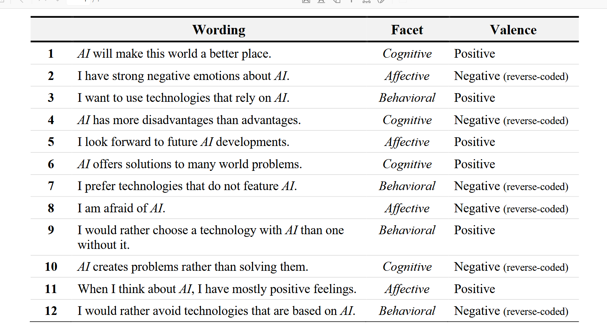
Table 2: ATTARI-12 (Stein et al., 2024)

To gather more direct vocal education perspectives, a Likert item was added: “I can see positive uses for AI in vocal education”. Additional close-ended questions gathered demographic data and information on vocal educators’ current technology use. Anticipating a higher number of questionnaire respondents than interview participants, and to gather additional qualitative data, two open-ended questions captured vocal education specific responses: “What do you consider the biggest challenge in providing vocal education?” and “Is there anything that you wish AI could assist you with in providing vocal education?” (Glasow, 2005; Braun et al., 2021) (Appendix D: Questionnaire). These responses aided in structuring questions for phase 2.
- Phase 2

Phase 2 employed semi-structured interviews with nine phase 1 participants to gain deeper insight into vocal educators’ needs and concerns. All available participants who volunteered were interviewed individually via Zoom, yielding 265 minutes of audio/video data. Transcripts were generated using Zoom’s built-in AI tool, which I later reviewed manually, correcting errors and removing off-topic content (Appendix K: Transcripts). Six questions were developed based on phase 1 findings, beginning with a question inviting participants to elaborate on their previously identified biggest teaching challenges. Question 2 was intentionally polarising: "Do you believe AI could complement or potentially disrupt traditional vocal pedagogy? Why?", encouraging participants to justify both extreme and neutral perceptions reported on the Likert scale. Participants organically guided the discussion, while additional questions examined their AI knowledge and use, concerns about integrating AI into vocal education, potential opportunities for AI, and strategies to help increase vocal educators' comfort using AI (Appendix E: Semi-Structured Interview Questions).

- Data Collection

Questionnaire data were collected using Google Forms, stored securely in a password-protected Google Sheet, and interview transcripts were saved as Microsoft Word documents in a secure directory. Participant anonymity was maintained across both formats through coded identifiers. To ensure ethical transparency, participants were informed of the study’s purpose, their role, and data security and retention timelines. Informed consent was obtained electronically before beginning the questionnaire. Participants were informed they could skip questions, exit the questionnaire at any time, or withdraw their data during the collection phase; however, once analysis began, data removal would no longer be possible (Appendix F: Participant Information and Consent Forms). The University of Wales Trinity Saint David Ethics Committee provided approval for the study (Appendix G: Application for Ethical Approval).

- Ethics and Insider Research

In addition to ethical transparency about the study’s purposes, it is important for researchers to avoid bias—any influence potentially altering the study’s results, intentionally or unintentionally, during all research stages (Resnik, 2015). As a peer to the vocal educators, my positionality as an insider researcher—a member of the studied community—required careful balancing of objectivity and subjectivity to minimise bias (Greene, 2014; Resnik, 2015; Yvonne Bulk and Collins, 2024).

During the semi-structured interviews, I strived to remain neutral to prevent influencing participants’ responses or compromising data validity (Fleming, 2018). Reflexive journaling was employed to critically evaluate interview practices and mitigate potential value conflicts between my technological perspectives and those expressed by participants (Basit, 2013). The aim was to be cognizant of potential risks rather than avoid them, recognising insider research can uniquely interpret and conceptualise data and participant experiences (Humphrey, 2013).

To further mitigate bias and strengthen data validity, triangulation was employed integrating a mixed-methods design along with a literature review and reflexive journaling (Greene, 2014) (Appendix H: Journals). Triangulation can help mitigate divergent findings emerging between research phases in data collected anonymously versus in-person or due to the quantitative component’s insensitivity to complex human experiences (Creswell and Garrett, 2008).

- Data Analysis

Phase 1’s quantitative data was analysed by summarising response patterns using medians, means, modes, and analysis of variance (ANOVA) utiising Jamovi and Microsoft Excel. Phase 1’s open-ended responses and phase 2’s interview transcripts were evaluated using a classic inductive thematic analysis, where themes emerge from the data, while integrating latent thematic analysis to identify unstated patterns and meanings utilising Taguette, Microsoft Word, and Microsoft Excel (Alkharusi, 2022; Naeem et al., 2023) (Appendix I: Technology Used). Analysis included immersion in the data, first and second coding cycles (succinct researcher shorthand), code categorisation, theme development, and recursive review and refinement (Saldaña, 2013). Together, the statistical and thematic analyses provided a scaffold for examining patterns across the full dataset (Bowen et al., 2017).

- FINDINGS AND ANALYSIS

- Phase 1: Questionnaire Findings

To contextualise participants' education and experiences, the questionnaire collected data on job descriptions (multi-selection), with most identifying “voice teacher” as a part of their professional role (Figure 5: Job Description), highest level of education completed (Figure 6: Highest Level of Education Completed) with the majority of participants evenly split between undergraduate and postgraduate degrees (15 each), and years working as a voice educator with the majority reporting more than 20 years in the industry (Figure 7: Number of Years Working as a Voice Educator).

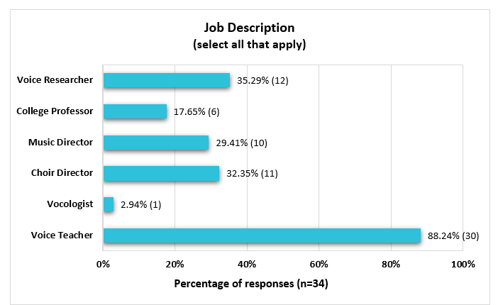
Figure 5: Job Description

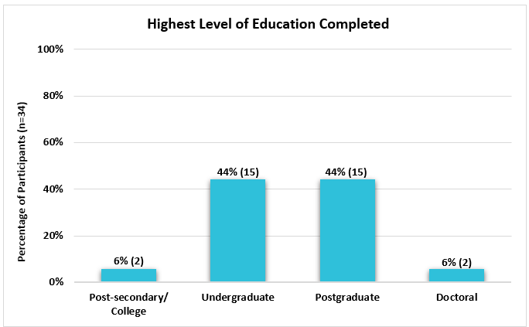
Figure 6: Highest Level of Education

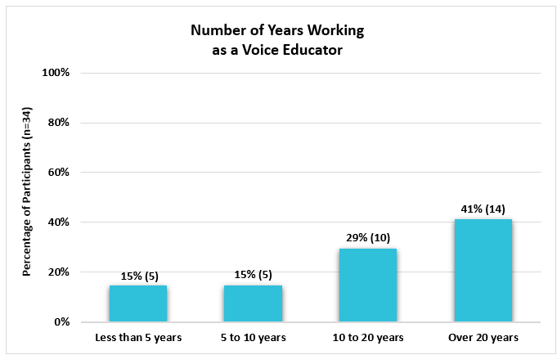
Figure 7: Number of Years Working as a Voice Educator

To assess comfort levels, participants were asked about their technology use in vocal education (multi-selection). All participants reported using technology in teaching, with prerecorded accompaniments and video conferencing cited most frequently (Figure 8: Technology Used).
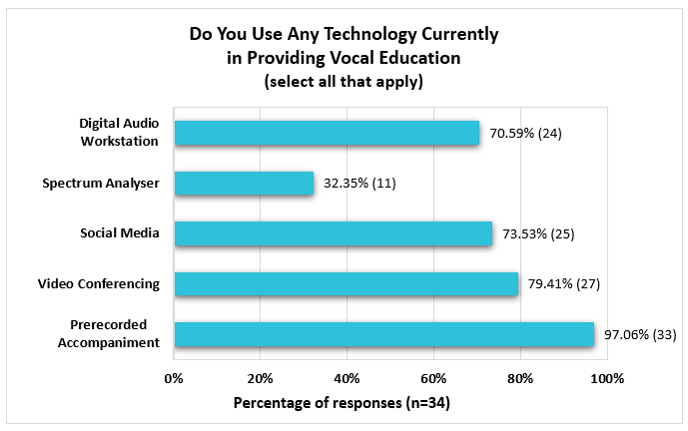
Figure 8: Technology Used

The next questionnaire section utilised a Likert scale (Table 3: Likert Scale Items). Reverse-coded questions were normalised by inverting the responses (using the formula 6 – x), enabling accurate comparison across positively and negatively worded items, where higher means indicated more positive AI perceptions (Datapott Analytics, 2022).

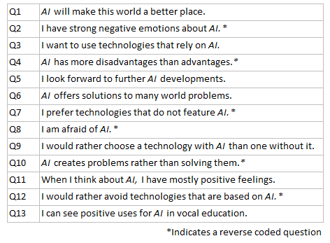
Table 3: Likert Scale Items

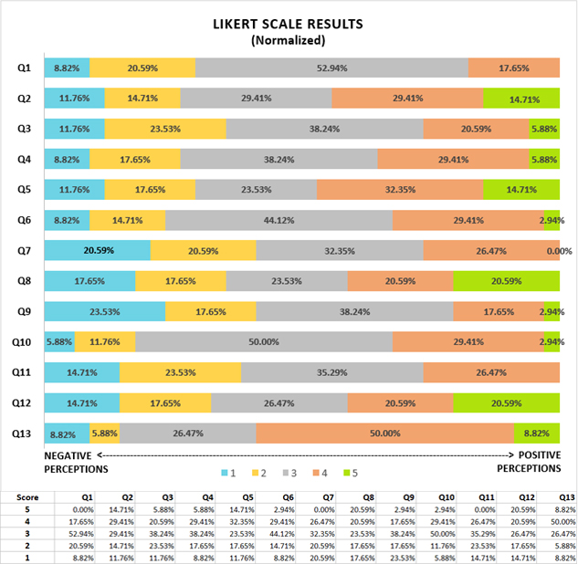
Figure 9: Likert Scale Results

- Phase 1: Quantitative Analysis

Following data normalisation, mean values across Likert items ranged from 2.59 to 3.44, with most items yielding a median of 3—suggesting a neutral stance overall—while Q13 (“I can see positive uses for AI in vocal education”) had a median of 4 (Figure 9: Likert Scale Results). The mode was 3 for most questions, with a mode of 4 in Q2 (“I have strong negative emotions about AI.”), Q5 (“I look forward to further AI developments”), and Q13 (“I can see positive uses for AI in vocal education”), showing higher levels of positivity in these areas (Table 4: Descriptive Statistics).

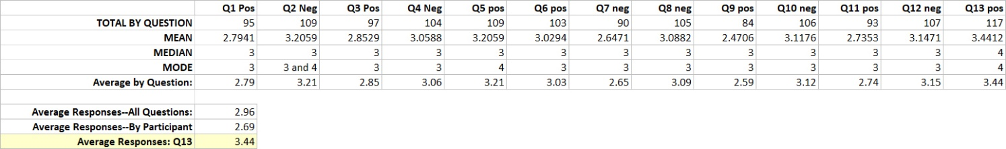
Table 4: Descriptive Statistics

Compared to the earlier study by Woodruff et al. (2023), these findings reflect fewer Extremely Negative responses, a notable reduction in Somewhat Negative responses, and a slight increase in Extremely Positive perceptions (Table 5: Comparison). Differences may stem from shifts in public AI perception since Woodruff’s data collection, or variations in research instruments or participants (Naeem et al., 2023).
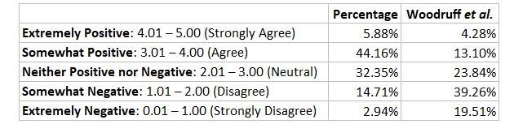
Table 5: Comparison (Woodruff et al., 2023)

A Spearman Correlation Matrix revealed strong correlations between the positively-worded questions, including Q13, and among the negatively-worded questions, reinforcing the ATTARI-12’s established high internal consistency (Gnambs et al., 2025). Notably, Q2 and Q5 exhibited a strong inverse relationship when reverse-coded (ρ = 0.722), suggesting enthusiasm for AI may correlate with reduced emotional resistance (Figure 10: Spearman Correlation Matrix).

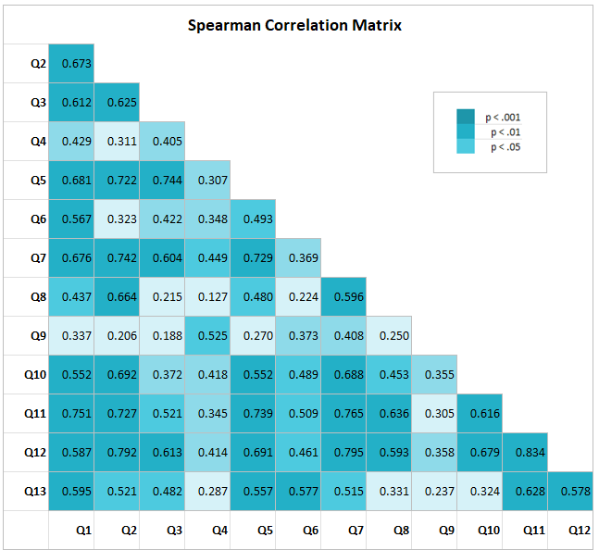
Figure 10: Spearman Correlation Matrix

While ANOVA results revealed no statistically significant differences in AI attitudes based on years of experience or job description, a significant correlation (0.035) emerged between Q9 (“I would rather choose a technology with AI than one without it”) and participants’ highest level of education. Further analysis of Q9 responses by education level indicated individuals with doctorates displayed the highest mean response (x̄ = 3.5), while those with post-secondary education showed the lowest (x̄ = 1.5). This suggests higher education may correlate with greater AI tool acceptance, although this interpretation is tentative given the small sample size (Table 6: Education Level Versus AI Acceptance).

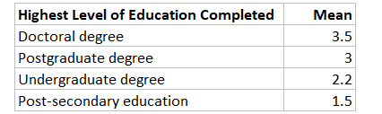
Table 6: Education Level Versus AI Acceptance

Despite the overall neutrality across most items (x̄ = 3), Q13 yielded a more positive response (x̄ = 3.44 and mode = 4). All participants noted using technology in their teaching, regardless of their AI positionality. These trends suggest openness to AI when tools are familiar or understood, aligning with Uzumcu and Acilmis’s (2024) study finding exposure influenced AI perceptions.

The Likert scale data did not yield definitive conclusions on AI perceptions. Likert scales can be affected by response biases: central tendency (avoiding extreme responses), acquiescence (agreeing with items), and social desirability (selecting favourable responses) (Alkharusi, 2022). Although some results may reflect response bias, the limitations of Likert scales in uncovering causal mechanisms underscore the importance of including qualitative data from phase 1 to help interpret correlations and reveal deeper insights (Braun and Clarke, 2008; Fryer, 2022).

From a Critical Realist perspective, correlations alone do not establish causality, but rather point to mechanisms driving perceptions of AI adoption (Lawani, 2021). To identify the underlying reasons for these perspectives, the quantitative data were triangulated with thematic codes from two open-ended survey questions and nine semi-structured interviews (Toyon, 2021).

- Phase 1: Open-ended Survey Responses

To discover vocal education needs potentially aligned with AI tools, participants responded to two open-ended questions: “What do you consider the biggest challenge in providing vocal education?” and “Is there anything that you wish AI could assist you with in providing vocal education?” Thematic analysis revealed recurring patterns, with several overlapping codes between the two questions, highlighting shared concerns with potential opportunities for AI integration (Fryer, 2022). Key themes include: business administration, repertoire selection, vocal diagnostics, and student-individualised lesson plans, which were explored further in phase 2.

Although these responses identified key vocal educators’ needs and AI opportunities, they provided limited insight into the participants’ underlying attitudes. Similarly, the prevalence of neutral Likert scale responses did little to deepen the interpretation. However, it did serve as a point of conversation, prompting participants to reflect on AI’s role in vocal education, facilitating further exploration through interviews.
- Phase 2: Interview Findings and Analysis

In the context of critical realism, the three stratified layers—empirical, actual, and real—correspond roughly with thematic analysis stages —data, codes, and themes—respectively (Fryer, 2022). Using an iterative approach, phase 1 and phase 2 qualitative data (the empirical) were coded (the actual), then categorised and refined into seven primary themes (the real) in order of prevalence representing potential causal explanations for educators’ perceptions, concerns, and pathways to AI integration (Appendix L: Codes; Appendix M: Groupings; Appendix N: Themes) (Onwuegbuzie and Frels, 2014).

- Theme 1: AI as a Tool, not a Replacement for Human Teachers—AI may be an effective tool in vocal education, but it is unable to replace humans.
- Theme 2: Concerns on Ethical and Practical Aspects of AI Use—Concerns included affordability, environmental impact, responsible tool creation, and technological inaccuracies.
- Theme 3: Encouraging AI Adoption Among Vocal Educators—Strategies to promote comfort with AI use in vocal education.
- Theme 4: AI Tools Supporting Student Learning and Practice—AI tools to support student education and individual practice.
- Theme 5: Individualising Voice Lessons Using AI to Support Student Needs—AI’s potential to assist educators in structuring individualised lessons.
- Theme 6: AI-Based Diagnostic, Assessment, and Visualisation Tools—AI-based diagnosis of pathologies, vocal assessments, and real-time visualisation tools.
- Theme 7: Discoverability of Good Information—Assistance with finding current, digestible, and accurate pedagogical literature.

Figure 11 presents a thematic map illustrating the relationships among the identified themes. The first three themes represent conditions required for AI integration, while the subsequent themes reflect its potential applications in vocal education.

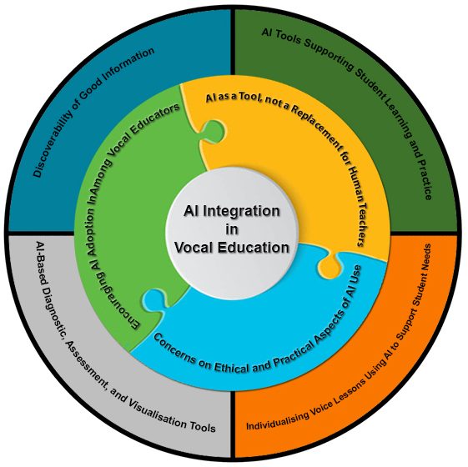
Figure 11: Thematic Map

- DISCUSSION

This study explored vocal educators’ perspectives on AI in vocal education to understand their hopes and concerns, while identifying strategies for ethical and effective integration. Guided by a critical realist stance, the study aimed to not only examine what educators think, but also explore why those perspectives exist (Zachariadis et al., 2013).

Combined phase 1 and phase 2 data suggest the Likert scale’s neutral-response trend may not indicate a lack of opinion for these participants, but rather reflects insufficient subject knowledge, especially given the lack of non-substantive Likert options such as “unsure” or “no opinion” (Lam and Green, 2019). Open-ended responses supported this interpretation, with many educators citing limited familiarity with AI to form clear opinions.

Despite uncertainties about its capabilities, participants’ curiosity led to their identification of potential AI tools for vocal education—many currently unavailable or not easily discoverable—particularly after reflecting on current teaching challenges, suggesting an openness to adopting AI tools provided they align with educators’ needs.

Thematic analysis revealed seven overarching themes clarifying vocal educators’ perspectives on AI and strategies for integration. Given this paper’s scope, only the three most prevalent themes will be explored in depth.

- Theme 1: AI as a Tool in Teaching, not a Replacement for Human Teachers

Across interviews, questionnaires, and literature, educators conveyed AI could be an effective tool in teaching, but not a complete replacement (Ng and Mahmoud, 2025). Questionnaire data supported this theme as seen in Q13 ("I can see positive uses for AI in vocal education"), which had the highest mean score (3.44) across all Likert items, with participants citing minimal concern over job displacement.

Participants emphasised AI’s limitations in emotional intelligence and contextual nuance, describing AI as a “well-meaning assistant”, not a stand-alone educator (Chen, 2022). Participant 4 (P4) observed, “Teaching vocals includes not only the ears, it includes the eyes, it includes the person,” highlighting the multisensory and interpersonal nature of effective instruction AI cannot replicate. Two participants noted that while platforms like YouTube offer free instruction, they have not replaced in-person teaching—suggesting that the human element remains essential despite the availability of online resources.

The idea AI could serve as an assistive tool rather than a replacement was prevalent throughout the data. P9 reflected: “There are things that we're not picking up on that maybe AI might be able to hear better…I see AI as an assistant…because there's so much nuance in a lesson that you can't teach that to an AI." This perspective recognises AI could enhance teacher-led education while acknowledging human instruction is irreplaceable.

These findings align with Woodruff et al.’s study, where 58% of educators expressed positive AI opinions and openness to its curricular use. Furthermore, Gai (2025) demonstrates measurable student improvement through AI-supported instruction, but also discusses weaknesses—like technical errors and privacy concerns—underscoring AI can potentially be valuable, but may require human guidance. All participants reported using technology in their teaching practice, suggesting they are not technologically averse when it aligns with pedagogical needs.

Data analysis revealed educators in this study are generally open to AI when it supports existing practices or builds on current technologies, suggesting AI’s success in education hinges on its role to support rather than replace established pedagogy.

- Theme 2: Concerns on Ethical and Practical Aspects of AI Use

While participants demonstrated openness to AI as a teaching tool, they also raised concerns about AI’s ethical and practical implications. Practical issues included affordability and inaccuracy, with ethical concerns focusing on environmental impact, privacy, and responsible development.

P4 shared, "There's definitely a place for AI…It's just not affordable for me yet." P13 noted the prevalence of AI errors, highlighting ongoing concerns about AI’s reliability, remarking, “even with scheduling or marketing, these are big errors”. P33 added, “I have been considering creating a GPT for voice training…though I'm wary of generative AI giving 'wrong advice'." This was reflected in Ghimire et al.’s (2024) study, where 27% of respondents identified concerns of "incorrect or fabricated results."

Ethical concerns were equally prevalent. P10 remarked, "I have concerns about how AI is being utilised and who is contributing to the algorithms." P24 stated: "It's always about the human responsibility—always—with any technology." P12 commented: "I would love AI assistance with administrative tasks…but I’m reticent to use it because of the environmental impacts.” Gai (2025) raised privacy issues in their SWOT analysis, reinforcing ethical hesitations around data visibility.

Several participants expressed little concern. P11 reflected: “I suppose there are existential concerns about AI in general…However, those existential concerns don’t concern me that much”, suggesting varied risk tolerance among the educators in this study.

While these ethical and practical concerns present challenges, participants also identified strategies for addressing barrier to AI adoption in vocal education.

- Theme 3: Encouraging AI Adoption Among Vocal Educators

Two elements emerged as necessary to aid AI adoption among vocal educators: discoverability and peer influence. Discoverability emerged as a key element, with participants recommending opportunities for public engagement (Robles and Mallinson, 2025). P24 stated: “The issue is people don’t know these tools exist, where to find them, how to use them.”

Many participants noted they lacked sufficient information about AI to form opinions or recommend uses for the technology, suggesting a need to be better educated in the technologies available (Ovcharenko et al., 2020). P8 admitted, "I might take the help, if I knew of a way it helps," while others, such as P15 and P29, reported not having researched available tools. The lack of awareness that tools exist represents a significant barrier which is reflected in the quantitative data, where the Likert data showed a trend towards neutrality, likely due to lack of AI knowledge and no “I don’t know” option.

Participants emphasised the importance of peer influence in aiding discoverability. P11 suggested: "If we want it to become more widely used, it has to be people like us beating the drum for it, creating programs for it, writing the papers about it, and presenting those papers to a wider audience…It has to be widely disseminated.” This suggests in order to facilitate acceptance of AI, early adopters need to be vocal about their opinions.

Uzumcu and Acilmis (2024) studied how observed exposure through hands-on experience and peer influence shifted AI perceptions, increasing user comfort. This aligns with the theory of diffusion of innovations (DOI), popularised by Everett M. Rogers in 1962, which posits innovation is communicated through members of society, with most individuals evaluating and adopting new ideas based on subjective peer assessments (García‐Avilés, 2020).

P23 discussed historical patterns, “The greatest challenge was not whether the technology existed…It’s just convincing people that it exists, and that it’s not a lie, because they’d been told by people with limited information that it was impossible.” This underscores the criticality that misinformation or limited exposure can create barriers towards adoption.
Quantitative data supported participants’ statements on discoverability and emotional comfort, showing a strong negative correlation between Q2 (negative emotions toward AI) and Q5 (look forward to AI developments) (ρ = –0.722), suggesting greater enthusiasm may align with lower emotional resistance, reinforcing the value of peer-driven awareness and trusted exposure. The findings suggest that increasing discoverability of AI applications through trusted peer discussions and scholarship may improve educator comfort and reduce resistance, consistent with the DOI framework (Stein et al., 2024).

Together, these themes suggest vocal educators in this study are not resistant to or ambivalent about AI, but cautiously optimistic—open to its integration when AI tools are ethical, practical, and pedagogically aligned. The perspectives captured reflect a need for transparency, ethical framework development, and interdisciplinary collaboration with vocal educators actively.

- STUDY LIMITATIONS

Several limitations of the study should be noted. The small sample size may not provide a comprehensive view of universal vocal educators' AI perceptions (Anderson and Vingrys, 2001). While widely used, a customised Likert scale tailored to vocal educators, including a nonsubstantive option, might have elicited more in-depth perceptions (Lam and Green, 2019). Additionally, Likert-related issues in combining regular and reversed items can lead to decreased response variability, possibly contributing to the high number of neutral responses (Suárez-Álvarez et al., 2018; Alkharusi, 2022). Given the constraints of this study, additional time for thematic analysis or lengthier interviews may have uncovered additional insights (Ivankova et al., 2006).

The explanatory mixed-methods approach aided in uncovering causal mechanisms, but may have benefited from additional open-ended questions to further capture participants' perspectives in an anonymous capacity. Additional researchers—investigator triangulation—may have further strengthened the analysis (Bhandari, 2023).

- CONCLUSION

Addressing a critical gap in vocal education research, this mixed-methods study examined vocal educators' perspectives on AI in vocal education and identified actionable strategies for its integration. Preliminary findings through statistical and thematic analysis suggest educators in this study are cautiously optimistic, viewing AI as a valuable pedagogical tool when it supports, rather than replaces, human educators.

Participants emphasised AI's potential as an assistive technology while recognising its limitations in emotional intelligence and contextual nuance. Concerns about affordability, accuracy, and environmental impact underscore the need for ethical frameworks guiding responsible AI tool development (Grassini, 2023; Ugoji, 2025). Increasing discoverability of AI applications through trusted peer discussions and scholarship may improve educator comfort and reduce resistance, consistent with the DOI framework. Additional themes revealed multiple potential uses for AI to support and enhance vocal education.

Effective AI integration in vocal education requires interdisciplinary collaboration—combining feedback from vocal educators, voice scientists, and AI developers through pedagogical needs assessments, design workshops, and iterative development cycles (Olorunfemi et al., 2024; Siddiqui, 2024). Tools should be designed with vocal educators, not for them, to support AI’s adoption.

Future research should focus on the specific needs of vocal educators and students, and define strategies for involving multidisciplinary teams in AI tool creation, ensuring vocal education tools align with pedagogical needs and values. Further research could also explore the potential correlation between educational background and AI acceptance, employing a larger and more diverse sample size.

This study, grounded in a critical realist perspective, contributes to a growing conversation about the ways vocal educators can and need to be involved in the development of AI tools. These insights point toward an emerging model of AI integration—one grounded in pedagogical relevance, peer engagement, and practitioner-informed governance. This model positions vocal educators as an integral part of guiding this evolving technology, suggesting AI adoption is reliant on collaboration with educators, researchers, and AI developers.

Applying Driscoll’s “What? So What? Now What?” reflective model, I have gained valuable insight into research instrument design and implementation (ILO1) (Greene, 2024). The validated ATTARI-12 scale added academic rigour, but its lack of a nonsubstantive response contributed to a prevalence of neutral responses (Lam and Green, 2019), limiting the depth of data collected. Moving forward, I may modify scale items or develop new instruments tailored to my research. As an insider researcher, I had a distinct ability to understand participant needs and concerns. My background in both vocal education and technology aided in my interpretation. At the same time, I remained aware of how my experience may have influenced my perspective. I learned to use quantitative data analysis tools and create visual data representations to communicate findings, a skill I intend to continue developing (ILO2) (Russell et al., 2023). Thematic analysis (ILO3) yielded important data, but was more time-consuming than anticipated within the mixed-methods design (Ivankova et al., 2006). I may reserve its use for projects with a lengthier timeframe in the future (Lim, 2024a). Compared to my previous work, my academic writing has improved, though transitions and narrative flow remain areas for further development (ILO4).

- REFERENCES

Abdikhakimov, I. (2023) ‘Unraveling the Copyright Conundrum: Exploring AI-Generated Content and its Implications for Intellectual Property Rights’, International Conference on Legal Sciences, 1(5), pp. 18–32. Available at: https://www.science-zone.org/index.php/conference/article/view/42.

Alkharusi, H. (2022) 'A descriptive analysis and interpretation of data from Likert scales in educational and psychological research', Indian Journal of Psychology and Education, 12(2), pp. 13-16. Available at: https://www.researchgate.net/publication/373096780.

Anderson, A.J. and Vingrys, A.J. (2001) ‘Small Samples: Does Size Matter?’, Investigative Ophthalmology and Visual Science, 42(7), pp. 1411–1413. Available at: https://pubmed.ncbi.nlm.nih.gov/11381039/.

Aromataris, E. and Riitano, D. (2014) ‘Systemic Reviews, Step by Step: Constructing a Search Strategy and Searching for Evidence’, The American Journal of Nursing, 114(5), pp. 49–56. Available at: http://www.jstor.org/stable/24466512.

Barrera Castro, G.P., Chiappe, A., Ramírez-Montoya, M.S. and Alcántar Nieblas, C. (2025) ‘Key Barriers to Personalized Learning in Times of Artificial Intelligence: A Literature Review’, Applied Sciences, 15(6), pp. 1-16. Available at: https://doi.org/10.3390/app15063103.

Basit, T. N. (2013) ‘Ethics, reflexivity and access in educational research: issues in intergenerational investigation’, Research Papers in Education, 28(4), pp. 506–517. Available at: https://doi.org/10.1080/02671522.2012.689318.

Bauer, W.L. (2023) Make AI Your Personal Music Teaching Assistant: 4 ideas you can use now! Available at: https://musiceducation.arts.ufl.edu/resources/ai-music-teaching-assistant/ (Accessed: 7 May 2024).

Bhandari, P. (2023) Triangulation in Research: Guides, Types, Examples. Available at: https://www.scribbr.com/methodology/triangulation/. (Accessed: 29 June 2025).

Bhaskar, R. (1975) A realist theory of science. New York: Routledge.

Blakeslee, S. (2004) ‘The CRAAP Test’, LOEX Quarterly, 31(3), pp. 6-7. Available at: https://commons.emich.edu/loexquarterly/vol31/iss3/4.

Blundel, R. (2007) ‘Critical Realism: A Suitable Vehicle for Entrepreneurship Research?’, in Neergaard, H. and Ulhøi, J.P. (eds.) Handbook of Qualitative Research Methods in Entrepreneurship. Cheltenham: Edward Elgar Publishing, pp. 49-74.

Boeren, E. (2018) ‘The Methodological Underdog: A Review of Quantitative Research in the Key Adult Education Journals’, Adult Education Quarterly, 68(1), pp. 63–79. Available at: https://doi.org/10.1177/0741713617739347.

Bowen, P., Rose, R. and Pilkington, A. (2017) ‘Mixed Methods – Theory and Practice. Sequential, Explanatory Approach’, International Journal of Quantitative and Qualitative Research Methods, 5(2), pp. 10-27. Available at: https://www.researchgate.net/publication/317545024_MIXED_METHODS-THEORY_AND_PRACTICE_SEQUENTIAL_EXPLANATORY_APPROACH.

Bransen, M. (2024) The 22 Best AI Education Tools (Students and Teachers) in 2024, Available at: https://tilburg.ai/2024/01/best-ai-education-tools/ (Accessed: 23 May 2025).

Braun, V. and Clarke, V. (2013) Successful Qualitative Research a practical guide for beginners. India: Sage Publications.

Braun, V., Clarke, V., Boulton, E., Davey, L. and McEvoy, C. (2021) ‘The online survey as a qualitative research tool’, International Journal of Social Research Methodology, 24(6), pp. 641–654. Available at: https://doi.org/10.1080/13645579.2020.1805550.

Brown, M.E.L. and Dueñas, A.N. (2020) ‘A Medical Science Educator’s Guide to Selecting a Research Paradigm: Building a Basis for Better Research’, Medical Science Educator, 30(2), pp. 545–553. Available at: https://doi.org/10.1007/s40670-019-00898-9.

Chen, W. (2022)’ Design of music teaching system based on artificial intelligence’, Mathematical Problems in Engineering, 2022, Article ID 2627395, pp. 1–7. https://doi.org/10.1155/2022/2627395.

Cheng, Z., Zhang, M., Sun, J. and Dai, W. (2025) ‘On weaponization-resistant large language models with prospect theoretic alignment’, in Proceedings of the 31st International Conference on Computational Linguistics, Abu Dhabi, UAE, January 2025, pp. 10309–10324. Available at: https://aclanthology.org/2025.coling-main.687.

Creswell, J.W. and Garrett, A.L. (2008) ‘The “movement” of mixed methods research and the role of educators’, South African Journal of Education, 28(3), pp. 321–333. Available at: https://doi.org/10.15700/saje.v28n3a176.

Datapott Analytics (2022) Statistical data analytics and research services. Available at: https://datapott.com. (Accessed 11 July 2025).

Edwards, B. (2025) AI search engines cite incorrect news sources at an alarming 60% rate, study says. ArsTechnica. Available at: https://arstechnica.com/ai/2025/03/ai-search-engines-give-incorrect-answers-at-an-alarming-60-rate-study-says/ (Accessed: 19 June 2025).

Ercikan, K. and Roth, W.M. (2006) ‘What Good Is Polarizing Research Into Qualitative and Quantitative?’, Educational Researcher, 35(5), pp. 14–23. Available at: https://doi.org/10.3102/0013189X035005014.

Fang, J., Su, H. and Xiao, Y. (2018) Will Artificial Intelligence Surpass Human Intelligence? Unpublished. Available at: http://dx.doi.org/10.2139/ssrn.3173876.

Fleming, J. (2018) ‘Recognizing and resolving the challenges of being an insider researcher in work-integrated learning’, International Journal of Work-Integrated Learning, Special Issue, 19(3), pp. 311-320. Available at: https://www.researchgate.net/publication/329356638_Recognizing_and_resolving_the_challenges_of_being_an_insider_researcher_in_work-integrated_learning.

Fletcher, A.J. (2017) ‘Applying critical realism in qualitative research: methodology meets method’, International Journal of Social Research Methodology, 20(2), pp. 181–194. Available at: https://doi.org/10.1080/13645579.2016.1144401.

Fryer, T. (2022) ‘A critical realist approach to thematic analysis: producing causal explanations’, Journal of Critical Realism, 21(4), pp. 365–384. Available at: https://doi-org /10.1080/14767430.2022.2076776.

Gai, M. (2025) ‘Implementation of an innovative approach to vocal training in college: The case of artificial intelligence technologies NSynth, Sing Like Me, and Flow Machines’, The Asia-Pacific Education Researcher, 34(2), pp. 215–232. Available at: https://doi.org/10.1007/s40299-025-01003-y.

García‐Avilés, J.A. (2020) Diffusion of innovation. In: Van den Bulck, J. (ed.) The International Encyclopedia of Media Psychology. 1st ed. Wiley, pp. 1–8. Available at: https://doi.org/10.1002/9781119011071.iemp0137.

Ghimire, A., Prather, J. and Edwards, J. (2024) ‘Generative AI in Education: A Study of Educators’ Awareness, Sentiments, and Influencing Factors’, Available at: https://doi.org/10.48550/arXiv.2403.15586 (Accessed: 14 April 2025).

Glasow, P.A. (2005) Fundamentals of Survey Research Methodology. McLean, VA: Mitre.

Gnambs, T., Stein, J.P., Appel, M., Griese, F. and Zinn, S. (2025) ‘An economical measure of attitudes towards artificial intelligence in work, healthcare, and education (ATTARI-WHE)’, Computers in Human Behavior: Artificial Humans, 3, pp 1-9. Available at: https://doi.org/10.1016/j.chbah.2024.100106.

Goundar, S. (2012) ‘Research Methodology and Research Methods’, in Cloud Computing. Research Gate Publications, pp. 1-47.

Grassini, S. (2023) ‘Development and validation of the AI attitude scale (AIAS-4): A brief measure of general attitude toward artificial intelligence’, Frontiers in Psychology, 14, pp. 1-12. Available at: https://doi.org/10.3389/fpsyg.2023.1191628.
Greene, J. (2024) Driscoll Model of Reflection. Available at: https://www.ebsco.com/research-starters/health-and-medicine/driscoll-model-reflection. (Accessed: 2025 July 07).

Greene, M. (2014) ‘On the Inside Looking In: Methodological Insights and Challenges in Conducting Qualitative Insider Research’, The Qualitative Researcher, 19(15), pp. 1-13. Available at: https://doi.org/10.46743/2160-3715/2014.1106.

Guba, E.G. and Lincoln, Y.S. (1994) Competing paradigms in qualitative research. In N.K. Denzin and Y.S. Lincoln (Eds.), Handbook of qualitative research. Sage Publications, Inc. pp. 105–117.

Hitsuwari, J. and Takano, R. (2025) ‘Associating Attitudes towards AI and Ambiguity: The Distinction of Acceptance and Fear of AI’, PREPRINT (Version 1). Available at: https://doi.org/10.21203/rs.3.rs-6007527/v1. (Accessed: 14 April 2025).

Huriye, A.Z. (2023) ‘The Ethics of Artificial Intelligence: Examining the Ethical Considerations Surrounding the Development and Use of AI’, American Journal of Technology, 2(1), pp. 37–45. Available at: https://doi.org/10.58425/ajt.v2i1.142.

Humphrey, N. (2013) Social and emotional learning: A critical appraisal. London: SAGE Publications.

IBM (2024) What is AI? Available at: https://www.ibm.com/topics/artificial-intelligence (Accessed: 14 May 2024).

Ivankova, N.V., Creswell, J.W. and Stick, S.L. (2006) ‘Using Mixed-Methods Sequential Explanatory Design: From Theory to Practice’, Field Methods, 18(1), pp. 3–20. Available at: https://doi.org/10.1177/1525822X05282260.

Jalali, S. and Wohlin, C. (2012a) ‘Systematic literature studies: database searches vs. backward snowballing’, Proceedings of the ACM-IEEE International Symposium on Empirical Software Engineering and Measurement. Presented at the ESEM ’12: 2012 ACM-IEEE International Symposium on Empirical Software Engineering and Measurement, ACM, Lund Sweden, pp. 29–38. Available at: https://doi.org/10.1145/2372251.2372257.
Juranek, J. and Pochwatko, G. (2025) ‘Measurement of General Attitude Toward AI and its Relationship with AI Anxiety, Attitude Toward Robots and Belief in Human Nature Uniqueness: Polish Adaptation of the ATTARI-12 Questionnaire’, Available at http://dx.doi.org/10.2139/ssrn.5166754. (Accessed: 14 April 2025).

Keita, Z. (2023) AI and Music Education. Available at: https://nafme.org/blog/ai-in-education/ (Accessed: 7 May 2024).

Khan, H. (2021) ‘Types of AI - Different Types of Artificial Intelligence Systems’, fossguru.com/types-of-ai-different-types-of-artificial-intelligence-systems. Available at: https://www.researchgate.net/publication/355021812_Types_of_AI_Different_Types_of_Artificial_Intelligence_Systems_fossgurucomtypes-of-ai-different-types-of-artificial-intelligence-systems. (Accessed: 3 October 2024).

Khaydarov, A. (2024) ‘The Impact of Modern Technologies on the Development of Vocal Art’, European Journal of Innovation in Nonformal Education, 4(12), pp. 163-167. Available at: http://innovatus.es/index.php/ejine.

Kieslich, K., Lünich, M. and Marcinkowski, F. (2021) ‘The Threats of Artificial Intelligence Scale (TAI)’, International Journal of Social Robotics, 13(9), pp. 1563–1577. Available at: https://doi.org/10.1007/s12369-020-00734-w.

Konidena, B.K., Malaiyappan, J.N.A. and Tadimarri, A. (2024) ‘Ethical Considerations in the Development and Deployment of AI Systems’, European Journal of Technology, 8(2), pp. 41–53. Available at: https://doi.org/10.47672/ejt.1890.

Krägeloh, C., Melekhov, V., Alyami, M. and Medvedev, O. (2024) ‘Artificial Intelligence Attitudes Inventory (AIAI): Development and Validation Using Rasch Methodology’, PREPRINT (Version 1) Available at: https://doi.org/10.21203/rs.3.rs-4403120/v1.

Lam, T. and Green, K. (2019) ‘Likert scale: misuse of mid-point anchor’, Advance, 28 February [online]. Available at: https://doi.org/10.31124/advance.7765463.v2. (Accessed: 4 May 2025).

Lawani, A. (2021) ‘Critical realism: what you should know and how to apply it’, Qualitative Research Journal, 21(3), pp. 320–333. Available at: https://doi.org/10.1108/QRJ-08-2020-0101.

Lim, W.M. (2024a) ‘What Is Qualitative Research? An Overview and Guidelines’, Australasian Marketing Journal, 0(0). Available at: https://doi.org/10.1177/14413582241264619 (Accessed: 4 January 2025).

Lim, W.M. (2024b) ‘What Is Quantitative Research? An Overview and Guidelines’, Australasian Marketing Journal, 0(0). Available at: https://doi.org/10.1177/14413582241264622 (Accessed: 4 January 2025).

Liu, H. and Guo, W. (2025) ‘Effectiveness of AI-Driven Vocal Art Tools in Enhancing Student Performance and Creativity’, Journal of Vocal Pedagogy, 12(3), pp. 45–62. Available at: https://doi-org.ezproxy.uwtsd.ac.uk/10.1111/ejed.70037.

McEvoy, P. and Richards, D. (2003) ‘Critical realism: a way forward for evaluation research in nursing?’, Journal of Advanced Nursing, 43(5), pp. 411–420. Available at: https://doi.org/10.1046/j.1365-2648.2003.02730.x.

Naeem, M., Ozuem, W., Howell, K. and Ranfagni, S. (2023) ‘A Step-by-Step Process of Thematic Analysis to Develop a Conceptual Model in Qualitative Research’, International Journal of Qualitative Methods, 22, pp. 1-18. Available at: https://doi.org/10.1177/16094069231205789.

Ng, A. and Mahmoud, B. (2025) Empowering Music Educators with AI for Personalized Instruction. OSF Preprints. Available at: 10.31234/osf.io/tcv6g_v1 (Accessed: 12 May 2025).

Olorunfemi, O., Shoetan, P., Amoo, O., Atadoga, A., Farayola, O and Abrahams, T. (2024) ‘Towards a Conceptual Framework for Ethical AI Development in IT Systems’, Computer Science and IT Research Journal, 5(3), pp. 616-627. Available at: https://fepbl.com/index.php/csitrj/article/view/910.
Onwuegbuzie, A., Frels, R. and Hwang, E. (2014) ‘Mapping Saldana’s Coding Methods onto the Literature Review Process,’ Journal of Education Issues, 2(1), pp. 130-150. Available at: https://eric.ed.gov/?id=EJ1127478.
Ovcharenko, N., Samoilenko, O., Moskva, O. and Chebotarenko, O. (2020) ‘Innovative Technologies in Vocal Training: Technological Culture Formation of Future Musical Art Teachers’, Journal of History Culture and Art Research, 9(3), pp. 115-126. Available at: http://dx.doi.org/10.7596/taksad.v9i3.2729.

Patel, M. and Patel, N. (2019) ‘Exploring Research Methodology: Review Article’, International Journal of Trend in Scientific Research and Development, 6(3), pp. 48-55. Available at: www.ijrrjournal.com (Accessed: 4 January 2025).

Pretorius, L. (2024) ‘Demystifying Research Paradigms: Navigating Ontology, Epistemology, and Axiology in Research’, The Qualitative Report, 29, pp. 2051–2064. Available at: https://doi.org/10.46743/2160-3715/2024.7632.

Resnik, D.B. (2015) What is ethics in research and why is it important? National Institutes of Health. Available at: https://www.niehs.nih.gov/research/resources/bioethics/whatisÐ (Accessed: 4 January 2025).

Robles, P. and Mallinson, D.J. (2025) ‘Artificial intelligence technology, public trust, and effective governance’ Review of Policy Research, 42(1), pp. 11–28. https://doi.org/10.1111/ropr.12555.

Russell, R.G., Lovett Novak, L., Patel, M., Garvey, K.V., Craig, K.J.T., Jackson, G.P., Moore, D. and Miller, B.M. (2023) ‘Competencies for the use of artificial intelligence–based tools by health care professionals’, Academic Medicine, 98(3), pp.348–356. Available at: https://doi.org/10.1097/ACM.0000000000004963.

Saldaña, J.M. (2013) The Coding Manual for Qualitative Researchers. 2nd ed. London, England: SAGE Publications.

Sarkar, S. and Bhatia, G. (2021) ‘Writing and appraising narrative reviews’, Journal of Clinical and Scientific Research, 10(3), pp. 169-172. Available at: https://doi.org/10.4103/jcsr.jcsr_1_21.

Schepman, A. and Rodway, P. (2020) ‘Initial validation of the general attitudes towards Artificial Intelligence Scale’, Computers in Human Behavior Reports, 1, pp. 1-13. https://doi.org/10.1016/j.chbr.2020.100014.

Shannon-Baker, P. (2016) ‘Making Paradigms Meaningful in Mixed Methods Research’, Journal of Mixed Methods Research, 10(4), pp. 319–334. https://doi.org/10.1177/1558689815575861.

Siddiqui, M. A. (2024) ‘A Comprehensive Review of AI: Ethical Frameworks, Challenges, and Development’, Adhyayan: A Journal of Management Sciences, 14(1), pp. 68-75, Available at: https://doi.org/10.21567/adhyayan.v14i1.12

Sindermann, C., Sha, P., Zhou, M., Wernicke, J., Pak, K., Li, M., Becker, B., Sariyska, R. and Montag, C. (2021) ‘Assessing the Attitude Towards Artificial Intelligence: Introduction of a Short Measure in German, Chinese, and English Language’, Künstl Intell, 35, pp. 109–118. Available at: https://doi.org/10.1007/s13218-020-00689-0.

South, L., Saffo, D., Vitek, O., Dunne, C. and Borkin, M. (2022) ‘Effective Use of Likert Scales in Visualization Evaluations: A Systematic Review’, Computer Graphics Forum, 41(3), pp. 43-55.

Stein, J., Messingschlager, T., Gnambs, T., Hutmacher, F. and Appel, M. (2024) ‘Attitudes towards AI: measurement and associations with personality’, Scientific Reports, 14(1), pp. 1-16. Available at: https://doi.org/10.1038/s41598-024-53335-2.

Suárez-Álvarez, J., Pedrosa, I., Lozano, L., Garcia-Cueto, E. Cuesta, M. and Muñiz, J. (2018) ‘Using reversed items in Likert scales: A questionable practice’, Psicothema, 30(2), pp. 149-158. Available at: https://doi.org/10.7334/psicothema2018.33.

Sukhera, J. (2022) ‘Narrative Reviews: Flexible, Rigorous, and Practical’, Journal of Graduate Medical Education, 14(4), pp. 414-417. Available at: https://doi.org/10.4300/JGME-D-22-00480.1.

Swanson, R.A. and Holton, E.F. (2010) Research in organisations: foundations and methods of inquiry. San Francisco, California: Berrett-Koehler.

Tanujaya, B., Prahmana, R. and Mumu, J. (2023) ‘Lesson study with sharing and jumping tasks in online mathematics classrooms for rural area students’, Journal on Mathematics Education, 14, pp. 169-188. Available at: https://doi.org/10.22342/jme.v14i1.pp169-188.

Tenser, Daniel (2025) 'Ex-Google CEO Eric Schmidt: AI That is ‘As Smart as the Smartest Artist’ Will Be Here in 3 to 5 Year’, Music Business Worldwide, Available at: https://www.musicbusinessworldwide.com/ex-google-ceo-eric-schmidt-ai-that-is-as-smart-as-the-smartest-artist-will-be-here-in-3-to-5-years/ (Accessed: 15 May 2025).

Toyon, M. (2021) ‘Explanatory sequential design of mixed methods research: Phases and challenges’, International Journal of Research in Business and Social Science, 10(5), pp. 253-260. Available at: https://www.ssbfnet.com.

trail (2024) EU AI Act: How risk is classified. Available at: https://www.trail-ml.com/blog/eu-ai-act-how-risk-is-classified (Accessed: 23 June 2024).

Ugoji, N (2025) ‘Ethical Considerations and Challenges of AI in Teaching and Learning of Music’, International Journal of Arts, History and Cultural Studies, 10(1), pp. 91-97. Available at: https://iigdpublishers.com/article/373.

University of San Diego (2024) 39 Examples of Artificial Intelligence in Education, Available at: https://onlinedegrees.sandiego.edu/artificial-intelligence-education/. (Accessed: 23 May 2025).

Uzumcu, O. and Acilmis, H. (2024) ‘Do Innovative Teachers use AI-powered Tools More Interactively? A Study in the Context of Diffusion of Innovation Theory’, Technology, Knowledge, and Learning, 29, pp. 1109–1128. Available at: https://doi.org/10.1007/s10758-023-09687-1.

Walter, Y. (2024) ‘Embracing the future of Artificial Intelligence in the classroom: the relevance of AI literacy, prompt engineering, and critical thinking in modern education’, International Journal of Educational Technology in Higher Education, 21. Available at: https://doi.org/10.1186/s41239-024-00448-3.

Woodruff, K., Hutson, J. and Arnone, K. (2023) ‘Perceptions and Barriers to Adopting Artificial Intelligence’ in K-12 Education: A Survey of Educators in Fifty States’, in Reimagining Education - The Role of E-learning, Creativity, and Technology in the Post-pandemic Era. Faculty Scholarship, pp. 1-28. Available at: https://digitalcommons.lindenwood.edu/faculty-research-papers/506.

Yvonne Bulk, L. and Collins, B. (2024) ‘Blurry Lines: Reflections on “Insider” Research’, Qualitative Inquiry, 30(7), pp. 568-576. Available at: https://doi.org/10.1177/10778004231188048.

Zachariadis, M., Scott, S. and Barrett, M. (2013) Methodological Implications of Critical Realism for Mixed-Methods Research. MIS Quarterly, 37(3), pp. 855–879. http://www.jstor.org/stable/43826004.

Zhang, Y., Fen, B.W., Zhang, C. and Pi, S. (2024). ‘Transforming Music Education Through Artificial Intelligence: A Systematic Literature Review on Enhancing Music Teaching and Learning’, International Journal of Interactive Mobile Technologies, 18(18), pp. 76–93. Available at: https://doi.org/10.3991/ijim.v18i18.50545.

Appendix A: Search Table

Topic | Database | Search Terms
AI in education | Google  Google Scholar  UWTSD library Database | AI in education  +hesitancy to use
AI in vocal education | Google  Google Scholar  UWTSD library Database | AI in vocal education  +hesitancy to use  AI in voice teaching  AI teaching singing  AI voice teacher
AI in music education | Google  Google Scholar  UWTSD library Database | AI in music education >2023  +hesitancy to use
Artificial Intelligence | Google  Google Scholar  UWTSD library Database | AI earliest remote controlled  AI prompts  Artificial Intelligence  +attitudes in  +categories > 2023  +categories weak strong  +creating ethical frameworks  +education  +energy usage  +environmental  +ethics  +general  +green  +intellectual property  +music education  +narrow  +scales  -AIAI  -AIAS-4  -ATTARI-12  -GAIA  -GAAIS  +singing  +types  +vocal education

Topic | Database | Search Terms
Diffusion of Innovation | Google Scholar | Theory of Diffusion of Innovation
Mixed Methods | Google  Google Scholar | Types of mixed methods  Explanatory sequential design
Likert Scales | Google  Google Scholar | Likert scales  +reverse coding  +how to analyse
Literature evaluation | Google  Google Scholar  UWTSD library Database | CRAAP test
Literature reviews | Google  Google Scholar  UWTSD library Database | Literature process review  +Commentary  +Types  Narrative literature review
Search strategies | Google  Google Scholar  UWTSD library Database | Snowballing  +Backward  +Forward
Technology in vocal education | Google  Google Scholar  UWTSD library Database | Software  +music education  +singing  +vocal education
Thematic Analysis | Google  Google Scholar | Thematic Analysis  +codes  + Saldaña  Latent Thematic Analysis
Vocal education | Google  Google Scholar  UWTSD library Database | Singing and vibrato  Vocal education  +Imagery  +Online  +Subjectivity  +Visualization > 2020  Voice science vibrato > 2023  Vocal visualization in singing education

Appendix B: Inclusion/Exclusion Criteria

- Include grey literature such as websites, blogs, conference proceedings, reports, editorials, podcasts, PhD dissertations, and videos.*
- Prioritize peer-reviewed literature.
- Prioritize most recent dates, but include all available research.
- Include literature that addresses both positive and negative aspects of using AI.
- Include all literature about AI, software, mobile applications, and VR related to vocal education.
- Use CRAAP for evaluations of literature.
- Include all studies regardless of number of participants.
*Many newer researchers in this area are only recently getting published.
Additionally, some foremost experts write blogs rather than traditional publications.

Appendix C: Types of Artificial Intelligence
 |   Artificial Narrow  Intelligence |   Artificial General  Intelligence |   Artificial  Superintelligence
Description | Machine learning | Machine intelligence | Machine consciousness
Compared to Humans | Not as smart as a human. | As smart as a human. | Smarter than any human.
Limitations | -Simple algorithms.  -Goal oriented.  -Created to perform a single task. | -Complex algorithms.  -Computer can reason and solve problems on its own. | No limitations.
Learning Capabilities | Trained on large quantities of data for deep learning. | Able to learn, think, and understand in order to solve problems. | No limitations.
Decision-making skills | Appears to be making decisions, but it is just advanced computer programming. | Can perform different tasks based on different situations similar to a human. | No limitations.
Self-awareness | Does not have a mind of its own and is not self-aware. | Exhibits strong cognitive behaviour including common sense and is self-aware. | Fully self-aware and autonomous.
Programming | Processes data using NLP (Natural Language Processing) and machine learning. | Uses advanced versions of NLP (Natural Language Processing), machine learning, and neural networks. | Will likely self-evolve from Artificial General Intelligence.
Examples | -Virtual Assistants (Siri, Alexa, Cortana)  -Google Search  -Netflix recommendations | Hypothetical, but we are proceeding towards it (estimated to become real around 2040). | Hypothetical such HAL 9000 (“2001: A Space Odessey”) and C3PO (“Star Wars”)
(ISIEINDIA, 2024; Khan, 2021; RevolveAI, 2024)

Appendix D: Attitudes Towards Artificial Intelligence Scale (ATTARI-12)

(Stein et al., 2024)

Appendix E: Questionnaire

- Section 1: Participant Demographics
Question | Question Type | Choices
Job Description  (please select all that apply) | Multiple choice,  Able to select multiple options | - Voice Teacher  - Vocologist  - Choir Director  - Music Director (for musical theatre, opera, etc.)  - College Professor  - Voice Researcher  - Voice Scientist  - Speech Language Pathologist
Number of Years Working as a Voice Educator | Multiple choice,  Only able to select one option | - Less than 5 years  - 5 to 10 years  - 10 to 20 years  - Over 20 years
Highest Level of Education Completed | Multiple choice,  Only able to select one option | - Secondary education (e.g., high school, GCSEs, O Levels)  - Post-secondary/College education (e.g., Associate's degree, A Levels, vocational training)  - Undergraduate degree (e.g., Bachelor's degree)  - Postgraduate degree (e.g., Master's degree, PGCE)  - Doctoral degree (e.g., PhD, EdD, etc.)

- Section 2: Likert Scale
Question | Question Type | Choices
AI will make this world a better place. | Likert scale,  1 to 5 | 1: strongly disagree  5: strongly agree
I have strong negative emotions about AI. | Likert scale,  1 to 5 | 1: strongly disagree  5: strongly agree
I want to use technologies that rely on AI. | Likert scale,  1 to 5 | 1: strongly disagree  5: strongly agree
AI has more disadvantages than advantages. | Likert scale,  1 to 5 | 1: strongly disagree  5: strongly agree
I look forward to further AI developments. | Likert scale,  1 to 5 | 1: strongly disagree  5: strongly agree
AI offers solutions to many world problems. | Likert scale,  1 to 5 | 1: strongly disagree  5: strongly agree
I prefer technologies that do not feature AI. | Likert scale,  1 to 5 | 1: strongly disagree  5: strongly agree
I am afraid of AI. | Likert scale,  1 to 5 | 1: strongly disagree  5: strongly agree
I would rather choose a technology with AI than one without it. | Likert scale,  1 to 5 | 1: strongly disagree  5: strongly agree
AI creates problems rather than solving them. | Likert scale,  1 to 5 | 1: strongly disagree  5: strongly agree
When I think about AI, I have mostly positive feelings. | Likert scale,  1 to 5 | 1: strongly disagree  5: strongly agree
I would rather avoid technologies that are based on AI. | Likert scale,  1 to 5 | 1: strongly disagree  5: strongly agree
I can see positive uses for AI in vocal education. | Likert scale,  1 to 5 | 1: strongly disagree  5: strongly agree

- Section 2: Multiple Choice
Do you use any technology currently in providing vocal education  (please check all that apply)? | Multiple choice,  Able to select multiple options | - Prerecorded accompaniments (midi, YouTube, mp3s, etc.)  - Zoom or other video conferencing  - Social media (e.g., Facebook, Instagram, LinkedIn, etc.)  - Overtone or Spectrum Analyser (e.g., VoceVista, etc.)  - Digital Audio Workstation (e.g., Garageband, Audacity, etc.)  - None

- Section 2: Open-ended Questions
What do you consider the biggest challenge in providing vocal education? | Open-ended question | NA
Is there anything that you wish AI could assist you with in providing vocal education? | Open-ended question | NA
I am interested in participating in an interview to discuss the use of AI in vocal education. | Dichotomous question,  Only able to select one option | - Yes  - No

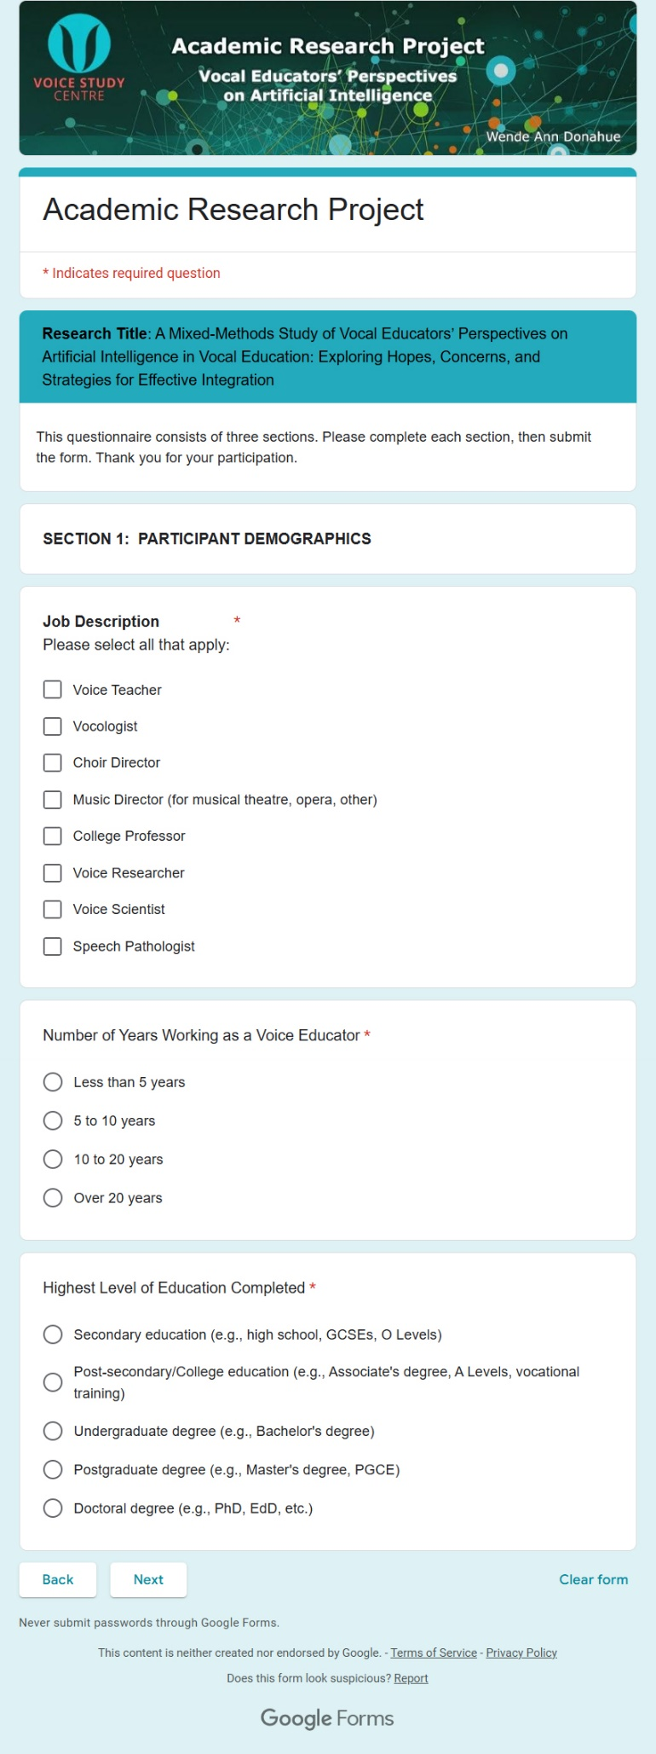 | 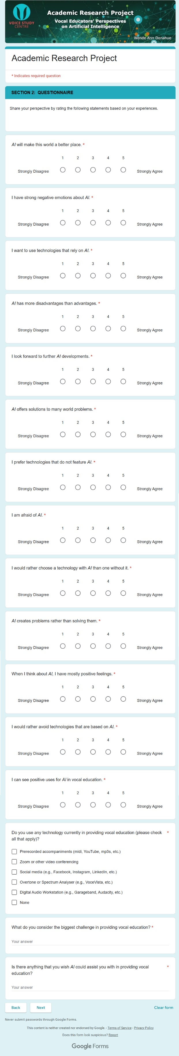
 | 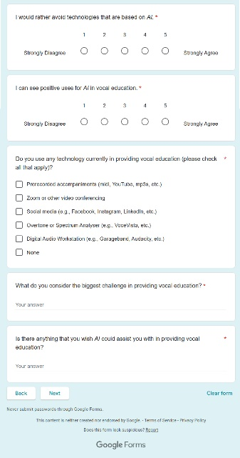

Appendix F: Semi-Structured Interview Questions
- What are the biggest challenges you face as a voice educator?
- a. Do you believe AI could complement or potentially disrupt traditional vocal pedagogy?
b. (Why?)
- a. Do you know of AI tools available for your teaching practice?
b. (Have you actively used AI tools in your teaching practice?)
c. (If yes, how have they helped or hindered your teaching?)
- What concerns do you have about integrating AI into vocal education?
- Do you see any areas where AI could play a role in vocal education?
- What might help vocal educators to feel comfortable using AI in vocal education?
(Indicates a question to be asked if participant has not already discussed.)

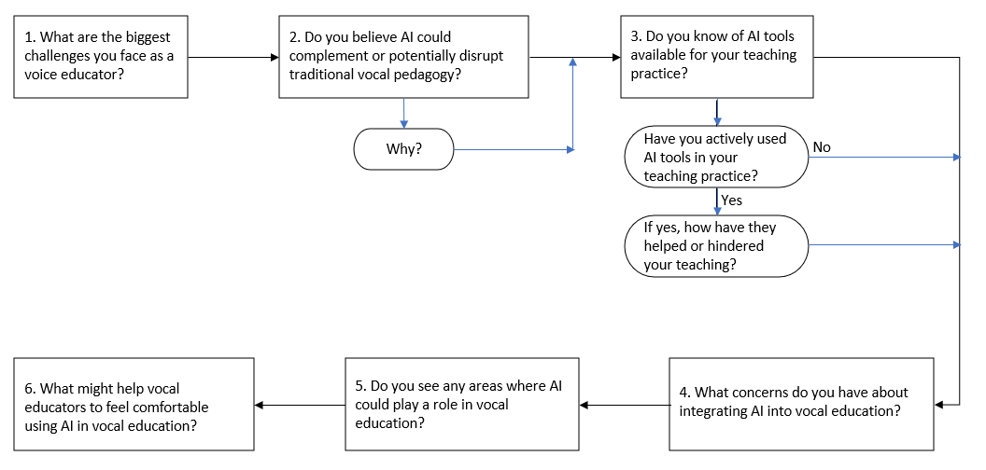

Appendix G: Participant Information and Consent Forms
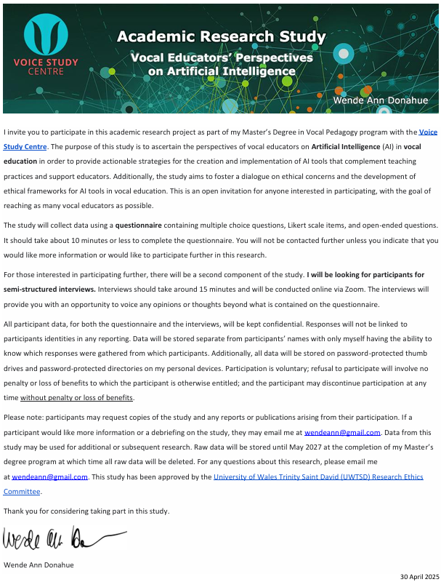
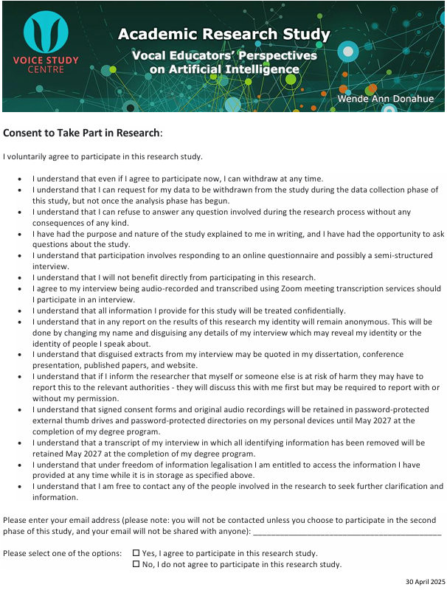

Appendix H: Application for Ethical Approval

RESEARCH STUDENTS
This form is to be completed by the student within SIX months for full-time students and TWELVE months for part time students, after the commencement of the research degree or following progression to Part Two of your course.

Once complete, submit this form via the MyTSD Doctoral College Portal at (https://mytsd.uwtsd.ac.uk).

This document is also available in Welsh.

RESEARCH STAFF ONLY
All communications relating to this application during its processing must be in writing and emailed to pgresearch@uwtsd.ac.uk , with the title ‘Ethical Approval’ followed by your name.

STUDENTS ON UNDERGRADUATE OR TAUGHT MASTERS PROGRAMMES should submit this form (and receive the outcome) via systems explained to you by the supervisor/module leader.

In order for research to result in benefit and minimise risk of harm, it must be conducted ethically. A researcher may not be covered by the University’s insurance if ethical approval has not been obtained prior to commencement.

The University follows the OECD Frascati manual definition of research activity: “creative work undertaken on a systematic basis in order to increase the stock of knowledge, including knowledge of man, culture and society, and the use of this stock of knowledge to devise new applications”. As such this covers activities undertaken by members of staff, postgraduate research students, and both taught postgraduate and undergraduate students working on dissertations/projects.

The individual undertaking the research activity is known as the “principal researcher”.

Ethical approval is not required for routine audits, performance reviews, quality assurance studies, testing within normal educational requirements, and literary or artistic criticism.

Please read the notes for guidance before completing ALL sections of the form.

This form must be completed and approved prior to undertaking any research activity. Please see Checklist for details of process for different categories of application.

SECTION A: About You (Principal Researcher)
1 | Full Name: |  | Wende Ann Donahue
2 | Tick all boxes that apply: |  | Member of staff: | ☐ | Honorary research fellow: | ☐
 | Undergraduate Student | ☐ | Taught Postgraduate Student | ☒ | Postgraduate Research Student | ☐
3 | Institute/Academic Discipline/Centre: |  | WAPPAR
4 | Campus: |  | Carmarthen
5 | E-mail address: |  | wendeann@gmail.com
6 | Contact Telephone Number: |  | +1 978-397-1631

 | For students:
7 | Student Number: | 2333885
8 | Programme of Study: | MA Professional Practice (Voice Pedagogy)
9 | Director of Studies/Supervisor: | Louise Emanuel/Julie Crossman/Debbie Winter

SECTION B: Approval for Research Activity
1 | Has the research activity received approval in principle?  (please check the Guidance Notes as to the appropriate approval process for different levels of research by different categories of individual) |  | YES | ☒ | NO | ☐
 |  |  |  |  | Date
2 | If Yes, please indicate source of approval (and date where known): Approval in principle must be obtained from the relevant source prior to seeking ethical approval | Research Degrees Committee |  | ☐
2 |  | Institute Research Committee |  | ☐
2 |  | Other (write in)  WAPPAR Ethics Board Representative |  | ☒

SECTION C: Internal and External Ethical Guidance Materials
 | Please list the core ethical guidance documents that have been referred to during the completion of this form (including any discipline-specific codes of research ethics, location-specific codes of research ethics, and also any specific ethical guidance relating to the proposed methodology). Please tick to confirm that your research proposal adheres to these codes and guidelines. You may add rows to this table if needed.
1 | UWTSD Research Ethics & Integrity Code of Practice | ☒
2 | UWTSD Research Data Management Policy | ☒
3 | [List any other relevant documents here]  https://research.fas.harvard.edu/ | ☒
4 | Policy on Data Use Agreements (Harvard University) | ☒
5 | Information Security Quick Reference Guide - Data Classifications with Administrative Examples | ☒

SECTION D: External Collaborative Research Activity
If there are external collaborators then you should gain consent from the contact persons to share their personal data with the university. If there are no external collaborators then leave this section blank and continue to section E.
1 | Institution
2 | Contact person name
3 | Contact person e-mail address
4 | Is your research externally funded? |  | YES | ☐ | NO |  | ☐
5 | Are you in receipt of a KESS scholarship? |  | YES | ☐ | NO |  | ☐
6 | Are you specifically employed to undertake this research in either a paid or voluntary capacity? | Voluntary | YES | ☐ | NO | ☐
7 |  | Employed | YES | ☐ | NO | ☐
8 | Is the research being undertaken within an existing UWTSD Athrofa Professional Learning Partnership (APLP)? | If YES then the permission question below does not need to be answered. | YES | ☐ | NO |  | ☐
9 | Has permission to undertake the research has been provided by the partner organisation? | (If YES attach copy)  If NO the application cannot continue | YES | ☐ | NO |  | ☐

Where research activity is carried out in collaboration with an external organisation
10 | Does this organisation have its own ethics approval system? | YES | ☐ | NO | ☐
 | If Yes, please attach a copy of any final approval (or interim approval) from the organisation (this may be a copy of an email if appropriate).

SECTION E: Details of Research Activity
1 | Indicative title: | An Exploratory Study: Perceptions of Artificial Intelligence Among Vocal Educators—Concerns, Future Prospects, and Paths to Acceptance
2 | Proposed start date: | 31/03/2025 | Proposed end date: | 16/09/2025
Introduction to the Research (maximum 300 words per section)
Ensure that you write for a Non-Specialist Audience when outlining your response to the points below:
- Purpose of Research Activity
- Proposed Research Question
- Aims of Research Activity
- Objectives of Research Activity
Demonstrate, briefly, how Existing Research has informed the proposed activity and explain
- What the research activity will add to the body of knowledge
- How it addresses an area of importance.
3 | Purpose of Research Activity  The purpose of this research activity is to explore the opportunities and challenges of integrating Artificial Intelligence (AI) into vocal education. Given the limited research currently available in this area, the study seeks to understand the hopes and fears of vocal educators regarding AI. By exploring different perspectives among vocal educators, the study aims to identify ways that AI may be an effective and ethical useful tool in vocal education.  The purpose of the study is to engage in pedagogical development within my own practice. Under current IRB regulations my study consists of PRACTICA using myself as a research subject. The purpose of the work-based learning project is to engage in professional development, and it constitutes an educational exercise. The audience for the results of the activity is myself and my students. IRB approval is not required. If the data offers a scholarly contribution, US IRB application can be sought subsequently to enable dissemination.
4 | Research Question  An exploratory study: How do vocal educators perceive Artificial Intelligence including their concerns, future prospects, and paths to acceptance?
5 | Aims of Research Activity  This research activity aims to discover potential applications for AI in vocal education. With limited existing research, this study aims to create a foundation for future AI applications that support vocal education.
6 | Objectives of Research Activity  The objectives of this research activity are to gather insights from vocal educators about their current understanding of AI, their hopes and fears regarding the technology, and their perspectives on its use, both positive and negative. The data collected will be analysed to propose effective ways for integrating AI into vocal education to support educators.
Proposed methods (maximum 600 words)

Provide a brief summary of all the methods that may be used in the research activity, making it clear what specific techniques may be used. If methods other than those listed in this section are deemed appropriate later, additional ethical approval for those methods will be needed. You do not need to justify the methods here, but should instead describe how you intend to collect the data necessary for you to complete your project.
7 | Participants will be vocal educators over the age of 18 recruited via targeted social media platforms to ensure a diverse sample. Participation is voluntary, and participants can exit the study at any time.  This research activity will utilize a mixed-methods approach with an explanatory sequential design, collecting quantitative and qualitative data simultaneously on a questionnaire in phase 1. This data will then inform a subsequent qualitative phase using semi-structured interviews and a focus group to expand on and explain the findings in phase 1. Methods employed will consist of:  - Phase 1: Survey data (administered to 40 participants)  - Quantitative Data Collection: A questionnaire with predetermined multiple-choice responses and Likert scale questions will be administered electronically.  - Qualitative Data Collection: Predetermined open-ended questions will be included in the same questionnaire to gather initial qualitative insights.  - Phase 2: Qualitative Data Collection  - Semi-structured Interviews will be conducted to expand on the findings from Phase 1 (conducted with 5 participants).  - A focus group will be used to expand on the findings from Phase 1 (conducted with 5 participants).  - Additional Methods  - Literature review: Focusing on existing research relevant to the use of AI in vocal education, identifying gaps in the research and future opportunities for exploration.  - Reflective journal: Documenting the research process and insights.  - Field notes: Observations during data collection.  The study will use quantitative and qualitative survey data, semi-structured interviews, a focus group, and triangulate with information from the literature review.
Location of Research Activity

Identify all locations where research activity will take place.
8 | Research activity will take place online (Zoom, Microsoft Teams, WhatsApp, Facebook, Facebook Messenger, Instagram, Threads, BlueSky, LinkedIn, Google Forms, and Survey Monkey), in person, and in my private voice studio.
Research Activity Outside of the UK

If research activity will take place overseas, you are responsible for ensuring that local ethical considerations are complied with and that the relevant permissions are sought. Specify any local guidelines (e.g. from local professional associations/learned societies/universities) that exist and whether these involve any ethical stipulations beyond those usual in the UK (provide details of any licenses or permissions required). Also specify whether there are any specific ethical issues raised by the local context in which the research activity is taking place, for example, particular cultural and/or legal sensitivities or vulnerabilities of participants. If you live in the country where you will do the research then please state this.
9 | My research will be conducted from Massachusetts in the United States. I have examined the research guidelines available through Harvard University and have not identified any ethical stipulations beyond those usual in the UK in regards to my research activity.
10 | Use of documentation not in the public domain: Are any documents NOT publicly available? | NO | ☒
10 |  | YES | ☐
11 | If Yes, please provide details here of how you will gain access to specific documentation that is not in the public domain and that this is in accordance with the current data protection law of the country in question and that of England and Wales.

 | Does your research relate to one or more of the seven aims of the Well-being of Future Generations (Wales) Act 2015? | YES | NO
12 | A prosperous Wales | ☐ | ☒
13 | A resilient Wales | ☐ | ☒
14 | A healthier Wales | ☐ | ☒
15 | A more equal Wales | ☐ | ☒
16 | A Wales of cohesive communities | ☐ | ☒
17 | A Wales of vibrant culture and thriving Welsh language | ☐ | ☒
18 | A globally responsible Wales | ☐ | ☒
19 | If YES to any of the above, please give details:

SECTION F: Scope of Research Activity
 | Will the research activity include: | YES | NO
1 | Use of a questionnaire or similar research instrument? | ☒ | ☐
2 | Use of interviews? | ☒ | ☐
3 | Use of focus groups? | ☒ | ☐
4 | Use of participant diaries? | ☐ | ☒
5 | Use of video or audio recording? | ☐ | ☒
6 | Use of computer-generated log files? | ☒ | ☐
7 | Participant observation with their knowledge? | ☐ | ☒
8 | Participant observation without their knowledge? | ☐ | ☒
9 | Access to personal or confidential information without the participants’ specific consent? | ☐ | ☒
10 | Administration of any questions, test stimuli, presentation that may be experienced as physically, mentally or emotionally harmful / offensive? | ☐ | ☒
11 | Performance of any acts which may cause embarrassment or affect self-esteem? | ☐ | ☒
12 | Investigation of participants involved in illegal activities? | ☐ | ☒
13 | Use of procedures that involve deception? | ☐ | ☒
14 | Administration of any substance, agent or placebo? | ☐ | ☒
15 | Working with live vertebrate animals? | ☐ | ☒
16 | Procedures that may have a negative impact on the environment? | ☐ | ☒
17 | Other primary data collection methods. Please indicate the type of data collection method(s) below. | ☒ | ☐
 | Details of any other primary data collection method:  Additionally, the research activity will make use of field notes and a reflective journal both maintained by the principal researcher. | ☒ | ☐
If NO to every question, then the research activity is (ethically) low risk and may be exempt from some of the following sections (please refer to Guidance Notes).

If YES to any question, then no research activity should be undertaken until full ethical approval has been obtained.

SECTION G: Intended Participants
If there are no participants then do not complete this section, but go directly to section H.

 | Who are the intended participants: | YES | NO
1 | Students or staff at the University? | ☒ | ☐
2 | Adults (over the age of 18 and competent to give consent)? | ☒ | ☐
3 | Vulnerable adults? | ☐ | ☒
4 | Children and Young People under the age of 18? (Consent from Parent, Carer or Guardian will be required) | ☐ | ☒
5 | Prisoners? | ☐ | ☒
6 | Young offenders? | ☐ | ☒
7 | Those who could be considered to have a particularly dependent relationship with the investigator or a gatekeeper? | ☐ | ☒
8 | People engaged in illegal activities? | ☐ | ☒
9 | Others. Please indicate the participants below, and specifically any group who may be unable to give consent. | ☐ | ☒
 | Details of any other participant groups: | ☐ | ☒

Participant numbers and source

Provide an estimate of the expected number of participants. How will you identify participants and how will they be recruited?
10 | How many participants are expected? | Questionnaire: 40 participants  Semi-structured Interviews: Five participants  Focus Group: Five participants
11 | Who will the participants be? | Participants will consist of adult vocal educators from private studios, public schools, private schools, charter schools, colleges/universities, choirs, theatre organizations, and private studios.
12 | How will you identify the participants? | Participants will be recruited via social media (Facebook, Facebook Messenger, Instagram, Threads, LinkedIn, WhatsApp, and Bluesky).

 | Information for participants: | YES | NO | N/A
13 | Will you describe the main research procedures to participants in advance, so that they are informed about what to expect? | ☒ | ☐ | ☐
14 | Will you tell participants that their participation is voluntary? | ☒ | ☐ | ☐
15 | Will you obtain written consent for participation? | ☒ | ☐ | ☐
16 | Will you explain to participants that refusal to participate in the research will not affect their treatment or education (if relevant)? | ☒ | ☐ | ☐
17 | If the research is observational, will you ask participants for their consent to being observed? | ☒ | ☐ | ☐
18 | Will you tell participants that they may withdraw from the research at any time and for any reason? | ☒ | ☐ | ☐
19 | With questionnaires, will you give participants the option of omitting questions they do not want to answer? | ☒ | ☐ | ☐
20 | Will you tell participants that their data will be treated with full confidentiality and that, if published, it will not be identifiable as theirs? | ☒ | ☐ | ☐
21 | Will you debrief participants at the end of their participation, in a way appropriate to the type of research undertaken? | ☒ | ☐ | ☐
22 | If NO to any of above questions, please give an explanation

 | Information for participants: | YES | NO | N/A
24 | Will participants be paid? | ☐ | ☒ | ☐
25 | Is specialist electrical or other equipment to be used with participants? | ☒ | ☐ | ☐
26 | Are there any financial or other interests to the investigator or University arising from this study? | ☐ | ☒ | ☐
27 | Will the research activity involve deliberately misleading participants in any way, or the partial or full concealment of the specific study aims? | ☐ | ☒ | ☐
28 | If YES to any question, please provide full details
 | Computers will be used for both data collection, storage, and analysis. Additionally, my personal cell phone and iPad will be used to view and manage data collection and storage.

SECTION H: Anticipated Risks

Outline any anticipated risks that may adversely affect any of the participants, the researchers and/or the University, and the steps that will be taken to address them.

If you have completed a full risk assessment (for example as required by a laboratory, or external research collaborator) you may append that to this form.
1 | Full risk assessment completed and appended? |  | Yes | ☐
1 |  |  | No | ☒
2 | Risks to participants  For example: sector-specific health & safety, emotional distress, financial disclosure, physical harm, transfer of personal data, sensitive organisational information
 | Risk to participants:  Potential risks to participants involve data being attributed to them. Additionally, participants may find the idea of AI concerning due to preconceived ideas. | How you will mitigate the risk to participants:  All data will be password protected and encrypted. I will be the only one to manage the data with my supervisor overseeing the process. Data will be coded to prevent any information from being attributed to the participant. I will make clear to participants that they may leave the study at any time if they feel distressed by any of the questions or ideas in the study.
3 | If research activity may include sensitive, embarrassing or upsetting topics (e.g. sexual activity, drug use) or issues likely to disclose information requiring further action (e.g. criminal activity), give details of the procedures to deal with these issues, including any support/advice (e.g. helpline numbers) to be offered to participants. Note that where applicable, consent procedures should make it clear that if something potentially or actually illegal is discovered in the course of a project, it may need to be disclosed to the proper authorities
 | Not applicable.
4 | Risks to the investigator  For example: personal health & safety, physical harm, emotional distress, risk of accusation of harm/impropriety, conflict of interest
 | Risk to the investigator:  There are no physical safety risks to the researcher due to the nature of the research (questionnaires, interviews, focus groups, and a literature review). While psychological risk is minimal, there is always the chance that I could experience anxiety either due to the content of the answers or due to social anxiety brought on by the interviews or focus group. | How you will mitigate the risk to the investigator:  Should I experience anxiety from any part of this study, I will take a break from my research or use reflective journaling to process my emotions.
5 | University/institutional risks  For example: adverse publicity, financial loss, data protection
 | Risk to the University:  Potential risks to the University involve data protection. | How you will mitigate the risk to the University:  All data will be password protected and encrypted. I will be the only one to manage the data with my supervisor overseeing the process. Data will be coded to prevent any information from being attributed to the participant
6 | Environmental risks  For example: accidental spillage of pollutants, damage to local ecosystems
 | Risk to the environment:  There are no environmental risks from this research study. | How you will mitigate the risk to environment:  Not applicable.

 | Disclosure and Barring Service
 | If the research activity involves children or vulnerable adults, a Disclosure and Barring Service (DBS) certificate must be obtained before any contact with such participants. | YES | NO | N/A
7 | Does your research require you to hold a current DBS Certificate? | ☐ | ☒ | ☐
8 | If YES, please give the certificate number. If the certificate number is not available please write “Pending”; in this case any ethical approval will be subject to providing the appropriate certificate number.

SECTION I: Feedback, Consent and Confidentiality

1 | Feedback  What de-briefing and feedback will be provided to participants, how will this be done and when?
 | I will also provide an email address for participants to contact me for further details or study results.
2 | Informed consent  Describe the arrangements to inform potential participants, before providing consent, of what is involved in participating. Describe the arrangements for participants to provide full consent before data collection begins. If gaining consent in this way is inappropriate, explain how consent will be obtained and recorded in accordance with prevailing data protection legislation.
Participants will receive written information on the first screen of the questionnaire prior to the start of the questions regarding participation involvement; data collection, storage, and security; and the purpose of the research study. Participants will have to select a checkbox providing consent and click “Continue” as an indicator of their consent before proceeding on to the questionnaire. The participants can exit the questionnaire at any time and can skip any question(s) they choose.

Participants of the semi-structured interviews and focus groups will be required to complete and submit an online form providing their informed consent to participate in the research activity. The online form will provide information regarding data collection, storage, and security; and the purpose of the research study.
3 | Confidentiality / Anonymity  Set out how anonymity of participants and confidentiality will be ensured in any outputs. If anonymity is not being offered, explain why this is the case.
 | Anonymity and confidentiality will be ensured by coding all participant information and assigning participant ID numbers, keeping any identifying information separate from the data collected. Identifying information will be removed from the dataset. All data will be stored in password-protected files.

SECTION J: Data Protection and Storage

 | Does the research activity involve personal data (as defined by the General Data Protection Regulation 2016 “GDPR” and the Data Protection Act 2018 “DPA”)? | YES | NO
1 | “Personal data” means any information relating to an identified or identifiable natural person (‘data subject’). An identifiable natural person is one who can be identified, directly or indirectly, in particular by reference to an identifier such as a name, an identification number, location data, an online identifier or to one or more factors specific to the physical, physiological, genetic, mental, economic, cultural or social identity of that natural person. Any video or audio recordings of participants is considered to be personal data. | ☒ | ☐
 | If YES, provide a description of the data and explain why this data needs to be collected:
2 | Email addresses will be collected to communicate with participants in the semi-structured interviews and focus group. Additionally, names will be collected by all participants in the research activity for providing informed consent to participate in the study. Anonymity and confidentiality will be ensured by coding all participant information and assigning participant ID numbers, keeping any identifying information separate from the data collected. Identifying information will be removed from the dataset. All data will be stored in password-protected files.
 | Does it involve special category data (as defined by the GDPR)? | YES | NO
3 | “Special category data” means sensitive personal data consisting of information as to the data subjects’ –  (a) racial or ethnic origin,  (b) political opinions,  (c ) religious beliefs or other beliefs of a similar nature,  (d) membership of a trade union (within the meaning of the Trade Union and Labour Relations (Consolidation) Act 1992),  (e) physical or mental health or condition,  (f) sexual life,  (g) genetics,  (h) biometric data (as used for ID purposes), | ☐ | ☒
 | If YES, provide a description of the special category data and explain why this data needs to be collected:
4

 | Will data from the research activity (collected data, drafts of the thesis, or materials for publication) be stored in any of the following ways? | YES | NO
5 | Manual files (i.e. in paper form)? | ☒ | ☐
6 | University computers? | ☐ | ☒
7 | Private company computers? | ☐ | ☒
8 | Home or other personal computers? | ☒ | ☐
9 | Laptop computers/ CDs/ Portable disk-drives/ memory sticks? | ☒ | ☐
10 | “Cloud” storage or websites? | ☒ | ☐
11 | Other – specify: | ☒ | ☐
12 | For all stored data, explain the measures in place to ensure the security of the data collected, data confidentiality, including details of backup procedures, password protection, encryption, anonymisation and pseudonymisation:
 | All data will be kept in password protected cloud storage (Google Cloud) which will not be shared. Data will be collected and stored using an online survey creator (Google Forms or Survey Monkey) behind a password-protected login. Additional data will be entered and/or downloaded to my password-protected personal computer and stored in a password-protected directory. Data will be backed up on a password-protected external memory stick.

 | Data Protection
 | Will the research activity involve any of the following activities: | YES | NO
13 | Electronic transfer of data in any form? | ☒ | ☐
14 | Sharing of data with others at the University outside of the immediate research team? | ☐ | ☒
15 | Sharing of data with other organisations? | ☐ | ☒
16 | Export of data outside the UK or importing of data from outside the UK? | ☒ | ☐
17 | Use of personal addresses, postcodes, faxes, emails or telephone numbers? | ☒ | ☐
18 | Publication of data that might allow identification of individuals? | ☐ | ☒
19 | Use of data management system? | ☐ | ☒
20 | Data archiving? | ☒ | ☐
21 | If YES to any question, please provide full details, explaining how this will be conducted in accordance with the GDPR and Data Protection Act (2018) (and any international equivalents, where appropriate):
 | All data will be encrypted and kept in a password-protected directory on my personal computer and will not be shared. Any USB sticks used to store or transfer data will be password protected. All data transfers will be encrypted and password protected. All participants will be given a unique identifier to ensure confidentiality and this list will be kept securely in the password protected folder. After the completion of the project, the data will be stored until the completion of my master’s degree and then deleted. In accordance with the DPA2018, participants will have the right to ask to see what data is held relating to them, and this data will be deleted immediately if the participant requests this, in which case the data will not be used in the project.
22 | List all who will have access to the data generated by the research activity:
 | The principal researcher and supervisor will have access to the data generated by the research activity.
23 | List who will have control of, and act as custodian(s) for, data generated by the research activity:
 | Only the principal researcher will act as custodian for the research-generated data.
24 | Give details of data storage arrangements, including security measures in place to protect the data, where data will be stored, how long for, and in what form. Will data be archived – if so how and if not why not.
 | All data will be encrypted and kept in a password protected directory on my personal computer and will not be shared. Any USB sticks used to store or transfer data will be password protected. All data transfers will be encrypted and password protected. After completion of the project, the data will be archived until the completion of my master’s degree and then deleted.
25 | Please indicate if your data will be stored in the UWTSD Research Data Repository (see https://researchdata.uwtsd.ac.uk/ ). If so please explain. (Most relevant to academic staff)
 | Data will not be stored in the UWTSD Research Data Repository.
26 | Confirm that you have read the UWTSD guidance on data management (see https://www.uwtsd.ac.uk/library/research-data-management/) | YES | ☒
27 | Confirm that you are aware that you need to keep all data until after your research has completed or the end of your funding | YES | ☒

SECTION K: Declaration
The information which I have provided is correct and complete to the best of my knowledge. I have attempted to identify any risks and issues related to the research activity and acknowledge my obligations and the rights of the participants.

In submitting this application I hereby confirm that I undertake to ensure that the above named research activity will meet the University’s Research Ethics and Integrity Code of Practice which is published on the website: https://www.uwtsd.ac.uk/research/research-ethics/
1 | Signature of applicant: |  | Date:  11/02/2025

For STUDENT Submissions:
2 | Director of Studies/Supervisor: | Laura James | Date:  9.4.25
3 | Signature: | Laura James | Date:  9.4.25

For STAFF Submissions:
4 | Academic Director/ Assistant Dean: |  | Date:
5 | Signature: |  | Date:

Checklist: Please complete the checklist below to ensure that you have completed the form according to the guidelines and attached any required documentation:
☒ | I have read the guidance notes supplied before completing the form.
☒ | I have completed ALL RELEVANT sections of the form in full.
☒ | I confirm that the research activity has received approval in principle
☐ | I have attached a copy of final/interim approval from external organisation (where appropriate)
☐ | I have attached a full risk assessment (where appropriate) ONLY TICK IF YOU HAVE ATTACHED A FULL RISK ASSESSMENT
☒ | I understand that it is my responsibility to ensure that the above named research activity will meet the University’s Research Ethics and Integrity Code of Practice.
☒ | I understand that before commencing data collection all documents aimed at respondents (including information sheets, consent forms, questionnaires, interview schedules etc.) must be confirmed by the DoS/Supervisor, module tutor or Academic Director.

RESEARCH STUDENTS ONLY
Once complete, submit this form via the MyTSD Doctoral College Portal at (https://mytsd.uwtsd.ac.uk).

RESEARCH STAFF ONLY
All communications relating to this application during its processing must be in writing and emailed to pgresearch@uwtsd.ac.uk , with the title ‘Ethical Approval’ followed by your name.

STUDENTS ON UNDERGRADUATE OR TAUGHT MASTERS PROGRAMMES should submit this form (and receive the outcome) via systems explained to you by the supervisor/module leader.

Appendix I: Journals

Date: 5/12/2025 7:12:00 PM

Type: Reflective Journal

Reflection:
After reviewing my initially submitted interview questions,, I decided to change them completely to make them more neutral. I did keep one polarizing item in an attempt to force participants to choose. I find I am disappointed by the minimal response to the survey. It's silly, but the perfectionist in me dreamt of hundreds of respondents. I would like to publish soon.
I have been deliberately not looking at responses yet so as not to prematurely decisions about the study. I have looked just enough to decide on my interview questions.

Date: 5/14/2025 5:00:00 PM

Type: Reflective Journal

Reflection:
I find that I am having an emotional response to this project. Submitting the questionnaire initially made we feel sick to my stomach. Now, after collective some data, I find I am again in the weeds of sadness. Some may be melancholy reaching out to past acquaintances. Some frustration that I don’t have more participants and that this is taking too much time. Unsure. Maybe imposter syndrome interacting with other professionals

Date: 5/27/2025 4:30:00 PM

Type: Field Notes, Interview Log, Reflective Journal

Coded Name: Participant 23

Field Notes:
Length: 45 Minutes, discussed many aspects of AI and tech in general

Interview Log:
See transcription

Reflection:
I found it difficult not to participate in this as a discussion. While I do not think I was leading the participant, and will check through the transcript to ensure anywhere that I may have, it became less of an interview and more of a conversation you would have over coffee. While that technique has validity in itself to assist an open conversation, it is not likely a typical interview approach and a hazard of insider research. This was a very knowledgeable participant, so it was difficult not to engage in a dialogue

Date: 5/27/2025 4:30:00 PM

Type: Field Notes, Interview Log, Reflective Journal

Coded Name: Participant 29

Field Notes:
Length:15 minutes

Interview Log:
This was more of a straighforward interview, although there was some non-AI discussions with a colleague. Useful perspective from someone not completely immersed in technology, but willing and interested in learning.

Reflection:
I felt awkward during this interview, possibly because I was drained after the stress of my first interview ever. We got through the questions quickly. This is a lovely colleague, and she provided some excellent points for the research study.

Date: 5/29/2025 12:35:00 PM

Type: Field Notes, Interview Log, Reflective Journal

Coded Name: Participant 13

Field Notes:
Length: 15 minutes

Interview Log:
This is someone who is very opposed to AI, and currently writing a research paper on why AI should not be used with children in education. Very articulate and clearly has thought through their positionality on AI.

Reflection:
Participant 23 hypothesized that the younger generation may be opposed to AI because they do not understand it. While that may be the case in many instances, this was not one of them. This participant understands the basics of technology, but is still opposed and is able to articulate specific reasons. This will definitely be a great point of view for my research.

Date: 5/29/2025 1:43:00 PM

Type: Field Notes, Interview Log, Reflective Journal

Coded Name: Participant 21

Field Notes:
Length: 15 minutes

Interview Log:
Great perspectives on ways to integrate AI. Open to ideas. Very positive and realistic.

Reflection:
I did a bit better staying on task with this interview, although I am finding many of the questions are being answered during other questions. I need to be aware not to reask something they just answered or quickly rephrase the question so that it targets something different. Or planning different areas for questions. Wonderful participant--great ideas and interested in learning.

Date: 5/30/2025 12:15:00 PM

Type: Field Notes, Interview Log, Reflective Journal

Coded Name: Participant 9

Field Notes:
Length: 15 minutes

Interview Log:
Perspective of a music teacher in school--working with choirs, show choirs, music directing adults, etc.

Reflection:
This is a colleague that I haven't seen in years, and not someone that I generally got along well with. I was surprised when he agreed to participate in the interview, but was grateful. It just felt awkward because we don't particularly like each other.

Date: 5/30/2025 10:20:00 AM

Type: Field Notes, Interview Log, Reflective Journal

Coded Name: Participant 9

Field Notes:
Length: 15 minutes

Interview Log:
Owns studio with 16 teachers. Also a VSC student, but with the Essex program. Very intelligent and well-spoken about their business and potential uses of AI.

Reflection:
This participant was a pleasure to speak with. Half way around the world from me, yet we were able to connect over our love of music, teaching, singing, and VSC.

Date: 6/10/2025 10:05:00 AM

Type: Field Notes, Interview Log, Reflective Journal

Coded Name: Participant 24

Field Notes:
This interview lasted for over an hour. The interview questions were covered in the first 25 minutes.

Interview Log:
A fellow VSC student from Cohort L. Using AI to generate items for their Module 6 project.

Reflection:
I had difficulty guiding this interview. She had many thoughts, and it once again became more of a dialog than an interview, which I guess is the semi-structured part. I probably should have tried to swing things back to the actual questions, but the participants had given all the information that I needed really.

Date: 6/5/2025 9:45:00 AM

Type: Field Notes, Interview Log, Reflective Journal

Reflection:
I had my first no-show for an interview. The participant had already rescheduled, so I presume this was a busy week. This participant seemed particularly against AI, so that would have been some nice data to add to the pile.

Date: 6/5/2025 2:00:00 PM

Type: Field Notes, Interview Log, Reflective Journal

Coded Name: Participant 34

Field Notes:
Good interview. Gained some good data. Nothing particularly new, but reinforcing of identified concepts.

Interview Log:
Good interview. Positive about the use of AI in vocal education.

Reflection:
I still find it difficult to not be chatty during interviews. Maybe I need to leave my house more. ;-)

Date: 6/6/2025 10:00:00 AM

Type: Field Notes, Interview Log, Reflective Journal

Coded Name: Participant 11

Interview Log:
Another good interview with some new perspectives on AI. Mostly positive and interested in tools to assist in teaching, particularly music reading (including sight reading).

Reflection:
This is my ninth and final interview for this research study. Again, I was chatty. Maybe the next study should not involve me interfacing with humans. I get excited, nervous, and chatty during these interviews even though I have notes upon notes of things to say. Presenting is easier than maintaining a dialogue because it's like acting--you follow a script. In this case, I had a hard time sticking to a script.

Date: 6/6/2025 11:30:00 AM

Type: Reflective Journal

Reflection:
After having a tutorial with David Cane this week, I realize how weak I am in statistics. I can do the math and understand the formulas, but I am not well-versed in what it means for the data overall. I need to spend some time this weekend reading more about correlation matrices, mean/mode/average. internal validity, etc. in order to write up my findings to go along with the graphs and charts that I have created.
Appendix J: Technology Used

Interviews
- ThinkCentre Mini PC, AMD Radeon 1.6 GHz, 8GB RAM connected via Ethernet
- Anker 2K HD Camera
- Zoom Workplace 6.4.12, audio and video recorded with password-protected cloud storage
- Zoom AI Companion Transcription Services with password-protected cloud storage

Literature
- iPad (9th Generation), OS 18.5
- Zotero 7.0.19 Reference Management Software
Process
- Annotations highlighted in Zotero, and exported to notes in Zotero
- Notes copied to Microsoft Word, cleaned, and sorted by subject area into separate documents; e.g., thematic analysis, Likert scales, AI in education, etc.
- Word documents converted to PDF and imported to NotebookLM (online note management).

Data Analysis – Quantitative
Likert data exported from Google Sheets and imported into Excel and Jamovi to analyse data and create charts.

Data Analysis – Qualitative
- Transcripts and open-ended question responses imported into Taguette to find codes.
- Codes exported to Microsoft Excel and Microsoft Word for sorting and categorization.

Writing
- Structure created for paper, quotes used from Microsoft Word documents.
- NotebookLM consulted to find information on specific topics; e.g., “where is there information about the ATTARI-12” which will then search my notes and show me the text within my annotations.
- Grammarly used to proofread for grammatically errors and run plagiarism check.
- Microsoft CoPilot used to list all citations in paper and check for corresponding items in the reference list.

Appendix K: Phase 1 Data (redacted)
PARTICIPANT DATA 1

Participant #: 1
Interview (Y/N):
Interview Date/Time:

Job Description (select all that apply): Voice Teacher, Music Director (for musical theatre, opera, other), College Professor, Voice Researcher

Number of Years Working as a Voice Educator: 10 to 20 years

Highest Level of Education Completed: Postgraduate degree (e.g., Master's degree, PGCE)

1. AI will make this world a better place. | 3
2. I have strong negative emotions about AI. | 2
3. I want to use technologies that rely on AI. | 3
4. AI has more disadvantages than advantages. | 4
5. I look forward to further AI developments. | 4
6. AI offers solutions to many world problems. | 4
7. I prefer technologies that do not feature AI. | 3
8. I am afraid of AI. | 1
9. I would rather choose a technology with AI than one without it. | 3
10. AI creates problems rather than solving them. | 3
11. When I think about AI, I have mostly positive feelings. | 3
12. I would rather avoid technologies that are based on AI. | 3
Added: I can see positive uses for AI in vocal education. | 4

Do you use any technology currently in providing vocal education (check all that apply):
Prerecorded accompaniments (midi, YouTube, mp3s, etc.), Zoom or other video conferencing tools, Overtone or Spectrum Analyser (e.g., VoceVista, Wasp2, etc.), Digital Audio Workstation (e.g., Garageband, Audacity, etc.)

What do you consider the biggest challenge in providing vocal education:
Staying on top of developments in the field of vocal science and technology is one side. The other side is the very human activity of singing and helping others to sing. It provides a vehicle to form and express the identity and spirit of a person.

Is there anything that you wish AI could assist you with in providing vocal education:
I would be useful to have it help map potential career paths in a multi-faceted and changing industry based on the motivational values of the artist.

PARTICIPANT DATA 2

Participant #: 2
Interview (Y/N):
Interview Date/Time:

Job Description (select all that apply): Voice Teacher, Choir Director, Voice Researcher

Number of Years Working as a Voice Educator: 10 to 20 years

Highest Level of Education Completed: Undergraduate degree (e.g., Bachelor's degree)

1. AI will make this world a better place. | 3
2. I have strong negative emotions about AI. | 3
3. I want to use technologies that rely on AI. | 2
4. AI has more disadvantages than advantages. | 3
5. I look forward to further AI developments. | 3
6. AI offers solutions to many world problems. | 3
7. I prefer technologies that do not feature AI. | 3
8. I am afraid of AI. | 4
9. I would rather choose a technology with AI than one without it. | 3
10. AI creates problems rather than solving them. | 3
11. When I think about AI, I have mostly positive feelings. | 3
12. I would rather avoid technologies that are based on AI. | 3
Added: I can see positive uses for AI in vocal education. | 4

Do you use any technology currently in providing vocal education (check all that apply):
Prerecorded accompaniments (midi, YouTube, mp3s, etc.), Social media (e.g., Facebook, Instagram, LinkedIn, etc.)

What do you consider the biggest challenge in providing vocal education:
Structuring the delivery of pedagogy around the specific needs and abilities of each individual student.

Is there anything that you wish AI could assist you with in providing vocal education:
If it could listen to a singer and assess specific things like ‘larynx height’ or ‘velum position’. I can, of course, hear this from training, but to have quick answers to this could aide in boosting my confidence in structuring the lessons.

PARTICIPANT DATA 3

Participant #: 3
Interview (Y/N):
Interview Date/Time:

Job Description (select all that apply): Voice Teacher, Choir Director

Number of Years Working as a Voice Educator: Over 20 years

Highest Level of Education Completed: Undergraduate degree (e.g., Bachelor's degree)

1. AI will make this world a better place. | 4
2. I have strong negative emotions about AI. | 2
3. I want to use technologies that rely on AI. | 2
4. AI has more disadvantages than advantages. | 2
5. I look forward to further AI developments. | 3
6. AI offers solutions to many world problems. | 4
7. I prefer technologies that do not feature AI. | 3
8. I am afraid of AI. | 2
9. I would rather choose a technology with AI than one without it. | 2
10. AI creates problems rather than solving them. | 2
11. When I think about AI, I have mostly positive feelings. | 4
12. I would rather avoid technologies that are based on AI. | 2
Added: I can see positive uses for AI in vocal education. | 4

Do you use any technology currently in providing vocal education (check all that apply):
Prerecorded accompaniments (midi, YouTube, mp3s, etc.), Zoom or other video conferencing tools, Social media (e.g., Facebook, Instagram, LinkedIn, etc.), Overtone or Spectrum Analyser (e.g., VoceVista, Wasp2, etc.), Digital Audio Workstation (e.g., Garageband, Audacity, etc.)

What do you consider the biggest challenge in providing vocal education:
Ability to diagnose tension/problems in an instrument that is inside the body and influenced by both motor impulses and autonomic

Is there anything that you wish AI could assist you with in providing vocal education:
Diagnostics , suggestions for repertoire based on student’s vocal quality and preferences.

PARTICIPANT DATA 4

Participant #: 4
Interview (Y/N): Y
Interview Date/Time: Friday, May 30, 10:00 am

Job Description (select all that apply): Voice Teacher

Number of Years Working as a Voice Educator: Over 20 years

Highest Level of Education Completed: Postgraduate degree (e.g., Master's degree, PGCE)

1. AI will make this world a better place. | 4
2. I have strong negative emotions about AI. | 2
3. I want to use technologies that rely on AI. | 3
4. AI has more disadvantages than advantages. | 3
5. I look forward to further AI developments. | 3
6. AI offers solutions to many world problems. | 4
7. I prefer technologies that do not feature AI. | 2
8. I am afraid of AI. | 1
9. I would rather choose a technology with AI than one without it. | 4
10. AI creates problems rather than solving them. | 2
11. When I think about AI, I have mostly positive feelings. | 4
12. I would rather avoid technologies that are based on AI. | 1
Added: I can see positive uses for AI in vocal education. | 4

Do you use any technology currently in providing vocal education (check all that apply):
Prerecorded accompaniments (midi, YouTube, mp3s, etc.), Zoom or other video conferencing tools, Social media (e.g., Facebook, Instagram, LinkedIn, etc.), Digital Audio Workstation (e.g., Garageband, Audacity, etc.)

What do you consider the biggest challenge in providing vocal education:
Adminstration

Is there anything that you wish AI could assist you with in providing vocal education:
Automate the administration and make better visualizations of the voice

PARTICIPANT DATA 5

Participant #: 5
Interview (Y/N):
Interview Date/Time:

Job Description (select all that apply): Voice Teacher, Voice Researcher

Number of Years Working as a Voice Educator: Over 20 years

Highest Level of Education Completed: Postgraduate degree (e.g., Master's degree, PGCE)

1. AI will make this world a better place. | 3
2. I have strong negative emotions about AI. | 3
3. I want to use technologies that rely on AI. | 4
4. AI has more disadvantages than advantages. | 3
5. I look forward to further AI developments. | 4
6. AI offers solutions to many world problems. | 3
7. I prefer technologies that do not feature AI. | 3
8. I am afraid of AI. | 4
9. I would rather choose a technology with AI than one without it. | 3
10. AI creates problems rather than solving them. | 3
11. When I think about AI, I have mostly positive feelings. | 3
12. I would rather avoid technologies that are based on AI. | 3
Added: I can see positive uses for AI in vocal education. | 4

Do you use any technology currently in providing vocal education (check all that apply):
Prerecorded accompaniments (midi, YouTube, mp3s, etc.), Zoom or other video conferencing tools, Social media (e.g., Facebook, Instagram, LinkedIn, etc.), Overtone or Spectrum Analyser (e.g., VoceVista, Wasp2, etc.), Digital Audio Workstation (e.g., Garageband, Audacity, etc.)

What do you consider the biggest challenge in providing vocal education:
To be able to truly provide for each individual's personal needs

Is there anything that you wish AI could assist you with in providing vocal education:
I don't know

PARTICIPANT DATA 6

Participant #: 6
Interview (Y/N):
Interview Date/Time:

Job Description (select all that apply): Voice Teacher

Number of Years Working as a Voice Educator: Less than 5 years

Highest Level of Education Completed: Postgraduate degree (e.g., Master's degree, PGCE)

1. AI will make this world a better place. | 1
2. I have strong negative emotions about AI. | 5
3. I want to use technologies that rely on AI. | 1
4. AI has more disadvantages than advantages. | 1
5. I look forward to further AI developments. | 1
6. AI offers solutions to many world problems. | 1
7. I prefer technologies that do not feature AI. | 5
8. I am afraid of AI. | 3
9. I would rather choose a technology with AI than one without it. | 5
10. AI creates problems rather than solving them. | 5
11. When I think about AI, I have mostly positive feelings. | 1
12. I would rather avoid technologies that are based on AI. | 5
Added: I can see positive uses for AI in vocal education. | 1

Do you use any technology currently in providing vocal education (check all that apply):
Prerecorded accompaniments (midi, YouTube, mp3s, etc.), Zoom or other video conferencing tools, Social media (e.g., Facebook, Instagram, LinkedIn, etc.), Digital Audio Workstation (e.g., Garageband, Audacity, etc.)

What do you consider the biggest challenge in providing vocal education:
Staying up-to date with the science.

Is there anything that you wish AI could assist you with in providing vocal education:
If it wasn't wrong all the time, I'd say analyzing the data from scientific papers

PARTICIPANT DATA 7

Participant #: 7
Interview (Y/N): Y
Interview Date/Time: x

Job Description (select all that apply): Voice Teacher, College Professor, Voice Researcher

Number of Years Working as a Voice Educator: 10 to 20 years

Highest Level of Education Completed: Postgraduate degree (e.g., Master's degree, PGCE)

1. AI will make this world a better place. | 2
2. I have strong negative emotions about AI. | 4
3. I want to use technologies that rely on AI. | 2
4. AI has more disadvantages than advantages. | 4
5. I look forward to further AI developments. | 3
6. AI offers solutions to many world problems. | 3
7. I prefer technologies that do not feature AI. | 3
8. I am afraid of AI. | 3
9. I would rather choose a technology with AI than one without it. | 3
10. AI creates problems rather than solving them. | 3
11. When I think about AI, I have mostly positive feelings. | 3
12. I would rather avoid technologies that are based on AI. | 3
Added: I can see positive uses for AI in vocal education. | 3

Do you use any technology currently in providing vocal education (check all that apply):
Prerecorded accompaniments (midi, YouTube, mp3s, etc.), Zoom or other video conferencing tools, Social media (e.g., Facebook, Instagram, LinkedIn, etc.), Digital Audio Workstation (e.g., Garageband, Audacity, etc.)

What do you consider the biggest challenge in providing vocal education:
keeping up with repertoire

Is there anything that you wish AI could assist you with in providing vocal education:
not sure

PARTICIPANT DATA 8

Participant #: 8
Interview (Y/N): Y
Interview Date/Time: x

Job Description (select all that apply): Voice Teacher

Number of Years Working as a Voice Educator: Less than 5 years

Highest Level of Education Completed: Undergraduate degree (e.g., Bachelor's degree)

1. AI will make this world a better place. | 1
2. I have strong negative emotions about AI. | 3
3. I want to use technologies that rely on AI. | 2
4. AI has more disadvantages than advantages. | 3
5. I look forward to further AI developments. | 1
6. AI offers solutions to many world problems. | 1
7. I prefer technologies that do not feature AI. | 5
8. I am afraid of AI. | 5
9. I would rather choose a technology with AI than one without it. | 1
10. AI creates problems rather than solving them. | 3
11. When I think about AI, I have mostly positive feelings. | 2
12. I would rather avoid technologies that are based on AI. | 3
Added: I can see positive uses for AI in vocal education. | 3

Do you use any technology currently in providing vocal education (check all that apply):
Prerecorded accompaniments (midi, YouTube, mp3s, etc.), Zoom or other video conferencing tools, Digital Audio Workstation (e.g., Garageband, Audacity, etc.)

What do you consider the biggest challenge in providing vocal education:
Helping students develop better proprioception and also develop better hearing for the nuances of singing

Is there anything that you wish AI could assist you with in providing vocal education:
I'm sure it could help with organizing lessons and exercises, for the rest I don't know, how it cities help and can't say that I wish it would help me, but I might take the help, if I knew of a way it helps.

PARTICIPANT DATA 9

Participant #: 9
Interview (Y/N): Y
Interview Date/Time: Friday, May 30, 12:00pm

Job Description (select all that apply): Voice Teacher, Choir Director, Music Director (for musical theatre, opera, other)

Number of Years Working as a Voice Educator: Over 20 years

Highest Level of Education Completed: Postgraduate degree (e.g., Master's degree, PGCE)

1. AI will make this world a better place. | 3
2. I have strong negative emotions about AI. | 4
3. I want to use technologies that rely on AI. | 3
4. AI has more disadvantages than advantages. | 2
5. I look forward to further AI developments. | 4
6. AI offers solutions to many world problems. | 4
7. I prefer technologies that do not feature AI. | 3
8. I am afraid of AI. | 3
9. I would rather choose a technology with AI than one without it. | 3
10. AI creates problems rather than solving them. | 3
11. When I think about AI, I have mostly positive feelings. | 4
12. I would rather avoid technologies that are based on AI. | 2
Added: I can see positive uses for AI in vocal education. | 4

Do you use any technology currently in providing vocal education (check all that apply):
Prerecorded accompaniments (midi, YouTube, mp3s, etc.), Zoom or other video conferencing tools, Social media (e.g., Facebook, Instagram, LinkedIn, etc.), Digital Audio Workstation (e.g., Garageband, Audacity, etc.)

What do you consider the biggest challenge in providing vocal education:
Useful videos and online sites for questions and support

Is there anything that you wish AI could assist you with in providing vocal education:

PARTICIPANT DATA 10

Participant #: 10
Interview (Y/N): Y
Interview Date/Time: x

Job Description (select all that apply): Voice Teacher

Number of Years Working as a Voice Educator: Less than 5 years

Highest Level of Education Completed: Undergraduate degree (e.g., Bachelor's degree)

1. AI will make this world a better place. | 3
2. I have strong negative emotions about AI. | 3
3. I want to use technologies that rely on AI. | 4
4. AI has more disadvantages than advantages. | 3
5. I look forward to further AI developments. | 4
6. AI offers solutions to many world problems. | 4
7. I prefer technologies that do not feature AI. | 4
8. I am afraid of AI. | 5
9. I would rather choose a technology with AI than one without it. | 1
10. AI creates problems rather than solving them. | 3
11. When I think about AI, I have mostly positive feelings. | 2
12. I would rather avoid technologies that are based on AI. | 4
Added: I can see positive uses for AI in vocal education. | 3

Do you use any technology currently in providing vocal education (check all that apply):
Prerecorded accompaniments (midi, YouTube, mp3s, etc.), Zoom or other video conferencing tools, Social media (e.g., Facebook, Instagram, LinkedIn, etc.), Overtone or Spectrum Analyser (e.g., VoceVista, Wasp2, etc.), Digital Audio Workstation (e.g., Garageband, Audacity, etc.)

What do you consider the biggest challenge in providing vocal education:
Misguided education caused by misinformation.

Is there anything that you wish AI could assist you with in providing vocal education:
I am very into the laryngostroboscopic glasses! I believe technology makes life better and when it comes to health and quality of life I wholeheartedly support any advancements. However, I do have concerns about how AI is being utilized and who is contrib

PARTICIPANT DATA 11

Participant #: 11
Interview (Y/N): Y
Interview Date/Time: Friday, June 6, 9:00 am

Job Description (select all that apply): Voice Teacher, Choir Director, Music Director (for musical theatre, opera, other), Voice Researcher

Number of Years Working as a Voice Educator: Over 20 years

Highest Level of Education Completed: Postgraduate degree (e.g., Master's degree, PGCE)

1. AI will make this world a better place. | 3
2. I have strong negative emotions about AI. | 2
3. I want to use technologies that rely on AI. | 3
4. AI has more disadvantages than advantages. | 3
5. I look forward to further AI developments. | 4
6. AI offers solutions to many world problems. | 3
7. I prefer technologies that do not feature AI. | 2
8. I am afraid of AI. | 1
9. I would rather choose a technology with AI than one without it. | 3
10. AI creates problems rather than solving them. | 2
11. When I think about AI, I have mostly positive feelings. | 3
12. I would rather avoid technologies that are based on AI. | 2
Added: I can see positive uses for AI in vocal education. | 3

Do you use any technology currently in providing vocal education (check all that apply):
Prerecorded accompaniments (midi, YouTube, mp3s, etc.), Zoom or other video conferencing tools, Social media (e.g., Facebook, Instagram, LinkedIn, etc.), Digital Audio Workstation (e.g., Garageband, Audacity, etc.)

What do you consider the biggest challenge in providing vocal education:
Students' inability to read music.

Is there anything that you wish AI could assist you with in providing vocal education:
Backing tracks and chorale parts for sectionals

PARTICIPANT DATA 12

Participant #: 12
Interview (Y/N): Y
Interview Date/Time: x

Job Description (select all that apply): Voice Teacher, College Professor

Number of Years Working as a Voice Educator: Less than 5 years

Highest Level of Education Completed: Postgraduate degree (e.g., Master's degree, PGCE)

1. AI will make this world a better place. | 3
2. I have strong negative emotions about AI. | 3
3. I want to use technologies that rely on AI. | 2
4. AI has more disadvantages than advantages. | 2
5. I look forward to further AI developments. | 3
6. AI offers solutions to many world problems. | 4
7. I prefer technologies that do not feature AI. | 4
8. I am afraid of AI. | 4
9. I would rather choose a technology with AI than one without it. | 4
10. AI creates problems rather than solving them. | 2
11. When I think about AI, I have mostly positive feelings. | 2
12. I would rather avoid technologies that are based on AI. | 4
Added: I can see positive uses for AI in vocal education. | 4

Do you use any technology currently in providing vocal education (check all that apply):
Prerecorded accompaniments (midi, YouTube, mp3s, etc.), Zoom or other video conferencing tools, Social media (e.g., Facebook, Instagram, LinkedIn, etc.), Overtone or Spectrum Analyser (e.g., VoceVista, Wasp2, etc.), Digital Audio Workstation (e.g., Garageband, Audacity, etc.)

What do you consider the biggest challenge in providing vocal education:
The business side of things.

Is there anything that you wish AI could assist you with in providing vocal education:
I would love AI assistance with administrative tasks running my private studio, but I’m reticent to use it because of the environmental impacts.

PARTICIPANT DATA 13

Participant #: 13
Interview (Y/N): Y
Interview Date/Time: Tuesday, May 29, 12:15 pm

Job Description (select all that apply): Voice Teacher

Number of Years Working as a Voice Educator: Less than 5 years

Highest Level of Education Completed: Post-secondary/College education (e.g., Associate's degree, A Levels, vocational training)

1. AI will make this world a better place. | 1
2. I have strong negative emotions about AI. | 5
3. I want to use technologies that rely on AI. | 1
4. AI has more disadvantages than advantages. | 5
5. I look forward to further AI developments. | 1
6. AI offers solutions to many world problems. | 1
7. I prefer technologies that do not feature AI. | 5
8. I am afraid of AI. | 5
9. I would rather choose a technology with AI than one without it. | 1
10. AI creates problems rather than solving them. | 5
11. When I think about AI, I have mostly positive feelings. | 1
12. I would rather avoid technologies that are based on AI. | 5
Added: I can see positive uses for AI in vocal education. | 1

Do you use any technology currently in providing vocal education (check all that apply):
Prerecorded accompaniments (midi, YouTube, mp3s, etc.), Zoom or other video conferencing tools, Social media (e.g., Facebook, Instagram, LinkedIn, etc.)

What do you consider the biggest challenge in providing vocal education:
Gauging interest for students, especially beginners

Is there anything that you wish AI could assist you with in providing vocal education:
Nothing. AI should not mix with art

PARTICIPANT DATA 14

Participant #: 14
Interview (Y/N): Y
Interview Date/Time: x

Job Description (select all that apply): Voice Teacher, Music Director (for musical theatre, opera, other)

Number of Years Working as a Voice Educator: 10 to 20 years

Highest Level of Education Completed: Undergraduate degree (e.g., Bachelor's degree)

1. AI will make this world a better place. | 3
2. I have strong negative emotions about AI. | 2
3. I want to use technologies that rely on AI. | 3
4. AI has more disadvantages than advantages. | 4
5. I look forward to further AI developments. | 4
6. AI offers solutions to many world problems. | 3
7. I prefer technologies that do not feature AI. | 4
8. I am afraid of AI. | 4
9. I would rather choose a technology with AI than one without it. | 2
10. AI creates problems rather than solving them. | 2
11. When I think about AI, I have mostly positive feelings. | 3
12. I would rather avoid technologies that are based on AI. | 3
Added: I can see positive uses for AI in vocal education. | 3

Do you use any technology currently in providing vocal education (check all that apply):
Prerecorded accompaniments (midi, YouTube, mp3s, etc.), Zoom or other video conferencing tools

What do you consider the biggest challenge in providing vocal education:
My own knowledge gaps and scheduling

Is there anything that you wish AI could assist you with in providing vocal education:
Not really

PARTICIPANT DATA 15

Participant #: 15
Interview (Y/N): Y
Interview Date/Time: x

Job Description (select all that apply): Choir Director

Number of Years Working as a Voice Educator: 5 to 10 years

Highest Level of Education Completed: Undergraduate degree (e.g., Bachelor's degree)

1. AI will make this world a better place. | 3
2. I have strong negative emotions about AI. | 5
3. I want to use technologies that rely on AI. | 3
4. AI has more disadvantages than advantages. | 2
5. I look forward to further AI developments. | 2
6. AI offers solutions to many world problems. | 3
7. I prefer technologies that do not feature AI. | 4
8. I am afraid of AI. | 5
9. I would rather choose a technology with AI than one without it. | 4
10. AI creates problems rather than solving them. | 3
11. When I think about AI, I have mostly positive feelings. | 1
12. I would rather avoid technologies that are based on AI. | 5
Added: I can see positive uses for AI in vocal education. | 2

Do you use any technology currently in providing vocal education (check all that apply):
Prerecorded accompaniments (midi, YouTube, mp3s, etc.), Social media (e.g., Facebook, Instagram, LinkedIn, etc.)

What do you consider the biggest challenge in providing vocal education:
Motivation for the singers we are teaching. Working with adolescence who haven't necessarily grown up where singing happens regularly (weekly at church, around the house, etc.) makes it less motivating for them to want to sing out and explore their voice

Is there anything that you wish AI could assist you with in providing vocal education:
I am uneducated when it comes to AI and all the possibilities. I haven't done much research on what is available or thought through what could be in regards to AI. Thinking quickly: tuning and pitch accuracy for singers who struggle with pitch accuracy;
PARTICIPANT DATA 16

Participant #: 16
Interview (Y/N):
Interview Date/Time:

Job Description (select all that apply): Music Director (for musical theatre, opera, other)

Number of Years Working as a Voice Educator: Over 20 years

Highest Level of Education Completed: Undergraduate degree (e.g., Bachelor's degree)

1. AI will make this world a better place. | 3
2. I have strong negative emotions about AI. | 4
3. I want to use technologies that rely on AI. | 3
4. AI has more disadvantages than advantages. | 3
5. I look forward to further AI developments. | 4
6. AI offers solutions to many world problems. | 3
7. I prefer technologies that do not feature AI. | 3
8. I am afraid of AI. | 4
9. I would rather choose a technology with AI than one without it. | 2
10. AI creates problems rather than solving them. | 3
11. When I think about AI, I have mostly positive feelings. | 2
12. I would rather avoid technologies that are based on AI. | 4
Added: I can see positive uses for AI in vocal education. | 4

Do you use any technology currently in providing vocal education (check all that apply):
Prerecorded accompaniments (midi, YouTube, mp3s, etc.), Zoom or other video conferencing tools, Social media (e.g., Facebook, Instagram, LinkedIn, etc.), Overtone or Spectrum Analyser (e.g., VoceVista, Wasp2, etc.), Digital Audio Workstation (e.g., Garageband, Audacity, etc.)

What do you consider the biggest challenge in providing vocal education:
Consistency and commitment to the process and authentic vocal production

Is there anything that you wish AI could assist you with in providing vocal education:
Not at this time

PARTICIPANT DATA 17

Participant #: 17
Interview (Y/N): Y
Interview Date/Time: x

Job Description (select all that apply): Voice Teacher, College Professor

Number of Years Working as a Voice Educator: Over 20 years

Highest Level of Education Completed: Postgraduate degree (e.g., Master's degree, PGCE)

1. AI will make this world a better place. | 2
2. I have strong negative emotions about AI. | 3
3. I want to use technologies that rely on AI. | 2
4. AI has more disadvantages than advantages. | 4
5. I look forward to further AI developments. | 2
6. AI offers solutions to many world problems. | 2
7. I prefer technologies that do not feature AI. | 5
8. I am afraid of AI. | 2
9. I would rather choose a technology with AI than one without it. | 1
10. AI creates problems rather than solving them. | 4
11. When I think about AI, I have mostly positive feelings. | 1
12. I would rather avoid technologies that are based on AI. | 4
Added: I can see positive uses for AI in vocal education. | 2

Do you use any technology currently in providing vocal education (check all that apply):
Prerecorded accompaniments (midi, YouTube, mp3s, etc.), Zoom or other video conferencing tools

What do you consider the biggest challenge in providing vocal education:
Getting students to understand that there is technique to be learned, rather than thinking of it as "just singing."

Is there anything that you wish AI could assist you with in providing vocal education:
No.

PARTICIPANT DATA 18

Participant #: 18
Interview (Y/N):
Interview Date/Time:

Job Description (select all that apply): Choir Director, Music Director (for musical theatre, opera, other)

Number of Years Working as a Voice Educator: Over 20 years

Highest Level of Education Completed: Undergraduate degree (e.g., Bachelor's degree)

1. AI will make this world a better place. | 2
2. I have strong negative emotions about AI. | 4
3. I want to use technologies that rely on AI. | 1
4. AI has more disadvantages than advantages. | 5
5. I look forward to further AI developments. | 1
6. AI offers solutions to many world problems. | 3
7. I prefer technologies that do not feature AI. | 5
8. I am afraid of AI. | 2
9. I would rather choose a technology with AI than one without it. | 1
10. AI creates problems rather than solving them. | 4
11. When I think about AI, I have mostly positive feelings. | 2
12. I would rather avoid technologies that are based on AI. | 5
Added: I can see positive uses for AI in vocal education. | 4

Do you use any technology currently in providing vocal education (check all that apply):
Prerecorded accompaniments (midi, YouTube, mp3s, etc.), Digital Audio Workstation (e.g., Garageband, Audacity, etc.)

What do you consider the biggest challenge in providing vocal education:
Working with many different experience levels together at the same time.

Is there anything that you wish AI could assist you with in providing vocal education:
I can’t think of anything.

PARTICIPANT DATA 19

Participant #: 19
Interview (Y/N):
Interview Date/Time:

Job Description (select all that apply): Voice Teacher, Music Director (for musical theatre, opera, other), College Professor

Number of Years Working as a Voice Educator: 5 to 10 years

Highest Level of Education Completed: Postgraduate degree (e.g., Master's degree, PGCE)

1. AI will make this world a better place. | 4
2. I have strong negative emotions about AI. | 2
3. I want to use technologies that rely on AI. | 4
4. AI has more disadvantages than advantages. | 3
5. I look forward to further AI developments. | 5
6. AI offers solutions to many world problems. | 5
7. I prefer technologies that do not feature AI. | 4
8. I am afraid of AI. | 2
9. I would rather choose a technology with AI than one without it. | 3
10. AI creates problems rather than solving them. | 3
11. When I think about AI, I have mostly positive feelings. | 4
12. I would rather avoid technologies that are based on AI. | 1
Added: I can see positive uses for AI in vocal education. | 5

Do you use any technology currently in providing vocal education (check all that apply):
Prerecorded accompaniments (midi, YouTube, mp3s, etc.), Social media (e.g., Facebook, Instagram, LinkedIn, etc.), Digital Audio Workstation (e.g., Garageband, Audacity, etc.)

What do you consider the biggest challenge in providing vocal education:
Learner access to technology / free access to technology

Is there anything that you wish AI could assist you with in providing vocal education:
Transcribing sheet music

PARTICIPANT DATA 20

Participant #: 20
Interview (Y/N):
Interview Date/Time:

Job Description (select all that apply): Choir Director, Music Director (for musical theatre, opera, other)

Number of Years Working as a Voice Educator: 10 to 20 years

Highest Level of Education Completed: Postgraduate degree (e.g., Master's degree, PGCE)

1. AI will make this world a better place. | 3
2. I have strong negative emotions about AI. | 1
3. I want to use technologies that rely on AI. | 3
4. AI has more disadvantages than advantages. | 3
5. I look forward to further AI developments. | 4
6. AI offers solutions to many world problems. | 2
7. I prefer technologies that do not feature AI. | 2
8. I am afraid of AI. | 1
9. I would rather choose a technology with AI than one without it. | 3
10. AI creates problems rather than solving them. | 1
11. When I think about AI, I have mostly positive feelings. | 3
12. I would rather avoid technologies that are based on AI. | 1
Added: I can see positive uses for AI in vocal education. | 3

Do you use any technology currently in providing vocal education (check all that apply):
Prerecorded accompaniments (midi, YouTube, mp3s, etc.), Digital Audio Workstation (e.g., Garageband, Audacity, etc.)

What do you consider the biggest challenge in providing vocal education:
In my current field it is having mixed classes of voice parts. Band and string teachers typically don’t have to teach multiple instruments at the same time, whereas choir teachers will have our entire choir at once. We don’t get to meet with just our sopranos.

Is there anything that you wish AI could assist you with in providing vocal education:
I can’t think of anything

PARTICIPANT DATA 21

Participant #: 21
Interview (Y/N): Y
Interview Date/Time: Thursday, May 29, 1:30 pm

Job Description (select all that apply): Voice Teacher

Number of Years Working as a Voice Educator: 10 to 20 years

Highest Level of Education Completed: Undergraduate degree (e.g., Bachelor's degree)

1. AI will make this world a better place. | 3
2. I have strong negative emotions about AI. | 1
3. I want to use technologies that rely on AI. | 5
4. AI has more disadvantages than advantages. | 2
5. I look forward to further AI developments. | 5
6. AI offers solutions to many world problems. | 3
7. I prefer technologies that do not feature AI. | 2
8. I am afraid of AI. | 1
9. I would rather choose a technology with AI than one without it. | 1
10. AI creates problems rather than solving them. | 2
11. When I think about AI, I have mostly positive feelings. | 4
12. I would rather avoid technologies that are based on AI. | 1
Added: I can see positive uses for AI in vocal education. | 5

Do you use any technology currently in providing vocal education (check all that apply):
Prerecorded accompaniments (midi, YouTube, mp3s, etc.), Zoom or other video conferencing tools, Social media (e.g., Facebook, Instagram, LinkedIn, etc.), Digital Audio Workstation (e.g., Garageband, Audacity, etc.)

What do you consider the biggest challenge in providing vocal education:
I guess the challenge is to keep up with new discoveries in the scientific and pedagogical world. and I’m not sure this will answer your question, but for example there are so many restrictions in my city for in home studios, that finding a place to work

Is there anything that you wish AI could assist you with in providing vocal education:

PARTICIPANT DATA 22

Participant #: 22
Interview (Y/N):
Interview Date/Time:

Job Description (select all that apply): Voice Teacher

Number of Years Working as a Voice Educator: 5 to 10 years

Highest Level of Education Completed: Undergraduate degree (e.g., Bachelor's degree)

1. AI will make this world a better place. | 2
2. I have strong negative emotions about AI. | 3
3. I want to use technologies that rely on AI. | 4
4. AI has more disadvantages than advantages. | 2
5. I look forward to further AI developments. | 3
6. AI offers solutions to many world problems. | 4
7. I prefer technologies that do not feature AI. | 3
8. I am afraid of AI. | 5
9. I would rather choose a technology with AI than one without it. | 3
10. AI creates problems rather than solving them. | 3
11. When I think about AI, I have mostly positive feelings. | 2
12. I would rather avoid technologies that are based on AI. | 1
Added: I can see positive uses for AI in vocal education. | 4

Do you use any technology currently in providing vocal education (check all that apply):
Prerecorded accompaniments (midi, YouTube, mp3s, etc.), Digital Audio Workstation (e.g., Garageband, Audacity, etc.)

What do you consider the biggest challenge in providing vocal education:

Is there anything that you wish AI could assist you with in providing vocal education:
Making adminstrative tasks faster

PARTICIPANT DATA 23

Participant #: 23
Interview (Y/N): Y
Interview Date/Time: Tuesday, May 27, 3:00 pm

Job Description (select all that apply): Voice Teacher, Vocologist, College Professor, Voice Researcher

Number of Years Working as a Voice Educator: Over 20 years

Highest Level of Education Completed: Doctoral degree (e.g., PhD, EdD, etc.)

1. AI will make this world a better place. | 3
2. I have strong negative emotions about AI. | 3
3. I want to use technologies that rely on AI. | 3
4. AI has more disadvantages than advantages. | 4
5. I look forward to further AI developments. | 3
6. AI offers solutions to many world problems. | 2
7. I prefer technologies that do not feature AI. | 4
8. I am afraid of AI. | 3
9. I would rather choose a technology with AI than one without it. | 3
10. AI creates problems rather than solving them. | 4
11. When I think about AI, I have mostly positive feelings. | 3
12. I would rather avoid technologies that are based on AI. | 3
Added: I can see positive uses for AI in vocal education. | 4

Do you use any technology currently in providing vocal education (check all that apply):
Zoom or other video conferencing tools, Social media (e.g., Facebook, Instagram, LinkedIn, etc.), Overtone or Spectrum Analyser (e.g., VoceVista, Wasp2, etc.), Digital Audio Workstation (e.g., Garageband, Audacity, etc.)

What do you consider the biggest challenge in providing vocal education:
Discoverability of good information

Is there anything that you wish AI could assist you with in providing vocal education:

PARTICIPANT DATA 24

Participant #: 24
Interview (Y/N): Y
Interview Date/Time: Tuesday, June 3, 9:00 am

Job Description (select all that apply): Voice Teacher, Voice Researcher

Number of Years Working as a Voice Educator: Over 20 years

Highest Level of Education Completed: Postgraduate degree (e.g., Master's degree, PGCE)

1. AI will make this world a better place. | 3
2. I have strong negative emotions about AI. | 1
3. I want to use technologies that rely on AI. | 3
4. AI has more disadvantages than advantages. | 2
5. I look forward to further AI developments. | 5
6. AI offers solutions to many world problems. | 3
7. I prefer technologies that do not feature AI. | 2
8. I am afraid of AI. | 1
9. I would rather choose a technology with AI than one without it. | 4
10. AI creates problems rather than solving them. | 2
11. When I think about AI, I have mostly positive feelings. | 4
12. I would rather avoid technologies that are based on AI. | 1
Added: I can see positive uses for AI in vocal education. | 4

Do you use any technology currently in providing vocal education (check all that apply):
Prerecorded accompaniments (midi, YouTube, mp3s, etc.), Zoom or other video conferencing tools, Social media (e.g., Facebook, Instagram, LinkedIn, etc.)

What do you consider the biggest challenge in providing vocal education:
Inclusivity, given the range of people’s learning approaches

Is there anything that you wish AI could assist you with in providing vocal education:
Not specifically, but it could elevate inclusivity by supporting the learning evolution of the teacher.

PARTICIPANT DATA 25

Participant #: 25
Interview (Y/N):
Interview Date/Time:

Job Description (select all that apply): Voice Teacher, Choir Director, Music Director (for musical theatre, opera, other), Voice Researcher

Number of Years Working as a Voice Educator: Over 20 years

Highest Level of Education Completed: Postgraduate degree (e.g., Master's degree, PGCE)

1. AI will make this world a better place. | 4
2. I have strong negative emotions about AI. | 1
3. I want to use technologies that rely on AI. | 5
4. AI has more disadvantages than advantages. | 2
5. I look forward to further AI developments. | 5
6. AI offers solutions to many world problems. | 3
7. I prefer technologies that do not feature AI. | 2
8. I am afraid of AI. | 3
9. I would rather choose a technology with AI than one without it. | 3
10. AI creates problems rather than solving them. | 3
11. When I think about AI, I have mostly positive feelings. | 4
12. I would rather avoid technologies that are based on AI. | 2
Added: I can see positive uses for AI in vocal education. | 4

Do you use any technology currently in providing vocal education (check all that apply):
Prerecorded accompaniments (midi, YouTube, mp3s, etc.), Zoom or other video conferencing tools, Social media (e.g., Facebook, Instagram, LinkedIn, etc.), Overtone or Spectrum Analyser (e.g., VoceVista, Wasp2, etc.), Digital Audio Workstation (e.g., Garageband, Audacity, etc.)

What do you consider the biggest challenge in providing vocal education:
Teaching voices which are physiologically different than your own and therefore demonstrate a target in a meaningful way for students of the opposite sex or in a different age bracket.

Is there anything that you wish AI could assist you with in providing vocal education:
Immediate feedback on registration changes

PARTICIPANT DATA 26

Participant #: 26
Interview (Y/N):
Interview Date/Time:

Job Description (select all that apply): Voice Teacher, Choir Director, Voice Researcher

Number of Years Working as a Voice Educator: 10 to 20 years

Highest Level of Education Completed: Undergraduate degree (e.g., Bachelor's degree)

1. AI will make this world a better place. | 4
2. I have strong negative emotions about AI. | 2
3. I want to use technologies that rely on AI. | 3
4. AI has more disadvantages than advantages. | 1
5. I look forward to further AI developments. | 4
6. AI offers solutions to many world problems. | 4
7. I prefer technologies that do not feature AI. | 2
8. I am afraid of AI. | 2
9. I would rather choose a technology with AI than one without it. | 3
10. AI creates problems rather than solving them. | 2
11. When I think about AI, I have mostly positive feelings. | 4
12. I would rather avoid technologies that are based on AI. | 2
Added: I can see positive uses for AI in vocal education. | 4

Do you use any technology currently in providing vocal education (check all that apply):
Prerecorded accompaniments (midi, YouTube, mp3s, etc.), Zoom or other video conferencing tools, Social media (e.g., Facebook, Instagram, LinkedIn, etc.), Digital Audio Workstation (e.g., Garageband, Audacity, etc.)

What do you consider the biggest challenge in providing vocal education:
There is always more to learn and ways to improve

Is there anything that you wish AI could assist you with in providing vocal education:
Not really

PARTICIPANT DATA 27

Participant #: 27
Interview (Y/N):
Interview Date/Time:

Job Description (select all that apply): Voice Teacher, Voice Researcher

Number of Years Working as a Voice Educator: 10 to 20 years

Highest Level of Education Completed: Postgraduate degree (e.g., Master's degree, PGCE)

1. AI will make this world a better place. | 2
2. I have strong negative emotions about AI. | 5
3. I want to use technologies that rely on AI. | 1
4. AI has more disadvantages than advantages. | 5
5. I look forward to further AI developments. | 2
6. AI offers solutions to many world problems. | 2
7. I prefer technologies that do not feature AI. | 5
8. I am afraid of AI. | 5
9. I would rather choose a technology with AI than one without it. | 1
10. AI creates problems rather than solving them. | 4
11. When I think about AI, I have mostly positive feelings. | 1
12. I would rather avoid technologies that are based on AI. | 5
Added: I can see positive uses for AI in vocal education. | 3

Do you use any technology currently in providing vocal education (check all that apply):
Prerecorded accompaniments (midi, YouTube, mp3s, etc.), Zoom or other video conferencing tools, Social media (e.g., Facebook, Instagram, LinkedIn, etc.)

What do you consider the biggest challenge in providing vocal education:
Social Media. I teach children, and their expectations don’t always match their ability or work ethic.

Is there anything that you wish AI could assist you with in providing vocal education:
Help with song choices, backing tracks, tailored exercises, for groups and/or individuals

PARTICIPANT DATA 28

Participant #: 28
Interview (Y/N):
Interview Date/Time:

Job Description (select all that apply): Voice Teacher

Number of Years Working as a Voice Educator: Over 20 years

Highest Level of Education Completed: Undergraduate degree (e.g., Bachelor's degree)

1. AI will make this world a better place. | 4
2. I have strong negative emotions about AI. | 1
3. I want to use technologies that rely on AI. | 4
4. AI has more disadvantages than advantages. | 2
5. I look forward to further AI developments. | 4
6. AI offers solutions to many world problems. | 3
7. I prefer technologies that do not feature AI. | 2
8. I am afraid of AI. | 2
9. I would rather choose a technology with AI than one without it. | 3
10. AI creates problems rather than solving them. | 3
11. When I think about AI, I have mostly positive feelings. | 3
12. I would rather avoid technologies that are based on AI. | 2
Added: I can see positive uses for AI in vocal education. | 5

Do you use any technology currently in providing vocal education (check all that apply):
Prerecorded accompaniments (midi, YouTube, mp3s, etc.), Zoom or other video conferencing tools, Overtone or Spectrum Analyser (e.g., VoceVista, Wasp2, etc.), Digital Audio Workstation (e.g., Garageband, Audacity, etc.)

What do you consider the biggest challenge in providing vocal education:
The amount of garbage taught by big institutions because of poor listening skills of the staff.

Is there anything that you wish AI could assist you with in providing vocal education:
Weed out the BS being taught.

PARTICIPANT DATA 29

Participant #: 29
Interview (Y/N): Y
Interview Date/Time: Tuesday, May 27, 3:45 pm

Job Description (select all that apply): Voice Teacher

Number of Years Working as a Voice Educator: 5 to 10 years

Highest Level of Education Completed: Undergraduate degree (e.g., Bachelor's degree)

1. AI will make this world a better place. | 3
2. I have strong negative emotions about AI. | 3
3. I want to use technologies that rely on AI. | 3
4. AI has more disadvantages than advantages. | 3
5. I look forward to further AI developments. | 2
6. AI offers solutions to many world problems. | 2
7. I prefer technologies that do not feature AI. | 3
8. I am afraid of AI. | 3
9. I would rather choose a technology with AI than one without it. | 1
10. AI creates problems rather than solving them. | 3
11. When I think about AI, I have mostly positive feelings. | 3
12. I would rather avoid technologies that are based on AI. | 3
Added: I can see positive uses for AI in vocal education. | 3

Do you use any technology currently in providing vocal education (check all that apply):
Prerecorded accompaniments (midi, YouTube, mp3s, etc.)

What do you consider the biggest challenge in providing vocal education:
Maintaining student motivation

Is there anything that you wish AI could assist you with in providing vocal education:
I don't know enough about the possibilities at the moment

PARTICIPANT DATA 30

Participant #: 30
Interview (Y/N):
Interview Date/Time:

Job Description (select all that apply): Voice Teacher

Number of Years Working as a Voice Educator: Over 20 years

Highest Level of Education Completed: Post-secondary/College education (e.g., Associate's degree, A Levels, vocational training)

1. AI will make this world a better place. | 3
2. I have strong negative emotions about AI. | 2
3. I want to use technologies that rely on AI. | 4
4. AI has more disadvantages than advantages. | 3
5. I look forward to further AI developments. | 4
6. AI offers solutions to many world problems. | 3
7. I prefer technologies that do not feature AI. | 3
8. I am afraid of AI. | 2
9. I would rather choose a technology with AI than one without it. | 2
10. AI creates problems rather than solving them. | 3
11. When I think about AI, I have mostly positive feelings. | 3
12. I would rather avoid technologies that are based on AI. | 3
Added: I can see positive uses for AI in vocal education. | 3

Do you use any technology currently in providing vocal education (check all that apply):
Prerecorded accompaniments (midi, YouTube, mp3s, etc.), Zoom or other video conferencing tools, Social media (e.g., Facebook, Instagram, LinkedIn, etc.), Overtone or Spectrum Analyser (e.g., VoceVista, Wasp2, etc.), Digital Audio Workstation (e.g., Garageband, Audacity, etc.)

What do you consider the biggest challenge in providing vocal education:
That it is a very personal experience and everyone is different.

Is there anything that you wish AI could assist you with in providing vocal education:
Maybe in the area of pitch accuracy training, music theory training, and reportoire searching and matching for students.

PARTICIPANT DATA 31

Participant #: 31
Interview (Y/N):
Interview Date/Time:

Job Description (select all that apply): Voice Teacher, Choir Director, Voice Researcher

Number of Years Working as a Voice Educator: 10 to 20 years

Highest Level of Education Completed: Undergraduate degree (e.g., Bachelor's degree)

1. AI will make this world a better place. | 2
2. I have strong negative emotions about AI. | 3
3. I want to use technologies that rely on AI. | 2
4. AI has more disadvantages than advantages. | 4
5. I look forward to further AI developments. | 2
6. AI offers solutions to many world problems. | 3
7. I prefer technologies that do not feature AI. | 4
8. I am afraid of AI. | 4
9. I would rather choose a technology with AI than one without it. | 2
10. AI creates problems rather than solving them. | 3
11. When I think about AI, I have mostly positive feelings. | 2
12. I would rather avoid technologies that are based on AI. | 4
Added: I can see positive uses for AI in vocal education. | 4

Do you use any technology currently in providing vocal education (check all that apply):
Prerecorded accompaniments (midi, YouTube, mp3s, etc.), Zoom or other video conferencing tools, Social media (e.g., Facebook, Instagram, LinkedIn, etc.), Overtone or Spectrum Analyser (e.g., VoceVista, Wasp2, etc.), Digital Audio Workstation (e.g., Garageband, Audacity, etc.)

What do you consider the biggest challenge in providing vocal education:
Gaps in research affecting clarity in teaching

Is there anything that you wish AI could assist you with in providing vocal education:
Diagnosing technical issues and giving solutions

PARTICIPANT DATA 32

Participant #: 32
Interview (Y/N):
Interview Date/Time:

Job Description (select all that apply): Voice Teacher, Choir Director, Music Director (for musical theatre, opera, other)

Number of Years Working as a Voice Educator: Over 20 years

Highest Level of Education Completed: Postgraduate degree (e.g., Master's degree, PGCE)

1. AI will make this world a better place. | 2
2. I have strong negative emotions about AI. | 4
3. I want to use technologies that rely on AI. | 2
4. AI has more disadvantages than advantages. | 3
5. I look forward to further AI developments. | 2
6. AI offers solutions to many world problems. | 3
7. I prefer technologies that do not feature AI. | 5
8. I am afraid of AI. | 3
9. I would rather choose a technology with AI than one without it. | 2
10. AI creates problems rather than solving them. | 3
11. When I think about AI, I have mostly positive feelings. | 2
12. I would rather avoid technologies that are based on AI. | 4
Added: I can see positive uses for AI in vocal education. | 1

Do you use any technology currently in providing vocal education (check all that apply):
Prerecorded accompaniments (midi, YouTube, mp3s, etc.), Zoom or other video conferencing tools, Social media (e.g., Facebook, Instagram, LinkedIn, etc.)

What do you consider the biggest challenge in providing vocal education:
Staying on to-,of research and professional development. Work/life balance

Is there anything that you wish AI could assist you with in providing vocal education:
No

PARTICIPANT DATA 33

Participant #: 33
Interview (Y/N): Y
Interview Date/Time: X

Job Description (select all that apply): Voice Teacher, Voice Researcher

Number of Years Working as a Voice Educator: 5 to 10 years

Highest Level of Education Completed: Doctoral degree (e.g., PhD, EdD, etc.)

1. AI will make this world a better place. | 3
2. I have strong negative emotions about AI. | 2
3. I want to use technologies that rely on AI. | 3
4. AI has more disadvantages than advantages. | 3
5. I look forward to further AI developments. | 5
6. AI offers solutions to many world problems. | 4
7. I prefer technologies that do not feature AI. | 2
8. I am afraid of AI. | 1
9. I would rather choose a technology with AI than one without it. | 4
10. AI creates problems rather than solving them. | 2
11. When I think about AI, I have mostly positive feelings. | 4
12. I would rather avoid technologies that are based on AI. | 1
Added: I can see positive uses for AI in vocal education. | 4

Do you use any technology currently in providing vocal education (check all that apply):
Prerecorded accompaniments (midi, YouTube, mp3s, etc.), Zoom or other video conferencing tools, Social media (e.g., Facebook, Instagram, LinkedIn, etc.)

What do you consider the biggest challenge in providing vocal education:
I feel like the biggest challenge is the initial awareness of voice and the possibilities of it. Even actors often don't realise what is possible with voice training. Once they recognise what's possible, then there are so many "upper levels" they can reach

Is there anything that you wish AI could assist you with in providing vocal education:
Well... I have been considering creating a GPT for voice training, as I do like to help students learn to create their own warm-ups for their specific needs on a particular day. Though I'm wary of generative AI giving "wrong advice", so it would probably

PARTICIPANT DATA 34

Participant #: 34
Interview (Y/N): Y
Interview Date/Time: Thursday, June 5, 1:30 pm

Job Description (select all that apply): Voice Teacher

Number of Years Working as a Voice Educator: 10 to 20 years

Highest Level of Education Completed: Undergraduate degree (e.g., Bachelor's degree)

1. AI will make this world a better place. | 3
2. I have strong negative emotions about AI. | 2
3. I want to use technologies that rely on AI. | 4
4. AI has more disadvantages than advantages. | 2
5. I look forward to further AI developments. | 3
6. AI offers solutions to many world problems. | 4
7. I prefer technologies that do not feature AI. | 3
8. I am afraid of AI. | 3
9. I would rather choose a technology with AI than one without it. | 4
10. AI creates problems rather than solving them. | 2
11. When I think about AI, I have mostly positive feelings. | 3
12. I would rather avoid technologies that are based on AI. | 2
Added: I can see positive uses for AI in vocal education. | 4

Do you use any technology currently in providing vocal education (check all that apply):
Zoom or other video conferencing tools, Social media (e.g., Facebook, Instagram, LinkedIn, etc.), Digital Audio Workstation (e.g., Garageband, Audacity, etc.)

What do you consider the biggest challenge in providing vocal education:
At the moment issues arising from online teaching- sound quality, connection issues, distance with students

Is there anything that you wish AI could assist you with in providing vocal education:
Yes, mostly in helping generating ideas or helping implementing my ideas into teaching practices

Appendix L: Interview Transcripts (Redacted)

PARTICIPANT 4, TRANSCRIPT, 5-30-25, 15 MINUTE SEMI-STRUCTURED INTERVIEW

QUESTION 1
Interviewer: Well, we, as you know, we're here to discuss perspectives on integrating artificial intelligence into voice education. You said one of the biggest challenges is administration, and you're not the only one. There's many people who have flagged that. Could you elaborate on that a bit?

Participant 4: Well, I have a music school. I'm the owner of the music school, and I have about 16 teachers working at my music school and it's not necessarily the admin as such, but them like one of them are leaving. And I have to employ a new teacher, and I need to find the correct teacher. And this one is working with this syllabi. And this one is working with this syllabi. And so there's just a lot of things strings, to hold on to.

Interviewer: How long have you had your studio?

Participant 4: Well, I've been teaching now for 25 years. But it's a music school. Well, here we are, currently with 16 teachers. Before that we were just 4 is now 8 years going online.

QUESTION 2 and 5
Interviewer: Do you think AI will potentially complement or disrupt traditional vocal education.

Participant 4: Both. I personally think both. There's definitely place for for AI well, for me, definitely like we talked about the administration now. There they will be at this stage. It's just not affordable for me yet, but I know there are systems in place. But yeah, my problem is the rent dollar, for example, conversion is is terrible. So for me, if I have to look into any of the resources that there are or the programs that are developed for music teachers. It's just too expensive. I cannot afford it, but I'm sure that by time that will be more more affordable, it will become more affordable, and there will be a system that I can use which will help a lot.

Participant 4: And I do think AI in the vocal lessons specifically can be great with visualizing. I mean, we've done some of the acoustic work. And I mean having something like that in a vocal lesson, and that the student can see what's happening with their voice is a completely different ball game. which I think can be amazing at this stage, like I don't. I don't have any of that in my lesson, so I would like to incorporate in my lessons that sometimes or someday hopefully not too far away.

Participant 4: And then and then yes, the the bad thing about AI is gonna be people trying to teach themselves with AI and not taking the whole person into account and learning bad habits, and nobody telling them. But listen, this is a bad habit. I can see tension in your neck, or whatever that AI can't do, because they don't have eyes at this stage. We never know what's going to happen, but I do think teaching vocals includes not only the ears, it includes the eyes. It includes the person. This it includes a lot more than just the ears.

Participant 4: So, and that is where I think it will definitely not necessarily well. it will make our work harder, because I love it. When a student comes to me, and there's nothing I have to fix so.

Interviewer: Yes.

Participant 4: And that might not that I'm oh, let me just rephrase that, because I'm not. I'm not there to fix anybody voices. Not at all, not at all, but a bad habit.

QUESTION 3
Interviewer: Do you use any AI tools currently with anything?

Participant 4: Yes, I do. I obviously I do. I use backtracks because I'm a pop pop vocal coach. I'm focused on the contemporary or Ccm, and so obviously, backtracks is the is the thing of the day. So that I do use quite often, although that's not necessarily AI, but it's digital. So I don't know where's the line? Yeah. And that AI might play a bigger role in that in the future. It might be easier to get backtracks through AI. I don't know, but and then, of course, I use it for marketing. I use Chat Gpt. To help me to write a letter, or to work out an advertisement or something like that, and I use canva to design the advertisements and stuff like that.

Participant 4: In the lesson in the actual lesson. No, not necessarily at this stage, other than backtracks.

QUESTION 4
Interviewer: Do you have any concerns about integrating AI into vocal education?

Participant 4: No, just the same that I said a few minutes back, just about people using AI too much to learn how to sing, and then learning bad habits or damaging their voices, and there's no one to tell them. Listen, you're damaging your voice. Yeah, so that would be my biggest concern.

QUESTION 6
Interviewer: Last question, what do you think would help vocal educators to be more comfortable using AI in vocal education?

Participant 4: Vocal educators. I think. What age are they? Because it would be a different thing for the older vocal educators. Some of them might never even go into that. My age group which is in the forties, late forties.
I think we are still trying, and we are still attempting it, and the younger ones. They won't need anything. They're just going to be happy with whatever they can use. So to answer your questions. I don't really know.

Interviewer: Varied by ages potentially.

Participant 4: Definitely, definitely, and I think if I think most, let's say good vocal coaches, if I can put it that way. Well, if they can see the benefit of it. They will use it.

Participant 4: That is for me. If I can see well, obviously it must be cost effective, and I must be able to reap the benefits from it, then I will use it.

PARTICIPANT 9, TRANSCRIPT, 5-30-25, 15-MINUTE SEMI-STRUCTURED INTERVIEW

QUESTION 1
Interviewer: You mentioned that your biggest challenge in providing education is useful videos and online sites for questions and support.

Participant 9: Yeah. So like, wasn't sure if I wasn't sure if I answered the question that I was thinking it. But like. basically, I've been. I've been kind of doing a little bit more of flipped classroom approach because the kids nowadays like are Youtube nowadays has all these tutorial videos on how to play any kind of song. And so I I troubleshoot with my kids on how to use that tool to so they can teach themselves, and it's been remarkably successful. I think that's more of where I was thinking.

QUESTION 2
Interviewer: Now, so do you believe AI could complement or potentially disrupt vocal education?

Participant 9: Well, I mean, I think I can see AI, as you know, basically as a as a useful diagnostic tool.
Potentially, you know in terms of, because, like yes, you as a as a vocal coach, as a vocal pedagogy. You know we're assessing on what we hear and kind of what we see as the person you know, in terms of how they're producing the sound. But I'm sure that there are. There are things that we're not picking up on that maybe AI might be able to, you know, hear better, or even just, you know, different ways of of showing or presenting, you know, and teaching, setting what you're trying to, what you're trying to get the singer to do. I see AI as an assistant in that sense. I don't see it as my AI person, because there's so much nuance in a in a lesson that you can't teach that to an AI. Yet.

QUESTION 3
Interviewer: Do you use any AI tools in teaching? Currently, I know there's a lot of lesson plan things and other stuff.

Participant 9: I I haven't currently used it in my lesson planning I've used it once for a cover letter and my resume but that's the extent to which I've used AI. As an artist, as you know, someone who who recognizes being part of the art community. We're always having those conversations about plagiarism versus copying and improving, you know, as musicians, and whether or not…where you fall on that kind of spectrum, with regards to whether or not, you know, copying is played, whatever as a musician is like, where? Where is it?

Participant 9: When, when, when do we decide that something is art, or when it is something generated by a computer to be commercialized.
Participant 9: That's the struggle. You know, as artists what is real, what is original, you know, I know, I know, the computer guys are so excited. Just throw all the literature and all examples of art into a computer and get, you know. get some type of readout, or, you know, analytical, logistical analysis of what's going on. But there's that you can't replicate through zeros and ones.

QUESTION 6
Interviewer: Is there anything that you think might help vocal educators to feel more comfortable in using AI?

Participant 9: I don't know if there's gonna be any one thing that'll help music vocal educators. I think they're all gonna have to come to their own kind of belief.

Participant 9: Think you know. So I think everybody's going to come to their own kind of they have to come to their own decision. I think when it comes to how they use. AI, I. I'm not at the point where I'm like, Yeah, let's have AI just take over.

Participant 9: I know it can't replicate what I can do. It could probably replicate what I could maybe not not now, but I mean eventually, you know soon it probably can replicate what I can do in terms of listening and diagnosing and that sort of thing. But there's a whole other element of interpretation expression. You know, emotion that that you just can't replicate through an algorithm.

Participant 9: Now, quantum computing, that's gonna probably change things a little bit. But.

QUESTION 7
Interviewer: is there anything else that you would like to share about your perceptions of AI.

Participant 9: I mean, I think I think when it comes down to it I would… use of AI will come. It comes from as an educator. You know what I mean. Like I I come at it from like. How would it be useful in breaking down and destigmatizing the “us versus them,” you know, kind of feel that I think music has in general, you know, like I feel like you, you probably recognize this as much as is you know, anywhere from our generation growing up. People either knew music or they didn't, and it was like that. Was it like you either read it, or you didn't, and it was like, but we all take music classes right? So like. And then and I know part of it. I feel part of it just has to do with it's too stigmatized like it's too. It is a language. But it's not that hard like English is actually harder. So like.

Participant 9: But we grew up with all those people like I come out of music, or I can't music, you know, and so I'm there for anything that helps students music as long as it doesn't take my job away.

Participant 9: And I also think, too, that there is a technological ceiling still with when it comes to like if you're gonna replace me as an accompanist. In that setting. Well, I'm not just playing the music and the notes I'm also reacting to and building off of what the other person's doing, and I'm sure you can do that mathematically. But

Participant 9: Yeah, well, because and I think that's the thing is music is. It is one of those mediums that is both past and present. You know what I mean, so you can hear what it sounded like, and then you also can experience it in the moment. But that doesn't mean it's always exactly the same.

PARTICIPANT 11, TRANSCRIPT, 6-6-25, 15 MINUTE SEMI-STRUCTURED INTERVIEW

QUESTION 1
Interviewer: So on the questionnaire you had said, one of your biggest concerns is students not being able to read music. Can you elaborate on that a bit?

Participant 11: Yes, I can. I teach in a primary school. So it goes in the Uk. It goes up to year 8 and I teach at a musical theater school on a Saturday, and I am a music director for productions. And in all 3 of those spaces. Most of my students or performers, I would say, probably 80 to 90% cannot read music. Therefore, learning music is a completely different for me. As a teacher. Okay, let me put it in this way for me. As a teacher to teach music, it becomes a completely different ball game because I can't rely on the dots on the page even though I insist that they have the dots on the page, even if they can't read them.

Participant 11: I find it very challenging. I find that they can't go away and practice on their own except by ear. You know they can't plunk it out on the piano like I do. I always have done. All they can listen to is a recording either of me playing their melody, or listening to a cast recording which comes with its own issues.

Participant 11: Because even the ones who say they can. Often they're counting like they can't. Just look at the staff and tell me what it is, they have to count their lines and spaces, and I know that's how you start, and that's better than nothing. But I find that a lot of them have started piano, and they have quit piano because it's hard and they're expected to practice. So what I end up doing is teaching a bunch of kids who never rehearse. They never practice. Come in, and they want to have a sing song.

Participant 11: They have to seek it out, and they have to be willing to do it, and I don't see any parents who are concerned about it. A few, but very few.

QUESTION 2
Interviewer: Do you believe that AI could complement or potentially disrupt traditional vocal education.

Participant 11: I think, in my very limited experience with AI, that it would complement. I have recently started using AI for all sorts of things. And I find it amazing. I find it amazing. And so yes, absolutely. I can see so many places where it could help in the in the voice studio and out of the voice studio, you know, for for practicing and rehearsing.

Participant 11: There's so many applications that I don't even have the perception of them yet, because for me,
I'm thinking, you know, oral skills. You know, it would be so helpful for things like that. And I know there's already things out there like that. But yeah, I mean the the physicality. I mean, things like alignment and fascia, you know, and all the things you know. You know all the physical body, body, things physiological things. I guess it will be able to to bring that into more mainstream.

QUESTION 3
Interviewer: is there any specific AI tools that you have been using, or like chatgpt, or….

Participant 11: I've used chatgpt. I've used Claude. I think I've used apple intelligence, but it's not the same, because I mean, I'm not gonna let it write my emails for me. You know, I don't really send emails that are that in depth to use that. And it's not really the same as the others. I haven't used the pilot, the Microsoft pilot, but my husband uses Pilot quite a lot. He has a Microsoft laptop, and so he uses that. So I have secondhand knowledge of that. So those are the. That's what I've used so far.

Participant 11: I haven't used them in the studio. Yet.

QUESTION 4
Interviewer: Hey, do you have any concerns about integrating AI into vocal education?

Participant 11: I suppose there are existential concerns about AI in general and that those existential concerns would apply to the voice studio as well as to the general usage. However, those existential concerns don't concern me that much.

Participant 11: I don't worry about technology taking over. Maybe I should. But I don't. I don't worry about things like my address being on the Internet and things like that, because I know that because of how I and most other people live our lives that any information about us is out there and can be gotten. So I'm not one of those persons, I mean, even though I've worked in data privacy. And I've worked in. You know, I've done those kinds of roles in another life. I know what is out there. So I I'm not that concerned. And so in the studio. No. Am I worried about it? Taking my job?

Participant 11: I'm at the I'm in the back half of my career, and I don't intend on ever retiring from this. As long as I have my mind, and you know my body. It's one of the things that I've always said. I can work until the day I die.

Participant 11: I don't have to make a living from it anymore, like I once did and would have. So maybe that is my bias…my age and my experience, but I don't have a big worry.

QUESTION 5
Interviewer: Is there anything that you think would be particularly useful that AI could do in vocal education?

Participant 11: I mean vocal education is huge. Right? Well, as I mentioned before, I think some of the the oral training, the sight, reading, training teaching intervals, and you know it's just I don't know about you. But when I was studying, you know I had I had sight reading books. There were books about sight reading. There was no way, you know, like you had to physically go to a piano and use the book, and you know now I mean, I know there are already things out there, but I think you know, I think what AI can do is refine. Ai can target spots that need work. So AI will be able to say, Okay, you know, thirds now. But minor sevenths are a problem.

Participant 11: I mean, obviously with tuning. And I again, I know there are already tools out there, but it's almost like I can't even imagine how much better it could get.

Participant 11: I I am a big believer in singer, as athlete or singer, as you know the physical, and there are so many, you know. How are the feet? Feet are connected to the vocal cords? Well, how? And you know, just making some of those models so that students can see them. Instead of, you know, like finding the website of the one teacher who teaches this trying to find the blog where there was a you know what I mean like, it's just like, can you model me? The connection between the the soles of the feet and the vocal cords. I think I think all of those things. It obviously helps in research, and I'm not talking about again, not talking about writing your paper for you, or anything like that, but like with anything it can, it can give you ideas to, then delve into further on your own.

QUESTION 6
Interviewer: Is there anything that you think that would help to make teachers feel more comfortable with using AI?

Participant 11: Well, Interviewer, I think I can almost guess that you have found in your research so far that the people who are most comfortable with AI are the people who understand technology now maybe not across the board. But it's I guess there's an education element. I mean, it's not something that you could ever mandate the teachers you could. You just can't do that. So.

Participant 11: I think if we want it to become wider, more widely used it has to be people like us beating the drum for it, creating programs for it, writing the papers about it, and presenting those papers to a wider audience. Possibly I think it has to be. It has to be widely disseminated.

Participant 11: When I've been to events, I get a lot of old-fashioned ideas coming out of it. And this is a very cutting-edge idea. This is not an old-fashioned idea, so get them young. Maybe the younger singing teachers won't have any problem with it, and it will be second nature to them because they use it all the time. I tend to think of middle-aged people and older people. But if I'm thinking about younger people, it might be more baked in because they're growing up with it.

PARTICIPANT 13, TRANSCRIPT, 5-29-25, 15 MINUTE SEMI-STRUCTURED INTERVIEW

QUESTION 1
Interviewer: First for biggest challenges as a voice teacher gauging the interest of students. Can you elaborate on that a bit?

Participant 13: Of course, so I tend to teach very, very young people. I think my oldest client currently is 15.

Interviewer: Awesome.

Participant 13: They are little babies, and it's very hard for me to gauge their level of attentiveness. Particularly. I have a student who's 5. She doesn't want to sit there and focus on me being like, okay. So now we're gonna do this.

Interviewer: Right.

Participant 13: So it's a lot of like I try to meet my students where they are, and rather than like push them, especially since they're all young, and their voices are changing literally all the time. So it's gauging where they're at and also gauging what they want to do when they're not old enough to necessarily formulate that opinion.

Participant 13: I think a lot of the challenge, I also agree, is just trying to engage like music education, because it's so different per school per parents, because I have a lot of students whose parents are like, I know nothing about singing. But then I have a couple like definitely like stage tiger moms who are like this is exactly how these notes go, and I'm like cool.

QUESTION 2
Interviewer: So I already know the answer to this question. Do you believe AI could complement or potentially disrupt traditional vocal education?

Participant 13: I think the my honest answer is that it would cause which much more harm than it would good within vocal education. I think. in natural like, it's just very disruptive services that especially for anyone under the age of 18, it should not be incorporated into vocal teaching.

QUESTION 3
Interviewer: Do you use any AI, did you, when you were going for your paralegal degree. Did you use any AI grammarly, any of those types of services?

Participant 13: I actually did. There was a class that I took where a big part of it was using Chat Gpt to analyze cases and seeing the difference between an AI synopsis versus like a human synopsis, and it was kind of weighing like, which is better comparatively to the understanding of making it more digestible, for, like people who maybe aren't as attuned to those words.

Interviewer: Oh, that's fascinating. Actually, it's kinda cool to see the cause. Sometimes you put stuff in and it comes out garbage and sometimes kernels of things that you're like. Oh, all right. Yeah, I didn't see that. Yeah.
Thanks. AI. Good job.

Participant 13: I think honestly like as much as I hate. AI there are certain things it can really help with especially for making things more digestible. I just wish it was more environmentally friendly. At the end of the day.

Participant 13: I think it would be great if cause I definitely think, outside of the arts, we can use it for a bunch of other things like, I know, a bunch of my friends use it for programming, and I think that's really helpful for them, because I would go brain mindingly numb during programming, too. I don't blame you.

QUESTION 4 and 5
Interviewer: Do you see any areas in vocal education that AI could be of assistance? Not necessarily working directly with the student, but I know some people use it for marketing, or scheduling or accompaniment, like I am the worst piano player on the planet.

Participant 13: I am also the worst piano player on the planet. I totally get you. I can. Plunk notes, cannot accompany someone to save my life. Can I accompany someone on the guitar? Yes, I can do that.

Participant 13: Not accompany someone on the piano and short answer, no, I don't think it should be involved in those things because of how wrong AI is. I saw this study the other day. That is. 67% of input searches in AI are incorrect and 89% of it is preventable error it is, and even with scheduling or marketing, these are big errors that can be created which can make your business either look less credible or alternatively mess up your schedule cause. I've had people who've used AI for scheduling where they've been double booked, or you won't get that information. And also AI misspells things. You don't want to come up and see like “vacal” coach.
Something stupid. It's gonna make your business look stupid.

Interviewer: Exactly.

Participant 13: But regarding stuff like that, I think that we should just result to having that human to human connection, because it does make your business feel more authenticated when it is vocal teaching that at the end of the day it's a human-to-human connection.

Interviewer: I agree.

Participant 13: As well as with accompaniment. Honestly, Youtube accompaniments. My best friend. Or I get <name of pianist friend> to do it.

Participant 13: I think, regarding the accompaniment. Also, I've heard the AI generated music, and I just feel like it. Just maybe it's because I know so much about music. It feels wrong to me like it doesn't sound correct. It feels very, very clunky, and I honestly would have like as a singer myself, I would prefer someone to mess up on the piano rather than a robot, to mess up and ruin the flow.

Interviewer: Yeah. And and my teacher would just come down on me every week as an adult and be like you need to practice. I'm like legit. I'm practicing an hour a day. I have just no skills. But the one thing she did say. She's like, I can tell you're a musician, because the way that you're approaching the music isn't, you know, very cookie cutter by the measure you're playing it. You're phrasing it and stuff. And I think that is kind of what you're getting at with AI. You're missing that musicality part of it.

Participant 13: Absolutely, especially since everyone, like everyone who plays piano plays piano different. You can be really good at piano. But there's gonna be another person who's really really good at piano, and your tones are entirely different. And just the way you hit those keys, like the best example I can think of it is listening to <name of another friend who plays piano> play piano is different than listening to literally anyone play piano. As an individualized tone.

Participant 13: And I think that's something that I really like about performing with live accompanists because they you hear it. And you're like, Yeah. I like what you're getting at like.

QUESTION 6
Answered above, and does not think it should be used at all.

QUESTION 7
Interviewer: What else do you think would be good to shove into this paper?

Participant 13: Emphasis on AI being generative, generative is not creation. Ai thrives off plagiarism, and it can't make its own idea. It's a computer. And I think at the end of the day, when we lose that connection with the arts through the communication like that, you're losing the passion behind it because it's not the same.

Participant 13: And we're going. If we're going down the direction of having like AI music we're gonna lose a lot of that social, emotional culture that we've built up as human beings with that artistic ability that we harbor.

Participant 13: So my long term partner at the time right now is an environmental science major. So I hear a lot about AI impact on the environment. And I'm actually doing my own project right now for another class that I'm taking, because I'm doing a little bit of a human service like alternate semester just for my new job.

Participant 13: And it's about why I think AI shouldn't be around children. Because there's the push of I don't know if you've heard about this, which, like scary thing as a parent, I was telling my mom about it this morning. She was like, What are you talking about? There are AI Chatbots that they're encouraging children to speak sexually and romantically to them.

Participant 13: And there was actually a really sad case recently where I'm citing this. My project is where A person was talking. The app is called character AI, and a kid. Unfortunately took his own life into something, the Chatbot said, because Participant 13: when you're a child your brain isn't fully cooked, and you don't kind of realize that you're talking to something Participant 13: that's not human, and is trained to not say no to you.

Interviewer: Right, and you don't understand the consequences of your actions fully.

Participant 13: and it's backed up by something you're like. Wow! It's told me it loves me.

Participant 13: Yeah, I think about AI a lot. And it just kind of is like one of those things that weighs on my mind being like, wow! This is where we're going as a reality.

PARTICIPANT 21, TRANSCRIPT, 5-29-25, 15 MINUTE SEMI-STRUCTURED INTERVIEW

QUESTION 1
Interviewer: So you said in providing, what you find to be the biggest challenge in providing vocal education is keeping up on the new discoveries in the pedagogical world. Could you elaborate on that a bit?

Participant 21: Yes, it's like, you know, everything we've learned as students when we were singing students, when we were children, does not apply anymore. So it's like now we know that to be more efficient, more maybe respectful of students' emotions, space, curiosity, now it's better to do things a different way. So yeah, it's like every year there is a new study that comes out and it's like, oh, now this would be better to put the tongue like this and then the acoustics would be boosted. But now it's like, oh, okay, so should I put the corner of my lips this way or not do anything with it? And every year there is something new. So it's really hard to keep up. I think it's sort of our job to keep up. But we also have to make choices with what we use.

Interviewer: I find that quite complicated. I agree. I first took voice lessons, it's now 40 years ago, and life was very different. It was just passed down from person to person. My voice teacher, I'm quite sure, never had a course in vocal pedagogy or knew anything about it. There wasn't anything to know about the anatomy then. There wasn't enough information. They didn't have the scopes that they have now. So it's definitely, I agree. I love the learning of it, but it's a moving target. Yes.

QUESTION 2
Interviewer: You seem encouraged by artificial intelligence. Do you believe that AI could complement or potentially disrupt traditional vocal education?

Participant 21: I think both. Yeah. I'm not sure it could replace teachers. But I think it's getting very good at analyzing. I'm sorry about the pronunciation. Analyzing things. Giving exercises. I think in the future, it will even be able... Maybe it's the case already. I don't know. Create exercises based on a recording of your voice. I guess it's going towards something like that. But I feel like the human interaction will still be sort of a safeguard to that. So possibly it's going to disrupt a little bit the way we teach. But I think it's so useful in the meantime. Because sometimes you just go into lessons. Maybe you're having a bad day. I don't know. Maybe you're just not that motivated. And you're like, okay. Let's just ask AI to create an exercise that will keep me motivated. So that will be respectful of this type of student. So that's great. And as a tool altogether, I think it's super useful.
Like there are great tools right now just to get rid of voices on recordings. So useful for us. I love that.

QUESTION 3
Interviewer: Do you use that? Moises, I think it's called.

Participant 21: I don't use that one. I used to use Audacity, which is not AI. And recently I've started to use. How's it called again? I think it's just vocal remover. It's called. So yeah. And then you can just change the pitch on a very simple interface. Love this one. Yeah.

Interviewer: I'll have to look at that one. That's. It's so useful. Not a good pianist. I can plunk parts, but I can't accompany a student. So technology like that is very useful.

Participant 21: Yeah, it's really convenient. And I find if I'm focusing so much on accompanying, I can't focus on the student what they're doing. I'm too worried about what I'm playing that I potentially miss things that they're doing.

QUESTION 4
Interviewer: Do you have any concerns about integrating artificial intelligence into vocal education?

Participant 21: I have zero concerns. I'm ready to have my mind swing. If someone comes with an argument, I have not thought about. But at the moment, I'm not.

QUESTION 5
Interviewer: Is there anything in AI, particularly anything that you think AI could do to assist you in vocal education?

Participant 21: Yeah, definitely. So I've mentioned that before, but sometimes you just like ideas. Sometimes you're just not as creative as another day. And it is so useful for that. It just helps a lot in thinking out of the box. And I think out of the box thinking makes lessons more impactful for students. And therefore, it's better for their learning. So for that, yeah, definitely.

QUESTION 6
Interviewer: What do you think would help educators feel more comfortable about using AI in vocal education.

Participant 21: So what type of art of AI are you talking about? Is it more like that GPT like or is it Moises use?

Interviewer: Any form. Any use that you would think might be some educators are a bit hesitant to incorporate AI of any sort into their teaching. Is there anything that you think could make that easier for them?
Participant 21: Yeah, you know what? I mean, I guess if it's not your thing, then it's not your thing. Maybe people who are hesitant don't see the scope of what's possible. Maybe there's this underlying fear of our principle that we're humans, we're not machines. And so I guess it would be more of a probably very long conversation about why are you reluctant to use this? And then we could build the conversation on that. But I guess just demonstrating all of the options that are possible because it's infinite, right? Every idea you have, you can create a thousand more ideas with AI. So yeah, I guess just demonstrating what's possible could help.

QUESTION 7
Is there anything else that you would like to discuss about artificial intelligence in vocal education? Any other perspectives or perceptions you have?

Participant 21: There is nothing that comes to mind right now. Very sorry.

Interviewer: No, there is no wrong answer with these interviews. It's all data gathering.

PARTICIPANT 23, TRANSCRIPT, 5-29-25, 15 MINUTE SEMI-STRUCTURED INTERVIEW

QUESTION 1
Interviewer: You mentioned on the questionnaire that you had filled out, that “what do you consider to be the biggest challenge in providing vocal education?” And you said, “discoverability of good information.”

Participant 23: I agree.

Interviewer: Can you elaborate on what that means to you?

Participant 23: Are we specifically talking like in a technology context?

Interviewer: In any context you wish.

Participant 23: Yeah, well, I mean, so if you, if you blow it way out, I think that you know much of the problem of music education is that the people who are essentially charged to discern where a quality education exists are the least qualified people. So, for example, you know, look at your average conservatory, and if you really think through the faculty selection, and if you really look at the curriculum. they're designed to appeal to. What a 17 year old thinks the music industry is, they're not actually designed to appeal to people who want to enter the music industry. And so, broadly speaking, I think discoverability is a huge challenge, just even knowing what is out there in the 1st place, and then the ability to parse that information and make judgments on it is, oh, my good lord, you ultimately you just have to pick somebody you trust and like whatever they say, that's what you go with. I was struck during the pandemic. You may know I went a little crazy and trying to have the academic voice world, especially like do a great job teaching online voice lessons rather than do a terrible job. And one of the things I found was the example that I like is the the blue Yeti effect. I hope there's going to be a dissertation in 20 years called the Blue Yeti the pandemic of The Yeti effect in music education.

Interviewer: <holds up Blue Yeti>

Participant 23: The reason you have that if I, if I may be so bold as to suspect why you have that the reason people bought Blue Yetis, which at the time were like $160 or 170. And once you spent that money you did not have that money to spend it on something else. Right? Like most people had one budget for the pandemic. Once you'd spend it, it's gone. People bought that because they didn't know who to talk to about microphone technology. And so they talk. They do what everybody does. They talk to the people they know. And the people they know would say things like, Oh, well, I think you should buy this blue Yeti microphone right? That seems to be what's out there and like nobody, nobody asked a follow up question. And this is the clutch question is, and whenever anybody gives you advice, what you should say is, have you touched another microphone right like, do you actually know, or are you just telling me what you think And so I found over and over again the the biggest challenge in breaking through with better solutions than zoom, which is great for what we're doing right now, totally blows for making music on Online. The greatest challenge was like, not whether the technology existed.

But I had a call this morning over far play with somebody in Boston. who teaches at one of the conservatories and is a client of mine, and over farplay, and you can have total low latency. I can accompany people from here in Ann Arbor. Right? It's like the technology exists. It's not the technology issue. It's just convincing people that it exists, and that it's not a lie, because they'd been told by people with limited information that it was impossible. And so like, thank God, the number of times right at the beginning of the pandemic. We just like shared out as many example videos like, we just created media after media after media to show people what was possible. And I might as well have been telling people. The earth was flat, like people's responses would be right. But can I see the unmixed files, please? Right? Because it was in the literal sense of word. It was incredible, right? They just did not think it was possible. So so that that's why I think discovery is the challenge right? And so like like I just did a project with one of my former grad students, Theodore Nestrova for the National Center for Voice and Speech, and they had an AI focused conference. And it was like voice and AI and or Medicine and AI, or voice research and AI. And so she and I did this project, and and what we were looking at is we. We took a number of standard acoustical measurements of voice quality, and what I did was, I recorded myself singing a phrase from a Schubert song along with a recording of a piano, and then I mixed those together. So I had my separate audio recording. And then this mixed audio recording. And then we processed that with a number of AI voice extraction algorithms and then ran the same voice analysis protocols on that extracted voice, and also on the actual isolated voice. And so just trying to see what the effect of those platforms was. and I found discoverability of those platforms was a huge challenge.

Interviewer: Yes.

Participant 23: Right, because I would. I would ask people, and I felt like I was getting. It's the elephant metaphor, right where it's like we're all blind men, a committee of blind men trying to describe an elephant and and so it took a long time to even like narrow down to 5 that put out any sort of quality right where it's like the low one was like bad, but it wasn't unusable. right? And and so I if if that's if that's true for me on that kind of project like, I can't imagine how limited the discoverability for most of these things are so like, if today you wanted to take this recording and have AI transcribe it for you like, I suspect that you would just pick whatever platform somebody else had used previously. Right? It's like more personal relationships. And what the people who you otherwise trust as humans suggest you should use. So sorry. That's a long, long way around saying it's like this, discoverability thing is just a problem left right? Especially in a field where there's actual innovation.

Interviewer: Yes.

Participant 23: and Actual generation of new options and new products, like weekly.

Interviewer: And there's not a lot of information out there, and there's not a lot of peers saying, Try this. This is how you do that, and.

Participant 23: Know where I think one of the big challenges is. And this was true. Trying to find these AI voice extraction algorithms is if you go to the research literature, they're only pointing to open source options right? And so, like Moises or Lala.ai or Fader was decent, not great, like these are commercial platforms, and they're objectively better than the open source options. But like, but you can't read about their algorithms.

QUESTION 2
Interviewer: Do you believe AI will complement or potentially disrupt traditional vocal education?

Participant 23: Education specifically.

Interviewer: Yes.

Participant 23: I think the problem is, it's not good right now. And and anybody like all you need to do is look at what Elon Musk and his people tried to do with the Federal Government. Right? They were very AI forward, and it's it's just not ready for it. It's just not good enough yet. And part of like I watch Sam Altman get on TV and be like “it'll be reading me bedtime stories,” but like he's very like mystical future is happening for all of us, and I'm like, when like, could you show me an example of it, anyway. And so I think that there is as much hype around AI and the music industry as there was, for, like any early recording medium that actually sounded like shit.

Participant 23: Like you have your victrola, and it's like, Oh, it's like you're in the room, but it's like, and so I personally feel like, I can answer that question now in a way different from if the prognosticators are right. Right. And so it's it's a little bit tricky. I think that there there is some low hanging fruit that AI doesn't do a terrible job at

Participant 23: So like summarizing, pre-existing work, or attempting to bring structure to pre-existing like text or audio recording work, I found some utility in that it still absolutely requires human intervention to edit it, or we all need to become prompt engineers

QUESTION 3

Participant 23: right? But but like but like I, I don't use chat. Gpt. I use Claude, and when I do use AI and I have a prompt that I've had to come up with that starts every single session, because otherwise it's a nitwit right. And there's too many exclamation points, and it's like way, too exciting all the time.

Participant 23: But like I have a client who runs a company. It's like a… it's a voice teaching business right? And also like a voice teacher training business. And she I was just like, Oh, my God, how are you sending me so many emails like all the time it was like, here's another essay that I wrote! And she was like no, it's all AI.

Participant 23: I think some people are actually using it in a way that seem at least creates the illusion of productivity. the actual education itself always seems to me to be the the challenge right? And and I as a as a voice Interviewer, I'm having several papers being presented at the voice foundation this weekend, and like I had an article come out on pitch Synchronous analysis of singing voice sample, like I, I can do actual research, and like. I don't think we can actually study the voice, like I think it's too multidimensional phenomenon. I think it's too complex. And so I don't know that the problem is that we haven't just thrown the right machine learning algorithm at it. You know, it's like, ultimately, this is culturally situated. This is highly subjective and so I think it's far more promising that we're going to be able to diagnose pathologies using machine learning right than it is that we're going to replace a voice teacher.

Interviewer: Absolutely. Yeah, right?

Participant 23: Or at least the mind share that would be captured by AI in terms of getting trained by an AI is already captured by Youtube videos. Right? It's it's like the the people that don't want to work with the human are already solving that problem so I don't see it replacing voice teachers so much.

Interviewer: To replace that scope thing because I never want to have that again.

Participant 23: I know. No, it's not so great, and and that's that is by far not the most uncomfortable procedure you could have done for your voice.

Participant 23: So yeah. And I think there is some promise in that respect. There were some people doing presentations at the National Center for Voice and Speech Conference that I presented up, that I was just dumbfounded. Like the the advanced, and and a lot of it was like.

Participant 23: and if you remove this piece of bubble gum, the whole thing falls apart like a lot of it was like, not ready for prime time

Participant 23: but but the stuff like with massaging and coaxing of a research team, the stuff that it can get out is fairly stunning for implications for the medical field. I'm excited for that.

Interviewer: Yes.

Participant 23: So I could imagine, you know, people who use something like Notion like, there is a machine learning. There's an algorithmic component to like compacting your schedule. I see stuff like that, I think, arguably setting up like automated email workflows like, clearly, it's not AI, but also you're making the electronic slave do work for you right? Like, I think there are ways in which we're incrementally stepping in that direction, anyway. And I'm not sure it's a big lift for some chat Bot, to say, looks like you created a new digital product.

Participant 23: Would you like me to, based on your previous things? Would you like me to generate a new email that automatically gets sent out to welcome people to like. I think I think it's far more likely to enter that space. For music educators than it is to actually enter the music education.

Participant 23: And I would say, I don't think the models are trained on sufficiently sophisticated data sets at this point to give you correct answers for most of.

Interviewer: Garbage in garbage out. If you haven't given it the data to process anything. Anyway, it's just going to spit out what the programmer did.

Participant 23: Is exactly right, and I've tried like I tried to make my own gpts. I tried to feed it the entire Prat manual and have it like, look at a bunch of examples of coding, and Claude is actually better at Prat coding than than Chat Gpt is because Chat Gpt would throw me back a chunk of code, and I'd look at it and be like, that's a Python function. I was like. This is not prat syntax.

Participant 23: Yeah. And and it would be like, you are completely correct. Blah, blah blah, and it would give you a different one. And like, that's a different Python function. What are we even doing here? So I don't know. I remember right when it 1st came out there were right when Chat GPT 1st launched. I mean, there were a lot of people who immediately acted like it was intelligence from beyond and there was a wild transitional period where, you know and I just started running people's comments in Facebook groups through AI checkers, taking a screenshot and posting a picture.

Participant 23: Because I was like, do you want my robot to talk to your robot like? What are we doing here? Can we actually have a conversation about this, and I think it'll get more sophisticated to the point where it's harder and harder to see. I think you're right. It is ego. And like I'm putting together like a Pratt Coding Professional Development course right now to to sell. And I basically just did like stream of consciousness description of what I think each unit should be and what should be covered. And then I took screenshots of that and gave it to Claude, and Claude. Did Ocr, and then organized an entire like 4-unit online course. And and then I told it what was wrong with it, and it gave me corrections. And then I told it what was wrong with it, and it gave me corrections. Then I was like, and can you add this and this, and this, and reorganize this, and it did it and then I asked it to write me out step by step assessments and lab assignments, and it needs fixed. I don't know that ultimately it's going to take more time than it would have taken me initially, and I think the real nice thing is that it like gives me a person to bounce ideas off of person. But I think there's value in that, especially for independence, especially. I think there's a high value in that.

Participant 23: I remember when I was doing my when I was finishing my doctorate like So many years ago 10 years ago, when I was finishing it 10 years ago, like Cutting Edge was, I was using evernote. And so every document I had I put into evernote, and it was a big deal that it did the optical text recognition or the text recognition. But I would even just like I remember doing my comps, and like I had to go to 4 different libraries in Boston, and every I would just go there, and I would like find that one source that was like only at Brandeis, and wasn't at Tufts, and I would just take pick like I wouldn't even read it. Just take pictures of it uploaded to evernote. And then, by the time I got back home it had already done the text recognition, and then I was just word searching right, which, like now sounds quaint, but like it was a big deal.

Participant 23: I remember that there's this amazing have you read what is it called? Is it “capturing sound?” Have you read that.

Interviewer: No.

Participant 23: Katz from Ucla. He has this amazing line where he's talking about technology. And he says that every successful technology or every technology its success is based on how it interacts with improves upon or ultimately supplants existing technology. And it's fascinating to think like all technology essentially is transitional. And so the example he gave is when the automobile came. The reason it worked is because we had roads that the horses were already on. but if tomorrow you invented like an absolutely perfect, highly efficient time travel sickness pill like it would mean nothing, because so so like I remember when when the pandemic came along that it was. It was Ethernet. Like the fact that Ethernet existed, and it just had its 40th birthday, like years ago as a protocol. Right? It's like

Participant 23: that. If that didn't exist we wouldn't have been able to do any of the the real time interactive connectivity stuff. And so I think it's a it's a little hard like thinking about the present versus the future. God, like Zapier, didn't exist years ago, right and like, and like the thought that you can do interactive Apis
communicating with one another between different companies, platforms like, I. I'm waiting for the exponential growth. Part of this curve. Where something really useful comes along. And it's easy.

Participant 23: what I don't know, like, given given the existing technology and then imagining a yet to be technology that leverages it. I'm I think, the leap from a like a brother laptop. Oh, sorry! A brother typewriter like you're talking about to like you know, the Powerpc Macintosh clamshell laptops like.

Participant 23: Yeah, it. It's gonna be that big a change right?

Participant 23: It's like, it's not incremental. It's like the entire format of it of interacting with it changes. I don't know. I mean, you tell me. What do you think.

Interviewer: Yeah, no, I agree. I mean, as somebody who's watched a lot of evolution of technology. I mean my web developing job that didn't exist when people would say, Oh, where'd you go to college for this? This didn't exist. When I was in college we.
Participant 23: When was the last time you opened Dreamweaver.

Interviewer: Yeah, I love Dreamweaver.

Participant 23: Oh, it's great! But I I used to hand code. I used I could write the HTML headers, and I used to hand code websites myself, and like I would never do that. Now I use Squarespace for everything.

Interviewer: But at each stage of these inventions I've seen hesitation from users of no, that's going to destroy the universe. No. Why do you have a computer at home? And up to going from chat boards in somebody's basement to Internet..And AOL, and then the y2k. Uselessness that I stayed up all night staring at my databases, and I mean there's been so many. Oh, no! What's going to happen? This is just the latest technology to me. Is it developing? sort of. I feel like they're putting their eggs in the wrong basket.

Participant 23: I don't know if it's the right basket or not, but I don't think they're thinking about whether it's the right basket. I don't think there's any question in their mind as to whether this is the thing to do. I have a voice client who was a Facebook engineer, who's one of the people who helped build the messenger app and also sings, and he
He's just like he made his money, and so he's kind of like floating around a little bit until something interesting comes along. And he got roped into an AI startup. And it's like 4 of them who are working there. And he literally said. This is going to happen anyway. If I'm doing it, at least I can stop it from being evil is what he said.

Interviewer: And that is pretty much the summary of my paper. So thank you. This is coming anyway. So whether people want it or not. unless you need to say, What do you guys want.

Participant 23: Yeah.

Interviewer: What do vocal educators think would be useful rather than just letting some programmers in their basements come up with some things and marketing it and selling it to a corporation. This is the time to say what we need and what we want.

Participant 23: I would say there's been many fascinating things to watch post pandemic, and one of them is the use of the Webrtc Open source Codec, right like that, that whole system, because you would think that people would just want to use whatever is great right? But actually, people want to use whatever's easy. That has “you can do it” stickers. like, appear on the screen for their 8 year. Old student. Right? It's it's like the the thing that's actually usable is not state of the art. And so I'm off the top of my head. There's there's Musi There was something called musicology, which ultimately went bankrupt. There's forte, There's muse is a new one. There's like all of these all these platforms. They're all skins of Webrtc, every single one of them. And I know it because I test them. And I know where the frequency intensity thresholds are, where the algorithm kicks in and gives you above 8k. And then it kicks in and gives you above 12k. Like a trumpet. Crescendo would be garbage.
Participant 23: But what all people care about is the interface. Yes, that is way more important to them than the quality. And that was that was weird to learn about people. But if you think about it like I have a Subaru like I don't have a Ferrari.

Participant 23: Right? It's it's like, I, yeah, I have the one that like wraps my children in a tank. And that's all I need

Participant 23: And so so I mean May. Maybe I'm too close to what the really good stuff looks like

Participant 23: right, but I have been a little stunned at what people are actually interested in.

Interviewer: It's been fascinating to watch.

Interviewer: They want the pat on the back and the easy stuff and the colors. And the yeah, they.

Participant 23: 1 button instead of 2 buttons. Man.

Interviewer: Sticker charts and sticker charts.

Participant 23: Or or the ability to, you know, have a have an online repository of Pdfs that's integrated into the app instead of a separate dropbox folder that people click on. It's like.

Interviewer: Right.

Participant 23: And a lot of those apps like Forte is doing this. A lot of those apps are basically trying to be marketplaces for teachers to meet students right? And so the like. you're using it. But actually a little bit, you're the product that they're making the money off of right.

Interviewer: Right. So you think it's for your benefit.

Participant 23: Yeah. Yeah. So I don't know. I know people right now who are using like, I think the best one is probably moises.ai, MOISes.ai, like I know voice teachers right now today who are using that because their students will bring in recordings, and it's like instant karaoke tracks.

Interviewer: Yes.

Participant 23: Right. And stuff like that is like

Participant 23: so unimaginative in terms of what it's doing and so amazing. And how it does it right, like, whatever their algorithms are. Oh, my God, right! That digital single processing.

Participant 23: yeah. I think that I think I'm waiting for when on balance. It seems like it's better than it is worse even to the point that, like I'm amazed that you're not using an an AI meeting summarizer. Right? May. Maybe it's built into zoom in the back.
Interviewer: Built into zoom.

Participant 23: It is okay. But and you're using it right now.

Interviewer: I am using it.

Participant 23: Okay, you you a lot of the times when I'll be on calls like this. It'll be like a a 3rd party, which, like, joins as an additional zoom member. But I've I've seen people use that for meetings I've been a part of, and then they'll send out notes after the fact. And I'm like kinda.

Interviewer: Yeah.

Participant 23: Like kind of those were our priorities, but like not really.

Participant 23: But the the AI bot turned itself on for the group, and the Mods hadn't realized it. And so it was regularly posting summaries of what was happening, and it was weighing in on posts. People were making offering suggestions for previous posts to go look at and one it was not recommending good previous posts, so like ding, but the thing that ended me, and I yelled at the Mods long enough that they disabled it. But the thing that ended me for it was we had a there were several threads about. Wtf, there's an AI bot in this group. Now what is going on? And people were listing, coming in and listing one. I was like, you know, it's garbage. And and a bunch of people were listing like, well, there's, you know, significant environmental impact to the use of AI and like, what are we even doing building all of these server farms? For this and enough days passed that the AI summarized those conversations and the AI made it sound like people were hyperbolic.

Participant 23: AI, where, like some people jokingly even suggested that it was a threat to the planet. And I was like, Oh, my God, what we're trying to tell you not to do this, and you're telling us how silly we were to.

Interviewer: Sense of self.

QUESTION 5

Participant 23: Yeah, I it was. It was weird.

Participant 23: So, anyway, I don't know I'm I'll be really curious to know. My suspicion is people that you talk to like people probably have, like individual positive experiences with specific pieces of technology that they're using you know I don't. I don't know that something like flex time and logic is so far off from an algorithm. You know, it's like you're manipulating the thing, anyway and I'm not sure if it matters. If you're the one doing the driving. And so I don't know. I feel like the groundwork is certainly laid for A wider acceptance of it. I just haven't seen it yet.

Participant 23: I just really haven't, and and certainly not. I haven't seen it become. I haven't seen it gain agency in terms of being like a community member or like a Participant 23 in the process.

Participant 23: So I'll I'll be really. I'll be curious to read your your project like I'm I'm really curious whether anybody does or or we're all just like looking around like not wanting to be the one that says it.

Interviewer: Yeah, so far, I have the most boring data set known to man from my likert scale…3, 3, 3, 3.

Participant 23: I'm not shocked at all about that. I'm sorry you don't have a more interesting data set out of the gate, but like that passes the smell test to me right? And and I don't think anybody.

Participant 23: unless you're trying to collect social security like I don't think anybody is afraid of it yet.

Interviewer: I have some that were.
Participant 23: Really.

Participant 23: Because it was going to take their job or cause it was going to kill them? The power grid accident.

Interviewer: I shall find that out when I do the interviews. I have somebody today who was polarly opposed and will see they're younger. They're a much younger demographic seems to be more against AI, not just for environmental reasons, more of a fear so interested to find out where that's coming from.

Participant 23: I remember during the pandemic, too, everybody thought like, Oh, these young people are going to be great and no, they suck the technology.

Participant 23: They're really bad at it, like they don't understand. I gave a talk at the Audio Engineering Society, maybe 3 years ago I was on a paper there, and there was like a round table where all these teachers at all these audio engineering programs all over the country were talking about the state of education and When I participated, I was like nobody knows where the phantom power button is, I was like, that's our biggest challenge right now in accessing education. But people were saying things like you have to let in that they don't know what a computer file is, right good because they don't have files. They have. They have files in apps. right? And they don't see that it's part of a cloud structure that has a directory structure to it. Like we we think in stuff you get from radio shack, right? Like, we think in terms of of directories. And even if it's pretty on my macintosh like it's still, you know, backslash CD, or whatever right it's still fundamentally, that's what the file structure is. And and they were like. Kids don't understand. They don't know what a wave file is.

Participant 23: They just don't, because it's just there, And so it wouldn't. It wouldn't surprise me if they don't. If they fear AI specifically, because actually deep down, they fear all of it, because they don't know how any of it works. It just works.

PARTICIPANT 24, TRANSCRIPT, 6-3-25, 15 MINUTE SEMI-STRUCTURED INTERVIEW

QUESTION 1
Interviewer: For the biggest challenge in providing vocal education, you listed inclusivity. Given the range of people's learning approaches. Can you elaborate on that a bit?

Participant 24: Yeah, so what I think I understand, and just in this course context, this would be a good, if you like, a demonstration is that if you have people from different backgrounds with different knowledge experiences and different kind of pathways coming into any kind of educational area. You've got an option to use an AI assistant to tailor the education to the level at which you're coming in at. And that's what I find so deeply inclusive.

Participant 24: And you can apply that to any educational space, can't you? All the skills to do that, perhaps I'm not competent enough translator. So it's about having that other translation in the space, albeit having to be obviously verified. And I see the AI assistance technology as a really well-meaning assistant that has to be kind of supervised and it's curated by us and we're babysitting it.

Participant 24: I'm not sure how long that will last actually because I think it's going to get better. But I just think in any educational sphere, you're not limited by the practitioner. The practitioner's ability to convey information.

Participant 24: And I think that's what I think is the most inclusive elements of it in an educational setting, and that could be anywhere, especially in voice because we're dealing with such niche stuff. And I don't have a science background. And if you want to talk about acoustics with me, I'm going to, you know, steam's going to come to my ears.

Participant 24: It's about making what you're saying is right. It's multimodal learning, isn't it? You know, if you think about children in the, because I'm in the UK, so in the education system, they're always measured.
They're always being measured.

Participant 24: So if, if all of a sudden we can actually help people to level up to get through those bloody measurement obstacles, then I think that's brilliant and wonderful. And it's just exciting and even exciting for teachers because all of a sudden, if I want to learn about new learning theories, I can traipse around Google in a really clumsy way, or I can have quite an intuitive conversation with a platform. That I still have to verify that I'm getting to the nuance sooner.

Participant 24: And that's what I've noticed with, with this learning journey, I'm getting nuanced stuff sooner.
Although I have had to correct it intermittently. So I don't think for me, it stops critical thinking.

Participant 24: I think it can enhance it. That's my question. And I know that it's not the end all be all answer.

Participant 24: No, it's not a fail-safe oracle, if only it was, but it's more about, yeah, it's more about just recognizing how to curate it and how it can benefit critical thinking. And I do appreciate what the concerns are. And absolutely, of course, you could use it to generate any piece of information, but why are you in an institution? Why would you be in education? Why would you? Yeah.

Participant 24: So, I mean, there'll always be people that do that, but on the whole. It's like the internet. If you think about the advent of the internet, we all got concerns, rightly so, and then we all kind of celebrated it, and it's still the same kind of double-edged sword because that's the nature of technology.

Participant 24: It's how you use it. So that's been very much a mirror to that time. Which I remember because I'm old enough.

Interviewer: And I mean, there's at every stage there has been, oh, no, it's going to kill us. And we're still here.
Yeah.

Participant 24: And it still is about, if you think about it, it's not the, it's the humans. It's still humans that are the actual pivotal, if you like, the agent of change. It's still the human that can use it for bad, use it for good.

Participant 24: It's not the actual engine itself, although I do appreciate the sustainability issue. However, I always think what we do in globally is we get to a point where we necessitate change globally. That seems to be what we do historically.

QUESTION 2 and 3 and all
Interviewer: Do you believe AI could complement or potentially disrupt traditional vocal education?

Participant 24: Oh, well, my current experience is complimentary. So, but that's only my lane.

Participant 24: I appreciate you might have concerns if you're a voice, if you're a composer with voice, or if you're concerned about authentic voice work. Although what I've noticed, so I did some work with AI imagery.
And what I've found is what I needed it for was actually quite repetitive.

Participant 24: It didn't have any of the kind of human psyche or authenticity. It was very, it was limited. It was lovely, but it wasn't.

Participant 24: I'm still about human creation. I still think there's this kind of counterculture. There's still this celebration of things that are authentically, organically human.

Participant 24: So my instinct is that won't go away. And that's not actually replaceable because kind of as I understand it, AI doesn't have that emotional intelligence in the way that we understand a human would have emotional intelligence. And that also makes me think, well, it doesn't have emotional intentionality.

Participant 24: It doesn't have any intentionality, essentially. So that's also something that's wrapped around artists, isn't it? This idea of what your intention is. So I think I don't focus too much on what is disrupted because it isn't disrupting my lane yet.

Participant 24: If that makes sense. So what I might use it for is for making a lesson plan, a workshop plan. I might have an idea and I want it to change some lyrics for me, which might be to make it a child friendly format.

Participant 24: I work with very, very little infants and I've made a resource. And it helped me design the construction of the resource at the show. So I work with little bit.

Participant 24: I work with all kinds of people. But the moment you do not just a good little one. Oh, that's all this work.

Participant 24: That would be an important thing. But I've been, I've loved that I've been able to access something with no copyright issue that works for the class that I'm in. The kids love it.

Participant 24: And it's, it's been an easy thing to actually construct because I've been able to ask advice about how to construct. Like, have you got any ideas how to get this image onto a piece of wood? Yes, I have. Have you tried this? And I've found out about things I wouldn't have known about, like transfer paper and Google it.

Participant 24: But the Google's approach would be very clunky and it would be just a different approach. So that's kind of how I'm winding it in. I've had, yeah, I've had some lovely, it's funny because it's very interactive for me.

Participant 24: So if I have a workshop idea, I might say, here's a theme I need to think about. Here's some phones. Have, could you? So it's still like an interactive, it's not doing the thinking for me.

Participant 24: It's again, this idea to curation. You're bouncing ideas. It's like having another person.

Participant 24: And I think that's how I do. And I think it's that thing of it's well meaning. So I still have to double check everything. But it is well meaning. Definitely. In my head.

Participant 24: Yeah. Isn't that interesting? Because they probably bought into that mantra that surrounding it, the negative propaganda around it, which I think is. There is some validity in there, but it's also it's that thing of like, it's like anything.

It's not going to be the whole picture, is it? Not necessarily. Unless you dig in and you start to actually discover what it is. Where that where that message comes from and why it's all that.

Participant 24: And this is critical thinking, isn't it? Yeah. Because most of what's being put out there is fear mongering. Yeah.

Participant 24: And if I supported someone discovering how to fix cancer, I mean, Jesus, we will be, we'll be heralding it, won't we? Okay. So, and the thing it's medically is that it is transformational, isn't it? So, yeah, I'm probably quite a. Yeah. I'm probably in the positive camp like you are in the sense that I appreciate.

Participant 24: It's always about the human responsibility always with any technology. And we know that because of the internet. Right.

Participant 24: You know, clinical practitioners in psychology or. And they're not as this is what's interesting. They are teaching in those fields, but they're not versed with the The platforms that available to them that will assist. So I am really keen to. Share what I know with people. The benefits, like the things that are going to really help your time efficiency or support your. And teaching or become another resource for you. There isn't about generative, you know, isn't about plagiarism, which is the.

Participant 24: Of course, you know, worry, but. It's actually a massive benefit. And I feel quite. I do. I feel kind of like it's a responsibility. Now I've got this information. Let people know. Life can be smoother. The discoverability is part of the issue is people don't know. That these tools exist where to find them, how to use them. They just know what the media is telling them. Yeah, I think this is a thing you've got. You've got universities as well that are just slow to, you know, the slow to the, to the content. Aren't they have actually divide? They're not addressing because it's so rapid, I think. Yes. They're not addressing it really in a timely way, which is. Which is why it's brilliant. You're doing this because it's really important that, you know, our community, our peers know what's available because they are.

Participant 24: I think they're malnourished. I agree. Academically, you're just just the support system you can have.

Participant 24: And I do think about this. If you're leveling up with something like a masters, all of a sudden you've got these tools to equip yourself with. So that when you're doing lectures, when you're doing a research philosophy module, which is just vocab heavy, like it's dense.

Participant 24: And if you've never done, if you've never done philosophy, if you haven't done science, then this is new terminology. And all of a sudden you've got a way to kind of decipher it into your, to your level. I love that.

Participant 24: A lot of people in my generation going, yeah, what happened there? I feel like I know more about grammar if I'm learning Italian or German rather than I know I did. But what something like Grammarly would do is actually be educating me at the same time as maybe repairing something as simple as just switching a sentence around. Like really simple switches.

Participant 24: It's still my thinking. It's still my words, but it's switching it. And I really, really like that because it's cleaning.

Participant 24: I'm learning as well as cleaning up a document. I'm actually learning something. But if I wanted to do a funding bit, I would absolutely use the generative stuff because it would be stupid not to.

Participant 24: I think that's where I'm a bit more of a kind of an advocate, you know, a very outward advocate of use it because you're still going to have to proofread it. Right. But also if you want to kind of coherently explain something to a demographic, you've got that option to use as a translation device again. It's translating it to whatever it needs to be. It might be scientists. It might be businessmen. It might be the general public. It might be parents. It's that thing of tone. And if I don't have an experience in life and I'm not, or I'm just not versed in how to kind of hit the tone of something. All of a sudden I've got a way to translate. So, yeah, I've used it in a funding bid to help me.

PARTICIPANT 29, TRANSCRIPT, 5-27-25, 15 MINUTE SEMI-STRUCTURED INTERVIEW

QUESTION 1
Interviewer: So you had said on “what do you consider the biggest challenge in providing vocal education?” “maintaining student motivation.” Can you elaborate on that a bit?

Participant 29: Yeah. And I was actually thinking that didn't sound like it related in any way to AI. But now I'm thinking, because my students don't, and they're young, but they don't practice. And they could really do with some tools to practice because they are not. No matter what I do, I can't access that kind of well, I can't access their parents. I can't encourage them to practice, so I think them lacking any kind of anything that they can use at home. So that's a major issue.

I mean, it's true, and with it feels different with piano or something, because, you know, when somebody hasn't practiced but singing, it's like they could say they'd practice. But you know they haven't…so it is a bit more concrete than just it. It is a definite. They are lacking the means to do it properly.

QUESTION 2
Interviewer: When it comes to AI, do you think that it's going to make things better or make things far worse in vocal education? Do you think it's going help? Or is it going to drastically change vocal education for the negative?

Participant 29: I think that I would be concerned if the voice teacher, the voice teacher, was pushed out of the equation, and if students became too reliant on that, I mean. But, on the other hand, if we could find ways of using it, and that it became advantageous for us, I think that would be. It would be okay, because I've suddenly realized I'm not. You know, I'm not such a technophobe. I would like to think that I could actually, you know, embrace some of this, even though I know there are ethical considerations as well. I think all of that would need to be addressed before we could really trust it. but I'd certainly be open to the idea that it could be beneficial. I wouldn't. I think I was a bit of a fence sitter on this, because I just don't know enough about what you know. I think I would immediately be suspicious. But I think that's not the right way to go about it, actually, because it's here. It's coming.

QUESTION 3
Interviewer: Do you use any AI tools at all in life, practice, education, paper writing?

Participant 29: Not really. But I didn't. Well, I mean to be honest. My only real brush with it is if I'm offered an AI answer on Google, or something like that. And you know, and actually, you know, some of it's quite useful. Some of it's some of it, actually. Well, some of it's complete nonsense, I think I was looking up something very specific, and it obviously gave me something that was completely wrong, and you know. But you know, it seems very plausible. So I don't know whether that's also an issue. But so that's really the only thing I use as a and certainly as a voice teacher. I have. I don't think I'm using it at all.

QUESTION 4
Interviewer: Do you see anywhere that you think AI would be useful in voice education?

Participant 29: I'm quite intrigued by the idea that you might be able to you know, investigate or have a song selection that would it be appropriate for your Voice. Now I hadn't realized that that was that was something that could be done. But if that was something that could assist me as a teacher. That sounds really good, actually.

Interviewer: Instead of pouring through book after book.

Participant 29: That would give me a bit more authority to say, well, this song really suits you, because usually my students are like, well, I'm not singing that I get that most of the time, so I don't know if it would actually help, but you know they.

Interviewer: They want more pop music kind of stuff?

Participant 29: They do, they do. And but you know I have one student who just wants to sing the same song every week, which is colors of the wind, which is fine. But I just said, Are we really just singing that till the end of term, you know. But I. I so I don't know whether, having a range of different songs. I don't know. I'm wondering what kind of song selections it would be possible to get. Yeah, I know. So I don't know. Maybe there is that that would be a kind of tool that would be useful. And also I was thinking of.

So vocal exercises and vocal health advice and things like that is, that is that currently a thing with AI? I don't know.

QUESTION 5
Interviewer: What is there anything that would make you feel more comfortable about using AI in vocal education?

Participant 29: Yeah, yeah. I mean, I think it's seeing some people getting enthusiastic about it. Who, you know, singing teachers seem to follow, you know. Like vocal process, you know, you've probably come across, and I don't know getting excited about Chat gpt, and and what you know is it the large language model. I don't really know anything about that. But yeah. you know. So I like the idea that that you know you could. We could use it. and I think I would just need to be informed properly, and if there was someone who could inform me that would be really good. I'd be more likely to, because I don't want to stay. I don't want to be a dinosaur. I want to. you know. I want to embrace change. But also, you know, you hear other industries, you know, very, very worried about it.

QUESTION 6
Interviewer: Is there anything else that you would like to bring up or discuss, or any other thoughts that you have about AI, or about things that the vocal education industry could use, or anything.

Participant 29: I mean, I don't know. You probably know about the fears about gender stereotyping as well.

Interviewer: Oh, please discuss that.

Participant 29: Oh, I don’t know much about that. But I'm very much into the idea that we get beyond that, I mean, are we going to go backwards in that respect in terms of. you know, is some yeah, and male voices and female voices. And I don't know whether that's a good thing, because it's not gonna make decisions that we could make as people about. Yeah. So that that would concern me. I think.

Interviewer: That it would keep it separate, you mean, or not, just see more of a spectrum?

Participant 29: not and exclude people without meaning to exclude people, because there's there's nothing real there. So so. And and I guess there's also the issue of fake fake voices key, you know. Can people tell the difference? I think that would slightly worry me. You know. Are we gonna be able to tell the difference? Have given it some thought, but I realized I didn't know.

Interviewer: That's fantastic. There are no wrong answers. There are, you know, because this is about your perceptions, and where you're coming from without having any knowledge or having what knowledge you've come with. It's what do you think about it now? Because that's it's a perspective. Everybody's coming at it from a different side.

PARTICIPANT 34, TRANSCRIPT, 6-5-25, 15 MINUTE SEMI-STRUCTURED INTERVIEW

QUESTION 1
Interviewer: So you said, the biggest challenge you currently have in providing vocal education is the online teaching from bandwidth and connection issues sound quality distance with students. Can you elaborate on that?

Participant 34: No, I mean, I'm just relying on that type of teaching right now, because I am transitioning. And you know I just don't have the time or the energy really to go about, you know, locally.

Interviewer: And are you using zoom for.

Participant 34: Yes, yes, I'm using primarily zoom, sometimes facetime. It depends on the person. Yes.

QUESTION 2
Interviewer: Do you believe AI could complement or potentially disrupt traditional vocal education.

Participant 34: I tend to be positive about it. So I think that it has the potential to help a lot used with intelligence and and not as an easy way out. You know what I mean. Not an easy, you know. This is not a shortcut. Shouldn't be a shortcut.

QUESTION 3
Interviewer: Do you use any AI tools in teaching or in paper writing, or in anything currently?

Participant 34: I use. I've used several times, Chat Gpt, for to build my website.

Participant 34: Kind of help me, because, you know, I want to teach also here, and and internationally, too, I want to continue. So I need to build that. And you know it's giving me some ideas. I'm also, I mean.
AI is pretty much implemented into most of the things that I do. So it's Photoshop or word, or any software that I have. There's AI, so yeah, basically in everything.

Participant 34: Yes, yes, I think I argue a lot with Chat Gpt, or you know there are others at this point they're probably better. But yes, I've argued a lot about building icons for my website, just like.

Participant 34: so, yeah, I want, I want this icon rounded. And then it would change the colors. And I'm like.

Participant 34: Bed rounded the same. I said the same thing rounded like, Okay, okay, I'll do it. And then he. you know, he changes it again. And I'm like, so it can be challenging. You have to be very, very specific. And you it's depending on the level of AI that you were paying for. Really you can get. You can kind of stuck so far.
Anyway, we'll see. I mean, it is gonna change. I'm sure.

QUESTION 4
Interviewer: Do you have any concerns about integrating AI and vocal education?

Participant 34: not really. I think that, you know, if if people want to learn on Youtube at this point, they can already. So there is free education. If that's okay, if the concern is is gonna take away jobs.

Participant 34: Not really. I think that the in person is ultimately
crucially important, especially for kids, teenagers, and all that. And I I'm not too worried about that. Yeah, I don't know, for singing, is. It? Is such a it? Singing is a physical experience.

Participant 34: It's not. It's not something you have to write for writing music, for moving and placing songs and singing for that, so that as a job that I can see a big issue with. So I'm not too concerned with that. In fact, I am. I really love the idea of using more of AI as a tool to to use with students. I love the, you know, even just this little software that you can find now, where you can actually see your vibrato in person, and you see, like it moves, or it doesn't.

QUESTION 5
Interviewer: Is there anything you can think of that might help vocal educators feel more comfortable in using AI.

Participant 34: Well, I guess it depends where the concern is. If I'm not going to have a job, or it's gonna take away my ability to do my job. The way I feel is, you know, or to be create completely creative and to make mistakes, you know, but that's 1 thing. and I can see that I can see the concern. even though I wouldn't worry about that. But if the concern is, I don't know. I mean, what what else? What else could it be like in terms of concern? to maybe to to lose the kids, you know, so to speak, you know, like that. They're just gonna take that and go away. I don't know. I mean, I don't. I don't know. But they still need to sing, after all. So

Participant 34: I think that if AI becomes so powerful that emotionally replaces the you know, the presence of a teacher which could totally happen. But then you land into yeah, you could land into some trouble. But again, I can't predict that I can't predict how far we're going to go. If there's gonna be a robot that is going to basically teach singing. I hope we're not going to get to that.

Participant 34: Let's put it this way. I think that if if there's something good about AI is probably to push educators to go out of the box and be amazing, and be just beyond and really find ways to connect.

Participant 34: So you know, if there was a way for me to understand by, you know, with with some kind of software. Okay, let's narrow it down. I can give you some ideas. It could be this, this and that. but that can be incredibly helpful, because, you know, I can. I can tell this person, and I can use my humanity to change something there and get it and do it faster and get this person to it.

Appendix M: Codes (Total: 105)

- Accompaniment
- Administration tasks
- Age-dependent Intro to AI
- AI as ‘well-meaning assistant’ under supervision
- AI as a tool
- AI as assistant, not replacement
- AI can't replicate nuance
- AI impacting children emotionally
- AI improving accessibility for neurodiverse learners
- AI is Wrong All the Time
- AI lacks emotional intentionality
- AI refining sight-reading and interval training
- AI thrives off plagiarism
- AI tools not ready for prime time
- Analyzing scientific papers
- Assessing larynx height or velum position
- Backtracks and chorale generation
- Bandwidth and connection issues
- Beat the drum on AI
- Business administration burdens
- Career path mapping
- Chatgpt helps generate lesson materials
- Chatgpt helps me write ads
- Concerns about AI teaching bad habits
- Create warm-ups for specific
daily needs
- Creating tailored exercises
- Demonstrate possibilities
- Diagnosing hidden vocal tension
- Diagnostics based on vocal characteristics
- Discoverability of Good Information
- Disruptive to students under 18
- Distrust stemming from misinformation
- Diversity/inclusivity
- Don’t know enough about AI possibilities
- Education for Educators
- Engaging very young learners
- Environmental impacts
- Excitement tempered by existential concern
- Fear of AI harming children
- Fear of tech replacing human nuance
- Gaps in research affect clarity in teaching
- Gauging young learners’ interest
- Gender-based demonstration issues
- Generative is not creation
- Help with song choices
- Human-to-human connection irreplaceable
- Immediate feedback on registration changes
- Inability to practice without proper skills
- Inability to read music
- Inclusive instructional support
- In-person teaching irreplaceable
- Interval training
- Keep up with repertoire
- Keeping up with pedagogical discoveries
- Lack of emotion from AI
- Lack of Knowledge of AI
- Lesson planning automation
- Maintaining student motivation
- Misguided education from misinformation
- Mixed-level class challenges
- Modeling of Physical Connections
- Motivation for adolescents is low
- Multimodal learning
- Multiple syllabi across staff
- Music literacy training
- Need help matching repertoire to vocal traits
- No in-lesson AI use yet
- Online teaching bandwidth issues
- Organizing Lessons and Exercises
- Pitch accuracy training
- Plagiarism vs. Artistry tension
- Proprioception is undervalued
- Quantifying registration shifts
- Real-time Feedback
- Scheduling overload
- Sharing of information on AI
- Sheet music transcription
- Sight-reading and interval training
- Skewed Expectations Due to Social Media
- Social emotional culture
- Song selection based on vocal traits
- Staffing challenges in private studios
- Stroboscopic glasses are exciting tech
- Structuring pedagogy around individual needs
- Student motivation
- Student reliance on ear learning
- Students don’t rehearse
- Support for proprioception and diagnostics
- Teaching Voice Parts to Different Student Levels
- Teaching voices physiologically different than one’s own
- Technology access barriers
- Technology makes life better
- Think out of the box
- Tools for practicing
- Translating complex knowledge for learners
- Unable to replace teachers
- Uncertainty
- Useful diagnostic potential
- Visualizations of the Voice
- Vocal assessments during lessons
- Want help but not to be replaced
- We need humans to curate
- Weeding out misinformation with AI
- Youtube already replaces teachers for some

1. Administrative Assistance Using AI
- Administrative tasks
- Bandwidth and connection issues
- Business administration burdens
- Career path mapping
- ChatGPT helps generate lesson materials
- ChatGPT helps me write ads
- Lesson planning automation
- Multiple syllabi across staff
- Online teaching bandwidth issues
- Organizing Lessons and Exercises
- Scheduling overload
- Sheet music transcription
- Staffing challenges in private studios
- Technology access barriers
2. Use of AI as a Tool for the Educator
- Accompaniment
- AI as ‘well-meaning assistant’ under supervision
- AI as a tool
- Backtracks and chorale generation
- Demonstrate possibilities
- Stroboscopic glasses are exciting tech
- Technology Makes Life Better
- Think out of the box
- Want help but not to be replaced
- We need humans to curate
3. AI Diagnostics and Real-time Feedback
- Assessing larynx height or velum position
- Diagnosing hidden vocal tension
- Diagnostics based on vocal characteristics
- Immediate feedback on registration changes
- Quantifying registration shifts
- Real-time Feedback
- Useful diagnostic potential
- Vocal Assessments During Lessons
4. Customizing Lessons with AI
- Create warm-ups for specific daily needs
- Creating tailored exercises
- Diversity/Inclusivity
- Engaging very young learners
- Gauging young learners’ interest
- Gender-based demonstration issues
- Inclusive instructional support
- Maintaining student motivation
- Mixed-level class challenges
- Motivation for adolescents is low
- Structuring pedagogy around individual needs
- Student motivation
- Teaching Voice Parts to Different Student Levels
- Teaching voices physiologically different than one’s own
5. Discoverability of Information for Educators
- Education for Educators
- Gaps in research affect clarity in teaching
- Keeping up with pedagogical discoveries
- Translating complex knowledge for learners
- Weeding out misinformation with AI
6. Emotional, Ethical, Practical, and Philosophical Issues
- AI can't replicate nuance
- AI impacting children emotionally
- AI is Wrong All the Time
- AI thrives off plagiarism
- AI tools not ready for prime time
- Concerns about AI teaching bad habits
- Disruptive to students under 18
- Distrust stemming from misinformation
- Environmental Impacts
- Excitement tempered by existential concern
- Fear of AI harming children
- Generative is not creation
- Lack of emotion from AI
- Misguided education from misinformation
- Plagiarism vs. artistry tension
- Social Emotional Culture
- Zero concerns
7. Visualization Tools Using AI
- Modeling of Physical Connections
- Proprioception is undervalued
- Visualizations of the Voice
8. Repertoire Selection Assistance Using AI
- Help with song choices
- Keep up with repertoire
- Need help matching repertoire to vocal traits
- Song selection based on vocal traits
9. Student Education Support Tools
- AI improving accessibility for neurodiverse learners
- AI refining sight-reading and interval training
- Inability to practice without proper skills
- Inability to read music
- Interval training
- Multimodal learning
- Music Literacy Training
- Pitch accuracy training
- Sight-reading and interval training
- Skewed Expectations Due to Social Media
- Student reliance on ear learning
- Students don’t rehearse
- Tools for Practicing
10. AI Cannot Replace Teachers
- AI as assistant, not replacement
- AI lacks emotional intentionality
- Fear of tech replacing human nuance
- Human-to-human connection irreplaceable
- In-person teaching irreplaceable
- Unable to Replace Teachers
- YouTube already replaces teachers for some
11. Pathways to AI Acceptance in Vocal Education
- Age-dependent Intro to AI
- Beat the drum on AI
- Don’t know enough about AI possibilities
- Lack of Knowledge of AI
- Sharing of information
- No in-lesson AI use yet
- Uncertainty

Appendix O: Themes (Total: 7)

Theme 1: AI as a Tool, Not a Replacement for Human Teachers
Participants discussed how AI could be used as an effective tool in teaching including assistance in selecting appropriate repertoire for students according to their level, range, and needs, but is unable to replace the human element. Participants discussed a potential opportunity for AI to assist with administrative tasks including scheduling, lesson plan creation, transcribing music, and marketing.

Related Participant Quotes
- Participant 13: But regarding stuff like that, I think that we should just result to having that human to human connection, because it does make your business feel more authenticated when it is vocal teaching that at the end of the day it's a human-to-human connection.
- Participant 13: Absolutely, especially since everyone, like everyone who plays piano plays piano different. You can be really good at piano. But there's gonna be another person who's really really good at piano, and your tones are entirely different. And just the way you hit those keys, like the best example I can think of it is listening to <name of another friend who plays piano> play piano is different than listening to literally anyone play piano. As an individualized tone.
- Participant 23: Or at least the mind share that would be captured by AI in terms of getting trained by an AI is already captured by Youtube videos. Right? It's it's like the people that don't want to work with the human are already solving that problem so I don't see it replacing voice teachers so much.
- Participant 9: And I also think, too, that there is a technological ceiling still with when it comes to like if you're gonna replace me as an accompanist. In that setting. Well, I'm not just playing the music and the notes I'm also reacting to and building off of what the other person's doing, and I'm sure you can do that mathematically
- Participant 24: So my instinct is that won't go away. And that's not actually replaceable because kind of as I understand it, AI doesn't have that emotional intelligence in the way that we understand a human would have emotional intelligence. And that also makes me think, well, it doesn't have emotional intentionality.
- Participant 9: But there's a whole other element of interpretation expression. You know, emotion that that you just can't replicate through an algorithm.
- Participant 34: not really. I think that, you know, if if people want to learn on Youtube at this point, they can already. So there is free education. If that's okay, if the concern is is gonna take away jobs.
- the the bad thing about AI is gonna be people trying to teach themselves with AI and not taking the whole person into account and learning bad habits, and nobody telling them. But listen, this is a bad habit. I can see tension in your neck, or whatever that AI can't do, because they don't have eyes at this stage. We never know what's going to happen, but I do think teaching vocals includes not only the ears, it includes the eyes. It includes the person. This it includes a lot more than just the ears.
- Participant 4: just about people using AI too much to learn how to sing, and then learning bad habits or damaging their voices, and there's no one to tell them. Listen, you're damaging your voice. Yeah, so that would be my biggest concern.
- Participant 9: There are things that we're not picking up on that maybe AI might be able to, you know, hear better, or even just, you know, different ways of of showing or presenting, you know, and teaching, setting what you're trying to, what you're trying to get the singer to do. I see AI as an assistant in that sense. I don't see it as my AI person, because there's so much nuance in a in a lesson that you can't teach that to an AI. Yet.
- Participant 21: Let's put it this way. I think that if if there's something good about AI is probably to push educators to go out of the box and be amazing, and be just beyond and really find ways to connect.
- Participant 23: I think that if AI becomes so powerful that emotionally replaces the you know, the presence of a teacher…which could totally happen. But then you land into yeah, you could land into some trouble. But again, I can't predict that I can't predict how far we're going to go. If there's gonna be a robot that is going to basically teach singing. I hope we're not going to get to that.
- Participant 23: And we're going. If we're going down the direction of having like AI music we're gonna lose a lot of that social, emotional culture that we've built up as human beings with that artistic ability that we harbor.
- Participant 24: No, it's not a fail-safe oracle, if only it was, but it's more about, yeah, it's more about just recognizing how to curate it and how it can benefit critical thinking.
- Participant 24: And I see the AI assistance technology as a really well-meaning assistant that has to be kind of supervised and it's curated by us and we're babysitting it.
- Participant 9: That would give me a bit more authority to say, well, this song really suits you, because usually my students are like, well, I'm not singing that I get that most of the time, so I don't know if it would actually help, but you know they.
- Participant 21: I'm quite intrigued by the idea that you might be able to you know, investigate or have a song selection that would it be appropriate for your Voice. Now I hadn't realized that that was that was something that could be done. But if that was something that could assist me as a teacher. That sounds really good, actually.
- Participant 4: Well, I have a music school. I'm the owner of the music school, and I have about 6 teachers working at my music school and it's not necessarily the admin as such, but them like one of them are leaving. And I have to employ a new teacher, and I need to find the correct teacher. And this one is working with this syllabi. And this one is working with this syllabi. And so there's just a lot of things strings, to hold on, to.
- Participant 12: I would love AI assistance with administrative tasks running my private studio, but I’m reticent to use it because of the environmental impacts.

Theme 2: Concerns on Ethical and Practical Aspects of AI Use
Participants expressed concerns including environmental impact, responsible tool creation, and technological inaccuracies.

Related Participant Quotes
- Participant 24: It's always about the human responsibility always with any technology
- Participant 13: I think my honest answer is that it would cause which much more harm than it would good within vocal education. I think. in natural like, it's just very disruptive services that especially for anyone under the age of 8, it should not be incorporated into vocal teaching.
- Participant 10: However, I do have concerns about how AI is being utilized and who is contributing to the algorithms.
- Participant 13: Not accompany someone on the piano and short answer, no, I don't think it should be involved in those things because of how wrong AI is. I saw this study the other day. That is. 67% of input searches in AI are incorrect and 89% of it is preventable error it is, and even with scheduling or marketing, these are big errors that can be created which can make your business either look less credible or alternatively mess up your schedule cause. I've had people who've used AI for scheduling where they've been double booked, or you won't get that information. And also AI misspells things. You don't want to come up and see like “vacal” coach. Something stupid. It's gonna make your business look stupid.
- Participant 11: I suppose there are existential concerns about AI in general and that those existential concerns would apply to the voice studio as well as to the general usage. However, those existential concerns don't concern me that much.
- Participant 33: Though I'm wary of generative AI giving "wrong advice", so it would probably have to involve a mixture of AI and more conventional rule-based programming.

Theme 3: Encouraging AI Adoption Among Vocal Educators
Participants recommended ways to assist vocal educators in accepting the use of AI by discoverability of available tools and reassuring safe use through user education. Many participants were unable to hypothesise potential uses for AI in vocal education due to a lack of knowledge of the technology.

Related Participant Quotes
- Participant 23: I feel like the groundwork is certainly laid for a wider acceptance of it. I just haven't seen it yet.
- Participant 23: Every successful technology or every technology its success is based on how it interacts with improves upon or ultimately supplants existing technology. And it's fascinating to think like all technology essentially is transitional. And so the example he gave is when the automobile came. The reason it worked is because we had roads that the horses were already on. but if tomorrow you invented like an absolutely perfect, highly efficient time travel sickness pill like it would mean nothing
- Participant 23: It's like more personal relationships. And what the people who you otherwise trust as humans suggest you should use. So sorry. That's a long, long way around saying it's like this, discoverability thing is just a problem left right? Especially in a field where there's actual innovation.
- Participant 23: And so I found over and over again the the biggest challenge in breaking through with better solutions than zoom, which is great for what we're doing right now, totally blows for making music on Online. The greatest challenge was like, not whether the technology existed. It's like the technology exists. It's not the technology issue. It's just convincing people that it exists, and that it's not a lie, because they'd been told by people with limited information that it was impossible.
- Participant 11: When I've been to events, I get a lot of old-fashioned ideas coming out of it. And this is a very cutting-edge idea. This is not an old-fashioned idea, so get them young. Maybe the younger singing teachers won't have any problem with it, and it will be second nature to them because they use it all the time. I tend to think of middle-aged people and older people. But if I'm thinking about younger people, it might be more baked in because they're growing up with it.
- Participant 11: I think if we want it to become wider, more widely used it has to be people like us beating the drum for it, creating programs for it, writing the papers about it, and presenting those papers to a wider audience. Possibly I think it has to be. It has to be widely disseminated.
- Participant 4: Vocal educators. I think. What age are they? Because it would be a different thing for the older vocal educators. Some of them might never even go into that. My age group which is in the forties, late forties. I think we are still trying, and we are still attempting it, and the younger ones. They won't need anything. They're just going to be happy with whatever they can use.
- Participant 10: I am very into the laryngostroboscopic glasses! I believe technology makes life better and when it comes to health and quality of life I wholeheartedly support any advancements
- Participant 8: For the rest I don't know, how it cities help and can't say that I wish it would help me, but I might take the help, if I knew of a way it helps.
- Participant 29: I don't know enough about the possibilities at the moment
- Participant 15: I haven't done much research on what is available or thought through what could be in regards to AI.

Theme 4: AI Tools Supporting Student Learning and Practice
Several voice educators emphasised the challenges of teaching due to students’ lack of music literacy and infrequent practice, and proposed AI tools may assist in providing education on music literacy, basic vocal anatomy, and potential career paths, while providing tools for autonomous student practice.

Related Participant Quotes
- Participant 29: My students don't, and they're young, but they don't practice. And they could really do with some tools to practice because they are not. No matter what I do, I can't access that kind of well, I can't access their parents. I can't encourage them to practice, so I think them lacking any kind of anything that they can use at home. So that's a major issue.
- Participant 11: I mean vocal education is huge. Right? Well, as I mentioned before, I think some of the the oral training, the sight, reading, training teaching intervals, and you know it's just I don't know about you. But when I was studying, you know I had I had sight reading books. There were books about sight reading. There was no way, you know, like you had to physically go to a piano and use the book, and you know now I mean, I know there are already things out there, but I think you know, I think what AI can do is refine. Ai can target spots that need work. So AI will be able to say, Okay, you know, thirds now. But minor sevenths are a problem.
- Participant 1: I would be useful to have it help map potential career paths in a multi-faceted and changing industry based on the motivational values of the artist.
- Participant 15: Motivation for the singers we are teaching. Working with adolescence who haven't necessarily grown up where singing happens regularly (weekly at church, around the house, etc.) makes it less motivating for them to want to sing out and explore their voice in the classroom.
- Participant 27: Social Media. I teach children, and their expectations don’t always match their ability or work ethic.
- Participant 17: Getting students to understand that there is technique to be learned, rather than thinking of it as "just singing."
- Participant 11: What I end up doing is teaching a bunch of kids who never rehearse. They never practice.
- Participant 11: Most of my students or performers, I would say, probably 80 to 90% cannot read music. Therefore, learning music is a completely different for me. As a teacher. Okay, let me put it in this way for me. As a teacher to teach music, it becomes a completely different ball game because I can't rely on the dots on the page even though I insist that they have the dots on the page, even if they can't read them.
- Participant 11: I find it very challenging. I find that they can't go away and practice on their own except by ear. You know they can't plunk it out on the piano like I do. I always have done. All they can listen to is a recording either of me playing their melody, or listening to a cast recording which comes with its own issues.
- Participant 28: The amount of garbage taught by big institutions because of poor listening skills of the staff.

Theme 5: Individualizing Voice Lessons Using AI to Support Student Needs
One recurring perspective was the potential usefulness of AI to structure individualized lessons.

Related Participant Quotes
- Participant 24: Yeah, so what I think I understand, and just in this course context, this would be a good, if you like, a demonstration is that if you have people from different backgrounds with different knowledge experiences and different kind of pathways coming into any kind of educational area. You've got an option to use an AI assistant to tailor the education to the level at which you're coming in at. And that's what I find so deeply inclusive.
- Participant 34: It just helps a lot in thinking out of the box. And I think out of the box thinking makes lessons more impactful for students. And therefore, it's better for their learning.
- Participant 33: Well... I have been considering creating a GPT for voice training, as I do like to help students learn to create their own warm-ups for their specific needs on a particular day.
- Participant 30: That it is a very personal experience and everyone is different.
- Participant 25: Teaching voices which are physiologically different than your own and therefore demonstrate a target in a meaningful way for students of the opposite sex or in a different age bracket.
- Participant 2: Structuring the delivery of pedagogy around the specific needs and abilities of each individual student.

Theme 6: AI-Based Diagnostics, Assessments, and Visualization Tools
Several educators emphasized a need for AI-based diagnosis of pathologies and vocal assessments, and tools for visualising and tracking vocal characteristics in real time such as pitch accuracy, vibrato, and vocal acoustics.

Related Participant Quotes
Participant 23: So I think it's far more promising that we're going to be able to diagnose pathologies using machine learning right than it is that we're going to replace a voice teacher
Participant 34: I really love the idea of using more of AI as a tool to to use with students. I love the, you know, even just this little software that you can find now, where you can actually see your vibrato in.
Participant 2: If it could listen to a singer and assess specific things like ‘larynx height’ or ‘velum position’. I can, of course, hear this from training, but to have quick answers to this could aide in boosting my confidence in structuring the lessons.
Participant 3: Ability to diagnose tension/problems in an instrument that is inside the body and influenced by both motor impulses and autonomic
Participant 25: Immediate feedback on registration changes
Participant 4: And I do think AI in the vocal lessons specifically can be great with visualizing. I mean, we've done some of the acoustic work. And I mean having something like that in a vocal lesson, and that the student can see what's happening with their voice is a completely different ball game. which I think can be amazing at this stage, like I don't. I don't have any of that in my lesson, so I would like to incorporate in my lessons that sometimes or someday hopefully not too far away.

Theme 7: Discoverability of Good Information
Several participants emphasized the difficulty in discoverability of accurate, digestible, and current information in scientific and pedagogical literature suggesting a potential tool.

Related Participant Quotes
- Participant 23: I think that you know much of the problem of music education is that the people who are essentially charged to discern where a quality education exists are the least qualified people
- Participant 3: Suggestions for repertoire based on student’s vocal quality and preferences.
- Participant 28: Weed out the BS being taught
- Participant 6: If it wasn't wrong all the time, I'd say analyzing the data from scientific papers
- Participant 21: Yes, it's like, you know, everything we've learned as students when we were singing students, when we were children, does not apply anymore. So it's like now we know that to be more efficient, more maybe respectful of students' emotions, space, curiosity, now it's better to do things a different way. So yeah, it's like every year there is a new study that comes out and it's like, oh, now this would be better to put the tongue like this and then the acoustics would be boosted. But now it's like, oh, okay, so should I put the corner of my lips this way or not do anything with it? And every year there is something new. So it's really hard to keep up. I think it's sort of our job to keep up. But we also have to make choices with what we use.
- Participant 31: Gaps in research affecting clarity in teaching.
- Participant 21: I guess the challenge is to keep up with new discoveries in the scientific and pedagogical world

