
Learning in the digital era
Assignment 1: E-Portfolio

BSc Applied Computing (Computer Networks and Cyber Security)
University of Wales Trinity Saint David
Daniel James (2218766)
2218766@student.uwtsd.ac.uk

Contents
E-Portfolio 2
Task 1 – Written Summary 4
Task 2 – Academic Poster 6
Task 3 – Automatic Referencing Tool 7
Task 4 – E-Portfolio Creation and Review 8

E-Portfolio
https://2218766.wixsite.com/e-portfolio







Task 1 – Written Summary
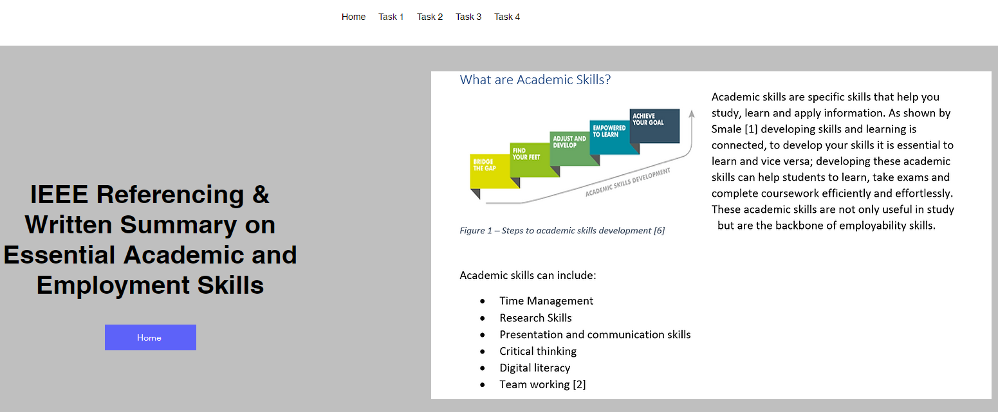
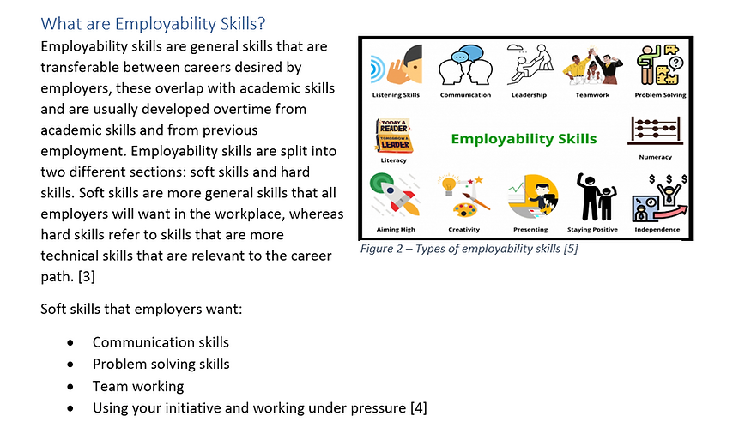
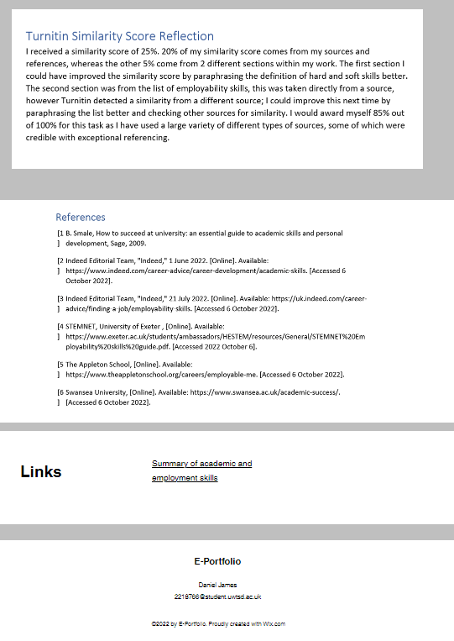

Task 2 – Academic Poster
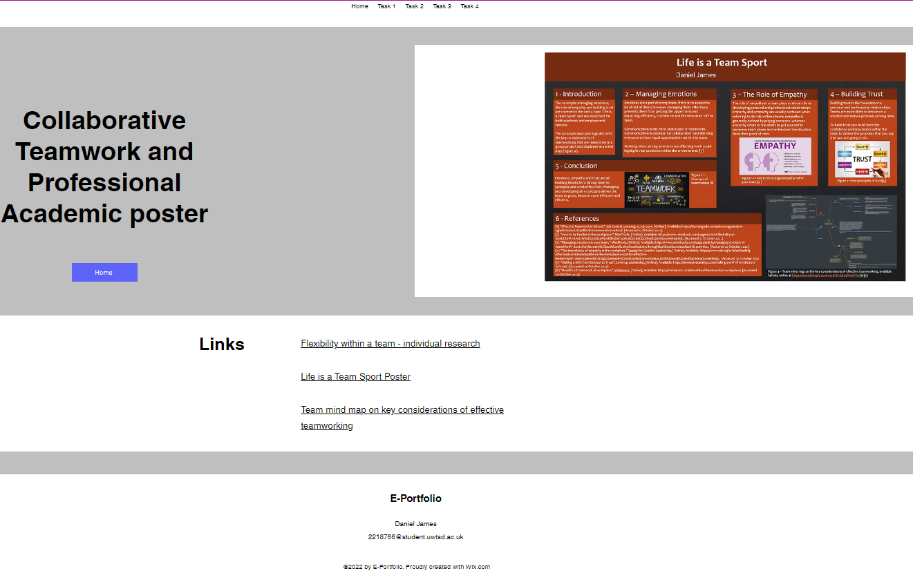
Task 2ii.pptx

Task 3 – Automatic Referencing Tool
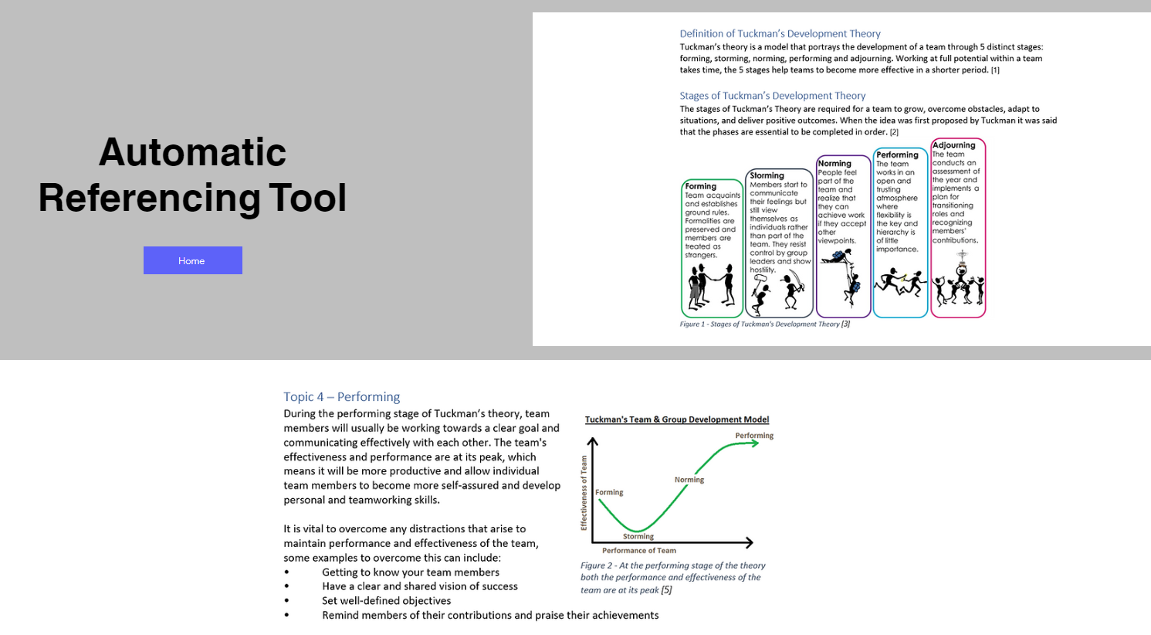
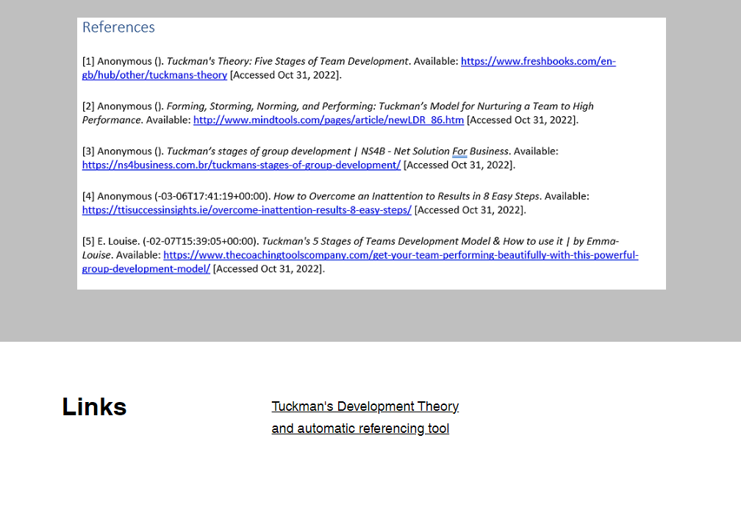

Task 4 – E-Portfolio Creation and Review


