
PROFESSIONAL CAREER DEVELOPMENT
[Reflective report ]


Huda Haroon (1919280)
10 June 2020
UNIVERSITY OF WALES TRINTY SAINT DAVID

Executive Summary:
In this reflective report of professional career development.
I addressed and explained all areas related to my last 6 weeks lectures what I learned and understood. In my work research and investigate about my self awareness, my PDP plan SMART goals, SWOT Analysis, Go Mad thinking.
I clearly demonstrated that my foregoing experiences constitute a good start for my self-knowledge and will help more for the improvement of my journey during this academic year at the UWTSD. As I have developed and explained what competencies and goals I am planning to achieve, I will be working on it related to my SMART goals in order to accomplish all of it.
In the meantime, I will be using all resources available in the Campus which would better support me for example a face to face tutorial for feedback from my lecturers, all evaluation and assessment and all learning styles and support from colleagues to lead me in a good result. The Go Mad and the Johari window are good illustrations of my progress.
In conclusion, reaching my final goals is one of my priorities in this academic year 2019-2020 as I really want it, I will be focus on my SMART goals in the short term first and in undergraduate program. I will make it possible by anchoring my goal in reality. I will finally prospect and emphasize what duty and activities need involvement from others.

Table of Contents
Executive Summary 1
Terms of Reference 3
Procedure 4
Introduction 5
Findings 6
Conclusion 7
Recommendations 8
References 9
Appendices 10
Acknowledgements 11

Terms of Reference:

Miss Laura James who is our lecturer requested the assignment of professional career development reflective report. 12th of June 2020, the purpose of the report is to Analyse and understand skill and knowledge. My name is Huda (student) who compiled the report, brief outline of the areas addressed and investigated.

Procedure:
I have used to compile the report eg, Module lectures, Peter learning style questionnaires, Johari window, Google search, books, editions resource of employability skills,websites to complete my report.
Introduction :
In order to be familiarized and enhance my knowledge in professional development by following the UK requirement, I decided to join this academic year 2019-2020 the skills for the workplace into the UWTSD.
Having knowledge in administration field. I learnt how to acquire managerial capacities within 3 years of experience of volunteering and paid work in various departments including ticket sales, admin and reception role, making spread sheets handling procurement work with medical secretary in hospital environment and finally in the administrative and receptionist in GPOOH service.
Moved in UK Swansea since August 2015, I have had difficulties to apply for jobs in a new world where I need to be more specific and realistic by demonstrating my strengths and weaknesses.
In order to build my confidence in a foreign Country where I met some barrier language, I have decided to undertake volunteering Jobs with Oxfam Shop, SCVS and the EYST included ESOL class with GCS to develop myself professionally.
PDP helps me to think in advance and taking the most befitting steps now, convenient to give myself the best discipline of choices in the future. PDP provides me inestimable understanding of my prosecution by having a larger independence and confidence of my academic, professional and personal life. (Cottrell, 2015).
I have experience of working but I still needed a foundation and an added value for a good achievement of my goals. To complete these goals, I need my PDP which I will support through different theories studied so far such as my skills self-assessment, the Johari window, Smart goal setting and swot analysis (Morgan,2017).

Professional development refers to the process of identifying goals and learning new skills to help you grow and succeed at work. Professional development may lead to a promotion or change in job, or simply to doing better in a current position, knowledge of the skills required to succeed, formal or informal assessments, and an individual development plan. This guide is designed to take you through each of these elements.(LEARNING & ORGANISATIONS DEVELOPMENT)

Findings:

Reflective practice is a tool for improving my learning both as a student and in relation to my work and life experiences. Although it will take time to adopt the technique of reflective practice, it will ultimately save time and energy.
Professional development Reflective practice has huge benefits in increasing self-awareness, which is a key component of emotional intelligence, and in developing a better understanding of others. Reflective practice can also helps me to develop creative thinking skills, and encourages active engagement in work processes.

In work situations, keeping a learning journal, and regularly using reflective practice, will support more meaningful discussions about career development, and my personal development, including at personal appraisal time.

interview situation PDP should have four important questions to put onward (Beausaert, 2011):

-What have I done so far?
I started building my career of administration in(2016) as a Volunteer in EYST Organisation where I perform various duties handling phone calls do admin work gradually I realize that I need to improve and more focus on customer service skills like communication skills as well as reading, writing skills.
It gives me a summarization of the competencies I worked on in the past;

-What do I want to achieve?
What competencies and goals am I planning to work on in the future?

-How am I going to manage with that?
All training and studies that I am going through with some feedback from my lectures, colleagues and all learning styles available to lead me in a good result.

-What is the next step to take?
At the end of this academic year, I should be able to have clear idea to reach my final goal.

I will develop in more detail my PDP to elucidate this process for an expected result at the end of this assessment.

3. Personal Development Plan Practice

3.1 My learning and reflection

Austin, Marini, and Desroches (2005), give an account of PDP as credentials that recommend an idealized person who is aware on how to self-reflect, is objective to change, keen in his expansion and knows how to categorize himself and his surroundings to facilitate academic attainment.
Reflection means a censorious evaluation of prior experiences and plans at reinforcing cognitive improvement on those experiences; theoretically, it guides to external changes in the course of time. (Anseel, Lievens, and Schollaert, 2009).
In other terms, reflecting provides apprehension into my processes of academic studying. This process of a personal studying can best be illustrated by referring to Kolb’s model of experiential learning, in which reflection on personal experiences takes part in a central role. (Kolb, 1987).This theory stipulates that studying happens through established experiences.

As a result, I reflect on what I experienced by using PDP. In addition, I can use my prior experiences and what I learned from those experiences as a foundation for new active experimentation, and, eventually, an improved progressiveness.

3.2 Setting my personal SMART Goal

The SMART objective was firstly introduced by Peter Drucker in 1954 in his book the practice of Management (Drucker, 1954). According to Drucker, Managers should avoid the routine in their daily basis and should keep their main purpose by being involved for a better functioning of the organization.

SMART is an acronym which has multiple kind of distinct change that can be used to afford an entire definition of goal setting. In terms of my own personal smart goal, during my journey in the UWTSD for the academic year 2019-2020, I can describe my goal as follow:
2
Specific : I want to have the grade of 80% during this academic year, not only in Professional Career Development module but at all modules.

Measurable : I will have gained by the end of this academic year a certificate which I will reach by improving module after module for a good achievement.

Achievable : To achieve this goal, I will be attending all the classes, participating in group discussion, asking for help when needed. In addition, I will have two hours every night to review my lessons and using the library for more reading resources every Saturday, from 11:00 am to 15:00 pm. From my prior experience, I will use my learning logs to identify my knowledge which I consider useful for my future career and success.

Realistic : By using my prior experience, I will adapt to the all relevant resources’ available in the Campus, speaking to native students included. I will use all support from the lectures’ to the Student Unit and whoever is able for a better progress.

Time bound : By the end of September 2020, I would have achieved my goal and would have received my Certificate and would have registered in accounting program.

Subsequently, many people are unsuccessful in achieving one’s goal in life, not for absence of capacity or wisdom or even determination, but simply because they have never disposed their strengths around a goal. (Hubbard, 1923).

It follows that to identify my internal strengths and weaknesses and external opportunities and threats, I need a swot analysis.

3.3 SWOT and TOWS Analysis

3.3.1 Definition

Swot is an acronym which means:
Strength: is attribute or capability that I have which give me ascendancy. In other words, things that I am good at such as experiences, qualifications, attitude, training and technical abilities, and so on.
Weaknesses: are circumstances or character of being weak. (Harrap’compas dictionary,2008).That is to say what do I avoid because of lack of confidence, what are my negative habits regarding organisation, mood, time management and communication skills and so on.

Opportunities : are possibilities or occasions that I have to achieve my goals. this means, what networking educational classes, colleagues and lectures that I can use increase my effectiveness and efficiency.

Threats : Is all kind of obstacles or competitions do I currently face in my education and around my environment. To put it simply, what obstacles do I currently face in my studies and my development? Will new style of teaching slow my progress?
Similarly, a swot and tows analysis should develop a vigorous planning for my education.

3.3.2 SWOT and TOWS analysis

Tows Analysis is an alternative of my classic study tool, Swot Analysis. Tows and Swot are acronym for various compromises of the words Strengths, Weaknesses, Opportunities and Threats.

I will use these mechanism to think about my education and analyse the external environment (treats and opportunities), and my internal environment (weaknesses and strengths). Also, to think about my own skills and experiences.
Swot analysis accentuate my internal environment whereas Twos analysis accentuate the external environment. (Weihich, 1982).

In both situations, the analyse results in a Swot (or Tows) Matrix as illustrated below (Khan, Barrow, 2019):
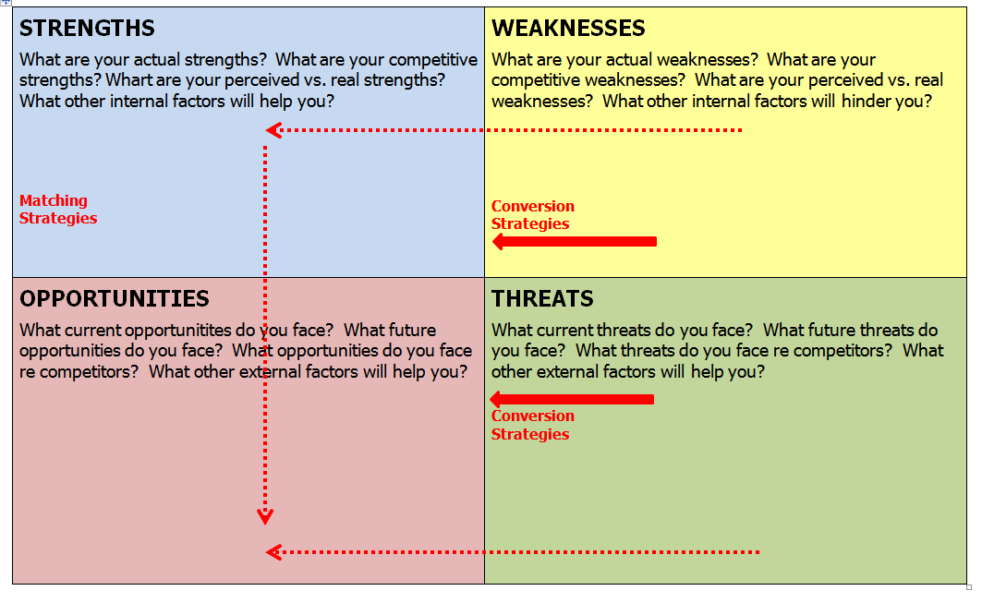Fig.1 Matrix Swot/ Tows
The Matrix above shows how I can extend my use of Swot and Twos by thinking in detail about plan of action to take throughout my education. But at the same time, I will present in appendices a concrete matrix where I will express my Swot and Tows as an example to have a better understanding of planned choices.
In spite of Swot/ Twos analysis, I will turn my attention to other learning useful methods accepted for understanding my personal progress. Such as, Johari window model, Go MAD MODEL and some learning style.
4
3.4 JOHARI METHOD
3.4.1 Definition

The Johari window was developed by Joseph Luft and Harrington Ingham talking about correlation and reciprocal comprehension between representatives. It is represented by a quadrant which shows the attitude of a person understood to him but not understood to the others. Namely, this tool helps a person to understand its own relation and to other group of people.(Luft, Ingham, 1955).
3.4.2 Aim or Object
The aim of a Johari window is to empower a person to improve confidence or assurance with others by revealing its own information and to get a feedback on what others know about him.
As explained above that the Johari window is represented by a quadrant in which it is clearly demonstrated a global correlation of a person and others. To illustrate as follows:
Fig.2: Johari Window model
OPEN | BLIND
HIDDEN | UNKNOWN
- Open Self: This quadrant reveals the conduct, manners, thinking, position, proficiency skills of a person that he is well informed and disposed to share with others. It shows a state where the person is open and directly to himself and others about what he is doing, how is he doing and what his purposes are. According to my present PDP, I am situated in this open self-quadrant.
- Blind Self: The blind self, reveals the situation of a person known to others but not known to him. It usually happens, when a person or a subject copies the habits of some significant personalities unknowingly since his infancy. This situation is relative to me, my colleagues and all the students I will be working with during this academic year as well at my working place.
5
- Hidden Self: This quadrant of the Johari window reveals the situation of a person known to him but not known to the others. This is mostly perceived in persons who are recessive and do not like to explain their private lives with anyone. The individual keeps his feelings, plans or thoughts to himself and do not divulge it in front of other people.
- Unknown self: This is the unexplainable situation of a person who is neither known to him, nor to others. Nobody can understand him even himself or others.
In brief, these quadrants will help me to have my self-understanding, my understanding with others and how people will perceive me as well my hidden situation and the others’.
Once I have understood clearly my belief and the people’ believes in the environment where I am living and studying, it would ensure me to make a difference (MAD) and will introduce me to the next method.
3.5 The GO MAD Thinking
This methodology of making a difference was firstly developed by Andy Gilbert and Ian Chakrvorty in the latest ninety year. It has the purpose of encouraging people to make a difference. Also, getting them interested in developing people by equipping them with an effective and efficient toolkit for thinking and achieving greater success.
To improve the outcomes of my PDP, I need to check my self-belief and take my own responsability, understand my strengths in order to achieve the goal fixed.
In addition, I need to understand those who are in my environment, get them involved and be motivated in order to develop confidence and celebrate success.
To understand gradually how I learn and how I get a self-knowledge, I used learning styles which will be uploading in the appendices.
3.6 Learning Styles Questionnaire

As stated below, learning styles questionnaire such as Peter Honey and Alan Mumford learning style is a way to understand how we learn, students and teachers. How we get self-knowledge and the useful of inventories. To understand more about the learning style, I have uploaded in appendices my learning styles questionnaire for a good improvement.

Learning Styles Questionnaire

Name: Huda Haroon
This questionnaire is designed to find out your preferred learning style(s). Over the years you have probably developed learning "habits" that help you benefit more from some experiences than from others. Since you are probably unaware of this, this questionnaire will help you pinpoint your learning preferences so that you are in a better position to select learning experiences that suit your style and having a greater understanding of those that suit the style of others.

This is an internationally proven tool designed by Peter Honey and Alan Mumford.
There is no time limit to this questionnaire. It will probably take you 10-15 minutes. The accuracy of the results depends on how honest you can be. There are no right or wrong answers.

If you agree more than you disagree with a statement put a tick by it.
If you disagree more than you agree put a cross by it.
Be sure to mark each item with either a tick or cross.

× | - I have strong beliefs about what is right and wrong, good and bad.
× | - I often act without considering the possible consequences
/ | - I tend to solve problems using a step-by-step approach
× | - I believe that formal procedures and policies restrict people
/ | - I have a reputation for saying what I think, simply and directly
/ | - I often find that actions based on feelings are as sound as those based on careful thought and analysis
/ | - I like the sort of work where I have time for thorough preparation and implementation
× | - I regularly question people about their basic assumptions
× | - What matters most is whether something works in practice
/ | - I actively seek out new experiences
/ | - When I hear about a new idea or approach I immediately start working out how to apply it in practice
/ | - I am keen on self discipline such as watching my diet, taking regular exercise, sticking to a fixed routine, etc.
/ | - I take pride in doing a thorough job
/ | - I get on best with logical, analytical people and less well with spontaneous, "irrational"
/ | - I take care over the interpretation of data available to me and avoid jumping to conclusions
/ | - I like to reach a decision carefully after weighing up many alternatives
× | - I'm attracted more to novel, unusual ideas than to practical ones
/ | - I don't like disorganised things and prefer to fit things into a coherent pattern
Conclusion:
Therefore, it has been clearly demonstrated that my foregoing experiences constitute a good start for my self-knowledge and will help more for the improvement of my journey during this academic year at the UWTSD. As I have developed and explained what competencies and goals I am planning to achieve, I will be working on it related to my SMART goals in order to accomplish all of it.
In the meantime, I will be using all resources available in the Campus which would better support me for example a face to face tutorial for feedback from my lecturers, all evaluation and assessment and all learning styles and support from colleagues to lead me in a good result. The Go Mad and the Johari window are good illustrations of my progress.
In conclusion, reaching my final goals is one of my priorities in this academic year 2019-2020 as I really want it, I will be focus on my SMART goals in the short term first and in undergraduate program. I will make it possible by anchoring my goal in reality. I will finally prospect and emphasize what duty and activities need involvement from others.

References/Bibliography
- (LEARNING & ORGANISATIONS DEVELOPMENT) Google search.
- Bryan Greetham, (2014),How to write your undergraduate dissertation, 2nd edition.
- Carol Martin, (2009),interviews fitness training, 4rth edition, kindle edition
- Fleming N, and Baume D(2006),learning styles again VARKING up the right tree, Educational development, SEDA LTD
- Harap’s Compact Dictionary, (2008)3rd edition, Chambers Harap publishers Ltd,;Edinburgh
- Heinz weihich(1982),long range planning, Vol, 15,issue 2,The Tows Matrix, for situational analysis.
- Hubbard Elbert(1923)Elbert scrap Book 1st edition, wise, NY.
- Luft J, Ingham H(1995)The Johari window, a graphic Model of interpersonal awareness,UClA
- Peter Morgan, (2017)The business student ‘s guide to study and Employability, sage.
- Stella Cottrell, (2015)Skull for success, 3rd edition Palgrave.
- Http://www.gomadthinking.com/com/about/our-story/.

Appendices
1. Learning Styles Questionnaire- Vak
2. Learning Styles Questionnaire- Peter Honey and Alan Mumford

Acknowledgements
I really appreciate for assistance of my lecturer she is really supportive her module related videos really helpful and she made us understand and enhanced skills which I followed to completing the report,she guides us to follow, online resources, books and journeys etc also online journals, books and materials provider.

