

Cover Page

Student Name: Susannah Moriarty
Student Number: 2331924
Module Name: Changemakers: Creativity and Value Creation
Module Code: BMP5014
Lecturer: Alice Clayton

Contents page

Task 1 ………………………………………………………………. pp.3-4

Task 2 ………………………………………………………………. pp.4-5

Task 3 ………………………………………………………………. pp.5-7

Task 4 ………………………………………………………………. pp.7-8

Task 5 ……………………………………………………………… p.8

Task 6 ………………………………………………………………. p.9

Task 7 ………………………………………………………………. p.10

Reference list ………………………………………………………. pp.11-12

Task 1 – directly results in added value.

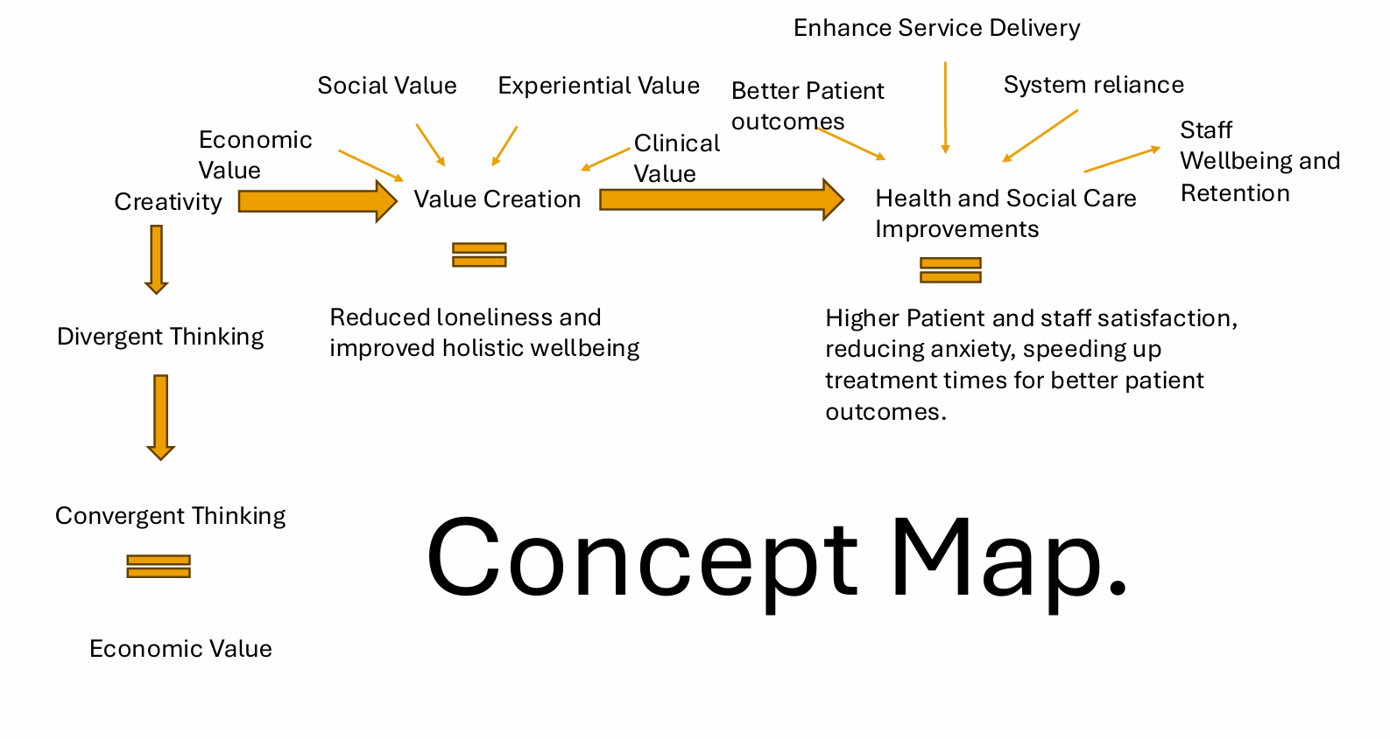

Creativity is the cognitive process of generating ideas that are both imaginative and useful. It is beneficial in health and social care because it drives essential problem solving and adaptations. Creativity involves two main modes, divergent thinking exploring many possible ideas, while convergent thinking evaluates and selects the single best solution.
Motivation influences this process. The internal interest and enjoyment of the task is the significant force driving persistence and risk taking that are needed for breakthrough ideas within health and social care.
Value creation is the process of generating a worth or benefit that exceeds the total investment. Creativity directly links to this by providing a new and useful component, a unique idea that when implemented directly results in added value.
A creative innovation in Health and Social Care is social prescribing, where GPs connect patients to non-clinical community services (community fitness classes or support groups) to combat chronic health conditions and loneliness. This creative solution generates social value by improving patient wellbeing, reducing reliance on clinical services, and reducing NHS costs.
Combining creative problem solving with deliberate value creation ensures that innovation in health and social care is not just new but targeted, effective and sustainable, leading to superior and positive social impact.

Task 2 - Self-Reflection of Group Activity

Reflection on Divergent and Convergent Thinking, using the Gibbs Reflective Cycle (The University of Edinburgh, 2024)
This academic reflection analyses a group activity involving a paper clip using Gibbs Reflective cycle to understand the practical dynamics of divergent thinking and convergent thinking.

Description and feelings
The objective was to brainstorm an extensive list of paper clip uses. Our group of four generated 28 distinct unconventional concepts, including temporary jewellery, picture hangers and functional tools for cleaning nails. Critically one of our peers attempted to use a search engine for answers, the immediate group intervention redirected us to unassisted creativity. This moment defined the exercise focus. The immediate success of collaborative brainstorming validated and energised my appreciation for unassisted creativity.

Evaluation and Analysis
Generating 28 diverse ideas exemplified Divergent Thinking, prioritising volume and novelty over immediate feasibility. The early search attempts highlighted the need to isolate the creative phase. Convergent Thinking then involved a rigorous, analytical evaluation based on criteria of utility and efficiency. This critical process logically, if not ironically, concluded that the paper clips most optimal use remained its original function, holding paper together.

Conclusion and Action plan
The exercise confirmed that maximising creative output requires the strict separation of divergent and convergent cognitive thinking. My primary learning outcome is a commitment to implementing a formalized, two-phase process. In future collaboration projects, I will deliberately structure time for non-judgemental divergent brainstorming period before commencing any critical, criteria based convergent selection.

Task 3 - Case Study of a UK innovation
Case Study. Integrating Artificial Intelligence in Radiology for Early Cancer Diagnosis
Introduction
The integration of Artificial Intelligence (AI) into the National Health Service (NHS) radiology directly addresses the critical challenges of early cancer detection. Subtle indicators are often missed due to the inherent difficulty of the task. This project deploying advanced deep learning AI as an assistive technology to enhance diagnostic precision and manage the increased demand for high volume screening programs.

Creativity As a Drive for Change.
The innovation lies in its strategic deployment as a workflow optimisation tool (North East London Cancer Alliance, 2024). Instead of replacing the skilled radiologists, the intervention establishes a human AI partnership. The system immediately triages the workload, assigning priority scores to suspicion cases. This creative step allows specialists to focus their expertise on more complex cases, enhancing clinical capacity and reducing (The Royal College of Radiologists, 2025). This strategic shift mitigates specialist burnout, creating a more sustainable pathway (WHO, 2019).

Value Created for Patients and Service Users
This approach creates substantial measurable value for both patients and NHS staff. The AI system accelerates the slow diagnostic process by screening images in seconds, meeting NHS waiting times and enabling earlier treatment. As a sophisticated second opinion, it significantly reduces the false negatives by identifying minute anomalies overlooked in high volume environments. AI’s ability to factor in patient specific data, such as genetics allow a personalised risk assessment, prioritising high risk individuals, ensuring early diagnosis and treatment (Hunter, Hindocha and Lee, 2022).

How Benefit is Measured.
The value created is measured using several key performance indicators (KPIs). These include a reduction in the false negative diagnosis, improving diagnostic precision. A decrease in the average results waiting time, improving efficiency and speed while increasing clinical capacity. Staff benefit is measured by a reduction in reported specialist burn out and retention of staff (Bejarano, 2023).

Potential Challenges
Despite its clinical success, implementing Ai into radiology presents significant challenges. These include the initial high cost and the integration of the AI system into exciting NHS software. The ethical issue arises around data security and ensuring the AI algorithms are free from algorithmic bias that could inadvertently disadvantage certain patients' demographics. Finally, the risk of over reliance on the system is a concern, which could lead to critical diagnostic oversight when AI identifies scans as low priority (Ahmad et al., 2021).

Conclusion
In summary, the NHS adoption of AI in radiology is a creative success, not just technology but strategically (Northeast London Cancer Alliance, 2024). By implementing AI as a clinical partner focused on workload triage and diagnostic support, the initiative delivers significant measurable value. This process translates complex data into faster more accurate and personalised care pathway that ultimately enhances patient survival rates and reduces systematic pressures across the NHS service, despite the challenges regarding cost and implementation.

Task 4 - Research Task

The construction sector characterised by an acute public crisis marked widespread substance misuse which significantly compounds existing occupational hazards. Construction workers exhibit the second highest rate of heavy alcohol and substance use disorders compared to other industries such as hospitality. The widespread substance abuse directly compromises safety, as workers report reduced attention spans and tiredness, increasing the risk of accidents in the sector where the fatality rate is already six times higher than the industry average

Impact of Substance Abuse on Construction Workers
This case study is based on a survey of 50 construction workers, aimed to identify the factors contributing to substance abuse, specifically focusing on the reasons for the use and how substances help the construction workers in their environment. The research found that substance consumption is driven by the preserved functioning utility it offers. The study concluded that the primary reason for substance abuse is the intense physical and mental strain in the trade, leading workers to use substances as a necessary strategy for chronic fatigue, pain and the sustained demands of high-pressure worksites (Fredericton, Kahani and Safiuddin, 2018).

Suicides among Construction Occupations in the United Kingdom.
This study examined the severe mental health crisis, noting construction workers suicide risk is 3.7 times high than the national average. Research linked these outcomes to occupational stressors. The key findings were that two out of three UK tradespeople misuse drugs and or alcohol specifically to mitigate symptoms of mental ill health. The conclusion identifies substance abuse as a direct result of chronic psychosocial hazards, high workload (42%), work pressure (35%) and financial stress (32%). These generate anxiety and low mood that workers attempt to surprises. (Hare, Lawani and Mcewen, 2023)

Conclusion.
Both studies indicate substance abuse is not a standalone issue but a maladaptive response to systematic occupational distress. The Case Study shows workers use substances to cope functionally with demanding physical realities. Conversely, the Suicide analysis reveals that the work environment creates unmanageable burdens from high workload, pressure, and economic insecurity, driving workers to use drugs and alcohol to mitigate mental ill health symptoms. This convergence of physical strain and severe psychosocial stress establishes chronic occupational hazards as the root reason for substance dependence (Fredericton, Kahani and Safiuddin, 2018; Hare, Lawani and Mcewen, 2023).

Task 5 – Podcast

Podcast The Groundwork.m4a

Task 6 - NHS Leadership Framework Analysis
The NHS Leadership Farmwork establishes a single, universal standard for effective leadership across all Health and social care staff; it emphasises that leadership is a shared responsibility by all staff across all sectors. Its core purpose is to promote a consistent, value driven approach to development, empowering individuals to contribute to the success and transformation of services, with patients at the heart of the care (NHS Leadership Academy, 2021).
The framework is structured around seven domains that cover a range of necessary behaviours. The five core main domains apply to all staff, focusing on practical day-to-day leadership, demonstrating personal qualities, for example working with integrity and self-awareness. Working with others, building effective teams, and strong relationships. Managing services, overseeing performance, and effective planning. Improving services with innovations, driving quality, and improving patient safety. Finally, setting direction using evidence to make decisions aligned with strategy. (Akhtar et al., 2019)
Additionally, for those in senior roles there are two senior domains. Creating the Vision, which involves developing and communicating a compelling future direction. While Delivering the Strategy, focuses on translating that vision into actionable implementation of plans. The comprehensive model guides staff through four stages of career progression ensuring leadership behaviours evolve from the immediate team level to the wider health and social care system. (Akhtar et al., 2019), (NHS Leadership Academy, 2021).
The NHS Leadership Frameworks Domain 4, Improving Services is the catalyst for driving creativity and enhancing patient care. This domain mandates that leaders, regardless of their role, actively encourage innovation by critically evaluating current processes and fostering a culture where staff feel safe to suggest solutions. This support for front line creativity is what fuels service transformation.
Applying this domain directly results in better patient outcomes by increasing safety and improving efficiency. For example, a clinic administrator can demonstrate this by encouraging desk staff to creatively redesign the patient's check-in process (the innovation). Instead of one long queue, staff implemented a simple fast track system for follow-up appointments. This professional practice immediately reduces patient frustration, leading to a calmer environment and quicker access to care. The effective result ensures smoother and higher quality of patient centred care.
Task 7 - Self-Reflection Journal Entry
This module expanded my view of creativity from imaginative generating to the cognitive process of generating ideas that are both imaginative and useful. The vital link to innovation is value creation, creativity must deliver a unique component that generates worth exceeding the investment, exemplified by social prescribing model.
My understanding of technology in Health and Social Care innovation developed through the AI in radiology case study. Innovation is less about the technology itself but more about its strategic deployment as a workflow optimising tool. This creative human AI partnership delivers measurable value, enhancing and personalising patient care.
Self reflection proved vital, confirming the need to strictly separate divergent thinking from convergent thinking. This informs my professional practice by committing me to a formal, two-phase creative process in all future collaborations. This focus aligns with the NHS Leadership Frameworks mandate to champion a culture of safe innovation.
My key takeaway is creativity in Health and Social Care must be deliberate and strategic. It is the essential driver for sustained service transformation, supported by measured value creation and reflective leadership.

Reference List

Ahmad, Z., Rahim, S., Zubair, M. and Abdul-Ghafar, J. (2021) ‘Artificial intelligence (A potential and promise in pathology: Present and future impact, obstacles including costs and acceptance among pathologists, practical and philosophical considerations. A comprehensive review’, Diagnostic Pathology, [online] 16(24). Available at: https://www.ncbi.nlm.nih.gov/pmc/articles/PMC7971952/.

Akhtar, M., Casha, J.N., Ronder, J., Sakel, M., Wight, C. and Manley, K. (2019) ‘Leading the health service into the future: transforming the NHS through transforming ourselves’, International Practice Development Journal, [online] 6(2), pp.1–21. doi:https://doi.org/10.19043/ipdj.62.005.

Bejarano, A. (2023) ‘The Benefits of Artificial Intelligence in Radiology: Transforming Healthcare through Enhanced Diagnostics and Workflow Efficiency’, The Review of Contemporary Scientific and Academic Studies, 3(8). doi:https://doi.org/10.55454/rcsas.3.08.2023.005 (Accessed 7 October 2025)

Davenport, T and Kalakota, R. (2019) ‘The potential for artificial intelligence in healthcare’ Future healthcare journal, 6 (2): pp.94-98 (Accessed 5 October 2025)

Fredericton, C., Kahani, M. and Safiuddin, M. (2018) GC171-1 Building Tomorrow’s Society Bâtir la Société de Demain CASE STUDY: IMPACT OF SUBSTANCE ABUSE ON CONSTRUCTION WORKERS. [online] Available at: https://legacy.csce.ca/elf/apps/CONFERENCEVIEWER/conferences/2018/pdfs/Paper_GC171_0607032414.pdf (Accessed: 7 October 2025).

Hare, B, Lawani, K. and McEwen, G. (2023) 'Suicides among construction occupations in the UK', Journal of Engineering, Project, and Production Management, vol. 14, no. 2, 0017. https://doi.org/10.32738/JEPPM-2024 (Accessed 7 October 2025)

Hunter, B., Hindocha, S. and Lee, R.W. (2022) ‘The Role of Artificial Intelligence in Early Cancer Diagnosis’, Cancers, [online] 14(6), p.1524. doi:https://doi.org/10.3390/cancers14061524.
NHS Leadership Academy (2021) Healthcare Leadership Model – Leadership Academy. [online] www.leadershipacademy.nhs.uk. Available at: https://www.leadershipacademy.nhs.uk/healthcare-jxjleadership-model/. (Accessed: 10 November 2025).

North East London Cancer Alliance (2024) Using Artificial Intelligence for faster Chest X-ray results. (Online). Available at: https://www.nelcanceralliance.nhs.uk/news/using-artificial-intelligence-faster-chest-x-ray-results (Accessed: 05 October 2025).

The Royal College of Radiologists (2025) AI Deployment in the NHS: reviewing progress made and defining future action. (Online). Available at: https://www.rcr.ac.uk/media/422p3xus/rcr-reports-ai-deployment-in-the-nhs.pdf (Accessed: 05 October 2025).

The University of Edinburgh (2024) Gibbs’ Reflective Cycle. [online] The University of Edinburgh. Available at: https://reflection.ed.ac.uk/reflectors-toolkit/reflecting-on-experience/gibbs-reflective-cycle. (Accessed: 07 October 2025).

Weinfass, I. (2023). Loaded question: construction’s drugs and alcohol problem. [online] Construction News. Available at: https://www.constructionnews.co.uk/health-and-safety/loaded-question-constructions-drugs-and-alcohol-problem-18-12-2023/. (Accessed: 9 October 2025)

World Health Organization (WHO) (2019) Burn-out an occupational phenomenon: International Classification of Diseases. [Online]. Available at:Burn-out an "occupational phenomenon": International Classification of Diseases (Accessed: 09 October 2025).

