ROS17841199 (Ben Ross)

A study into Transistors Amplifiers

Contents
- Introduction  - Objectives  - Theory/Research  - Transistor  - Use of Capacitors  - Roles of Resistance  - Equipment/Apparatus  - Experimental Procedure/Methodology  - Results/Analysis  - Standard Circuit  - Addition of Load Resistor  - Addition of a Bypass Capacitor  - Two Stage Amplifier  - Discussion/Evaluation  - Conclusion  - References | 2  2  3  3  8  8  9  9  11  11  12  12  13  14  14  15

Introduction

My objective in this report is to show that I can successfully design, create, and analyse a single stage and two stage amplifier, also showing that can work out the exact calculations needed to make the design work, am able to create the working circuit in a simulation, in this case LTSpice, and provide results to showcase the effectiveness of my design. After this, I will review my design and see if there could have been any components or quantities changed that could have made an improvement to the circuit overall. In terms of assistance, I have been given the amount of gain needed in the circuit (gain of 4), and the voltage level of the power supply (9V).

Objectives

My objectives are to:
- Calculate the values of the components in the circuits
- Research the components and their use in the circuits
- Create a working simulation of each design
- Discuss the results of each simulation, and if the results match up to my expectations.

Theory/Research

Transistors
The three most common types of transistors include:
- Common Base Configuration
- Common Emitter Configuration
- Common Collector Configuration

- In the common base configuration, there is no current gain but the gain in terms of the voltage is present.
- In the common collector there is current gain but there will be no voltage gain.
- The common emitter is the configuration in which both current and the voltage gains are present.
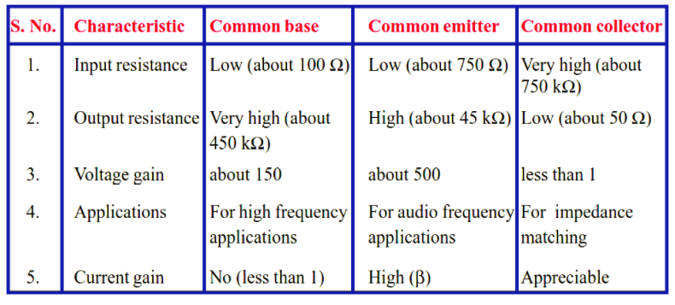
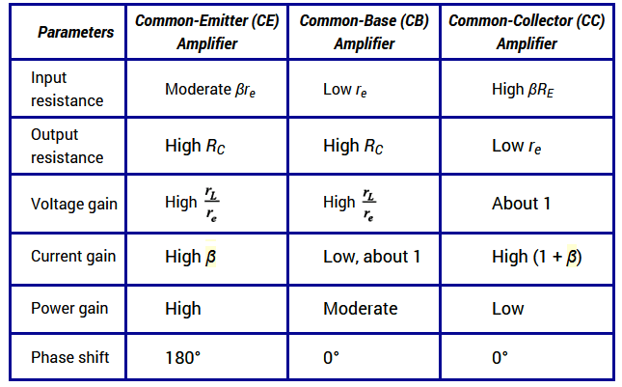

Common-Emitter Configuration
For a transistor to work as an amplifier we usually use the common-emitter configuration. The figure below shows how the transistor is set up when it is connected in a circuit as an amplifier.
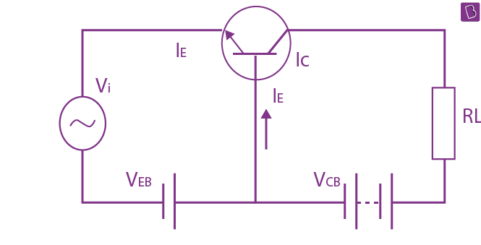
In the figure given above [1], the input is connected in forward-biased, and the output is connected in reverse-biased. The input signal is applied on the base-emitter junction and the output is taken through the load in emitter-collector junction. There is also an application of DC voltage in the input circuit for amplification. Besides, a small change in signal voltage results in the change of emitter current which is mainly due to the low resistance in the input circuit [2].
The output is taken across the load connected on the output side. The load can be in any combination of R, L or C. The load resistance is of high value which causes a large voltage drop. Overall, the weak signal is thus amplified in the collector circuit.
However, to work as an amplifier, the transistor must work in the active region of the output voltage versus input voltage curve as seen in the figure below [1].
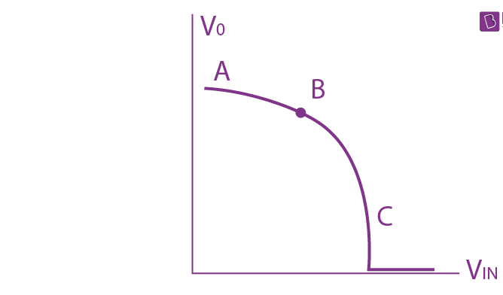
In the above graph, we have AB as the cut-off region, BC as the active region and from C we have a line parallel to X-axis, which is the saturation region.

Common Base Configuration
In common base configuration, emitter is the input terminal, collector is the output terminal and base terminal is connected as a common terminal for both input and output. That means the emitter terminal and common base terminal are known as input terminals whereas the collector terminal and common base terminal are known as output terminals.
In common base configuration, the base terminal is grounded so the common base configuration is also known as grounded base configuration. Sometimes common base configuration is referred to as common base amplifier, CB amplifier, or CB configuration.
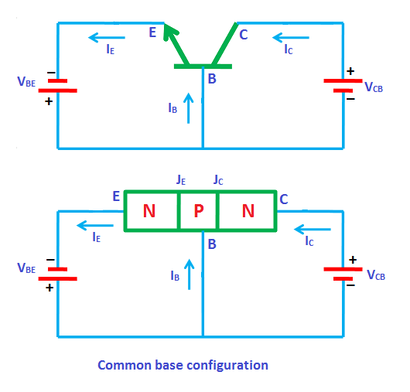[3]
The input signal is applied between the emitter and base terminals while the corresponding output signal is taken across the collector and base terminals. Therefore, the base terminal of a transistor is common for both input and output terminals and hence it is named as common base configuration.
The supply voltage between base and emitter is denoted by V_{BE} while the supply voltage between collector and base is denoted by V_{CB}.
As mentioned earlier, in every configuration, the base-emitter junction J_{E} is always forward biased and collector-base junction J_{C} is always reverse biased. Therefore, in common base configuration, the base-emitter junction J_{E} is forward biased and collector-base junction J_{C} is reverse biased.

The common base configuration for both NPN and PNP transistors is shown in the below figure.
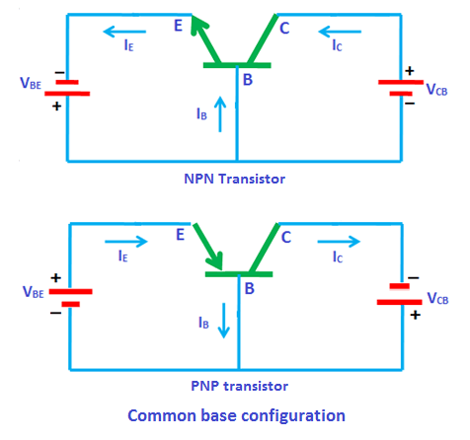[3]

Common Collector Configuration

In this configuration, the base terminal of the transistor serves as the input, the emitter terminal is the output and the collector terminal is common for both input and output. Hence, it is named as common collector configuration. The input is applied between the base and collector while the output is taken from the emitter and collector.
In common collector configuration, the collector terminal is grounded so the common collector configuration is also known as grounded collector configuration.
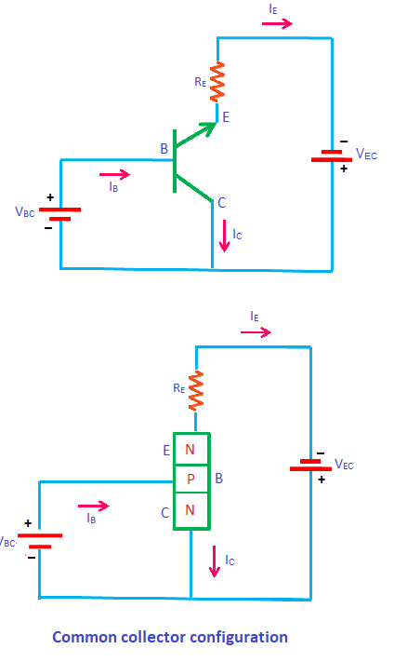[4]
Sometimes common collector configuration is also referred to as emitter follower, voltage follower, common collector amplifier, CC amplifier, or CC configuration. This configuration is mostly used as a voltage buffer.
The input supply voltage between base and collector is denoted by V_{BC} while the output voltage between emitter and collector is denoted by V_{EC}.
In this configuration, input current or base current is denoted by I_{B} and output current or emitter current is denoted by I_{E}. The common collector amplifier has high input impedance and low output impedance. It has low voltage gain and high current gain.

Gain in Power, Current and Voltage
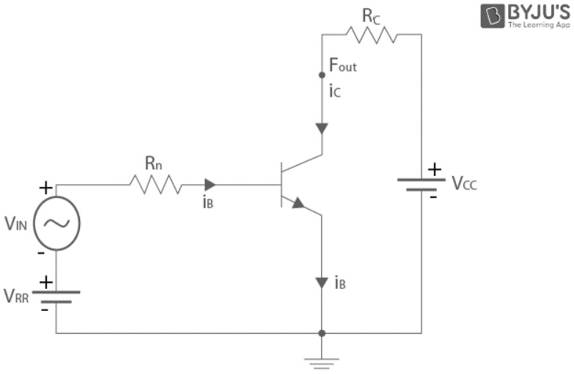
From the figure that is given above it is clear that on the output side, V₀ = V_{CC}– I_{C}R_{C}, where V₀ is the output voltage, I_{c} is the collector current, R_{c} is the load resistance and V_{cc} is fixed voltage on the output side.
If we consider ∆V₀ and ∆V_{i} as small changes in output and input voltages respectively, then ∆V₀ / ∆V_{i} is called as the small-signal voltage gain, A_{v} of the amplifier.
Therefore, ∆V₀= 0 – R_{c} ∆I_{C}
The gain in terms of voltage when the changes in input and output currents are observed is called Voltage gain.
Similarly in input side,
V_{in} = I_{B} R_{B} + V_{BE}
Or
∆V_{in} = ∆I_{B}R_{B} + ∆V_{BE} ~ ∆V_{in} = ∆I_{B}R_{B} (∆V_{BE} <<∆I_{B}R_{B})
Or,
A_{v} = ∆V₀ / ∆V_{in} = – R_{c} ∆I_{C} / R_{B} ∆I_{B} = -β_{ac} R_{c} / R_{B}
where β_{ac} = ∆I_{C} / ∆I_{B} is the AC current gain. [5]
When there is gain in terms of current due to the changes in input and output currents is called current gain. β value can range between 20 to 500. Power gain of an amplifier is defined as the product of the current gain and voltage gain of the amplifier. It is also defined as the rate of change in output power to the change in input power.
Mathematically, A_{p} = β_{ac} x A_{v}
Use of Capacitors

Coupling capacitors are essential components in amplifier circuits. They are used to prevent interference of a transistor’s bias voltage by AC signals. In most amplifier circuits, this is achieved by driving the signal to the base terminal of a transistor through a coupling capacitor.

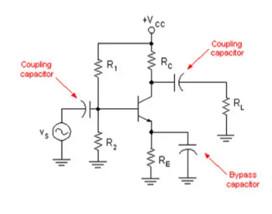[6]

Role of Resistance
The resistors form the voltage division circuit to supply the DC voltage to the base of the transistor. The resistors R_{C} and R_{E} control the collector and emitter currents respectively. Proper selection of these resistors helps us to control the value of the limiting currents. These resistors provide the required junction voltages between E-B, C-B, C-E, and currents I_{E}, I_{B} and I_{C} to work the transistor in the active region of the output characteristics.
The emitter resistor R_{E} produces the following changes in the performance of CE amplifier:
- It causes bias stabilization
- It causes current gain to remain essentially unaltered.
- Increases the input and output impedances.
- It stabilizes the voltage gain.

Equipment/Apparatus
The main equipment used is the circuit simulator MultiSim, a standard scientific calculator for the equations and a pen and paper.
The components used in the circuit include an NPN Bipolar Junction Transistor, two signal generators, two capacitors, four resistors and standard component wire connectors.

Experimental Procedure/Methodology
I first worked out the equations for the 1 Stage Amplifier, working out components such as the numbers for the 4 different resistors. I did not work out the numbers for the Gain, VCC and Capacitors, as I was given those calculations beforehand.

VCC= 9v
Gain= 4
RL= 600Ω
RC= RL= 600Ω
VC= VCC/2 = 9/2 = 4.5V
IC= VC/RC= 4.5/600= 7.5mA
RE = RC/Gain= 600/4= 150Ω
IE= IC= 7.5mA
VE= IC x RE= 7.5mAx 150= 1.125V= 1.13V
VB= VE + 0.7= 1.83V
IB= IC/200= 37.5mA
IE= IC + IB= 37.5mA + 7.5mA
IR1= 11xIB= 412.5x10⁻⁶
IR2= 10xIB= 375x10⁻⁶

VR2= VB= 1.83V
VR1= VCC- VR1= 7.17V
R1= VR1/IR1 =7.17/412.5x10⁻⁶ = 17381.81Ω
R2= VR2/IR2 = 1.83/375x10⁻⁶ = 4880Ω

I then worked out the 2 Stage Amplifier.

Gain= 12.5
RE=48Ω
VE= 0.3618V
VB= 1.0618V
VR2= 1.0618V
VR1= 7.9382V
R1= 19244.12Ω
R2= 2831.46Ω

Results/Analysis
Standard Circuit
The basic voltage divider bias common-emitter amplifier circuit consists of four resistors, and an NPN bipolar junction transistor. In addition to these core components, there are two coupling capacitors which effectively block the DC current from input signal as well as the output signal. The signal that appears at the Vin of the circuit is amplified, and phase shifted by 180 degrees when it reaches Vout.
The gain is slightly above the expected amount (the gain is now 4.1 instead of 4), but besides that, everything is working as planned.
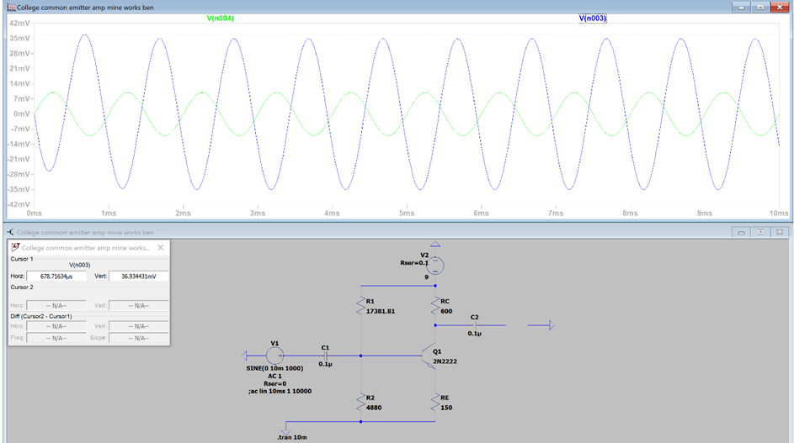

Addition of Load Resistor
As shown below, adding a load resistor decreases the gain significantly, reverses the phase shift of 180 degrees, and delays the amplification slightly. The amount for the load resistor (RL) is matched with RC.
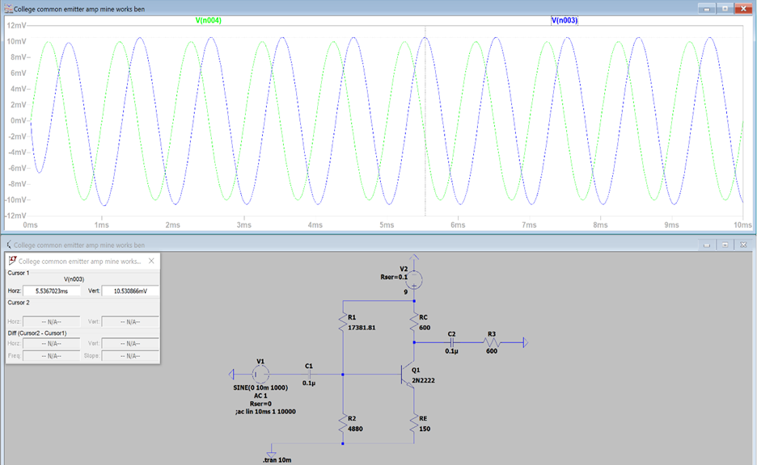
The gain has now m0ved down from 4.1 to 1.16667, a large drop that is all caused by the load resistor.

Addition of a Bypass Capacitor
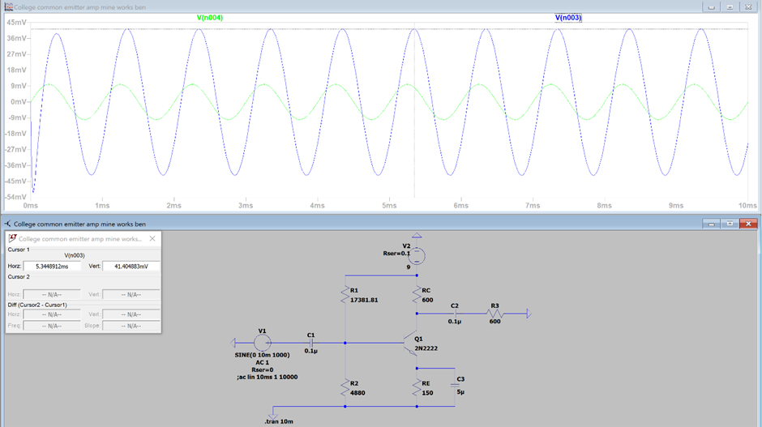
A bypass capacitor is added to an amplifier circuit in order to allow AC signals to bypass the emitter resistor. This effectively removes it from the output gain equation resulting in an increase to the amplifiers AC gain.
For a circuit with a bypass capacitor, resistor RE will now be disregarded, as it is now bypassed for AC signals and does not contribute to the voltage gain. This is the main reason why the gain is increased, as there is less resistance to lower it.
We can now compare the voltage gains calculated with or without the bypass capacitor by using a ratio of the two values, such as the example given below [7].
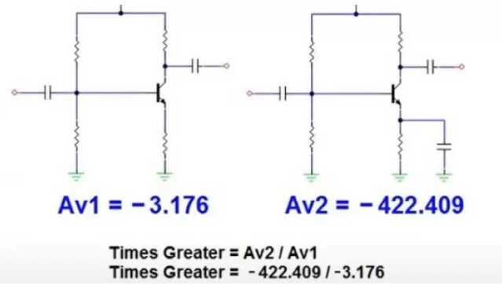
In conclusion, we can see that a bypass capacitor causes a significantly higher AC voltage gain in amplifier circuit 2, thus pulling more AC voltage than amplifier circuit 1.

Two Stage Amplifier
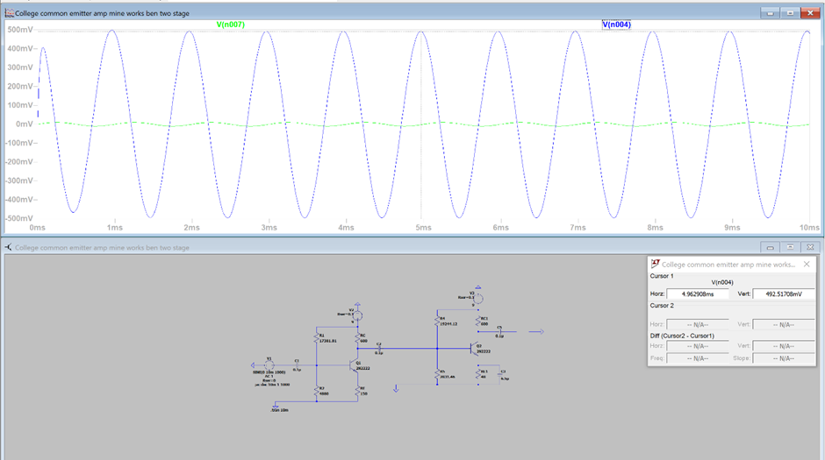
For most systems single transistor amplifier does not provide sufficient gain or output impedance matching. The solution is only to combine multiple stages of amplification. This amplifier circuit shows a simple two transistor amplifier. In the single transistor amplifier circuit, I made a simple amplifier with one transistor, four resistors and two capacitors but this amplifier has been designed with two transistors, eight resistors, and four capacitors.

The gain, its increase and other statistics are as expected. The gain is increased due to a bypass capacitor being added to the second stage of the amplifier, increasing the gain from 12.5 to 50.
Discussion/Evaluation
Applications for the system:
The applications for a common emitter amplifier include the following:
- These amplifiers are used typically in the RF circuits.
- In general, the amplifiers are used in the Low noise amplifiers [8]
- Common-emitter amplifiers are also used in radio frequency transceiver circuits.

Disadvantages
The disadvantages of the system include:
- In the high frequencies, the common emitter amplifier does not respond
- The voltage gain of this amplifier is unstable
- The output resistance is exceedingly high in these amplifiers
- In these amplifiers, there is a high thermal instability [9]

As seen by the simulations and results section (Page 13), the addition of a load resistor adds a significant drop in gain to the circuit. A load of 600Ω has reduced the gain of the circuit from 4.1 to 1.16667, a drop of 71.5446341%, or 71.55%.

Conclusion

I have found that my common emitter amplifier does meet my expectations but does have more disadvantages than I was aware of beforehand, such as high thermal instability and output resistance, due to not having a physical copy of the circuit, and the output resistance not being the main point of research in the overall task.

I have successfully calculated the values for, and have designed a one stage common emitter amplifier, with the only problem being a slight increase in gain, with an expectation of the gain being 4, and the gain in reality being 4.1, although slight differences were expected. I have also done the same with a two-stage amplifier, with the gain being 50, as expected. I have also researched the advantages and disadvantages of my circuit and discovered the effect of a load resistor of 600Ω on the overall gain, decreasing it by over 70%.

In conclusion, I have shown capable skills to design and create a one and two stage amplifier in a simulation software program. I have also shown skills in calculating the exact values needed for each circuit and prove that said calculations are correct for each circuit to perform to its expectations, with the least number of flaws.

References
- https://byjus.com/jee/transistor-as-amplifier
- https://byjus.com/physics/characteristics-of-a-transistor/#common-emitter-configuration-of-transistor
- https://www.physics-and-radio-electronics.com/electronic-devices-and-circuits/transistors/bipolarjunctiontransistor/commonbaseconfiguration.html
- https://www.physics-and-radio-electronics.com/electronic-devices-and-circuits/transistors/bipolarjunctiontransistor/commoncollectorconfiguration.html
- Fundamental Electrical and Electronic Principles- Christopher R Robertson
- https://passive-components.eu/capacitor-selection-for-coupling-and-decoupling-applications
- https://www.etcourse.com/news-blog/bypass-capacitor-what-its-importance-amplifier-circuit
- https://www.watelectronics.com/common-emitter-amplifier-working/
- https://high-tech-guide.com/article/what-are-the-disadvantages-of-using-common-emitter-amplifier

