MODULE TITLE: GUEST SERVICES
M4X01915

ASSIGNMENT TITLE: QUALITY MANAGEMENT EVALUATIVE REPORT

STUDENT NAME: EMANUELA STAN

STUDENT ID NUMBER: 1815346

LECTURER NAME: DALE CLARK

1



Chapter List

1. Introduction.......................................................................................... Page 3
2. Items and Services at JW Marriott Bucharest Grand Hotel................. Page 3-5
3. Strategies............................................................................................ Page 6
4. USP (Unique Selling Point) .................................................................Page 6
5. The executives Guest Service............................................................. Page 7
6. Quality Guest Service ......................................................................... Page 7-8
7. Administration setting.......................................................................... Page 8
8. Administration arrangement and quality management........................ Page 8-9
9. Conclusion........................................................................................... Page 9
10.References......................................................................................... Page 10

1.Introduction
The reason for this examination I to see very well the job and significance of visitor benefits in an inn and by and large in the travel industry and recreation industry
This paper presents the JW Marriot Hotel in Bucharest.
Starting from the fact that Marriott stands for tradition, quality and value, the company owns hotels designed for specific customer segments, creating brand names and pictures specific to each. Our own website promotes Marriott brands and presents to customers the company's successful initiatives. Any loyal customer can be rewarded by adding either points to allow him free accommodation in Marriott hotels, or miles of flight to allow for free air travel with certain airlines (Marriott, 2017).
Thus, Marriott has succeeded in successfully transferring branding to the digital environment (online). The brand adds value to the product / service and differentiates it from the competition. In the hospitality industry, branding is fundamental in getting competitive advantage. Numerous prestigious companies such as Marriott have successfully deployed online branding strategies.
The study was started by presenting the hotel, how it was created and what is the current offer.

2. Items and Services at JW Marriott Bucharest Grand Hotel
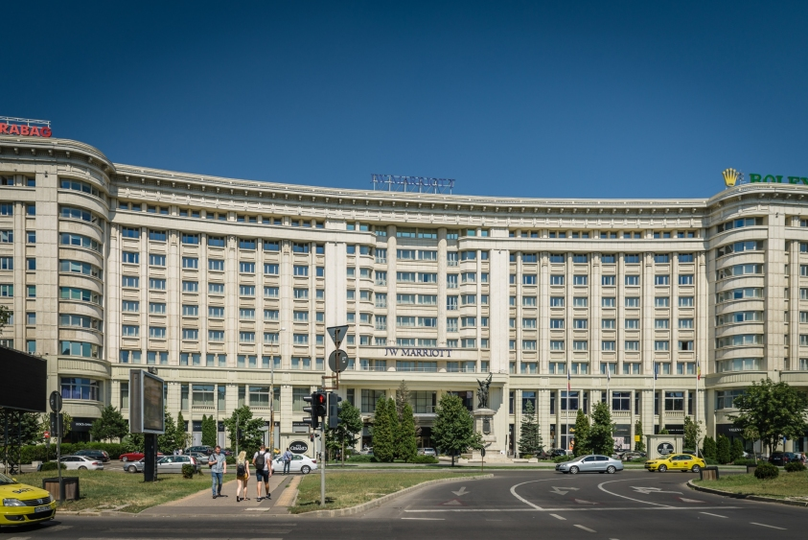 Marriott International is an American worldwide extended settlement association that regulates and foundations a wide plan of motels and related inn workplaces. Set up by J. Willard Marriott, the association is by and by driven by his tyke, Executive Chairman Bill Marriott, and President and Chief Executive Officer Arne Sorenson. Marriott International is the biggest lodging network on the planet.

Welcome to quiet luxury in Bucharest
“We will become your favourite hospitality organisation in Bucharest. We turn into a marketplace leader and obtain our monetary dreams, constantly delivering first class service at great prices. "(Marriott's declared at Bucharest Grand Hotel).
Marriott Bucharest, the inn worked by Strabag, is the main Marriott Continental Europe lodging evaluated JW Marriott extravagance.
The JW molecule assigns Marriott inns in the extravagance section, a portion where 39 lodgings are positioned far and wide, of which 16 are in the United States and 23 are around the world (in Europe there are two JW Marriott inns, one on the Italian island of Capri and just one on mainland Europe, in Bucharest).
The Marriott inn network is one of the biggest and most known chains in the lodging business. From a privately-owned company, the organization has more than 2,800 lodgings in 70 nations. The organization offers a wide scope of administrations through 16 brands. Marriott's administrations and offices include: shoe clean administration, looking after children, focus, secretarial administrations, safe store box, 24-hour room administration 24 hours per day and that's just the beginning. The Marriott chain is available in Romania through the five-star JW Marriott Hotel in Bucharest.

Deluxe King Room Deluxe Double Room Superior King
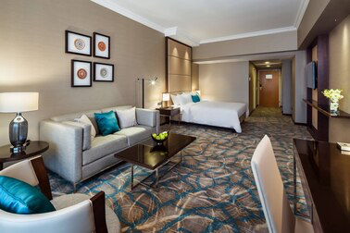
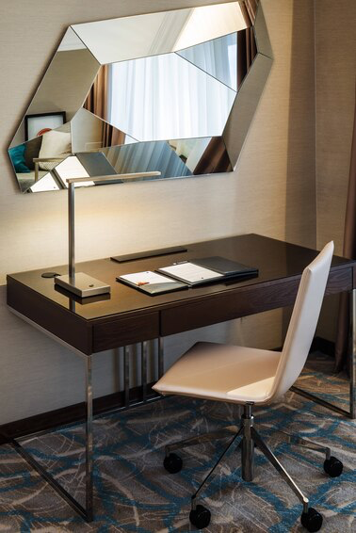
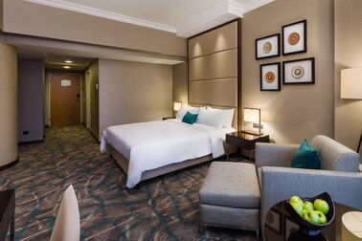
Guest room, 1 King Guest room, 2 Double Guest room,1King

Inn directors have comprehended that site guests never again buy organization sending however purchase suppositions. They never again buy administration astounding however buy recollections. Clients don't purchase nourishments and beverages, buy culinary audits. (Campbell-Smith, 1967).

KEY AMENITIES






Airport shuttle Fitness Area Full service spa Swimming Area
On the local market, JW Marriott dominates the top of the most profitable hotels.
Finances
For the budgetary year 2017, Marriott International uncovered salary of US $ 1.372 billion, with a yearly pay of US $ 22.894 billion, an extension of 34.1% over the past financial cycle. Marriott International's offers were traded at over $ 101 for each offer, and its market capitalization was regarded at over US $ 39.1 billion in October 2018.
Year | Revenue  in mil. USD$ | Net income  in mil. USD$ | Total Assets  in mil. USD$ | Price per Share  in USD$ | Employees
2005 | 11,129 | 669 | 8,530 | 26.26
2006 | 11,995 | 608 | 8,588 | 30.79
2007 | 12,990 | 696 | 8,942 | 35.90
2008 | 12,879 | 362 | 8,903 | 23.03
2009 | 10,908 | −346 | 7,933 | 18.56
2010 | 11,691 | 458 | 8,983 | 28.61
2011 | 12,317 | 198 | 5,910 | 29.01
2012 | 11,814 | 571 | 6,342 | 34.10
2013 | 12,784 | 626 | 6,794 | 39.34 | 123,000
2014 | 13,796 | 753 | 6,833 | 59.89 | 123,500
2015 | 14,486 | 859 | 6,082 | 72.48 | 127,500
2016 | 17,072 | 780 | 24,140 | 67.57 | 226,500
2017 | 22,894 | 1,372 | 23,948 | 101.81 | 177,000
The principle part of JW Marriott's business is the 60% lodging rental activities, and the remainder of the 40% originates from the Food and Beverage portion. Roughly 1,750 visitors per day (54,000 every month) are served in the inn's eateries, bars, bistros, and occasions and feasts. The vast majority of them are businesspeople from Bucharest. By and large, about 80% of the lodging's clients on the nourishment and drinks portion are Romans, and the staying 20% are outside.

3.Strategies

The inn contends with all the new inns entering the market in light of the fact that the lodgings that have a place with a chain and every ha its devoted clients. The Bucharest inn market is developing at a quick enough pace to ingest new ventures.

The Rezidor lodging gathering opened in September 2008 the Radisson SAS Hotel in Bucharest, the biggest five-star inn on the nearby market, bringing an extra of 424 rooms.

How are we ready to (my individuals or my task) satisfy the requirements of our clients? Subtleties are significant. The thoughtfulness regarding component is significant if a task is to make progress. As indicated by Jana and Chandra (2016), buyer fulfilment is the most extreme significant issue of the hotel endeavour.

For the visitor fulfilment, Marriott is the primary lodging network to serve sustenance that is totally free of trans fats at all of its North American properties.

4.USP (Unique Selling Point)

Drench yourself in the immortal extravagance of JW Marriott Bucharest Grand Hotel. Arranged by the Palace of the Parliament and minutes from Old Town, our lodging is a goal unto itself, with painstakingly considered pleasantries and world-class administration. Delightfully invigorated rooms and suites are planned with extravagance livens, for example, pillowtop beds and larger than average Smart TVs, just as rapid Wi-Fi, marble restrooms with robes and lit cosmetics mirrors. Feast at one of a few on location cafés, which incorporate a contemporary steakhouse and an Italian restaurant; make sure to sit on our open-air porch when the climate in Bucharest is warm. Ruin yourself with a treatment at the spa, take a dip in the indoor pool or stop by our shopping display and club. Those facilitating occasions will value our nimbly named scenes, which incorporate the superb Grand Ballroom. Whatever your purpose behind visiting Romania's capital city, we're certain you'll be excited with your stay at JW Marriott Bucharest Grand Hotel.

HIGHLIGHTS
Our promise to greatness has earned our inn a Trip Advisor Certificate of Excellence, just as a Travelers' Choice honor.
Make yourself agreeable in our extravagance suites, which are among the biggest in Bucharest. What's more, carry your canine with you - our lodging is pet-accommodating.
Our radiantly arranged lodging gives helpful access to railroad and tram stations, just as a large number of Bucharest's most well-known attractions.

5. The executives Guest Service
Hotel managers have understood that site visitors no longer purchase company shipping but buy opinions. They no longer purchase service excellent but purchase memories. Customers do not buy foods and drinks, purchase culinary reviews. (Campbell-Smith, 1967).
Marriott Bonvoy (once in the past known as Marriott Rewards) is the dependability program utilized by Marriott. Marriott Rewards was established in 1983. In 1997, Marriott Rewards turned into the principal inn unwaveringness program to enable clients to acquire focuses at constrained administration inns, (for example, Fairfield Inn) and recover them at full-administration inns, (for example, JW Marriott) In February 2019, Ritz-Carlton Rewards and Starwood Preferred Guest were converged into Marriott Rewards, and the consolidated program was renamed Marriott Bonvoy.

6. Quality Guest Service
As indicated by Dana V. Tesone, visitor administration comprises of those connections and exchanges that meddle between the client and the staff, from the minute the visitor enters the unit until it leaves. In JW Marriott lodging, communications among customers and staff transform into genuine, long haul or transient connections, contingent upon the customer's stay in the inn. "In the friendliness business, we are prepared to envision the necessities of our visitors and proactively act to fulfil those requirements." (Tesone, 2017).

FEATURES


Room Premium
Find our Premium Rooms which highlight an assortment of extravagance courtesies and better administration than hoist your stay in Bucharest higher than ever.

7. Administration setting
Marriott is a good example of the relationship between branding and the quality of service provided. One of the company's principles is to provide the best services to its customers. In order to penetrate new market segments, Marriott has adopted multiple brand strategy (e.g. Marriott Hotels & Resorts, JW Marriott Hotels & Resorts, Renaissance Hotels & Resorts, Courtyard, Residence Inn, so on).
Starting from the fact that Marriott stands for tradition, quality and value, the company owns hotels designed for specific customer segments, creating brand names and pictures specific to each. Our own website promotes Marriott brands and presents to customers the company's successful initiatives. Any loyal customer can be rewarded by adding either points to allow him free accommodation in Marriott hotels, or miles of flight to allow for free air travel with certain airlines (Marriott, 2017).
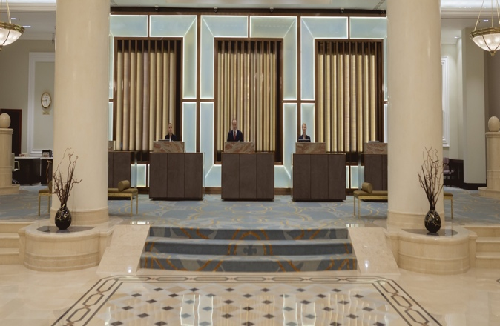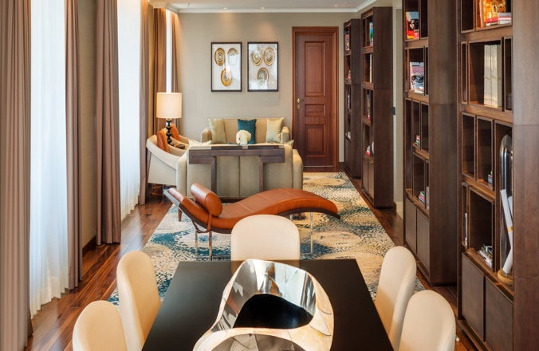

8. Administration arrangement and quality management
So as to have the option to adapt to every one of these adjustments in the conduct of the visitors, administrators must distinguish their customers and their desires and at last assess their observations about administrations. (Felix, 2015)
A good manager needs to understand the needs of their guests. To guess all the needs of guests for example making the feel like home and to offer them what they are not expecting to get given.

PROMOTIONS FOR YOU
Do everything with our application
Get alarms when your room is prepared, talk with your lodging, recover focuses and that's only the tip of the iceberg.

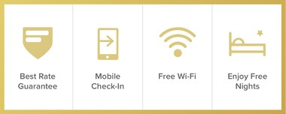
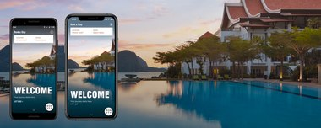
Senior Discounts
In case you're 62 years or more seasoned, you can spare at any rate 15% on your room rate at Marriott inns.
Our Lowest Price. Moment Benefits. Just on Marriott.com
Appreciate moment advantages like our Best Rate Guarantee, Mobile Check-In, Free Wi-Fi and win free evenings just when you book straightforwardly on Marriott.com.

9.Conclusion

Reading the document carefully showed us must offer our clients high-quality service. JW Marriott and his son have devised numerous rules to ensure that the services provided by them are of high quality. There are even unwritten rules within each company. Most employees of the Marriott hotel chain interact with the public, so their image is very important.
A business-like Marriott requires people who are very hospitable, who can assimilate new things quickly and who have the desire to advance. The manager's personality can greatly influence employees. The best managers are those who are aware of their own qualities and who, through their actions, manage the other employees in the right direction.

10.References

•Campbell-Smith, G. (1967). Showcasing of the Meal Experience; a Fundamental Approach. London: University of Surrey (Department of Hotel and Catering Management Research Unit), pp.11-209.

•Doyle, A. (2019). The most effective method to Answer Job Interview Questions About Customer Service. [online] The Balance Careers. Accessible at: https://www.thebalancecareers.com/inquiries questions-about-client administration 2063349 (Accessed 21 May 20)

•Felix, E. (2015). Advertising Challenges of Satisfying Consumers Changing Expectations and Preferences in a Competitive Market. Global Journal of Marketing Studies, 7(5), p.41.

•J. Willard Marriot (January 20, 1964) The Marriott Management Philosophy. "A living convention of qualities and convictions."

•Jana, An., and Chandra, B. (2016). Intervening Role of Customer Satisfaction in the Mid-Market Hotels: An Empirical Analysis. Indian Journal of Science and Technology, p9

•Kotler, P. (2002). At the point when to utilize CRM and When to overlook it! Paper exhibited at the Academy of Marketing Science, Sanibel Harbor Resort and Spa, 30 May

•Marriott (2017). Marriott International, accessible @: marriott-international_5880c2a6b6d87fa1738b5c6c.html (Accessed 3 July 2019).

•Sipe, L.J. what's more, Testa, M.R., 2018. From Satisfied to Memorable: An Empirical Study of Service and Experience Dimensions on Guest Outcomes in the Hospitality Industry. Diary of Hospitality Marketing and Management, 27(2), pp.178-195.

•Tesone, D. (2017). Standards OF MANAGEMENT FOR THE HOSPITALITY INDUSTRY. [S.l.]: ROUTLEDGE, pp.4 to 20.

