Feedback Sheet

Student No./Name: 1600433 – Tim Chapman

Module Code: SHSS5093
Module: Biomechanics of sport and Exercise

Personal Evaluation – to support your academic progress please complete the section below BEFORE submitting your work.
What do you consider to be the best aspects of this work? |  |  | Understanding the different effects behind specific running techniques
Which aspects do you consider could have been improved in this piece of work? |  |  | Finding specific research behind different variables in the sprint.
What have you found most satisfying whilst undertaking this submission? |  |  | Comparing the angles and seeing different style of runs.
ASSESSMENT CRITERIA | Learning  Outcomes |  | GRADE
ASSESSMENT CRITERIA |  |  | Poor  < 20% | Weak  20-29% | Unsatisfactory  30-39% |  | Satisfactory  40 – 49% | Good  50 – 59% | Very Good  60 – 69% | Excellent  70 – 84% |  | Exceptional  85– 100% | %
Abstract | 1,2 |  |  |  |  |  |  |  |  |  |  |  | 5
Introduction | 1,2 |  |  |  |  |  |  |  |  |  |  |  | 15
Method | 1,2 |  |  |  |  |  |  |  |  |  |  |  | 10
Results | 1,2 |  |  |  |  |  |  |  |  |  |  |  | 25
Discussion | 1,2 |  |  |  |  |  |  |  |  |  |  |  | 25
Conclusion | 1,2 |  |  |  |  |  |  |  |  |  |  |  | 5
References | 1,2 |  |  |  |  |  |  |  |  |  |  |  | 5
Article format | 1,2 |  |  |  |  |  |  |  |  |  |  |  | 10
It is expected that students will present work that is proof read, correctly referenced and adheres to the Assessment Checklist. Therefore a range of 0 – 10 marks will be deducted for non-completion of any of the points on the checklist below.
TUTOR COMMENTS:
Submission date:  via Turnitin |  | Return date:  (at least within 4 weeks) |  |  |  | Tutor: |  |  |  |  | Mark:

Analysing the difference of a single stride during the ‘take-off’ phase between a sprinter and a non-sprinter.
Tim Chapman
School of Sport, Health and Outdoor Education, UWTSD, College Road, Carmarthen, Wales
(Accepted January 2018)

Abstract
Keywords: Acceleration, techniques, Angle of hip joints, training techniques.

Objectives: To analyse the take-off phase during a sprint between a sprinter and a non-sprinter.
Methods: A sprinter and a non-sprinter volunteered themselves to take part in a kinematic analysis of a single stride analysis during a take-off phase in a sprint. The sprint was analysed over five metres and was looked at through the ‘Hudl technique’. This helped analyse the joint of angles and the strides that were achieved in this distance.
Results: The Sprinter achieved a lower hip angle, meaning more of a horizontal movement, resulting in a decrease in stride rate and an increase in stride length. This technique is more beneficial than the non-sprinters technique during this stage, due to these biomechanical variables.
Conclusion: Having a horizontal movement during the “take-off” phase, is more beneficial than a vertical movement, to reach higher speeds at a quicker rate. Different resistance programmes can help contribute to these factors and improve technique and physical aspects. Future research is needed to analyse the effects of other biomechanical variables, contributing to this phase.

Introduction
Sprinting is a key physical aspect in many sports as it can consist in game or competition winning situations. Having the right technique can influence the performance of the athlete in a positive way, as they will have an advantage over their opposition. Many other factors can influence the speed of the athlete such as hip thrust or angles of joints, which will be discussed further in the research.
Previous research has suggested that having the right technique, as well as other biomechanical variables can influence the speed of the athlete (Kunz and Kaufmann, 1981). They suggested that the stride length and stride frequency can have a greater impact on speed performance and other factors, such as hip angle and landing angle can influence this. This was illustrated by Mann and Herman (1985) in the 1984 Olympics. They found that there was a difference in biomechanical variables between the winner and eighth place. This included the angle of the upper leg during the strides, the stride rate and the overall bodies horizontal velocity.
Velocity has a major role in sprinting; athletes will try to power themselves in a horizontal movement, rather than a vertical movement. This is due to the momentum that increases their speed in this direction, due to the centre of mass playing a part. Previous research has suggested that this has a significant role in sprinting (Morin et al., 2012). They conclude that overall sprinting performance and acceleration is associated with a velocity-oriented profile. Kugler (2010) explains that having a higher vertical force would slow the athlete down, resulting in an increase in stride frequency and prolonged distance covered. The research found that higher acceleration and speeds were associated with lower, but more forward orientated forces.
Other research suggest that the acceleration can affect the overall sprint performance, due to body positioning and other biomechanical variables (Coh et al., 2017). They found that faster sprinters show greater force development and can optimize force distribution better than slower sprinters, resulting in efficient and effective speeds. The acceleration can also affect the results or competition found within Tellez and Doolittle (1984) study. The research demonstrated that during a 100m event, the acceleration made up 64% of the overall sprint time, so it is key that the technique is effective to achieve these results.
To improve on the technique and the efficiency of the sprint, resistance programs have been advised to athletes to utilise, as previous studies have suggested this can increase the speeds of the sprint (Slawinski et al., 2010). Cronin and Hansen (2006) suggested that using trainings such as weights, plyometrics and resisted sprinting trainings have been designed to increase the force output by the athlete during the acceleration phase, which will aid the athlete into reaching quicker speeds, as they are producing more power through the strides. Young, McLean and Ardagna (1995) explains that strength qualities have been directly related to sprint performance, so applying strength training to athletes is key. Like previous research, they also found that maximum speed was seen through the force production in the 100m, relating back to strength qualities. Applying the right technique, with addition to the right training programmes can be effective in many ways, during the sprint performance.

Methods
Two participants were chosen to take part in a kinematic analysis of a single stride during a sprint. One of the athletes was a sprinter and the other one was not a sprinter. This would help compare the biomechanics between each athlete to compare the technique of both athletes and the effectiveness of their technique. The sprint was performed at the University of Wales Trinity Saint David, Carmarthen campus. Both runners had to run 10m that was coned out; a cone every 5 metres. The athlete was then recorded through the ‘Hudl technique’. This was recorded from the side of the athlete.
After the recording was done, analysis of the sprint would take place. The angle of the hip was recorded, as well as the knee and the ankle. This would help see if the athletes would show either more of a horizontal or vertical velocity, as well comparing their technique by looking at the angle of their joints. The athlete was analysed through 5 different motions between the single stride (right foot to right foot). This was the take off being the first motion, going to the landing of the right foot again. Identical motions were analysed between each athlete to see the angles of each joint. This would then help provide future recommendations for the athlete, identifying certain training methods to help improve technique, if necessary.

Results
Below (Page 6 and 7) are the results of the sprinter and the non-sprinters’ angle of joints during the stride. These tables and figures are disapplying the ‘take off’ phase of the sprint. Table 1 displays both sprinters’ hip angle in degrees, with figure 1 displaying the same results, but in an image form of both athletes’ posture during the sprint. Figure 1 also displays how many strides it took the athlete to reach the first 5m mark (alternative strides).
Table 2 displays the angle of joints displayed by both sprinters’ during the single stride. At each identical motion showed, the angle of the joint (Hip and right knee), was noted. Figure 2 shows the same results but in an image form. The angle of the left knee is also displayed on the image; however, this part of data is only for single stride; this being the right leg from the take-off of the right leg to the landing of the right foot.

Table 1: Hip angle at take-off from alternative strides.
Stride | Sprinters’ hip angle (degrees) | Non-Sprinters’ hip angle (degrees)
1 | 28 | 41
2 | 34 | 40
3 | 35 | 39
4 | 36 | 50
5 | ---- | 48

Table 2: Angle of joints during a single stride (right leg).
Sprinter | Joints and Angle.
Motion | Knee | Hip
1 (Take off) | 174 | 110
2 | 151 | 70
3 | 92 | 53
4 | 85 | 68
5 (Landing) | 110 | 79
Non-Sprinter
Motion | Knee | Hip
1 (Take off) | 170 | 78
2 | 125 | 65
3 | 89 | 20
4 | 142 | 70
5 (Landing) | 142 | 65

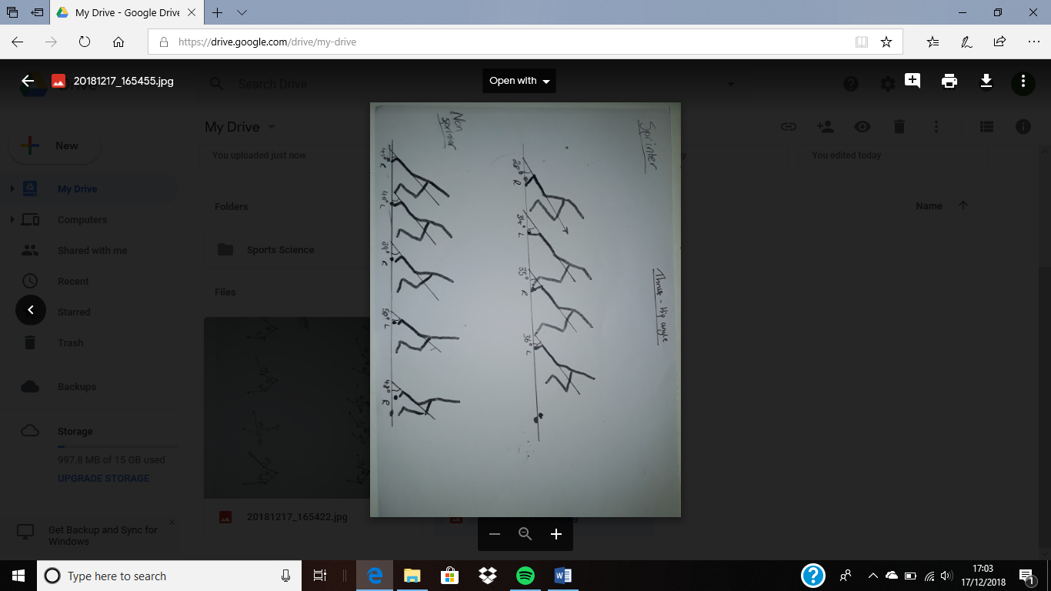
Figure 1: Hip angle and stride rate of both sprinters within 5m.


Figure 2: Angle of joints of both sprinters during a single stride.

Discussion
From the results shown by both sprinters’ is it quite evident that there are differences in the technique, displaying different joint angles.
Table 1 and figure 1, displays the hip angle, resulting in either more of a horizontal or vertical thrust. Maximal sprinting velocity is defined “biomechanically by the stride frequency and length” (Coh, Jost and Stuhec,1998, p.g. 237). It is evident that the sprinter has more of an acute hip angle during the sprint, over the non-sprinter during the sprint, as table 1 displays. This results in more of a horizontal movement of the non-sprinter, resulting in many factors such as an increase in stride length and a decrease in stride rate, as seen in figure 1. This can result in the sprinter reaching a quicker speed over these first few metres, within a shorter period, than the non-sprinter. This can then go on to potentially determine the race result. The non-sprinters’ technique would be beneficial come the ‘fight phase’ or during the 2nd half of the race as Kivi (2007) explains that generating a high vertical velocity, results to successful sprinting. However, as figure 1 examines the take-off phase, having more of a horizontal velocity is beneficial.
During this take-off stage, the sprinter is seen to record a lower rate of stride. This is because they have more of a horizontal movement during the sprint. Hunter, Marshall and McNair (2004) explain that factors such as the angle and the speed at take-off with the foot, can determine the step length, resulting in the stride rate achieved. They predict that achieving a lower take-off angle, with a high take-off speed, can alter the stride pattern, due to the trajectory achieved by the athlete. This is seen in figure 1 as the trajectory of the sprinter is lower than the non-sprinter, resulting in fewer strides needed to reach the five metres. McGinnis (2005) however explains that many other factors can affect the flight time of the sprinter. This is down to the sprinters’ vertical velocity at take-off, the average drag force and the height of the sprinters’ centre of gravity. Future research in this area will be acquired, to determine the effects of using these different techniques of the run.
To improve the horizontal velocity during the take-off phase, training techniques such as uphill running, limb-loading and weighted vests are used as Cronin and Hansen (2006) explain. This is because resisted sprinting is used to train muscular power. From this research, the suggested that limb-loading was proven to increase muscle activity that is required during motion. Limb-loading also increases inertia significantly. When it comes to technique, limb-loading shows to improve this by decreasing step frequency as well as decreasing velocity.
Uphill running is used to increase power, especially around the hip region. Using this training shows to increase and maximize step length of sprinters. This is because this method focuses more on the hip extensor muscles and increasing the load on this region will result in more of a force required to drive the hip in more of a vertical movement. Finally, weighted vests are used to increase the explosive power within the lower limb regions. This will help produce greater forces at higher velocities.
Previous research has shown that a plyometric training program has improved biomechanical variables during the sprint (Rimmer and Sleivert, 2000). As plyometric training has been designed to improve explosive speed in a vertical and horizontal movement, it was evident that this training method would improve the technique and physicality of the athlete at a sprinter needs to adequately move powerfully in both planes of movement, as different stages of the race, requires more of one plane of movement than the other.
Using these different kinds of training methods have been proven to improve a sprinter physically and technically and having that advantage over their opponents can be majorly beneficial.

Conclusion
Sprinting is a key physical aspect in many sports as it can consist in game or competition winning situations. Applying the right technique in certain phases can determine a race and an advantage over the opposition. This research looked at the technique between a sprinter and a non-sprinter during the “take-off phase” of a sprint. The Hip joint and the hip angle were looked at.
This research found that having a lower hip angle can result in biomechanical variables such as an increase in stride length and a decrease in stride rate, that can result in higher speeds achieved. Training methods such as limb loading, uphill running, weighted vests and plyometric training can improve the technique and physical aspects in this phase.
Other factors contribute to this phase such as the vertical velocity at take-off, the drag force and the height of the sprinters’ centre of gravity. Future research will be needed to conclude the effects of the technique used by the sprinters’ as seen, with these variables taken into consideration.

Conflict of interest
None.

References
Coh, M., Jost, B. and Stuhec, S., (1998). Kinematic and dynamic structure of the sprinting stride of top female sprinters. Biology of Sport, 15(4), pp.237-243
Coh, M., Peharec, S., Bačić, P. and Mackala, K., (2017). Biomechanical differences in the sprint start between faster and slower high-level sprinters. Journal of human kinetics, 56(1), pp.29-38.
Cronin, J. and Hansen, K.T., (2006). Resisted sprint training for the acceleration phase of sprinting. Strength and conditioning Journal, 28(4), p.42.
Hunter, J.P., Marshall, R.N. and McNair, P.J., (2004). Interaction of step length and step rate during sprint running. Medicine & Science in Sports & Exercise, 36(2), pp.261-271.
Kivi, D.M.R., (2007). Analysis and simulation of the recovery leg during sprinting. University of Alberta.
Kugler, F. and Janshen, L., (2010). Body position determines propulsive forces in accelerated running. Journal of biomechanics, 43(2), pp.343-348.
Kunz, H. and Kaufmann, D.A., (1981). Biomechanical analysis of sprinting: decathletes versus champions. British Journal of Sports Medicine, 15(3), pp.177-181.
Mann, R. and Herman, J., (1985). Kinematic analysis of Olympic sprint performance: men's 200 meters. International journal of sport biomechanics, 1(2), pp.151-162.
McGinnis, P.M., (2013). Biomechanics of sport and exercise. Human Kinetics.
Morin, J.B., Bourdin, M., Edouard, P., Peyrot, N., Samozino, P. and Lacour, J.R., (2012). Mechanical determinants of 100-m sprint running performance. European journal of applied physiology, 112(11), pp.3921-3930.
Rimmer, E. and Sleivert, G., (2000). Effects of a plyometrics intervention program on sprint performance. The Journal of Strength & Conditioning Research, 14(3), pp.295-301.
Slawinski, J., Bonnefoy, A., Levêque, J.M., Ontanon, G., Riquet, A., Dumas, R. and Chèze, L., (2010). Kinematic and kinetic comparisons of elite and well-trained sprinters during sprint start. The Journal of Strength & Conditioning Research, 24(4), pp.896-905.
Tellez, T. and Doolittle, D., (1984). Sprinting from start to finish. Track technique, 88, pp.2802-2805.
Young, W., Mc Lean, B. and Ardagna, J., (1995). Relationship between strength qualities and sprinting performance. Journal of Sports Medicine and Physical Fitness, 35(1), pp.13-19.

