Student Number 2114731

Module BMHR7015

A Report into the Resourcing and Talent Management Strategy of the Welsh Ambulance Services NHS Trust – A Challenging Climate and the Future of Unscheduled Care Recruitment and Retention.


Word Count 3776

Executive Summary
This report aims to highlight how the current climate has opened both challenge and opportunity to refresh thinking, critically analyse current HR systems and processes to evaluate internal and external factors impacting on the organisation now and in the future. Line Managers are more than ever requiring corporate steer on new and emerging trends and people professionals are central to advocating staffing considerations when business decisions are being made, in partnership with trade unions and key stakeholders.
This reports explores how the future of the Welsh Ambulance Service can work towards Employer of Choice. Being globally recognised as world leader of innovative emergency and non-emergency care relies on how its recruitment and retention processes are managed.
Our workforce planning is vital to achieve strategic goals with an engaged, motivated and experienced workforce. Today is about how we can meet tomorrows objectives and how talent management and intelligent system processes can deliver what the public need and the service can offer with a motivated and engaged workforce.
Current strategy for service delivery needs towards 2024 is based on data sets pre-pandemic and skillsets that are now largely changed as the ways we work has changed to meet new world thinking. This report offers recommendations based on a critical analysis of the current Strategic Workforce Plan, internal and external factors impacting on WAST whilst we operate in a challenging climate with continuing and sustained pressures in order to achieve core workforce establishment and integrity whilst meeting the demands of an economic crisis and emergent themes in the world of work.

Abbreviations
WAST – Welsh Ambulance Service
NHS – National Health Service
TM – Talent Management
ESR – Electronic Staff Record
GRS – Global Resourcing System
WAG – Welsh Assembly Government
HIW – Health Inspectorate Wales
CIPD – Chartered Institute of Personnel and Development
PESTLE – Political, Economic, Socio-cultural, Technology, Legal, Environment

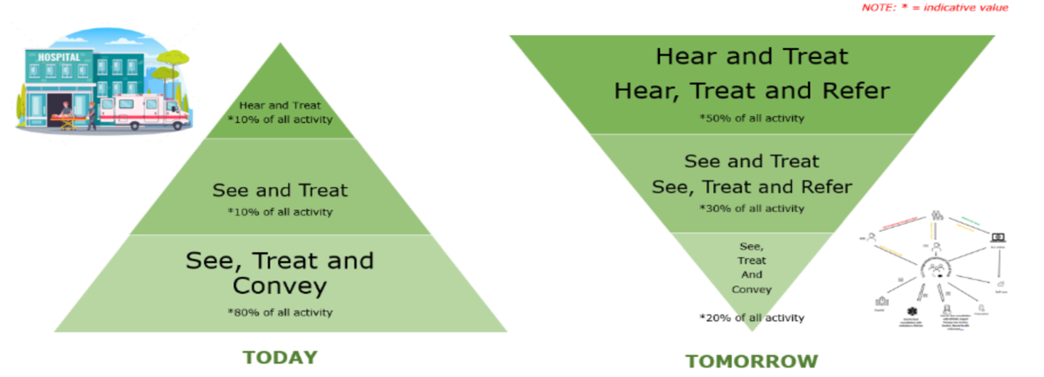

Contents
Cover Page Page 1
Executive Summary Page 2
- Introduction Page 6
2.0. Internal Factors impacting on WASTs Strategic Page 7
Human Resource Management.
2.1. Challenging Climate; Maximising Current Page 7
Workforce Strategies to Align with Future Needs.
2.2. Current Position in the challenge of Page 8
Talent Management.
2.3. Recruitment Factors for Talent Centric Page 8
or Data Centric focus.
2.4. Considering Talent Management in the NHS. Page 9
2.5. Public Sector Talent Management. Page 9
2.6. Recruitment in a pandemic and beyond. Page 9
  - Current Recruitment Processes in WAST. Page 11
  - Recruitment and HR Processes within WAST. Page 11
  - Organisational Change and TM. Page 12
  - Employer Image and Branding. Page 14

3.0. External Factors impacting on WASTs Strategic Page 15
Human Resource Management.
3.1. – Political Page 15
3.2. – Economy Page 16
  - – Socio-cultural Page 18
  - – Technology Page 19

4.0. Conclusion. Page 19

5.0. Recommendations. Page 20
5.1. People, Culture and Inclusion Page 21
5.2. Mega trends and Strategy. Page 21
5.3. Employer Brand. Page 21
5.4. Agile/Hybrid/Flexibility. Page 22
5.5. Remote Working for Clinicians. Page 22
5.6. Rostering and Resourcing. Page 22

References Page 24

Recruitment Video Bibliography and link Page 35

- Introduction.
The Welsh Ambulance Ambulance Services NHS Trust (WAST) is a major employer across Wales, employing over 4000 people across all grades, including clinical and non-clinical staff. There are over 1000 volunteer first responders and over 100 volunteer car drivers with 250 military personnel currently supporting the Emergency Operations Directorate due to system wide pressures (WAST, 2022).
New world ways of working requires proficient recruitment and selection of new employees coupled with induction and retention practices, upskilling and role clarity. The more volatile, unpredictable, competitive and uncertain the future world of work and service delivery in the NHS becomes, flexibility and creativity to seize opportunities will place WAST as not only the hosts for Phone First for Wales (WAG, 2020) but also the Employer of Choice for all grades of staff.
Our people are our assets;

‘WAST is both contracting and expanding; as one area is challenged another is progressive’ (Taylor, 2019) p11. ‘WAST is both contracting and expanding; as one area is challenged another is progressive’ (Taylor, 2019) p11.

Demands on services within the portfolio have stretched to its limits, at a critical point in the Trust Regional Escalation Action Plan (WAST, 2021) with wider health and social care system pressures impacting ambulance response times, patients safety and staff wellbeing.
Further workforce modelling is required to shift focus from a 999 response to care at home and remote clinical triage. This allows an inclusive approach to Talent Management (TM); nurturing and upskilling existing talent opens up career opportunities, benefits the organisation to showcase it as progressive and responsive as a public service that values its people and public.

2.0. Internal Factors impacting on WASTs Strategic Human Resource Management.

2.1. Challenging Climate; Maximising Current Workforce Strategies to Align with Future Needs
It is not without acknowledgement that the NHS is overwhelmed, pre-pandemic this did not attract the widespread attention it has today. In the most recent NHS Staff Survey (2020), 26.5% of participants often think about leaving the NHS with 14% reported to plan to leave as soon as they secure another job, though it is thought has increased since the survey was concluded. Organisational attractiveness and employer image plays a role in its social identity, organisations must adapt workforce strategies to survive and compete in uncertain times (Younis & Hammad, 2021).
A report prior to the pandemic by the Manpower Group (2018) found that more employers than ever were struggling to fill vacancies. A further finding found that larger organisations reported talent shortages of 67% with smaller enterprises reporting challenges in recruiting the skills they need. This is reinforced in the NHS with the challenges of TM, the impact of voluntary employee turnover within a restricted pool of talent and the flow of staff across services. TM and recruitment is one of the most expensive and disruptive business problems that health and social care encounter as well as retention of its valued employees (Boyd, 2017) an issue WAST currently faces.

WAST must recognise that our people are fundamental to a sustainable value creation in a challenging climate, our human capital are our ‘most important asset’ (CIPD, 2021).

2.2. Current Position in the challenge of Talent Management.
WAST made fast and decisive changes to mobilise the workforce at the start of the pandemic in March 2020, significant shifts continue to be required in order to maintain business critical operations as we continue to face unprecedented pressures on services, employee shortages in key areas of resourcing and TM.
As we face a further recession, workforces costs and TM requires further focus to ensure WAST has the skills required to encompass new ways of working and agility, with an organisational image that will place WAST in a global talent economy in attracting and recruiting talented people locally and internationally (Younis and Hammad 2021).

2.3. Recruitment Factors for Talent Centric or Data Centric focus.
WAST currently leverages data from NHS Electronic Staff Records (ESR) and Global Rostering Systems (GRS). These data sets must align with Demand and Capacity Reviews and WAST’s Strategic Workforce Plans to ensure a TM approach that is future based and future fit with a healthy and engaged workforce. This is a systems based approach that requires all elements to communicate and deliver reporting and business intelligence to inform further workforce needs and compassionate management of our people.
There is a disconnect on workforce data from these systems, a significant lengthy process from interview to onboarding and induction also impact on the challenges WAST faces in meeting business critical needs in times whereby recruitment is vital for the immediate and long term success of the Trusts strategic direction and achieve University status.

2.4. Talent Management in the NHS.
Kravarti & Johnson (2020) report public sector TM as conceptualised and includes competencies, knowledge and values that are in line with the public sector core principles that enable the individual to use their exceptional abilities to serve the public for the common good. This also aligns to the NHS Core Principles (2021) and Public Life Principles (Nolan Principles, 2021). They add the proposition that private sector TM practices facilitate staff development for optimal organisational performance as opposed to the greater good.

2.5. Public Sector Talent Management.
Kravarti& Johnston (2020) conducted a literature review of private sector TM and propose that transferability of talent management strategy to the public sector is prime for a new direction and a timely contribution. Interestingly Brunetto et al (2018) adds caution to this hypothesis linking negative consequences when private sector TM principles are influenced by New Public Management.

2.6. Recruitment in a pandemic and beyond.
According to a CIPD survey into Resourcing and TM there is a dramatic change in the labour market with pressures rising to recruit into talent gaps and recruiting into high skilled roles (CIPD, 2021). This is compounded by new ways of working, most recently the impact of Omicron variant of Coronavirus which is significantly impacting on an already strained and exhausted workforce.

Crisis always presents both danger and opportunity; the pandemic has presented both an opportunity for accelerated change and adaptation in workforce strategy (Cheese, 2021).

A report by CIPD also highlights how cross-boundary, partnerships and collaboration in the new world of work is vital in facing future challenges (CIPD, 2022).
Morely et al (2015) posed that the strategic direction of an organisation is impacted by the talent available within the organisation, having a learning and coaching culture such as the strategy and focus in WAST, builds a strong foundation of respect and professional integrity which has a strong influence on talent attraction, retention and succession planning (Gallardo et al, 2019).

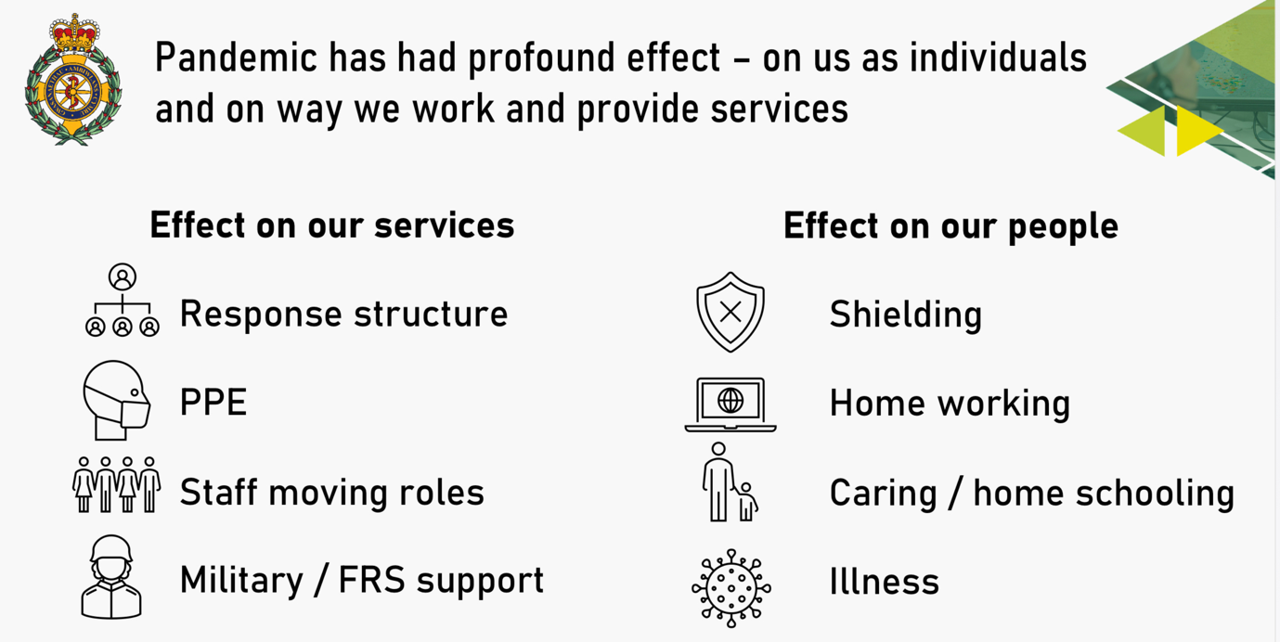
2.7. Current Recruitment Processes in WAST
Recruitment is managed by Civica UK Ltd with an online recruitment management system, Tracs. Much of the key areas of our workforce team and HR is devolved to regional directorates and local line management teams with workforce analysis completed via ESR business analytics. ESR is a difficult system to navigate and whilst it communicates with GRS and Tracs the whole system and processes are clunky offering an opportunity to integrate further and more simplistically as a payroll function.
Whilst some HR functions are devolved, our HR and Workforce Organisation Development Directorate provides a key strategic overview of our services with HR Business Partners providing line management support and guidance.

2.8. Recruitment and HR Processes within WAST.
Thunnissen (2016) linked the role of line managers in ‘owning talent’ and responsible for investing in talent and making decisions and were the connection between practice and theory. In addition to this key stakeholders such as HR and trade unions along with employees influence the TM approach within an organisation. Investing in leadership development, coaching and mentorship of line managers will significantly influence the culture, development and retention of its employees, current internal offerings must be developed to include CIPD and ILM courses as part of a career progression plan and bi-annual performance and development reviews in addition to monthly one to one coaching conversations.
Cheese (2021)p13 sees managers as having a particular bias towards humans and the future of work is human, adding that there is an inter-relationship between individual and collective wellbeing and is an important outcome of good work.

2.9. Organisational Change and TM.
One of the five key drivers for the future world of work is how an organisation responds to internal change and evolving organisational processes, workforce structures and models (CIPD, 2020).
Organisational change is pivotal in order to be responsive and future fit. When exploring the internal factors influencing TM, an outward facing organisational culture in the attraction of potential candidates, talent attraction and retention are predicted by high performance organisational cultures (Kontoghiorghes, 2016).
A more strategic approach to resourcing and TM is now required in order to maximise performance and key targets (Taylor, 2019) p15.

Role clarity, clear career development and pathways within WAST is vital to enrich current talent and re-model the workforce to meet new demands and opportunities to diversify the workforce.

It is a vital strategic goal to invest in our people, nurture and develop our own talent, recruit and retain from talent pools to meet the evolving needs of the service and meet long term needs (Cheese, 2021)p24.
WAST has strong Workforce Organisation and Development presence at a strategic level, these actions and intent need to be communicated widely internally to boost confidence, commitment and morale within the workforce to mitigate any potential loss of talent pools to external stakeholders and promote career progression within.
An example of a positive shift in workforce modelling is the re-branding of the Clinical Support Desk (CSD); the internal shift to redeploy paramedics from frontline duties to remote clinical practice thus opening opportunities for staff to aspire and develop into paramedic roles providing a more balanced skill mix at the patient facing arm of the portfolio (WAST, 2020).
This is a responsive yet transformational approach to how services are delivered, a business model that is a progressive strategic direction and sets WAST as different from other NHS Trusts (Taylor, 2019) p15.
A review by Healthcare Inspectorate Wales (HIW) pre-pandemic highlighted that further focus was required to ensure that staff are provided with adequate training, development and support to enable them to undertake their relevant roles. This is much more significant now the pandemic has changed the ways we work, the system pressures impacting on how WAST now need to deliver services and maintain business critical activity (HIW, 2020).
The redeployment of paramedics to CSD not only opens up opportunities to increase functionality of remote access but also opens up talent pipelines by recruiting internally, then externally, the future workforce of unscheduled care and how this is delivered.

2.10. Employer Image and Branding.
For an organisation to function effectively, efficiently and fairly it needs to recruit, retain and secure staff in the right roles, at the right time and place (Taylor, 2019) p4. Wellbeing is inextricably linked to job satisfaction so attention to employees interests in resourcing and TM is high on the HR agenda (Taylor, 2019) p6.
WAST’s Wellbeing Strategy along with People and Culture Strategy current offerings, these must be part of the recruitment and advertising process to share our values and principles to attract potential candidates as an organisation with its people at its core and their wellbeing as central.
Current offerings can be improved on though the Occupational Health and Wellbeing Strategy is progressive and offers support in house and externally for staff to access, this is a key driver in employee value in recruitment and experience.

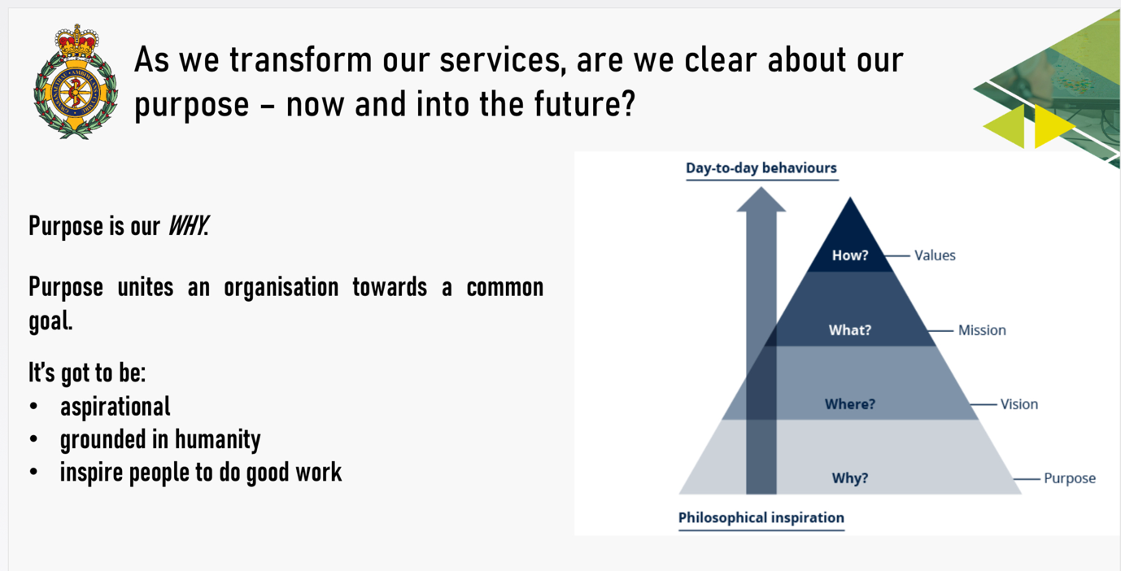

3.0. External Factors.
A PESTLE Analysis of the factors affecting recruitment and retention of all grades of staff within WAST highlights areas of concern, progress, recommendations to identify current and future views (CIPD, 2021).

This analysis of external factors highlights areas whereby improvements can be considered where external risks can influence internal factors of resourcing and service delivery.

3.1. Political.
The Emergency Ambulance Services Committee (EASC 2021/22) Annual Plan sets out the focus of the Ministerial Ambulance Availability Taskforce (2020): in particular, the development of a citizen centred, modern ambulance service. One focus area is on workforce recruitment and wellbeing and the implementation of the independently commissioned WAST Demand and Capacity Review (2020). This review aims to specifically complete the closure of the relief gap by projecting staffing levels required to achieve the forecasted demand but does not differentiate between clinical grades and advances in clinical and collaborative care. There is no focus on retention and upskilling of existing talent for employee value in this plan that is basing future workforce requirements on pre pandemic projections and datasets to provide a whole time equivalent staffing summary towards 2024.
To achieve strategic workforce planning these data sets must be implemented inline with employees well-being and value as central to strategic operational based requirements, the Wellbeing of Future Generations (Wales) Act (2015), Stakeholder Commissioning Intentions and the Ministerial Task Force Recommendations.
WASTs Integrated Medium Term Plan (IMTP) (2021-2024) has a specific focus on collaboration and a shift left in the ambulance care pathway, this requires workforce modelling that values existing talent as well as broadening the pool of potential external candidates.
Whilst the Demand and Capacity Review (2020) provides data sets it fails to acknowledge the workforce and talent required to deliver such intent and opportunities; the pandemic has accelerated new ways of working and a shift in focus in service delivery.
Given the recent White Paper on Rebalancing Care and Support (2021), the proposals to re-designate Regional Partnership Boards (RPB) as statutory bodies with the ability both to hold their own budgets and employ staff, it will be even more important that WAST continues to have a voice at RPB tables across Wales and a Strategic Workforce Agenda. It is evident as part of the Fair Work Commission, the Fair Work Wales (2019) report noted that an industry that does not contribute to individual and social well-being is also a sector that displays retention issues associated with insecurity and poor working environment.
This adds further strain to the wider Health and Social Care Economy; movement of talent across sectors becomes an opportunity for WAST to access talent pools via RPBs and co-located hubs such as Mental Health Remote Access Teams and Hospital at Home initiatives thus opening the labour market to specialities not considered core services for an emergency service. This diversity and inclusion opens up more pooling of talent, positive Employer Branding with more pull in a tight labour market.

3.2. Economy.
Funding of the NHS, commissioning and staffing need to represent not only the current picture but the emerging horizon of service delivery and resourcing of a skilled workforce. With tighter budgets, increased pressures in services, increasing impact of the pandemic the economic downturn has made it more difficult to recruit skilled and experienced staff. The NHS is said to have been poorly funded for many years, there are economic reasons as well as political Barnett Formula (1979) as an example.
RCN (2021) report nursing as an area deprived of investment and no pay rise with real term decrease and supported a claim of at least 12.5% pay rise, Wales were offered 3%.

With mediocre salaries and poor uplifts on pay reviews, the NHS has never been a particularly attractive workplace for clinical professionals (Fraher et al, 2020).
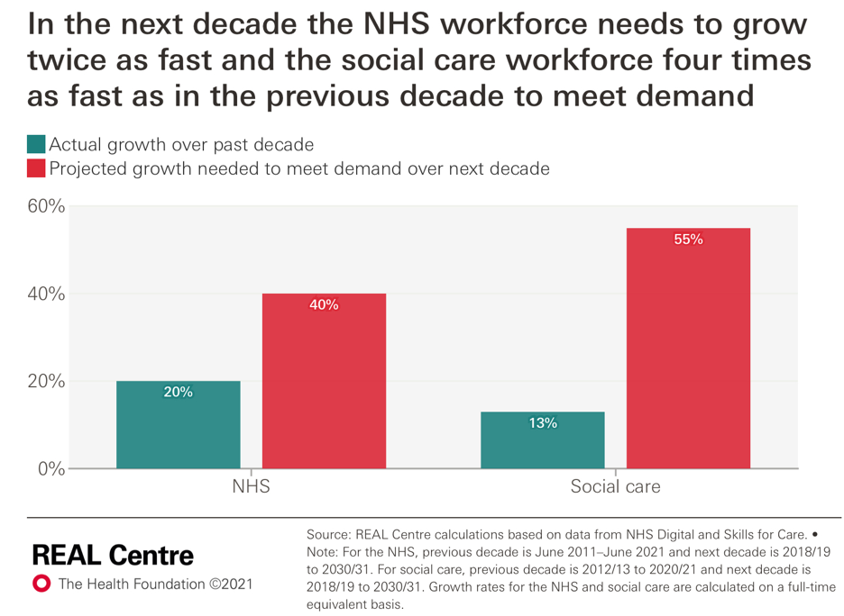
This makes it difficult for the NHS to provide a sufficient quality of care to its patients under budget restrictions, poorly funded services, emergent specialties, medical/pharmaceutical developments and an under resourced workforce.
Rocks et al (2021), based on workforce demand in the previous decade, the NHS workforce is required to double, with social care sector staffing requirements four times more than the previous decade, see below for an illustration.
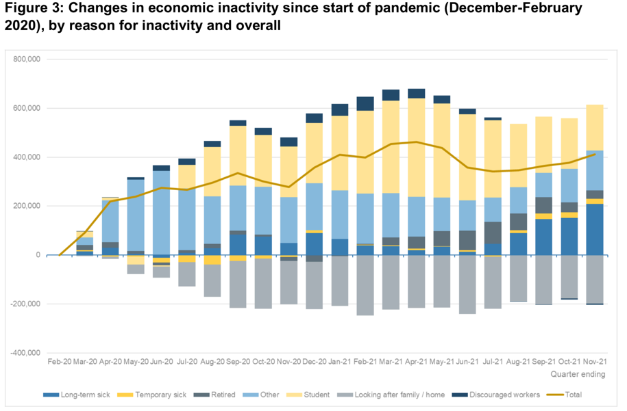
It is evident from another study by the Institute of Employment Studies (IES) (2022) below;
employment growth has stalled, economic inactivity has risen with employment levels
remaining 600 thousand below pre-pandemic levels whilst economic inactivity is 400
thousand higher. This is as a result of record levels of vacancies, further falls in unemployment and the tightest labour market in at least fifty years (IES, January 2022).

3.3. Socio-cultural Factors.
The era of societal change, the impact of the pandemic on socio-cultural changes and changes in societies beliefs, expectations and affiliations adds a possible loss of trust in establishments. Media and social media create echo chambers and there is growth of ‘populism’ (Cheese, 2021) p69.
The NHS is exploring ways of using its influence as a large employer to change the economic status of local populations. But this approach is currently the exception rather than the norm (Kings Fund, 2019). This is a National position where the ability to raise standards of living depends on its ability to improve output per worker (Cheese, 2021) p36. This must manifest as improved employment rates and improved productivity but not at the expense of being a responsible business and a positive force for good work. There is a significant shift with reflection and a reset on individual values following experiences of the pandemic and what is most important, talk of resignations as a result compounded by the tight labour market and continuing of the pandemic (Cheese, 2022) p5.

3.4. Technology.
Digital transformation, sustainability and responsible business were front of mind when considering future trends that people professionals and functional managers will need to navigate (CIPD, 2022). The digitalisation of the NHS and use of social media platforms to advertise and recruit means a digital presence must have a conscience.
TM via such platforms must be clearly articulated, equality impact assessed and be clear on the `trusts position on flexibility, agile learning and working and have clear principles of good work and responsible employment (Cheese, 2021).p32.

4.0. Conclusion
Recruitment power is in the hands of the employee, recruitment experience must reflect this in order to attract, employ, train, maintain and nurture the best candidates in a tight labour market. Our future workforce requires a digitalised and agile workplace, technology is changing the nature of work as we know it (CIPD, 2021). The NHS needs to prepare its workforce to deliver a digital future, understand the impact on recruitment, education, training, diversity and inclusion with a focus on lifelong learning and development from hire to retire (Topol, 2019).
There is an increase in the use of new media/technology to attract candidates and with the increase in millennial candidates entering the workforce, social media will be increasingly important in talent branding and attraction; the digital by default generation is already here (Walford-Wright & Scott-Jackson 2018).
For the first time WAST has the potential for five generations of an united workforce with the inclusion and diversity opportunities this presents as well as the challenges to the existing workforce. This should help shape the thinking for pandemic recovery planning about how technology and a digital workplace can support a modern set of service offers as well as helping the wider WAST workforce to become more agile and reap the benefits of matrix working across teams.
The pandemic has been a disruptor but also an enabler for change and progressive approaches to good work. This catalyst for change must continue to keep forward thinking; be adaptable to the ever changing economic, societal and political change and NHS specific trends (CIPD, 2022).
TM in todays globalised market not only means competition from partner organisations but also governments and private sector (Khilji & Schumer 2017).p400. A mobile workforce within WAST is key for career development and retention rather than loosing valuable talent to other parts of the health and social care system or to private entities with relational employer branding.

5.0. Recommendations.
Whilst this report addresses some recommendations within the report the following specific recommendations are offered.

5.1. People, Culture and Inclusion.
WAST is a principles and values led, evidence based and outcomes driven organisation with inclusion and well-being at the heart of talent management, recruitment and retention. Organisational Culture and creativity in, developing and managing a diverse workforce is vital to future proof our critical business needs, remote clinical practice and working is key to achieving this as well as flexibility and agility.
We must continue to value our workforce as an asset, our talent is an investment to assist in achieving business objectives, the talent decisions of today will determine the organisation WAST will be come in the future (Deloitte, 2020).

5.2. Mega trends and Strategy.
Global talent mega trends such as mobility opens up more opportunities for agility and hybrid working opening up the talent market, there are downsides to this is as a magnet external to the organisation. Employee value and employer branding must focus on benefits and rewards of a career with WAST. This must be based in strategy with succession planning, retention and employer branding (Taylor, 2019).

5.3. Employer Brand.
It is time to refresh WASTs employer brand portfolio and re-launch WAST as the NHS Ambulance Service Employer of Choice, promoting inclusion, diversity and progressive leadership and clinical excellence for all grades of staff.
Building on the Trust’s Wellbeing Strategy and benefit schemes, opening up use of social media platforms to advertise as well as shared partnership services to broaden the reach of potential UK and global candidates can place WAST more prominent in the global labour market.

5.4. Agile/Hybrid/Flexibility.
This is important in order for WAST to engage with a wider talent pool. Engaging and supporting people with flexible offerings such as agile/hybrid, part-time and day one rights on these matters will engage people in choice of meaningful careers without limitations. This must be partnered with managers support in supporting and managing such diverse teams and prevent any perceived situational bias, ensuring inclusion and diversity in the workforce with robust succession planning.

5.5. Remote Working for Clinicians.
Our response to the pandemic escalated CSD Remote Working Pilot from four assets to a fully remote function in six weeks (WAST, 2021). This must continue to be the catalyst for change and new ways of working, redefining what a standard job is, (Cheese 2021. p35).

5.6. Rostering and Resourcing.
It is recommended that the board acknowledge the contents of this report and current HR recruitment systems in 2.3, pause the current rostering review in order to consider the impact the pandemic has had on the 2020 Demand and Capacity Review data in order to include variations and new ways of working, both for clinicians and non clinical employees.

The board are asked to consider the findings in this report when making decisions on the current and future workforce needs, recruitment and commissioning expenditure/requests and to approve the continuation of focus on employee value and wellbeing in order to fully realise the benefits of the investments and commissioning intent.

References

- Barnett Formula (1979).
https://www.instituteforgovernment.org.uk/explainers/barnett-formula
Accessed January 10th 2022.

- Boyd, J. (2017) Voluntary Employee Turnover: Retaining High-Performing Healthcare Employees. Unpublished Doctorate. Walden University.
Available at: https://scholarworks.waldenu.edu/dissertations/3931/
Accessed January 26th 2022.

- Ltd.
- Please cite this article in press as: Brunetto, Y., Teo, S., Shacklock, K. and Farr-Wharton, R. (2012) ‘Emotional intelligence, job satisfaction,
- well-being and engagement: explaining organisational commitment and turnover intentions in policing’. Human Resource Management Journal
- 22: 4, 428–441.
- Brunetto, Y., Teo, S., Shacklock, K. & Farr-Wharton, R. (2012) ‘Emotional intelligence, job satisfaction, well-being and engagement: explaining organisational commitment and turnover intentions in policing’, Human Resource Management Journal, 22(4), pp. 428–44. https://doi.org/10.1111/j.1748-8583.2012.00198.x Accessed January 10th 2022.

- Bush, T. (2019) PESTLE Analysis of the NHS. Pestle Analysis.com.
https://pestleanalysis.com/nhs-pestle-analysis/.
Accessed 10th January 2022.

- Cheese, P. (2021) The New World of Work, Shaping a future that helps people, organisations and our societies to thrive. London. Logan Page.

- Cheese, P. (2022) ‘Light at the end of the tunnel’, People Management, February, p5.

- Cheese, P. (2021) ‘An inflection point of opportunity’, People Management, October/November, p5.

- CIPD. (2020) People Profession 2030; Report. A Collective View of Future Trends. London: Chartered Institute of Personnel and Development. https://www.cipd.co.uk/Images/people-profession-2030-report-compressed_tcm18-86095.pdf.
Accessed January 10th 2022.

- CIPD. (2021) PESTLE Analysis. Factsheet. London: Chartered Institute of Personnel and Development.
https://www.cipd.co.uk/knowledge/strategy/organisational-development/pestle-analysis-factsheet#grefttps://www.cipd.co.uk/knowledge/strategy/organisational-development/pestle-analysis-factsheet#gref.
Accessed January 12th 2022.

- CIPD. (2021) Resourcing and talent planning survey 2021. London: Chartered Institute of Personnel and Development.
https://www.cipd.co.uk/knowledge/strategy/resourcing/surveys#gref.
Accessed 12th January 2022.

- CIPD. (2021) Strategic Human Resource Management. Factsheet. London: Chartered Institute of Personnel and Development.
https://www.cipd.co.uk/knowledge/strategy/hr/strategic-hrm-factsheet.
Accessed 10th January 2022.

- CIPD. (2021) Workforce Planning. Fact sheet. London: Chartered Institute of Personnel and Development.
https://www.cipd.co.uk/knowledge/strategy/organisational-development/workforce-planning-factsheet.
Accessed January 12th 2022.

- CIPD. (2022) Effective Cross-Functional Collaboration in a Changing World of Work. London: Chartered Institute of Personnel and Development.
https://www.cipd.co.uk/knowledge/strategy/hr/cross-functional-collaboration?utm_source=mc&utm_medium=email&utm_content=cipdupdate_12012022.EdL1_Cross-functional_Collaboration&utm_campaign=cipd_update&utm_term=8429178. Accessed January 10th 2022.

- Deloitte. (2013) The Open Talent Economy – People and Work in a Borderless Workplace. Available at: https://www2.deloitte.com/content/dam/Deloitte/global/Documents/HumanCapital/dttl-hc-english-opentalenteconomy.pdf.
Accessed January 10th 2022.
- Deloitte. (2020) The Social Enterprise at Work: Paradox as a way forward. Global Human Capital Trends Report. Available at: https://www2.deloitte.com/cn/en/pages/human-capital/articles/global-human-capital-trends-2020.html.
Accessed January 27th 2022.

- Emergency Ambulance Services Committee. (2020). Ministerial Taskforce Ambulance Availability. Available at:
https://easc.nhs.wales/the-committee/archived-papers/march-2020/3-1-2-appendix-2-ministerial-aa-taskforce-brief-1-24-feb-2020-easc-10-march-2020-docx/
Accessed January 27th 2022.

- Emergency Ambulance Services Committee (EASC) Annual Plan 2021/2022. Available at:
https://easc.nhs.wales/publications/position-statements/easc-annual-plan-2021-2022/https://easc.nhs.wales/publications/position-statements/easc-annual-plan-2021-2022/.
Accessed January 22nd 2022.

- Fraher, E. P., Pittman, P., Frogner, B. K., Spetz, J., Moore, J., Beck, A. J., Armstrong, D., & Buerhaus, P. I. (2020). ‘Ensuring and sustaining a pandemic workforce’, New England Journal of Medicine, 382(23), pp.2181– 2183.
https://doi.org/10.1056/NEJMp2006376

- Gallardo-Gallardo. E, Thunnissen, M, & Scullion, H. (2020) ‘Talent management: context matters’, The International Journal of Human Resource Management, 31(4), pp. 457-473. https://doi.org/10.1080/09585192.2019.1642645
Accessed December 15th 2021.

- Health Inspectorate Wales (HIW). (2020) Local Review: Welsh Ambulance Service Trust.
Assessment of Patient Management Arrangements within Emergency Medical Service Clinical Contact Centres. Available at:
https://hiw.org.uk/sites/default/files/2020-09/20200923%20-%20WAST%20Review%20-%20FINAL%20ENGLISH.pdf.
Accessed January 15th 2022.

- Institute of Employment Studies. (2022) Labour Market Statistics January 2022.Available at: https://www.employment-studies.co.uk/system/files/resources/files/IES%20briefing%20-%20Labour%20Market%20Statistics%20January%202022.pdf?utm_source=IES+emailing+list&utm_campaign=35d3fc09d4-.EMAIL_CAMPAIGN_2019_05_14_03_45_COPY_01&utm_medium=email&utm_term=0_f11585705b-35d3fc09d4-471382738.
Accessed January 23rd 2022.

- Kravariti, F. & Johnston, K. (2020) ‘Talent management: a critical literature review and research agenda for public sector human resource management’, Public Management Review, 22(1), pp.75-95.
https://doi.org/10.1080/14719037.2019.1638439
Accessed December 12th 2021.

- Khilji, S. E., & Schuler, R. S. (2017) Talent management in the global context. In D. G. Collings, K.Mellahi, & W .F. Cascio (Eds.), The Oxford handbook of talent management, pp. 399–420. Oxford: Oxford University Press.

- Kontoghiorghes, C. (2016) ‘Linking high performance organisational culture and talent management: satisfaction/motivation and organisational commitment as mediators’, The International Journal of Human Resource Management, 27(16), pp.1833-1853. https://doi.org/10.1080/09585192.2015.1075572
Accessed December 10th 2021.

- Manpower Group. (2018) Talent Shortage Survey: Solving the Talent Shortage, build buy borrow bridge. Available at: https://go.manpowergroup.com/hubfs/TalentShortage%202018%20(Global)%20Assets/PDFs/MG_TalentShortage2018_lo%206_25_18_FINAL.pdf?t=1541194110105
Accessed January 27th 2022.

- Morley, M.J., Scullion, H., Collings, D.G. and Schuler, R.S. (2015) ‘Talent management: a capital question’, European J. International Management, 1(9), pp1-8.
https://dx.doi.org/10.1504/EJIM.2015.066668
Accessed January 10th 2022.

- NHS Staff Survey. (2020) National Results Briefing. Available at:
https://www.nhsstaffsurveys.com/static/afb76a44d16ee5bbc764b6382efa1dc8/ST20-national-briefing-doc.pdf.
Accessed January 10th 2022.

- NHS Core Values. (2021). Available at: https://www.wales.nhs.uk/nhswalesaboutus/thecoreprinciplesofnhswales.
Accessed January 10th 2022.

- NHS Wales Public Principles. (2021). Available at: https://www.webarchive.org.uk/wayback/archive/20191119180424ba_/http://www.wales.nhs.uk/governance-emanual/nolan-principles.
Accessed January 10th 2022.

- Rocks, S., Shembavnekar, N., Boccherini, G. (2021) How much does the NHS and social care workforce need to grow by over the next decade to meet demand? The Health Foundation. REAL Centre. Available at:

https://www.health.org.uk/news-and-comment/charts-and-infographics/how-much-does-the-nhs-and-social-care-workforce-need-to-grow.

Accessed January 20th 2022.
- Royal College Of Nursing. (2021). Submission to NHS Pay Review Body: 2020/21 Pay Round. Available at: https://www.rcn.org.uk/-/media/royal-college-of-nursing/documents/publications/2021/march/009-601.pdf?la=en.
Accessed January 18th 2022.

- Taylor, S. (2019) Resourcing and Talent Management. 7th Ed. Logan Page.

- The Kings Fund. (2020) The Economic Influence of the NHS at a Local Level. Available at:
https://www.kingsfund.org.uk/publications/economic-influence-nhs-local-level. Accessed January 10th 2022.

- Thunnissen, M. (2016). ‘Talent management: For what, how and how well? An empirical exploration of talent management in practice’, Employee Relations, 38(1), pp.57–72. http://dx.doi.org/10.1108/ER-08-2015-0159
Accessed January 10th 2022.

- Topol, E. (2019). The Topol Review: Preparing the healthcare workforce to deliver
the digital future. An independent report on behalf of the Secretary of State for
Health and Social Care. Available at:
https://topol.hee.nhs.uk/wp-content/uploads/HEETopol-Review-2019.pdf .
Accessed November 12th 2021.

- United Kingdom : ‘Record funding of 227m announced to expand NHS Wales workforce’ (2020) MENA Report [Preprint]. Available at:
https://www.proquest.com/trade-journals/united-kingdom-record-funding-227m-announced/docview/2468089090/se-2?accountid=130472.
Accessed January 10th 2022.

- Walford-Wright, G. and Scott-Jackson, W. (2018) ‘Talent Rising; people analytics and technology driving talent acquisition strategy’, Strategic HR Review. Available at https://www.researchgate.net/deref/https%3A%2F%2Fdoi.org%2F10.1108%2FSHR-08-2018-0071.
Accessed December 10th 2021.

- Welsh Ambulance Services NHS Trust. (2020) Demand and Capacity Review. Available at:
https://easc.nhs.wales/the-committee/archived-papers/january-2020/2-2-1-appendix-1-final-report-demand-and-capacity-review-from-orh-easc-28-jan-2020a-pdf/.
Accessed January 15th 2022.

- Welsh Ambulance Services NHS Trust. (2021) Clinical Support Desk. Remote Working Project Capital Bid End Report. Unpublished.

- Welsh Ambulance Services NHS Trust. (2021) Clinical Support Desk. Increase in CSD Establishment and Procurement of External EMT Training 2021/22. Unpublished.

- Welsh Ambulance Services NHS Trust. (2021) Integrated Medium Term Plan, 2021/22 - 2023/24. Available at: https://www.ambulance.wales.nhs.uk/assets/documents/ee37a642-439f-41a0-8bc2-f873c604a7a5636342424824864700.pdf.
Accessed January 12th 2022.

- Welsh Ambulance Services NHS Trust. (2021) Regional Escalation Action Plan. Unpublished.

- Welsh Ambulance Services NHS Trust. (2021) Strategic Transformation Board. Future Model for CSD. A Proposal. Unpublished.

- Welsh Ambulance Services NHS Trust. (2022) Clinical Support Desk. Pan Wales Establishment ESR Report. Unpublished.

- Welsh Assembly Government. (2019) Fair Work Wales. A Report of the Fair Work Commission.
Available at: https://gov.wales/sites/default/files/publications/2019-05/fair-work-wales.pdf
Accessed January 10th 2022.

- Welsh Assembly Government. (2015) Wellbeing of Future Generations (Wales) Act (2015). Available at: https://www.futuregenerations.wales/about-us/future-generations-act/.
Accessed January 10th 2022.

- Welsh Assembly Government. (2020). Phone first for better A&E Care. Available at: https://gov.wales/phone-first-for-better-a-and-e-care.
Accessed January 15th 2022.

- Welsh Assembly Government. (2021) White Paper: Rebalancing Care and Support. Available at: https://gov.wales/sites/default/files/consultations/2021-01/consutation-document.pdf.
Accessed January 12th 2022.

- Younis, R., & Hammad, R. (2021) ‘Employer image, corporate image and organisational attractiveness: the moderating role of social identity consciousness’, Personnel Review, 50(1), pp.244-263. https://doi.org/10.1108/PR-02-2019-0058.
Accessed December 10th 2021.

Link to Clinical Support Desk Recruitment Video

https://emea01.safelinks.protection.outlook.com/?url=https%3A%2F%2Fyoutu.be%2F1x7waaVhgi0&data=04%7C01%7C%7Caa5bdb360097414a00d408d9e49dbb28%7C84df9e7fe9f640afb435aaaaaaaaaaaa%7C1%7C0%7C637792188372748925%7CUnknown%7CTWFpbGZsb3d8eyJWIjoiMC4wLjAwMDAiLCJQIjoiV2luMzIiLCJBTiI6Ik1haWwiLCJXVCI6Mn0%3D%7C3000&sdata=df5i7BQKFDiraAlWHXLPhpZ8Rq3JfP6RBwAs8Pstqs8%3D&reserved=0

Bibliography for Recruitment Video

- Cheese, P. (2021) The New World of Work, Shaping a future that helps people, organisations and our societies to thrive. London. Logan Page.

- CIPD. (2020) People Profession 2030; Report. A Collective View of Future Trends. London: Chartered Institute of Personnel and Development. https://www.cipd.co.uk/Images/people-profession-2030-report-compressed_tcm18-86095.pdf.
Accessed January 10th 2022.

- CIPD. (2021) Strategic Human Resource Management. Factsheet. London: Chartered Institute of Personnel and Development.
https://www.cipd.co.uk/knowledge/strategy/hr/strategic-hrm-factsheet.
Accessed 10th January 2022.

- CIPD. (2021) Workforce Planning. Fact sheet. London: Chartered Institute of Personnel and Development.
https://www.cipd.co.uk/knowledge/strategy/organisational-development/workforce-planning-factsheet.
Accessed January 12th 2022.

- CIPD. (2022) Effective Cross-Functional Collaboration in a Changing World of Work. London: Chartered Institute of Personnel and Development.
https://www.cipd.co.uk/knowledge/strategy/hr/cross-functional-collaboration?utm_source=mc&utm_medium=email&utm_content=cipdupdate_12012022.EdL1_Cross-functional_Collaboration&utm_campaign=cipd_update&utm_term=8429178

- Welsh Ambulance Services NHS Trust. (2020) Demand and Capacity Review. Available at:
https://easc.nhs.wales/the-committee/archived-papers/january-2020/2-2-1-appendix-1-final-report-demand-and-capacity-review-from-orh-easc-28-jan-2020a-pdf/.
Accessed January 15th 2022.

- Welsh Ambulance Services NHS Trust. (2021) Clinical Support Desk. Increase in CSD Establishment and Procurement of External EMT Training 2021/22. Unpublished.

- Welsh Ambulance Services NHS Trust. (2021) Regional Escalation Action Plan. Unpublished.

- Welsh Ambulance Services NHS Trust. (2021) Strategic Transformation Board. Future Model for CSD. A Proposal. Unpublished.

- Welsh Ambulance Service Integrated Medium Term Plan, 2021/22 - 2023/24. Available at: https://www.ambulance.wales.nhs.uk/assets/documents/ee37a642-439f-41a0-8bc2-f873c604a7a5636342424824864700.pdf.
Accessed January 12th 2022.

- Welsh Ambulance Services NHS Trust. (2022) Clinical Support Desk. Pan Wales Establishment ESR Report. Unpublished.

- Welsh Assembly Government. (2015) Wellbeing of Future Generations (Wales) Act (2015). Available at: https://www.futuregenerations.wales/about-us/future-generations-act/.
Accessed January 10th 2022.

- Welsh Assembly Government. (2020). Phone first for better A&E Care. Available at: https://gov.wales/phone-first-for-better-a-and-e-care.
Accessed January 15th 2022.

- Younis, R., & Hammad, R. (2021) ‘Employer image, corporate image and organisational attractiveness: the moderating role of social identity consciousness’, Personnel Review, 50(1), pp.244-263. https://doi.org/10.1108/PR-02-2019-0058.

