
Digital Marketing (LCMB7010)
Analysis of
Google Bard

Student name: Dewan Ashrafi
Student Number: 1916230
Lecturer: Dr Jaya Gopalkrishnan
Word count: 5000

- Introduction
- Definition of AI
- Background
- Mission and Vision Statement
- PESTEL Analysis (The UK market or Bard?)
- Consumer insights of the UK market
- The POEM Model
- Customer Lifecycle Management
- Race Framework
- buyer personas
- Customer Experience
- Micro environment analysis (Including competitor analysis)
- SMART objectives
- Overarching strategy (TOWS)
- Strategic framework for developing a Digital Marketing
- Digital communications tools
- key metrics and KPI
- costs Projection
- Recommendation
- Conclusion

Introduction

In the rapidly evolving landscape of technology, Artificial Intelligence (AI) has emerged as a transformative force in innovation, reshaping various facets of modern society and industries and concurrently becoming a driving force behind innovative marketing strategies. Despite concerns about AI's impact on jobs, ethics, and privacy, its integration into business operations seems inevitable. McKinsey and Company predicts that "Generative AI" could contribute $4.4 trillion annually to the global economy, with 50% of labour tasks potentially automated by 2060 (McKinsey Digital, 2023).
Recognising this technology's enormous potential, numerous tech giants have entered the quest to develop new AI-based applications, and Google is no exception. Google Bard is a conversational-generating artificial intelligence chatbot created by Google AI. It is built on the LaMDA (Language Model for Dialogue Applications) family of large language models at first, then subsequently on the PaLM LLM (Pathways Language Model) (Pichai, 2023).
This essay aims to provide Google Bard with a comprehensive digital marketing plan for the UK market based on a thorough analysis of the UK market, Google Bard's competitors, influencing factors, marketing tools and its organisational strategy. It also includes recommendations for how Google Bard can improve its digital marketing performance.
Definition of Artificial intelligence
AI, as described by Goodfellow, Bengio, and Courville (2016), is a field of computer science dedicated to creating machines and software capable of human-like tasks such as problem-solving, reasoning, language comprehension, pattern recognition, and decision-making.

Background
Artificial intelligence first appeared in academia in 1956, but it was only in 2012 that deep learning's superiority over previous AI methods led to increased funding and interest (Russel & Norvig, 2020). By 2016, the AI market encompassing hardware, software, and related products exceeded $8 billion (Lohr, 2016).
Since 2011, Deep learning developments fuelled advancements in text analysis, speech recognition, picture and video processing, and other fields. It is a subset of machine learning that constructs intricate representations of data by employing a complex graph structure consisting of multiple layers for processing (LeCun, Bengio and Hinton, 2015).
Big data is pivotal for enhancing AI technology, encompassing vast and intricate datasets beyond traditional processing methods' reach. These datasets, marked by volume, variety, velocity, and veracity, contribute to substantial technological progress and ongoing innovation (Pence, 2014).
Large language models (LLMs) like GPT-3, LaMDA, and Jurassic-1 Jumbo are advanced AI systems trained on vast text and code datasets, enabling coherent text generation (OpenAI, 2019) (Toews, 2023). These LLMs are transforming NLP, content creation, virtual assistants, healthcare, education, business, and marketing (Keever, 2023) (Biswas, 2023) (Malik, 2023).

Figure: Global AI market size and Projection
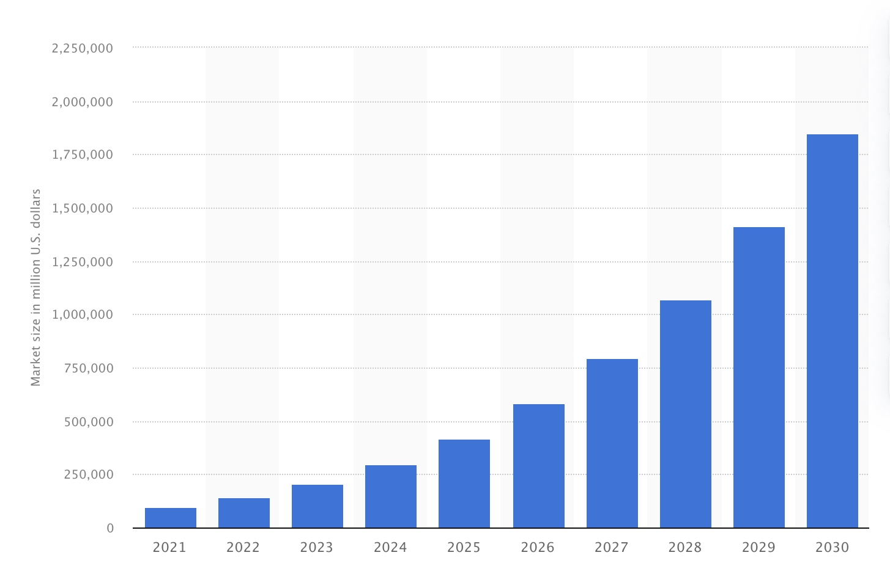
Source: (Thormundsson, 2023)
Google launched Bard, an independent online tool, on March 21, 2023, in response to OpenAI's ChatGPT's popularity (Grant and Metz, 2023) (Heaven, 2021). It is available in over 40 languages and across 230 countries, including the UK; Google Bard provides global accessibility (Google, 2023).

Mission and Vision Statement of Google Bard

Google's mission is 'To organise and make the world's information universally accessible and helpful.' Google uses automated systems to provide the most relevant and reliable information, considering factors like query words, page content, source expertise, and language and location. The company maximises access to information by presenting it most helpfully, using approachable language and design. (Google, 2023a).

Google Bard is designed to provide users with natural and friendly assistance in information retrieval and tasks. Trained on extensive text and code data, it comprehends cues and inquiries, enabling tasks like research, content creation, translation, and insightful responses. With ongoing development, Bard holds promise as a valuable tool for information-seeking and task completion (Pichai, 2023).

PESTEL Analysis of Google Bard

Conducting a PESTEL analysis will help Google Bard to identify potential opportunities and threats from external factors. A PESTEL analysis is a strategic framework used to assess and analyse the external macro-environmental factors that impact a brand or business. PESTEL stands for Political, Economic, Social, Technological, Environmental, and Legal factors (CIPD, 2023). By examining these factors, a brand can gain insights into the broader context in which it operates and make informed decisions about its strategies and operations.

Figure 2: PESTEL Analysis
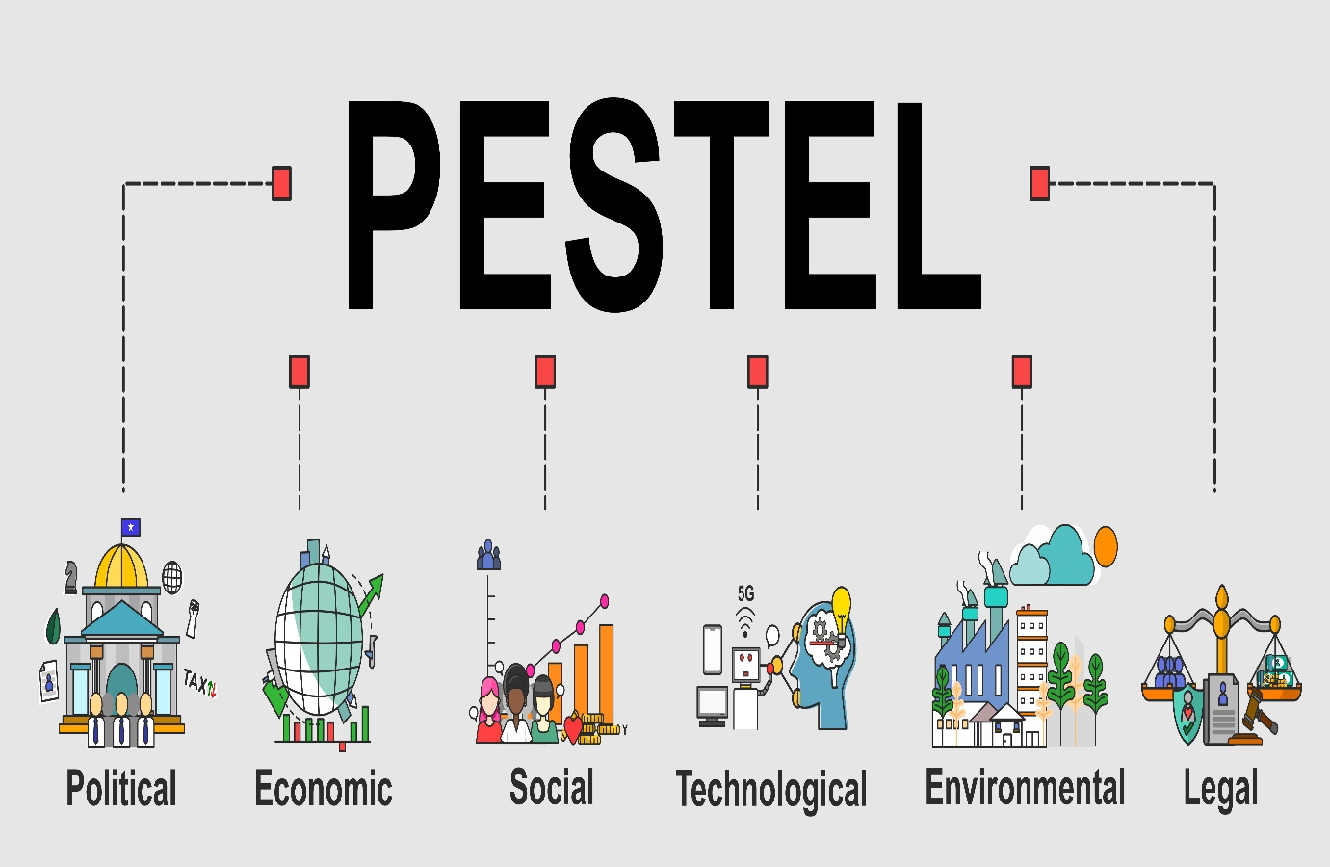
Source: Author

PESTEL Analysis of Google Bard
 | Factors | Influence
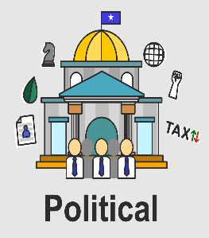 | Brexit: Post-Brexit, Google shifted UK user data to its US parent company, Google LLC, exposing millions of UK data to non-GDPR protection (Murgia, 2020). Such data transfers may impact Google Bard's data quality, performance, local context, and user experience. | Unfavourable
 | Political Stability: A stable UK political environment bolsters Google Bard through reduced regulation risks, increased investment, improved market access, and enhanced brand reputation. It mitigates conflicts, enhances security, and safeguards employee well-being and data integrity.  Government Policies: The UK government's tech industry support benefits Google Bard (GOV.UK, 2023); however, they also address concerns about technology's adverse effects like misinformation, privacy breaches, and job impacts (UK Government, 2023), potentially leading to stricter industry regulations that may challenge Google Bard. | Favourable  Favourable/  Unfavourable
 | Inflation and Cost of Living: The UK's inflation and cost of living situation have become alarming due to the combined impact of Brexit, the Ukraine-Russia conflict, and the COVID-19 pandemic. (Page, 2023) (ONS, 2023). AI technology can potentially reduce the cost of individuals and organisations (Deloitte, 2023). However, a mounting worry exists that AI technology will replace numerous human jobs, which could reduce demand for AI-powered products and services (Vallance, 2023).  Economic Growth: The UK economy, showing signs of recovery, is projected to grow by 1.0% in 2024 (OECD, 2023). Economic growth typically embraces technology adoption (Çalışkan, 2015), which is beneficial for Google Bard due to increased demand for AI-powered offerings. | Favourable/  Unfavourable  Favourable
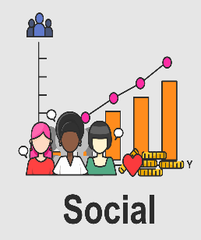 | Evolving Consumer Choices: Consumer preferences are constantly changing (Alldredge & Grimmelt, 2021). Google's operations, algorithms, products, and services are closely interconnected with people's choices and behaviours (Search, 2023).  Globalisation and Diversity: Globalisation is experiencing an upward trajectory, and numerous nations, including the United Kingdom, are undergoing increased diversity. (Bai, Ramos & Fiske, 2020) (Gov.UK, 2023). Google has implemented features to improve the relevance of search results for users in various countries, considering their diverse cultural and linguistic characteristics (Adsense, 2023). For example, Google Bard was available in 40 different languages on July 2023 (Bard, 2023)  Influence of social media: The social media platforms are increasingly popular worldwide (Dixon, 2023). There are 57.1m active users of social media in the UK (Dixon, 2023). The global market for AI in social media is predicted to rise from $1.64 billion in 2023 to $5.66 billion by 2028 (ReportLinker, 2023). Google Bard holds significant potential in social media, offering avenues for personalisation, engagement, efficiency, safety, and communication enhancement (Bard, 2023). | Favourable/ Unfavourable  Favourable  Favourable
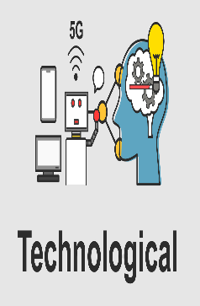 | Competitors: Google faces competition from notable technology giants such as Amazon, Microsoft, and Apple (Marketline, 2020). This competitive environment spurs Google's impetus for innovation and the introduction of fresh offerings. The launch of Google Bard is a direct response to the ChatGP initiative, supported by Microsoft Bing-backed OpenAI (Faguy, 2023).  Improved Technology: The progressive refinement of AI technology, escalating computing capabilities, advancing algorithms, and integrating enhanced data management mechanisms collectively hold the potential to foster the augmentation of Google Bard's performance (Adadi, 2021) (Company, 2023).  Collaboration with Tech Giants: Google Bard and Adobe's collaboration involves Adobe's Firefly functioning as the AI art generator for Bard (Greenfield, 2023), a significant partnership uniting potent AI technologies for enhanced creative and productive potential. | Unfavorable/  Favourable  Favourable  Favourable
 | Reducing waste and carbon emission: Google Bard optimises resource utilisation, identifies waste reduction strategies in manufacturing and transportation, and pioneers environmental protection technologies like monitoring air quality and deforestation.  High Energy Consumption: AI technology's energy consumption exceeds conventional levels (Tamburrini, 2022) due to the substantial computing power required for training models on vast datasets. Research from the University of Massachusetts Amherst highlights that training a large language model like GPT-3 consumes up to 100 megawatt-hours, equivalent to a typical US household's energy consumption for over a year (Strubell, Ganesh & McCallum, 2019). | Favourable  Unfavourable
 | Government Regulations and Policies: Governments are starting to regulate AI, which could impact the development and use of Google Bard. For example, governments may require companies to disclose how they are using AI, or they may restrict the use of AI in specific applications (European Parliament, 2023). In the UK, By adopting this novel strategy for AI regulation, the government aims to enable the UK to capitalise on the prospects and advantages offered by AI technologies (Government, 2023).  The UK Laws and Policies: UK IP law can help Google Bard by protecting its creative content and ensuring it is used responsibly and ethically (Government, 1994).  Data Protection Laws and Legislations: Operating within a regulatory framework, Google Bard is influenced by data privacy regulations like GDPR in the European Union and the UK and CCPA in California, which govern its user data practices (Marketline, 2020) (Union, 2023) (Justice, 2023) (Government of UK, 2018). Particularly stringent, GDPR safeguards users and has shielded Google's users from privacy breaches (Kostov & Schechner, 2019). | Unfavourable/  Favourable  Favourable/  Unfavorable  Unfavourable

Consumer insights of the UK market
Customer insight is a thorough understanding obtained from analysing consumer behaviours, preferences, and needs (Laughlin, 2014) (Janiszewska, 2013), drawn from data analytics, research, and interactions to inform decisions and effective marketing strategies (Mckinsey, 2023), often using the POEM model in digital marketing for brand development (Lovett and Staelin, 2016).

Figure 3: Components of the POEM Model
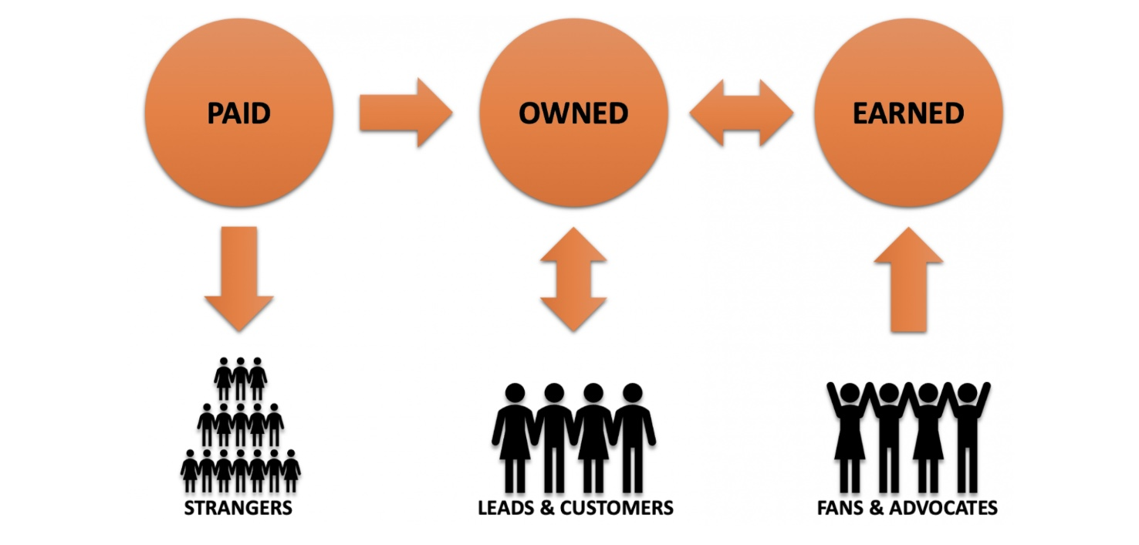
Source: (Grayson, 2023)
The breakdowns of the POEM model are (Lovett and Staelin, 2016):
Paid Media: It includes traditional advertising methods like display ads, paid search, paid social media advertising, and sponsored content.
Earned Media: Earned media is when a business receives coverage or mentions in media outlets, blogs, social media posts, reviews, and customer word-of-mouth recommendations.
Owned Media: Owned media encompasses platforms and assets a business controls, such as its website, blog, social media profiles, and email lists.

Figure 4: POEM Framework of Bard
Image: Author

Customer Lifecycle Management
The customer's experience throughout all interactions and stages with an organisation constitutes the customer journey (Lemon & Verhoef, 2016). Customer Lifecycle Management (CLM) is a strategic approach that focuses on understanding and managing the various stages of a customer's journey with a business, from initial awareness to post-purchase interactions, and evaluates performance according to these metrics (Gerardus Blokdyk, 2021). CLM aims to create positive customer experiences and build long-lasting relationships by tailoring marketing efforts and interactions to each stage of the customer lifecycle (Lou et al., 2018) (Forbes, 2022).
Sales Funnel: According to Venermo, Rantala and Holopainen (2020), the sales funnel visually represents a customer's journey from prospect to purchase, aiding in visualising the customer journey and business pipeline analysis.

Figure 5: Sales Funnel of Google Bard
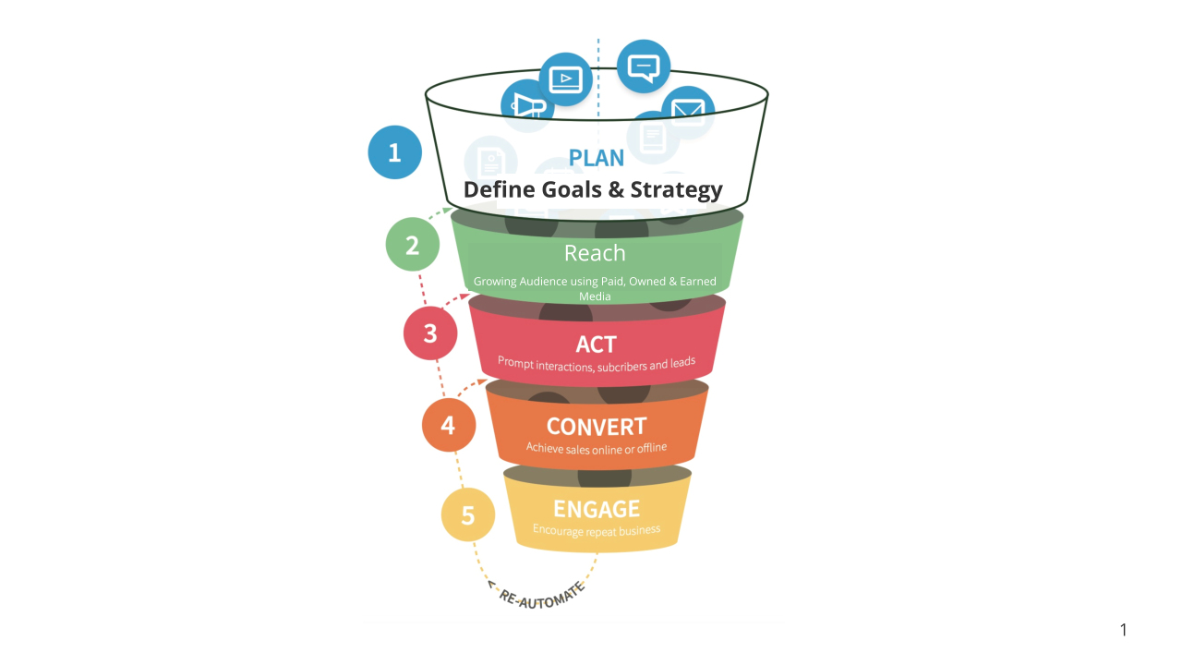
Source: smartthings.com

The customer life journey encompasses a few phases. These phases are (CIM, 2022):
Awareness: During this phase, potential buyers become acquainted with the product (Google Bard) through advertisements, recommendations, and social media exposure.
Consideration: Consumers delve into research, evaluating their choices by comparing other similar products, product features, and reviews, often seeking advice from family and friends.
Decision/ Purchase: Customer purchase, considering factors like price, quality, convenience, and brand reputation before purchasing/ choosing the product. Nonetheless, Google Bard remains an experimental offering, accessible to all users at no cost. Potential buyers might not extensively deliberate or assess alternatives before opting for it.
Post-purchase/ Retention: Customers seek assistance from the company or user groups after acquiring the product. The company may also foster loyalty by maintaining contact. Feedback, criticism, and brand endorsements may occur during this stage.
Advocacy/ Loyalty: Customers share their experiences with the product, influencing others' perceptions. Content customers might remain loyal and recommend Google Bard, leading to increased business opportunities.
Conducting a Customer Lifecycle Analysis for Google Bard entails defining distinct customer journey stages, collecting User data, segmenting, and creating journey maps. Touchpoints, engagement, and conversion rates are to be analysed. Feedback and campaign impact are evaluated to enhance user experience and personalisation, as well as to refine marketing strategies and boost user retention. The process is iterative, ensuring ongoing improvements in outcomes (Forbes, 2022).
To manage customer lifecycle effectively, Google Bard must identify customer touchpoints. Customer touch points are vital as they can impact sales, customer contentment, and brand perception. These points have the potential to prompt initial purchase (In this case, use), foster repeat use, and enhance overall customer (User) satisfaction.

Figure 6: Some Digital Touchpoints of Google Bard
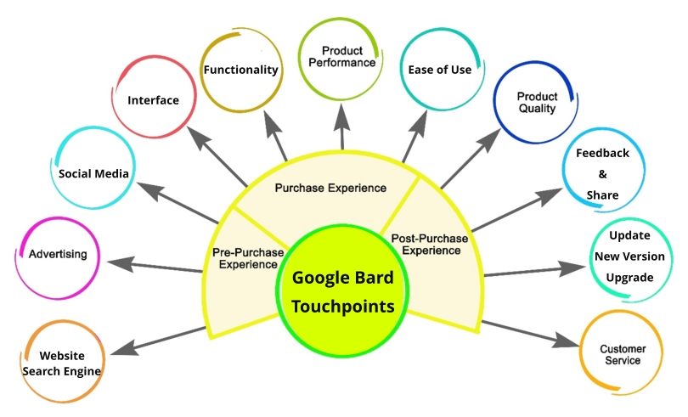
Source: Author
RACE Model
The RACE model in marketing is a strategic framework that outlines the four essential stages of a digital marketing strategy: Reach, Act, Convert, and Engage. It provides a structured approach to planning and executing digital marketing campaigns by focusing on each customer journey stage (Chaffey, 2019).

Figure 7: RACE Model for Google Bard
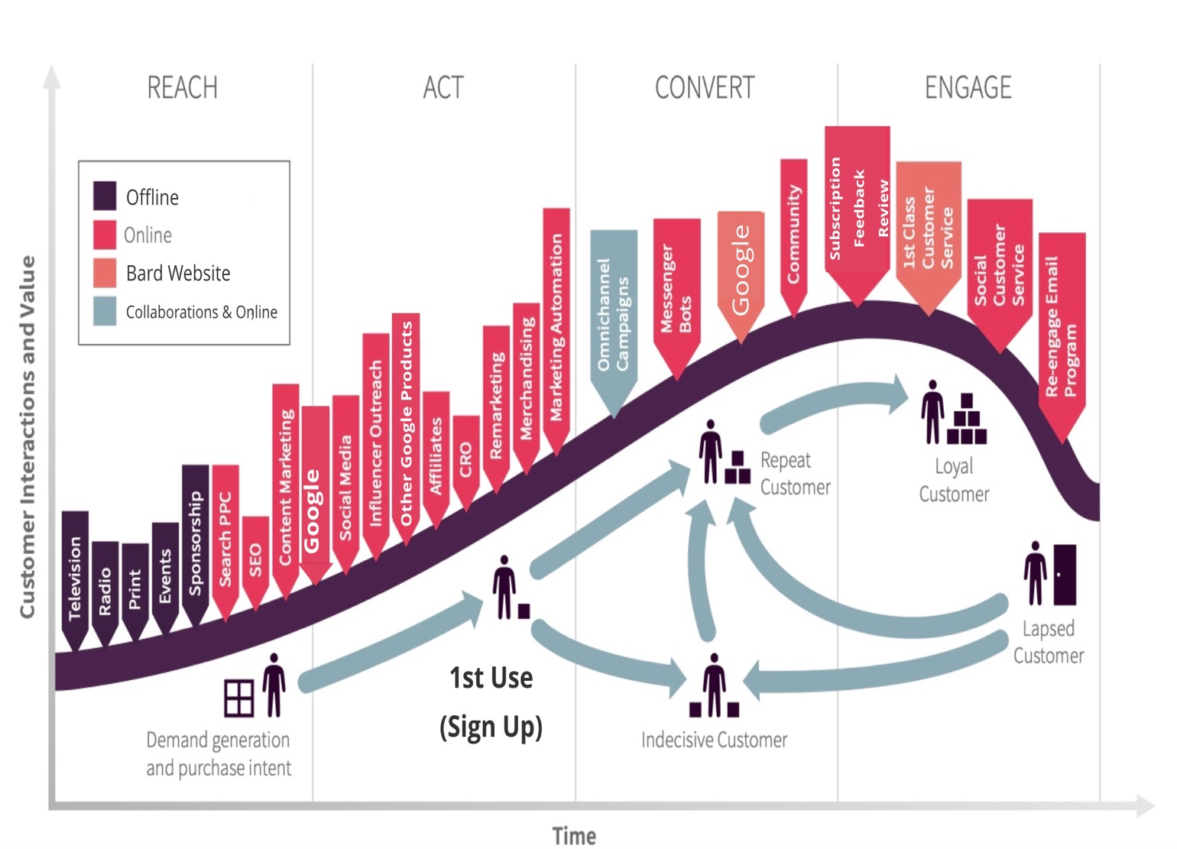
Source: Author
By aligning Google Bard's marketing efforts with the RACE model, the company can ensure a holistic and targeted approach to engaging potential users, guiding them through their journey from awareness to becoming loyal customers and fostering a lasting relationship that encourages advocacy and retention.
Customers Persona
In marketing, a persona refers to a fictional, generalised representation of an ideal customer or target audience segment. Personas are developed based on research, data, and insights about customers' characteristics, behaviours, preferences, and needs (Jansen, Salminen and Jung, 2020). They help marketers better understand and empathise with their target audience, allowing them to create more relevant and effective marketing strategies.
Image 1: Customer Persona 1
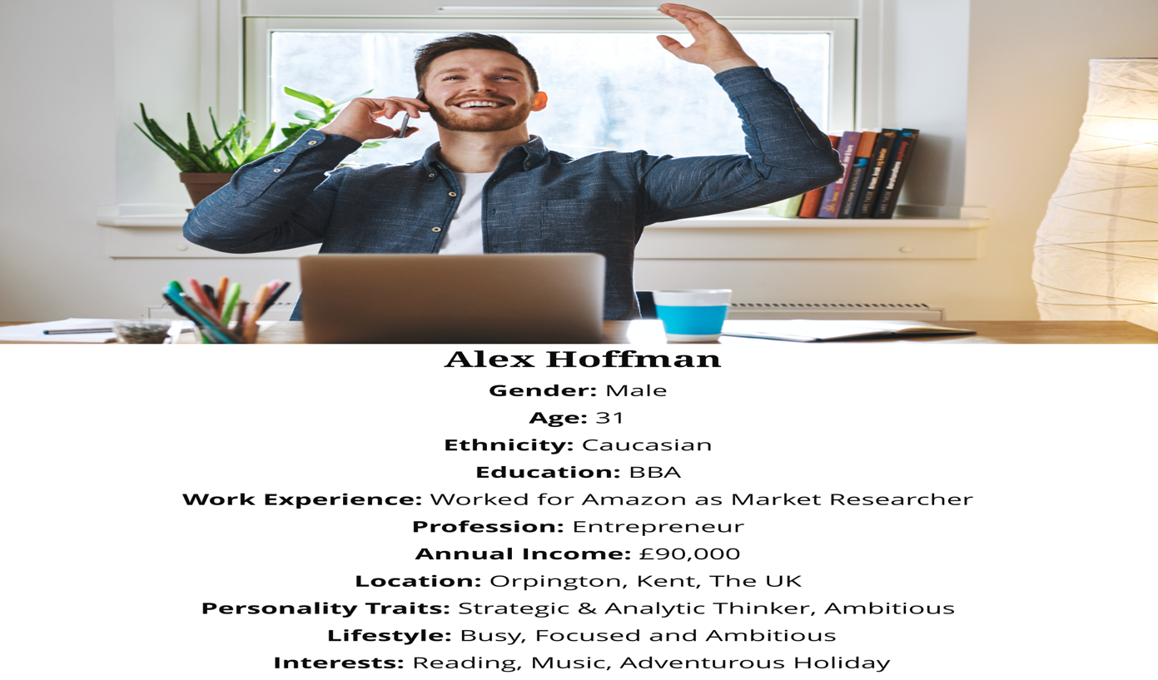
Image 2: Customer Persona 2
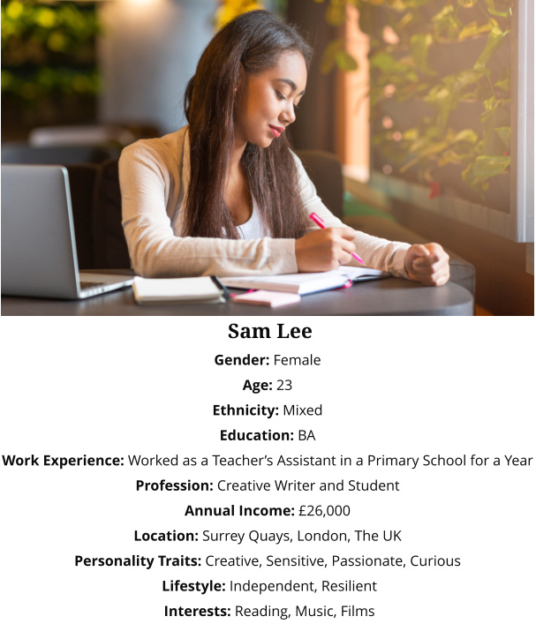
Image 3: Customer Persona 3

Image 4: Customer Persona 4
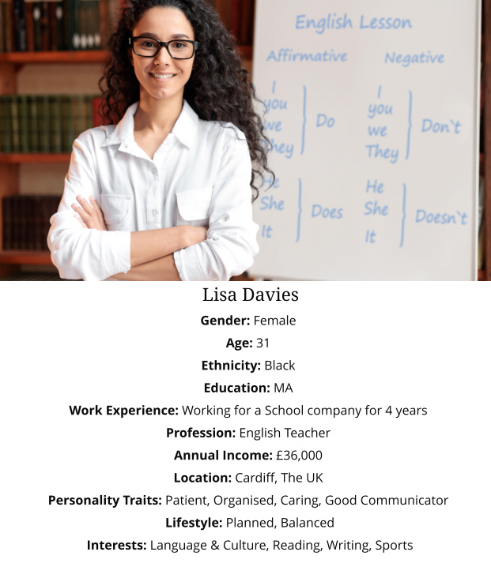

Despite variations in professions, geographic locations, and income levels among the four customer personas, shared attributes hold significance for formulating a strategic marketing approach for Google Bard. All four personas fall within the age range of 20 to 45, possess strong educational backgrounds, and exhibit a fondness for reading, indicative of a desire for learning and intellectual curiosity. This intellectual curiosity frequently correlates with creativity (Jauk et al., 2013). Google Bard holds the potential to assist these people across a range of tasks, encompassing information retrieval, content organisation, creative text generation, language translation, and diverse content creation.
Customer Experience
The customer experience (CX) is the sum of cognitive, emotive, sensory, and behavioural customer responses at all phases of the consumption process, covering pre-purchase, use, and post-purchase (Godovykh and Tasci, 2020). Customer experience design involves strategically and intentionally crafting every aspect of the customer journey to ensure that customers have positive, meaningful, and memorable interactions with a brand, product, or service. It focuses on understanding customer needs, behaviours, and preferences and then designing solutions that meet those needs and create value. This process involves various disciplines, including user experience (UX) design, service design, and interaction design, to create a cohesive, holistic experience that aligns with the brand's values and goals. Customer experience design aims to optimise touchpoints, processes, and interactions to deliver exceptional experiences that foster customer loyalty, satisfaction, and advocacy (Ponsignon, Durrieu and Bouzdine-Chameeva, 2017).

Figure 8: Framework for Understanding Digital Customer Experience
Source: (Rose, Hair and Clark, 2011)

A good customer experience must have the following (Iwuozor, 2023):
- Empathy: Developing emotional connections by comprehending and appreciating customers' desires and viewpoints.
- Personalisation: Crafting experiences specific to individual customer preferences, fostering a sense of uniqueness and understanding.
- Centralized Technology Stack: Employing technology to integrate data from different touchpoints, enabling a comprehensive overview of customer interactions.
- Value: Offering benefits and advantages that surpass customer expectations, generating a favourable brand perception.
From the four personas illustrated, a good CX can have the following experience consisting of various touchpoints:
Figure 8: Google Bard Customer Journey Map
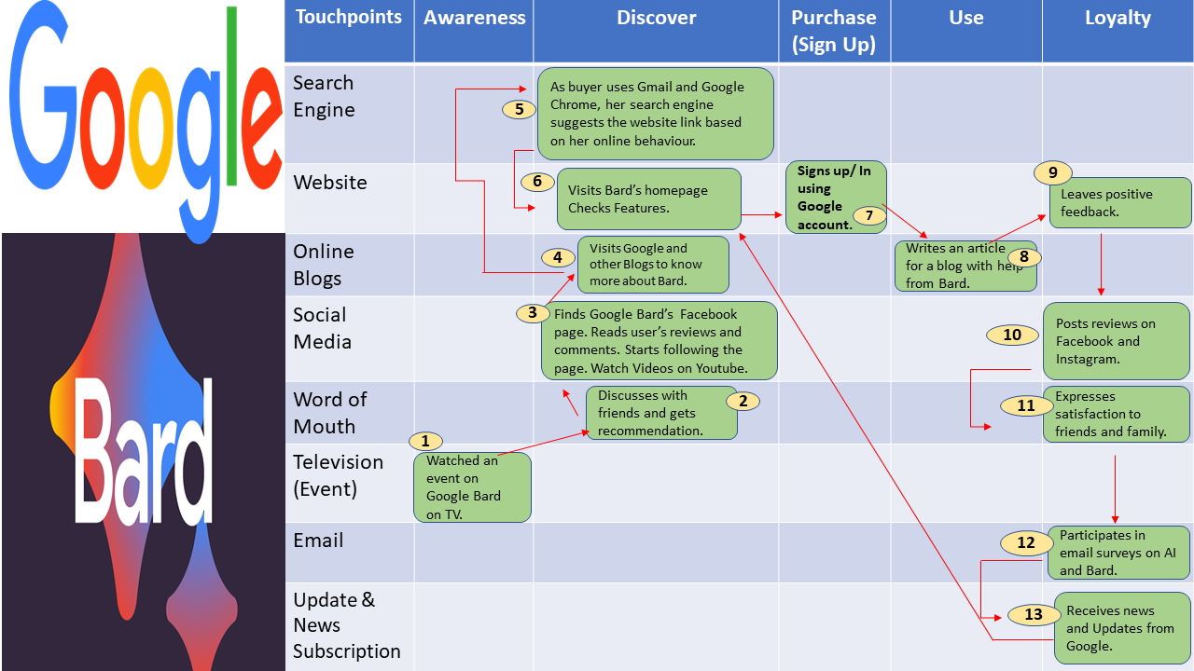
Source: Author
Micro Environment Analysis
The micro-environment consists of the components in the company's immediate surroundings that impact its performance. Suppliers, marketing intermediaries, competitors, customers, and the public are among them (Singh, Sarangal and Singh, 2021).
Analysing a company's rivals exposes its constraints, opportunities, and hurdles in the sector (Adom et al., 2016). Michael E. Porter's renowned Five Forces framework, developed at Harvard Business School, provides a strategic tool for assessing industry competitiveness and attractiveness (HBS, 2023). This model examines five key factors that shape the intensity of competition and the industry's profitability (Porter, 1979).

Figure 9: Porter's Five Forces Framework
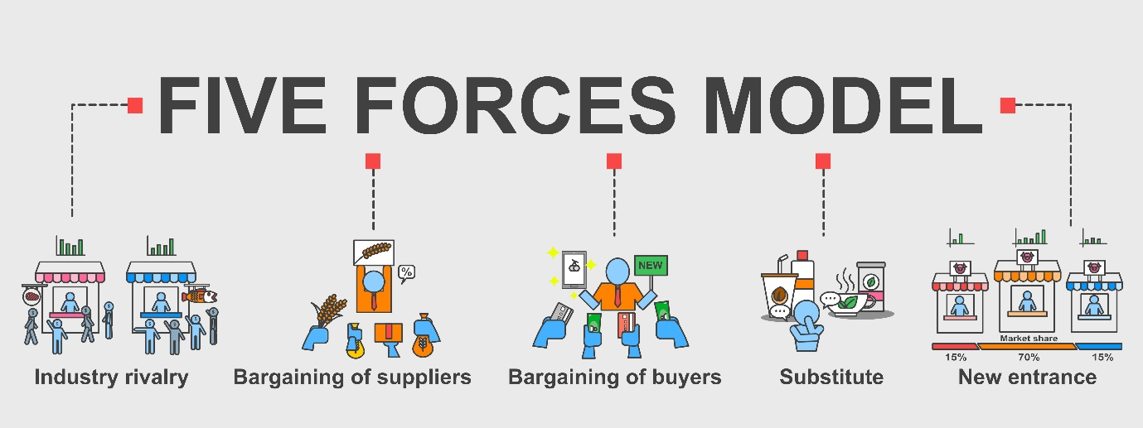
Source: Author
Porter's Five Forces Analysis of Google Bard indicates the following:
Threat of New Entrants (Medium): Google's services demand substantial technology and data infrastructure, acting as a barrier. Strong brand recognition and a vast user base further discourage new entrants. However, many tech giants such as Meta, Amazon, and Microsoft have invested in AI-based language model technology since Chat GPT was launched (Leswing, 2023).
Bargaining Power of Suppliers (Low): Google's dominance reduces supplier influence, though some power remains, especially for hardware or content. Google's brand and scale counterbalance this.
Bargaining Power of Buyers (Moderate): Google's diverse services and user base limit individual buyer power. Nevertheless, ChatGpt has emerged as a preeminent AI technology-driven language model, predating Google Bard. The industry is witnessing a growing influx of companies seeking entry, affording buyers a diversified array of options. (Hu, 2023) (Leswing, 2023)..
Threat of Substitutes (Low): Possible substitutes for language model AI include traditional rule-based systems, pre-existing databases or knowledge repositories, human-generated content, and human translators or interpreters. While these alternatives may serve specific language-related tasks, they often lack the scalability, efficiency, and adaptability of advanced language model AIs.
Intensity of Competitive Rivalry (High): Google Bard's main competitor is ChatGPT, developed by OpenAI. Both are large language models (LLMs) that are trained on a massive dataset of t code and text (Pichai, 2023)(Lock, 2022). Intense competition from Amazon, Microsoft, and Apple also are expected as these tech giants are developing their versions of AI-powered Chatbots (Leswing, 2023).
Competitor (Chat Gpt) Analysis
ChatGPT is an extensive language model chatbot developed by OpenAI. It is trained on a massive dataset of text and code and can generate text, translate languages, write different kinds of creative content, and answer your questions informally. ChatGPT is based on the GPT-3 language model, a generative pre-trained transformer model. Transformer models are a type of neural network that is particularly good at learning long-range dependencies in text. This makes them well-suited for machine translation and question-answering (Haleem, Javaid and Singh, 2023).
"ChatGPT" is a general term that refers to chatbots or conversational agents built using OpenAI's GPT (Generative Pre-trained Transformer) models. "Chat.openai.com," on the other hand, specifically refers to a platform provided by OpenAI that allows users to interact with GPT-based chatbots. So, the main difference lies in the specificity of the terms. "ChatGPT" could refer to any chatbot built using GPT models, while "Chat.openai.com" refers to the specific platform OpenAI provides for interacting with such chatbots. (OpenAi, 2023)
ChatGpt can generate text (in various styles), translate, answer in an informative manner and write creative content (Homolak, 2023). However, it is still under development, so its information is not always accurate or reliable and can not provide data sources. Moreover, it lacks common social sense and emotional intelligence (Homolak, 2023) (Weitzman, 2023).
Here is a table summarising the key differences between ChatGPT and Google Bard (Homolak, 2023) (Weitzman, 2023) (OpenAI, 2019) (Coulter and Bensinger, 2023) (Bard, 2023) (Carr, 2023) (SimilarWeb, 2023):
Features | Chat GPT | Google Bard
Data source | Publicly available | Proprietary to Google
Architecture | GPT-3 | LaMDA
Availability | Publicly available | Beta, limited availability
Strengths | Good at generating creative text formats, translating languages, and answering questions | Good at generating natural and engaging text, access to specialised information
Weaknesses | It may not be as accurate as Google Bard. | It may not be as versatile as ChatGPT.

Figure 10: Performance of Google Bard website compared to major ChatGpt sites (May 23 to July 23)
Other than Chat GPT, Jurassic-1 Jumbo, created by AI21 Labs, is a vast language model trained on a dataset of text and code that's 100 times larger than the one employed for training ChatGPT, while Megatron-Turing NLG, a large language model jointly developed by Microsoft and Nvidia, is trained on a text dataset with 530 billion parameters (Bloomberg, 2023; Microsoft, 2021). As the field of LLMs continues to develop, new competitors will likely emerge.
SMART objectives
SMART objectives are specific, measurable, achievable, relevant, and time-bound goals that provide a clear and structured framework for setting and evaluating purposes in various contexts, including business, project management, and personal development. The concept of SMART objectives was introduced by George T. Doran in 1981. The acronym SMART stands for Specific, Measurable, Achievable, Relevant, and Time-bound (Doran, 1981).
Figure 11: SMART Goals of Google Bard
Specific  | Measurable  | Achievable  | Relevant  | Time-Bound 
1. Drive more visitors to Google Bard's website.  2. Increase the page views and the time spent on the site each visit. | Increase web traffic by 20%. | A 20% increase in website traffic is attainable, given Google's resources, brand recognition, and technological capabilities. | Increasing website traffic and improving website metrics aligns with Google's core objectives of expanding its online visibility and user engagement. A new, enhanced digital marketing plan needs to be implemented. It starts with budgeting, evaluating current situations, and identifying the issue. | December 31, 2023
 | Lower Bounce rate of less than 40%.  Improve average visit duration to 7 minutes.  Improve pages per visit to 4. | Lowering the bounce rate below 40%, increasing the average visit duration to 7 minutes, and improving pages per visit to 4 is feasible through enhanced content, interactive elements, and strategic content placement. |  | December 31, 2023

TOWS Matrix
A TOWS matrix is a strategic planning tool that helps businesses identify and evaluate their strengths, weaknesses, opportunities, and threats. The matrix can be used to develop strategies that capitalise on strengths and opportunities while mitigating weaknesses and threats (Weihrich, 1982).
Figure 12: TOWS Matrix
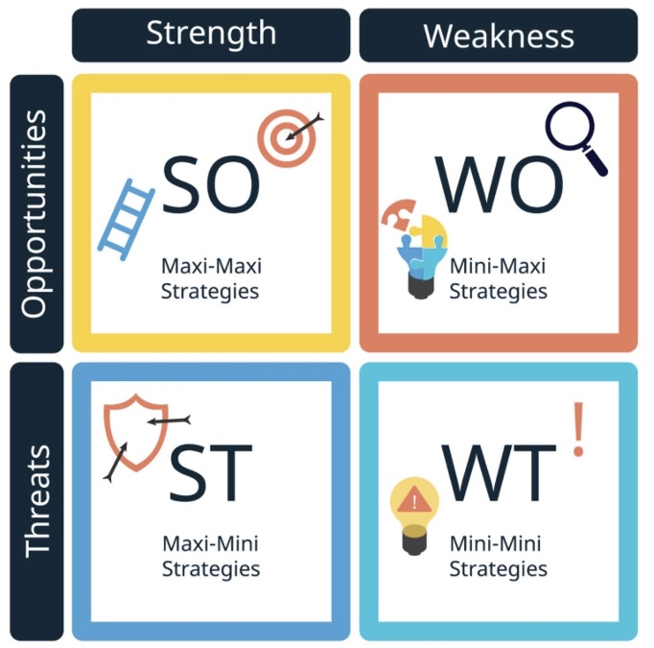
Source: Author
TOWS Matrix Analysis of Google Bard

Strengths (S):
Advanced AI Technology: Google Bard's advanced AI capabilities provide an opportunity to create personalised and engaging content for users.
User Data Analysis: Analysing data collected from user interactions can enhance content relevancy and enable tailored marketing approaches.

Weaknesses (W):
Limited Contextual Understanding: The challenge lies in Google Bard's potential inability to grasp complex context, which might result in inaccurate responses.
Learning Curve: There is a need to develop user-friendly interfaces to address the learning curve associated with interacting with an AI chatbot.

Opportunities (O):
Content Generation: Google Bard's capacity for high-quality content generation can streamline content marketing efforts and improve efficiency.
Real-time Interaction: Exploring real-time chat interactions can enhance customer support and drive better user engagement.

Threats (T):
Competition: The growing competition in the AI chatbot sector necessitates continuous innovation to differentiate Google Bard from its competitors (Leswing, 2023 (Lock, 2022).
Data Privacy Concerns: Addressing user data privacy concerns is crucial to complying with regulations and maintaining user trust.

Strategies:
S-O Strategy: Leveraging Google Bard's advanced AI capabilities to create personalised content can enhance engagement by resonating with user preferences.
W-O Strategy: Developing intuitive user interfaces and tutorials can ease user adoption, using the AI learning curve to enhance user experience. Investing in marketing and advertising to generate awareness and demand for Google Bard would be beneficial.
S-T Strategy: Utilising Google Bard's superior content generation can set it apart from competitors and address data privacy concerns transparently.
W-T Strategy: Addressing Google Bard's context limitations through continuous AI algorithm refinement can minimise the risk of inaccurate responses.

Figure 13: Strategic Framework for a Digital Strategy
Source: (Chaffey, 2019)
Digital tools for Marketing of Google Bard
Digital marketing tactics are vital for reaching a global audience, achieving cost-effective campaigns, measuring results accurately, personalising experiences, fostering engagement, and gaining a competitive edge in modern business (Chaffey, 2019) (Barone, 2023).

Figure 14: Online and Offline Marketing Tactics
Source: (Chaffey and Smith, 2017)
The following are some tactics and digital communication tools/ media channels that can be included in the digital marketing plan for Google Bard (Chaffey and Smith, 2017) (Chaffey, 2019) (Barone, 2023):
Search Engine Optimisation (SEO)
This is the process of optimising a website to rank higher in search engine results pages (SERPs). This can be done by creating high-quality content, using relevant keywords, and building backlinks.
- Keyword optimisation: Researching and targeting relevant product/ service-related (AI, Chatbot, language models for Bard) keywords and virtual assistants.
- On-page optimisation: Optimising website content, meta tags, and headings for improved search rankings.
- Technical SEO: Ensuring website speed, mobile-friendliness, and proper indexing.
Search Engine Marketing (SEM)
This is the use of paid advertising to appear higher in SERPs. This can be done through Google Ads, Bing Ads, and other search engines.
- Pay-Per-Click (PPC) Advertising: Running Google Ads campaigns targeting keywords related to services/ products.
- Retargeting: Showing ads to users who have visited the Google Bard website to re-engage and encourage conversions.
Display Advertising
This is the use of graphical ads on websites, social media platforms, and other online channels. This can be used to reach a wider audience and target specific demographics.
- Banner Ads: Designing visually appealing banners promoting the product's (Google Bard) features and benefits.
- Retargeting Ads: Displaying ads to users who have interacted with the product (Google Bard) but didn't convert.
Social Media Marketing
It is using social media platforms to promote a product or service. This can be done by creating engaging content, running social media ads, and engaging with users.
- Content Creation: Develop engaging posts, graphics, and videos showcasing the Product's (Google Bard) capabilities.
- Influencer Collaboration: Partnering with influencers to promote the product.
- Paid Social Ads: Running targeted ads on platforms like Facebook, Instagram, and LinkedIn to reach a wider audience.
- Interacting with visitors: Regular social presence and responding to queries, comments, and feedback.
Permission Marketing
Permission marketing is a marketing strategy that involves obtaining consent from potential customers before delivering marketing messages or content to them (Kenton, 2022).
- Email Marketing: Sending marketing messages to potential and existing customers.
- Newsletter Campaigns: Send regular newsletters with updates, use cases, and success stories of Google Bard.
Content Marketing
This is creating and distributing high-quality content relevant to a target audience. This can be done through blog posts, articles, infographics, and videos.

Online Partnerships
Online partnerships refer to collaborations between businesses or individuals in the digital space. These partnerships can take various forms, such as joint marketing campaigns, co-branded content, affiliate marketing programs (Commission-based partnerships), Sponsorships, link-building and strategic alliances.

Online public relations (PR)
It involves:
- Managing a brand's reputation.
- Building relationships with the online audience.
- Communicating messages through various digital channels.
- Brand Protection

To effectively implement these strategies for Google Bard, optimising their website for optimal outcomes is imperative. Additionally, consistent analysis and measurement using key metrics and KPIs are crucial to success.
Key Metrics and KPI
Key metrics and Key Performance Indicators (KPIs) for a website are measurable data points that provide insights into its performance, user engagement, and effectiveness.
Figure 15: Some Engagement KPIs of Google Bard
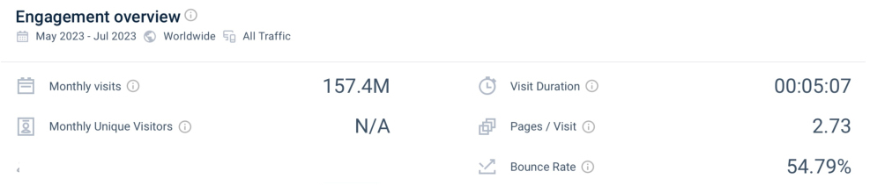
Source: (SimilarWeb, 2023)
Figure 16: Social Media KPIs (Google Bard)
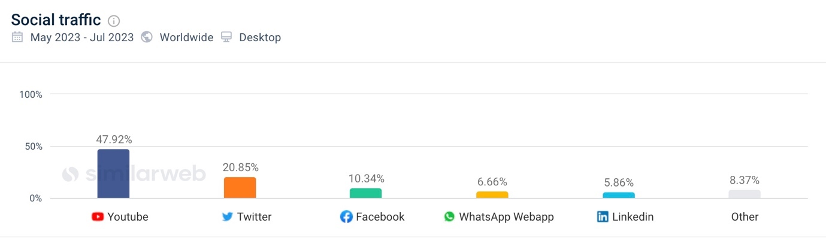
Source: (SimilarWeb, 2023)

Figure 17: Traffic Channels
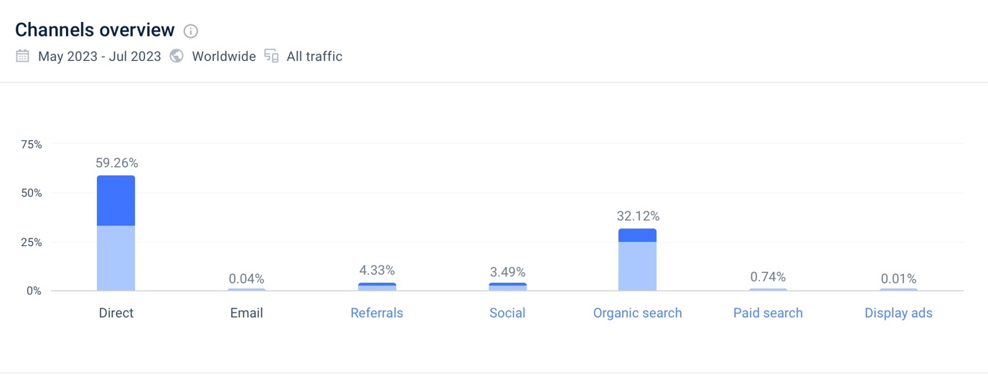
Source: (SimilarWeb, 2023)
Figure 18: Visitors Geographic Locations
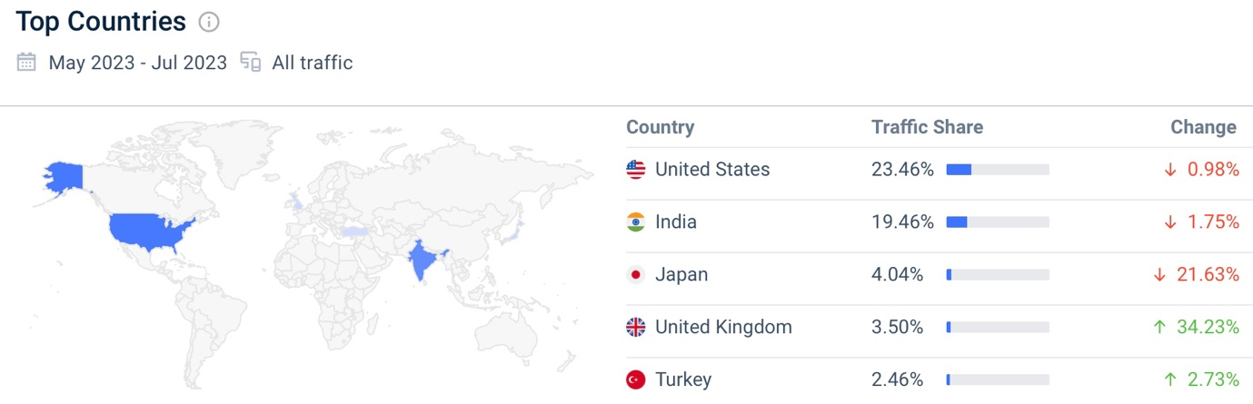
Source: (SimilarWeb, 2023)

Some important key metrics and KPIs for a website include (Piga, 2022) (Olafson, 2021) (Chaffey and Smith, 2017) (Hardwick, 2021) (Soulo, 2018):
Website Traffic:
  - Total Visits
  - Unique Visitors
  - Pageviews
  - Bounce Rate
User Engagement:
- Average Visit Duration
- Pages per Visit
- Click-Through Rate (CTR)
- Conversion Rate
Audience Demographics:
  - Geographic Location
  - Age and Gender
  - Interests and Behaviour
Source of Traffic:
  - Organic Search
  - Referral Traffic
  - Direct Traffic
  - Social Media Traffic
Conversion Metrics:
  - Conversion Rate
  - Goal Completions
  - E-commerce Sales
Website Performance:
  - Page Load Time
  - Mobile Responsiveness
  - Website Errors (404s, 500s)
SEO Metrics:
  - Organic Search Rankings
  - Keyword Performance
  - Backlinks
Social Media Metrics:
  - Social Media Engagement (Likes, Shares, Comments)
  - Follower Growth
  - Social Media Referral Traffic
Email Marketing Metrics:
  - Open Rate
  - Click-Through Rate
  - Unsubscribe Rate
Customer Feedback and Satisfaction:
  - Net Promoter Score (NPS)
  - Customer Reviews and Ratings

Estimated digital marketing Budget of Bard
A well-crafted marketing budget empowers businesses to make strategic decisions, optimise their marketing efforts, and better understand their campaigns' financial impact, ultimately contributing to the company's overall success and growth (Krizanova et al., 2019).
Figure: Alphabet's (Google) Marketing Expenditure (Global)
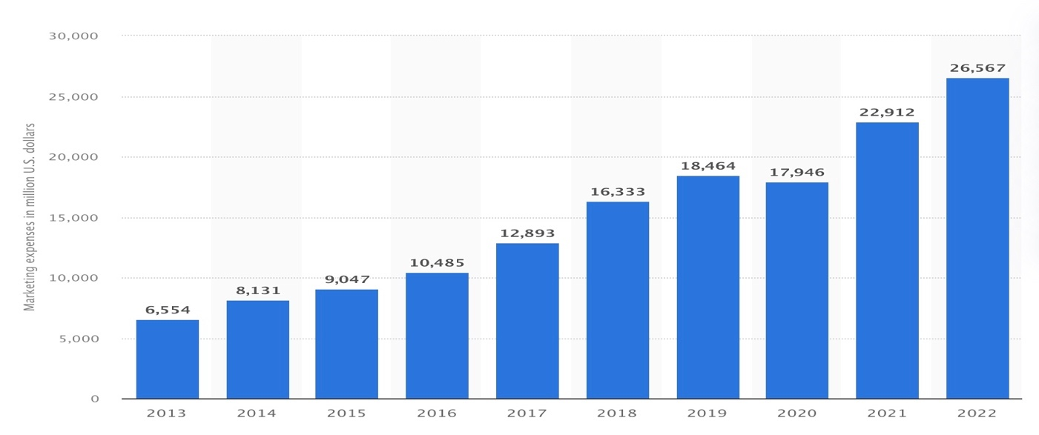
Source: (Statista, 2023)
Figure: Google's Advertising Cost in the UK
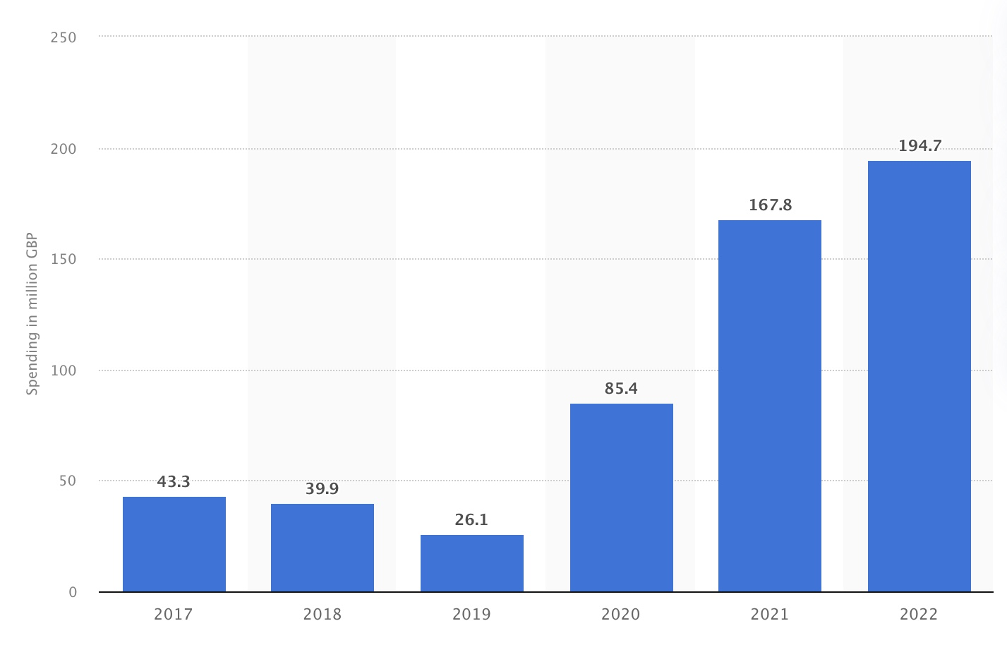
Source: (Department, 2023)
Making an estimated marketing budget for a brand as big as Bard is challenging. Google is one of the biggest companies in the world. It spent over $26 billion on marketing in 2022 (Statista, 2023). However, Google does not indicate how much they have spent promoting Bard. Hence, the subsequent marketing budget is an approximate calculation, considering the company's scale, magnitude, and benchmarking against other firms in the technology sector.
Marketing Budget of Google Bard (October 23 to December 23)
Marketing Channel | Budget Allocation
Search Engine Optimisation (SEO)  On-page optimisation  Off-page optimisation  Content creation and optimisation | £50,000
 | £30,000
 | £60,000
Search Engine Marketing (SEM)  Google Ads campaign  Bing Ads campaign | £80,000
 | £20,000
Display Advertising  Banner ads and retargeting | £40,000  £40,000
Social Media Marketing
Facebook Ads
Instagram Ads
Twitter Ads
LinkedIn Ads
YouTube Ads
 | £60,000
 | £40,000
 | £30,000
 | £20,000
 | 80,000
Email Marketing
Email campaign tools
Content creation and design
 | £10,000
 | £20,000
Content Creation
Blog posts, articles, and guides
Video creation and editing
Infographics and visual content
 | £50,000
 | £40,000
 | £30,000
Influencer Collaborations  Partnering with influencers | £50,000
Analytics and Tools
Marketing analytics software
A/B testing tools
 | £30,000
 | £20,000
Miscellaneous and Contingency  Unforeseen expenses | £30,000
Total Digital Marketing Budget | £760,000

Recommendations
Recommendations for Google Bard (Chat GPT) should focus on enhancing its digital marketing strategy and overall user experience to achieve its business objectives. Here are some suggestions:
Refinement of User Experience: The user interface and interaction design of Google Bard should be continuously improved to ensure seamless and intuitive user experiences.
Implementation of Personalisation: Advanced personalisation techniques should be implemented to provide users with tailored responses and recommendations based on their interactions, preferences, and history.
Emphasis on Data Privacy and Security: Robust data privacy measures should be emphasised, reassuring users about protecting their personal information, which is crucial for building trust and loyalty.
Offering Educational Initiatives: Educational resources and guides should help users make the most of Google Bard's capabilities, fostering a sense of empowerment and encouraging usage.
Exploration of Collaborations and Partnerships: Partnerships with relevant platforms, applications, and brands should be explored to expand Google Bard's reach and enhance its utility across different contexts.
Implementation of Analytics and Insights: Comprehensive analytics tools should be implemented to track user engagement, behaviour, and trends. These insights can then refine the user experience and inform marketing strategies.
Continual Learning: Google Bard should be updated with the latest trends, topics, and information to ensure users receive relevant and up-to-date responses.
Integration with social media: Integration with social media platforms should be achieved, enabling users to seamlessly interact with the AI on various channels and fostering a more comprehensive online presence.
Introduction of Innovative Features: New features leveraging cutting-edge AI technologies, such as natural language understanding, sentiment analysis, and voice recognition, should enhance user engagement.
User Training and Onboarding: Tutorials, guides, and onboarding processes should be provided to help users effectively navigate and utilise Google Bard's capabilities.
By implementing these recommendations, Google Bard can optimise its digital marketing strategies and deliver enhanced user value and experiences, fostering lasting engagement and loyalty.

Conclusion
The exploration of Google Bard's journey within the realms of AI has illuminated its strategic approach to the dynamic world of digital marketing. The foundational understanding of AI's significance and an in-depth analysis of the UK market through PESTEL and consumer insights frameworks have provided essential context for its marketing endeavours. Integrating the POEM Model, Customer Lifecycle Management, RACE Framework, buyer personas, and the emphasis on customer experience underscores the commitment to delivering tailored and meaningful interactions. The micro-environment analysis, SMART objectives, and TOWS strategy have set the stage for a focused and adaptable marketing approach. The strategic framework for digital marketing, encompassing various tools and metrics, serves as the roadmap for achieving the desired marketing outcomes. With projected costs and prudent recommendations in place, Google Bard is poised to harness its potential and embark on a successful journey in the ever-evolving digital landscape.

