Traffic Infringement Reporting
and Notification System (TIRNS)
“An Intelligent Traffic Violation Notification System
Using Government APIs and Real-Time Vehicle Data”



Name: Zainab Naweed

Student ID: 2221255
Supervisor Name: Dr Sana Jokhio
BSc Applied Computing
University of Wales Trinity Saint David (Birmingham)
Date of Submission: 28 November 2025

Declaration of Originality
I, Zainab Naweed declare that I am the sole author of this Project; that all references cited have been consulted; that I have conducted all work of which this is a record, and that the finished work lies within the prescribed word limits.
This work has not previously been accepted as part of any other degree submission.

Signed: Zainab Naweed
Date: 15th November 2025

FORM OF CONSENT
I Zainab Naweed hereby consent that my Project, submitted in candidature for the B.Sc.(Hons) Computer Networks degree, if successful, may be made available for inter-library loan or photocopying (subject to the law of copyright), and that the title and abstract may be made available to outside organisations.

Signed: Zainab Naweed
Date: 15th November 2025

Copyright Acknowledgement
I acknowledge that the copyright of this project report, and any product developed as part of the project, belongs to the University of Wales Trinity Saint David, Swansea.

APPRECIATION:
In the name of Allah SWT, the Most Gracious and Most Merciful, and peace and blessings be upon Prophet Muhammad SAW, his family, and his chosen companions. I extend my deepest gratitude to Allah, whose grace and guidance enabled me to complete this report on the Traffic Infringement Reporting and Notification System (TIRNS): An Intelligent Traffic Violation Notification System Using Government APIs and Real-Time Vehicle Data. I also sincerely thank my academic supervisor, Dr Sana Jokhio, whose kind direction and consistent guidance were invaluable at every stage of this project, shaping the project into its final form. I extend my heartfelt appreciation to my family, whose support sustained me during demanding moments.

1.0 Abstract:

Traffic enforcement in the UK relies heavily on ANPR systems and speed cameras to detect violations instantly, yet motorists still receive Notices of Intended Prosecution (NIPs) through postal mail. This delay often causes missed deadlines and reduced confidence in enforcement processes. Existing digital services, such as MOT and tax reminders, remain fragmented and do not provide real-time offence communication.
This project develops the Traffic Infringement Reporting and Notification System (TIRNS), a mobile prototype designed to deliver instant offence notifications and support compliance tracking. The project initially planned to use Flutter and Firebase, but transitioned to Adalo due to time, compatibility, and backend integration limitations. The final prototype includes user authentication, offence lists using simulated data, compliance reminders, and admin management features.
Testing showed that TIRNS offers a clear and user-friendly interface and demonstrates strong potential for improving communication speed, transparency, and overall user experience within UK traffic enforcement systems.

Table of Contents
1.0 Abstract: 2
Table of Figures 5
Chapter 1: 6
2.0 Introduction: 6
2.1 Background: 7
2.1 Problem Statement: 8
2.3 Aims & Objectives: 8
Aims: 8
Objectives: 9
2.4 Scope & Limitations: 10
2.5 Chapter Summary: 10
Chapter 2: 10
3.0 Literature Review: 10
2.1 Automated traffic enforcement and road-safety policy: 11
2.2 ANPR and smart-challan systems: 13
2.3 Intelligent Speed Assistance and driver-support technologies: 13
2.4 Digital notification, scams and trust in enforcement: 14
2.5 No-code Mobile Development and Adalo: 14
2.6 Emerging Trends in Traffic Enforcement: 15
2.6 Identified gaps and justification for TIRNS: 16
Detection is well-covered; notification is not: 16
Digital enforcement communication is fragmented and vulnerable to scams: 16
Smart-challan systems stop at email/SMS: 16
No-code enforcement solutions are under-explored: 17
TIRNS Contribution: 17
Chapter 3: 17
3.0 Methodology: 17
3.1 Research and Development Approach: 17
3.2 Requirements Gathering: 18
a. Literature and Policy Review: 18
b. Analysis of Existing UK Systems 18
c. User-Focused Observations: 19
3.3 System Design: 19
a. Architectural Design: 19
b. Workflow and Data Modelling 20
User Use Cases: 20
Admin Use Cases: 20
c. User Interface (UI) Design. 22
3.4 Development Methodology and Tool Transition: 23
a. Initial Plan: Flutter + Firebase 23
b. Challenges with Flutter + Firebase 23
c. Transition to Adalo: 23
d. Limitations of Adalo: 23
3.5 Data Simulation and Ethical Considerations: 23
a. Data Simulation: 23
b. Ethical and GDPR Compliance 24
3.6 Testing Strategy: 24
3.7 Chapter Summary: 24
Chapter 4: 24
4.0 IMPLEMENTATION & DEVELOPMENT: 24
4.1 Development Environment: 25
a. Transition to Adalo: 25
b. Project Structure in Adalo: 25
4.2 Interface Design: 28
a. Screen Navigation: 28
b. Dashboard Interface 28
4.3 Database & Logic Implementation 29
a. Offence Simulation: 29
b. Notification Workflow 30
c. Compliance Tracking 30
4.4 Admin Features: 30
4.5 Challenges and Solutions: 31
4.6 Chapter Summary: 31
Chapter 5: 31
5.0 TESTING & EVALUATION: 32
5.1 Testing Approach: 32
a. Functional Testing 32
b. Usability Testing: 32
c. Scenario-Based Testing 32
5.2 Test Results Summary: 32
a. Functional Test Results 32
b. Usability Findings 33
c. System Limitations Identified 33
5.3 Evaluation Against Objectives: 33
5.4 Overall Performance Evaluation: 33
5.5 Chapter Summary: 34
Chapter 6: 34
6.0 CONCLUSION & RECOMMENDATIONS: 34
6.1 Conclusion: 34
6.2 Limitations: 35
6.3 Recommendations for Future Work: 35
a. Technical Improvements: 35
b. User Experience Enhancements: 35
c. Operational/Policy Considerations 35
6.4 Final Statement: 35
7.0 References: 36
8.0 Appendices: 40
Appendix 1: 40
Appendix 2: 41
Appendix 3: 41
Appendix 4: 42
Appendix 5: 42
Appendix 6: 43
Appendix 7: 43
Appendix 8: 44
Appendix 9: 44
Appendix 10: 44
Appendix 11: 45
Appendix 12: 46
Appendix 13: 46
Appendix 14: 46
Appendix 15: 47
Appendix 16: 47

Table of Figures:
Figure 1: Types of Traffic Violations Detected by ATES. 12
Figure 2: Example of an AI‑enabled traffic enforcement camera 16
Figure 3: Illustration of the Software Development Lifecycle (SDLC) (source: Salesforce [37]). 18
Figure 4: Illustration of Mobile Backend as a Service (MBaaS) concept (source: Brininger [43]). 19
Figure 5: UML Use Case Diagram for the TIRNS Mobile Application 21
Figure 6: Admin Flowchart of the development of your TIRNS project 21
Figure 7: User Flowchart of the development of your TIRNS project 22
Figure 8: login screens of the TIRNS mobile application, illustrating user registration, authentication, and personalised welcome interface 26
Figure 9:Home screen of the TIRNS mobile application, displaying user profile and navigation options for vehicle management, offence tracking, and notifications 27
Figure 10: Offence tracking screens in the TIRNS app showing violation details and user actions 27
Figure 11:Vehicle management interface of the TIRNS mobile application, showing user profile, vehicle list, and detailed compliance data including MOT, tax, and insurance expiry 28
Figure 12: TIRNS dashboard with user profile and navigation buttons 29
Figure 13: Illustration of identified challenges and their solutions within the TIRNS prototype 31

Chapter 1:

2.0 Introduction:

Traffic law enforcement is an important part of the United Kingdom’s transport system, helping to protect public safety and guide driver behaviour [1]. By checking that drivers follow the law, enforcement reduces accidents, lowers risks from unsafe driving, and supports responsible road use. It also helps keep national transport networks stable and predictable. In recent years, computing technologies such as automated number plate recognition (ANPR) [2], predictive analytics, and artificial intelligence have made enforcement more data-driven. These tools improve efficiency and accuracy but also raise concerns about privacy, fairness, and ethics in public governance. For this reason, traffic law enforcement provides a clear example of how computing, policy, and social well-being are closely linked.
The Notice of Intended Prosecution (NIP) is a statutory mechanism used in the United Kingdom to notify vehicle keepers of alleged traffic offences [3]. Although modern digital services exist for vehicle management, the issuing of NIPs continues to rely primarily on postal delivery [4]. This dependence on traditional communication methods often results in delays, missed correspondence, and administrative inefficiencies for both drivers and enforcement authorities. Such delays can cause stress, confusion, and in some cases, increased penalties when offenders remain unaware of the violation until receiving a physical notice day or weeks later.
Speeding continues to be a major contributing factor to traffic accidents. According to World Health Organization, Excessive speed is a key risk factor for crashes, increasing both crash risk and crash severity, Thus, effective enforcement of speed limits is critical for achieving and maintaining road safety [5].
While enforcement technologies such as automated cameras and ANPR systems have advanced significantly in the UK, the communication layer between enforcement agencies and drivers has not evolved at the same pace. As a result, the enforcement ecosystem remains fragmented, reactive, and largely dependent on slow, paper-based processes.
At the same time, the UK government offers a broad range of digital tools, such as online services for vehicle licensing and MOT reminders [6]. However, these services operate independently, and none provide a unified space for managing vehicle compliance or receiving real-time enforcement notifications. Systems like the DVSA MOT reminder service send SMS or email alerts only for MOT expiry and lack integration with tax, insurance, or penalty data, leaving vehicle owners dependent on multiple disconnected platforms for compliance management. Mobile government projects show that these systems can make services more efficient and increase user participation [7]. Countries such as Singapore and Estonia are often highlighted as examples of how real-time legal communication can be successfully implemented [8]. This gap in integration highlights the need for a comprehensive, mobile-first solution that centralises compliance tasks and delivers timely alerts.

2.1 Background:

Traffic enforcement in the UK uses advanced technologies such as ANPR and speed cameras to detect offences instantly, yet motorists are still notified through slow, paper-based NIPs. This delay often leads to missed deadlines, increased fines, and reduced trust in the system. Existing digital services like MOT reminders or tax checks operate separately and do not provide real-time offence alerts. There is no unified mobile platform that supports immediate notification and compliance monitoring. The TIRNS project aims to address this gap by delivering immediate digital alerts and an integrated compliance management platform.

2.1 Problem Statement:

This project addresses delays in notifying motorists of traffic offences, especially speeding violations. Reliance on postal delivery causes slow communication, leading to late responses, higher fines, administrative inefficiencies, and reduced trust in enforcement. Unexpected penalties, received without prior awareness of an offence, can cause significant stress for motorists.
This project was inspired by personal traffic violations, emphasising the need for a more efficient, stress-free traffic system. Inspiration for an app that alerts vehicle owners when their car is detected speeding or involved in an accident by innovative traffic systems emerged. Intelligent traffic monitoring systems help track speed limits, detect violations, and monitor suspicious vehicle behaviour on roads and highways [9]. The app promotes eco-friendly, paperless communication by sending secure digital notifications instead of physical letters. “The development of an environmentally friendly work culture certainly needs to be carried out at all levels of world society [10].” ​

The issue isn’t the fines, but the lack of immediate notification. Currently, motorists only know they’ve been caught speeding if stopped by police or when the Notice of Intended Prosecution (NIP) arrives by post, which can be frustrating [11].

The proposed system is a digital platform designed to enhance traffic law enforcement by facilitating the prompt issuance of Notices of Intended Prosecution (NIPs) through integration with government and transport authorities. It offers role-based access for motorists, enforcement agencies, and licensing authorities. The application allows private vehicle owners, rental companies, and fleet operators to scale their use efficiently, providing secure driver activity tracking, real-time incident reports, and streamlined NIP management. Future developments may encompass integration with in-vehicle systems for real-time compliance monitoring.

2.3 Aims & Objectives:

Aims:

This project aims to develop a secure, real-time mobile application, the Traffic Infringement Reporting and Notification System (TIRNS), that replaces traditional postal NIP delivery with instant digital notifications while providing comprehensive compliance management tools for motorists. The system will simulate integration with enforcement authorities, enabling immediate access to offence details, vehicle status reminders, and educational resources, thereby improving the efficiency of road law enforcement and enhancing public engagement with compliance processes.

Objectives:

To accomplish the project’s goal, key objectives are outlined to ensure a practical, focused, and timely system delivery within the academic schedule.

- Analyse existing traffic enforcement systems, notification methods, and legal frameworks (e.g., GDPR, DVLA) to identify gaps and evaluate proposed solutions that can guide system design.
- Develop a secure and user-friendly app prototype that provides penalty alerts, supports fine payments and appeals, and issues MOT and insurance reminders, thereby centralising road law compliance in one platform.
- Deliver the complete app prototype within 12 weeks, incorporating core features such as NIP alerts, offence tracking, payments, dispute handling, and course booking. Effectiveness will be measured through testing, user feedback, and integration trials.
- Advance sustainability by replacing paper-based correspondence with digital solutions that align with smart city and e-governance objectives.
- Produce comprehensive documentation and maintenance guidelines to ensure adaptability, including future integration with vehicle manufacturers and smart traffic systems.
- Apply a structured Software Development Life Cycle (SDLC), aiming for prototype completion by Week 10, testing by Week 12, and final submission at the end of the term.

2.4 Scope & Limitations:

This project aims to develop a prototype of TIRNS that showcases real-time alerts, vehicle compliance management, enforcement data simulation, and an accessible interface design. Due to legal and ethical restrictions, direct integration with DVLA or police systems is not possible; instead, the prototype will use simulated datasets and mocked API responses. User testing will also be limited to small groups and role-based scenarios. These constraints are recognised in the proposal and ensure that the project remains compliant with GDPR and ethical research standards.

2.5 Chapter Summary:
This chapter has introduced the background and motivation for developing a real-time traffic infringement notification system, outlined the aims and objectives, and established the scope and limitations of the project. The next chapter presents a detailed review of existing systems, enforcement technologies, and academic literature to contextualise the need for TIRNS.

Chapter 2:

3.0 Literature Review:

The purpose of this literature review is to examine existing research, technologies, and systems relevant to digital traffic enforcement, real-time notifications, vehicle compliance management, and the emerging role of low-code/no-code platforms in public-sector digital innovation. This chapter is structured thematically to critically analyse gaps in current UK systems, with the findings supporting investment in technology-driven enforcement platforms such as the proposed Traffic Infringement Reporting and Notification System (TIRNS).
At the policy level, European and national authorities are pursuing casualty-reduction targets through technology. The European Court of Auditors’ 2024 report stresses the importance of speed control, camera enforcement, and intelligent transport systems for Vision Zero goals, while noting uneven implementation and fragmented data across member states [12]. In the UK, the Driver and Vehicle Standards Agency (DVSA) updated its Enforcement Sanctions Policy in 2025 to standardise the use of fixed penalties, prohibitions and follow-up sanctions, explicitly framing consistent enforcement as central to maintaining road safety and operator compliance [13]. The policies highlight that enforcement must combine technology with timely, proportionate, and clear communication, an area where TIRNS can provide significant benefit.

2.1 Automated traffic enforcement and road-safety policy:

Automated Enforcement Systems (AES) are central to modern traffic management, using tools such as speed and red-light cameras to improve compliance and reduce accidents while lessening reliance on frontline policing. According to Luca, Automated Enforcement Systems (AES) enhance traffic efficiency and lower violation rates by providing unbiased, evidence-based monitoring [14].

Recent work in traffic management emphasises a shift from manual policing towards Automated Enforcement Systems (AES) and Automated Traffic Enforcement Systems (ATES) as core components of “Safe System” road safety strategies. A 2025 systematic review finds that ATES reduces crashes and fatalities, but its effectiveness depends on design, transparency, and continuous monitoring [15]. The basic types of violations detected by ATES are shown in Figure 1 below.

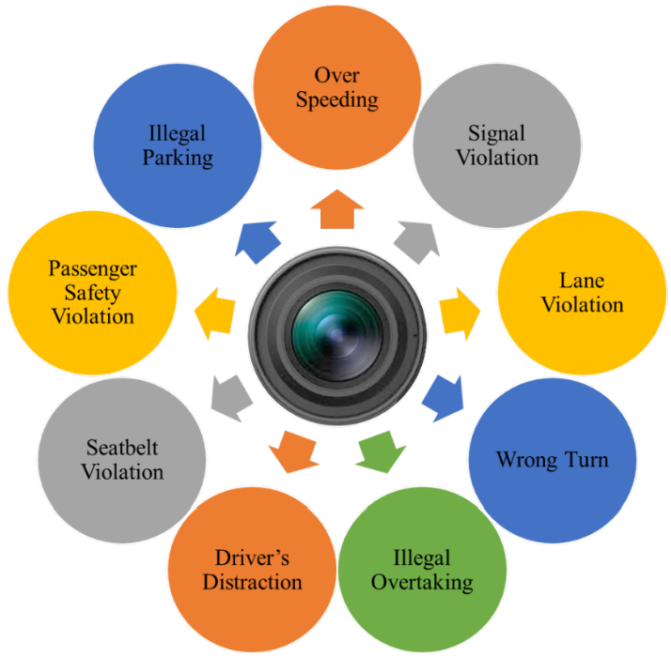
Figure 1: Types of Traffic Violations Detected by ATES.

Industry and practitioner sources indicate that automated traffic enforcement is shifting from pilot projects to mainstream use. A 2025 Police1 article notes the deployment of LiDAR-based scanning systems and AI-enabled ALPR to manage speed and red-light violations, particularly as traditional traffic stops decline due to resource and safety constraints [16]. An industry blog post published by Elovate (Modaxo Group) in 2025 on Europe’s automated traffic enforcement reports significant and sustained reductions in fatalities in countries like Sweden and Cyprus after widespread camera deployment, while emphasising the need for legal clarity, public engagement, and strong data-analytics systems [17].
Together, these sources support TIRNS’s focus on integrating with existing enforcement data (e.g. ANPR, camera events) while presenting violations to drivers through a more transparent, user-centred digital channel.

2.2 ANPR and smart-challan systems:

At the technical level, a core building block of TIRNS is reliable vehicle identification through ANPR/ALPR. While earlier studies focused on plate detection and OCR accuracy, recent work addresses full enforcement workflows. Niwankar et al. [18] propose a “Smart-Challan” system that integrates object detection with number-plate recognition to automatically generate electronic challans from transport office data. Crucially, they stress same-day digital delivery via email and SMS to overcome delays in paper-based processes, reinforcing the TIRNS vision of real-time infringement reporting. The study highlights plate variability, lighting, and noise as key challenges, reporting 80.8% accuracy and suggesting improvements via deeper neural models and refined camera setups.

Over 50 million vehicle reads are captured daily for enforcement, with the new NSAP boosting analytics and API integration [19]. However, the issues of plate cloning and “ghost plates” pose risks to system accuracy, leading to demands for tighter regulation [20]. This system primarily concentrates on back-end enforcement rather than direct, real-time communication with drivers [21].
TIRNS assumes integration with established ANPR and enforcement systems, directing its innovation toward notification, compliance, and user-experience functions that are insufficiently addressed in existing studies.

2.3 Intelligent Speed Assistance and driver-support technologies:

While AES and ANPR focus on detecting and sanctioning violations, newer in-vehicle technologies aim to prevent offences in the first place. Intelligent Speed Assistance (ISA) is a prime example: it combines map and sign data to warn or actively limit drivers when they exceed posted speed limits. A 2024 UK stakeholder study summarised that around three-quarters of surveyed road-safety practitioners support ISA deployment, although there is debate over whether systems should be advisory (warnings only) or intervening (automatic speed control). The study stresses that safety benefits depend not only on technical performance but also on driver acceptance and clear communication about how data is used [22].
Although TIRNS is not an in-vehicle ISA system, it complements the Safe System by providing near real-time post-event feedback. Unlike ISAs’ in-drive alerts, TIRNS delivers transparent, contextualised infringement notifications with educational guidance to support behaviour change beyond simple fines.

2.4 Digital notification, scams and trust in enforcement:

A key driver for TIRNS is enhancing the secure communication of infringements, as text and email channels are frequently exploited by scammers. In 2024, the DVSA [23] warned of fake parking-fine SMS messages that mimicked official notices and directed users to phishing sites. The UK Traffic Penalty Tribunal warns of SMS scams around PCN payments, noting that neither local authorities nor the Tribunal request payment via unsolicited texts. While secure, current reliance on postal notices and council portals causes delays and fragmented user experiences. The TPT’s “Free, fair and fast appeals” platform shows the value of online dispute resolution, yet a gap remains in delivering clear, authenticated, real-time notifications at the point of infringement [24].

Niwankar et al. address timeliness through same-day email and SMS delivery [25], yet their design does not explicitly incorporate phishing resistance, centralised identity management, or a unified interface. In contrast, TIRNS is conceived as a single trusted mobile application, securely integrated with verified sources such as police and DVLA systems. By clearly distinguishing official in-app notifications from external emails or SMS, TIRNS directly responds to fraud-prevention and usability concerns highlighted in recent government advisories.

2.5 No-code Mobile Development and Adalo:
From a software-engineering perspective, platform choice is critical for feasibility and alignment with practice. Recent literature highlights the rapid rise of no-code and low-code tools for prototyping and deploying mobile apps without traditional coding [26]. Adalo is a mobile-oriented platform offering drag-and-drop UI design and integrated data management, aimed at non-technical users seeking rapid app delivery. Reviews of no- and low-code tools highlight its strengths in building native iOS and Android applications through a visual interface, while noting constraints in advanced customisation and scalability of pricing. Adalo’s 2025 platform overview identifies features highly relevant to TIRNS, including free development tiers, template-based scaffolding, integrated database backends, and streamlined publishing to web and app stores. These capabilities make Adalo particularly suitable for academic implementation, allowing researchers to prioritise requirements analysis, workflow design, and user experience over low-level coding. The literature thus supports the methodological choice of Adalo as the primary environment for TIRNS, given compatibility and cost considerations [27].
Most no-code research focuses on business apps, with little attention to regulated domains. TIRNS addresses this gap by testing Adalo for traffic enforcement, offering a case study on its security, scalability, and compliance potential.

2.6 Emerging Trends in Traffic Enforcement:
Technology is increasingly central to road safety. AI speed cameras are illustrated in Figure 2, sourced from This is Money [28].
like Red Speed Sentoid and Jenoptik Vector SR detect multiple offences, with 2024 trials producing over 400,000 distracted driving convictions [29]. In London, 97% of speeding penalties come from cameras, though nearly half are cancelled, raising concerns as severe crashes persist on 20–30 mph roads [30]. Intelligent Speed Assistance (ISA), mandated in the EU from 2024, is also gaining traction in UK vehicles [31], while AI models such as YOLOv5 detect red-light running and lane misuse [32]. TfL uses ANPR for congestion and ULEZ zones, but monthly statements and 2024 errors caused issues [33][34]. The DVSA MOT reminder service provides alerts before expiry yet lacks integration for tax, insurance, or penalties [35].
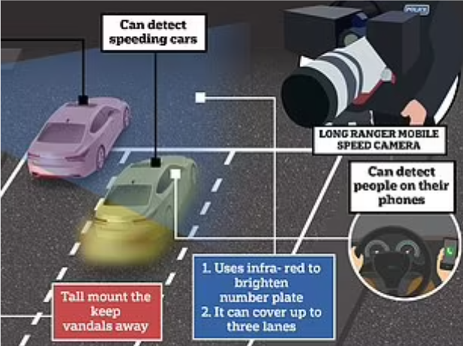
Figure 2: Example of an AI‑enabled traffic enforcement camera

2.6 Identified gaps and justification for TIRNS:

Across the reviewed literature, several gaps become evident:
Detection is well-covered; notification is not:
Research on AES/ATES largely emphasises detection accuracy, crash reduction, and policy frameworks, yet gives limited attention to the user-facing notification and interaction layer specifically how drivers are informed, the timeliness of communication, the channels used, and the explanatory context provided.
Digital enforcement communication is fragmented and vulnerable to scams:
Official advisories and tribunal guidance highlight phishing risks and fragmented digital processes for PCNs, but no unified, secure mobile interface has been proposed to support road users.

Smart-challan systems stop at email/SMS:
Existing smart-challan studies demonstrate same-day delivery through common channels, but fail to address identity management, scam resistance, or deeper multi-agency integration.
No-code enforcement solutions are under-explored:
Although platforms like Adalo are widely promoted for rapid app development, there is little published work assessing their suitability in safety-critical or regulatory contexts.
TIRNS Contribution:
TIRNS is designed to bridge these gaps by implementing a prototype in Adalo that integrates with existing enforcement and ANPR systems. It aims to deliver secure, timely, and user-friendly notifications while evaluating how such a system could enhance compliance, reduce confusion, and mitigate fraud. This literature review therefore establishes both the conceptual foundation and a clear justification for the project’s aims, scope, and methodology

Chapter 3:

3.0 Methodology:

This chapter outlines the SDLC methodology used to develop TIRNS, including the transition from Flutter to Adalo, and covers requirements, design, technologies, data simulation, ethics, and testing. A project time line table and Gantt chart is in Appendix 1 and 2.

3.1 Research and Development Approach:
The project adopted the SDLC methodology for its structured, phase-based workflow planning, analysis, design, development, testing, and evaluation as shown in Figure 3. This model was chosen for its clarity and suitability in academic software projects. Recent studies emphasise that SDLC models enhance predictability and streamline project planning under resource constraints [36].
The research used a qualitative approach to review literature, practice, and enforcement workflows, identifying delays, limited digital integration, and the need for real-time user-facing solutions.
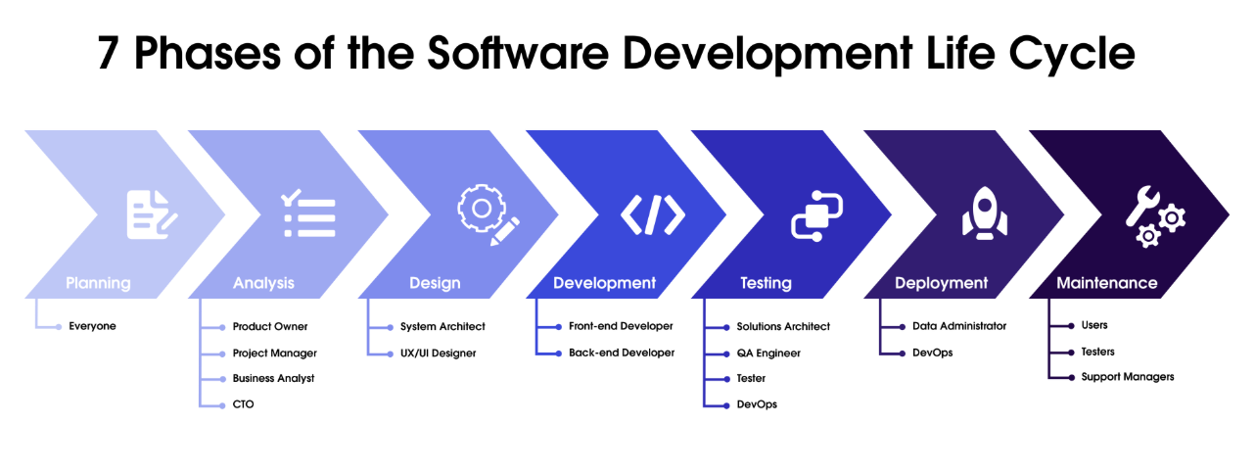
Figure 3: Illustration of the Software Development Lifecycle (SDLC) (source: Salesforce [37]).

3.2 Requirements Gathering:

System requirements were derived from three primary sources.

Literature and Policy Review:
Recent research on automated enforcement systems and ANPR highlights the importance of timely communication and accuracy in violation reporting. Studies on smart-challan and ANPR-based enforcement emphasise the role of digital delivery mechanisms for fines [38]. Government advisories on fraudulent parking fine text messages further underline the need for secure digital communication channels [39].

Analysis of Existing UK Systems
The project proposal identifies key limitations in current UK enforcement systems, including delayed postal NIPs, fragmented digital services, and the absence of a unified compliance or notification platform. These shortcomings directly informed the functional requirements of TIRNS, such as instant alerts, offence history logs, and compliance reminders.

User-Focused Observations:
Scenario-based evaluations and personal experiences refined user needs, highlighting simplicity, clarity, and trust as priorities. Stress caused by unexpected penalties and the lack of real-time notifications reinforced the necessity of an accessible, mobile-first system [40].

3.3 System Design:
System design encompassed the development of architecture, the modelling of workflows, and the prototyping of interfaces.

Architectural Design:
The project originally planned to use Flutter as the UI framework and Firebase as the backend. These choices aligned with academic evaluations demonstrating Flutter’s cross-platform efficiency and as illustrated in Figure 4 Firebase’s suitability as a backend-as-a-service (MBaaS) for mobile applications [41], [42].


Figure 4: Illustration of Mobile Backend as a Service (MBaaS) concept (source: Brininger [43]).

Workflow and Data Modelling
UML use-case diagram as shown in Figure 5, admin and user flows as shown in Figure 6 and 7, and data models were created to map:

User Use Cases:
Register
Login
View Dashboard
View Offences (mock data)
View Offence Details
Receive Offence Notifications
Receive Compliance Reminders
View Compliance Status
Update Profile
Log Out

Admin Use Cases:
Add Offence
Edit Offence
Delete Offence
Manage Users
This modelling followed standard system-design recommendations focusing on clarity and usability [44].

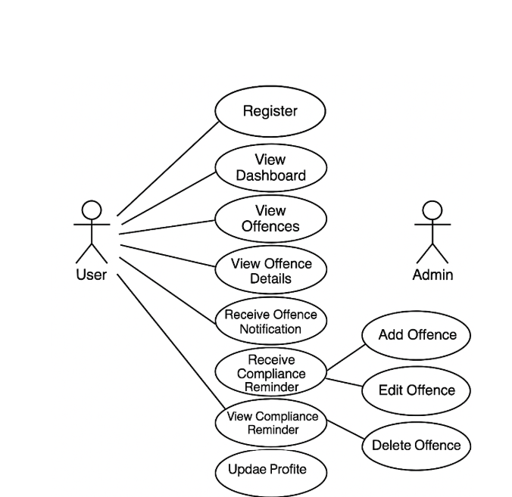
Figure 5: UML Use Case Diagram for the TIRNS Mobile Application
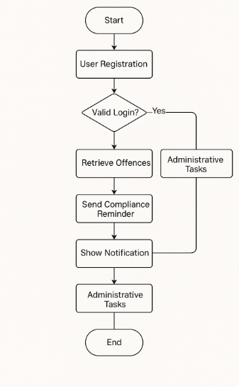
Figure 6: Admin Flowchart of the development of your TIRNS project
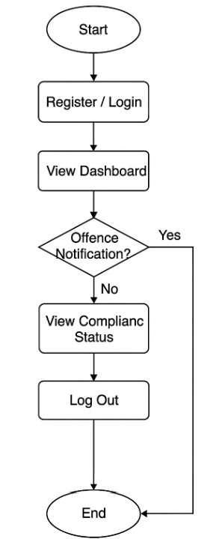
Figure 7: User Flowchart of the development of your TIRNS project

User Interface (UI) Design.
Wireframes were developed in Moqups [45], guided by Nielsen’s UX principles that emphasise simplicity, intuitive navigation, and reduced cognitive load [46]. These designs later guided the layout of Adalo screens.

3.4 Development Methodology and Tool Transition:

Initial Plan: Flutter + Firebase
The project initially adopted Flutter for cross-platform UI and Firebase for backend services (real-time database, authentication, messaging, analytics), reflecting recommendations for scalable mobile architectures.

Challenges with Flutter + Firebase
Early development revealed issues: complex configuration, limited free-tier push notifications, restricted API access, and emulator performance constraints. Strict time constraints guided tool changes, requiring rapid design and reduced configuration to finish on time. These challenges align with findings that cross-platform frameworks often demand advanced skills and longer cycles in student projects [47].

Transition to Adalo:
To address these barriers, Adalo, a no-code platform, was adopted for rapid prototyping, built-in databases, drag-and-drop UI, and simplified authentication. Literature highlights the efficiency of no-code tools in reducing development time and supporting academic prototyping [48] [49] [50].

Limitations of Adalo:
Constraints included limited API integration, reduced customisation, performance risks with large datasets, and reliance on hosted backends issues consistent with critiques of no-code architectures.

3.5 Data Simulation and Ethical Considerations:

Data Simulation:
Due to restrictions on live enforcement data, dummy data (e.g., speeding offences, MOT/tax expiries) were used, following best practices in enforcement prototypes.

Ethical and GDPR Compliance
No personal data was collected; fictional accounts and anonymisation ensured GDPR compliance and a clear distinction between simulated and real data.

3.6 Testing Strategy:
The system was evaluated through a multi-layered testing approach [51]. Functional testing verified navigation, button actions, and logic flows, while usability testing involved peer reviews to assess clarity, interface quality, and notification readability. Performance testing ensured efficient screen loading within Adalo, and scenario testing simulated offences to validate notification logic. Collectively, these methods align with established mobile app evaluation frameworks.

3.7 Chapter Summary:
The chosen methodology ensured systematic development of TIRNS through a structured SDLC process, comprehensive requirements analysis, and evidence-based tool selection. The transition from Flutter to Adalo was justified by technical constraints, project timelines, and industry-supported no-code advantages. This method enabled the creation of a functional prototype demonstrating the feasibility of real-time digital traffic infringement notification.

Chapter 4:

4.0 IMPLEMENTATION & DEVELOPMENT:
This chapter presents the implementation of the Traffic Infringement Reporting and Notification System (TIRNS), detailing the development environment, database design, interface modelling, simulation processes, and key challenges. While the initial plan proposed Flutter with Firebase, the project transitioned to Adalo due to compatibility and resource constraints, enabling delivery of a functional prototype within the available timeframe.

4.1 Development Environment:

Transition to Adalo:
The development of the prototype was completed using Adalo, a no-code mobile application builder. All screen images and app features are provided in Appendix Sections 3-8. The development environment was selected after Flutter proved unsuitable within the project timeframe due to technical setup complexity and limited backend integration options under free tiers. Adalo provided a visual, component-driven interface, native database collections, built-in authentication, and automated workflows, allowing the system to be implemented efficiently while still meeting project objectives.

Project Structure in Adalo:
The TIRNS application was implemented with a clear structure to support user workflows and admin data management.
Screens:
Login and Registration for authentication as shown in Figure 8.
Dashboard for central navigation as shown in Figure 9.
Offence List and Offence Details for offence tracking as shown in Figure 10.
Compliance Status for MOT, tax, and insurance monitoring as shown in Figure 11.
The Notification and Alerts Screen is attached in Appendix 9.
Fine payments and Appeal screen is attached in Appendix 10 and 11.
Admin Management for administrative oversight
Collections (Databases):
Users: App login credentials and profile data
Offences: Contains mock offence records for testing
Compliance: Holds MOT, tax, and insurance details
Notifications: Simulates alerts and reminders
Vehicle: Maintains vehicle information and compliance status.
This architecture ensured seamless integration between user actions and the app’s underlying databases, enabling efficient and responsive functionality.

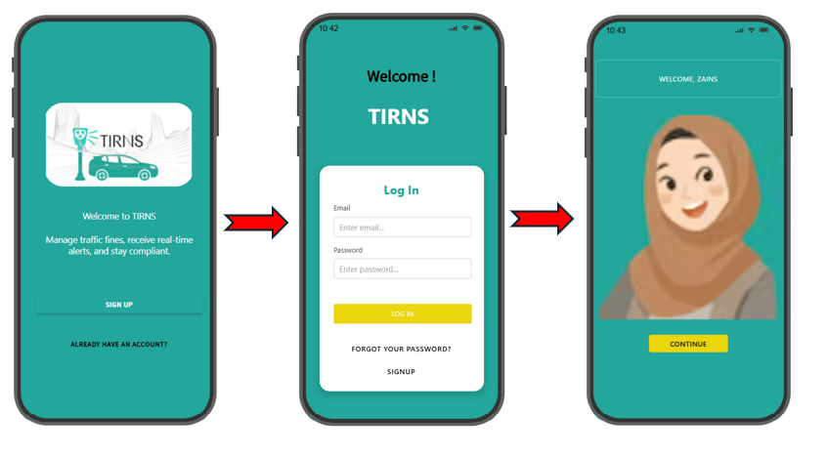
Figure 8: login screens of the TIRNS mobile application, illustrating user registration, authentication, and personalised welcome interface

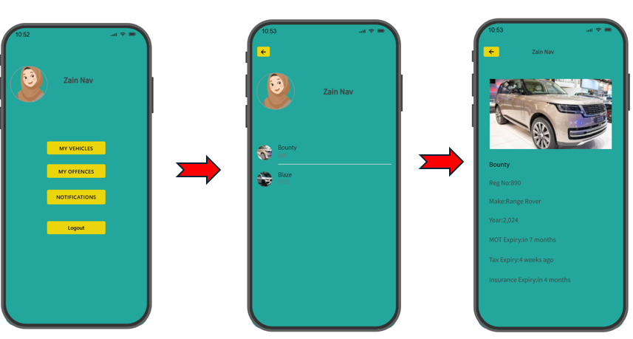
Figure 9:Home screen of the TIRNS mobile application, displaying user profile and navigation options for vehicle management, offence tracking, and notifications
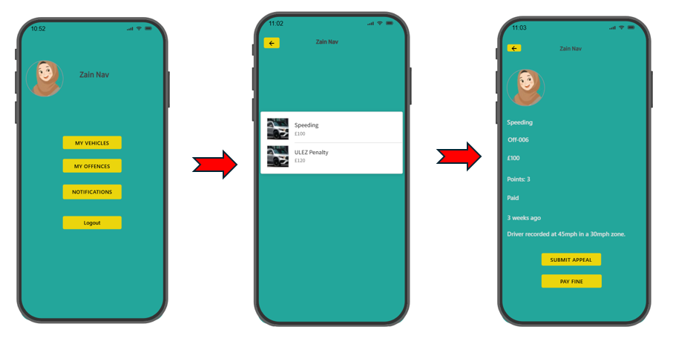
Figure 10: Offence tracking screens in the TIRNS app showing violation details and user actions

Figure 11:Vehicle management interface of the TIRNS mobile application, showing user profile, vehicle list, and detailed compliance data including MOT, tax, and insurance expiry

4.2 Interface Design:

Screen Navigation:
The application employs a straightforward linear-to-hierarchical navigation structure. Users begin at the Login/Register screens, proceed to the Dashboard, and can then access specific modules such as the Offence List (with drill-down into Offence Details), the Compliance page, and the Profile Update section. This navigation model aligns with established mobile UX principles, prioritising clarity, simplicity, and predictability in user journeys [52].

Dashboard Interface
The Dashboard operates as the central hub of the TIRNS application, consolidating key functions into a single, accessible interface. Its design incorporates:
Notification Button: Provides real-time alerts and reminders, ensuring users are informed of newly generated offences or compliance updates.
Vehicle Compliance Button: Offers direct access to compliance information such as MOT, tax, and insurance status, enabling users to quickly verify vehicle legality.

Offence Detail Button: Allows users to navigate directly to offence records, with drill-down capability into specific offence details for clarity and transparency.
The interface applies a minimalistic design, offering essential features through clear labels to reduce complexity and cognitive load while ensuring ease of use as shown in Figure 12.

Figure 12: TIRNS dashboard with user profile and navigation buttons

4.3 Database & Logic Implementation

a. Offence Simulation:
Since access to real enforcement data is restricted, the application relies on mock offences stored in the Offences collection. Each offence record contains:
Offence ID
Violation type
Location
Date/time
Status
Fine amount
Supporting notes

b. Notification Workflow
A simulated notification system was implemented using:
Conditional visibility
Dynamic fields
Preloaded notification records
Whenever a new mock offence is added, the system automatically updates the user’s dashboard with a notification indicator.

Compliance Tracking
The Compliance collection stores mock MOT, tax, and insurance dates. Simple logic is applied to:
Display whether each item is “Valid” or “Expired”
Provide reminders when expiry dates are approaching
The records were utilised to dynamically generate mock up data and are documented in the Appendix 12-15.

4.4 Admin Features:
Admin screens were included to demonstrate how offences could be managed by authorities within a real system. Admins can:
Add new offence records
Edit existing offences
Delete offences
Assign offences to specific users
These features show scalability toward an actual enforcement back-office system

4.5 Challenges and Solutions:
The challenges and corresponding solutions are presented in Figure 13.

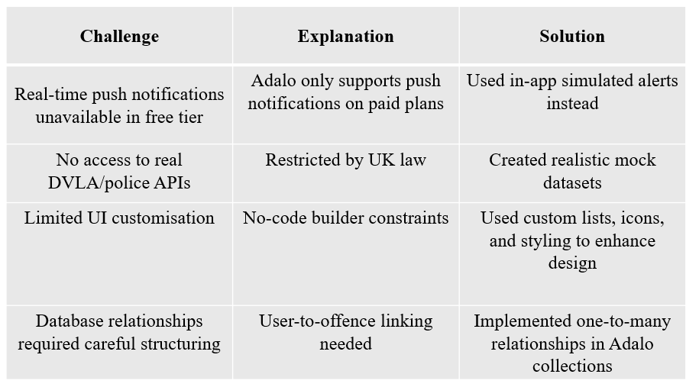
Figure 13: Illustration of identified challenges and their solutions within the TIRNS prototype

4.6 Chapter Summary:
The Adalo implementation of TIRNS showed that no-code platforms can enable rapid prototyping of compliance and notification systems, integrating registration, offence tracking, reminders, and administrative functions within a user-friendly app. A working app link has been provided in the appendix 16.

Chapter 5:

5.0 TESTING & EVALUATION:

Testing was carried out to assess the functionality, usability, and reliability of the prototype. The process involved functional tests, usability evaluation, scenario-based testing, and reflection against the project objectives [53].

5.1 Testing Approach:

Functional Testing
Testing confirmed that the core components of the system functioned as intended, including registration and login, screen navigation, offence data loading, offence detail display, notification visibility, and compliance status calculations. All features were validated through both desktop preview and mobile device testing.

Usability Testing:
Five voluntary testers assessed the system in terms of ease of understanding, interface layout, navigation clarity, readability of offence details, and the ability to locate compliance information. Feedback was collected informally through direct observation and brief comments.

Scenario-Based Testing
Simulated scenarios, including the assignment of new offences, expiry of compliance items, profile updates, and administrative actions such as adding or deleting offences, were used to validate the system’s logical workflows

5.2 Test Results Summary:

a. Functional Test Results
All screens loaded as expected, offence lists were dynamically populated, compliance reminders displayed correctly, and administrative operations such as adding, editing, and deleting offences functioned properly. Notification badges updated as intended, and no major functional failures were identified during testing.

b. Usability Findings
Testers provided positive feedback highlighting the simple interface, ease of navigation, and clear grouping of offence and compliance features. Minor suggestions included incorporating colour coding for overdue compliance, adding tooltips for first-time users, and enhancing the dashboard with icons or at-a-glance data.

c. System Limitations Identified
The system’s limitations included the absence of real push notifications due to the Adalo free tier, slight performance slowdowns when loading long lists, and database constraints that may affect scalability. These weaknesses are inherent to no-code platforms rather than errors specific to the project.

5.3 Evaluation Against Objectives:

The TIRNS prototype successfully fulfils all initial objectives.
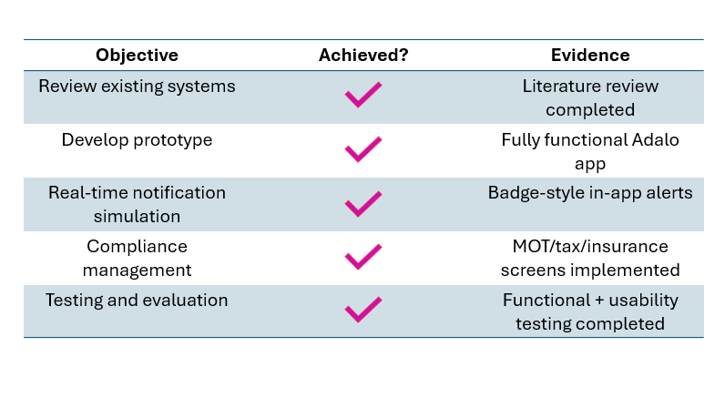

5.4 Overall Performance Evaluation:
The system performs effectively as a proof of concept.
While it is not a production-level app, it demonstrates how mobile-first enforcement communication can reduce delays, streamline information delivery, and simplify compliance tracking.

5.5 Chapter Summary:
TIRNS successfully passed functional and usability testing, with results indicating strong potential for further development. Limitations identified were mostly associated with the constraints of the no-code platform.

Chapter 6:

6.0 CONCLUSION & RECOMMENDATIONS:
This chapter summarises the research outcomes, reflects on project achievements and limitations, and offers recommendations for future work.

6.1 Conclusion:
The Traffic Infringement Reporting and Notification System (TIRNS) was developed to address inefficiencies in how UK motorists receive traffic offence notifications and manage their compliance responsibilities. The existing reliance on postal communication leads to delays, confusion, and unnecessary penalty escalation. Through literature review, system analysis, and prototype development, this project demonstrated that a mobile-app approach can significantly improve clarity, convenience, and timeliness.
The final Adalo-built prototype delivers:
Instant digital offence alerts (simulated)
Clear offence details
Compliance reminders (MOT, tax, insurance)
User profile management
Admin controls for offence management
The project achieved all aims and objectives within the given timeframe.

6.2 Limitations:
Key limitations of the prototype include the absence of real API integration with DVLA or enforcement systems, reliance on simulated offence data, limited push notifications due to platform constraints, limited security features beyond Adalo defaults, and a small sample for usability testing.

6.3 Recommendations for Future Work:

a. Technical Improvements:
Future enhancements could include integrating real-time push notifications, establishing connections to enforcement APIs when legally accessible, improving scalability through Flutter or a custom-coded backend, and adding optional geolocation features to provide contextual information for offences

b. User Experience Enhancements:
Future improvements could involve adding colour-coded compliance tracking to enhance clarity, incorporating educational content to guide users on actions following a penalty, and integrating payment and appeal options to streamline compliance management within the app.

c. Operational/Policy Considerations
Future directions include exploring partnerships with DVLA, local councils, and police to strengthen integration, assessing GDPR compliance for handling real user data, and evaluating potential barriers to public trust and adoption to ensure effective implementation.

6.4 Final Statement:
The TIRNS prototype demonstrates that a no-code platform can deliver a feasible, user-friendly, and modern solution for traffic infringement communication. By streamlining processes such as offence tracking, compliance reminders, and notification management, the system reduces reliance on manual administration and helps ensure timely communication between authorities and users. With further development, TIRNS could integrate real enforcement APIs, enhance scalability, and incorporate features such as geolocation or payment options. These improvements would strengthen its potential to support road safety initiatives, minimise administrative delays, and provide a more accessible and efficient user experience across the UK.

7.0 References:
[1] R. G. Yasanthi, et al., "Determinants of traffic safety enforcement behaviour among police officers: A narrative review," Case Studies on Transport Policy, vol. 16, pp.101206, 2024.
[2] UK Home Office, Guidance for the Development and Review of ANPR Infrastructure, Version 1.1, June 2021. [Online]. Available: Guidance for the Development and Review of ANPR Infrastructure
[3] GOV.UK, "Speeding penalties." GOV.Uk. Accessed: Nov 10, 2025. [Online]. Available: https://www.gov.uk/speeding-penalties
[4] West Yorkshire Police, "What is the notice of intended prosecution." West Yorkshire Police. Accessed: Nov 10, 2025. [Online]. Available: https://www.westyorkshire.police.uk/ask-the-police/question/Q557
[5] R. Zahnow, S. Bennett, L. Bates, E. Antrobus, and C. Irvine, ‘An analysis of the effect of social norms on payment of speeding fines’, Psychol. Crime Law, vol. 30, no. 6, pp. 583–599, Jul. 2024, doi: 10.1080/1068316X.2022.2104278.
[6] N. A. Khan, N. Z. Jhanjhi, S. N. Brohi, R. S. A. Usmani, and A. Nayyar, ‘Smart traffic monitoring system using Unmanned Aerial Vehicles (UAVs)’, Compute. Commun., vol. 157, pp. 434–443, May 2020, doi: 10.1016/j.comcom.2020.04.049.
[7] R. R. Saxena, "Artificial Intelligence in Traffic Systems," arXiv preprint arXiv:2412.12046, 2024.
[8] A. Sugiarto, "Building an Enviromentally Friendly Work Culture in Goverment Agencies Offices," JENIUS (Jurnal Ilmiah Manajemen Sumber Daya Manusia), vol. 6, pp.325–338, 2023.
[9] UK Department for Transport, “Traffic Commissioners for Great Britain Annual Report 2023–24,” Gov.uk, 2024. [Online]. Available: https://www.gov.uk/government/publications/traffic-commissioners-annual-report-2023-to-2024
[10] T. Alqubaysi, et al., "Federated learning-based predictive traffic management using a contained privacy-preserving scheme for autonomous vehicles," Sensors (Basel, Switzerland), vol. 25, no. 4, pp.1116, 2025.
[11] Rac. “Speeding fines - how much you have to pay.” Rac. Accessed: July. 10, 2025. [Online]. Available: https://www.rac.co.uk/drive/advice/legal/speeding-fines/
[12] European Court of Auditors, Special Report 04/2024: Reaching EU Road Safety Objectives, European Union, 2024. Accessed: Nov. 10. 2025. [Online]. Available: https://www.eca.europa.eu/ECAPublications/SR-2024-04/SR-2024-04_EN.pdf
[13] Driver and Vehicle Standards Agency, “Enforcement Sanctions Policy." DVSA enforcement section policy. Accessed: Nov 12, 2025. [Online]. Available: https://assets.publishing.service.gov.uk/media/683f0103619fa00d0be98e05/dvsa-enforcement-sanctions-policy.pdf
[14] C. Luca, "The Impact of Automated Enforcement Systems on Traffic Management Efficiency," 2024.
[15] A. M. Alobaidallah, A. Alqahtany and K. M. Maniruzzaman, "Safety effectiveness of automated traffic enforcement systems: A critical analysis of existing challenges and solutions," Future Transportation, vol. 5, no. 1, pp.25, 2025.
[16] Lexipol Media Group, "Police1." Automated Traffic enforcement moves mainstream as road safety rises. Accessed: Nov 2, 2025. [Online]. Available: https://www.police1.com/police-products/traffic-enforcement/automated-traffic-enforcement-moves-mainstream-as-road-safety-rises

[17] Elovate (Modaxo Group), “Automated Traffic Enforcement: Lessons from Europe’s Success,” Modaxo, Accessed: Nov 2, 2025. [Online]. Available: https://modaxo.com/elovate/article-url
[18] R. Niwankar, V. Mahajan and M. Maniyar, “Study on Enhancing Traffic Law Enforcement Through Automated Smart-Challan System,” Int. Adv. Res. J. Sci., Eng. Technol., vol. 11, no. 5, pp. 478–481, May 2024. doi: 10.17148/IARJSET.2024.11571.
[19] Gov.UK. “National ANPR standards.” Gov.UK. Accessed: July. 10, 2025. [Online]. Available: https://www.gov.uk/government/publications/national-anpr-standards?utm_source=chatgpt.com

[20] AUTOCAR. “Wider use of ANPR reveals spike in numberplate cloning” AUTOCAR. Accessed: July. 10, 2025. [Online]. Available: https://www.gov.uk/government/publications/national-anpr-standards?utm_source=chatgpt.com

[21] Gov.UK. “National ANPR standards.” Gov.UK. Accessed: July. 10, 2025. [Online]. Available: https://www.autocar.co.uk/car-news/consumer/wider-use-anpr-reveals-spike-numberplate-cloning?utm_source=chatgpt.com

[22] M. Day, et al., "Stakeholder perspectives on the adoption and application of Intelligent Speed Assistance in UK vehicles," Journal of Transport & Health, vol. 38, pp.101868, 2024.
[23] Driver and Vehicle Standards Agency (DVSA), “DVSA Issues Warning About Parking Fine Scam Text Messages,” GOV.UK, Accessed: Nov 12, 2025. [Online]. Available: https://www.gov.uk/government/news/dvsa-issues-warning-about-parking-fine-scam-text-messages
[24] Traffic Penalty Tribunal, “Free, Fair and Fast Appeals,” TrafficPenaltyTribunal.gov.uk, Accessed: Nov 12, 2025. [Online]. Available: https://www.trafficpenaltytribunal.gov.uk/
[25] R. Niwankar, V. Mahajan and M. Maniyar, “Study on Enhancing Traffic Law Enforcement Through Automated Smart-Challan System,” Int. Adv. Res. J. Sci., Eng. Technol., vol. 11, no. 5, pp. 478–481, May 2024. doi: 10.17148/IARJSET.2024.11571.
[26] N. Upadhyaya, "Low-Code/No-Code platforms and their impact on traditional software development: A literature review," No-Code Platforms and Their Impact on Traditional Software Development: A Literature Review (March 21, 2023), 2023.
[27] Adalo Team, “The Best Platform for Easy No-Code App Development in 2025,” Adalo Blog, Nov. 18, 2025. [Online]. Available: The Best Platform for Easy No-Code App Development in 2025 | Adalo Blog
[28] This is Money, “Money News, Guides and Advice,” This is Money, Accessed: Nov. 27, 2025. [Online]. Available: https://www.thisismoney.co.uk/money/index.html

[29]Express & Star. “Distracted driving convictions set to skyrocket thanks to new speed camera tech.” Express & Star. Accessed: Nov. 10, 2025. [Online]. Available: https://www.expressandstar.com/news/motors/2024/07/02/distracted-driving-convictions-set-to-skyrocket-thanks-to-new-speed-camera-tech/?utm_source=chatgpt.com

[30] AVZ Briefing. “AVZ Briefing – Speed Enforcement in London.” AVZ Briefing. Accessed: Nov. 10, 2025. [Online]. Available: https://actionvisionzero.org/2025/02/19/avz-briefing-speed-enforcement-in-london/?utm_source=chatgpt.com
[31] Road Safety GB. “UK drivers encouraged to use ISA in vehicles.” Road Safety GB. Accessed: Nov. 10, 2025. [Online]. Available: https://roadsafetygb.org.uk/news/uk-drivers-encouraged-to-use-isa-in-vehicles/

[32] R. R. Saxena, "Artificial Intelligence in Traffic Systems," arXiv preprint arXiv:2412.12046, 2024.
[33] Money Saving Experts. “Do I receive notifications when ULEZ charge triggered and my ULEZ account is charged.” Money Saving Experts. Accessed: Nov. 10, 2025. [Online]. Available: https://forums.moneysavingexpert.com/discussion/6426278/do-i-receive-notifications-when-ulez-charge-triggered-and-my-ulez-account-is-charged

[34] BBC News. “Black-cab drivers wrongly sent penalty charges.” BBC News. Accessed: Nov. 10, 2025. [Online]. Available: https://www.bbc.co.uk/news/articles/c5yj80npzd9o?utm

[35] Gov.UK. “Get, view or stop MOT reminders.” Gov.UK. Accessed: Nov. 10, 2025. [Online]. Available: https://www.gov.uk/get-stop-view-mot-reminder
[36] D. B. Aniley, E. A. Jalew and G. A. Agegnehu, "Selection of Software Development Life Cycle Models using Machine Learning Approach," Int J Comput Appl, vol. 186, pp.36–43, 2024.
[37] Salesforce, “Software Development Lifecycle (SDLC),” Salesforce Platform, Accessed: Nov. 27, 2025. [Online]. Available: https://www.salesforce.com/platform/software-development/lifecycle/
[38] Home Office, National ANPR Standards for Policing and Law Enforcement, Version 3.3, Nov. 2024. [Online]. Available: nasple 3.3
[39] GOV.UK, National ANPR Service Compliance Dashboard: Q3 and Q4 2024, Sept. 2025. [Online]. Available: National ANPR Service compliance dashboard: Q3 and Q4, 2024 - GOV.UK
[40] A. Dibben, The Importance of a Mobile-First Approach in 2024, Expect Best, Jan. 2024. [Online]. Available: The Importance of a Mobile-First Approach in 2024 | Expect Best Web Design Bournemouth & Poole
[41] S. A. Bhagat, "Review on mobile application development based on Flutter platform," International Journal for Research in Applied Science and Engineering Technology, vol. 10, no. 1, pp.803–809, 2022.
[42] C. S. Lwin, N. K. Dim and S. Aye, "Firebase as a backend service in mobile and web application development," J Myanmar Acad Arts Sci, vol. 19, no. 2, 2021.
[43] E. Brininger, “MBaaS (Mobile Backend as a Service): What It Is & Best Providers,” Medium, Aug. 30, 2023. [Online]. Available: https://elianabrininger.medium.com/mbaas-mobile-backend-as-a-service-what-it-is-best-providers-32484c4ae297
[44] A. Mirabdolah, M. Alaeifard and A. Marandi, "User-centered design in HCl: Enhancing usability and interaction in complex systems," International Journal of Advanced Human Computer Interaction, vol. 1, no. 1, pp.16–33, 2023.
[45] Moqups, “Moqups: Online Wireframing and Prototyping Tool,” Moqups, Accessed: Nov. 27, 2025. [Online]. Available: https://app.moqups.com/D8vp8M8Vdka0kjNRKMmbjOaxgZ9mC5Lh/edit/page/a7bc758b4
[46] A. F. Rosmani, A. A. Mutalib and S. SARIF, "HYBRIDISING SIGNALING PRINCIPLE AND NIELSEN'S DESIGN GUIDELINES IN A MOBILE APPLICATION." Asia-Pacific Journal of Information Technology & Multimedia, vol. 10, no. 2, 2021.
[47] P. Chougale, et al., "Firebase-overview and usage," International Research Journal of Modernization in Engineering Technology and Science, vol. 3, no. 12, pp.1178–1183, 2021.
[48] T. Guthardt, J. Kosiol and O. Hohlfeld, "Low-code vs. the developer: An empirical study on the developer experience and efficiency of a no-code platform," Proceedings of the ACM/IEEE 27th International Conference on Model Driven Engineering Languages and Systems, 2024.
[49] Adalo, “Learn: Adalo No-Code App Development Platform,” Adalo, Accessed: Nov. 27, 2025. [Online]. Available: https://www.adalo.com/learn
[50] B. John, "Low-Code and No-Code Platforms: Accelerating Enterprise Software Development,"
[51] V. B. Ramu, "Performance Testing and Optimization Strategies for Mobile Applications," International Journal of Performance Testing and Optimization, vol. 13, no. 2, pp.1–6, 2023.
[52] C. Okonkwo, "Assessment of user experience (UX) design trends in mobile applications," Journal of Technology and Systems, vol. 6, no. 5, pp.29–41, 2024.
[53] D. Amalfitano, et al. , "Testing android mobile applications: Challenges, strategies, and approaches," in Advances in Computers, Elsevier, 2013, pp. 1–52.

8.0 Appendices:

Appendix 1:

Proposed TIRNS Development Timeline (6–9 Months with Key Milestones)
Phase 1: Project Initiation (Weeks 1–2)
Defining the project topic, confirming scope, outlining aims and objectives, and reviewing initial requirements.
Phase 2: Literature Review (Weeks 3–5)
Gathering and analysing academic sources, industry reports, and policy documents to understand existing systems and identify gaps.
Phase 3: System Design (Weeks 6–8)
Developing UML diagrams, workflow models, data structures, and initial interface wireframes for the TIRNS application.
Phase 4: Prototype Development in Adalo (Weeks 9–12)
Building all screens, linking database collections, implementing offence simulation, compliance features, notifications, and admin functions.
Phase 5: Testing & Evaluation (Weeks 13–15)
Carrying out functional testing, usability evaluation, scenario-based testing, and identifying issues for refinement.
Phase 6: Final Documentation & Submission (Weeks 16–18)
Writing the dissertation chapters, inserting diagrams and screenshots, final editing, and preparing the project for submission

Appendix 2:
Gantt chart outlining phased development and milestones for the TIRNS project over 6–9 months.
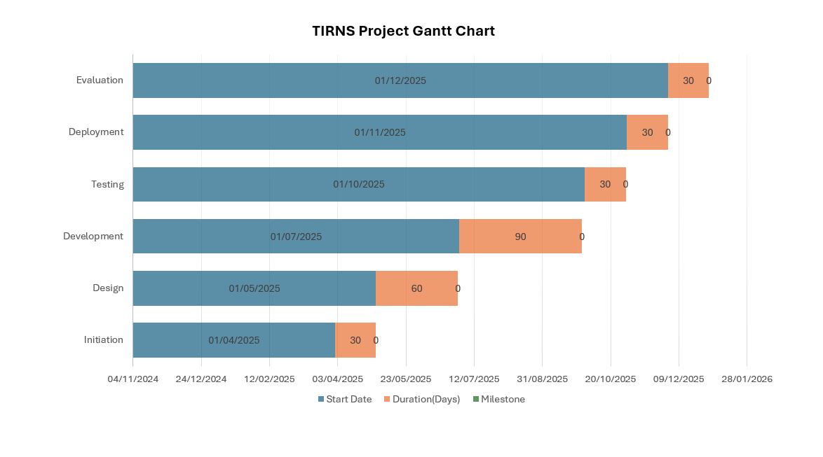

Appendix 3:

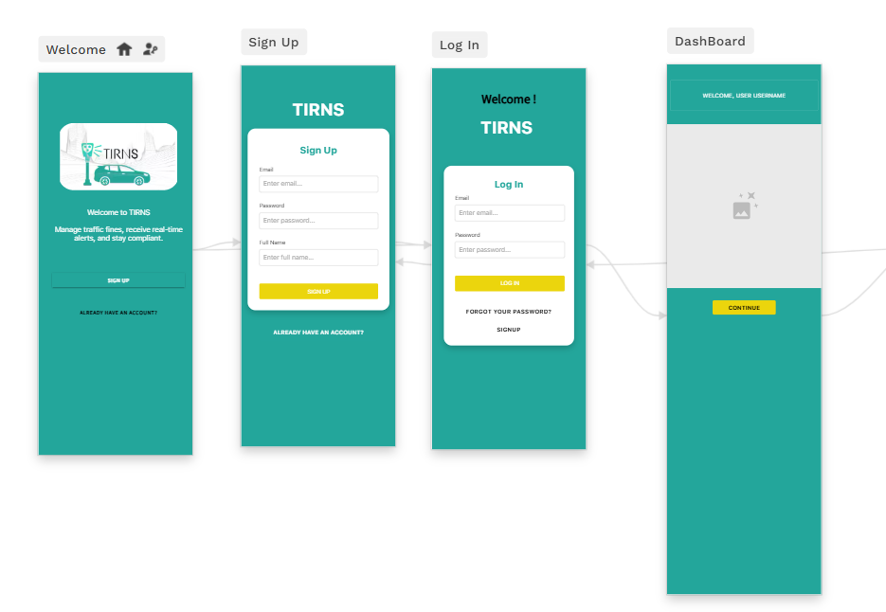

Appendix 4:
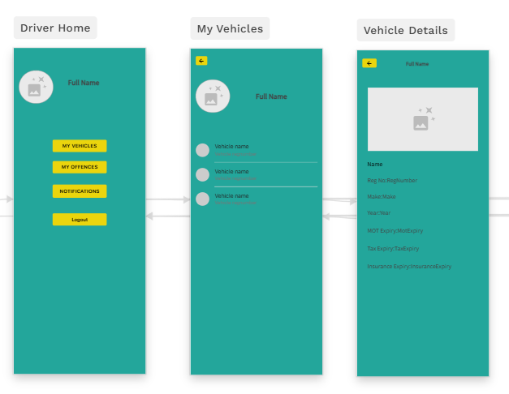

Appendix 5:
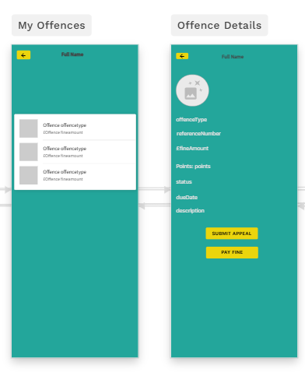

Appendix 6:
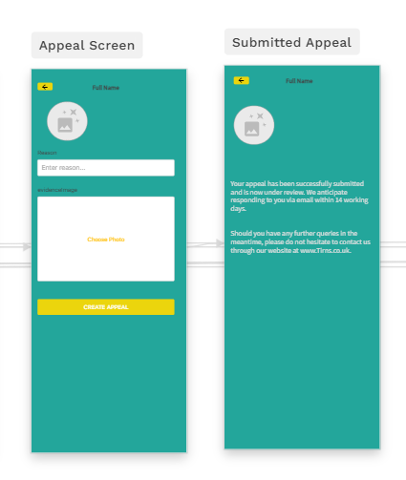

Appendix 7:
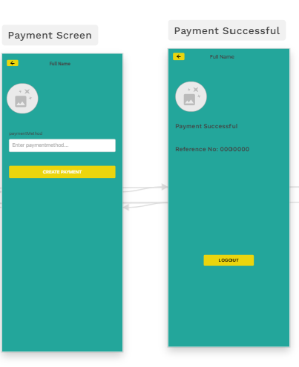

Appendix 8:
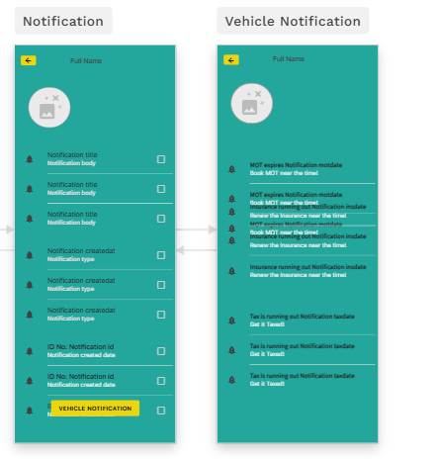

Appendix 9:
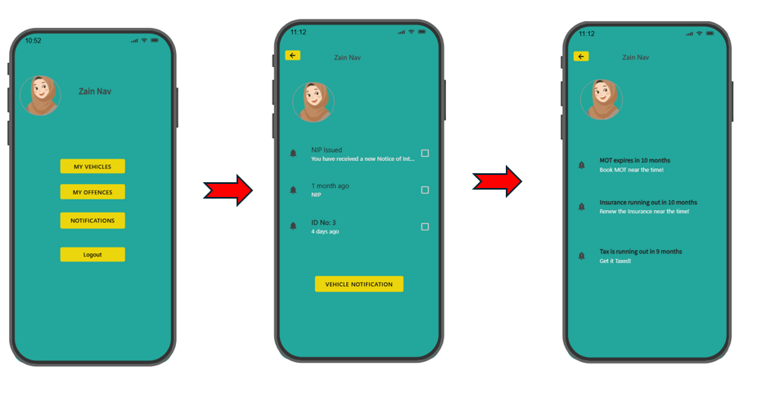

Appendix 10:

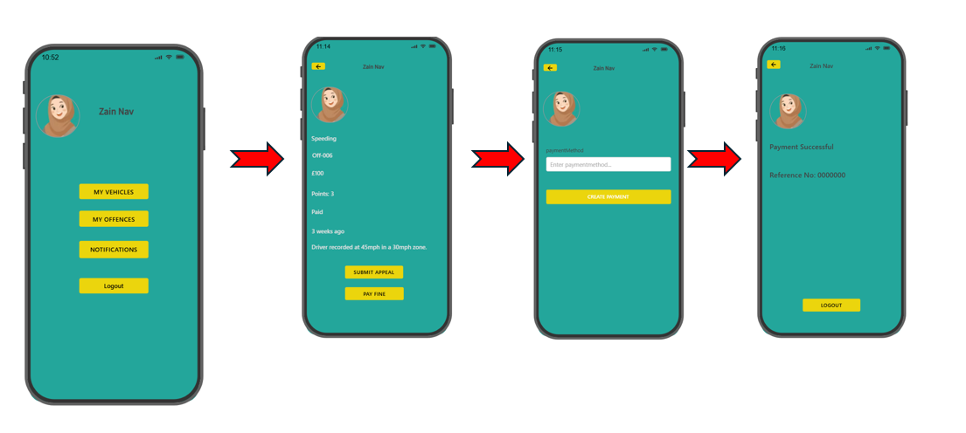

Appendix 11:
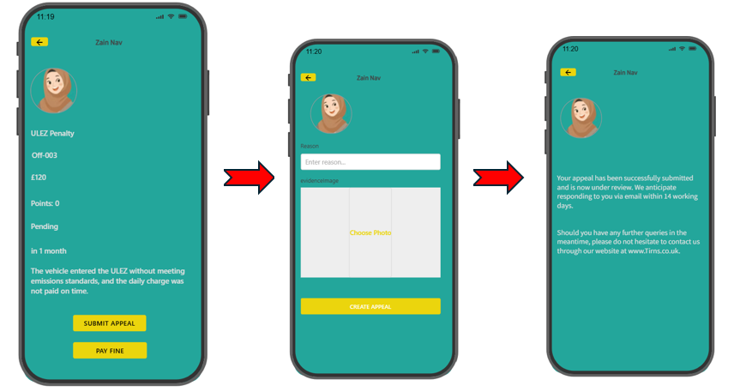

Appendix 12:
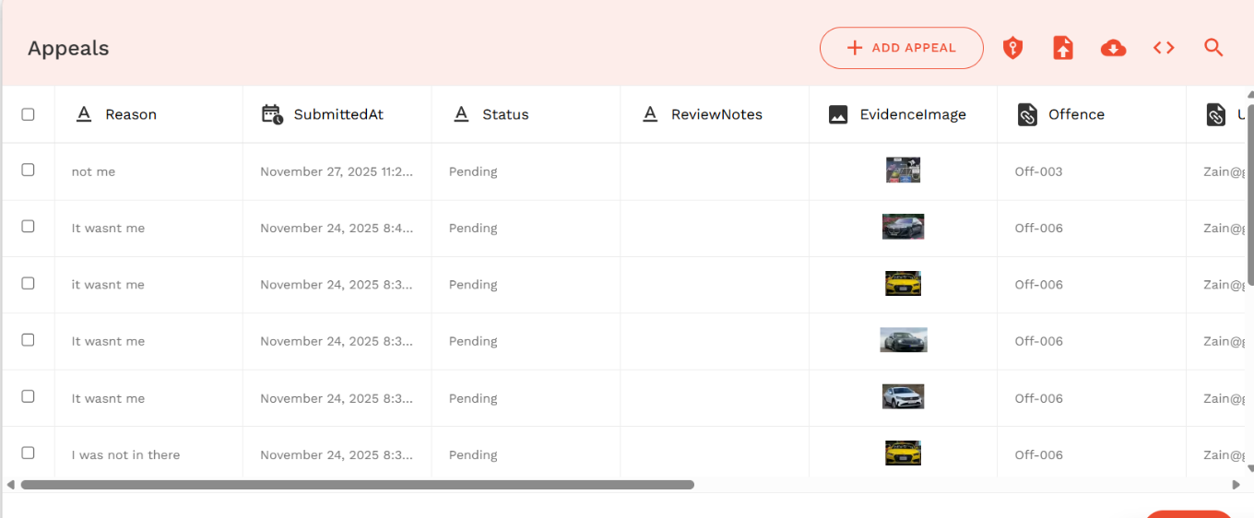

Appendix 13:

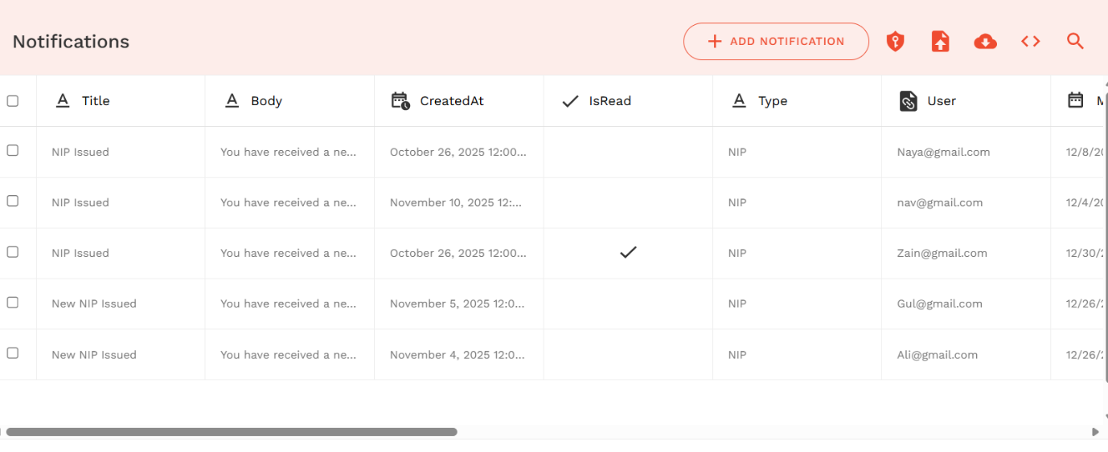

Appendix 14:

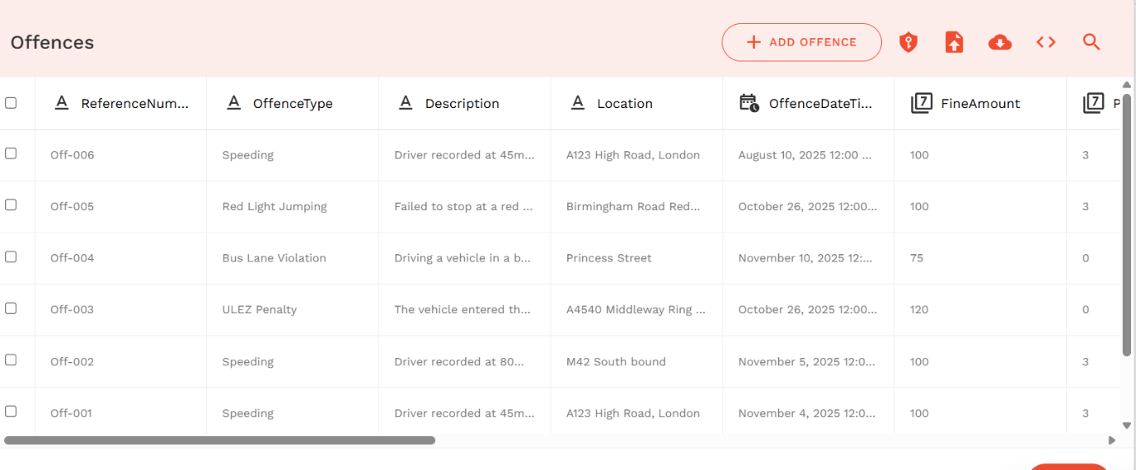

Appendix 15:
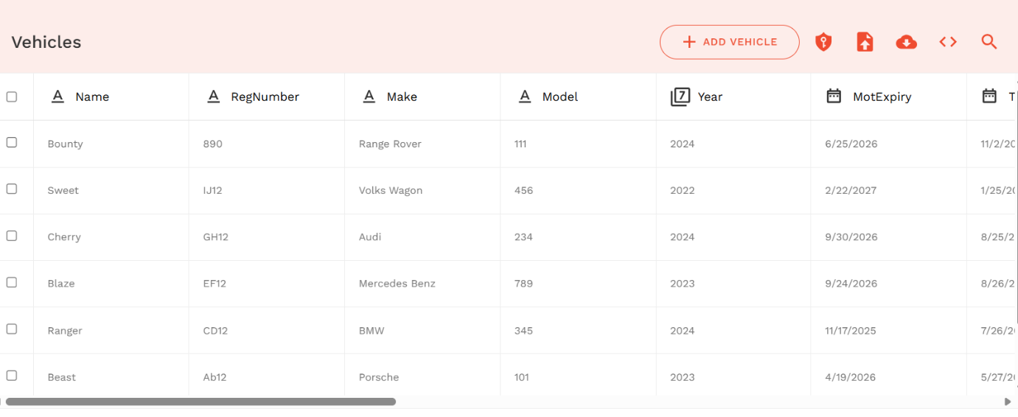

Appendix 16:
https://previewer.adalo.com/12d1d2ae-d1a0-41fd-8f20-9f345246c461?target=818468a1bfad492599706dafa106d579&params=%7B%7D

