

Developing a cloud based ETL Pipeline for data linkage to facilitate predictive ML research of SSRI related suicide risk using publicly available UK health data
by
Aaron David

Supervisor: Dr Tim Bashford
Second Marker: NAME HERE

Project submitted as part of the requirements for the award of MSc Software Engineering

August 2024

Appendix 1: Declaration and Form of Consent

DECLARATION
I, Aaron Christopher John David declare that I am the sole author of this Project; that all references cited have been consulted; that I have conducted all work of which this is a record, and that the finished work lies within the prescribed word limits.

This work has not previously been accepted as part of any other degree submission.

Signed : A.David
Date : 28/08/2024
FORM OF CONSENT

I Aaron Christopher John David hereby consent that my Project, submitted in candidature for the M.Sc. Software Engineering, if successful, may be made available for inter-library loan or photocopying (subject to the law of copyright), and that the title and abstract may be made available to outside organisations.

Signed 
Date __________28/08/2024

Appendix 2: Ethics Approval Form
Ethics Approval Form
Before you complete this form, please take time to carefully consider the following questions:
Have you considered yet whether there are any problematic ethical issues in your proposed research project? If you have not you should talk to your Course Tutor or Supervisor.
Have you already completed an Ethics Approval Form? Yes – then you do not need to complete this form
No – please complete this form in as much detail as you can

Name: | Aaron C J David
Project/Research Title: | Developing a cloud based ETL Pipeline for data linkage to facilitate predictive ML research of SSRI related suicide risk using publicly available UK health data
Name of Supervisor: | Dr. Tim Bashford
School/Dept. | School of applied computing
Proposed Start Date: | 17.07.2024 | End Date: | 28.08.2024

1. Summary of planned research (please indicate below the purpose of your planned project/research, together with your aims, main research questions and research design – you should continue onto a separate sheet if necessary)
To develop a pipeline that integrates data from multiple publically available health data sources in order to use Machine Learning to identify relationships between SSRI prescription rates and suicide rates.
Research questions: What is the relationship between SSRI prescription rates and suicide rates across Integrated Care Boards (ICBs) in England?
How can a cloud-based ETL pipeline be developed to effectively integrate and standardize mental health and prescription data from disparate UK healthcare databases?
A cloud based ETL pipeline will be created that extracts and transforms data into a data set appropriate for use in a machine learning model with the aim of identifying any relationships between SSRI antidepressants and suicide rates.

2. Methodology (You need to be clear about the methodology you intend to use in your study; this could include any number of methods, so either tick those shown below (where appropriate) or put the details in the box marked *)
 | Interviews |  | Participant Observation |  | Use of personal data
 | Focus groups |  | Questionnaire | ✓ | Literature Review
 | Performance |  | Presentation |  | Other (state below)*

*

3. Participants - Does your proposed project/research involve human participants?

 | 1. Yes, as a primary source* |  | 2. Yes, as a secondary source* | ✓ | No- go to section 4

*If you have ticked yes, it is likely you will need an Advanced CRB check before undertaking your study
If yes, indicate who your participants are:
 | Early years/Pre-School children |  | Adults - give details below
 | School age children |  | Vulnerable people - give details below
 | Young People aged 17-18
 | Unknown at this stage
4. Ethical issues - you should tick all that apply
 | Administration of drugs incl. alcohol |  | Deprivation
 | Unpleasant stimuli in any manner or form |  | Active deception or withholding information
 | Collection of highly personal information |  | Payment

5. Are there any ethical concerns other than those listed above? (continue onto a separate sheet if necessary)

6. If there are any ethical concerns, please state how you intend to minimise any risk of harm or distress that could be caused (continue onto a separate sheet if necessary)

You should enclose any materials (e.g. questionnaire, interview schedule), plus the Consent Form, and the Debriefing Sheet when submitting the Ethics Approval Form to your supervisor.
Student Signature
____________________________________________Date_____28.08.24__________

***************************************************************************
 | Advanced CRB check required |  | CRB confirmation received - Date:_______________
 | Recommendation of approval given at Faculty Level
 | Approval not given at Faculty level – forwarded for discussion at the next meeting of the University Ethics Committee
Comments:

Signature: (Assistant Dean/Head of School) _______________ ____________ Date: ________________

Abstract
Suicide is a critical area of public health research that has far-reaching implications for individuals, social policy, and healthcare policy. This dissertation explores the curation of data and the application of machine learning, in order understand the relationship between a commonly prescribed anti-depressant, Selective Seratonin Reuptake Inhibitors (SSRIs) and Suicide rate. Recognising the complex nature of suicide this research integrates data from two publicly available UK data sources into a unified cloud-based dataset optimised for ML analysis. The study aims to address a gap in Ml research into the relationship between SSRI use and Suicide rate, with a focus on improving accessibility to quality related data.
A robust Extract Transform Load pipeline was developed using Azure Cloud Services in order to create a clean integrated dataset that contains relevant features related to SSRI prescription rates and suicide rates across Integrated Care Boards in England.
Following the creation of this data set, a Random Forest regression model was used to predict and analyse associations between SSRI prescription rates and suicide rates. Two versions of the model were evaluated. An initial model and a secondary model which utilised grid search with cross validation to perform hyper parameter optimisation. Both models resulted in poor performance metrics, with negative R-squares values indicating a lack of predictive power. This suggests that’s SSRI prescription rates alone are insufficient in predicting suicide rates, mirroring the contentious findings of previous studies regarding the relationships between antidepressant use and suicide risk.

Contents
Chapter 1: Introduction 12
1.1 Importance of population research into Mental Health 12
1.2 Application of ML/AI in Suicide research 13
1.3 Data quality issues in previous research 14
1.4 Data opportunities in UK 15
1.5 Aims and Objectives of this Research 15
Chapter 2: Literature review 17
2.1 Introduction 17
2.2 Background on Suicide and its associations with SSRI use 18
2.2.1 Epidemiology of Suicide 18
2.2.2 Suicide and SSRI use 20
2.3 Machine Learning 22
2.3.1 Introduction to Machine Learning 22
2.3.2 Feature Selection and Engineering 23
Case Studies and Examples in Suicide related ML Research 27
2.4 Machine Learning Models 29
2.4.1 Introduction to Machine Learning models 29
2.4.2 Supervised Learning 29
2.5 ML research in Public Health 34
2.4.3 Ethical Considerations of Public Health ML research 35
2.4 Suicide Related ML Research 37
2.4.1 Overview 37
2.3.5.2 Applications of Machine Learning in Suicide Prediction 37
2.3.5.3 Overview of ML Advancements in Suicide Research 38
2.3.5.4 Expanding Data Sources for Suicide Related Research 39
Chapter 3: Experimental Design 41

Chapter 1: Introduction
Mental health is a critical area of public health that has wide reaching influence on various societal aspects, from individual well-being to broader social and socio-economic policy. Among the most pressing issues in mental health research is the occurrence of acute mental health episodes, particularly those involving suicidal ideation and behaviour. Understanding the complex network of factors that contribute to such episodes is a highly important area of research, contributing to effective prevention strategies and well-informed guidance for clinical practice.
This dissertation seeks to explore the intersection of mental health research and the rapidly developing use of Machine Learning in gaining deep, valuable insights from an ever-growing amount of publicly available health data. By creating a cloud-based dataset that integrates data on the prescription of Serotonin Reuptake Inhibitors and Suicide Rates in England into a clean, easily accessible, high quality data set optimal for ML research, and demonstrating the its implementation in machine learning models, this research hopes to facilitate ML research into the subject area and provide valuable insights into the dynamics of SSRI usage and its implications for suicide prevention.

1.1 Importance of population research into Mental Health
Mental health is an area of public health that has a significant impact on numerous other areas of health, social, and economic policy. Research in this area is complicated by a high number of interplaying variables whose effects on a chosen focal area are often difficult to interpret and visualise. To gain valuable and reliable insight into specific areas of population mental health dynamics however, we must consider and account for the complicated and nuanced relationships present.
A critical area within mental health with a particularly high social impact is the occurrence of acute mental health episodes, particularly those linked to suicidal ideation, and those that result in suicide. Unravelling the factors that lead to these events could help guide positive change in clinical practice and healthcare policy.
Annually, in the 5 – 19 age group alone 52,000 deaths are attributed to suicide globally. Gaining an understanding of the specific risk factors that lead to suicidal ideation and action is invaluable. However, research into this area is complex, social and economic risk factors vary greatly from country to country, therefore focused research is needed.
One risk factor of particular focus in this area is the associations between the prescription rates of particular pharmaceuticals and the rate of suicide. Several studies have highlighted a possible link between the prescription of Selective Serotonin Reuptake Inhibitors (SSRIs) and newly onset suicidal ideation, particularly in children and adolescents[1]. With mixed results in further studies on the impact SSRIs have on the possibility of suicide in adults, further research is needed. [2]

1.2 Application of ML/AI in Suicide research
With the amount of publicly available data ever growing, and the advancement of ML and AI technologies, these resources could offer a valuable avenue for research into population wide mental health and particularly the associations between certain indicators and suicide rates within a population.
The application of ML in this field has been shown to improve diagnostic results related to suicide and related risk factors [3]. A number of studies have shown that ML models utilising a number of data types can offer valuable insights into the complex relationships involved in mental health, the prediction of suicide attempts and ideation, and thus prevention of these events. Current research shows the value of data sets composed of individual patient records, as well as those that represent wider populations, both psychiatric and general.

1.3 Data quality issues in previous research
A major issue with past research in this area is a lack of consideration for the quality of the data that is being utilized in Models. A recent publication by researchers from the World Health Organisation (WHO) highlights distinct failures in current research regarding data quality assurance mental health related AI research. They identified shortcomings in all aspects of data quality control including; consideration for the applicability and potential biases in initial data being used, the sample size of data, and the preprocessing of data in order to ensure it is optimal for use in AI/ ML models. The reasons for this oversight on behalf of researchers is generally attributed to a focus on producing a usable model, leading said researchers to push on quickly through data acquisition and processing stages in order to spend more resources and time on technical AI/ML modelling work.
The importance of data quality in all forms of research can be summarised by the widely recognised phrase ‘Garbage in, Garbage out’. The quality of the data that we put into an ML Model ultimately determines the quality of the conclusions that a model allows us to draw. If we create a model that is supposed to provide predictions on the mental health outcomes of a population, but the data that we provide that model is not actually representative of that population or is not structured in a way that retains the quality of the initially acquired data, then the final results of the model lose all value.

1.4 Data opportunities in UK
In recent years the accessibility and diversity of publicly available health data in the UK has advanced significantly. There is a wealth of resources available that offer a wide range of mental health related data from the national health service and other related bodies. One key issue however is the decentralised nature of this data. This means that many of these data sources are heterogenous, making the compilation of a data set that includes features from across these services a long process and acts as a barrier to research. There have been a number of attempts to create centralised data banks however there are shortcomings. The two major data banks of this type are the Secure Anonymised Information Linkage Databank and the Administrative Data Research Network. Both bring together a significant number of data sets into a central repository, however they still present a number of challenges in their use for ML research into Suicide/ pharmaceutical relationships as the data sets are somewhat limited in scope. In addition to this, both require a protracted application process in order to access data.

1.5 Aims and Objectives of this Research
Aim:
The aim of this research is to develop a robust cloud-based data pipeline that will facilitate the exploration of the relationship between prescription rates and suicide rates using machine learning, with a focus on ensuring data quality and accessibility for predictive analytics.
Objectives:
- The extraction and integration of homogenous sets of data related to prescription rates and suicide rates in English Integrated Care Boards into a unified, clean, and well structured dataset.
- The implementation of a machine learning model using regression analysis to predict and analyse associations between SSRI prescription rates and Suicide Rates.

1.4 Conclusion
ML research into suicide and related risk factors is becoming more possible as the availability of associated data grows. In order to facilitate valuable research in this area efforts must be made to ensure that this data is easily accessible and that the data is of a high quality, reliable and consistent. This study aims to create a data pipeline that merges and homogenises data from two of the UKs health care related data banks, fingertips and Open Prescribing, in an easily accessible SQL server, ensure that the resulting data set is accurate and consistent, and ultimately prove its value by utilising it in a predictive ML model that assesses the relationship between the prescription of SSRIs and suicide rates across Integrated Care Boards in England.

Chapter 2: Literature review

2.1 Introduction
As mentioned in the introduction, the global burden of suicide is a critical issue in public health. Despite extensive research, the prediction and prevention of suicide remains a highly complex task due to the multifaceted relationships between risk factors such as those related to patient behaviour, socioeconomics, medical practice and access. Due to recent advances, and availability of tools, ML research has emerged as a promising tool in attempting to explain this nuanced area by identifying risk factor relationships and predicting future outcomes in both individual patients and wider populations using the ever-growing wealth of public health data available.
The integration of the diverse data sources available is essential in realising the full potential of ML research in this area. Numerous studies have shown the potential of ML in predicting suicide risk, however the data used is often limited, and the task of integrating multiple valuable data sets is a barrier to research. To address these issues, this dissertation aims to create a cloud based integrated data set that combines multiple open datasets related to mental health and prescription data. By utilising cloud computing to do so, this research aims to increase access to such data and facilitate ML research into the associations between the prescribing of psychiatric medications and suicide risk in the UK.
This literature will first explore the epidemiology of suicide, with a particular focus on the relationship between the prescription of psychiatric medicines and suicide rates in a population. Next the review will discuss the significance and challenges in integrating the diverse related data sets. Finally, it will synthesize current research on suicide related ML research, clarifying the gaps and challenges that this research aims to address.
By critically analysing the current body of knowledge in this area, we hope to highlight the need for combining innovative approaches to the integration of open mental health data with the use of modern ML in order to improve the scope and accuracy of research in this field.

2.2 Background on Suicide and its associations with SSRI use
Unravelling the complex factors that contribute to suicidal behaviour and gaining a greater understanding of related risk factors is vital in the development of effective prevention strategies. The interplay of sociological, biological and environmental factors offers many avenues for research that must be explored in order to gain a greater understanding of the risk present for an individual or population. This section aims to offer a brief overview of the key factors involved, moving to focus particularly on the possible links between SSRIs and suicide, in order to provide a greater understanding of the research area and therefore provide a foundation for the selection of relevant data and proper selection of features employed in this research.

2.2.1 Epidemiology of Suicide
Suicide is a major public health concern across the globe. It consistently sits as one of the leading causes of death worldwide. The world health organisation lists suicide as the cause of over 700,000 deaths per year globally. Large scale traumatic events such as the COVID-19 pandemic and increasing financial hardship, and various ongoing conflicts in many countries have led to increasing suicide rates, the prevention and treatment of suicide is as crucial as ever.
The WHO puts the global suicide rate at 10.7 in 100,000 however the rate within Europe is significantly higher than the global average at 14.1 in 100,000 despite it being a region that comparatively offers more access to mental health treatment and more avenues for suicide prevention. Office for National Statistics data for 2022 puts the England and Wales suicide rate at 10.7 deaths per 100,000.
Suicide rates in the UK show clear distinctions in suicide risk between demographics within the population. Sex is a significant factor in suicide rate in a population. The male suicide rate in England and Wales (2021) is significantly above the national average at 16.4 in 100,000. This is significantly higher than the rate amongst females in the same population which was 5.4 in 100,000. Disparities can also be clearly seen between age groups; The highest rate was observed amongst those in the middle age group with the highest being those within ages 50 to 54 at 15.2%. When accounting for sex and age, the highest rate was found within men aged 90+ at 32.1 in 100,000 followed by men aged 50 to 54 at 22.7 in 100,000. [4]
This data shows the drastic differences that can be observed within demographics of a population purely based upon simple traits such as sex and age. Other risk factors also show the complexity of this area of research. [5] utilised data from the UK Biobank in order to identify behavioural and physiological risk factors present within patients that had attempted suicide. They identified significant associations between suicide attempts and 58 individual risk factors including behavioural factors such as smoking, and physiological factors including genetic predispositions to psychiatric disorders such as major depressive disorder. Their results showed that behaviour-related measures such as smoking, mental-distress, lifetime number of sexual partners, and neuroticism, demonstrate a stronger overall association with suicide attempts. This study encompassed a comprehensive statistical analysis of UK Biobank profiles and included ML analysis of their results which will be discussed in a later section of this review.
The purpose of discussing this is to demonstrate the complexity of the factors associated with suicide and highlight the need for a diverse range of research in this area to further our understanding of the causes and possible preventative measures for suicide. The resources that have been discussed clearly display the many risk factors involved and exemplify the fact that both inherent traits such as sex, age, and genetics, and behavioural/environmental traits, all contribute significantly to the likelihood of an individual attempting suicide. While researching these risks individually can provide valuable insights, it is also important to consider the relationships between the risk factors themselves. In the case of age, it is unlikely that age itself is the acting variable that increases the likelihood of suicide, and it is rather the fact that people of a certain age are more or less likely to possess any number of the other possible risk factors versus people of a different age. As a loose example, in 2022, the same year as the ONS statistics discussed were recorded, high risk alcohol consumption (over 14 units per week) was highest amongst men aged 55 to 64 [6]. Previous research has shown that alcohol use can be linked to a higher risk of suicide. Then when we consider the reasons for higher alcohol use, there are a wider set of social and economic risk factors that must be considered. All of this is to say that the concepts that are discussed within the literature on suicide risk must be viewed within this context of a complex interconnected set of variables.

2.2.2 Suicide and SSRI use
Selective Serotonin Reuptake Inhibitors (SSRI’s) are a class of antidepressants widely prescribed in the UK in the treatment of mental disorders. They are recommended by the National Institute for Health and Care excellence as the primary antidepressant, favourable over other types [7]. In 2022-23 antidepressants were prescribed to a total of 8.6 million patients in England alone with the majority of those being SSRIs[8]. While the efficacy of SSRIs has been proven, little is known about their action other than their initial interaction with serotonin transporter proteins. This has led to a significant amount of research into other potential mechanisms that may have unintended side effects [9]. The most contentious side effect being the onset of suicidal ideation within those prescribed. For the past two decades this has been the subject of many studies, however there are many that show evidence for[10] [11] [12] and against [13] [14][15] this association, with numerous studies stating inconclusive results [16].
The most compelling evidence for SSRI linked suicidal ideation and attempts is within youth and adolescent populations, where suicidality has been shown to be doubled [17]. This association is generally observed within the short period after initiation of treatment with SSRIs. However, the relationship within adult populations is more contentious [11]. A number of theories for this disparity between youth/ adolescent and adult patients, with one of the most widely accepted being that younger patients may be more susceptible to factors such as activation syndrome, a condition that can lead to impulsiveness, aggressiveness, and agitation when in the initation period of SSRI treatment [18].
Evidence for the links between SSRI use and suicidality in adults is less clear cut. A review carried out on data from Denmark’s health registry found no significant relationship between incidents of suicide attempts or ideation among adults diagnosed with depression. Some studies have shown a negative correlation between SSRI usage rates and suicide amongst those who persist with treatment beyond the initiation stage [12].
As with many of the risk factors for suicide, the potential for confounding variables is high. There is a particular risk of ‘confounding by indication’ within this area of research as those who are severely depressed and therefore have a greater potential risk of suicide also have a greater likelihood of being treated with SSRI’s. This potentially skews the associations observed.
While SSRIs have been proven to be and effective treatment for anxiety and depression, current research suggests that they do have nuanced relationship with suicide risk. Further, comprehensive research is needed to bring more clarity to the topic and assist in advising health policy and psychiatric practice.

2.3 Machine Learning

2.3.1 Introduction to Machine Learning
Traditional computing and statistical methods have long been vital tools in gaining insight from data. However, as traditional programs do not assess the data that they output, improvements in accuracy and efficiency often require a significant amount of manual intervention, involving large amounts of manual coding through a drawn-out iterative process. Machine learning (ML) addresses this limitation by allowing programs to autonomously learn from data and improve performance over time. ML combines computing and statistical algorithms to analyse data sets and gain insights into patterns and trends in the data that may not be immediately apparent when using traditional methods.
This section will; give an understanding of the current application of ML in public health and assessing suicide risk with the aim of providing context, and identifying the best methods, for each step of our research process.

In order to effectively use ML in research, there are a number steps that must be taken. A basic machine learning workflow involves;

- Data Collection: The gathering of data from selected sources.
- Data Preparation: Cleaning and preprocessing data by handling missing values, normalising or scaling features, and other modifications such as transforming categorical data into numerical form in order to optimise the data for use by a ML model.
- Feature Engineering: Identifying and creating the relevant features (variables) that will be used by a ML model.
- Model Selection: Choosing the most appropriate model for the data that we are using.
- Model Training: Use training data to develop ML model from which the model creates and optimises its rules.
- Model Evaluation: Testing data is used to evaluate the performance of the ML model.

2.3.2 Feature Selection and Engineering

Feature selection and engineering are critical processes in ML that have a significant impact on the accuracy and interpretability of predictions. In a research area such as suicide prediction, where model outcomes can directly influence patient care, the careful selection of relevant features is paramount.

  - Feature Engineering
Feature engineering involves the process of choosing, transforming, and creating features from raw datasets in a way that creates an optimized set of data for use in an ML model. This is a crucial factor in the ultimate accuracy, generalizability, and interpretability of predictions.
Below are examples of some of the most common feature engineering techniques:

  - Feature Scaling
Feature scaling is crucial in preprocessing data for algorithms with a sensitivity to the scale of features such as Neural Networks and Support Vector Machines. Having features in a dataset with multiple different ranges can skew the results of such models. Both normalisation and standardisation are methods that ensure that all data falls within a certain set of parameters.
Normalisation is the process of transforming numerical data so that all numerical values present in a feature fall within a particular range while maintaining their value in distinguishing data points, often this is performed using range standardisation, linearly scaling values within a particular range, often the 0 to 1, or -1 to 1 range. [19]
Another common method in normalisation is through standardisation. Rather than scaling to a numeric range, standardisation converts data into a measure of how far in standard deviations a data point is from the mean value for that feature. The reliance on standard deviation does mean however that standardisation is not well fitted to data sets that are not normally distributed. In which case standardisation has a tendency to create distortions in the data that lead to a loss of accuracy in the final model.
  - Encoding of Categorical Data
Many ML models, such as Linear Regression and Support Vector Machines, require data to be in numerical format to function. In this case any Features that contain categorical data must be transformed into a numerical format. There are various techniques commonly used to encode categorical data.
One of the most common, and simple, techniques is label encoding (LE). LE involves the assigning of a unique integer to each category type e.g. Red = 1, Blue = 2, Green = 3. The simplicity of this approach is attractive, however in some cases it can result in unwanted ordinal relationships being identified by a model. [20]
One-Hot encoding is a popular alternative to label encoding that creates columns for each category containing binary values that state whether a row belongs to that category i.e. ‘1’ represents yes, ‘2’ represents no. This method mitigates the risks associated with ordinal values as in label encoding. However, when used to encode features with a high number of unique values it will greatly increase the complexity of the data set as a new field will be created for every value, likely impacting model performance [21].
An encoding method that shows particular suitability in supervised ML is Target Encoding. This method encodes each category as the mean of the target variable for the category being encoded. This method is effective when working with features with a high cardinality, however in some models without careful handling it can lead to data leakage and sometimes overfitting. Target encoding has been shown by multiple studies to produce better model performance over other encoding methods. [21]

  - Interaction Terms
The creation of interaction terms is a process that allows the analysis of complex relationships between multiple features and the target variable. The use of Interaction Terms can be particularly valuable in an area such as suicide and mental health research, where many factors such as age, sex, etc can contribute to a target variable such as suicide risk, as it allows the analysis of the effect of one feature on the relationship between a second feature and the target variable[22]. It involves the creation of features that contain a value calculated by multiplying two or more features together. Interaction terms can aid greatly in testing statistical significance of the interactions between features. [23]

  - Feature Selection
Feature selection involves the careful curation of features from a dataset to ensure that only the most relevant and informative variables are included in the model. Datasets typically contain a mix of informative features that have a true relationship with the target outcome, and noisy features that do not contribute to accurate predictions. The primary goal of feature selection is to minimize the influence of these irrelevant features, thereby enhancing model generalizability and accuracy, particularly when applied to unseen data. This can be done through various methods, either through domain knowledge and manual omission of features from a dataset or through the use of algorithms and statistical analysis. There are three primary types of feature selection that use algorithms and statistical analysis; Filter, Wrapper, and embedded.

Filter
The filter approach to feature selection involves the assessment of feature relevance independent of ML models through statistical testing. Depending on the type of data in a dataset this is done by using correlation coefficients, chi-squared, Anova, and other statistical analysis to measure the relationships between features and the target value. In a mental health context, this could be the analysis of the relationship between various demographic factors and suicidal ideation [24]. This allows the omission of features that hold little relevance before more complex models are applied [19].

Wrapper
Wrapper methods utilise specific algortithms in order to use the results obtained by training a ML model using data and then assessing feature performance based on the output of the model. They ‘Wrap’ around the desired model in order to assess a subset of features overall impact on the performance of said model [19]. These methods allow direct analysis of the selection of features within a model. Wrapper methods do however often have a high computational cost in comparison to other methods.[25]

Embedded
Embedded Feature selection is the process of incorporating selection methods into the model itself. Models such as decision trees, support vector machines and Lasso incorporate embedded selection as an inherent property.

Case Studies and Examples in Suicide related ML Research
Sanchez-Pinto et al. conducted a comprehensive examination of feature selection methods in the context of clinical data predictive modelling. They compared traditional statistical techniques, such as classical regression, with modern tree-based methods like Gradient Boosted Feature Selection. Parsimony (a measure of overall model simplicity and accuracy) was calculated for each model by comparing the feature number against an area under the curve (AUC) value. Area under the curve is an accuracy measure that calculates the probability that a model will rank a positive value higher than a negative value. Their results show that within smaller data sets with under 20 records for each feature, classical regression results in more accurate and interpretable results, whereas in larger datasets modern tree-based methods such as Gradient Boosted Feature Selection performed better. The likely explanation for these results is that traditional regression is more simple in structure and less capable in capturing complex relationships in large data sets than tree-based methods. Their research highlights the importance of robust feature selection methods, particularly when using clinical data sets.

Nordin et al. combined insights from established suicide-related literature with expert consultations from practicing psychiatrists, ensuring a comprehensive approach to feature selection that accounted for the complex nature of suicide risk factors. They used a meta-analysis from a previous study that identified risk factors for suicide and consulted with expert psychiatrists in order to select 36 of the most significant factors from the dataset to be used in their models. This approach ensures that feature selection is grounded in established research and supported by expert input by practicing clinicians

Ahuja et al (2015) carried out a study in order to identify key predictive factors for suicidal ideation in adolescents. They incorporated a hybrid approach using a filter method, using chi-squared tests and correlation co-efficients to calculate the relevance of each of a number of demographic and clinical factors in the risk of suicidal ideation and thus eliminate features of low relevance to the target variable. Then proceeding to use a wrapper method, namely Multi-Objective Genetic Algorithms, to assess features further. This provides a more thorough selection process and by reducing the number of features through an initial filter stage, reduced computational overhead in the wrapper method. [26]

2.4 Machine Learning Models

2.4.1 Introduction to Machine Learning models
ML models typically fall under three types; Supervised Learning, Unsupervised Learning, and Reinforcement Learning.

2.4.2 Supervised Learning
Supervised learning (SL) involves the training of data on labelled data that has been prepared and structured for use in a model. A supervised model learns to map input data to a corresponding output. In this approach the initial dataset is split into two; training data and test data. The typical percentage split of the initial data set is 80% training 20% test. Training data is used to train the model initially and the test data is then used to evaluate performance.
SL is generally used to classify or to use regression to make predictions about a data set. Classification aims to predict categorical labels such as filtering emails as ‘spam’ or ‘not spam’. Whereas regression models involve the prediction of cont inuous numerical data such as, in the case of our research, predicting the association between suicide risk and prescription of antidepressants.
Common Supervised Learning Algorithms
There are a number of algorithms commonly used in supervised learning. Some of the most commonly used are Support Vector Machines (SVMs), Decision trees, Random Forests.

Support Vector Machines
SVMs are particularly effective for high dimensional data and offer a high degree of robustness in both regression and classification tasks. The central mechanism involved in SVMs is the use of a decision boundary that separates classes. SVMs find the optimal hyperplane that produces a maximal margin between classes. This margin is the determined as the distance between the nearest data points from each class and the hyperplane. The boundaries that match the positions of the corresponding data points support vectors. This function of maximising margins aids in the generalisability of the models outputs and accounts for the risk of overfitting to the training set that can often be a limitation of other algorithms such as decision trees. SVMs use of a limited set of data points also means that they utilise less memory than other algorithms that use all data points in their analysis. Another ability that sets SVMs apart from other algorithms is their use of a range of kernel functions in handling non-linear associations, negating the need for extensive data transformations in high dimensional data.
SVMs do however present a few limitations. Firstly, SVM performance is heavily dependent on the kernel function chosen, the selection of this function can in some instances require extensive experimentation [27]. Despite SVMs recognition as a robust algorithm, they can be sensitive to noisy data and anomalous data points, these can significantly alter the hyperplane positioning and therefore lead to inaccurate models [28].
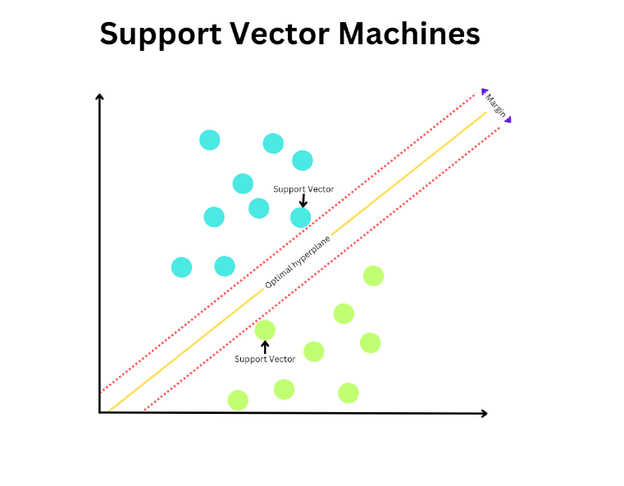
Figure 1 Showing Support Vector machine model

Decision Trees
Decision trees are a widely used method for both regression and classification machine learning models. They used a laser comparatively simple algorithm to Recursively split data into subsets creating a tree like structure with each node representing a split in the data and each node at the base of the tree known as a leaf node representing an outcome in classification or a prediction in regression.
Constructing a decision tree begins with the creation of a root node with containing all features and target values from the data set the DT algorithm then selects a feature that best splits data into two subsequent homogeneous groups. Generally dictated in regression tasks by minimising variance in data points.
Each split creates At least 2. Child nodes which are then. Because of the split. Until a predetermined. Stopping criteria. Is Met. Generally, this stopping criterion is set as a minimum number of data points in a node or a maximum tree depth. Regression models the leaf nodes contain predicted values which are typically calculated as a mean of third target values for data points contained within that note think last vacation however delete notes represent a predicted class.
One of the key advantages of DTs is this implicit E and ease of interpretability that comes from this. The structure of ADT is straightforward, making it easy to understand the process and the relationships identified between features. Another advantage of DTS is their flexibility in data handling without the need for extensive pre-processing they do not require normalisation and scaling of features as the construction process is not sensitive to magnitude. They also mitigate for the presence of missing values as those data points can simply be ignored during splits.
Despite the highlighting strengths there are several limitations in using DTs. They have a tendency to overfit training data particularly where the tree is allowed it to grow too deep, in many cases leading to nodes that contain small amounts of data and increase sensitivity to noise and anomalous data. This then means that results are not generalizable two unseen data. Such as this pruning can be used to remove nodes that contain data of little predictive value.
DTs are also sensitive to slight changes in data as these can influence the results of splitting decisions. This is another vulnerability of DTS to anomalous and noisy data. DTS are also likely to present bias when data sets are unbalanced.
Decision trees offer a simple and highly interpretable 24 both classification and restaurant modelling. However, the day potential for overfitting and sensitivity to variations in data require careful consideration when utilising complex data sets.
Random Forest (RF)
Random Forest is a form of ensemble learning used in both classification and regression that is known for its robustness and accuracy in handling large, complex data sets. RFs build upon the traditional decision tree model by utilising multiple DTs to improve overall predictive performance and mitigate the risk of overfitting.
RFs build multiple DTs, each using a random sample of data known as bootstrapping. This approach ensures that the trees are diverse and that final outputs are not weighted towards particular data points. This is mirrored in the selection of data that is split in each node, which again is chosen by random rather that evaluating all data points for homogeneity as in DTs. This process is controlled by a hyperparameter set when constructing the model which simply dictates the number of features to be considered at each split. In regression tasks, this is typically set to one third of the total number of features present.
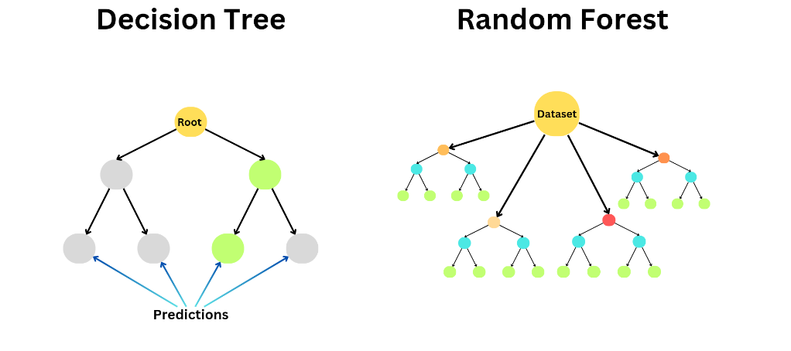

Figure 2 Comparison of Decision Tree and Random Forests structure

In comparison to DTs in particular, RFs offer a number of advantages. They offer increased accuracy, particularly in large data sets with complex high dimensional data, making them suitable for a wide range of regression and classification tasks. RFs also include the ability to estimate the importance of individual features by analysing each features contribution to splitting decisions. This can be invaluable in gaining an understanding of the data used in the model.
Despite the highlighted strengths, RFs also have a number of limitations. When using large data sets they can be intensive on computing power. Additionally, in these cases, a large number of trees are creates, making it difficult to extract clear conclusions.
Overall RFs offer a powerful and robust way to handle complex data sets and Identify complex relationships within them. Their ability to balance the need for accuracy and the risk of overfitting, and deal with large data sets makes them an extremely valuable tool for both classification and regression.

2.5 ML research in Public Health
2.4.1 Overview
The current state of ML research in the sphere of public health, particularly mental health, mirrors the rapidly evolving landscape of ML applications, methodological progress, and a general increase in the recognition of the benefits of ML technologies.
The rapid advancement of ML tools in recent years has brought them to the forefront as an invaluable method of analysis in the field of public health. By applying ML in the analysis of public health data, inferences can be made by researchers that can help advise public health policy and healthcare practice, potentially improving interventions and increasing the efficacy of resource allocation. . The results of the use of these ML methods have been shown to have a promising effect on the accuracy of diagnoses and the early detection of mental health disorders [29].

2.4.2 Applications of ML in Mental Health
One of the primary applications of ML in Public Mental Health is in the prediction of mental health disorders or diagnosis. There are numerous studies that show the efficacy of well known ML algorithms such as Support Vector Machines (SVMs), and Random Forests in the classification and prediction of health conditions, both using individual patient records, and population level data [30]. Research by Zhou et al (2022) demonstrates accuracy in the prediction of depression symptoms by analysing prevalence of mental health risk factors present in health workers using least absolute shrinkage and selection operator (LASSO), random forest, and gradient-boosting tree models [31]. A similar study by Jha et al (2021) utilised multiple ML models including SVMs and Random Forests to analyse data on mental health indicators related to the COVID-19 pandemic collected by survey. The results of this study showed ~80% accuracy in predicting individuals deemed to be “mentally vulnerable” [32].
Both studies mentioned however showed significant limitations, particularly in the data used. Both used cross-sectional data, which can identify relationships, but not accurately show the directionality of those associations. In addition to this, neither study included data on pre-existing mental health diagnosis, access to treatment, or other variables that can have an impact on mental health outcomes. Jha et al also used Synthetic Minority Over-sampling (SMOTE) to address a class imbalance in their data, a method for generating synthetic data in order to balance the representation of a class. This method can prove useful however is limited in that it assumes that each instance of the class in question is close in feature space. If the data of the minority class is limited, the data generated through SMOTE will likely not represent real-world data, rather it will simply conform to the training data set [33].

2.4.3 Ethical Considerations of Public Health ML research
The thorough consideration potential ethical implications is a critical step in any form of research. This need is amplified when the research is in the context of public health. There are a number of factors that make this of particular importance in public health, and mental health, related research.
Data Privacy and Confidentiality
Many ML studies into public health utilise patient data. Health data is particularly sensitive as it can sometimes contain personally identifiable information and its mishandling can have extremely detrimental consequences on individuals whom the data belongs to. To many people, health records, particularly mental health records, contain some of their most sensitive and personal information. Ensuring the confidentiality of health records used in research of vital importance both the safety of individuals, and in ensuring that public trust in healthcare organisations and researchers, and therefore the accessibility highly valuable data is not impeded. [34]
Generally, when health data is accessed through a governmental or healthcare organisation, it goes through a process of anonymisation before it is passed on to a third party. Despite this, there are cases where data can still be linked back to an individual. Therefore when handling sensitive data of this type researchers must take additional steps in ensuring data security through the use of encryption and access controls.

Potential for Bias
If data used in an ML model is not truly representative of a population, or contains inherently biased data against a particular demographic, the results of the model will reflect any biases present. When the results of research could potentially guide healthcare policy, these biases could have far reaching detrimental effects on patient outcomes [35].
For example, if mental health data from a private health organisation in the UK, the likelihood is that the data will represent a population that can afford to undergo private medical treatment. In the UK the proportion of the population that uses private healthcare is around 10% to 12% [36]. That proportion of the population is likely of a higher socio-economic status and therefore any model trained on that data has a high likelihood of bias against a significant part of the UK population. Diverse and representative training data is vital in producing valuable research.

2.4 Suicide Related ML Research

2.4.1 Overview
The application of ML in the prediction of suicide rates has gained significant traction in recent years. The integration of ML techniques in the assessment of suicide risk in individual patients and wider populations offers a promising path for the improvement of current risk prediction methods such as traditional statistical analysis and clinical observational studies.
The scope of current predictive ML research related to suicide is wide and varies greatly. Research in this area generally attempts to either provide tools for clinical use in which data on potential risk factors and their link to suicidality is used to create a model that can be used to show the potential suicide risk for an individual patient, or it utilises wider population data to develop a model that can help draw conclusions regarding the prevalence of risk factors within a population and the effect that they can have on that populations suicide rate. This section of the literature review will focus on the latter, as the purpose of this research is to bring together SSRI prescription data for a population and its suicide rate to make predictions regarding any possible associations between the two for a population.

2.3.5.2 Applications of Machine Learning in Suicide Prediction
Machine learning (ML) has significantly impacted the accuracy of suicide rate predictions and enhanced our understanding of the relationships between risk factors and suicide rates. Numerous studies underscore the potential of ML in this critical area of mental health research.

2.3.5.3 Overview of ML Advancements in Suicide Research

Linthicum et al. (2019) conducted a comprehensive review of ML applications in suicide science. Their review identified significant improvements in the accuracy of ML methods for suicide risk prediction, particularly in recent years. This claim is supported by various studies that report accuracy rates exceeding 90% when using ML to predict suicide rates [37].
The development and ongoing refinement of methods such as random forests, neural networks and support vector machines that the study covered show particular promise due to their capabilities in capturing non-linear, complex relationships between large sets of risk factors. This makes them especially useful when attempting to detect intricate patterns amongst the wide range of interrelated risk factors that play a role in suicide prediction.
Simon et al. utilized data from the Mental Health Research Network, including over 2.9 million patient records and data on nearly 20 million mental health-related clinical visits. They developed a logistic regression model using lasso variable selection to predict suicide attempts or deaths within 90 days post-clinical visit. The model incorporated 313 individual predictors, covering a wide range of demographic, healthcare utilization, and clinical data from the five years preceding the target visit. Despite less than 0.1% of the sample presenting suicide events, the model achieved a high accuracy rate, with a C statistic ranging from 83% to 86%. Risk scores above 75% and 95% successfully identified 80% and 43% of suicides, respectively.
The use of lasso variable selection in this study is a crucial step in managing the complex data set. Lasso selection selects a subset of predictors that have the largest effect on model accuracy. Within large data sets of this size, this method also contributes significantly to reducing the risk of overfitting by preventing the use of features that hold little significance to the final predictions. By reducing the number of features, a balance can be struck between accuracy and complexity making eventual interpretation and application of results an easier process [38].
Kessler et al. conducted a similar study using data from the U.S. Veterans Health Administration. Their model included data from over 6,000 veterans who died by suicide and 2.1 million control samples. Like Simon et al., they used a logistic regression model based on 61 suicide predictors, aiming to predict suicide events within 30 days post-clinical visit. The model demonstrated improved sensitivities among individuals in the top 15% at risk of suicide, marking an enhancement over previous studies. Additionally, they briefly evaluated other ML approaches, including support vector machines and random forests, which supported the results of their primary model [39].
Both Simon et al. and Kessler et al. underscore the potential of ML in suicide risk prediction using health data. However, Simon et al.’s model, which utilized a far larger and more comprehensive dataset, may offer greater generalizability to a wider population.

2.3.5.4 Expanding Data Sources for Suicide Related Research
Increasing access to diverse data sources related to suicide risk factors and rates enhances the potential for ML-driven suicide prediction research. Various forms of data, including electronic health records (EHRs), demographic data, clinical data, and behavioural data, are highly valuable for this research.
Sue et al. (2020) demonstrated the use of EHRs combined with demographic and clinical data to develop models that accurately predict suicide attempts in a pediatric patient population. As highlighted in previous sections, the complex and nuanced nature of suicide requires multifaceted approaches made possible by these diverse datasets. Integrating structured health record data with unstructured data such as clinical notes can be challenging. However, combining diverse data sets can help in improving the accuracy of models and ensure that they are comprehensive and generalisable.

Leveraging Social Media Data for Suicide Risk Prediction
In addition to clinical and formal health data, the widespread use of social media generates massive amounts of unstructured data that has been increasingly utilized in suicide-related ML research. Metzler et al. (2018) used natural language processing (NLP) to analyze social media interactions on Twitter, identifying the nature and risk level of suicide-related interactions. Similarly, Al Diani et al. (2022) employed linguistic analysis and textual features to identify social media posts that indicate suicidal ideation.
While using social media data can provide valuable insights it is important to recognise its limitations. Social media users represent a portion of a population, it is difficult to gain perspective on the demographic makeup of users represented in social media data therefore predictions using this data cannot be generalised to the wider population [40].

Chapter 3: Experimental Design

3.1 Introduction
As outlined previously in this document, the aim of this document is to develop a cloud-based data pipeline that will facilitate the exploration of the relationship between prescription rates and suicide rates using machine learning, with the objectives to extract and integrate homogenous sets of data related to prescription rates and suicide rates in English Integrated Care Boards into a unified, clean, and well structured dataset and to implement a machine learning model using regression analysis to predict and analyse associations between SSRI prescription rates and Suicide Rates. In this section I will break down the experimental process implemented in reaching both of these objectives.

3.2 Data Sources and Collection Methods
Data Sources
In order to determine appropriate data sources a review of publically accessible UK based mental health, and prescription data sets was conducted. Three possible data sources were identified;
Fingertips
Fingertips is a large public health data collection provided by the Office for Health Improvement and Disparities. It offers a centralised repository of data collected from various sources such as the NHS, Office for National Statistics, and various local authorities. Data on many aspects of health is present including various statistics on health outcomes, related risk factors, healthcare strategies, including that related to both physical and mental health. Fingertips data is organised into 39 distinct profiles, with 6 of those being directly related to Mental Health; Common Mental Health Disorders, Severe Mental Illness, Suicide Prevention Profile, Mental Health and Wellbeing JSNA, Perinatal Mental Health, and Children and Young People's Mental Health and Wellbeing.

Open Prescribing
Open prescribing is a publicly available platform that aggregates primary care prescribing data from NHS England. It was launched in 2016 as an attempt to aid research that improves prescribing practices by providing access to raw data and analytical tools.
The data provided by Open Prescribing includes information on medications prescribed by primary care providers across England including the quantities prescribed and related costs. This data can be accessed on a local, regional, and national level. [41] This data is made accessible directly on the Open Prescribing Website but is also available via API.
The Open Prescribing website also acts as a collaborative space for research by providing a platform for the sharing of insights by researchers and healthcare professionals into the data they provide.

NHS Open Data Portal
NHS open data portal is a platform that provides access to a wide range of Health data generated by NHS practices. Datasets available cover the areas of General Hospital activity such as admissions appointments and emergency visits, prescription rates and spending, clinical outcomes data, and General demographic data, and a number of specific datasets related to mental health services.
These data sources were highlighted as potential sources for our research all three are publicly accessible via API, as opposed to other major databanks such as the Secure Anonymised Information Linkage Databank and the Administrative Data Research network, both of which required a prolonged application process to access. And all three contain relevant data, FingerTips contains a number of Suicide and mental health related profiles, OpenPrescribe contains prescription rate information, and NHS Open Data portal contains a mixture of both.
After exploring the available data sets from each source more deeply Fingertips was selected to extract suicide rate related data and OpenPrescribe to extract prescription related data. These were chosen over NHS open data portal as they both offer datasets that already include data from NHS open portal, fingerprints suicide rate profile contains data from the NHS open data portal and other sources such as the office for national statistics, providing more data points for analysis.
At first the Suicide Prevention profile from fingertips was selected, as it contains a range of suicide indicators that would be useful in our model including socioeconomic and behavioural risk factors. Upon attempting to access the profile it became apparent that a recent FingerTips update had erroneously made the profile inaccessible. Therefore an alternative profile, Suicide Rates was utilised. This profile contains data on suicide rates by local, regional, and national localities, including suicide rate per 100,000 for whole populations and by sex.
In order to select the OpenPrescribe data that would be used in creating our dataset a list of the most commonly prescribed SSRIs in the UK was established, and the corresponding data from OpenPrescribe located.
Collection Methods
Azure Data Factory was selected as the platform on which to build the pipeline. This was chosen as it offered low cost, easy scalability, and easy integration with databases via Azure in the form of an azure SQL server. Additionally, it offers an easily visualisable approach to building data pipelines.
An Azure SQL and Azure Blob storage account were created in order to facilitate the building of our data set.
Following this the data collection process was undertaken in Azure Data Factory. A REST API linked service was created in Azure Data Factory for each OpenPrescribe SSRI data set. This allows DataFactory to access the OpenPrescribe API URL for each dataset. A dataset object was then created that linked to the Azure Blob previously mentioned. For each linked service a copy object was then created in a DataFactory Pipeline in order to populate the JSON formatted data from the API into a Blob. To convert the JSON data from OpenPrescribing into a format suitable for analysis, a Data Factory copy activity was configured to transform the JSON data into SQL format.The same process was carried out for FingerTips data however this was in a csv format.
Both datasets created were then converted into SQL format and stored as tables on the Azure SQL server built previously.

Data Transformation and Preparation
Once the data was extracted and stored in the SQL database steps were taken to clean and restructure the tables to ensure consistency and reliability and to facilitate their merging into a single table. An SQL stored procedure was created in order to clean the data, removing unnecessary fields, duplicate values and null values.

Data Integration and Harmonisation
To ensure meaningful analysis in an Ml Model both tables underwent a process of harmonisation and integration. This involved the alignment of datasets on common fields, and the conversion of fields into a shared format.
The data was then merged into a single table providing our final dataset.

Exploration of the dataset
Steps were taken to asses the quality of the final dataset. Outlier data points were identified and a normalisation process was undertaken. Preliminary analysis of the relationships were undertaken.

3.3 Machine Learning Model
In order to analyse the relationships between SSRI prescription rates and suicide rates, a random forest regression model was selected. This model was chosen give it to its robustness in handling complex datasets with potential nonlinear relationships, as there was no linear relationship identified in the exploration stage, and its ability to handle continuous and categorical variables.
Feature selection and Data Splitting
The features to be used in the model within selected based on their relevance to the objective of assessing a relationship between SSRI prescription rates and suicide rates. The features selected were TotalQuantity (The quantity of items prescribed) and TotalItems (The total of prescription instances). The target variable selected what's the value for suicide rate per 100,000 individuals.
The data set was split into training and testing sets at an 80:20 training to test ratio. This is a commonly used ratio for splitting as it ensures that the model is trained on an adequate amount of data While also retaining a large enough portion of data for the evaluation of prediction performance.

Hyperparameter Tuning
In order to improve the performance of the initial model hyperparameter tuning was conducted using grid search with cross validation. This technique search is a specified parameter grid and identifies optimal combination of hyperparameters based on the initial models performance.
Visualisation of Results
In order to understand the models behaviour and evaluate performance Scatter plots were generated for the untuned and tuned models, residual plots where created to examine the distribution of errors across the range of predicted values, facilitating the identification of any patterns or bias in the model's predictions, and a feature important plot was produced for the tuned model in order to show the contribution of each feature to the models predictions.

Chapter 4: Methodology

4.1 Overview
The objective of this section of our methodology is to develop an ETL pipeline using cloud based services to link data on SSRI prescription rates from OpenPrescribing with suicide rate data from Fingertips. This pipeline follows a structured approach that extracts data from original sources, transforms, and stores it, resulting in a final integrated dataset ready for ML analysis.
Utilizing Azure cloud services, a data pipeline will be developed that extracts SSRI prescription spending data for ICBs in 2019-2020 from OpenPrescribing and suicide rate data for ICBs in the same time period from Fingertips. The data will then be pre-processed and stored in a relational database. This data will then be used to train an ML model in Azure Machine Learning in order to create a regression model to make predictions about the link between suicide rate and prescription of SSRIs. This data will then be analyzed to draw conclusions on any possible associations.

4.2 Data Collection
OpenPrescribing Data
Firstly, the API access URL for each of the four most commonly prescribed SSRIs was established and their connections tested for a successful connection response code. A REST API linked service was created for each of these with the naming convention of RestServiceOP followed by the name of each SSRI. Following this, for each dataset, a Data Factory copy object was configured to pass the JSON data provided by the API to Microsoft Azure Blob storage. All datasets were extracted into a single collective JSON blob.
JSON to SQL
In order to transform the extracted JSON data from the Open Prescribing API into a format suitable for analysis, a Data Factory Copy object was configured to transform the JSON data into SQL. A serial ID field was added in order to act as a primary key in the SQL table. The data was then passed into an Azure SQL Database.
Fingertips Data
Fingertips API documentation was used to find datasets containing suicide rate information for ICB locations in England and the appropriate API access URL identified. In Azure Data Factory, a REST service was created that linked to the URL. An object was then created that linked to that REST service, and a copy object was configured to pass the CSV formatted dataset from Fingertips into a CSV Azure Blob storage.
CSV to SQL
In order to match the data extracted from OpenPrescribing, this CSV data then had to be transformed into an SQL relational table. A copy object was then created in Data Factory that reformatted the dataset for SQL and populated it into a table in the same Azure SQL database as the OpenPrescribing data.

4.3 Data Transformation
The data extracted from each API contains data that is unnecessary for our dataset. In addition to this, we must ensure that there is no erroneous or null data present in the dataset. The data from each dataset was explored in order to identify unneeded fields and gain a better understanding of transformations needed.
Data Cleaning and Preparation
A stored procedure was created in the Azure SQL database containing SQL queries to clean and restructure the dataset. Corresponding SQL code can be found in the files attached to this dissertation, in a file named storedproceedure1.sql. The following steps were included:
Firstly, a general cleanup was performed. SQL queries were written to remove unneeded fields, duplicate rows, and rows containing null values from both tables.
Data Integration and Harmonization
In order to merge data from both of our sources, common fields needed to be identified to perform a join. ICB names and data values were chosen. The AreaName field, containing ICB names in the table created containing suicide rate data from Fingertips, differed slightly from the corresponding values in the table containing prescription data from OpenPrescribing.
The Fingertips table contained a number of non-ICB locations. These locations were significantly shorter in length than ICB names; therefore, a query was written to remove all values less than seven characters in length, as this was the longest of the non-ICB values.
Each ICB name in the Fingertips data contained the ICB name followed by a three-letter code. This code was not present in the OpenPrescribing table. In order to remove this code from each value, a query was created that removed the last six characters from all values in the AreaName field. In addition to this, Fingertips ICB names contained uppercase characters. A query was written to change all values to lowercase.
Time Period Alignment
In regards to the time period, Fingertips contained a small portion of values for a three-year period and a one-month period. These were incompatible with OpenPrescribing data, which only contained prescriptions from one-year periods. To account for this, a query was first written to remove all Fingertips rows for three-year periods. Then, a second query was created that merged rows containing data for one-month periods into single rows based on ICB name and year values. The values for suicide rate (Value field) for each newly generated row were populated with a mean value for those that generated the new row, meaning that the suicide rate in each of these rows contained a mean suicide rate over a one-year period.
Date Standardization
Date values in the OpenPrescribing table were in a different format than those in the Fingertips table, and both were stored as VARCHAR types. In order to create a common field that could be sorted, we chose to create a field in the OpenPrescribing table that corresponded to the TimePeriodSortable field in the Fingertips table. A query was written that took the year portion of the date field and populated it to the new field, appending ‘0000’ to match the corresponding field in the Fingertips table.

4.4 Integrating Datasets
A query was written that creates a new table in the same Azure SQL database named MergedFTandOpenPrescribeData. It performs a join on the AreaName and TimePeriodSortable fields in the Fingertips table and the ICB and TimePeriodSort fields in the OpenPrescribing table. Using this join, the fields ICB, TimePeriodSort, TotalQuantity, and TotalItems from OpenPrescribing data, and Value from Fingertips data are populated into the new table.

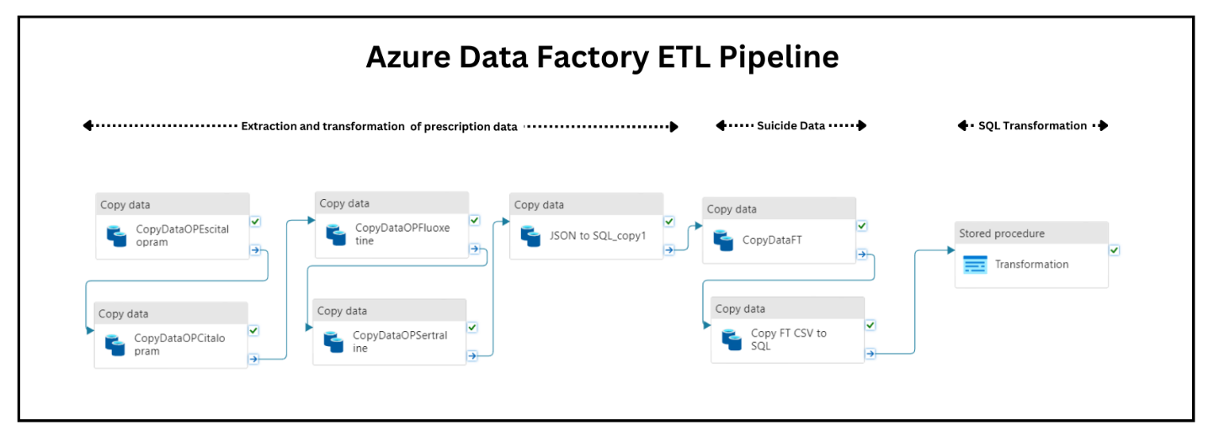
In order to allow the use of DateTime data in our exploration of this dataset and model, a final query was created to create a ‘year’ field. This query takes the first four characters of the TimeFrameSort field, converts it to the type datetime, and populates it into the ‘year’ field.
Figure 3 Showing flow of Azure Data Factory pipeline

4.5 Exploration of Final Dataset
Before using the data in an ML model an exploration of the dataset was carried out to assess the quality and structure of the dataset, and to identify any needed modifications .
The resulting dataset contains the following fields:
- icb: containing integrated care board name

- TimePeriodSort: A numeric representation of the time period

- TotalQuantity: The total number of individual medicines prescribed by an ICB in the time period.

- TotalItems: The total number of prescriptions prescribed in the time period.

- Year: The year corresponding to the time period

There are a total of four time periods represented in the data set; 2019, 2020, 2021, 2022.
Data Quality
Data quality issues such as Null Values and Duplicate rows have been addressed in previous steps. In the following steps descriptive statistics were used to identify outlier data that may effect model outcomes.
Firstly a boxplot (FIGURE) was created in python using the libraries seaborn, matplotlib and pandas, to visualise outlier data points in our data set for suicide rates (Value) and prescription rates (SSRI Prescriptions).
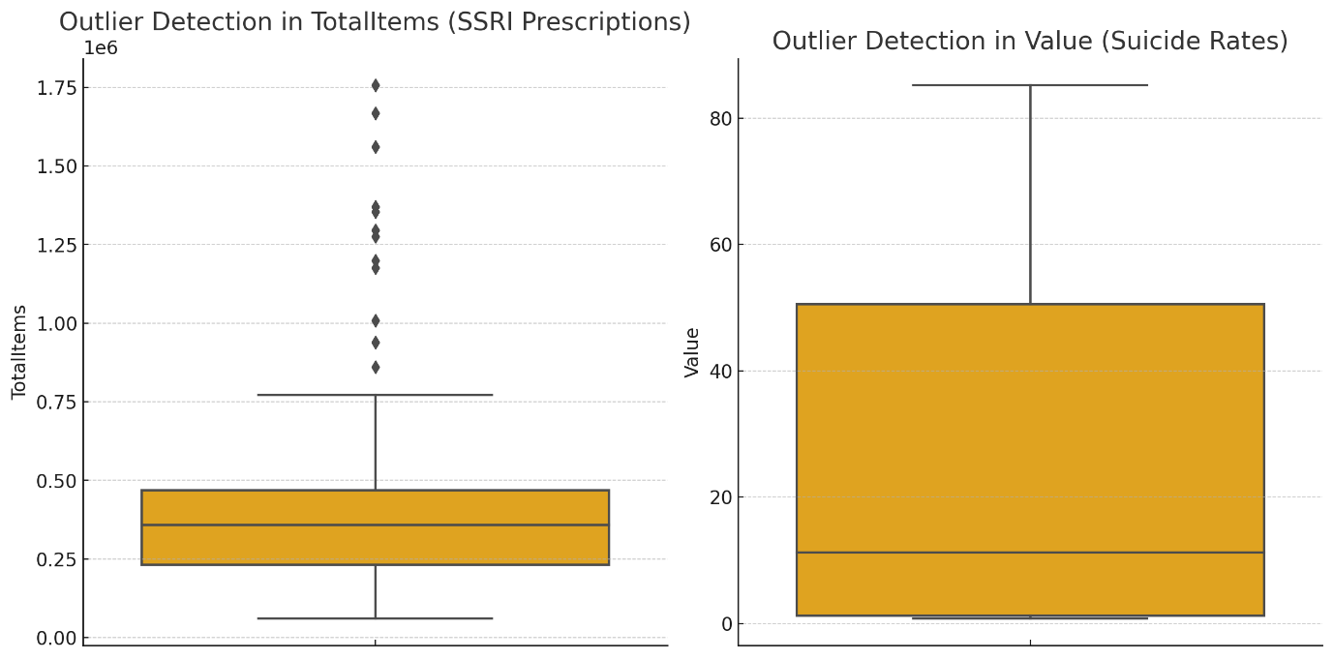
Figure 4 Boxplot showing outlier data for prescription and suicide rates
The data for SSRI prescription rates show a few values higher than average that could potentially represent outlier data. Upon further exploration, these values were generally linked to ICBs for areas with larger populations. It is likely that a higher population will mean a higher prescription rate for most medications.
Suicide rate data showed a few values with fairly high variation from the average. Suggesting that some regions have significantly higher suicide rates than others. However some of the values are drastically different from expected values for suicide rate per 100,000. Even in ML models that are robust in dealing with outliers, extreme outliers can skew results. Therefore, an SQL query was added to the stored procedure in our Azure Data Factory pipeline in order to omit values with a higher standard deviation from the from the mean value from our final dataset. The results of this change are visualised in FIGURE below.

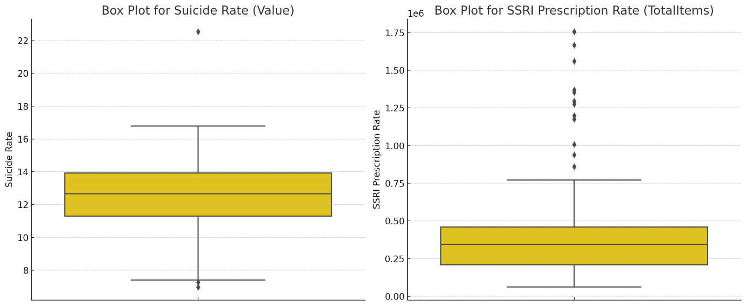
Figure 5 Box plot showing outlier data post clean

4.6 Building ML Model
Random Forest
A Random forest model was built in python using RandomForestRegressor from the SciKit Learn library. The features TotalQuantity and TotalItems were defined as X and the target feature. ‘Value’ (Suicide Rate) as Y. Training and test data was split into a 80:20 test to training ratio. The RandomForestRegressor initiated with parameters set at 100 decision trees (n_estimators) abd a seed of 42 for the random number generator. The model was then run. An R-squared, Root Mean Squared Error (RMSE), Mean Absolute Error (MAE) for the model were set to be produced on output.
Gridsearch CV was then used to tune hyperparameters and run a second Random Forest model.
Using Matplotlib a number of tables were created to visualise results; A scatter plot for both the tuned model and untuned (Figure 6) to visualise model predictions vs actual values. A residual plot for each model (Figure 7) to show any potential pattern in errors and to compare performance of each model. A Feature importance plot for the tuned model to visualise the contribution of each of the features used in predictions (Figure 8).
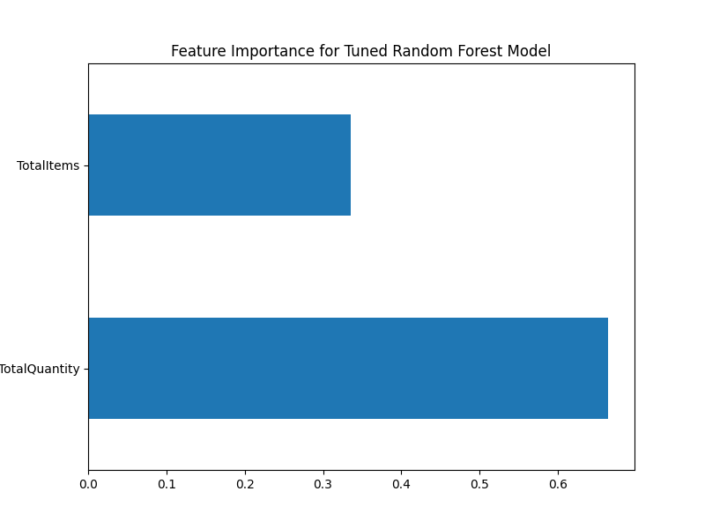
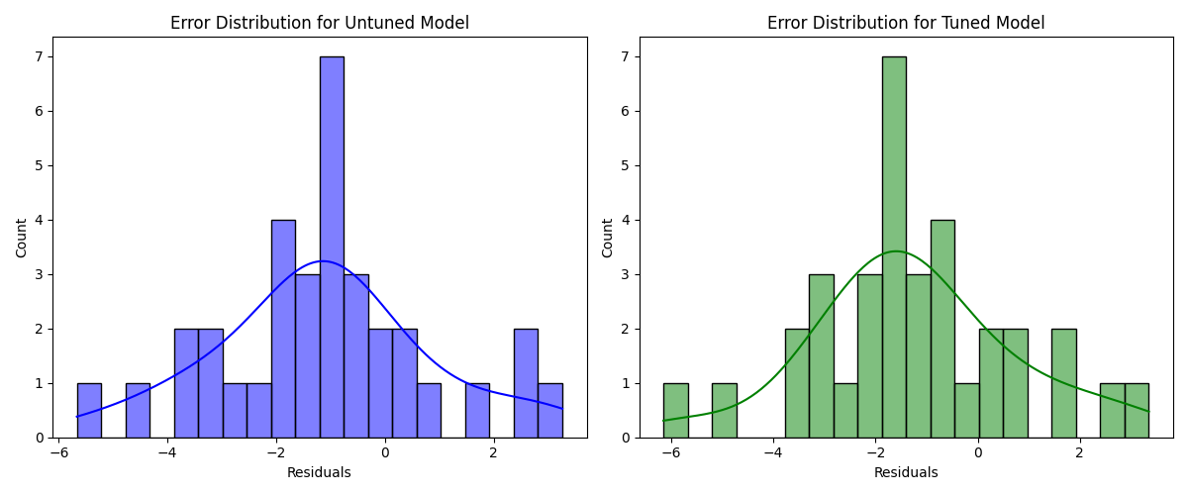
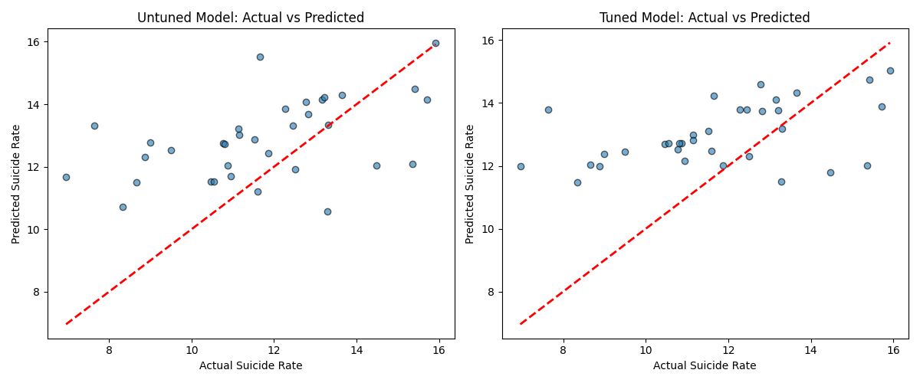
Figure 8 Feature importance plot for tuned model
Figure 7 Residual plot showing residuals for each model
Figure 6 Scatter Plot showing performance of first model and tuned model

Chapter 5: Results
  - Final Dataset
The final data set created combined data from Open Prescribing on SSRI prescription rates and Fingertips on the suicide rates for integrated care boards in England for the period 2019 to 2020. The data set includes key variables in the analysis of any relationships between prescription rates and suicide rates.
Data cleaning steps insured the removal of duplicate records the handling of missing values and the heterogeneity of data from each source resulting in a well structured data set suitable for machine learning analysis.
  - Machine Learning Models
Two versions of a random forest regression model with developed to explore the relationships between SSRI prescription rates and suicide rates. An initial model and a model tuned using hyperparameter optimization. Both models were trained using two features representing different measures of SSRI prescription to predict the target variable of suicide rate.
Model results
The initial random forest model produce the following performance metrics;
R-squared: -0.0217
Root Mean Squared Error (RMSE): 2.2741
Mean Absolute Error (MAE): 1.8436
The model tuned using GridSearchCV produced the following metrics:
R-squared: -0.0913
Root Mean Squared Error (RMSE):: 2.3503
Mean Absolute Error (MAE): 1.9486

Analysis of results
The negative R-squared value for this model suggests that there is little to no relationship between SSRI use and Suicide rates. The model does not explain the variation in the target variable. In addition to this the RMSE and MAE also suggest poor model performance ad their values are relatively high, showing the occurrence of fairly significant errors in model predictions.
Despite the tuning process these results show no improvement over the previous model. The values actually show that the model performed worse than the initial model, suggesting that hyperparameter optimisation was not successful in enhancing the models performance.
The scatter plot in Figure 6 showing actual vs predicted suicide rates for each model both show a broad scattering of data points around the regression line indicating that there is a significant lack of alignment between the actual and predictive values. In addition to this the Residual plots for model errors support the conclusion that the model performed poorly. Residuals for both models seem to be randomly distributed around zero with a high range of dispersion. The feature importance analysis shown in figure 8 shows that TotalItems does have a slightly higher importance compared to total quantity however the overall poor performance of the model suggests that neither is a significant indicator for suicide rates.
Conclusion
Overall these results show that the model had significant difficulty in identifying any relationships between suicide rate and SSRI prescription rates. This could possibly be because of the size of the data set or the model chosen, or may simply indicate that these features do have little significant impact on suicide rate.

Chapter 6: Discussion
The purpose of this research was to implement an ETL pipeline in the integration of publicly available UK SSRI prescription data and suicide rate data into a single data set. The integration of these datasets aimed to produce a comprehensive data set that could be used in a ML Model to assess the relationship between SSRI prescription rates and suicide rates.
After constructing a pipeline for the extraction of data from OpenPrescribing and Fingertips a Random Forest regression model was developed and evaluated. The overall results of the two models implemented suggest that in the data used there was no strong predictive relationship between SSRI prescription rates and suicide rates. This conclusion would somewhat fit with existing literature as research generally showed contention over the relationship between SSRI use and Suicide, with some studies showing a significant relationship, and others showing no relationship. A large proportion of studies that show a significant relationship are were conducted using data from younger populations. A potential further step in this research would be to include age ranges in the dataset in order to establish whether our model would corroborate this correlation in younger populations.
The objectives of the study were partially met. A dataset was created that linked data from heterogenous data sources that facilitated the use of an ML model in identifying relationships between SSRI use and suicide. However the poor performance of the model suggests that either the a relationship does not exist, that the dataset and features were not adequate, or that the modelling approach was unsuitable for the application.

If this study were to be conducted again, and in future building of the data set, the complexity of factors effecting suicide rate necessitates a broader data set that includes other risk factors such as socioeconomic, behavioural, and clinical data. It was the initial intention of this research to incorporate such factors into the data set, however technical issues on the side of the data source hindered the collection of related data.
The mechanism of SSRIs in treatment also needs further consideration in continuing to build the data set. SSRIs generally take a significant onboarding period in order to become effective, therefore it could be beneficial to include a lagged time period value to the data in order to assess the effect that prescription rates could possibly have on suicide rates in following years. In order to do this data from a broader time period will be needed.
One data quality factor that could potentially have effected the performance of the model is a loss of granularity when rows were merged in order to match the time frames represented in from each data source.
Utilising alternative modelling methods such as SVMs or deep learning approaches that are well suited to identifying complex non-linear relationships could also be used in order to establish whether model selection was the cause of the poor performance seen.

Chapter 7: Conclusion

In conclusion, while a successful ETL pipeline was developed, no significant relationship was found between SSRI prescription rates and suicide rates in the chosen ML model. The model performed poorly in predicting any form of relationship. This outcome reflects the complexity of mental health related ML research and the need for the consideration of a broad range of factors. Future research should integrate these factors into the dataset and explore the use of alternative modelling approaches in order to gain further insight into any potential relationships. Overall this research does provide an insight into the challenges of using ML in suicide related research and provides several avenues for further research to follow in gaining a better understanding of the dynamics involved in this complex subject.

Chapter 8: Reflection
Upon looking back at the research process there are a number of elements that I would change. When encountering the barrier to accessing more complex data on suicide risk factors, alternative sources should have been sought. This is evident when looking back at the literature review process as the need for a complex analysis of a broad range is well defined. In addition to this more research could have been done into studies that specifically look to identify relationships between suicide rates and risk factors rather than a broad study into suicide related ML. More consideration could also have been given to the model building process and examining the data set further to identify appropriate models. While I have followed the aims and objectives of the research, there is more that could have been done to ensure that the data used facilitated effective ML modelling such as the engineering of new features from the existing data.

References

[1] S. E. Hetrick, J. E. McKenzie, G. R. Cox, M. B. Simmons, and S. N. Merry, “Newer generation antidepressants for depressive disorders in children and adolescents,” BJPsych Adv, vol. 23, no. 2, 2017, doi: 10.1192/apt.23.2.74.
[2] J. F. Hayes, G. Lewis, and G. Lewis, “Newer-Generation Antidepressants and Suicide Risk,” 2019. doi: 10.1159/000502295.
[3] J. L. Gradus et al., “Prediction of Sex-Specific Suicide Risk Using Machine Learning and Single-Payer Health Care Registry Data from Denmark,” JAMA Psychiatry, vol. 77, no. 1, 2020, doi: 10.1001/jamapsychiatry.2019.2905.
[4] Office for National Statistics, “Suicides in England and Wales: 2022 registrations,” 2023.
[5] B. & Y. J. & R. E. & W. X. & K. J. & L. Y. & Z. R. & Z. W. & W. H. & X. S. & S. C. & J. Y. & X. C. & Y. J. & C. W. & F. Jiling. Zhang, “Identifying behaviour-related and physiological risk factors for suicide attempts in the UK Biobank,” Nat Hum Behav, pp. 1–14, 2024.
[6] NHS digital, “Health Survey for England, 2022 Part 1,” Jun. 2024.
[7] “Depression in adults: recognition and management. Clinical guideline [CG90]. ,” 2009.
[8] P. Bogowicz, H. J. Curtis, A. J. Walker, P. Cowen, J. Geddes, and B. Goldacre, “Trends and variation in antidepressant prescribing in English primary care: a retrospective longitudinal study,” BJGP Open, vol. 5, no. 4, 2021, doi: 10.3399/BJGPO.2021.0020.
[9] C. J. , D. R. S. , & C. P. J. Harmer, “How do antidepressantswork? New perspectives for refining future treatment approaches.,” Lancet Psychiatry, vol. 4, no. 5, pp. 409–418, 2017.
[10] A. A. Khan, A. Wong, V. Pasovic, and E. Akinyemi, “The Risk of Suicide with Selective Serotonin Reuptake Inhibitors in the Elderly,” in Essential Reviews in Geriatric Psychiatry, 2022. doi: 10.1007/978-3-030-94960-0_70.
[11] C. Björkenstam, J. Möller, G. Ringbäck, P. Salmi, J. Hallqvist, and R. Ljung, “An Association between Initiation of Selective Serotonin Reuptake Inhibitors and Suicide - A Nationwide Register-Based Case-Crossover Study,” PLoS One, vol. 8, no. 9, 2013, doi: 10.1371/journal.pone.0073973.
[12] J. Forsman, T. Masterman, J. Ahlner, G. Isacsson, and A. K. Hedström, “Selective serotonin re-uptake inhibitors and the risk of violent suicide: a nationwide postmortem study,” Eur J Clin Pharmacol, vol. 75, no. 3, 2019, doi: 10.1007/s00228-018-2586-2.
[13] T. Lagerberg, S. Fazel, A. Sjölander, C. Hellner, P. Lichtenstein, and Z. Chang, “Selective serotonin reuptake inhibitors and suicidal behaviour: a population-based cohort study,” Neuropsychopharmacology, vol. 47, no. 4, 2022, doi: 10.1038/s41386-021-01179-z.
[14] J. Ludwig, D. E. Marcotte, and K. Norberg, “Anti-depressants and suicide,” J Health Econ, vol. 28, no. 3, 2009, doi: 10.1016/j.jhealeco.2009.02.002.
[15] J. Ø. Sørensen, A. Rasmussen, T. Roesbjerg, F. C. Verhulst, and A. K. Pagsberg, “Suicidality and self-injury with selective serotonin reuptake inhibitors in youth: Occurrence, predictors and timing,” Acta Psychiatr Scand, vol. 145, no. 2, 2022, doi: 10.1111/acps.13360.
[16] N. Ghaziuddin, C. Merchant, R. Dopp, and C. King, “A naturalistic study of suicidal adolescents treated with an SSRI: Suicidal ideation and behavior during 3-month post-hospitalization period,” Asian J Psychiatr, vol. 11, 2014, doi: 10.1016/j.ajp.2014.03.014.
[17] A. Sharma, L. S. Guski, N. Freund, and P. C. Gøtzsche, “Suicidality and aggression during antidepressant treatment: Systematic review and meta-analyses based on clinical study reports,” BMJ (Online), vol. 352, 2016, doi: 10.1136/bmj.i65.
[18] T. Harada, K. Sakamoto, and J. Ishigooka, “Incidence and predictors of activation syndrome induced by antidepressants,” Depress Anxiety, vol. 25, no. 12, 2008, doi: 10.1002/da.20438.
[19] J. Kelleher, B. Mac Namee, and A. D’Arcy, Fundamentals of Machine Learning for Predictive Data Analytics: Algorithms, Worked Examples, and Case Studies, vol. 53, no. 9. 2020.
[20] C. Mougan, J. M. Alvarez, S. Ruggieri, and S. Staab, “Fairness Implications of Encoding Protected Categorical Attributes,” in AIES 2023 - Proceedings of the 2023 AAAI/ACM Conference on AI, Ethics, and Society, Association for Computing Machinery, Inc, Aug. 2023, pp. 454–465. doi: 10.1145/3600211.3604657.
[21] F. Pargent, F. Pfisterer, J. Thomas, and B. Bischl, “Regularized target encoding outperforms traditional methods in supervised machine learning with high cardinality features,” Comput Stat, vol. 37, no. 5, 2022, doi: 10.1007/s00180-022-01207-6.
[22] A. Shiroshita, N. Yamamoto, N. Saka, M. Okumura, H. Shiba, and Y. Kataoka, “Inappropriate Evaluation of Effect Modifications Based on Categorical Outcomes: A Systematic Review of Randomized Controlled Trials,” 2022. doi: 10.3390/ijerph192215262.
[23] X. Su, K. Meneses, P. Mcnees, and W. O. Johnson, “Interaction trees: Exploring the differential effects of an intervention programme for breast cancer survivors,” J R Stat Soc Ser C Appl Stat, vol. 60, no. 3, 2011, doi: 10.1111/j.1467-9876.2010.00754.x.
[24] A. Wongkoblap, M. A. Vadillo, and V. Curcin, “Researching mental health disorders in the era of social media: Systematic review,” 2017. doi: 10.2196/jmir.7215.
[25] C. W. Chen, Y. H. Tsai, F. R. Chang, and W. C. Lin, “Ensemble feature selection in medical datasets: Combining filter, wrapper, and embedded feature selection results,” Expert Syst, vol. 37, no. 5, 2020, doi: 10.1111/exsy.12553.
[26] J. Ahuja and S. D. Ratnoo, “Feature Selection using Multi-objective Genetic Algorith m: A Hybrid Approach,” INFOCOMP Journal of Computer Science, vol. 14, no. 1, pp. 26–37, Jun. 2015, doi: 10.18760/IC.14120153.
[27] W. P. Hong and M. J. Liao, “Application of fruit fly optimization algorithm-least square support vector machine in fault diagnosis of fans,” in Advanced Materials Research, 2014. doi: 10.4028/www.scientific.net/AMR.860-863.1510.
[28] “Realtime Visual Object Recognition using Support Vector Machine comparing with K- Nearest Neighbor algorithm for improving accuracy,” J Pharm Negat Results, vol. 13, no. SO4, 2022, doi: 10.47750/pnr.2022.13.s04.097.
[29] J. Chung and J. Teo, “Mental Health Prediction Using Machine Learning: Taxonomy, Applications, and Challenges,” 2022. doi: 10.1155/2022/9970363.
[30] T.-C. Wu et al., “Advanced machine learning methods in psychiatry: an introduction,” Gen Psychiatr, vol. 33, no. 2, 2020, doi: 10.1136/gpsych-2020-100197.
[31] Z. Zhou, D. Luo, B. X. Yang, and Z. Liu, “Machine Learning-Based Prediction Models for Depression Symptoms Among Chinese Healthcare Workers During the Early COVID-19 Outbreak in 2020: A Cross-Sectional Study,” Front Psychiatry, vol. 13, 2022, doi: 10.3389/fpsyt.2022.876995.
[32] I. P. Jha, R. Awasthi, A. Kumar, V. Kumar, and T. Sethi, “Learning the mental health impact of COVID-19 in the United States with explainable artificial intelligence: Observational study,” JMIR Ment Health, vol. 8, no. 4, 2021, doi: 10.2196/25097.
[33] L. Tao, H. Zhu, Q. Wang, Y. Liang, and X. Deng, “A Combined Priori and Purity Gaussian OverSampling Algorithm for Imbalanced Data Classification,” IEEE Access, vol. 11, 2023, doi: 10.1109/ACCESS.2023.3334272.
[34] J. Shaw et al., “Research ethics and artificial intelligence for global health: perspectives from the global forum on bioethics in research,” BMC Med Ethics, vol. 25, no. 1, Dec. 2024, doi: 10.1186/s12910-024-01044-w.
[35] S. Carr, “‘AI gone mental’: engagement and ethics in data-driven technology for mental health,” 2020. doi: 10.1080/09638237.2020.1714011.
[36] M. Anderson and E. Mossialos, “Are we heading for a two tier healthcare system in the UK?,” 2022. doi: 10.1136/bmj.o618.
[37] K. P. Linthicum, K. M. Schafer, and J. D. Ribeiro, “Machine learning in suicide science: Applications and ethics,” Behavioral Sciences and the Law, vol. 37, no. 3, 2019, doi: 10.1002/bsl.2392.
[38] G. E. Simon et al., “Predicting suicide attempts and suicide deaths following outpatient visits using electronic health records,” American Journal of Psychiatry, vol. 175, no. 10, 2018, doi: 10.1176/appi.ajp.2018.17101167.
[39] R. C. Kessler et al., “Predicting suicides after outpatient mental health visits in the Army Study to Assess Risk and Resilience in Servicemembers (Army STARRS),” Mol Psychiatry, vol. 22, no. 4, 2017, doi: 10.1038/mp.2016.110.
[40] S. R. Braithwaite, C. Giraud-Carrier, J. West, M. D. Barnes, and C. L. Hanson, “Validating machine learning algorithms for twitter data against established measures of suicidality,” JMIR Ment Health, vol. 3, no. 2, 2016, doi: 10.2196/mental.4822.
[41] L. E. M. Hopcroft et al., “Data-Driven Identification of Unusual Prescribing Behavior: Analysis and Use of an Interactive Data Tool Using 6 Months of Primary Care Data From 6500 Practices in England,” JMIR Med Inform, vol. 11, 2023, doi: 10.2196/44237.

Appendices:
All related code and data can be found in a separately submitted file.

