

Baglan Energy Park Economic Link

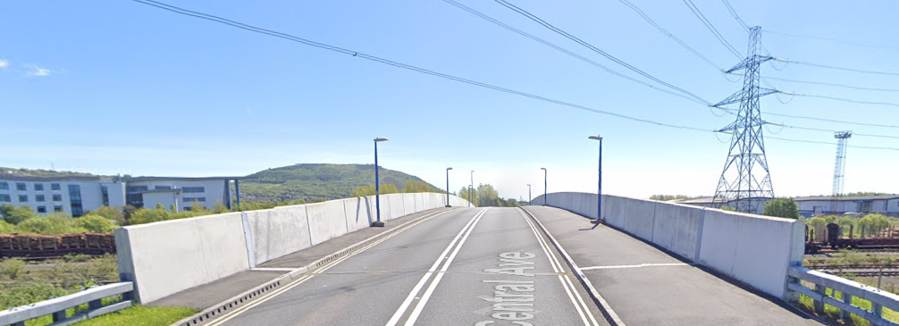

M. Riddler (1904663)- 1904663@student.uwtsd.ac.uk

This document has been prepared in accordance with Regulation 12 of the CDM Regulations 2015

Index:

1 – Introduction
  - Project description
1.2- Design
1.3- Programme of work & key dates

2- Construction phase plan
2.1- CDM duty holders
2.2- Responsibilities
2.3- Design & information
2.4- Review of H&S performance
2.5- Site security
2.6- Site induction & training
2.7- Site welfare facilities
2.8- Accident & near miss reporting
2.9- Site Rules
2.10- Fire & emergency procedures
2.11- H&S file information
2.12- Site Waste management plan

3- Method Statements & Risk Assessments
3.1- Method statements
3.2- Risk assessments

- Introduction
  - Project description
Trinity Civil Engineering ltd (TCE) have been awarded a contract by Neath Port Talbot County Borough Council to build a bridge on Central ave to provide an economic link between two industrial estates.
The main works locations are as follows:
National grid ref- 273864,192986
Works postcode- SA11 2FP

  - Design
The following designs have been submitted & have been signed off for construction use:
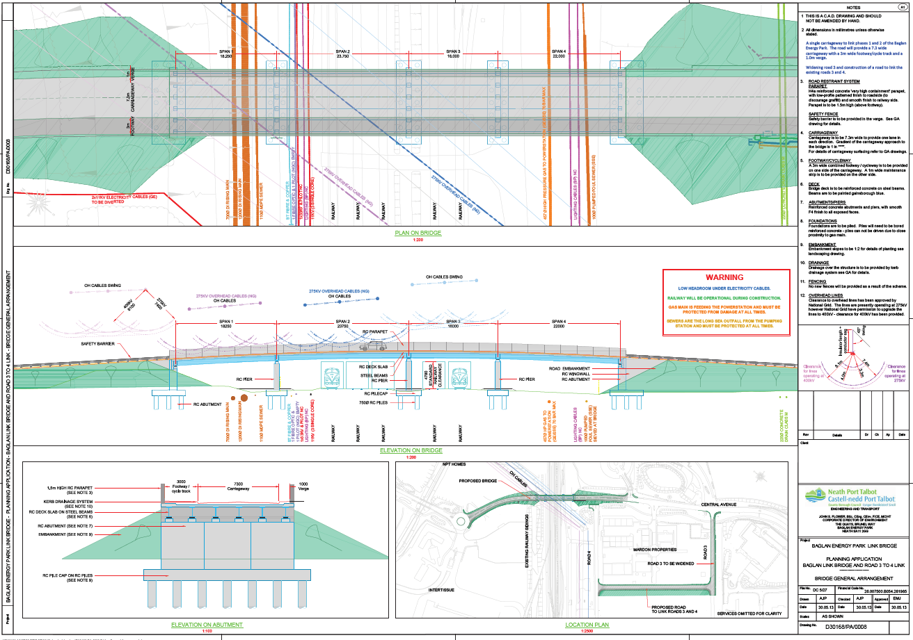

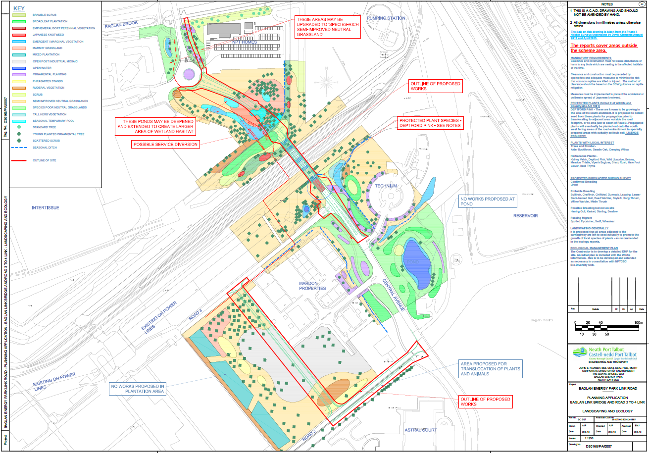
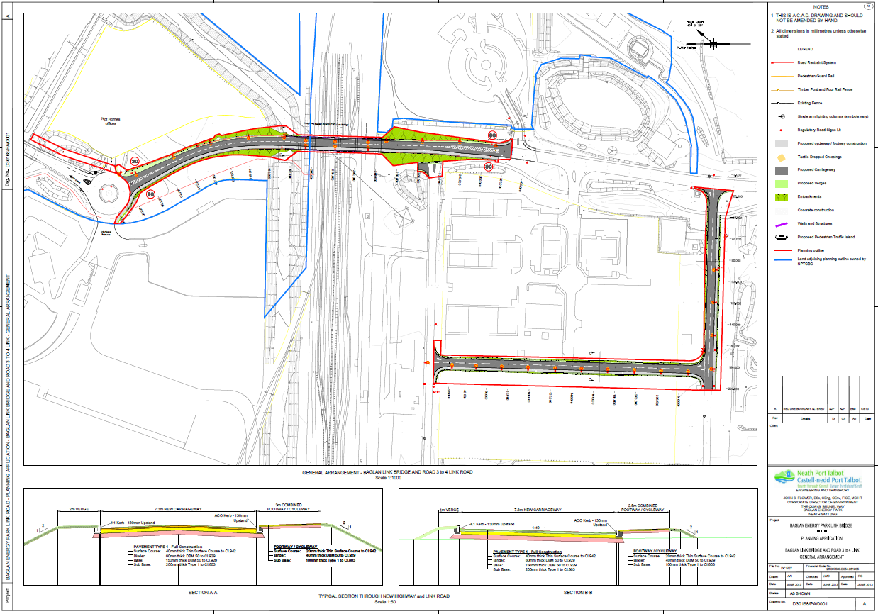
1.3- Programme of work & key dates
Mobilisation to site: | April 20th 2020
Start date: | May 6th 2020
Completion date | TBC

2- Construction phase plan
2.1- CDM duty holders
Client: | NPTCBC | Boris Johnson
Designer: | D Hughes Architecture ltd | Dr Debbie Hughes
Principal contractor: | Trinity Civil Engineering ltd | Managing director: Matthew Riddler  Project manager: Gregory Owen  Site manager: Allan Nantel  Regional SHEQ manager: Keerthi Ranasinghe

2.2- Responsibilities

NPTCBC
Project Team

SHEQ Team
Commercial Manager

Quantity Surveyor

TCE
Site Supervisor
Civils Teams
TCE
Project Manager

TCE
Managing Director

Managing Director
- Adequate resources are allocated to the project to meet health, safety and welfare standards.
- Health, Safety and Environmental Responsibilities are defined for all key position holders.
- Compliance is managed to relevant Legislation, Standards and Codes of Practice.
- Ensuring staff are adequately trained in Health, Safety and Environmental requirements
- Targets and objectives are set, monitored and reviewed.
- Progress of the project is monitored, and effective communication is being maintained throughout
Project Manager
- They lead by example and promote Health, Safety and Environmental issues when applicable.
- Close liaison with the site supervisor in developing the Health & Safety Plan and ensure relevant information is provided for the Health & Safety file.
- All work is carried out in line with current legislation, codes of practice, company procedures, project SHEQ Plans and activity Method Statements.
- Ensuring no person is set to work without an appropriate RAMS for the task.
- Plant & Equipment brought on to site is fit for purpose and that it is only operated by competent persons.
- Any substances used on site that are likely to be Hazardous to Health or the Environment are assessed, and details of any protective measures are provided to the user and others likely to be harmed.
- Sufficient emergency arrangements are in place on site and that all persons are aware of what actions to take.
- All incidents / near misses are reported in accordance with any Escalation Procedure as soon as practically possible.
- Accompany enforcement officers on site visits and for acting on their recommendations. In the case of the inspector issuing a notice, contact the Project Manager immediately after complying with any requirements to stop work.
- Contractors are given suitable access to site and ample time to prepare their RAMS
- Works are programmed onsite to minimise transfer of risk between activities.
- All relevant information is communicated between personnel on site.
- Regular meetings are held between parties to review SHE issues and drive improvements.
- Inductions are carried out to company and client requirements.
- All records are kept up to date and are easily accessible.
- That adequate and suitable supplies of PPE are maintained on site.

Site manager
- Receive instructions from the project manager and implement them on site.
- Ensure that activities on site are carried out in accordance with TCE & Client Safety Rules.
- Ensure that all personnel working on site have read, understood and signed onto the relevant RAMS for the tasks they are performing.
- Establish effective Emergency Procedures to be implemented in the event of an incident.
- Ensure that all personnel (employees, contractors or visitors) receive a site induction before commencing work on site.
- Maintain standards of quality and safety during the project.
- Ensure that all accidents are properly recorded and fully investigated.
- Ensure that all items identified during safety inspections are effectively dealt with.
- Report any visits from enforcement agencies to the client immediately
- Maintain all site documentation in the site files.
- Check Daily Site-Specific Risk Assessments.
- Ensure Work Equipment & PPE is checked before use.
- Stop work and report to project manager when there is a change of conditions not covered by the Risk Assessment & Method Statement.
2.3- Design & information
Any change in working methods, conditions or additional risks identified whilst work is in progress will need to be brought to the attention of the Site manager who will need to discuss the implications with TCE and the Designer. For any resultant change the corresponding RAMS will need to be reviewed and changes notified to all copy holders via planned meetings, training / toolbox talks as appropriate.

2.4- Review of H&S performance
Key Performance Indicators shall be established at the start of the project and published monthly for review.

Indicators to include, but not limited to:
Near Miss Reports
Toolbox Talks completed
Supervisor Audits/Inspections
Any positive interventions are raised & closed out in a timely manner
Accident Reports
Days lost due to Ill health
Utility Strikes

2.5- Site security
A secure compound will be established with temporary buildings and appropriate welfare facilities for use during the works by TCE.

- All personnel and visitors will be required to sign in at the site office before commencing work on site and sign out when leaving site.

- All personnel must be vigilant and report any suspicious or unsafe behaviour.

- All plant and vehicles to be switched off when not in use, keys removed from the ignition and doors locked, as appropriate. Trailers and towed plant should be secure, and hitch locked as appropriate when not in use.

- All work areas and excavations are to be signed appropriately and guarded with the use of road traffic barriers and/or Heras Fencing.

- All existing boundaries and means of access and egress must remain intact. Access gates to be closed after use.

2.6- Site induction & training
Before entry to the site and prior to any work commencing, all employees and visitors will receive a Site Induction and be made aware of the relevant sections of the Health and Safety Plan and instructed to work in accordance to its requirements. Site induction's and instructions are to be carried out by the Site Supervisor or their appointed deputy. Inductions shall include an explaining the project and identify the Health and Safety goals and conclude with an acknowledgement signature.
Control measures on site as applicable:
- Traffic routes
- Security
- Hearing protection zones
- Permits-to-work
- Arrangements for PPE
- Arrangements for housekeeping
- Welfare & First Aid arrangements
- Emergency Procedures
- Accident, Incident & Near Miss Reporting
- Planned training
- Arrangements for consultation
- Individual’s health & safety responsibilities
No person will be permitted work on site without first attending an Induction.

All visitors to site will be required to sign on to the Daily Risk Assessment.

2.7- Site welfare facilities
Site Welfare facilities will be provided by TCE.

- Provision of First Aid shall be in accordance with the Health and Safety (First Aid) Regulations 1981 Approved Code of Practice and shall be under review as the project progresses.

- First Aid shall be provided at each office location and temporary site welfare cabin. The level of qualified staff shall be appropriate to the task and remoteness from welfare provision.

- It is expected that at least one member of each team has received training to provide Emergency Aid and that Supervisors are trained to provide Emergency Aid.

2.8- Accident & near miss reporting
In order to avoid any misunderstanding, the organisation shall identify incidents as follows: -
- Accident: "any unplanned event that results in personnel injury or damage to property, plant or equipment.
- Near-miss: "an unplanned event which does not cause injury or damage but could have done so." (e.g. items falling near to personnel, incidents involving vehicles and electrical short-circuits.
- Dangerous Occurrence: As defined in RIDDOR (including overturned excavators, failure of a lifting appliance, contact with overhead lines, collapse of scaffold, etc.)
- Incident: A term that is used to refer to all above.

All accidents resulting in personal injury must be recorded in the site accident book which will be located in the main project site office and the SHEQ Manager notified. All incidents must be reported to TCE management & relevant NPTCBC staff.

2.9- Site Rules
Site rules will adopt TCE’s ‘Golden Rules’
- Always assess risks before starting work
- Only undertake work you have been instructed to carry out
- Only undertake work for which you are trained and competent
- Stop work and reassess risks when conditions change
- Always wear the appropriate PPE for the task that you are undertaking, including hand, eye and ear protection
- Always keep a tidy site and remove anything that could cause a slip, trip or a fall for you or passers by
- Always report incidents and near misses
- Don’t walk by - Always act on hazards with positive intervention
- All visitors must report to the site office and sign the visitor log.
- All delivery drivers shall report to the site office before unloading.
- All personnel & visitors shall keep to the designated walkways / footpaths identified.
- All visitors and operatives shall comply with the mandatory and warning signs posted.
- All operatives and staff carrying out works shall have read, understood and signed on to the relevant method statement and risk assessment.
- A minimum PPE of: Safety Boots, Hi-visibility clothing, Hard Hat, Safety Glasses and Gloves to be worn at all times whilst on site.
- Smoking is only allowed in designated smoking area.
- Zero Tolerance to Drugs & Alcohol
- All accidents, near misses and dangerous occurrences must be reported to the site manager immediately.
- All staff & operatives shall behave in a courteous manner to members of the general public and any site visitors.
- Welfare facilities are provided and must be utilised. No eating or drinking on site other than water during hot weather.
- No person under the influence of drugs or alcohol shall be permitted on site.
- All containers must be labelled and correctly stored to comply with COSHH regulations.
- Mobile phones shall be restricted to use outside the work unless specifically related to the safe operation of a task.

*IF IN DOUBT STOP WORK & ASK*

2.10- Fire & emergency procedures

- All activities / vehicles identified by risk assessments that need to be equipped with a fire extinguisher must ensure that it has been secured and serviced and that it is still in date.
- Only persons trained in use/operation of Fire Extinguishers shall operate them but in all circumstances no person should endanger themselves or others by attempting to fight a fire.
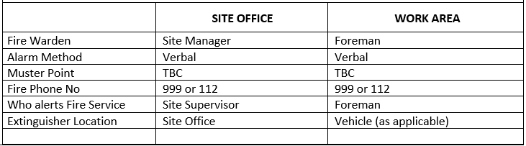

- Site specific Emergency Procedures are to be developed upon site setup and communicated during induction.
- All personnel will report to Site Manager upon arrival and agree the days risk assessment.
- All personnel have a duty to report unsafe practices or dangerous situations to their supervisor and/or the Site Manager.
- In the event of any emergency, the following procedure will need to be followed:
All operations to cease immediately and shut down all plant so as to present no further risk to persons present.
When calling Emergency Services on 999
Provide details of Service required with:
Location, Incident type, Numbers Injured (if any), Extent of any Injuries, Details of any existing Hazards

The nearest Hospital in relation to the site is:
Neath Port Talbot Hospital
Baglan Way
Port Talbot
SA12 7BX

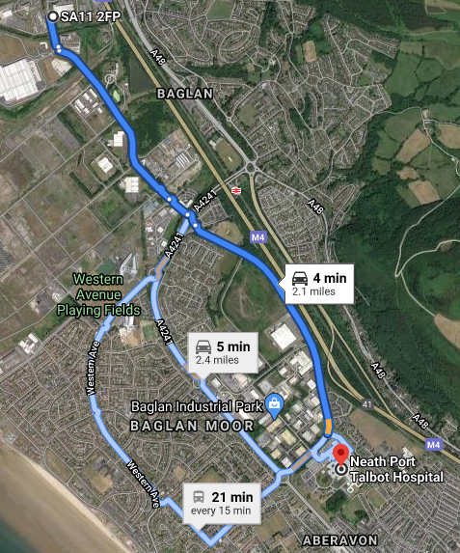
- All accident, incidents and near misses are to be reported as soon as practicable, in accordance with RIDDOR and the client’s requirements.
- Telephone numbers for site contacts and emergency services will be held by the Site Supervisor, clearly displayed in the office and provided to staff upon induction.

2.11- H&S file information
- During the construction phase on-going communication between TCE & NPTCBC shall be maintained by the Site Supervisor to ensure that all relevant information is provided in a timely fashion for entry in the Health and Safety File.
2.12- Site Waste management plan
- A record of all waste removed from site will be maintained, a record of licensed carriers and records of licensed brokers kept.
- Waste shall be managed in accordance with the Waste Hierarchy:

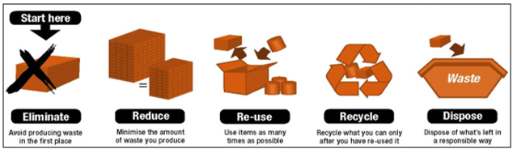

3- Method Statements & Risk Assessments
3.1- Method Statements
Scope of Works: Construct a road bridge using pile foundations & reinforced concrete piers as per approved design, the bridge deck will be manufactured off site & will be covered in this document.
Site Compound:
TCE yard
Brunel Way
Baglan
Port Talbot
SA11 2FP

Commencement date: 06/05/2020

The main hazards associated with these works are:
- Overhead & Underground cables & services
- Working with concrete
- Working with Power tools (diamond blades, abrasive wheels)
- Excavations
- Working from height
- Working near a railway
- Working in and around the carriageway and public vehicles
- Persons in excavations being struck by falling materials
- Building or structures collapsing due to ground condition
- Fumes from plant & dust
- Lifting operations
- Extreme weather conditions
- Plant & equipment
Lifting operations- All lifting operations shall be carried out in accordance with LOLER Regulations, HSE ACoP L113 Safe Use of Lifting Equipment.
Lifting certificates to be in place for all lifting appliances and accessories.

Lift Plan to be drawn up for lifting operations

Only trained operators to utilise lifting appliances.

Lifting equipment shall be suitable for purpose with SWLs clearly identified and tested/inspected in accordance with its 6/12 monthly cycle.

Where excavators are utilised for lifting then only Excavators suitably certified for lifting are to be used with a current certificate of Statutory Inspection and a copy of the lifting chart available to the Machine operator. Where an excavator’s SWL exceeds 1000kg then it must be fitted with a visual or acoustic warning device.

Plant & equipment: Plant must be accompanied by a certificate of inspection and test under the PUWER or LOLER regulations as applicable.
All plant and equipment shall be serviced and have been inspected prior to use and be in calibration where applicable. Any defects found MUST be reported to the supervisor/site manager.

This shall consist of but not limited to:
- Cable locator (e.g. CAT and Genny or GPR)
- Pneumatic/hydraulic breakers
- Floor/still saw
- Trench Rammer
- Rubber tracked excavator
- Grab lorry
- Various hand tools- shovels etc
- 6T Dumper
- Form Work
- Traffic management
- Lifting accessories
- Tractor and trailer for material transportation.

Power Tools (Diamond blades & abrasive wheels): Diamond blades should be manufactured to BS EN 13236
General

- All activities connected to the above must be carried out in a safe manner with competent personnel.
- A visual inspection of the wheel must be carried out prior to use.
- A visual inspection of the equipment being used must be made before the operation commences.
- The operator must be trained in the use of the equipment.
- The operator must be trained in the use of abrasive wheels
- Ensure the working area is clean, tidy and free from tripping hazards
- Any wheel being mounted on any piece of plant or machinery must be checked for damage, contamination and is of the correct type prior to use.
- The new wheel will be mounted on the plant or machinery as per the manufacturer’s specifications.
- Once completed, the newly fitted wheel MUST be run at its maximum speed for a minimum of 30 seconds.
- This MUST be done whilst the wheel is being pointed away from anything or anyone that could be affected by its omissions.
- Never walk around with the abrasive wheel still turning always ensure that it has fully stopped before moving
- Abrasive wheels must only be used for what they were designed to do.

Diamond Blades

As with bonded abrasive wheels, people working with diamond blades must be properly trained

Diamond blades are only used for cutting-off and cannot be used to cut metal.

As with bonded abrasive wheels, different grades are available to suit different materials.

General recommendations for diamond blades:
- Before use always check whether the blade is designed for wet or dry cutting and only use it as recommended by the manufacturer.
- Diamond blades are directional and must be mounted so that they rotate in the direction marked on the blade.
- Diamond blades can be used on handheld machine at speeds up to 100m/s provided that the machine is designed for this and the marked maximum permissible operating speed of the blade is not exceeded
- Do not allow the blade to overheat as this reduces diamond life.
- Periodically it may be necessary to redress blade by making cuts in block.
- These wheels last a comparatively long time, therefore before use and with the power disconnected, make a special point of checking the condition of the spindle bearings on the machine, as these can deteriorate considerably during the lifetime of a diamond cutting wheel.

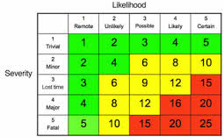
3.2- Risk Assessments


